Learning Outcome 5: Children are effective communicators

What do I want my child to learn?
- Develops dispositions such as creativity and persistence
- Expresses ideas and makes meaning in different ways
- Uses literacy in play
- Experiments with drawing and writing
- Explores concepts of print and text
- Develops a positive attitude to reading and writing
- Begins to understand how symbols and pattern systems work
- Uses beginning literacy skills in everyday activities
- Interacts verbally and non-verbally for a range of purposes
- Responds to and interacts positively with adults engaging in literacy

How can I support their progress?
- Provide lots of literacy play opportunities where your child is encouraged to explore concepts of print (books, magazines, pamphlets) and other communication styles (drawing and artwork, computer technology, speaking and listening, songs and rhymes).
- Provide an attractive nook for your child to choose and read books. You can access picture books at second hand book stores, street libraries and community libraries. Create an inviting space such as a bean bag and a small shelf or basket of books.
- A small writing centre can be provided nearby. If you don’t have a small table and chairs use a tub or large pencil case. Provide various types of paper and writing/drawing implements. Including tape, scissors, sticky notes and a stapler can further encourage your child’s creativity.
- Role model reading to your child and draw their attention to early concepts (such as directionality of print, title of books, differences between pictures and writing, title page, book cover, simple sounds that are of interest).
- Make reading joyful and exciting whenever you have an opportunity to read with your child. Aim for three times a day.
- Role model writing and focus on concepts such as where to start, how to form letters and some sounds for simple words in the context of the activity (eg: sounds for m-u-m are muh-uh-muh). Try to write for real life circumstances (eg: birthday card for family member, shopping list, reminder notes, sending a text to Granny).
- Write what your child says about a painting or drawing and talk out loud about how you’re going about it (“I’m going to spell out the word ‘dog’ while I write it. Hmmm, what does it start with? Oh yes,‘d’”; “oh dear, I nearly forgot the full stop”. “Would you read it with me?”)
- Talk to your child about choosing items during the day, such as cereal. Draw your child’s attention to such things as the signage on a food packet and compare this to another packet (for example weetbix and cornflakes).
- Make a scrapbook of all the words your child can read from common signage such as packaging, icons in junk mail, photos of local signs.
- Encourage your child to predict what a sign might say while you’re out and about, and celebrate their confidence to have a try. Avoid correcting your child’s mistakes. Say something like “That was a good suggestion, I can see how you were thinking that. It says ‘mobile phones sold here’. You can tell because it starts with a ‘m’, and there’s a picture of a mobile phone’”. If your child nearly got it right, celebrate their attempt: “Wow, yes, that’s it. It’s a sign telling us where to buy a mobile phone”.

How will I know if my child is learning?
- They are showing an interest in using literacy in their play. Some examples might include:
  - they take on roles as literacy users
  - sing and chant rhymes, jingles and songs
  - use creative arts to express meaning
  - engage with technology for fun and to make meaning
  - continue a remembered sequence in play
  - use symbols in play
  - imagine and create roles during dramatic play.
- They are beginning to experiment with resources and use literacy in every-day activities. Some examples might include:
  - playing with menu’s, tickets, recipes or labels
  - use keyboards to pretend being in an office
  - create various texts to support their play (such as a police charge form or a menu)
  - make use of various literacies available around the home.
- They view them self as a reader and writer by ‘having a go’. Some examples might include:
  - telling stories from the pictures in a book
  - confidently reading signage in the local environment
  - stringing symbols together to represent writing
  - making their own books or writing letters/cards to a family member or friend
  - labelling items on drawings
  - asking you to write things for them to copy
  - recognising significant words such as their name, mum, dad, granny.

Tips for learning at home
- Try to follow your child’s lead as much as possible and allow your child choice about which play experiences and activities they want to participate in.
- Give your child as much or as little time as they need for each learning experience.
- Provide your child with uninterrupted play time where possible.
- Support your child when they ask or show signs that they need help with their task.
- Offer praise and encouragement for any learning attempts, even if they don’t get it quite right.
- Engage in discussion with your child about their play and what they are learning.
- It doesn’t matter if the suggested experiences don’t go according to plan, allow your child to lead the play and learning.

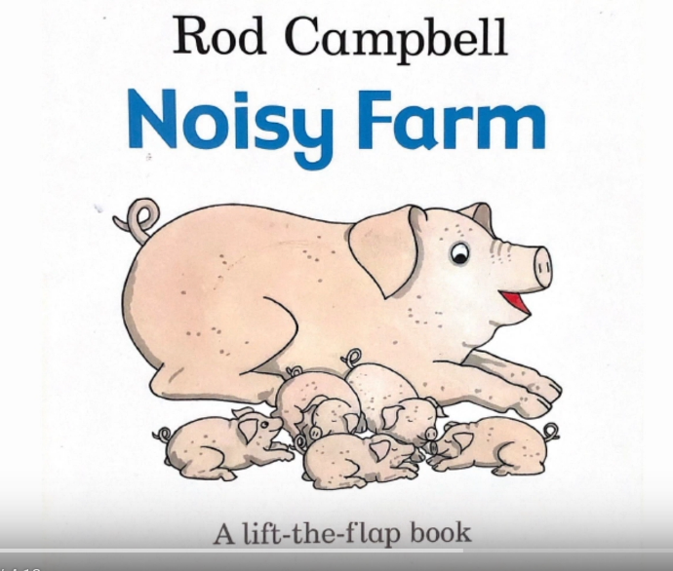
Story time: The noisy farm
View the story
- Open the story on YouTube.
- Enjoy the story.
- Read the story with your child. Encourage them to guess what will be on the next page, make the noises sound interesting and encourage your child to make the noises too.
Ideas to extend the learning
- Make your own book of the sounds you hear in your environment. Help your child to illustrate it and ask them to tell you what to write. Encourage your child to add their own writing to the book (you could also use photos from around your house/locality and print these for the book).
- Make a farm with blocks and plastic animals. Use the blocks for fences or buildings. Place the same animals within the fences and buildings. Make up labels for the animals and place them with the corresponding animal. Read the labels with your child. If they are interested, draw their attention to the sounds in the words.
- Make a dice or cards with animal characters pictured. Roll the dice and enact the noise and actions of the animal. (see next page for larger version).
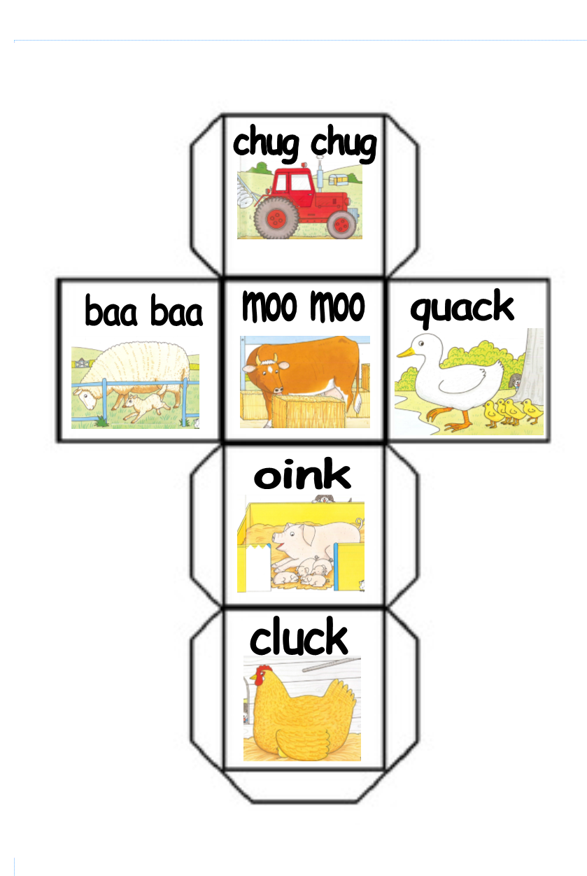

Story time: The three little pigs
Click on the link to view the story with your child. Use interesting voices for the different characters and encourage your child to ‘read along’ whenever there is a repetitive phrase such as “I’ll huff and I’ll puff and I’ll blow your house in!”
Ideas to extend the learning
- Use collage materials to create a scene from the story. Ask your child to describe the picture and write this on the artwork.
- Re-tell the story verbally and support your child to say the repetitive parts of the story, such as “Little pig, little pig, let me in!” and “Not by the hair of my chinny chin chin”. Use expression and draw your child's attention to the different voices.
- Support your child to illustrate their favourite part of the story. Help them notice features of the characters and draw these. “I notice the little pig has a round circular face”; “His body is round” “He needs eyes, and pointy ears” “Her snout is a circle too, with two little nostrils”.
- Cut out the pictures from the three little pigs and stick them onto paddle pop sticks. Encourage your child to retell the story using the puppets or they may like to create their own version of the story.

