This booklet belongs to:

Week N– Monday

Day at a glance:
 | Aboriginal story telling | Different opinions | Friendship | I'm proud to be me | Pyramids
Estimated time | 10 mins | 10 mins | 15 mins | 10 mins | 10 mins
Resources required |  |  |  |  | Small, flat objects such as coins or buttons

Aboriginal story telling
Learning goal: Children learn about and show respect for Aboriginal culture.
In these videos Aboriginal people share the stories of their Country.
- Choose the stories that you are interested in listening to via the QR codes below. If you can’t access the QR codes to watch the videos, talk with someone in your home about:
- Bush tucker
- Owls and bats that live in caves
- Dreamtime stories

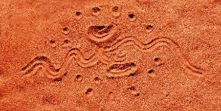

Watch this video to learn about the Gumbayngirr people and the Dorrigo National Park.
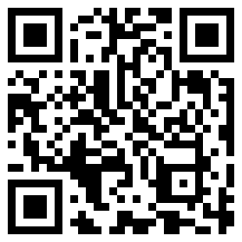
Watch this video to learn about the Walgalu people and the Kosciuszko National Park.
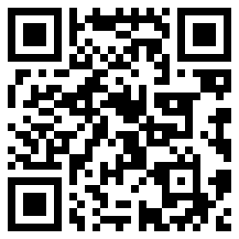
Watch this video to hear the dolphin story from the Coffs Coast Regional Park.
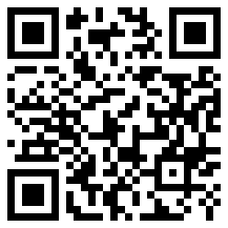
- What is one thing from the stories that you would like to learn more about? Ask someone to help you research that.

Is this activity too hard?
- Talk to someone about what you hear in the video.

Is this activity too easy?
- Who are the traditional custodians of the Country you live on? If you don't know, ask someone to help you research.

Different opinions
Learning goal: Children express ideas and feelings and respect the perspectives of others.
Often people have different ideas or feelings about the same thing. Your ideas and feelings are your 'opinion'. For example, one person's opinion might be that pineapple tastes good on pizza. Another person's opinion might be that it tastes bad. Both opinions are OK. We can find out what someone's opinion is by asking them questions.
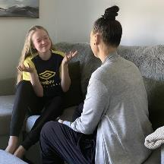
- Make up some interview questions to ask different people in your family their opinion, for example:
- Which TV show do you think is better; Bluey, Octonauts or Ben and Holly's Little Kingdom?
- Do you like cats or dogs more?
- Which sporting teams do you like?
- What do you think makes a good pet?

Is this activity too hard?
- Ask everyone in your family the same question, for example, 'Do you like cats or dogs better?'

Is this activity too easy?
- After you interviewed your family, whose opinion was most like yours?
- Interview a friend to find 5 things you both like and 5 things you both don't like. Did you have different opinions?

Friendship - Part 1
Learning goal: Children feel connected to others.

- Think about:
- What is a friend?
- Who are your friends?
- Watch the video via this QR code. If you can’t watch go to step 5.
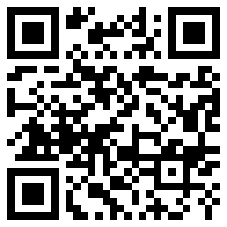
- What activities or games were the friends doing together?
- Do you and your friends do any of these things?
- What do you and your friends like to do together?

Is this activity too hard?
- Think of a memory you have of spending time with a friend. Share that memory with someone.

Is this activity too easy?
- What do you and your friends have in common?
- What do you and your friends NOT have in common?
- How will you make new friends when you start school?

Take a break
Here are some things you might like to do:
- have a drink of water and a healthy snack
- play or have a rest
- go to the toilet and wash your hands.
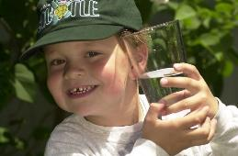
"Boy with glass of water, 2000" by Seattle Municipal Archives is licensed under CC BY 2.0
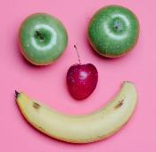
Smile made of ripe fruits by Any Lane, pexels.com

Photo by Andrea Piacquadio. pexels.com
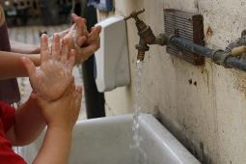
"Washing hands" by magnusfranklin is licensed under CC BY-NC 2.0

Proud to be me
Learning goal: Children feel recognised and respected for who they are.
- Watch the video via this QR code. If you can’t access the video, you can go to step 2.
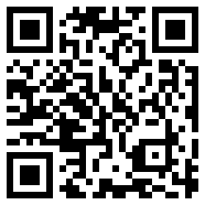
- Talk to someone about what it means to be or feel proud.
- What makes you proud of yourself? Perhaps you are proud of the way you help someone in your family or how hard you try to learn new things.
- Draw a picture of yourself.
- Ask someone to write down on your drawing what it is that makes you feel proud, for example 'I feel proud when I ... '.

Is this activity too hard?
- Talk with someone about what you do well.

Is this activity too easy?
- Do the thing that makes you feel most proud!
- When you are finished think about how you feel.

Making triangles
Learning goal: Children use trial and error to create a pyramid shape.
- Look at this pyramid. Each side is a triangle.
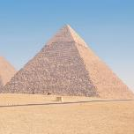
"Cairo pyramids, Dec 2008 - 59" by Ed Yourdon is licensed under CC BY-NC-SA 2.0

- Use 3 small objects to make a triangle like this.
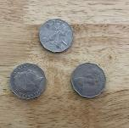
- Use 6 small objects to make a triangle like this.
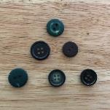

- Make a triangle with 10 counters.
- Count the objects in the bottom row. How many? (4)
- Count the objects in the second row. How many? (3)
- Count the objects in the third row. How many? (2)
- Count the objects in the top row. How many? (1)

Is this activity too hard?
- Draw a triangle. Place small objects along each side.

Is this activity too easy?
- Make a bigger triangle.
- How many objects did you use?

Extra learning activities
Develop literacy concepts through story: Amy and Louise, via this QR code.
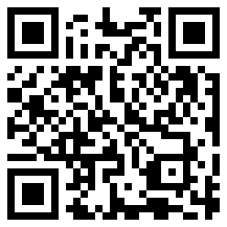
If you can’t access the QR code, choose a story you like to read with someone in your home. You can talk about what happened in the beginning, middle and the end of the story. You could even make up a different ending.
© State of New South Wales (Department of Education), 2021
The copyright material published in this document is subject to the Copyright Act 1968 (Cth) and is owned by the NSW Department of Education or, where indicated, by a party other than the NSW Department of Education.
Copyright material available in this document is licensed under a Creative Commons Attribution 4.0 International (CC BY 4.0) licence.
See https://education.nsw.gov.au/about-us/copyright for further details.
