This booklet belongs to:

Week L – Friday

Day at a glance:
 | What is this plant? | Make a herbal scrub | Transformation | Mindfulness | Getting through hard times
Estimated time | 15-20 mins | 15 mins | 10-15 mins | 15 mins | 10 mins
Resources required | Something to draw with and on | Sea salt or sugar, oil, mixing bowl, knife, lavender

What is this plant?
Learning goal: Children engage in problem-solving to hypothesise about plants.
- Listen to the poem via this QR code about a plant that just appeared in someone’s garden. If you can’t listen, go to step 4.

- After listening to the poem:
- think about why the plant sprouted, even though nobody planted it
- imagine the plant as a little seed, then a sprout, then growing big, bigger, tall and straight, with delicious green leaves.
- If you want to learn more about how plants grow from seeds, watch the video via this QR code. If you can’t watch, go to step 4.

- Draw a picture of a seed, then a sprout, then a tall plant.
- Look outside for plants and trees. Can you recognise some that are small and young, and others that are tall and old? Tall trees that we see in the bush would have been growing for many years.

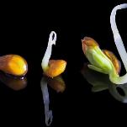
"Cress seed to Swans! Explored 12 December 2016" by aronalison is licensed under CC BY-NC-SA 2.0
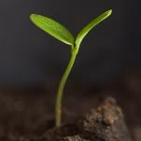
"Seedling" by _sjg_ is licensed under CC BY-NC 2.0
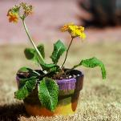
"Just another potted plant" by kevin dooley is licensed under CC BY 2.0
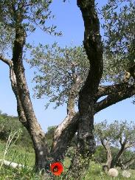
"Tree" by -epsilon- is licensed under CC BY 2.0

Is this activity too hard?
- Eat an apple, orange, mandarin or other fruit with seeds. Put a seed in the garden and water it. See if it grows.

Is this activity too easy?
- Create a puzzle for a friend:
  - draw the stages of growth of a plant from a seed, to a sprout, to a small plant, to a tall plant
  - draw what it looks like both under the ground and above the ground
  - cut the pictures out and see if your friend can arrange them in the correct sequence.

Make a herbal scrub
Learning goal: Children experiment with cause and effect and trial and error.
Watch the video to learn how to make a herbal body scrub. If you can’t watch, follow the instructions below.

What you need:
- mixing bowl
- herbs, such as lavender, lemongrass, mint or rosemary
- sugar or salt (approx. 5 cups)
- 1/2 cup oil.
What to do:
- Choose the herbs you want to use.
- Ask an adult to help chop up the herbs, the smaller the better, and place them into the mixing bowl.
- Add the sugar or salt and mix them together
- slowly pour in the oil, making sure the mixture holds together but isn't too oily.
- How does your body scrub feel? What does it smell like? How does your skin feel after touching it?
- You may wish to give your special body scrub to someone as a present. You will need to place your mixture in a clean jar. You might like to decorate the jar.

Is this activity too hard?
- Ask an adult to help you make the body scrub.

Is this activity too easy?
- Describe this learning experience to someone:
  - What did you need to do?
  - What is an important step for someone to know if they wanted to try it?

Transformation
Learning goal: Children explore the growth cycle of a butterfly.
- Watch the video of 'Little J and Big Cuz' via this QR code. If you can’t watch, go to step 2.

- Where do you think butterflies come from?
- Tell someone about the stages the caterpillar went through to become a butterfly. If you are not sure, look at the pictures below.
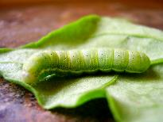
"caterpillar" by tamburix is licensed under CC BY-SA 2.0
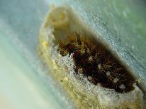
"Caterpillar cocoon" by r3gg is licensed under CC BY-NC 2.0
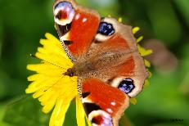
"Colour-my world" by johnb/Derbys/UK is licensed under CC BY-NC-SA 2.0

Is this activity too hard?
- Watch the story with someone and pause it if you have any questions.
- If you can’t watch the story, look at some pictures of caterpillars and butterflies in books or outside.

Is this activity too easy?
- Draw the stages that you saw the caterpillar go through to become a butterfly.

Take a break
Here are some things you might like to do:
- have a drink of water and a healthy snack
- play or have a rest
- go to the toilet and wash your hands.
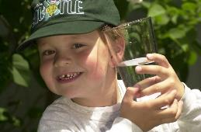
"Boy with glass of water, 2000" by Seattle Municipal Archives is licensed under CC BY 2.0
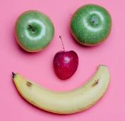
Smile made of ripe fruits by Any Lane, pexels.com

Photo by Andrea Piacquadio. pexels.com
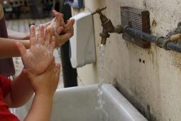
"Washing hands" by magnusfranklin is licensed under CC BY-NC 2.0

Mindfulness
Learning goal: Children enjoy moments of solitude.
- Watch the three videos of natural environments via these QR codes. If you can’t watch, go to step 3.
Spring garden

Australian bush

On the coast

- What things were in the spring garden, the coast and the bush?
- Were there big things such as the sky, the ocean, hills and trees?
- Were there little things such as bees, flowers, shells?
- What colours did you see?
- What animals did you see?
- Tell someone how the videos made you feel.
- Go to a place where you like to spend time.
- Look at the big things.
- Look for the smaller details.
- Notice the colours.
- Notice if there are animals.
- Think about how you feel in that place.
Spring garden
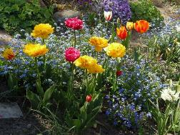
"SPRING GARDEN : MAY 2016" by swetlanahasenjäger is licensed under CC BY-NC-SA 2.0

Australian bush
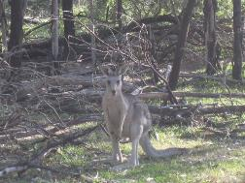
"Breakfast time in the Australian bush" by avilasal is licensed under CC BY 2.0
On the coast
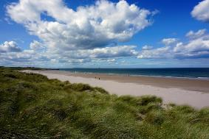
"beach" by barnyz is licensed under CC BY-NC-ND 2.0

Is this activity too hard?
- Talk to someone about what you see in the place you go to.

Is this activity too easy?
- Take photos or draw pictures of the place you go to. Share the images with someone.

Getting through hard times
Learning goal: Children express emotions and concern for others.
- Watch the video of a story called 'Birdie and the Drought' by Andrea Baldwin and Anil Tortop via this QR code. If you can’t watch, go to step 2.

- A drought happens when it doesn't rain for a long time. It can be very scary when there is no water for the plants to grow and the animals to drink.
- Have you ever been through something that was scary and hard?
- Who helped you to feel happy and safe?
- What can you do to help friends or family members if they experience something scary or hard?

Is this activity too hard?
- Tell someone about how you are feeling today.

Is this activity too easy?
- Draw a picture of a time in your life when you felt sad or scared.
- Include the people that helped you feel happy and safe in your drawing.

Extra learning activities
Practice your oral language skills with the story Giraffes can't dance via this QR code. If you can’t access the code, there are family tips below to support further learning.

Family tip: Taking learning further
- Have a family jungle dance, making sure everyone knows they can dance when there is music they enjoy.
- Talk with your child/children about their favourite sorts of dance music and take photos and/or short videos of them dancing.
- Use these snapshots for quiet reflection with your child/children about how this made them feel.
- Invite your child/children to make instruments such as shakers (yoghurt pot with rice inside), cymbals (2 saucepan lids) and drums (saucepan and spoon).
© State of New South Wales (Department of Education), 2021
The copyright material published in this document is subject to the Copyright Act 1968 (Cth) and is owned by the NSW Department of Education or, where indicated, by a party other than the NSW Department of Education.
Copyright material available in this document is licensed under a Creative Commons Attribution 4.0 International (CC BY 4.0) licence.
See https://education.nsw.gov.au/about-us/copyright for further details.


