This booklet belongs to:

Week K – Monday

Day at a glance:
 | Playing games | Shared story | Grow a plant | Dancing | Symbol hunt
Estimated time | 10 mins | 15 mins | 20 mins | 25 mins | 10 mins
Resources required | A board or card game |  | Plant cutting, container or jar |  | Something to draw with and on

Playing games

Learning goal: Children develop skills of focus, persistence and cooperation.
At school you will play games with other children which require you to concentrate and try hard. You will also need to follow game rules, wait your turn and cope when you are not the winner.
- Choose a game you would like to play, for example:
- dominoes
- hopscotch
- bingo
- memory
- snap.
- Ask one or two other people to play with you.
- Talk about the game rules to make sure everyone understands them.
- Play the game, making sure you concentrate well and follow the rules.
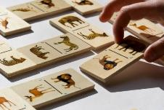
"After the extinctions ... at least our kids will always have the dominoes" by woodleywonderworks is licensed under CC BY 2.0
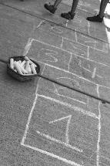
"Hopscotch Sidewalk 6167 B" by jim.choate59 is licensed under CC BY-NC-ND 2.0
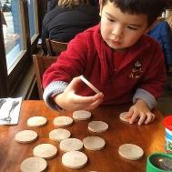
"Morning brain exercising - the memory game with dinosaurs of course" by cdorobek is licensed under CC BY 2.0
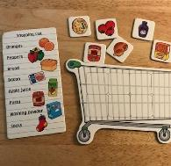

Is this activity too hard?
- Play in teams, so everyone has someone playing alongside them to help them.

Is this activity too easy?
- Choose a different game to play, perhaps a game that takes longer or is harder.

Shared story- Owl babies
Learning goal: Children identify the feelings of a story character.
- Watch the video of the story Owl Babies, via this QR code. If you can’t watch, go to step 6.

- How did the owl babies feel when they woke up?
- Why do you think they felt like this?
- How did the owl babies feel at the end of the story?
- Why do you think they feel like this?
- Choose a favourite story from home and ask someone in your home to read with you.
- Talk about what happened in the beginning of the story and the middle of the story.
- Talk about what happened at the end of the story. Can you think of a different ending for the story?

Is this activity too hard?
- As you enjoy the story (video or your own book), talk with someone about what you can see in the pictures.

Is this activity too easy?
- Can you retell the story using different characters?

Grow a plant
Learning goal: Children show an increasing understanding of how things grow.
Plants are always growing and changing. Watch the video via this QR code, and follow the instructions to grow a new plant from a cutting. If you can’t watch the video, go to the instructions below.


Instructions with images
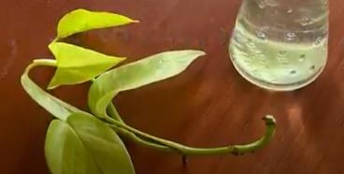
Take a cutting from another plant, making sure you cut at the node (the join).
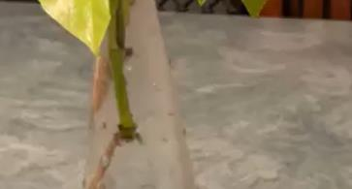
Put the cutting into a clear container filled with water. A good place to keep it is on a window sill or a place near light. Over time, roots will begin to grow.
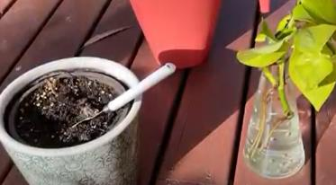
Once there are lots of roots, you can transplant to a pot with dirt.
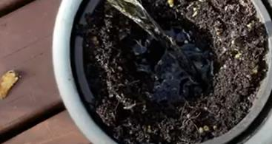
Make a hole in the centre of the dirt and add lots of water.
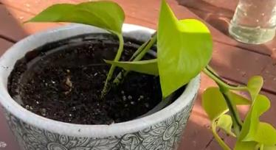
Place your plant in the hole and gently press the dirt in and down around the stem. Your plant is ready to grow. Water well in the first few weeks so the roots continue to grow strongly into the dirt.

Take a break
Here are some things you might like to do:
- have a drink of water and a healthy snack
- play or have a rest
- go to the toilet and wash your hands.
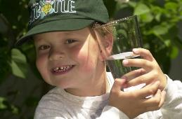
"Boy with glass of water, 2000" by Seattle Municipal Archives is licensed under CC BY 2.0
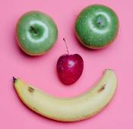
Smile made of ripe fruits by Any Lane, pexels.com

Photo by Andrea Piacquadio. pexels.com
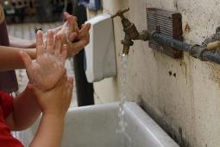
"Washing hands" by magnusfranklin is licensed under CC BY-NC 2.0

Action song
Learning goal: Children perform actions to match a song.
Join in singing and doing the actions for this song via this QR code. If you can’t listen, go to the lyrics and actions below and ask someone in your home to sing with you.

Lyrics and actions
If you’re happy and you know it, clap your hands
If you’re happy and you know it, clap your hands
If you’re happy and you know it then you really ought to show it
If you’re happy and you know it, clap your hands.
Replace clap your hands with other actions:
- Stomp your feet
- Shout hooray

Is this activity too hard?
- Focus only on copying the actions.

Is this activity too easy?
- Create a new verse for the song, for example, 'If you're happy and you know it spin around'.

Symbol hunt
Learning goal: Children understand how symbols work and recognise them in the environment.
- Watch the video about symbols via this QR code. Follow the instructions to look for symbols around your home. If you can’t watch the video, go to step 2.

- Look at the symbols below. Have you seen them before?
- Talk with someone in your home about what they mean
- What other symbols can you find in your home?

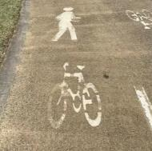



Is this activity too hard?
- When you see a symbol, talk with someone about what it means.

Is this activity too easy?
- Create a symbol for:
  - your favourite food
  - a pet
  - each room in your house
  - warning people of loud noise.

Extra learning activities
Explore and create based on the story of, “We're going on a bear hunt” via this QR code. If you can’t access the code, you might have this story at home that you can read. If not, choose your favourite thing to read, play with or relax with and enjoy some time doing it.

© State of New South Wales (Department of Education), 2021
The copyright material published in this document is subject to the Copyright Act 1968 (Cth) and is owned by the NSW Department of Education or, where indicated, by a party other than the NSW Department of Education.
Copyright material available in this document is licensed under a Creative Commons Attribution 4.0 International (CC BY 4.0) licence.
See https://education.nsw.gov.au/about-us/copyright for further details.


