This booklet belongs to:

Week K – Friday

Day at a glance:
 | Sound song | Learn Auslan | Wanda goes to the park | Run rabbit tag | Magical milk
Estimated time | 10 mins | 10 mins | 45 mins | 10 mins | 15 mins
Resources required |  |  | Soft toy, journal or book to write in | Strip of fabric, bucket or container | Tray, milk, food colouring, dishwashing liquid, twig, paper

Sound song
Learning goal: Children develop knowledge of letter-sound relationships.
- Each letter makes a different sound.
- Listen to the song via this QR code and try to sing along. You will hear different words starting with different sounds, and also see what each of the letters looks like. If you can’t listen, ask someone in your home to help you hear and say the beginning sounds of some words.


Is this activity too hard?
- Ask someone in your family to say some sounds for you to copy.
- Say the name of each person in your family. Now make the sound each name starts with.

Is this activity too easy?
- Line up some of your toys and say each of their names out aloud. Listen carefully to see what the first sound is.
- Write or copy the letters for each of these sounds.

Learn Auslan - Goodbye and thank you
Learning goal: Children learn to use sign language.
Auslan is the Australian sign language, a language developed by, and for, Australians who are deaf or hearing impaired. It’s a visual form of communication that uses hand, arm and body movements to convey meaning.
- Watch the video via this QR code to learn how to say goodbye in Auslan. If you can’t access the video, you can look at the picture.
- Use your hands to copy the sign.

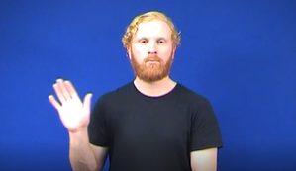
Move your hand back and forth to wave goodbye.
- Watch this video via the QR code to learn how to say thank you in Auslan. If you can’t access the video you can look at the pictures.
- Use your hands to copy the sign.

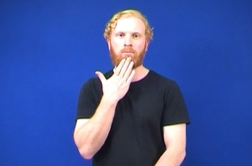
Place your finger tips on your chin.
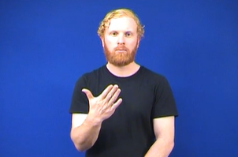
Move your hand forward away from your chin.

Is this activity too hard?
- Replay the video or re-look at the pictures and keep practicing.

Is this activity too easy?
- Use the sign words to communicate with your friends and family.
- Practice more words in Auslan via the Signbank dictionary: https://auslan.org.au/dictionary/words/


Wanda goes to the park
Learning goal: Children explore different places in their community.
- Watch the video of Wanda visiting her local park via this QR code. If you can’t watch go to step 2.

- Take your own travel buddy with you to the park with an adult.
- Take pictures, or when you are back home do drawings, of you and your buddy on your adventure.
- Ask someone to write about your adventure in your journal.
- Let your teachers know what you and your buddy have been up to when you get back to preschool or daycare.

Take a break
Here are some things you might like to do:
- have a drink of water and a healthy snack
- play or have a rest
- go to the toilet and wash your hands.
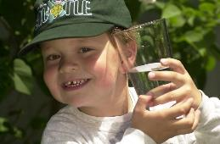
"Boy with glass of water, 2000" by Seattle Municipal Archives is licensed under CC BY 2.0
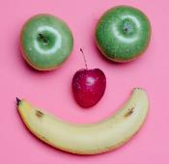
Smile made of ripe fruits by Any Lane, pexels.com

Photo by Andrea Piacquadio. pexels.com
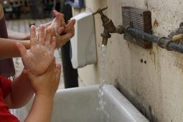
"Washing hands" by magnusfranklin is licensed under CC BY-NC 2.0

Run rabbit tag
Learning goal: Children develop the fundamental movement skill of running.
- Watch the video of a running tag game via this QR code. If you can’t watch, read the instructions below to play.

- Play this game with two or more people.
- Each person puts a strip of fabric or ribbon in the waistband of their pants or shorts.
- Everyone runs around, trying to steal someone else's ribbon or fabric.
- If you are able to steal from someone else, put the fabric or ribbon in a container.
- If you lose your fabric or ribbon, get another one from the container.

Is this activity too hard?
- Play the game on wheels, crawling or walking, if running is too tricky.
- Enjoy any movement or chasing game with others.

Is this activity too easy?
- Play in a large open area so you can run further and faster.

Magical milk
Learning goal: Children follow instructions to investigate and explore colour.
Follow the instructions in the video via this QR code. If you can’t access, look at the instructions written below to make a swirly pattern.

What you need:
- shallow tray
- a cup of milk
- food colouring (two or more different colours)
- dish washing liquid
- a twig or cotton bud
- strong paper.
What to do:
- Pour the milk into the tray, just enough to cover the bottom.
- Add a few drops of each of the food colours to the milk.
- Dip the end of the cotton bud into the dish washing liquid.
- Carefully put the cotton bud in the middle of each colour.
- Watch the swirls form.
- Place paper on the top of the milk to create an artwork.

Is this activity too hard?
- Squirt shaving cream into a tray or container. Add drops of food colour or paint. Use your hands to mix the colours around and around.

Is this activity too easy?
- Tip the milk out and try again, this time using more or less of each colour.
- What do you think will happen if you dip the cotton bud two or three times into each colour? Have a try and find out if you were right.

Extra learning activities
For families, the video Bilingualism: Speaking two languages at home talks about the importance of children learning both English and their families’ first language. You can access the video via this QR code. If you can’t watch, you can look at the transcript below.

Transcript
In this video, migrant worker Halime Duzen and parents from different cultures talk about speaking two languages. They say learning English is important, but it’s also good to keep speaking your family’s first language at home. It helps children stay connected to their community and talk to their relatives.
Halime Duzen [migrant advocacy worker, mother of two]: It is very important for parents to keep their own language because parents themselves are very comfortable with their own language, and they can easily talk about their emotions, their feelings.
Naime [mother of two]: I am speaking at home more Turkish, because I think important, the first language.
Halime: I think it’s very important for young children to grow up and learn with their own language; to belong with their community when they go to their own soccer club or their own festivals.
Tagrid [mother of four]: If I wanna go one day to Lebanon, I like my kids to speak Arabic like the other people, not sit and watch and ‘Oh, I’m not understand Mum, sorry, take me home.’
Tajma [mother of two]: When they go to school they need to speak English very well, but with our own community and with communication with parents, they need especially our language.
Halime: It’s very important to let them learn their own mother tongue language. And also, of course it’s important to talk in English as well, reading books in English, reading books in their own language. No problem at all, children are very intelligent, very clever. Just look for resources – they learn a lot.
Naime: In future, he have to learn English, because in Australia: speak English. At home, everywhere, speak English.
Tagrid: I can help my kids with Arabic, but I cannot help them in English. So now I wanna go and do an English course, to help my kids, and help myself as well.
Halime: It’s very important for parents to learn English – mums to learn English or dads to learn English – so they can read with their children at home, and sing. I think it helps the children to integrate outside the home culture.
Naime: I’m trying, but just small words, speak English. More, speak Turkish.
Halime: Parents can talk English with their children, or sit down and watch Playschool with them, or go to kinder and play with the other children in the kindergarten. Read English book together and sing a song in English.
Tajma: The Playschool program very good, ABC because they can hear the pronunciations. She learnt, and I helped her too.
© State of New South Wales (Department of Education), 2021
The copyright material published in this document is subject to the Copyright Act 1968 (Cth) and is owned by the NSW Department of Education or, where indicated, by a party other than the NSW Department of Education.
Copyright material available in this document is licensed under a Creative Commons Attribution 4.0 International (CC BY 4.0) licence.
See https://education.nsw.gov.au/about-us/copyright for further details.


