This booklet belongs to:

Week J – Wednesday

Day at a glance:
 | Roll and play game | Wombat poo | Feelings chart | Dance the day away | Wanda goes shopping
Estimated time | 15 mins | 30 mins | 15 mins | 10 mins | 45 mins
Resources required |  | Clay, dough, mud | Something to draw with and on |  | Soft toy

Roll and play game
Learning goal: Children share humour, happiness and satisfaction.
- Watch the video via this QR code and join in the activity of rolling a colour dice. If you can’t watch, go to step 2.
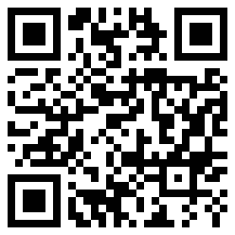
- Choose six actions (something like a funny face, silly dance, wobbly walk, shake your hands). Ask someone in your home to write them on six pieces of paper or card.
- Without looking, choose a card and do the activity on the card.

Is this activity too hard?
- Make up some funny faces in the mirror.

Is this activity too easy?
- Create your own dice game. Use the dots on a dice, instead of colours and make your own set of 6 cards (as in step 2).

Wombat poo
Learning goal: Children use skills of experimentation and hypothesis to explore properties of objects.
- Watch the video of Big Ted visiting the animals at the zoo via this QR code. If you can’t watch, go to step 2.
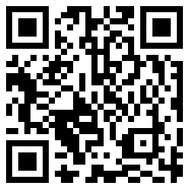
- Did you know that wombat poo is cubic, with straight sides? This is so wombats can use it to mark the area they live in without it rolling away.
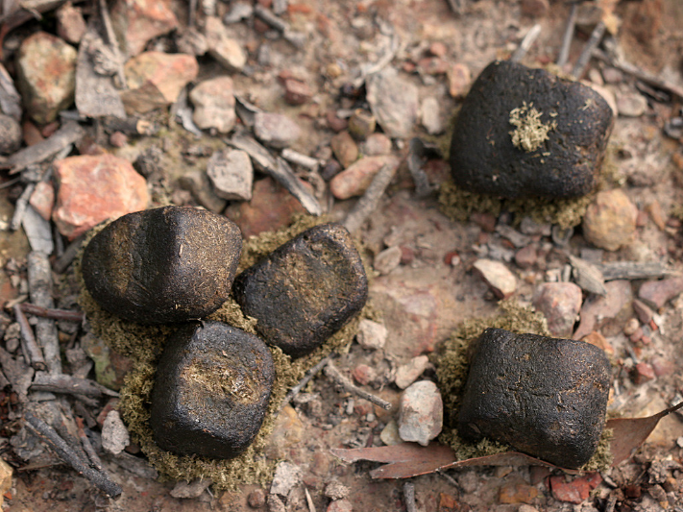
"Wombat droppings" by Dey is licensed under CC BY-NC-SA 2.0
- Look at your building blocks. Which do you think will roll? Which do you think won't roll?
- Test your blocks to see if you were right.
- Look at this picture. Which of these objects do you think will roll? Why do you think this?
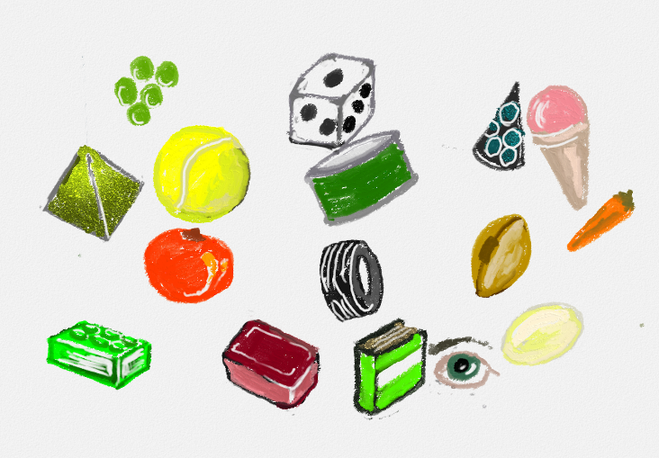
6. Make some wombat poo out of playdough, clay or mud. Make sure the poo is cubic, with straight sides so it can't roll.
Read facts about the wombat
Wombats are very territorial and use their poo to mark their territory (just like dogs use urine to mark their territory).
They like to poo up high, such as on rocks, as it provides a better marker.

Is this activity too hard?
- Use cubed shaped blocks to build a tower. Count how many blocks high your tower is.

Is this activity too easy?
- Look around your home to find objects that will roll.
- Find objects that won't roll, but will stack instead.

Feelings chart
Learning goal: Children identify how they are feeling.
- On a large piece of paper or cardboard draw a line of faces, each showing a different feeling.
- Ask someone to write the word for each feeling under each face.
- Each day, write your name or make a mark next to the face that shows how you are feeling.
- Ask other people in your family to do the same.
- Talk to each other about why you are feeling that way.
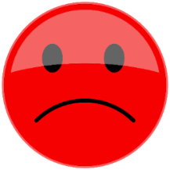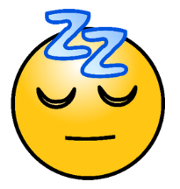

Is this activity too hard?
- Point to a face to show how you are feeling.

Is this activity too easy?
- Add more faces to your chart, showing different feelings, for example, nervous, jealous or scared.

Take a break
Here are some things you might like to do:
- have a drink of water and a healthy snack
- play or have a rest
- go to the toilet and wash your hands.
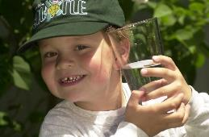
"Boy with glass of water, 2000" by Seattle Municipal Archives is licensed under CC BY 2.0
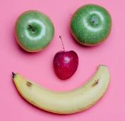
Photo by Any Lane from Pexels

Photo by Andrea Piacquadio from Pexels
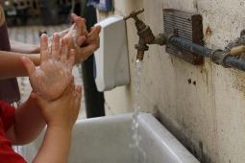
"Washing hands" by magnusfranklin is licensed under CC BY-NC 2.0

Dance the day away
Learning goal: Children explore their world and express themselves through song and dance.
Play the song and copy the dance movements via the QR code. If you can’t watch, play your favourite music and dance!
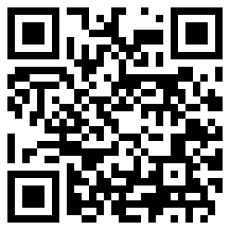

Is this activity too hard?
- Play a song that you know and move your body.

Is this activity too easy?
- Create some new dance moves to go with the music. Film yourself doing these in time with the music.

Wanda goes shopping
Learning goal: Children learn about their community.
- Watch the video of Wanda buying things at her local nursery via this QR code. If you can’t watch go to step 2.
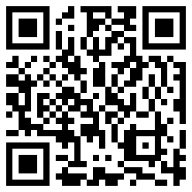
- Take your travel buddy with you next time you go shopping.
- Take pictures, or when you are back home do drawings, of you and your buddy on your adventure.
- Ask someone to write about your adventure in your journal.
- Let your teachers know what you and your buddy have been up to when you get back to preschool or day care.
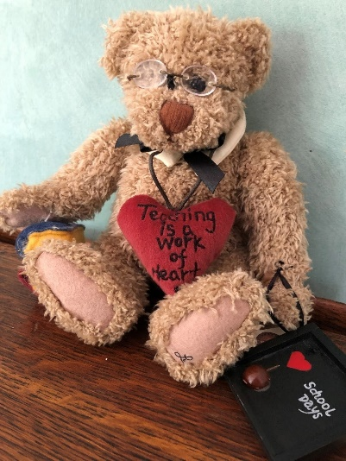

Is this activity too hard?
- Make a play shop at home for your buddy to buy things at.

Is this activity too hard?
- Before you next go shopping, write a shopping list of the things you need to buy. How many items do you need?

Extra learning activities
Use shapes to create your own artwork in the chicken challenge. You can access activities via this QR code. If you can’t access the code, go to the stepped-out version below.
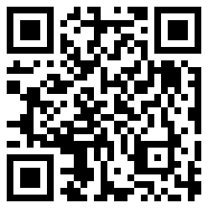
Create your own chicken artwork
- Using simple shapes like circles, triangles, rectangles, ovals, squares and diamonds, create your own chicken drawing.
- Colour in your drawing. You might like to use coloured pencils, crayons, textas or paint.
- You could also use leaves, feathers, ribbon or other craft supplies you have to add texture to your artwork.
- Can you see the shapes in the example below
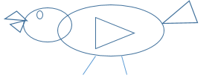
© State of New South Wales (Department of Education), 2021
The copyright material published in this document is subject to the Copyright Act 1968 (Cth) and is owned by the NSW Department of Education or, where indicated, by a party other than the NSW Department of Education.
Copyright material available in this document is licensed under a Creative Commons Attribution 4.0 International (CC BY 4.0) licence.
See https://education.nsw.gov.au/about-us/copyright for further details.
