This booklet belongs to:

Week F – Tuesday

Day at a glance:
 | Wanda's literacy and numeracy walk | Memory game | Aerobic activity | My likes | Shared story
Estimated time | 45 mins | 10 mins | 20 mins | 20 mins | 15 mins
Resources required | Soft toy | Paper cups, Lego piece |  | Book or journal, something to draw with

Wanda’s literacy and numeracy walk
Learning goal: Children engage with literacy and numeracy in their community.
- Watch the video of Wanda going for a walk in her local community via this QR code. If you can’t watch, go to step 2.
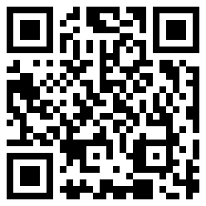
- Choose your own travelling buddy to take on a walk with an adult.
- As you walk, look for symbols, writing and numbers. Talk with the person you are walking with about what each means.
- Draw or take photos of what you see.
- When you are back home, ask someone in your family to write what you say about your walk in your journal.
- Let your teachers know what you and your buddy have been up to when you get back to preschool or day care.
- Did you see any symbols, writing or numbers like the photos below on your walk?
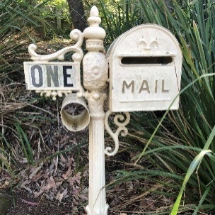
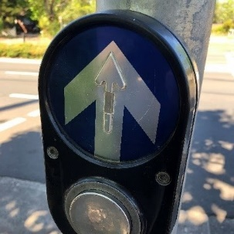
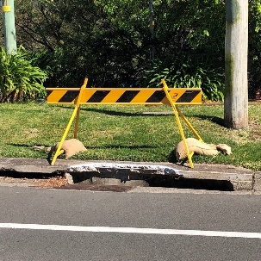
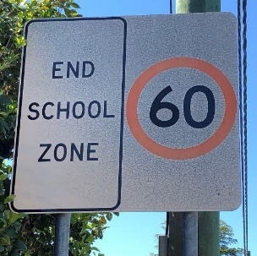
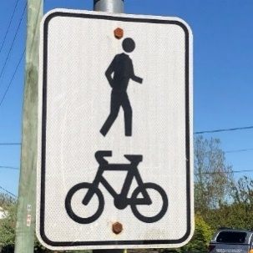

Is this activity too hard?
- Point to the photos that show things you have seen before. Talk with someone about what each means.

Is this activity too easy?
- When you see a new sign or symbol, challenge yourself to read and understand what it means.
- Think of an important thing people need to know and create a sign for this.

Memory game
Learning goal: Children develop cognitive skills through a memory game.
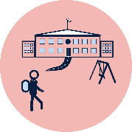
There are new things to learn and remember when you start school, so it's good to play memory games as practice.
What you need:
- 3 paper or plastic cups
- a small toy or Lego brick.
How to play:
Ask someone to play this game with you so you can take it in turns.
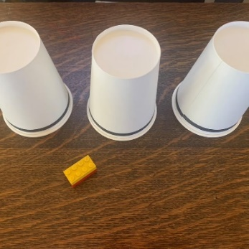
- Place 3 cups upside down on a table.
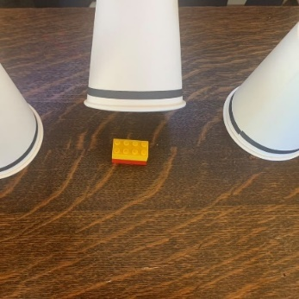
- Put a toy or Lego brick under one of the cups.
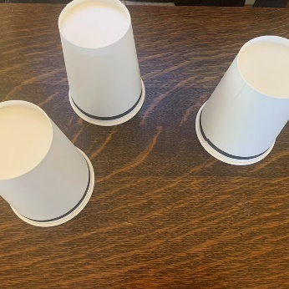
- Move the cups around as the other person to watches closely (remember which cup you put the toy or Lego under).
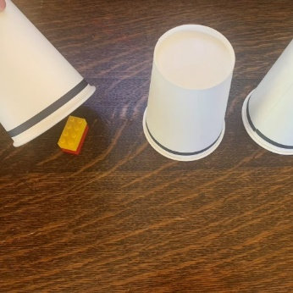
- Stop after a couple of moves. Ask the other person to guess which cup the toy or Lego brick is under.

Is this activity too hard?
- Play the game with 2 cups.

Is this activity too easy?
- Play the game with 5 or more cups.

Aerobic activity
Learning goal: Children show enthusiasm for participating in active physical play.
Aerobic activities are good for your heart and make you stronger. They make your heart beat faster so you pant and puff.
- Watch this video to see children doing different aerobic activities via this QR code. If you can’t watch, go to step 2.

- Pick an aerobic activity to get your heart beating faster, for example:
- running
- skipping
- climbing
- dancing
- bike riding
- soccer
- basketball.
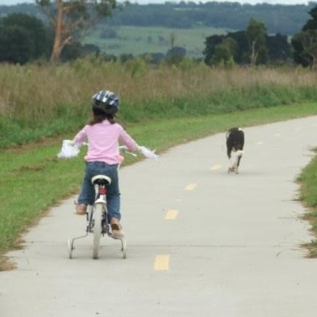
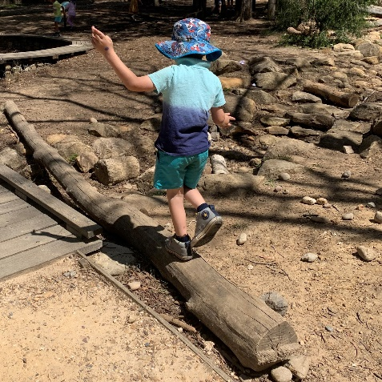
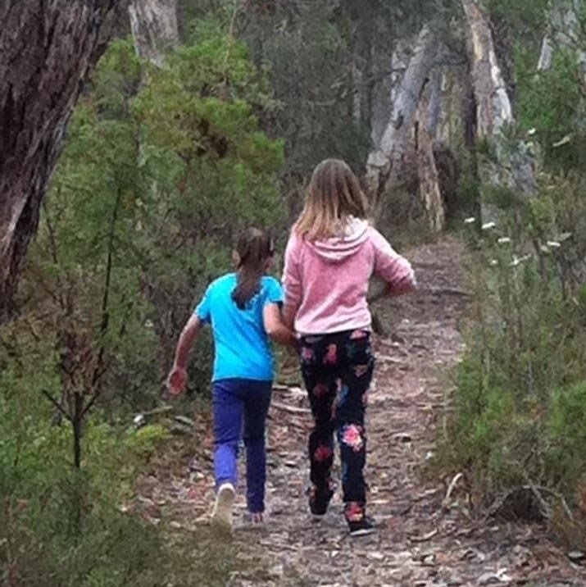
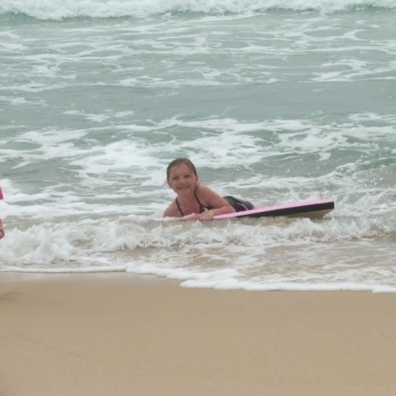

Is this activity too hard?
- What activity can you do to get your heart beating faster? Do this aerobic activity.

Is this activity too easy?
- Combine 2 or more of the aerobic activities into one fun game, for example, do ten skips and then kick a ball at a target.

Take a break
Here are some things you might like to do:
- have a drink of water and a healthy snack
- play or have a rest
- go to the toilet and wash your hands.
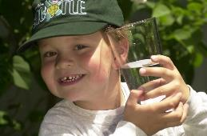
"Boy with glass of water, 2000" by Seattle Municipal Archives is licensed under CC BY 2.0

Photo by Any Lane from Pexels

Photo by Andrea Piacquadio from Pexels
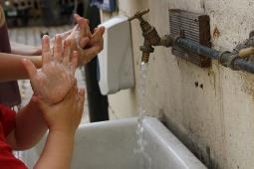
"Washing hands" by magnusfranklin is licensed under CC BY-NC 2.0

My likes
Learning goal: Children recognise and identify the things they like to do.
- Watch this video to see and hear about the things Sylvana likes to do via this QR code. If you can’t watch, go to step 2.

- Make a picture collage (an artwork made up of lots of smaller pictures) of the things you like to do and that make you happy. Use photos or small drawings of yourself doing things you like.

Is this activity too hard?
- Tell someone what you like to do.

Is this activity too easy?
- Ask an adult if you can use their mobile phone or another device to take a picture of all the things you like to do. Use these photos to create a picture collage on the device.

Shared story- Hello and welcome in Gamilaraay
Learning goal: Children engage with a range of texts and gain meaning from them.
- Listen to the story with some Aboriginal words in it via this QR code. If you can’t listen, go to step 3.

- Did you hear Gregg say some words in Gamilaraay, an Aboriginal language? Practice saying these words in Gamilaraay:
- Yarma (Yaama) = hello
- Gurra = welcome

Is this activity too hard?
- Talk with someone about the story.

Is this activity too easy?
- Investigate how the didgeridoo makes its amazing sounds.

Extra learning activities
- Enjoy Grandpa Honeyant story time: Molly the grey kangaroo and the bush clean-up crew via this QR code.
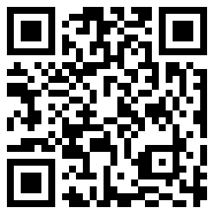
- Extended activities are available via this QR code.

- If you can’t access the QR codes, do one of the activities below.
- Retell your favourite story through a puppet show!
- Plan your show by drawing the beginning, middle and end of the story.
- Create finger or sock puppets of the main characters. You could use items out of your recycling or your toys instead.
- Practise acting out the story.
- Perform your puppet show for your family.
© State of New South Wales (Department of Education), 2021
The copyright material published in this document is subject to the Copyright Act 1968 (Cth) and is owned by the NSW Department of Education or, where indicated, by a party other than the NSW Department of Education.
Copyright material available in this document is licensed under a Creative Commons Attribution 4.0 International (CC BY 4.0) licence.
See https://education.nsw.gov.au/about-us/copyright for further details.


