This booklet belongs to:

Week H – Thursday

Day at a glance:
 | What makes you feel safe? | What is composting? | Be a photographer | First day of school | Phases of the moon
Estimated time | 15 mins | 20 mins | 15 mins | 15 mins | 10 mins
Resources required | Something to draw with and on | Supermarket catalogues | A device to take a photo on

What makes you feel safe?
Learning goal: Children recognise the feeling of belonging and safety.
- Listen to Bridget talking about feeling safe via this QR code. If you can’t listen, start at step 2.
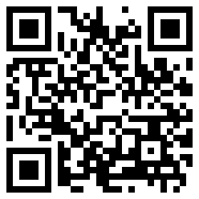
- Think about where you feel safe.
- Where is it?
- Who is there?
- What are you doing?
- Why does this place make you feel safe?
- Draw a picture of your safe place.

Is this activity too hard?
- Tell someone about your safe place.

Is this activity too easy?
- Tell someone about your drawing and describe how you feel in your safe place.
- What makes it safe for you?

What is composting?
Learning goal: Children explore what can be composted.
- Watch the video of Costa making compost via this QR code. If you can’t watch the video you can start at step 2.

- In the video Costa spoke about what to put in compost. These pictures will remind you:
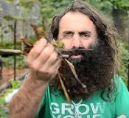
Twigs and leaves
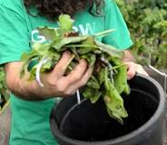
Vegetable leaves
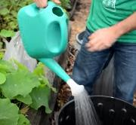
Water
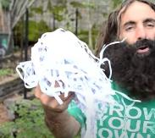
Shredded paper
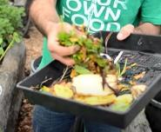
Fruit and vegetable scraps
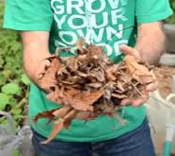
Dried leaves
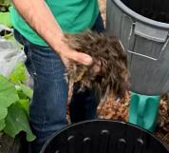
Grass clippings
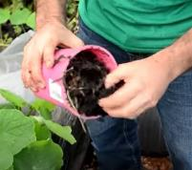
Soil
These images are still photos from the The DoSomething Foundation (30 July 2013) 'First steps to composting with Costa Georgiadis' [video], YouTube, accessed on 7 October 2021.
3. Cut out pictures of food from supermarket catalogues.
4. Sort the foods into two groups
- things that can be composted
- things that can't.
5. Fold a piece of paper in half.
6. Glue or tape the foods that can be composted on one side of the paper.
7. Glue or tape the foods that can't be composted on the other side.

Is this activity too hard?
- Look through the catalogues and name the fruits and vegetables you see. These food scraps can all be composted.

Is this activity too easy?
- Set up a container in your kitchen to collect fruit and vegetable scraps. Each day, empty these into your own compost, a friend's compost or your green bin.

Be a photographer
Learning goal: Children represent their thinking using images.
A photographer takes photos. Being a photographer is fun.
Photos capture the things we see so that we can look at them again later.
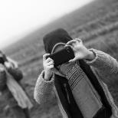
"Children who Took Pictures of a Photographer" by Alexandre Dulaunoy is licensed under CC BY-SA 2.0
1. Take a walk outside with someone from your family.
2. Use a camera, phone or tablet to take photos of the things you see.
3. When you are back home, look at the photos you took.
4. Make up a story about one or more of the photos. Remember, stories have a beginning middle and end.
5. Share your story with a friend.
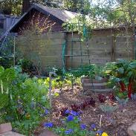
"Backyard Vegetable Garden" by Laura K Gibb is licensed under CC BY-NC-ND 2.0
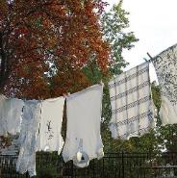
"Clothesline" by Mike Lacon is licensed under CC BY-SA 2.0
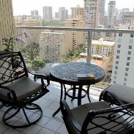
"Condo Balcony" by daryl_mitchell is licensed under CC BY-SA 2.0
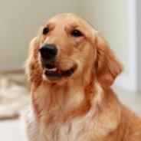
"A cute Dog 4" by Chen Vision is licensed under CC BY-NC 2.0

Is this activity too hard?
- Look at photos and discuss them with someone.
- Be the director and ask someone to take photos of things that interest you.

Is this activity too easy?
- Print your photos and create your own story book.

Take a break
Here are some things you might like to do:
- have a drink of water and a healthy snack
- play or have a rest
- go to the toilet and wash your hands
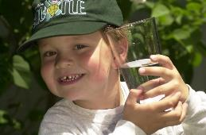
"Boy with glass of water, 2000" by Seattle Municipal Archives is licensed under CC BY 2.0
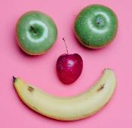
Photo by Any Lane from Pexels

Photo by Andrea Piacquadio from Pexels
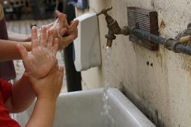
"Washing hands" by magnusfranklin is licensed under CC BY-NC 2.0

First day of school
Learning goal: Children identify what they already know about school to generalise and adapt knowledge.
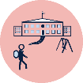
Reading stories about school will help you feel ready when it is time to start school.
- Share this book with someone special via the QR code. Talk about the pictures as you are reading together. If you can’t listen to the story, talk with someone in your home about starting school. How did they feel? How do you feel?
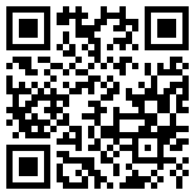
- Why did Daisy's tummy have butterflies?
- What did Spike and Daisy both like?
- Does your lunch box look like the one in the picture?
- Did Daisy enjoy her first day at school?
- If you are interested in hearing about someone else's first day at school, listen to this story
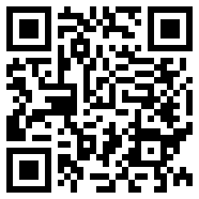

Is this activity too hard?
- Think about a time you went somewhere new, like your first day of preschool. How did you feel? Ask someone to talk about that day with you. How do you feel about that place now?

Is this activity too easy?
- What do you already know about your new school?
- What do you think your first day will be like?
- Can you create your own story book?

Phases of the moon
Learning goal: Children explore the natural wonder of the moon's phases.
- What do you know about the moon?
- What shape is the moon?
- Have you ever seen the moon during the day time?
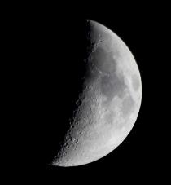
"Moon" by RichardTurnerPhotography is licensed under CC BY-NC 2.0
Investigation:
1. Observe the moon every night at about the same time.
2. Sketch what you see in a moon diary.
3. What did you notice? Why do you think the moon changes shape?

Is this activity too hard?

Look at the sky at night find the moon and the stars.

Do some artwork of the sky.

Try again in a few days’ time and see what you notice. Is it the same or different?

Is this activity too easy?
- Learn some more facts about the moon with someone at home via the internet or using the information below.
Information for families about the moon
Sometimes the moon appears in the sky like full circle, other times it looks more like a crescent. Sometimes we see a full Moon, sometimes not. It can even appear during the day. The terms waning, waxing, gibbous, full moon and new moon are terms we use to describe the Moon. We also might use the word phase.
The Moon shines at night because it reflects the Sun’s rays. It can look quite bright even though it reflects only about 8% of the sunlight that hits it. The Moon waxes and wanes because we cannot always see the entire surface that is lit up by sunlight.
Activity shared by Little Scientists Australia.

Extra Learning activities
Learn to count through song and story.
Open the Early childhood literacy and numeracy resource via this QR code or follow the activity below.
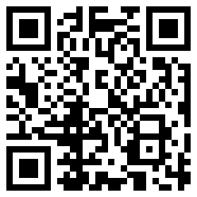
Learning about location and direction is important to introduce spatial language including: over, under, above, below, up, down, forwards, along.
Sing the song together with someone in your home. Talk about the rare words in the song and their common meaning – a fiddle is an old-fashioned word for a violin. Act out the song, using soft toys for the cat, cow and dog, a ball for the moon, and a small bowl and spoon. Sing the song while acting it out with their props and talking about position such as over and under.
‘Hey diddle diddle’ (song)
Hey diddle diddle,
The cat and the fiddle,
The cow jumped over the moon.
The little dog laughed,
To see such fun,
And the dish ran away with the spoon
Engaging with position
© State of New South Wales (Department of Education), 2021
The copyright material published in this document is subject to the Copyright Act 1968 (Cth) and is owned by the NSW Department of Education or, where indicated, by a party other than the NSW Department of Education.
Copyright material available in this document is licensed under a Creative Commons Attribution 4.0 International (CC BY 4.0) licence.
See https://education.nsw.gov.au/about-us/copyright for further details.


