This booklet belongs to:

Week G – Friday

Day at a glance:
 | Auslan sign along | Shared story | Lunch at school | Measuring and estimating | Where do dreams come from?
Estimated time | 10 mins | 15-20 mins | 15 mins | 10-15 mins | 10 mins
Resources required | None | None | Lunch box, water bottle | Something to draw on and with, scissors | None

Auslan sign-along
Learning goal: Children notice and show interest in different ways of communicating.
Did you know that some people communicate in sign language?
- Watch the video and listen to the song 'I am Australian' in Auslan (Australian sign language) via this QR code. If you can’t watch the video, talk to someone in your home about signing. What can you find out?
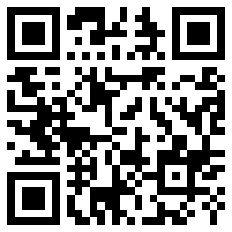
- Replay the video once it finishes and see if you can sing some of the words.
- Can you sing along in Auslan?

Is this activity too hard?
- Practice using Auslan language:
  - Wave your hand to say hello.
  - Put your thumbs up to say good.
  - Put one index finger up to say bad.

Is this activity too easy?
- Pause the video and try to copy some of the Auslan sign language. How much of the song can you sign?

Shared story- The hawke and the hen
Learning goal: Children broaden their understanding of the world.
Sometimes chickens are called chooks or hens.
- Listen to this folk tale from the Philippines called 'The hawke and the hen' via this QR code. If you can’t listen, you can start at step 4 and talk to someone in your home about chickens scratching in the ground.
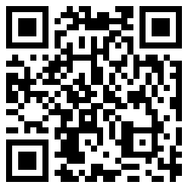
- After listening, tell someone the story.
- Watch Fudge, Buttercup and Hazel scratching and looking carefully at the ground via this QR code. Do you think they are looking for the golden ring?
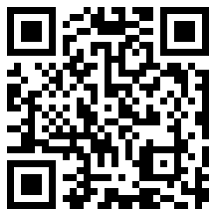
- Can you think of any other reasons why chickens scratch, look and peck over and over?

Is this activity too hard?
- Listen to the story.
- Have you ever lost something? Tell a story about it to another person.

Is this activity too easy?
- Think of the story of the Hawke and the hen. Can you draw some pictures to show the beginning, the middle and the end of the story?

Lunch at school
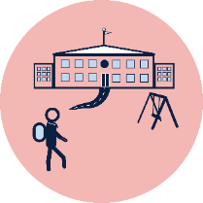
Learning goal: Children show independence when packing and unpacking their lunch.
Practicing how to pack and unpack your school lunch box will be very helpful for school.
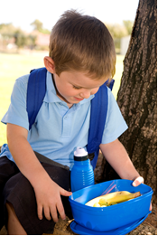
Image licensed under the iStock Getty Images Content License Agreement

Find something you can use as a school lunchbox.

Ask someone in your house to help you fill the lunchbox.

Decide on what you like to eat for lunch and what is healthy for your body.

Make a sandwich or wrap - try spreading the butter and cutting the sandwich in half.

Choose fruit or another healthy snack and get it ready for your lunchbox.

Put water in your drink bottle.

Choose a favourite toy or teddy to eat with you.

Sit with your lunch box on the ground or at a table.

Open your lunch and enjoy a lunch break with your toy/teddy.

Is this activity too hard?
- Make some choices about food that you would like in a lunch box and ask someone help you to pack it.
- Put some things you like to eat in a lunch box and enjoy a picnic with a toy or teddy.

Is this activity too easy?
- Draw or write the foods you enjoy to create a list of your favourite lunch box items.

Take a break
Here are some things you might like to do:
- have a drink of water and a healthy snack
- play or have a rest
- go to the toilet and wash your hands
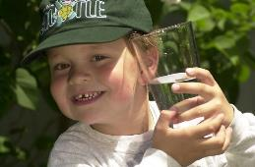
"Boy with glass of water, 2000" by Seattle Municipal Archives is licensed under CC BY 2.0
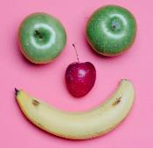
Photo by Any Lane from Pexels

Photo by Andrea Piacquadio from Pexels
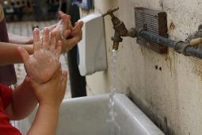
"Washing hands" by magnusfranklin is licensed under CC BY-NC 2.0

Measuring and estimating
Learning goal: Children use objects to measure and use mathematical language.
- Watch the video ‘MathXpolision – 7 feet follow up’ via this QR code. If you can’t access the video, follow the transcript below and then start at step 2.
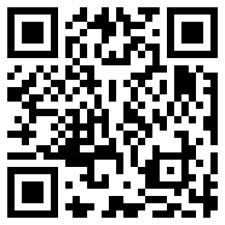
Transcript of MathXplosion – 7 feet follow up video:
Trace around your foot
Now, you have your footprint!
Next, carefully cut your foot out.
Alright mathematicians, so are you 7 feet tall?
Then can you find some things that are more than your 7 feet tall?
And can you find some things that are less than your 7 feet tall?
Over to you to investigate mathematicians.
- Trace around your foot and cut it out.
- Choose some things to measure.
- Can you find some things that are more than 7 feet tall?
- Can you find some things that are less than 7 feet tall?
- Try to guess or estimate how many of your feet the object will be.
- Using your cut out foot, see how many feet fit end to end on your object.
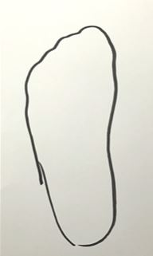

Is this activity too hard?
- Count how many steps it takes to cross a room.

Is this activity too easy?
- Do the activity with someone else. Both of you guess or estimate. See who is the closest.
- Use something else to measure with.

Where do dreams come from?
Learning goal: Children listen and respond to information they hear in a podcast.
It seems like Max's adventure in the story 'Where the wild things are' was all just a dream.
- Listen to this podcast and learn more about dreams. If you can’t listen, you can start at step 3.
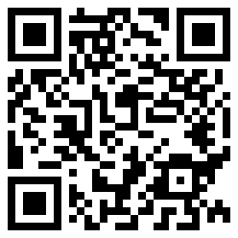
- Have you ever wondered why we dream or where dreams come from?
- Talk about dreams with your family. Have you had any strange or funny dreams lately?

"Taking a nap" by JohnFinn is licensed under CC BY-NC-ND 2.0

Is this activity too hard?
- Sit back and listen to the podcast.

Is this activity too easy?
- Draw one of your dreams using pictures.
- How do your dreams make you feel?

Extra learning activities
Access more learning activities from the early childhood literacy and numeracy resource: This is the way we wash our clothes via this QR code. If you can’t access the QR code, sing along to the song below.
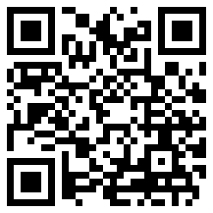

This is the way we wash our clothes (song)
(to the tune of "Here We Go 'Round the Mulberry Bush")
This is the way we wash our clothes,
Wash our clothes, wash our clothes,
See them getting clean and white,
Rub-a-dub-dub, rub-a-dub-dub.
This is the way we hang them out,
Hang them out, hang them out,
See them blowing in the wind,
Flippity-flap, flippity-flap.
This is the way we iron them flat,
Iron them flat, iron them flat,
Soon our wash day will be done,
And nice clean clothes for you and me.

Activity
As you help with washing or hanging the clothes think about directions and positions:
- over, under, above, below, top, bottom, side, on, in, between
- left, right, up, down, forwards, backwards, sideways, across, along, through.
© State of New South Wales (Department of Education), 2021
The copyright material published in this document is subject to the Copyright Act 1968 (Cth) and is owned by the NSW Department of Education or, where indicated, by a party other than the NSW Department of Education.
Copyright material available in this document is licensed under a Creative Commons Attribution 4.0 International (CC BY 4.0) licence.
See https://education.nsw.gov.au/about-us/copyright for further details.


