This booklet belongs to:

Week F – Friday

Day at a glance:
 | Rhythm and movement | Shoes in Gamilaraay | Kolap | Water painting | Percussion
Estimated time | 25 mins | 10-15 mins | 10-15 mins | 10-15 mins | 15-20 mins
Resources required | 2 red, 2 blue, 2 yellow pencils | None | Coins, large buttons or small bean bags | Bucket of water, large paintbrush | Rice, beads, small stones

Rhythm and movement
Learning goal: Children move rhythmically and develop self-regulation.
- Watch the ‘Rhythm and movement for self-regulation’ video via this QR code and follow the instructions to get your brain ready for learning today. If you can’t watch the video, you can move your body to your favourite song, and tap pencils along with the beat.


Is this activity too hard?
- Watch only the first half of the video.
- Watch along and do some of the movements.
- Use just one body part such as your hand or foot to keep the rhythm.

Is this activity too easy?
- After the video, try to remember some of the rhythms and movements and show a family member.

Shoes in Gamilaraay
Learning goal: Children learn about the world they live in and respect different ways of being and doing.
- Listen to this podcast from Gamilaraay Country via this QR code. If you can’t listen, you can start at step 2.

- Practice saying the word 'shoes' in Gamilaraay language - 'Mundhuis'. It sounds like this: mun-doo-ees.
- Put on your favourite Mundhuis and go for a walk outside.
- Now take your Mundhuis off and feel the earth between your toes. How does it feel?

Is this activity too hard?
- Sit or lay on the grass or sand. Notice how it feels.

Is this activity too easy?
- Explore different parts of nature with your bare feet and describe how it feels.

Kolap
Learning goal: Children develop the fundamental movement skill of an underarm throw.
- Follow the link to the instructions on how to play Kolap via the QR code. If you can’t access the instructions, you can view the picture below and set up a game where you compete to throw objects at a target on the ground.

- Have a go at playing the game with people in your family:
- Line up behind the mat.
  - Teams face each other.
  - First thrower ready. Go.
  - Underarm or sidearm throws. Be careful. Aim for the target. Bend the knees a bit.
  - Good throw. Watch the target.
  - Point your hand and follow through.
  - Next turn. Keep playing.
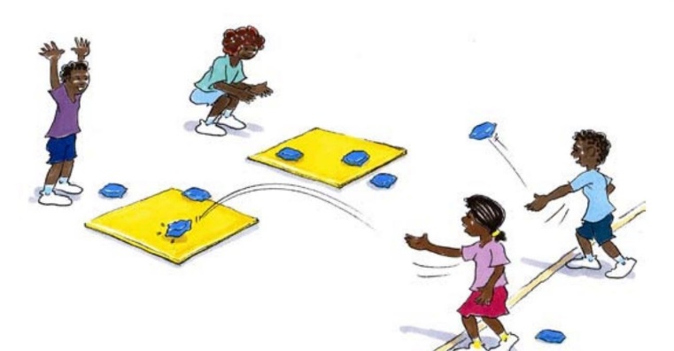
Australian Sports Commission (2008) 'kolap', ausport.gov.au/isp, PDF accessed 23 September 2021

Is this activity too hard?
- Throw an object onto a target on the ground.
- Different family members could throw from different distances.

Is this activity too easy?
- Keep score on a piece of paper by making a tally.

Take a break
Here are some things you might like to do:
- have a drink of water and a healthy snack
- play or have a rest
- go to the toilet and wash your hands.
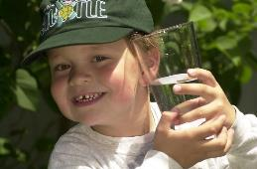
"Boy with glass of water, 2000" by Seattle Municipal Archives is licensed under CC BY 2.0
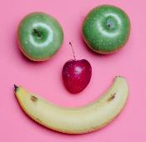
Photo by Any Lane from Pexels

Photo by Andrea Piacquadio from Pexels
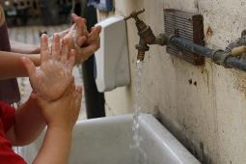
"Washing hands" by magnusfranklin is licensed under CC BY-NC 2.0

Water painting
Learning goal: Children use their creativity as they develop gross motor skills.
- Fill a container or bucket with water and a get a big paint brush.
- Go outside and paint with the water on the balcony, footpath or on a brick wall.
You might want to paint a picture, a pattern or your name.

Is this activity too hard?
- Use your sense of touch to explore the water.
- Use a large sponge on a concrete path. Try dabbing, splatting and sliding the sponge.

Is this activity too easy?
- Take a photo of your water painting before it dries.

Percussion
Learning goal: Children use play to investigate and explore sound.
- Your challenge is to make a percussion instrument that you can shake or tap.
  - To make a shaking instrument you will need a container and some small things to fill it with, such as rice, beads or small stones.
  - You can make a tapping instrument by finding something you can use to tap something else, like a tin and wooden spoon.
- When you have finished your instrument, play it.
- If you are not happy with the sound, try something different.
- When you are happy, play your favourite music and shake or tap to the beat.
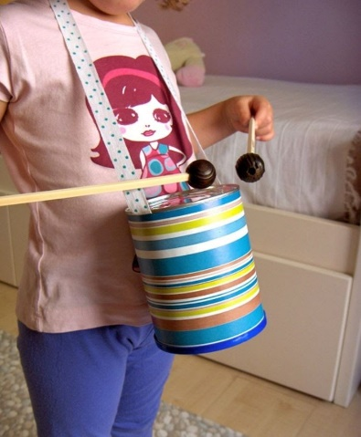
This photo by Unknown Author is licensed under CC BY-SA-NC

Is this activity too hard?
- Make sounds with your body.
- Make sounds with different things around the house.
- Have someone help make the instruments and explore the sounds.

Is this activity too easy?
- Find different things to use for tapping and explore the different sounds they make.

Extra learning activities

Learn to count through story and song. Open the early childhood literacy and numeracy resources via the QR code. If you can’t access the QR code you can read the action song and try the activity below.

Action song: Five elephants balancing
One grey elephant balancing,
Step-by-step on a piece of string.
Thought it was such a wonderful stunt,
That he called for another elephant.
Two grey elephants balancing,
Step-by-step on a piece of string.
Thought it was such a wonderful stunt,
That they called for another elephant.
Activity: Engaging with counting
- Find a small container and fill it with rocks, counters or leaves.
- Count out five items, saying the number as you pick them up.
- Try to count up to 10.
- Sing the song again, picking one item from the container each time to add to the group.
© State of New South Wales (Department of Education), 2021
The copyright material published in this document is subject to the Copyright Act 1968 (Cth) and is owned by the NSW Department of Education or, where indicated, by a party other than the NSW Department of Education.
Copyright material available in this document is licensed under a Creative Commons Attribution 4.0 International (CC BY 4.0) licence.
See https://education.nsw.gov.au/about-us/copyright for further details.


