This booklet belongs to:

Week E – Wednesday

Day at a glance:
Wednesday | Different families | Measurement | Hopscotch | Syllables | Fun with bubbles
Estimated time | 15-20 mins | 10-15 mins | 15 mins | 15-20 mins | 25-30 mins
Resources required | Something to draw and write with | Pencils | Chalk | Two sticks to tap together | Dishwashing liquid, glycerine, plastic garden wire or pipe cleaners

Different families
Learning goal: Children are aware and respectful of similarities and differences between people.
Your family are the people who love and care for you. Watch these videos via the QR codes to see children in different kinds of families. If you can’t watch the videos, you can start below with the drawing activity.
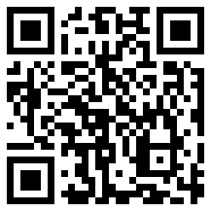
Extended families
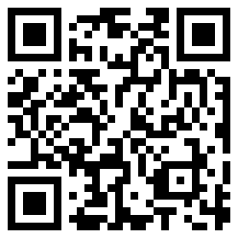
Adoptive families
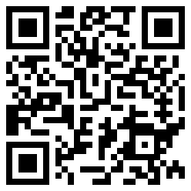
Two dads
- Draw or paint a picture of your family.
- Write or copy each person's name onto your picture.

Is this activity too hard?
- Look at a photo of your family. Say each person's name.
- Tell someone about your family.

Is this activity too easy?
- Include your extended family in the picture of your family. This might include your aunties, uncles and cousins.

Measurement
Learning goal: Children demonstrate an increasing understanding of measurement.
- Put some pencils in a line, end to end.
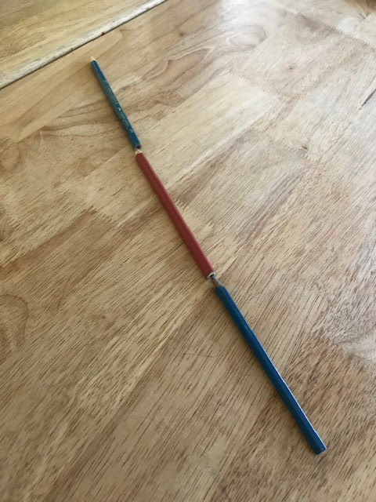
- Line up your pencils along the edge of a table. Start at one end and finish at the other end.
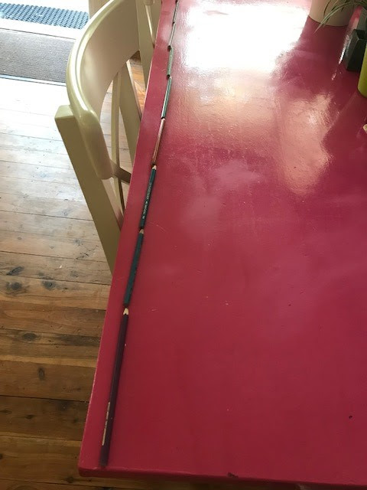
- Count each pencil. How many pencils long is your table?
- Line up your pencils along the floor and lie down alongside them. How many pencils long are you?
- How many pencils do you think it is from where you are to the door? Check if you were right.

Is this activity too hard?
- Hold two objects together. Which is the longest? Which is the shortest?
- Cut two pieces of ribbon or string. Which the longest? Which is the shortest?
- Roll out some playdough and cut into sections. Lay them in order from shortest to longest.

Is this activity too easy?
- What else can you use to measure? (paper clips, pegs, sticks)
- Use something different to measure how long you are.
- What else can you measure?

Hopscotch
Learning goal: Children develop the fundamental movement skills of hopping and jumping.
- Use chalk to draw a 'hopscotch' on cement.
- Hop on one foot in each square.
- Say each number as you hop on it.
- For the squares side by side, jump one foot in each square at the same time.
When you get to the end, turn around and jump back to the start again.
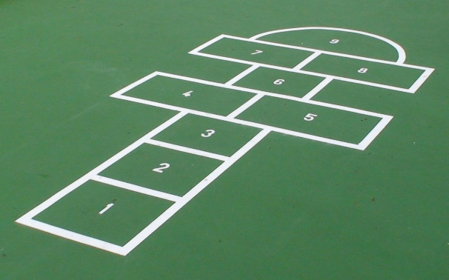
"File:TiuFeiKei(Hopscotch) pattern.JPG" by User:WikiCantona is licensed under CC BY-SA 2.5

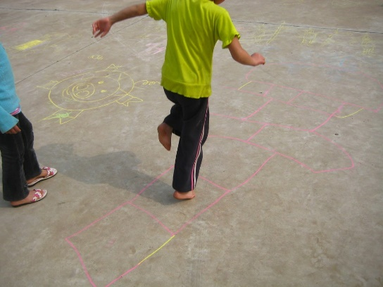

"Hopscotch on the Playground" by Wootang01 is licensed under CC BY-ND 2.0

Is this activity too hard?
- Practice standing on one foot and then the other.
- Practice hopping on one foot and then the other.
- Put out some stepping stones, carpet squares or use an outdoor path. Hop along the stones, or path, using a different foot for each step.

Is this activity too easy?
- Throw a small stone onto the hopscotch. Hop through the hopscotch, missing the square the stone landed in.

Take a break
Here are some things you might like to do:
- have a drink of water and a healthy snack
- play or have a rest
- go to the toilet and wash your hands.
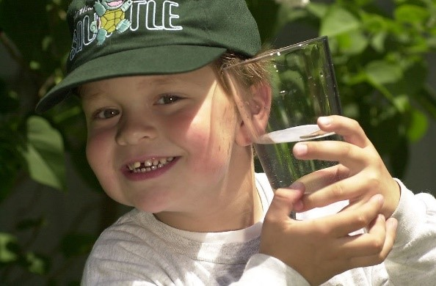
"Boy with glass of water, 2000" by Seattle Municipal Archives is licensed under CC BY 2.0
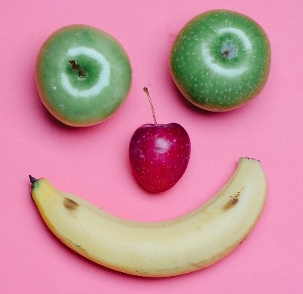
Photo by Any Lane from Pexels

Photo by Andrea Piacquadio from Pexels
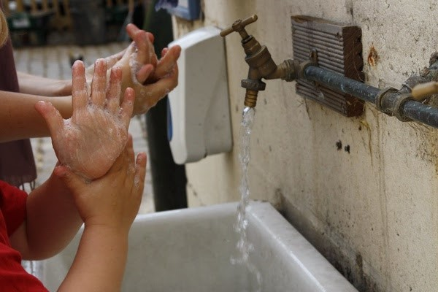
"Washing hands" by magnusfranklin is licensed under CC BY-NC 2.0

Syllables
Learning goal: Children listen and respond to syllables in speech.
View a mini lesson about syllables, via this QR code. If you can’t access the code, you can start at step 2.
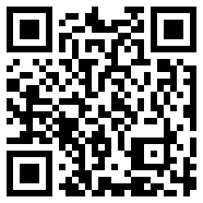
- Follow the instructions to clap, drum or jump the syllables.
- How many syllables in your name?
- How many syllables in the names of the people in your family?
- Think about the characters in your favourite shows. How many syllables in each of their names?
- How many syllables in each of these words. Remember, the syllables are the ‘beats’ in a word. You can beat a drum, tap your fingers or clap.
dog (1 syllable)
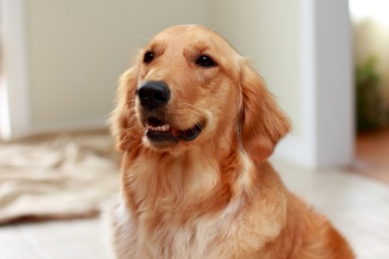
"A cute Dog 4" by Chen Vision is licensed under CC BY-NC 2.0
snake (1 syllable)
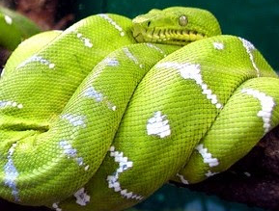
"Snakes" by tabacco is licensed under CC BY-NC-SA 2.0
penguin (2 syllables)
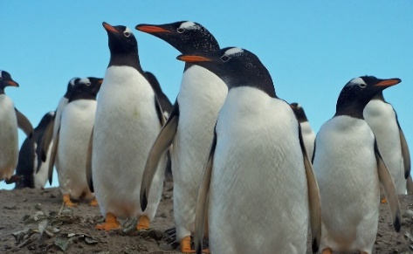
"Penguins" by HighlandBlade is licensed under CC BY-NC-ND 2.0
giraffe (2 syllables)
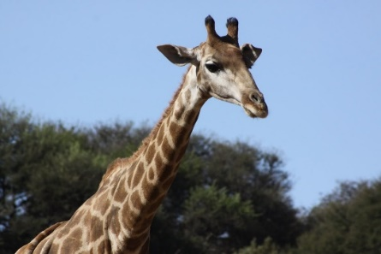
"Giraffe" by Derek Keats is licensed under CC BY 2.0

Is this activity too hard?
- Say the names of each person in your family.
- Ask someone to clap and count the syllables in each name.

Is this activity too easy?
- Draw some animals whose names have two or three syllables. Say each animal name and clap the syllables.

Fun with bubbles
Learning goal: Children experiment with cause and effect and use representations to record their findings.
- Ask someone to read you this poem, one line at a time. Copy them so you can say the poem too.
Bubble, bubble, turn around.
Bubble, bubble, land on the ground.
Bubble, bubble, float up high.
Bubble, bubble, float towards the sky.
Bubble, bubble, float down low.
Bubble, bubble, land on my toe.
Bubble, bubble, stop, stop, stop!
Bubble, bubble, now go pop!
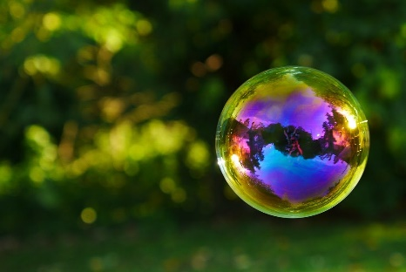
"Bubble" by zacktionman is licensed under CC BY-NC 2.0
- Follow these instructions to make your own bubble blowing mixture.
What you need:
- 1 cup dishwashing liquid
- 2 1/3 cups water
- 1/3 cup glycerine (optional, available from pharmacies)
- a container to store your mixture in
- plastic-coated garden wire (available from hardware stores)
What to do:
- Mix the detergent, water and glycerine (if you have it) together.
- Allow your bubble mixture to sit for a while before using.
- Make a wand by shaping the plastic-coated wire into a circle with a handle.
- Pour some mixture onto a plate and lay the circle part of your wand on it.
- Lift your wand out and gently blow into the circle.
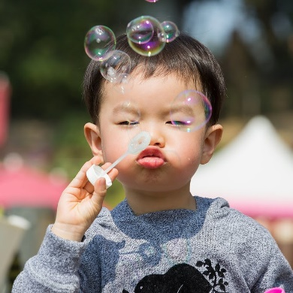
"bubble blowing" by Moody Man is licensed under CC BY-NC 2.0
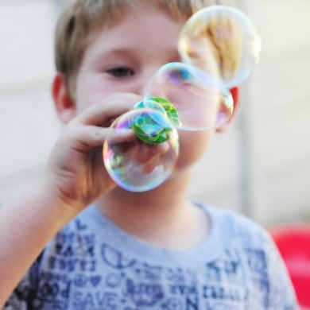
"bubble blowing" by paulscott56 is licensed under CC BY-SA 2.0
- Experiment to find out how to make the most bubbles:
  - Try shaking up the mixture before placing your wand in it. Does this create more bubbles?
  - Rather than blowing into the wand, try gently moving it through the air. Does this create more bubbles?
  - Record what you find by asking someone to take photos of the bubbles created.

Is this activity too hard?
- Get someone to blow bubbles. Can you catch the bubbles with your hands?
- Ask someone to hold the bubble wand as you blow into it.

Is this activity too easy?
- If you do have glycerine, make a mixture without the glycerine. Does this mixture work as well as the mixture with glycerine?
- How can you make small bubbles?
How can you make big bubbles?

Extra learning activities
View this Playgroup NSW video for families via the QR code. It shows some chalk and water art activities. If you can’t access the video you can follow the steps below.
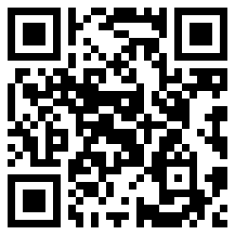
If you have chalk at home, here are some fun things you can do with it:
- Draw marks on the concrete and outside walls (can always wash it off!)
- See what you can draw when you do big, circle arms with the chalk.
- Use water with the chalk paint, or just use water on outside walls or fences
© State of New South Wales (Department of Education), 2021
The copyright material published in this document is subject to the Copyright Act 1968 (Cth) and is owned by the NSW Department of Education or, where indicated, by a party other than the NSW Department of Education.
Copyright material available in this document is licensed under a Creative Commons Attribution 4.0 International (CC BY 4.0) licence.
See https://education.nsw.gov.au/about-us/copyright for further details.
