This booklet belongs to:

Week E – Monday

Day at a glance:
Monday | What are you good at? | Playdough | Balance | Shared story | Board game
Estimated time | 10-15 mins | 25-30 mins | 10-15 mins | 15-20 mins | 25-30 mins
Resources required | None | Flour, salt, cream of tartar, oil, food colouring bowl and spoon | Music, small cushion | None | A board game such as snakes and ladders or dominoes

What are you good at?
Learning goal: Children celebrate their own efforts and achievements.
Everyone has strengths. Your strengths are the things you are good at.
These children are good at climbing.
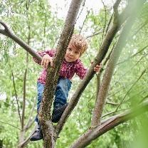
Image owned by the NSW Department of Education under the Copyright Act 1968 (Cth)​

Image owned by the NSW Department of Education under the Copyright Act 1968 (Cth)
- What are you good at? How did you become good at this?
- Spend time doing something you are good at.

Is this activity too hard?
- Often the things we are good at are the things we enjoy. What do you like doing?
- Show someone one thing you are good at.

Is this activity too easy?
- What is each person in your family good at?
- What do you want to be good at and how can you become better at it?

Playdough
Learning goal: Children use numeracy skills to successfully follow a recipe.
Ask someone in your family to help you follow this non-cook recipe to make playdough.
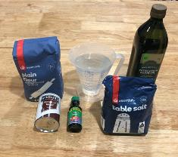
Ingredients:
- 2 cups plain flour
- 4 tablespoons cream of tartar
- 1 cup salt
- 2 cups very hot water
- 2 tablespoons cooking oil
- food colouring.

What to do:
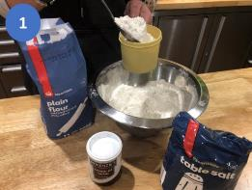
1. Place the flour, cream of tartar and salt in a large bowl.
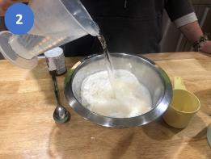
2. Carefully add the hot water and oil to the mixture.
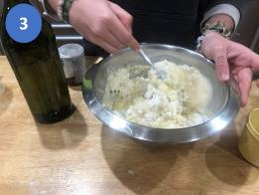
3. Stir the mixture together to form a dough
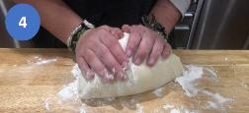
4. Take the dough out of the bowl and knead it.
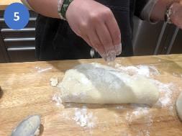
5. Add more flour if the dough is too moist or more water if the dough is too dry.
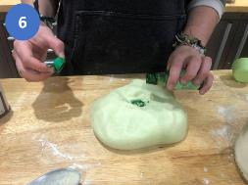
6. Add a few drops of food colouring.
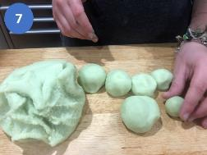
7. Play with your playdough!

Balance
Learning goal: Children develop the stability skill of balance.
Listen to this song via this QR code and follow the instructions to warm up your body. If you can’t listen to the song, you can start at step 1.

- Balance on one foot. Hold still while you count to five.
- Now try on the other foot. How long could you balance for?
- Walk along something with your arms stretched out wide, perhaps stepping stones, a log, long rope or even a line on the ground.
- Stretch up on your toes, then down again. Sit down and then stand up.
- Balance a small cushion or rice pack on your head, without touching it.
- Put your favourite music on and walk around with the cushion or rice pack balanced on your head.
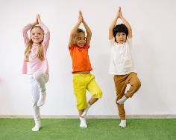
Active Children Doing Balancing Exercises by Yan Krukov, pexels.com

Image owned by the NSW Department of Education under the Copyright Act 1968 (Cth)​

Is this activity too hard?
- To help you balance, put one hand on a wall or piece of furniture.
- Practice lifting one heel up and then the other with your toes staying on the ground.
- Balance an object on your hand or foot, you can do this while sitting down.

Is this activity too easy?
- If you can access the QR code, copy the poses in this balance/stretch cool down video, holding each as the timer counts down.
- If you can’t access the QR code, you can play 'Simon Says' with a family member and practice tricky balances.

Take a break
Here are some things you might like to do:
- have a drink of water and a healthy snack
- play or have a rest
- go to the toilet and wash your hands.
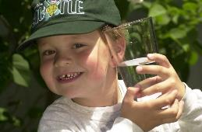
"Boy with glass of water, 2000" by Seattle Municipal Archives is licensed under CC BY 2.0
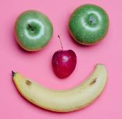
Photo by Any Lane from Pexels

Photo by Andrea Piacquadio from Pexels
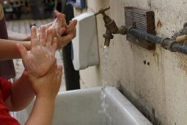
"Washing hands" by magnusfranklin is licensed under CC BY-NC 2.0

Shared story
Learning goal: Children begin to recognise letters.
Have you ever eaten spaghetti? Listen to the story My Spaghetti ABC via this QR code. If you can’t listen to the story you can ask someone to help make the letters in your name from the play dough.

- In the story there was an alphabet made of spaghetti. Join in singing one of these alphabet songs. The first is a slower song and the second is faster:




Is this activity too hard?
- Clap your hands to the song and listen.
- Stamp your feet to the song and listen.
- Practice saying the names of the letters in your name.

Is this activity too easy?
- Listen to the story again.
- Which rhyming words did you hear?
- Ask someone to write some letters for you to copy.
- Write, paint or make them out of playdough.

Board game
Learning goal: Children play cooperatively, demonstrating skills of self-regulation.
Ask someone in your family to play a board game with you, for example snakes and ladders or dominoes.
Make sure you follow the game rules and wait patiently for your turn to have a go.
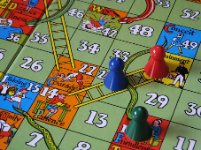
"Snakes and Ladders" by jacqui.brown33 is licensed under CC BY-SA 2.0
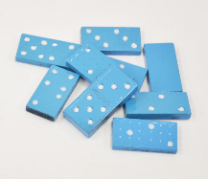
"Blue Dominos" by FestivitiesMN is licensed under CC BY-NC-SA 2.0
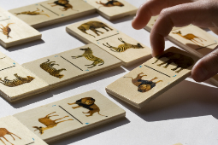
"After the extinctions ... at least our kids will always have the dominoes" by woodleywonderworks is licensed under CC BY 2.0

Is this activity too hard?
- Try an easier game such as bingo or memory.

Is this activity too easy?
- Make you own game of snakes and ladders.
- Play a harder game, for example, checkers or Go fish!

Extra learning activity
Complete an art lesson based on The Dot. You can access the art lesson via this QR code.

If you can’t access the QR code you can create your own dot-inspired artwork, using your imagination. You can be as creative as you like.
- Remember to start with a dot!
- Make sure you display it proudly for all to see!
© State of New South Wales (Department of Education), 2021
The copyright material published in this document is subject to the Copyright Act 1968 (Cth) and is owned by the NSW Department of Education or, where indicated, by a party other than the NSW Department of Education.
Copyright material available in this document is licensed under a Creative Commons Attribution 4.0 International (CC BY 4.0) licence.
See https://education.nsw.gov.au/about-us/copyright for further details.


