This booklet belongs to:

Week D – Tuesday

Day at a glance:
Tuesday | Superhero poses | Cubby building | Kicking game | I spy | Memory game
Estimated time | 15-20 mins | 20-25 mins | 20-25 mins | 15-20 mins | 20-25 mins
Resources required | Something to draw with and on | Towels or sheets | Ball, skittles | Collection of toys or objects | Paper/card, pencils, scissors

Superhero poses
Learning goal: Children engage in play to imagine, explore different identities and create roles.
Watch this video via the QR code below and follow the instructions to pose like a superhero. If you can’t watch the video, you can start at step 1.

- Pose like your favourite superhero.
- Invent your own superhero.
- Draw your superhero.
  - What does your superhero look like?
  - What is your superhero's special power?
  - How does your superhero help people?
  - Pretend to be your superhero.

Cubby building
Learning goal: Children use their imagination and creativity.
Watch the video on building cubbies via this QR code. If you can’t watch the video you can start at step 1.

- Build a cubby or fort:
  - Use things such as sheets, towels, large cardboard boxes or furniture.
  - Build your cubby inside or outside.
  - If you want ideas, watch the video to see Liz and Julie-Ann building a cubby made of sticks.
- Play in your cubby!
Is this activity too hard?
- Build your cubby by putting a sheet over the top of an empty table.
Is this activity too easy?
- Can you extend your cubby by adding another room?
- Take some snacks, toys, books and a torch into your cubby so you can stay a while.

Kicking game
Learning goal: Children develop the fundamental movement skill of kicking.
- Watch the first video to learn how to kick a ball. If you cannot watch the video, you can start at step 3, and set up some skittles or plastic bottles and see if you can knock them down by kicking a ball towards them.

- Watch the second video to learn how to play a kicking game.

- Set up skittles or plastic containers to play the kicking game.
Is this activity too hard?
- Instead of a ball, try kicking a balloon.
Is this activity too easy?
- Play a game of soccer with someone in your family.

Take a break
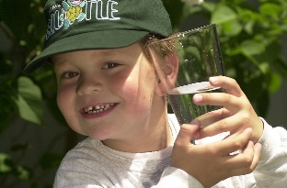
"Boy with glass of water, 2000" by Seattle Municipal Archives is licensed under CC BY 2.0
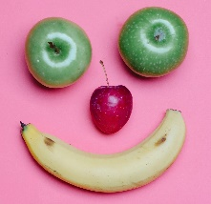
Photo by Any Lane from Pexels

Photo by Andrea Piacquadio from Pexels
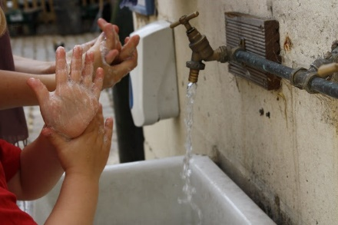
"Washing hands" by magnusfranklin is licensed under CC BY-NC 2.0

Sound ‘I spy’
Learning goal: Children begin to understand that words are made up of sounds.
- Gather a collection of small objects.
- Say the name of each object and practice making the sound it starts with (just the sound, not the letter name).
- Put the objects in a box or container.
- Pull out one object at a time, making the sound it starts with. For example, if you pull out a fork, make the sound 'f'.
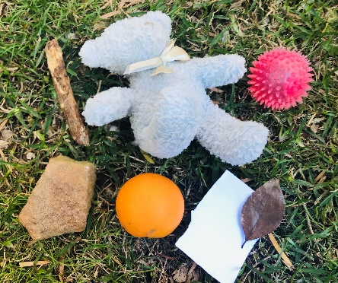
- Play 'I spy':
  - Ask someone to play with you.
  - Arrange all the objects in front of you.
  - The first person picks an object in their head but doesn't point or say which one it is.
  - They say, 'I spy with my little eye something beginning with (and says the sound the object starts with).'
  - The second person points to an object starting with that sound.
  - If they don't guess, they can try again.
  - Swap so the second person picks the object and makes the sound.
Is this activity too hard?
- Ask someone in your family to say each sound for you to copy.
Is this activity too easy?
- Rather than playing with a collection of objects, play in a room or outside using all the things around you.

Memory game
Learning goal: Children play a game cooperatively, taking turns and following rules.
Make your own memory game:
- Cut a piece of paper into 8 cards.
- On each pair of cards, draw the same picture.
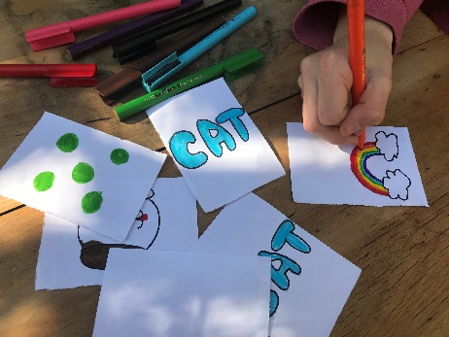

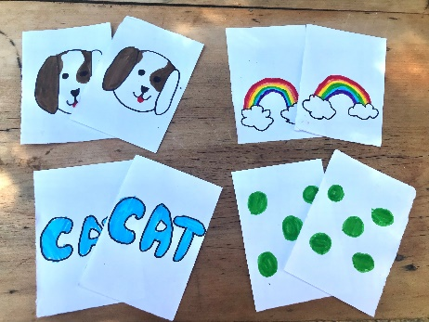
- Play the game:
  - You will need one other person to play with.
  - Turn all the cards over and mix them up.
  - Take it in turns turning over two cards at a time.
  - If the two cards turned over are the same, the person who turned them over holds the two cards.
  - If the two cards turned over are not the same, turn them over again and it is the next person's turn.
  - When all the pairs have been matched, the person holding the most cards is the winner.
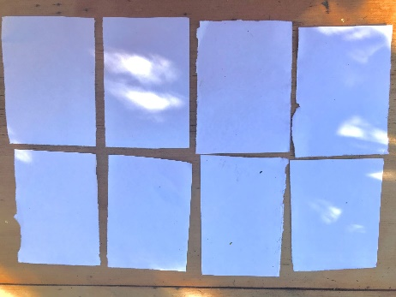
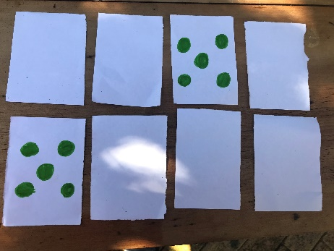
Is this activity too hard?
- Place all cards face up, so you can see the pictures. Take it in turns matching the pictures that are the same together.
- Play the memory game using only 4 cards.
Is this activity too easy?
- Play with more than 16 cards.
- Play with more than two people.

Extra learning activities
Use the early childhood literacy and numeracy resource using the QR code to learn to count through song and story. If you can’t access the QR code, you can do the activity below:

Let’s play a game of ‘Ten in the bed’.
- Gather ten favourite teddies or dolls and line them up in a bed or on the couch or floor.
- Count the teddies and dolls to be sure they have the right number.
- Begin by singing the first verse of ‘Ten in the bed’:
There were ten in the bed
And the little one said,
"Roll over! Roll over!"
So, they all rolled over and one fell out
There were nine in the bed
And the little one said,
“Roll over! Roll over!”
So, they all rolled over and one fell out (Continue singing until there is one in the bed)
- Count how many teddies and dolls are left before continuing with the next verse.
© State of New South Wales (Department of Education), 2021
The copyright material published in this document is subject to the Copyright Act 1968 (Cth) and is owned by the NSW Department of Education or, where indicated, by a party other than the NSW Department of Education.
Copyright material available in this document is licensed under a Creative Commons Attribution 4.0 International (CC BY 4.0) licence.
See https://education.nsw.gov.au/about-us/copyright for further details.


