This booklet belongs to:

Week A - Wednesday
Things you need:
- something to draw on
- something to draw with.

Breathing exercise
Learning goal: Children learn a breathing technique they can use to calm themselves and regulate their emotions.

Image licensed under the iStock Getty Images Content License Agreement
Sometimes we get upset and angry and need to calm down. How do you calm yourself down?
Some children find going outside and running around helps, or just sitting quietly on their own.
You might find this breathing exercise helps you:
- Lay quietly on the floor.
- Your eyes can be open or closed.
- Make sure you are comfortable.
- Breathe in for a count of 4, counting inside your head, 1, 2, 3 4.
- Hold your breath and count 1, 2, 3, 4.
- Breathe out, 1, 2, 3, 4

Shared reading
Learning goal: Children respond to questions and share their understanding of the story.
Listen to the story ‘Big rain coming’ by Katrina Germein.

Scan the QR code to listen to the story
- Before the rain comes, Rosie's kids drag their mattresses outside to sleep. Have you ever slept outside?
- What do you notice about the illustrations? Look carefully at the lines, the shapes and the colours.
- How do you think Old Stephen knew the rain was coming?

Count your steps
Learning goal: Children are able to count and know the order of numbers.
- Guess how many steps it is from your fridge to your bed. Have a go and count. How many steps did it take?
- Where else can you count your steps to? How many steps did you take?
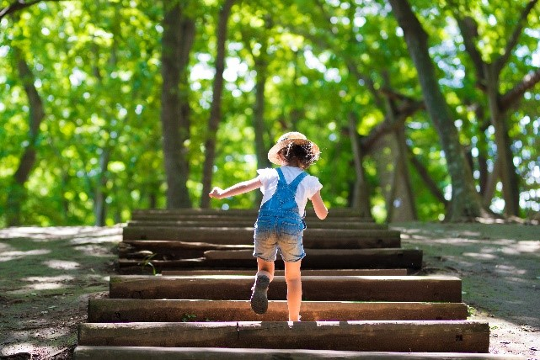
Image licensed under the iStock Getty Images Content License Agreement

Two-footed jump

Image licensed under the iStock Getty Images Content License Agreement
- Work with an adult to place markers on the floor or ground. This can be pieces of paper, small items of clothing or chalk drawing outside.
- With two feet together, jump from marker to marker.

Scan this QR code for a video on the two-footed jump from Munch and Move.
Video attribution: State of New South Wales NSW Ministry of Health (14 June 2017), 'Jump lily pad jumping - Munch and Move' [video], NSW Health Channel, Youtube, accessed 13 August 2021.

Want to learn more?
Make an obstacle course that includes the jumping markers. You might want to include:
- things to climb over, under or through, such as chairs, boxes, a table or tunnel
- things to walk along to balance, such as a long rope or cord, or a broom laid flat on the ground
- a marker to run to, such as a door, clothesline or tree.
© State of New South Wales (Department of Education), 2021
The copyright material published in this document is subject to the Copyright Act 1968 (Cth) and is owned by the NSW Department of Education or, where indicated, by a party other than the NSW Department of Education.
Copyright material available in this document is licensed under a Creative Commons Attribution 4.0 International (CC BY 4.0) licence.
See https://education.nsw.gov.au/about-us/copyright for further details.


