Early Adopter Schools second steps

In this segment following the Early Adopter School first steps, you will read about:
- the Attitude and Teaching Practices survey and analysis
- how schools used the data to set directions
- the key action that was chosen and the planned professional learning
- shared advice at this stage of their familiarisation
- their challenges and successes to date
- their goals and next steps and
- shared resources

Reflections
The Early Adopter Schools’ project was launched in December, 2019. The project follows the early adoption journey of a representative group of schools. At this point in the project these diverse schools have commenced in-depth professional learning and received some tailored support. Their journey started with face to face professional learning introducing the policy and baseline data was collected.
A film entitled ‘Early Adopter Schools first steps’ was produced to provide schools with a guide to their first steps.
The next two planning meetings occurred during the first semester of 2020. One of the face to face meetings was replaced by an online gathering due to COVID-19. Online PL and dialogue was not the most ideal forum for the Early Adopters project. COVID-19 also affected the schools’ familiarisation and implementation plans. It was important to keep the momentum going in spite of the complex situation in which schools found themselves.

First planning day
The February meeting focussed on leading change in schools. The participants were introduced to the Evaluation and Planning Tool to guide school planning.

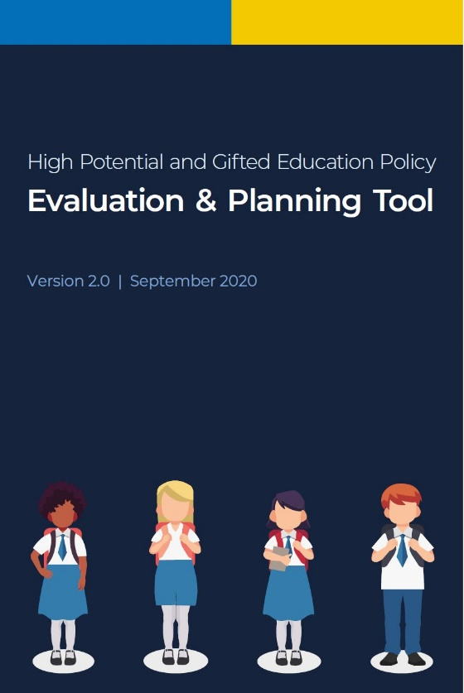

The Attitudes and Teaching Practices Survey (ATPS) was shared with the participants as a tool to guide school directions. Schools administered the survey among their staff and the raw data were forwarded to the HPGE team. A report was then provided to the schools and analysed by school leaders. Key findings were explored by schools before deciding the next steps.

Fig 1: Example of an ATPS graph
Every school should offer learning opportunities across all domains of potential that meet the needs of high potential and gifted students.
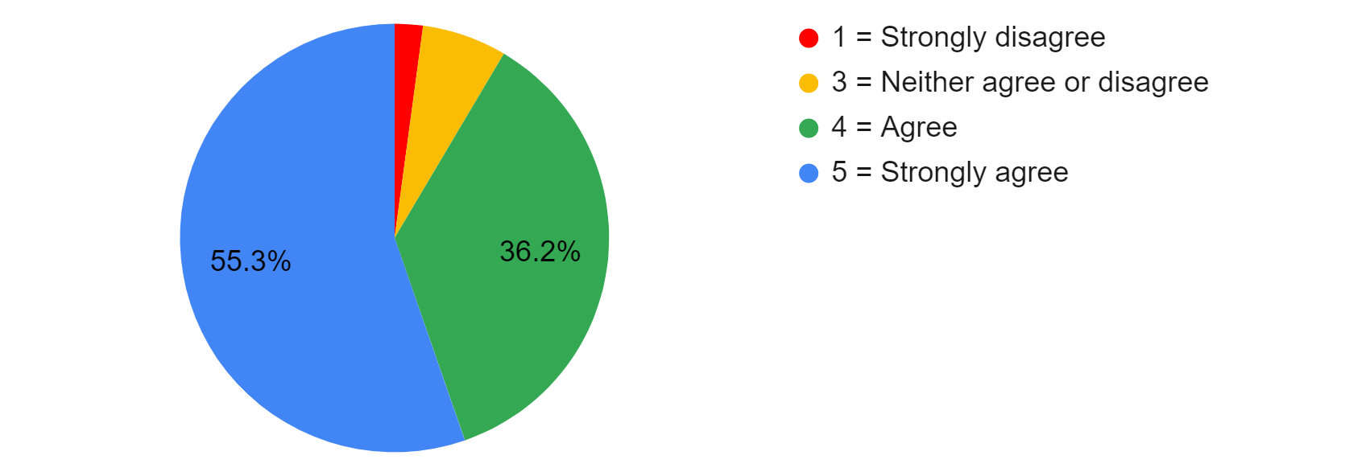

Table 1 Attitude and Teaching Practices Survey
School leaders | What qualitative data did you extract from the survey? What were the key findings?
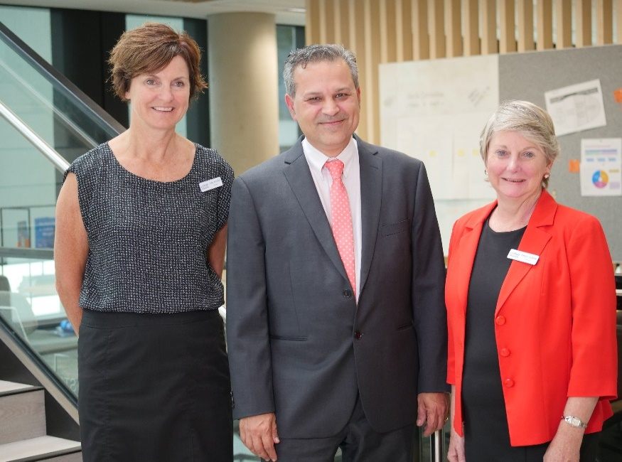 | Libby, Cyrus and Megan from Lindfield Public School  Results after analysis indicated:  - successes and areas that need attention  - the need to target students with high potential  - a lack of confidence to cater for students with high potential effectively.  - confidence in teaching the use of critical higher order thinking skills, questioning and providing group work  - a lack of confidence in the teaching of creative thinking  - professional learning to build staff capacity and confidence in engaging students with high potential across all four domains.
 | Trang, Jaclyn and Mark from Penrith Selective High School  Results after analysis indicated:  - that the individual needs of high potential and gifted students must be met  - a responsibility to ensure effective teaching occurs through ongoing assessment, identification and evidence based strategies  - staff value equally all domains of potential and giftedness  - staff value professional learning  - concerns around disengagement  - enhancing health and wellbeing through the executive team, wellbeing team and entire student body was necessary.
 | Glenn and Kylee from Leeton High School  Results after analysis indicated:  - assessment and identification of high potential and gifted students should be ongoing and based on specific learning needs  - staff offer students choices in presenting ways to show learning  - the use of formative assessment as part of ongoing assessment strategies needed to be used by all staff and with increased regularity  - pre-tests to determine mastery, combined with analysis and comparison of pre and post assessment data could be used to inform teaching and learning.
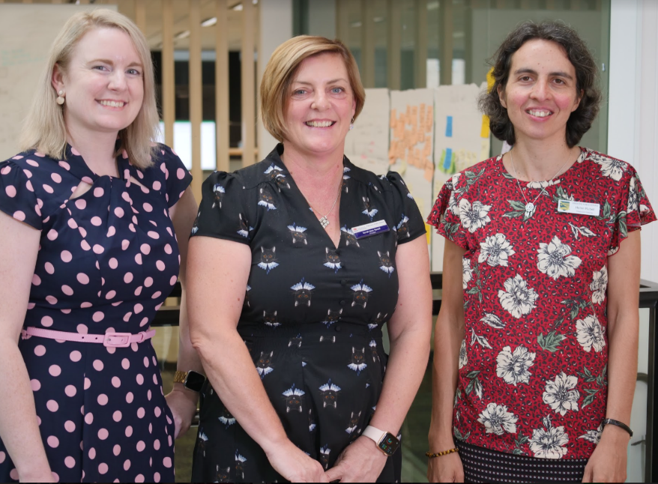 | Linden, Sarah-Jane and Helen from Dungog District Community of Schools  Results after analysis indicated:  - pleasing support for evidence-based practices for teaching HPG students  - concern for the learning and wellbeing needs of high potential and gifted students with inadequacies in this area  - role of responsibility for identification and assessment of students within a class was unclear  - sharing best practice in identification and assessment across community schools could be well received.

Table 2 – Key action and Professional learning
School | What is your key action? | What planned professional  learning will occur?
 | - Build teacher and leadership capacity through engagement with quality research and ongoing professional learning on effective practices to improve growth and achievement for all high potential and gifted students | - The nature of domains  - How to develop talent  - Identifying creativity  - Embedding creative thinking in teaching practice  - Building a culture of common language for differentiation
 | - Implement evidence-based procedures, programs and practices that meet the learning and wellbeing needs of all high potential and gifted students | - Developing a shared vision.  - Next steps for each faculty using effective practices  - Implementing action research as a form of professional learning  - Extending the top students  - Moving students along the continuum, considering all domains  - Facilitating talent development
 | - Evaluate school procedures, programs, practices, and analyse student growth and achievement data to inform school planning and policy implementation | - Introduction to policy via ‘canapé’ training  - Review of current practises and programs identifying HPGE strategies across all four domains  - Implementing new HPGE strategies while considering synergies with other areas - numeracy and literacy, differentiation and formative assessment  - Self-assessing the effectiveness of policy implementation through consideration of effective change management procedures.  Fig 2 Annotated PL plan
 | - Implement evidence-based procedures, programs and practices that meet the learning and wellbeing needs of all high potential and gifted students | - Familiarising staff with the policy  - Implementing strategies to meet the needs of identified students in all domains  - Identifying staff expertise in teaching high potential students for network sustainability  - Identifying which issues are school-specific and which issues are network-specific

Second planning day
After six months into the project, the early adopter schools were asked to reflect and consider advice they would give to other schools at this point in their familiarisation journey.
Table 3 – Advice and guidance
School leaders | What advice would you give to other schools at this stage of your journey?
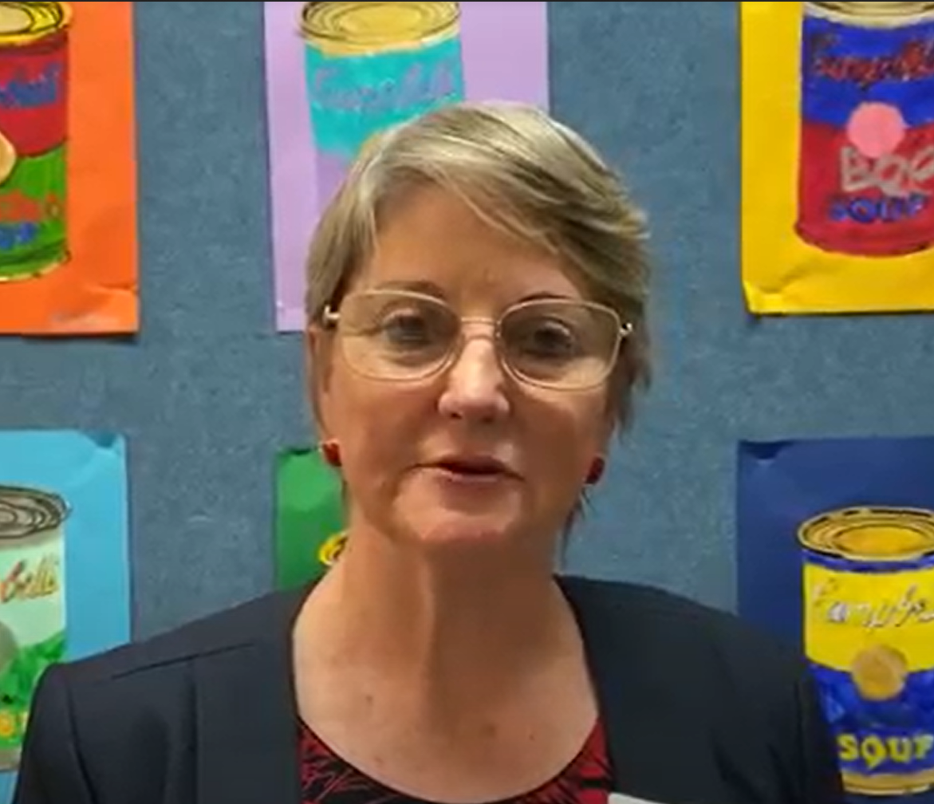 | Megan from Lindfield Public School  - Audit what is currently being done in high potential and gifted education, in all domains and celebrate  Fig 3 Audit
 | Mark from Penrith Selective High School  - Map what is happening at the school across the four domains to determine where the need for future focus is - backed by evidence-informed research.  - Make policy implementation relevant to school needs and ensure staff buy in through consultation and the development of a shared goal.
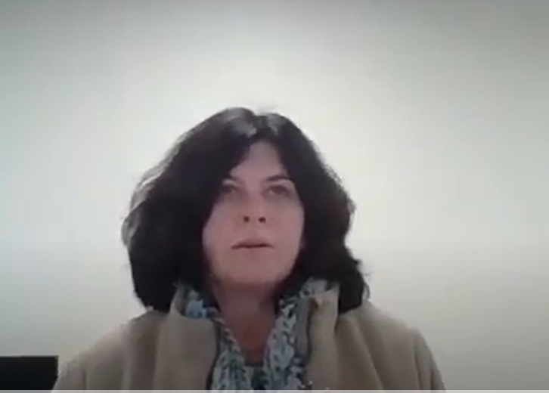 | Meagan from Leeton High School  - Allow staff time to reflect on their new knowledge and rethink how high potential and gifted education will fit into their context.  - Build the premise that meeting the specific needs of high potential and gifted students is part of best-practise teaching and therefore, should be a focus for every classroom teacher every day.
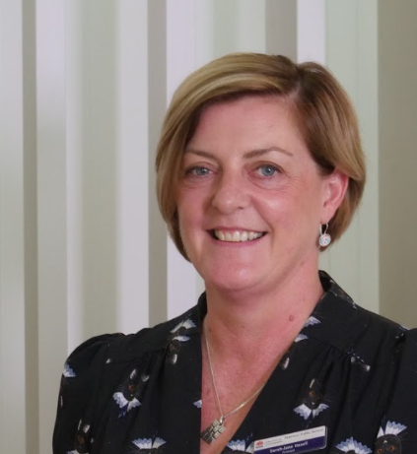 | Sarah-Jane from Paterson Public School  - From a network perspective, set up the structures. Allocate representatives from each school to be responsible for attending meetings, delivering the messaging back in their own schools and the professional learning.  - Put the steps into place to clarify and strengthen the roles of these representatives so they feel confident in leading the implementation of this new policy in their home schools.

Table 4 – Challenges and successes
School | At this stage of the journey, what are some of the challenges? | At this stage of the journey, what are some of the successes?
Lindfield Public School | - Consideration of what constitutes an engaging curriculum  - Understanding that students find it difficult to engage with concepts that have already been mastered | - Grouping strategies that are fundamental to differentiating the curriculum  - Open-mindedness about advancing students to higher curriculum levels
Penrith Selective High School | - The quick shift into blended learning (also a success)  - Collecting enough evidence and appropriate evidence to record/track student progress effectively | - Strong staff buy in regarding HPGE (core business based on school context)
Leeton High School | - Practising an ongoing cycle of feedback, monitoring and adjustments  - Developing a structured approach to the HPGE policy delivery | - Purposeful articulation of linking the work in HPGE to the school’s vision statement of inspiring, engaging and challenging all students to succeed
Dungog District Community of Schools | - In a network, it is important to ensure communication is clear between sites.  - Aligning the policy with student wellbeing | - During the Covid19 period, accessing online communication, made professional learning easier  - Momentum and recognition that the HPGE policy supports rural and remote students

Table 5 – Next steps
School | What are your goals and what next steps are planned based on the survey data and analysis of your context?
Lindfield Public School  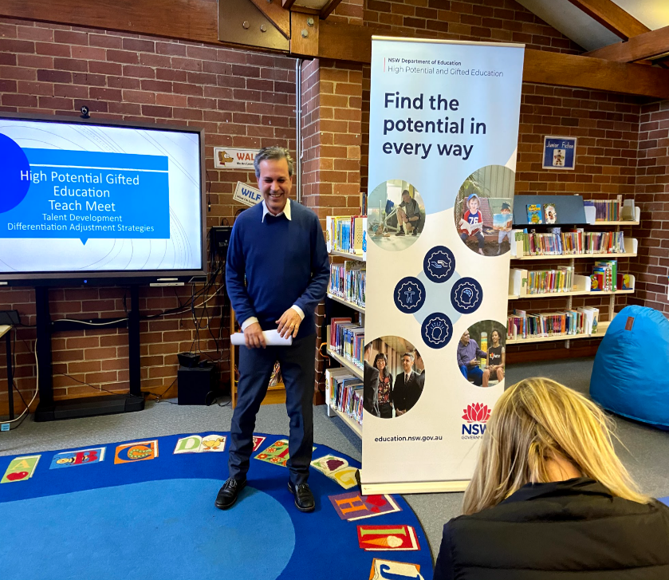 | - To ensure that teachers feel confident to differentiate lessons using the Differentiation Adjustment Strategies tool to modify core lessons and units.  Fig 4 Domains of potential
Penrith Selective High School  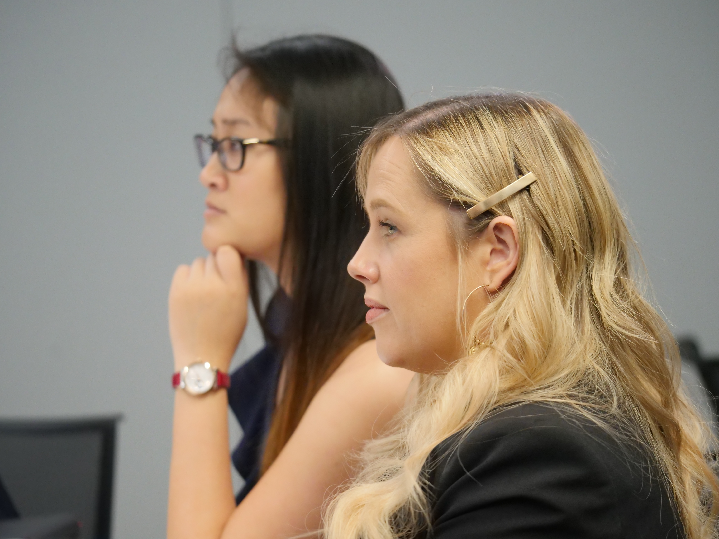 | - To explore implementation strategies, across faculty professional learning communities focussing on teaching practice within the four domains of potential.  - To shift teacher practice from proficient to working with the APST descriptors at the highly accomplished/lead levels.
Leeton High School   | - To build teachers self-efficacy and leadership capacity to implement evidence based procedures, programs and practices.  - To accurately identify high potential and gifted students and then tailor our practice to cater to the specific learning and wellbeing needs of these students.
Dungog District Community of Schools  | - To complete the canapé courses  - To align HPGE professional learning with rural and remote strategies, STEAM initiatives, wellbeing, whole child best practice and community engagement

Shared resources
- Differentiation adjustment strategy implementation – Lindfield Public School
- Dungog District Community of Schools network plan
- Implementation model used by Dungog District Community of Schools
- Action research project topics – Penrith Selective High School

Differentiation adjustment strategy implementation

(Lindfield PS)
Goal(s):
By the end of 2020, ensure that all teachers have engaged with the professional learning surrounding the HPGE Policy
By the end of term 3, ensure that teachers feel confident to differentiate lessons using the Differentiation Adjustment Strategies tool to modify core lessons and units. This will be measured at a ‘Teach Meet’, in week 5, where teachers will share and explain a learning adjustment used as a result of the PL.
Implementation date:
20/07/20 - SDD term 3
10.15 - 11am Megan introduces domains, giving authentic examples from our school. Cyrus and Libby present to revise understanding and nature of the domains.
Staff brainstorm and celebrate strategies currently in use at LPS that foster talent development in the four domains
11.30-12.30pm - Carmela from HPGE team explains the Differentiation Adjustment Strategies tool. Model annotations, then participants modify a unit of work they have brought with them to be taught in next few weeks.
Term 3, Week 5 Under the guidance of school leaders, a ‘Teach Meet’ occurs where small groups of teachers share an adjustment strategy recently trialled. Work samples and examples will be shared, evaluations made and plans made for future directions.

Dungog District Community of Schools network plan
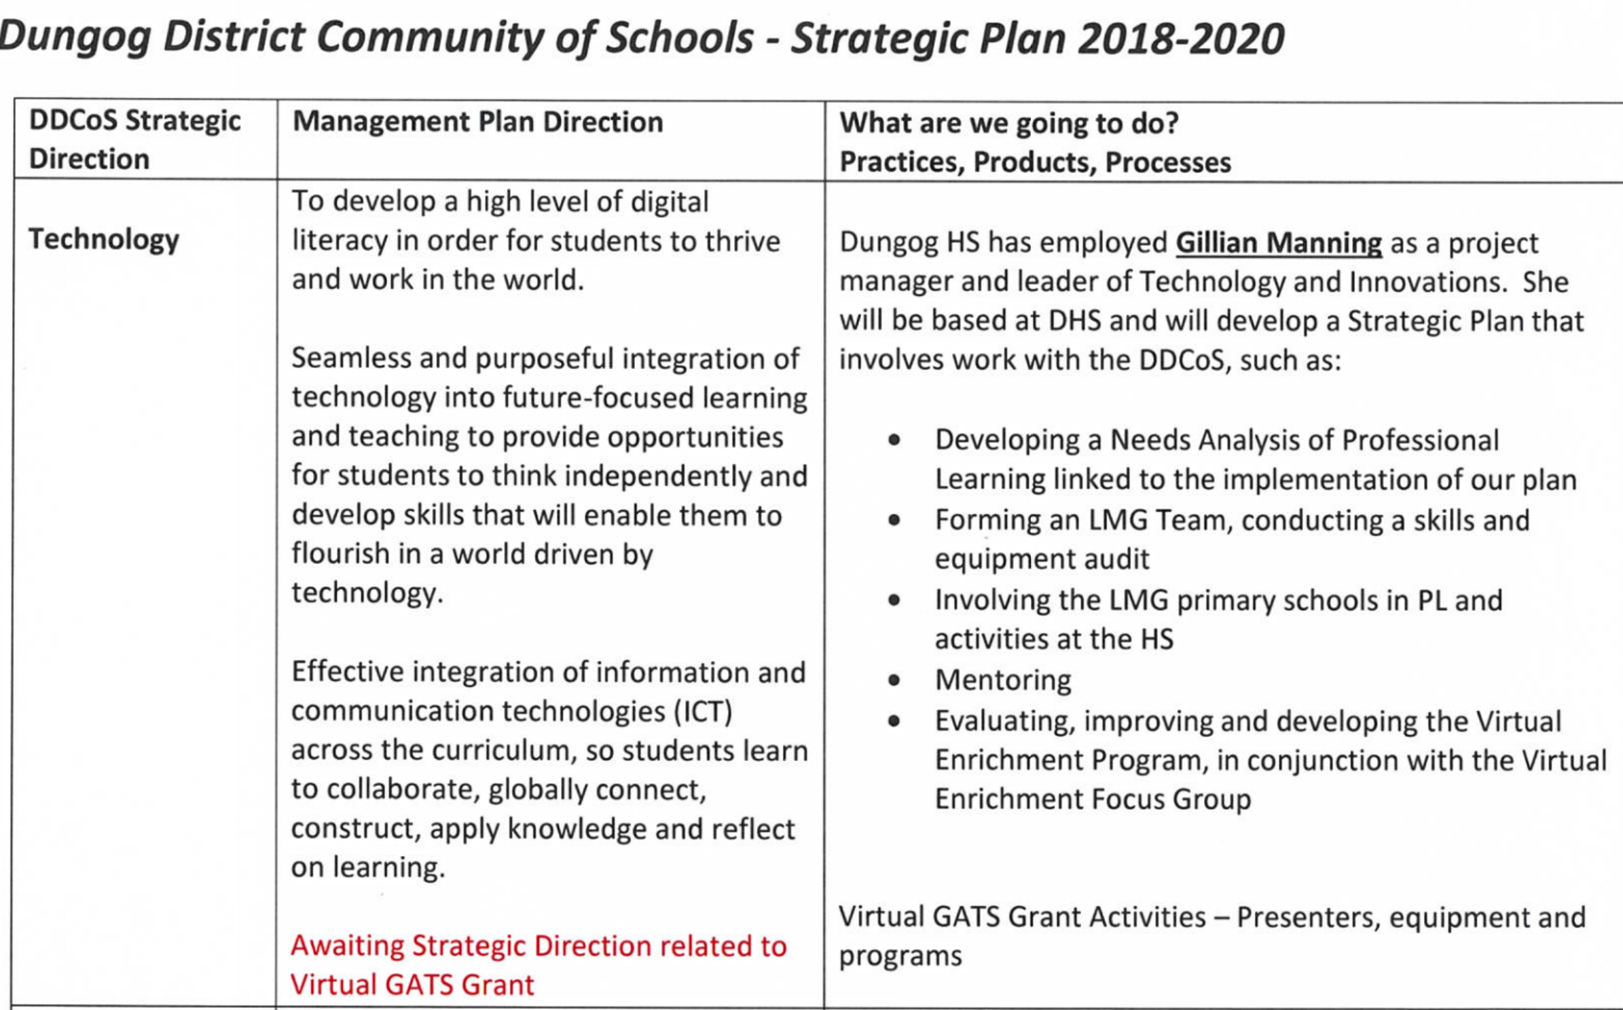
Dungog District Community of Schools employed a teacher with expertise in the technology area, who developed a digital literacy transition project, involving film-making. The network used a rural and remote funding initiative. As a result, teachers identified and met the specific needs of students who demonstrated high potential in skills such as script-writing, filming and editing techniques, producing and directing, stage management and acting. There is a commitment to sustainability and challenge, creating a perfect talent development program.

Fig 5 Implementation model used by Dungog District Community of Schools
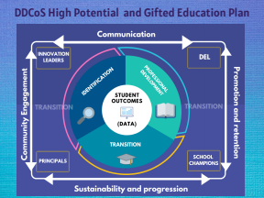

Action research project topics – Penrith Selective High School

Name | Focus Area | Focus Question
 | Creative thinking | Does the use of divergent and convergent thinking lead to higher levels (numerous and varied ideation) of creativity (in toy design)?
 | Deliberate Practice | To what extent does the deliberate practice improve depth and clarity in Year 8 English thesis development?
 | Academic Writing | Does explicit instruction in functional grammar enhance student-identified efficacy in subject (English) related assessments?
 | Creative thinking | To what extent does the use of a choice board encourage creative risk taking in Year 7 visual arts presentation on the conceptual framework?
 | Formative Assessment | To what extent does student choice of format affect formative assessment outcomes?
 | Academic Writing | To what extent does cognitive apprenticeship pedagogy help under-achieving students gain more confidence in essay writing and conceptual thinking?
 | Critical Thinking | What is the impact of dialectical reasoning on improving understanding in Year 8 history?
 | Critical Thinking | To what extent can the explicit teaching of NESA’s Glossary of Key Terms, by way of Bloom’s Taxonomy, improve the critical thinking of Year 7 history students?
 | Formative assessment | To what extent does the use of peer/self-feedback as formative assessment improve skill development in Year 7 PDHPE?
 | Academic Writing | How will gifted underachieving students’ perceptions of their ability in academic writing change following a specific writing intervention?
 | Creative Thinking | To what extent do open-ended questions in regards to volume and surface area, with choice board activity selection, improve student outcomes for the topic? Could this be an alternative assessment task?
 | Creative Thinking | Can the use of SCAMPER lead to more creative ways of communicating scientific concepts?
 | Creative Thinking | To what extent does the use of a choice board encourage students to be creative in designing their own modified sport to improve their performance and confidence?
 | Formative Assessment | In a gifted context, do students get the same motivation or satisfaction from a formative task compared to a summative task?
 | Formative assessment | Does informal formative assessment promote greater student growth than formal formative assessment?
 | Formative Assessment | How effective is the use of Google forms as a formative assessment tool in ascertaining Year 8’s understanding of scientific concepts?
 | Formative Assessment | To what extent does the use of peer/self-assessment improve a student’s awareness of areas for development?
 | Creative Thinking | Can students be taught to be creative while still demonstrating knowledge and understanding of content?

