Problem set for Year 12 Physics

Contents
Introduction 3
Module 5 – advanced mechanics 4
Question 1 (4 marks) 4
Question 2 (5 marks) 6
Question 3 (3 marks) 8
Question 4 (6 marks) 9
Question 5 (6 marks) 11
Question 6 (19 marks) 14
Question 7 (6 marks) 20
Question 8 (5 marks) 22
Question 9 (9 Marks) 25
Module 6 – electromagnetism 28
Question 10 (6 marks) 28
Question 11 (6 marks) 31
Question 12 (3 marks) 34
Question 13 (9 marks) 35
Question 14 (9 marks) 37
Question 15 (8 marks) 41
Question 16 (5 marks) 44
Question 17 (8 marks) 45
Module 7 – the nature of light 48
Question 18 (9 marks) 48
Question 19 (6 marks) 52
Question 20 (6 marks) 55
Question 21 (3 marks) 59
Question 22 (6 marks) 61
Module 8 – from the Universe to the atom 64
Question 23 (4 marks) 64
Marking Guidelines 64
Question 24 Multiple Choice Question (1 mark) 66
Question 25 Multiple Choice Question (1 mark) 66
Question 26 (3 marks) 68
Question 27 (9 marks) 70
Mapping grid 72
References 75

Introduction
This document contains questions to probe students’ understanding of various concepts in the Year 12 course of the Stage 6 Physics syllabus. The questions have been designed by NSW Physics teachers who attended the ‘Teaching the Year 12 modules in Stage 6 Science’ workshops in 2019, as well as the science curriculum support officers at the Learning and Teaching Directorate. The problem set may be used as classroom activities or in assessments to evaluate student understanding. Teachers are free to adapt or modify the questions in this problem set to suit the learning needs of their students.
This document references the Stage 6 Physics syllabus © 2017 NSW Education Standards Authority (NESA) for and on behalf of the Crown in right of the State of New South Wales.

Module 5 – advanced mechanics

Question 1 (4 marks)
A 5c coin (mass = 2.83 g) is placed on a smooth turntable spinning at 44 rpm.
- What is the period of rotation of the turntable? 1
- Given that the maximum frictional force between the coin and the turntable is 0.0139 N, calculate the maximum distance from the centre of the turntable that the coin could be placed without slipping. 3

Marking guidelines
(a)
Criteria | Marks
- correctly calculates the period of rotation | 1
Sample answer
$$\frac{44 rpm}{60}=0.7333 Hz$$
$$T=\frac{1}{f}= \frac{1}{0.7333}$$
$$T=1.4 s \left(2 sig. fig.\right)$$
(b)
Criteria | Marks
- correctly calculates the radius | 3
- calculates the radius that is substantially correct | 2
- attempts to calculate velocity OR radius  OR  - equates the friction and centripetal forces | 1
Sample answer
$$F_{fr}=F_{c}$$ | where $F_{fr}=0.0139 N, F_{c}=\frac{mv^{2}}{r},$  $$m=0.00283 kg$$
$$0.0139=\frac{0.00283v^{2}}{r}$$ | (1)
$$v=\frac{2πr}{T}$$ | from part (a) $T=1.36 s$
$$v=\frac{2πr}{1.36}$$ | rearranging
$$v=4.62r$$ | substitute into equation (1)
$$0.0139=\frac{(0.00283){(4.62r)}^{2}}{r}$$ | solve for r
$$r=\frac{0.0139}{0.0604}=0.23 m$$

Question 2 (5 marks)
Objects undergoing uniform circular motion are subject to a centripetal force. Describe the nature of this force, including TWO examples, one in which the centripetal force results from a single force and one where it results from the sum of multiple forces.

Marking guidelines
Criteria | Mark
- succinctly describes the features of the centripetal force required for UCM  - supports their response with suitable examples  - demonstrates how the centripetal force can be the resultant of two or more forces | 5
- correctly describes the features of the centripetal force required for UCM  - supports their response with a suitable example of centripetal force resulting from a single force AND multiple forces | 4
- describe a feature of the centripetal force  - supports their response with a suitable example of single AND/OR multiple force cases | 2-3
- identifies a feature of the centripetal force  OR  - identifies an example of uniform circular motion | 1
Sample answer
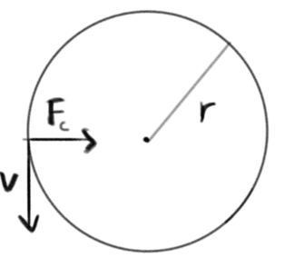
Uniform circular motion (UCM) requires that an object experiences a constant net force directed towards the centre of motion. This force is called the centripetal force, Fc. The net force is always directed perpendicular to the object’s velocity, which has a constant magnitude. The magnitude of Fc required to maintain UCM is described by:
$$F_{c}=\frac{mv^{2}}{r}$$
Where: m = mass, v=tangential velocity, r= radius of curvature.
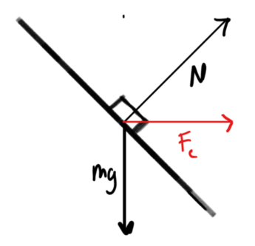
This centripetal force can be produced simply from a single force, as is the case with gravitational force experienced by a satellite orbiting a planet.
In this case, $F_{c}=F_{g}=\frac{GMm}{r^{2}}$
Alternatively, it could be produced by the sum of multiple forces. An example of this would be for an object moving around a banked curve. In this case, the centripetal force is the sum of weight force and normal force, as shown in the diagram.
$$F_{net}=F_{c}=mg+N$$

Question 3 (3 marks)
Applying the law of conservation of energy, explain why the escape velocity$, v_{esc}=\sqrt{\frac{2GM}{r}}$.
Marking guidelines
Criteria | Mark
- explains why $v_{esc}=\sqrt{\frac{2GM}{r}}$ by applying the law of conservation of energy | 3
- shows some understanding of the law of conservation of energy AND/OR $v_{esc}=\sqrt{\frac{2GM}{r}}$ | 2
- provides some relevant information | 1
Sample answer
The law of conservation of energy states that energy cannot be created or destroyed. It is transferred or transformed. Escape velocity is defined as the minimum initial velocity a projectile requires to escape the gravitational attraction of a planet or other body from its current position.
For an object to escape a gravitational field, its total energy, E, must equal zero. That is,
$$E=U+K=0$$ | given that $U=-\frac{GMm}{r}$ and $K=\frac{1}{2}mv^{2}$
$$E=-\frac{GMm}{r}+\frac{1}{2}mv^{2}=0$$
$$\frac{1}{2}mv^{2}=\frac{GMm}{r}$$ | cancel the mass of the object (thus $v_{esc}$ is independent of the mass of escaping object)
$$\sqrt{v^{2}}=\sqrt{\frac{2GM}{r}}$$ | make v the subject
$$v_{esc}=\sqrt{\frac{2GM}{r}}$$

Question 4 (6 marks)
Objects moving under the influence of either a gravitational or electric field may travel in a parabolic trajectory.
Compare the gravitational and electric fields that generate the forces required for such parabolic motion. Air resistance can be considered to be negligible in both cases.

Marking guidelines
Criteria | Marks
- compares and contrasts the nature of uniform gravitational and electric fields  - explains the principles of parabolic motion, including ideas that vertical and horizontal motions can be analysed independently  - Describes the forces that contribute to changes in motion | 6
- compares and/or contrasts the nature of uniform gravitational and electric fields  - describes the principles of parabolic motion  - describes the forces that contribute to changes in motion | 4-5
- compares and/or contrasts the nature of uniform gravitational and/or electric fields  - describes the geometry of an appropriate gravitational or electric field | 2-3
- any relevant information | 1
Sample answer
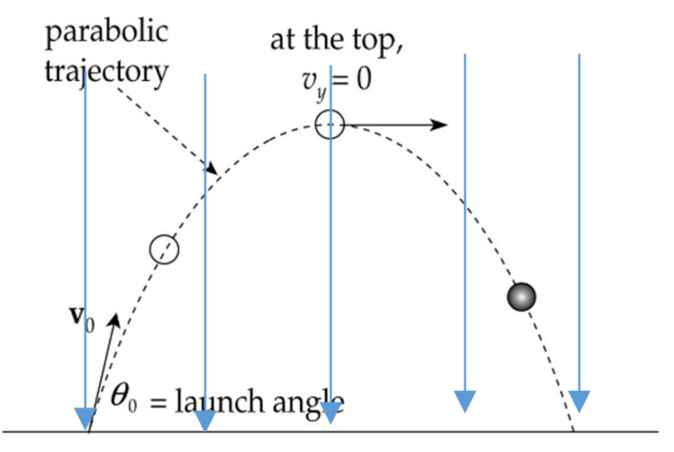
For gravity and electricity, uniform fields are required to produce a parabolic trajectory. In uniform fields, the field lines would be depicted as parallel and evenly spaced. Horizontal and vertical motion can be analysed independently; horizontal motion would be uniform, and there would be no net forces or acceleration in this dimension. Net forces only act in the vertical direction, resulting in an acceleration in the same direction.
A uniform gravitational field occurs by assuming that the section of the surface of the Earth below the projectile is flat, thus giving rise to a uniform local gravitational field. The force acting on the projectile is directed towards the Earth’s surface and is parallel to the force field lines. The force is calculated as F = mg, where m is mass of the projectile and g is gravitational field strength.
A uniform electric field occurs between oppositely charged parallel plates; where the force field lines are evenly distributed and flow from the positive plate to the negative plate. The magnitude of the force is calculated as F = qE, where q is the particle charge, and E is electric field strength. The direction of the force depends on the particle’s charge - towards the negative plate for positive charges and towards the positive plate for negative charges.

Question 5 (6 marks)
A group of astronauts on a newly identified planet performed an experiment and determined the acceleration due to gravity of the new planet as 1.2 ms⁻².
The astronauts then studied projectile motion on the planet’s surface. In their experiments, they assumed that there is a constant vertical acceleration due to gravity and that there was no air resistance. They projected a small, 0.40 kg object horizontally from the top of a high cliff at 20 ms⁻¹. Using special equipment, they measured the speed of the object as it moved along its trajectory. Their results are shown in the table below.
Speed of the object measured at different times after launch
Time after launch (s) | Speed (ms⁻¹)
0.0 | 20
10.0 | 23
20.0 | 31
30.0 | 41
40.0 | 52
Quantitatively analyse the above projectile motion by resolving it into its horizontal and vertical components and compare your analysis with the collected experimental data. Assess how well the results of the experiment support the model of projectile motion suggested.

Marking guidelines
Criteria | Marks
- provides an appropriate quantitative analysis of the motion  - demonstrates a thorough understanding of the features and analysis of projectile motion  - makes an informed judgement based on the provided experimental data and the results obtained from their own analysis | 6
- provides an appropriate quantitative analysis of some aspects of the motion  - demonstrates a sound understanding of the features of projectile motion  - compares the provided experimental data to the results obtained from their own analysis | 4-5
- provides an analysis of some aspects of the motion  - demonstrates a basic understanding of projectile motion  - attempts to compare the provided experimental data to the results obtained from their own analysis | 3
- analyses an aspect of the projectile’s motion  OR  - demonstrates a basic understanding of projectile motion | 2
- provides some relevant information | 1
Sample answer
When analysing projectile motion, it is useful to resolve the motion into two components:
a vertical component that is uniformly accelerated due to gravity, and
a horizontal component that remains constant.
The table below compares the experimental results with those predicted using the model of projectile motion and the data supplied.
$v_{x}=20 ms^{-1}$, $v_{y}=\frac{1}{2}at^{2}=0.6t^{2}$, and $v=\sqrt{v_{x}^{2}+v_{y}^{2}}$

Time after launch  (s) | Observed speed  (ms⁻¹) | Predicted speed V_{x}  (ms⁻¹) | Predicted speed V_{y}  (ms⁻¹) | Predicted speed V  (ms⁻¹)
0 | 20 | 20 | 0 | 20.0
10 | 23 | 20 | 12 | 23.3
20 | 31 | 20 | 24 | 31.2
30 | 41 | 20 | 36 | 41.2
40 | 52 | 20 | 48 | 52.0

The observations made during the experiment very closely match the predictions of the speeds of the object made using the suggested model. Because the vector components of the object’s velocity were not recorded during the experiment, it is possible that acceleration may have also occurred along the horizontal component of its motion. However, the consistency of the observations provides significant support for the model. The strength of the evidential support provided for the model would also be increased by the use of repeated trials to minimise the impact of random errors.

The diagram below shows the trajectory and changing the velocity of the projectile during its motion. The vertical and horizontal components are shown for the object at $t=20 s$. Please note that this diagram has been included to illustrate concepts relevant to this question further. It has been included as a teaching aid and is not required to answer the question.
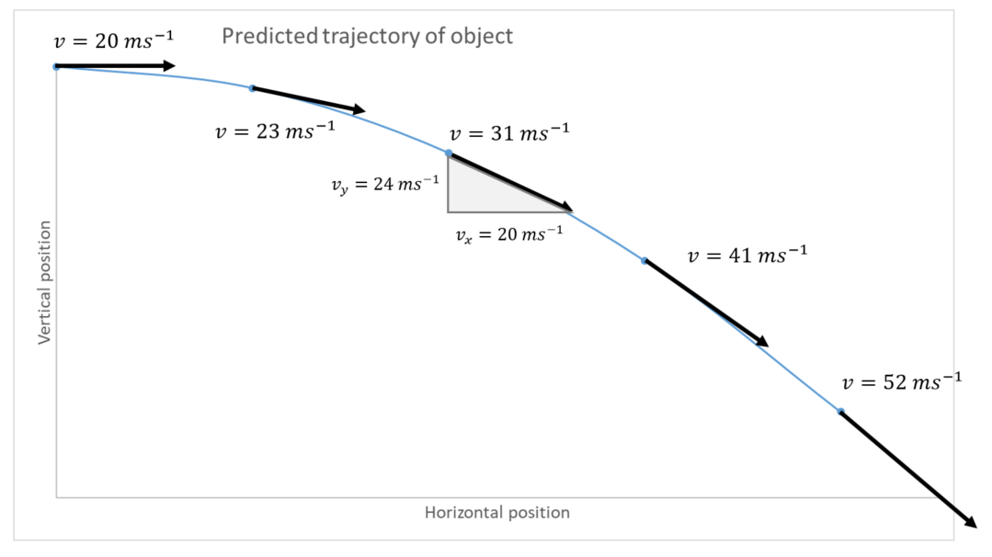

Question 6 (19 marks)
Note: Question 6 would be better suited to supporting an in-class assessment due to its extended length.
Two astronauts, Tom and Tam, performed an experiment to find the acceleration due to gravity on a fictional planet by measuring the time taken for 20 periods of a simple pendulum, consisting of a small mass at varying string lengths.
The results are shown below.
Length of pendulum (m) | Time for 20 oscillations (s) | Period | Period² | $$length/{time}^{2}$$
0.40 | 24.0
0.80 | 33.0
1.20 | 40.1
1.60 | 46.0
2.00 | 51.3
 |  |  | average
- Complete the columns for Period and Period², including appropriate units in each heading. 3
- Tom used the data in the table and plotted a graph of Period² vs. length of the pendulum and drew a line of best fit. Draw the graph produced. 3
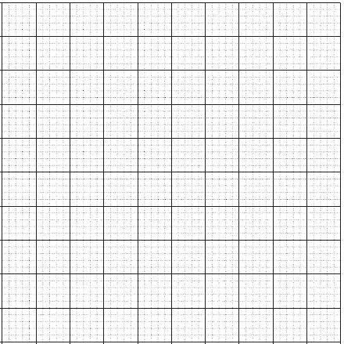
- Find the gradient (including units) of your line of best fit. 2
- Tom used the gradient from the line of best fit and the formula for the period of a simple pendulum (given below), to find the acceleration due to gravity on this fictional planet. Calculate the value of g obtained using this method. 2
$$T=2π\sqrt{\frac{l}{g}}$$
- Tam used the data in the table to calculate an average value of $length/{Period}^{2}$ by filling the information in the right-hand column of the results table. She then used the formula for the period of a simple pendulum given above and found the acceleration due to gravity on this fictional planet.
  - Fill in the $length/{Period}^{2}$column, including appropriate units. 2
  - Calculate the average value of$length/{Period}^{2}$. 1
  - Use the value you calculated in (ii) to determine the value of g. 2
- Compare Tom’s and Tam’s methods of calculating g to justify which is the better approach. 3

Marking guidelines
(a)
Criteria | Marks
- correctly calculates the period for all five lengths  - correctly calculates period² for all five lengths based on period data  - correctly identifies units for Period and Period² | 3
- TWO of the above | 2
- ONE of the above | 1
Sample answer
Length of pendulum (m) | Time for 20 oscillations (s) | Period T  (s) | Period²  (s²) | Length / time²  m/s²
0.40 | 24.0 | 1.20 | 1.44 | 0.277
0.80 | 33.0 | 1.65 | 2.73 | 0.293
1.20 | 40.1 | 2.00 | 3.61 | 0.299
1.60 | 46.0 | 2.30 | 5.30 | 0.302
2.00 | 51.3 | 2.57 | 6.58 | 0.304
Average = 0.295
(b)
Criteria | Marks
- uses appropriate scale  - labels axes correctly with units  - plots the data points accurately  - draws a line of best fit | 3
- provides a substantially correct graph | 2
- provides some basic features of the graph | 1

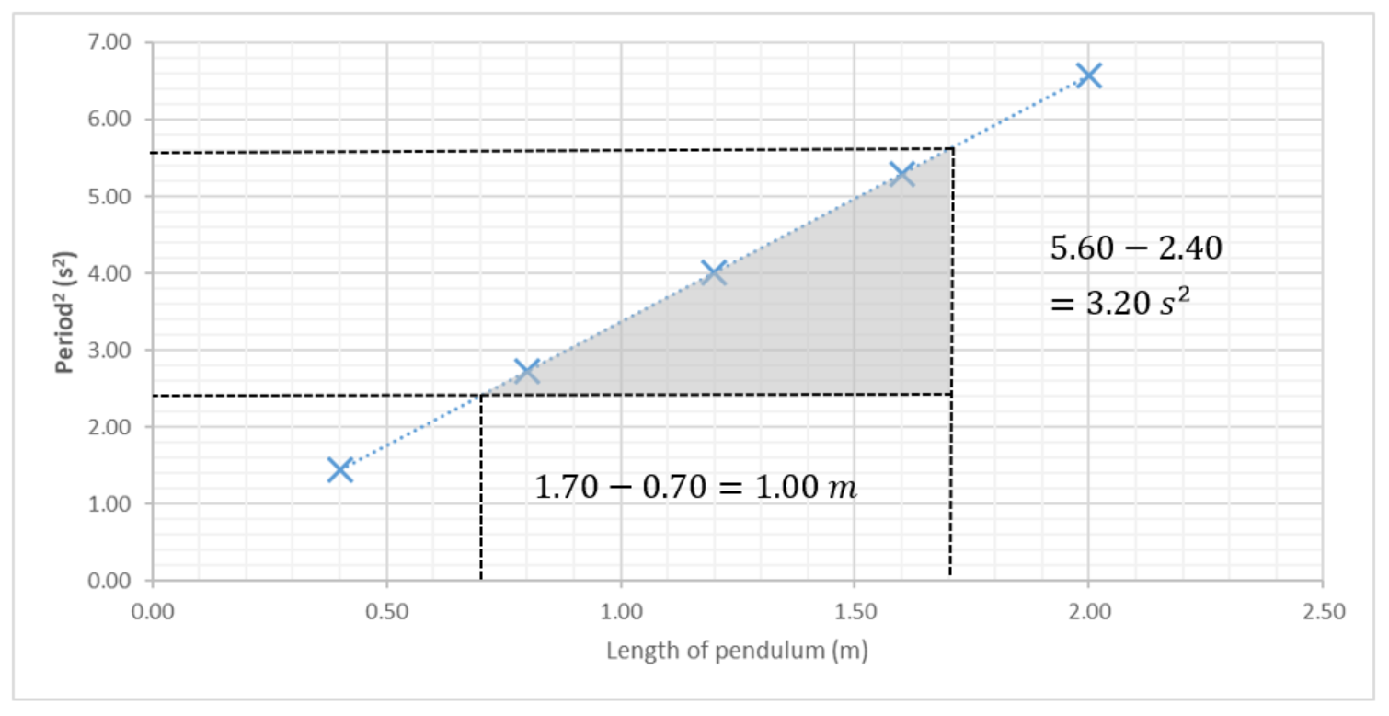
(c)
Criteria | Marks
- uses two, well-separated, valid points which lie on the line of best fit in part (b)  - uses $m=\frac{∆y}{∆x}$ or similar to find the gradient  - includes correct units for the gradient (s² m⁻¹) | 2
- partially correct calculation | 1
Sample answer
$$m=\frac{y_{2}-y_{1}}{x_{2}-x_{1}}=\frac{5.60-2.40}{1.70-0.70}=3.20 s^{2}m^{-1}$$
(d)
Criteria | Marks
- substitutes the value obtained in (c) into an appropriate equation and calculate g  - evaluates equation and expresses with correct units | 2
- partially correct calculation | 1
Sample answer
$$T=2π\sqrt{\frac{l}{g}}$$
$$g=\frac{4π^{2}l}{T^{2}}$$
$$g=4π^{2}×\frac{l}{T^{2}}$$
$$g=4π^{2}/gradient \\ g=4π^{2}×\frac{1}{3.20}=12.34 ms^{-2}=12 ms^{-2} (2 sig.fig.)$$
(e) (i)
Criteria | Marks
- correct data and units | 2
- substantially correct data or correct units | 1
(e) (ii)
Criteria | Marks
- correct average value calculated | 1
(e) (iii)
Criteria | Marks
- substitutes the average value obtained in the table into an appropriate equation and calculates g  - evaluates equation and expresses with correct units | 2
- partially correct calculation | 1
Sample answer
$$g=4π^{2}×\frac{l}{T^{2}}$$
$$g=4π^{2} ×(average of \frac{l}{T^{2}})$$
$$g=4π^{2}×0.295=11.65 ms^{-2}=12 ms^{-2} (2 sig. fig.)$$
(f)
Criteria | Marks
- applies concepts of error and/or reliability to the comparison of techniques used to process the experimental data  - relates a feature of each method to the quality of results produced  - supports a judgment of the better approach with relevant information | 3
- demonstrates a sound understanding error and/or reliability  - relates a feature of ONE method to the quality of results produced | 2
- any relevant information | 1
Sample answer
Whilst each of the techniques produced the same result for ‘g’ (to 2 sig. fig.) from the data collected in this experiment, they differ in their reliability due to the different techniques they use to process data. Random errors (for example in measuring the period) cause deviations from true values by varying amounts, but are generally symmetric above and below the true value. Both methods attempt to increase reliability by reducing the effect of random measurement errors by incorporating multiple measurements when determining a value for ‘g’. The line of best fit used in Tom’s method better utilises all the data than Tam’s method, which is more sensitive to errors for small values than for large values. Therefore, Tom’s method is generally preferable to Tam’s in terms of reliability.

Question 7 (6 marks)
A student used a projectile launcher to determine the relationship between the launch height and the range of a projectile. You may assume that the launcher is capable of reliably launching projectiles at a variety of angles and initial speeds.
Explain how the student could quantitatively derive the relationship between the height and range of a projectile accurately, validly and reliably.

Marking guidelines
Criteria | Marks
- explains how a quantitative relationship could be determined  - includes measures to ensure the accuracy, validity and reliability of data | 6
- describes a process for quantitatively determining the relationship  - addresses at least two of these areas: accuracy, validity, reliability | 4-5
- outlines relevant steps for testing the suggestion  - shows some understanding of accuracy, validity or reliability | 3-4
- identifies relevant step(s) for determining the relationship  AND/OR  - shows a basic understanding of accuracy, validity or reliability | 1-2
Sample answer
Validity – The range of a projectile could be affected by its launch height, initial velocity and launch angle. For any relationship between launch height and range to be valid, all variables apart from the independent variable must be controlled. Therefore, the launcher will be set to a fixed angle (30 degrees) and a consistent launch speed will be used in all trials.
Mount the projectile launcher 1.00 m off the ground.
Lay a sheet of carbon paper along the direction the projectile will travel. Tape it to the floor to avoid movement during the investigation.
Launch three projectiles and mark the location they first land on the carbon paper.
Lower the projectile launcher to 0.80 meters and launch three more projectiles
Repeat the above step for heights of 0.60, 0.40 and 0.20 meters, recording the range of each trial.
For each launch height, calculate the average range of the projectile.
Plot range vs launch height on a scatter plot and add a line/curve of best fit as appropriate. If the graph is linear, then calculate the gradient and y-intercept to express the relationship in the general form, y=mx+b. Otherwise, the variables displayed on the axes may need to be manipulated to produce a linear relationship.
Accuracy – the carbon paper creates a mark where the projectile impacts. This removes error associated with human judgment and provides accurate measurements of range.
Reliability – averaging the results of several trials minimises the effect of random errors that may occur in the motion of the projectiles. Constructing a line of best fit also minimises the effect of these random errors.
These measures, along with the effective control of variables, ensure that any quantitative relationship determined will be valid.

Question 8 (5 marks)
Question 8 refers to the diagram below. It describes an investigation used to experimentally measure the magnitude of the universal gravitational constant, G.
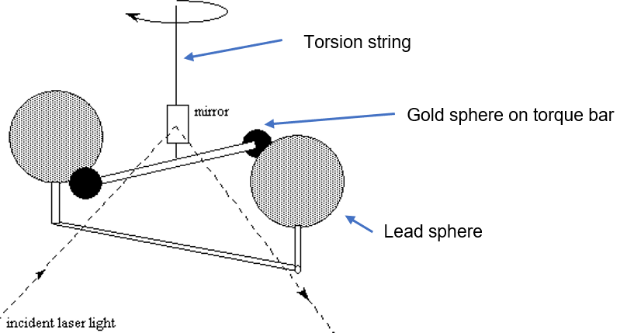
Image credit: sciencedemonstrations.fas.harvard.edu/presentations/cavendish-experiment
A scientist named Boys devised a method for finding the universal gravitational constant (G) by measuring the attractive force between two gold spheres and two lead spheres.
Two gold spheres of mass 500g were suspended on the end of a torque bar attached to a mirror. When two 10 kg lead spheres were brought near to the gold spheres, the force of attraction between the masses was determined from the angular deflection of the torque bar. A beam of light reflecting from the mirror onto a glass scale gave a value of the torque.
In one set-up lead spheres of radius 6.00 cm and gold spheres of radius 1.80 cm were used. Each lead sphere was positioned such that its edge was exactly 1 mm away from the edge of a gold sphere. A force of attraction of 5.00 x 10⁻⁸ N was recorded between each lead and gold sphere.
- Which of the following shows the correct value of G, based on the experiment described above?
  - 6.09 x 10⁻¹¹ Nm²kg⁻²
  - 6.24 x 10⁻¹¹ Nm²kg⁻²
  - 6.52 x 10⁻¹¹ Nm²kg⁻²
  - 6.63 x 10⁻¹¹ Nm²kg⁻²
- About 60 years after the death of Sir Isaac Newton, the value for G, described by Newton’s law of universal gravitational, was determined experimentally by Henry Cavendish. Cavendish used two masses, 1 kg and 100 kg, separated by a distance of 10 cm to produce a twisting force of $1×{10}^{-6} N$. Calculate this value for G. 2
- For the law of universal gravitation, where both masses (m and M) are constant, complete the two graphs below showing the relationship between each quantity. 2
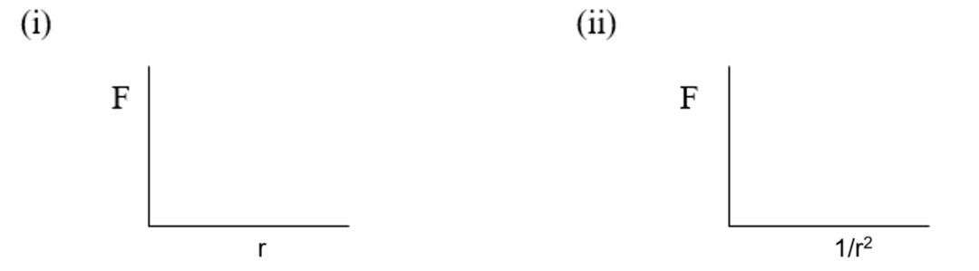

Marking guidelines
(a)
The correct answer is B
(b)
Criteria | Marks
- provides relevant data and calculations  - determines value of G correctly | 2
- provides some relevant information | 1
Sample answer
$$F=\frac{GMm}{r^{2}}$$
$$G= \frac{Fr^{2}}{Mm}$$
$$G={10}^{-10} N m^{2} {kg}^{-2}$$
(c)
Criteria | Marks
- sketches both graphs correctly | 2
- sketches one graph correctly | 1
Sample answer
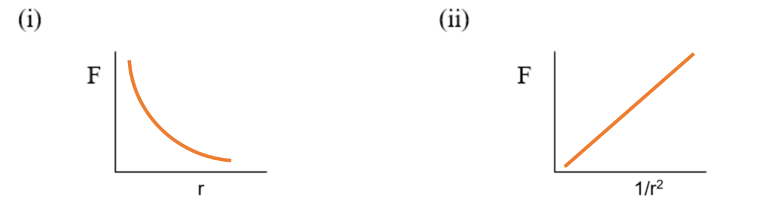

Question 9 (9 Marks)
A student collected the following freefall data by videoing an object as it falls from a variety of heights and using computer software to analyse the motion of the object.
Vertical displacement, Δy (m) | Time of release, t_{i} (s) | Time of impact, t_{f} (s)
0.10 | 1.60 | 1.80
0.25 | 2.87 | 3.10
0.40 | 0.52 | 0.82
0.55 | 1.78 | 2.09
0.70 | 3.20 | 3.60
0.85 | 3.51 | 3.94
1.00 | 1.27 | 1.72
1.15 | 0.60 | 1.10
1.30 | 5.20 | 5.73
1.45 | 0.82 | 1.38
1.60 | 1.60 | 2.17
- Construct a linear graph that can be used to determine the acceleration due to gravity from the slope. 4
- Use the graph to estimate the acceleration due to gravity. 2
- Assess the accuracy of the result. 1
- Identify TWO sources of error and state how the reliability could be improved. 2

Marking guidelines
(a)
Criteria | Mark
- constructed an appropriate linear graph  - the graph is accurately plotted and well labelled | 4
- constructs an accurately plotted and well-labelled graph that is not linear  OR  - constructs a poorly labelled linear graph | 3
- constructs a non-linear graph that is inappropriately constructed or labelled | 2
- provides a limited analysis of the data provided | 1
Sample answer
Graph of data from the freefall investigation
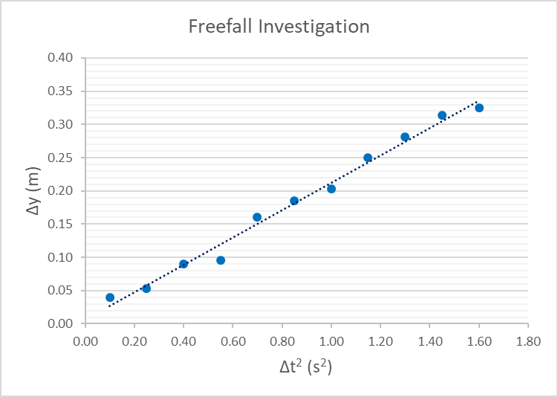
(b)
Criteria | Mark
- correctly calculates g from the slope and states with the correct units | 2
- uses data from the table to calculate g  OR  - provides correct working for slope  OR  - calculates slope from a tangent to a nonlinear graph | 1
Sample answer
$$gradient=\frac{rise}{run}=4.8 ms^{-2}$$ | from graph
$$s=ut+\frac{1}{2}at^{2}$$ | where $u=0$
$$a=2\frac{s}{t^{2}}$$ | rearranging
$$a=\left(2\right)\left(4.8\right)=9.6 ms^{-2}$$ | substitute $gradient=\frac{s}{t^{2}}$
(c)
Criteria | Mark
- assesses the accuracy of the calculated value by comparing it with the accepted value of 9.8m/s² | 1
Sample answer
The experiment is reasonably accurate with a relative error of only 2% from the expected 9.8 ms⁻².
(d)
Criteria | Mark
- provides TWO sources of error and states how reliability could be improved | 2
- identifies TWO sources of error  OR  - states how reliability could be improved | 1
Sample answer
Parallax error in height measurement
Random error in measurement of freefall time
Reliability could be improved by repeating the experiment more times/having multiple trials

Module 6 – electromagnetism

Question 10 (6 marks)
A group of students completed an investigation to demonstrate the motor effect in which a current-carrying conductor was placed in a uniform magnetic field directed into the page. A diagram of their experimental setup and results are shown below.
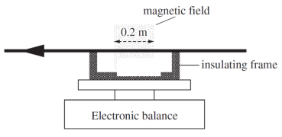
Image credit: NESA
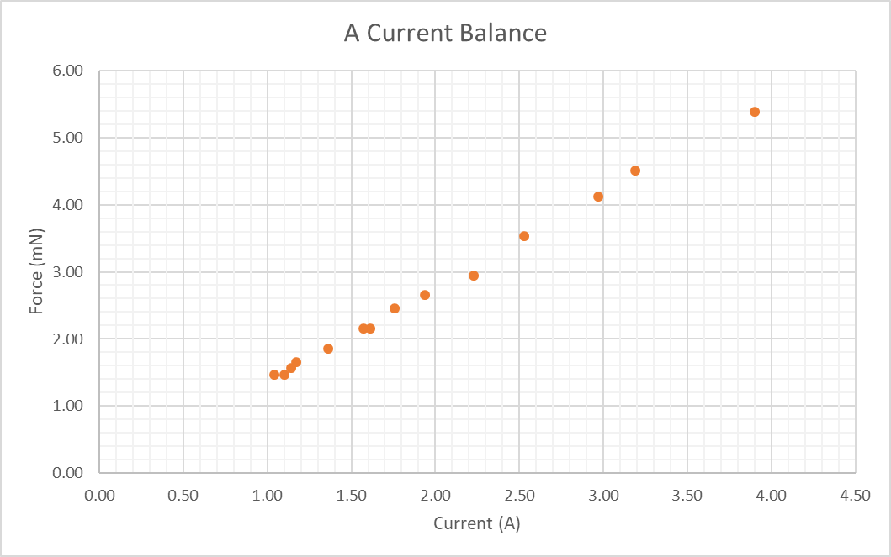
- Outline how students may have collected and processed their data to produce the above graph. 3
- Using the data provided, predict the strength of the magnetic field. 3

Marking guidelines
(a)
Criteria | Mark
- describes a suitable procedure for the collection and processing of data | 3
- outlines some relevant steps | 2
- provides some relevant information | 1
Sample answer
After setting up the apparatus, students could have:
Zeroed the scale.
Applied a DC voltage source to drive a 1 A current through the wire and recorded the mass, m (in kg) displayed on the digital scale.
Repeated the above measurement for a variety of currents up to 4 A.
The force, F, produced for each current was determined using $F=mg$, where $g=9.8 ms^{-2}$
The forces were then plotted against current to produce the scatterplot.
(b)
Criteria | Mark
- applies an appropriate method to determine the strength of the magnetic field  - provides relevant data and calculations | 3
- applies an appropriate method to determine the strength of the magnetic field  - provides some relevant data and/or calculations | 2
- provides some relevant information | 1
Sample answer
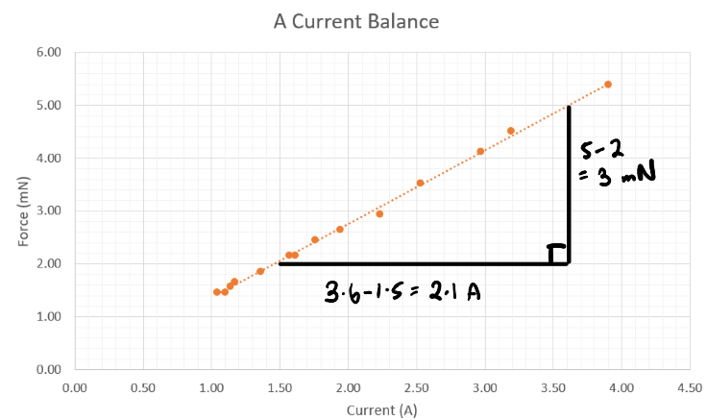
$$gradient=\frac{rise}{run}=\frac{{3×10}^{-3}}{2.1}={1.429×10}^{-3}$$ | from graph
$$F=lIBsinθ$$ | rearranging
$$\frac{F}{I}=lBsinθ$$ | substitute $gradient=\frac{F}{I}, l=0.2 m,θ={90}^{o}$
$${1.429×10}^{-3}=0.2B$$ | rearranging
$$B=7.1 mT$$

Question 11 (6 marks)
An electron and a proton are released from rest at a point mid-way between two parallel charged plates. The charges are allowed to move a distance of 5.0 mm.
The potential difference between the plates is 100 V, and the plate separation is 10 mm.
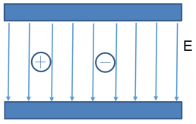
- Is the magnitude of the force on the electron greater than the force on the proton? Use working to justify your response. 3
- Is the acceleration of the electron greater than the acceleration of the proton? Use working to justify your response. 3

Marking guidelines
(a)
Criteria | Marks
- states that the forces are equal in magnitude  - justifies this equality in terms of the factors affecting the force of charged particles in electric fields  - uses working to support the response | 3
- clearly states that force on the electron is equal to the force on the proton  - attempts to use working to justify that the force is equal | 2
- states that the force is equal | 1
Sample answer
The force on the electron is equal to the force on the proton. This is due to the charges moving in a uniform electric field and both particles having the same amount of charge (1.602 x 10⁻¹⁹ C).
The force on a charge between two plates (F) is equal to the charge multiplied by the electric field strength (E).
$$F = qE$$
For our question, we need to find the electric field strength (E), which is equal to the potential difference between the plates (V) divided by the distance of the plates (d).
$E=\frac{V}{d}= \frac{100}{0.01}=10 000 V/m$ = 1.0 x 10⁴ V/m
Force on a proton | Force on an electron
F = q E = (+1.602 X 10⁻¹⁹) x (1.0 x 10⁴)  = +1.602 x 10⁻¹⁵ N | F = q E = (-1.602 X 10⁻¹⁹) x (1.0 x 10⁴)  = -1.602 x 10⁻¹⁵ N
Thus, the actual force of 1.602 x 10⁻¹⁵ N is the same.
(b)
Criteria | Marks
- clearly states that the acceleration of an electron is much greater than that of a proton  AND  - this is due to the mass of a proton being much greater than that of an electron  - uses working to support the response | 3
- clearly states that the acceleration of an electron is much greater than that of a proton  - attempts to use working to support the response | 2
- states that the acceleration of an electron is much greater than that of a proton | 1
Sample answer
The acceleration of an electron is greater than that of a proton. This is due to the mass of the proton being approximately 2000 times greater than that of an electron. The relation between force, mass and acceleration is:
$a=\frac{F}{m}$ Thus, there is an inverse relationship between mass and acceleration. As the mass increases, the acceleration decreases and vice versa.
Acceleration of proton | Acceleration of electron
$$a=\frac{F}{m}=\frac{(1.602 x {10}^{-15})}{(1.67 x {10}^{-27})}= 9.59 x {10}^{11} ms^{-2}$$ | $$a=\frac{F}{m}=\frac{(1.602 x {10}^{-15})}{(9.11 x {10}^{-31})}= 1.76 x {10}^{15} ms^{-2}$$
$\frac{mass proton}{mass electron}= \frac{1.67 x {10}^{-27}}{9.11 x {10}^{-31}}$ = 1833.15

Question 12 (3 marks)
Two parallel wires, 1.0 m in length each, have current of 12 A flowing through them in the same direction. Calculate the force acting between them when they are 20 cm apart.

Marking Guidelines
Criteria | Marks
- accurately calculates the force indicating that the wires are repelling each other | 3
- correctly substitutes data provided into a suitable equation  AND  - attempts to calculate the force | 2
- identifies the components of the $\left.\frac{F}{l}=\frac{μ_{0}}{2π}\frac{I_{1}I_{2}}{r}\right.$ from the data  OR  - attempts to calculate the force | 1
Sample answer
$$\left.\frac{F}{l}=\frac{μ_{0}}{2π}\frac{I_{1}I_{2}}{r}\right.$$ | rearranging
$$\left.F=\frac{μ_{0}}{2π}\frac{I_{1}I_{2}}{r}\right.l$$ | substitute $I_{1}=I_{2}=12 A, \frac{μ_{0}}{2π}=k=2.0×{10}^{-7}$  $$r=0.20 m, l=1.0 m$$
$$\left.F=\left(2.0×{10}^{-7}\right)\frac{\left(12\right)\left(12\right)}{0.20}\right.(1.0 )$$
$$\left.F=\right.1.44×{10}^{-4}N$$
The force acting between the wires is 1.44 x 10⁻⁴ N. Due to the current travelling in the same direction, the wires are attracting one other.

Question 13 (9 marks)
If a simple DC electric motor is prevented from rotating, it may be destroyed. Explain the normal operation of a motor and why it may be destroyed if it is prevented from rotating.

Marking guidelines
Criteria | Marks
- explains extensively how a motor operates, explaining the function of its components  - explains how back-emf reduces current and links this to an increase in current in the coil | 8-9
- describes parts of the motor and explains how each component operates  - states that the current will increase and links to back-emf | 6-7
- describes components of the motor  - links a reduction of back-emf to the motor being destroyed | 4-5
- describes components of the motor  AND/OR  - identifies the concept of back-emf | 2-3
- identifies a component of a motor | 1
Sample answer
The stator magnets produce a magnetic field in which the rotor coil is positioned. Current flow in the rotor coil will produce a force due to the motor effect directed as per the right-hand push rule. This force on the wire will produce a torque on the coil, and the motor will start to spin. The split ring commutator will reverse the direction of the current every half a turn of the coil so that the torque on the coil will always act in the same direction.
As the coil rotates in the magnetic field, the magnetic flux through the coil will change. This changing magnetic flux will induce an emf in the coil that is directed in such a way that it opposes the changing magnetic flux due to the rotation of the coil.
This induced emf opposes the supply emf provided by the battery and is known as the back-emf. $ε_{net}=ε_{supply}-ε_{back}$As the motor speed increases, the back-emf will increase until the net emf, net current, and hence the torque, is just enough to keep the motor rotating with constant speed, the motor load and friction.
If the motor is then prevented from turning, there will be no change in magnetic flux through the rotor coil. Therefore, no back-emf will be induced, and the current from the power supply will be at a maximum. This maximum current will heat the wire in the coil and may melt the insulating coating on the wire, thereby shorting the coil and eventually melting the wire in the coil itself. Some motors will include a temperature sensor which will shut the motor down if the motor is prevented from rotating freely.

Question 14 (9 marks)
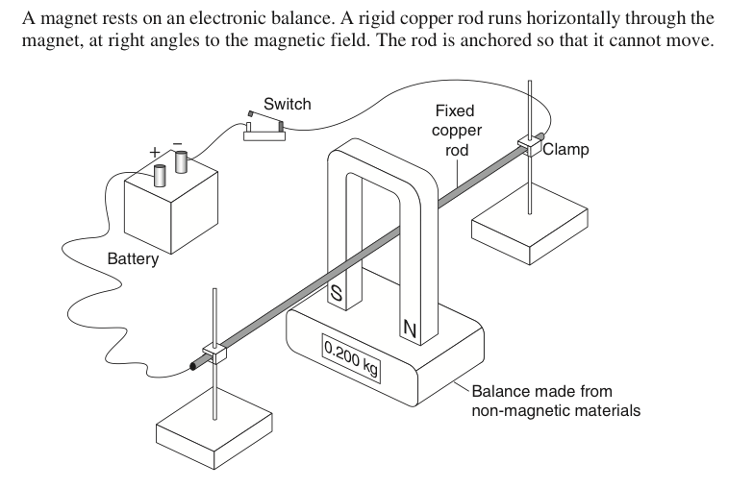
Image credit: NESA
- How should a rheostat and ammeter be connected in this circuit so that it could be used to determine the magnetic field strength of the magnet? 1
- Identify the independent and dependent variables for your investigation, along with one controlled variable. 3
- Describe how you would collect data to plot a graph with which to find B? You may assume that the length of the rod within the magnetic field is known. 3
- Describe how you would ensure your investigation is reliable and valid. 2

Marking Criteria
(a)
Criteria | Marks
- outlines how the devices should be connected | 1
Sample answer
An ammeter and a rheostat could be added in series with the rod, switch and battery.
(b)
Criteria | Marks
- correctly identifies all variables | 3
- correctly identifies TWO of the variables | 2
- correctly identifies ONE of the variables | 1
Sample answer
independent: current through the copper rod
dependent: change in mass or force on the scale
controlled: Length of rod in the magnetic field
(c)
Criteria | Marks
- describes collecting data of current and mass, calculating Force  - plotting F vs. I and calculating gradient to find $B=\frac{F}{I}\frac{1}{l}$ | 3
- collects current and mass, to calculate Force  - Wrong B formula | 2
- collects current and mass  - no force | 1
Sample answer
For a variety of different rod currents, I, record the change in mass observed on the scale.
Convert mass to force using $F=mg$, where $g=9.8 ms^{-2}.$
Plot F vs. I and draw a line of best fit. The gradient of the line can be used to determine B.
$$F=lIBsinθ$$ | where $θ=90, ∴sinθ=1$
$$F=lIB$$ | rearranging
$$\frac{F}{I}=lB=gradient$$ | assuming $l$ is known
$$B=\frac{gradient}{l}$$
(d)
Criteria | Marks
- describes measures to ensure the reliability AND validity of the investigation | 2
- describes measures to ensure the reliability OR validity of the investigation | 1
Taking a variety of measurements for a range of rod currents and plotting them on a scatter plot allows the effect of random errors to be minimised, thus improving reliability. This is done by drawing a line-of-best and using its gradient to determine B rather than relying on a single point.
Accurate measurements of variables including mass and current using appropriate technologies, such as a digital balance, and controlling the length of the rod in the magnetic field ensures that the calculation of B is valid.

Question 15 (8 marks)
A bar magnet was dropped through a solenoid, as shown in the diagram on the right.
Image credit: NESA
The positions of the falling bar magnet are:
(A) just before it enters the solenoid
(B) in the middle of the solenoid
(C) as it exits the solenoid
The relative size of the bar magnet to the solenoid are approximate, as shown in the diagrams. The magnet was an Alnico magnet.
- Sketch a graph of emf vs time as the magnet falls through the solenoid. On the graph, mark positions A, B, and C. 3
- Annotate your graph by explaining what is happening at each of these positions (A, B, and C). 3
- Predict the change in the graph – with regards to positions A, B, and C – if a stronger magnet was used. 2

Marking guidelines
(a)
Criteria | Marks
- draws set of labelled axes  - labels points A, B and C  - sketches the emf over time including the following features (A and C have opposite polarity, C has a larger magnitude than A, emf at B is zero) | 3
- provides a substantially correct graph | 2
- provides some basic features of the graph | 1
(b)
Criteria | Marks
- accounts for the key features of the induced emf at points A, B and C in terms of Faraday’s and/or Lenz’s law | 3
- relates the induced emf at ONE of the identified points to the rate of change in magnetic flux | 2
- provides some relevant information | 1
Sample answer
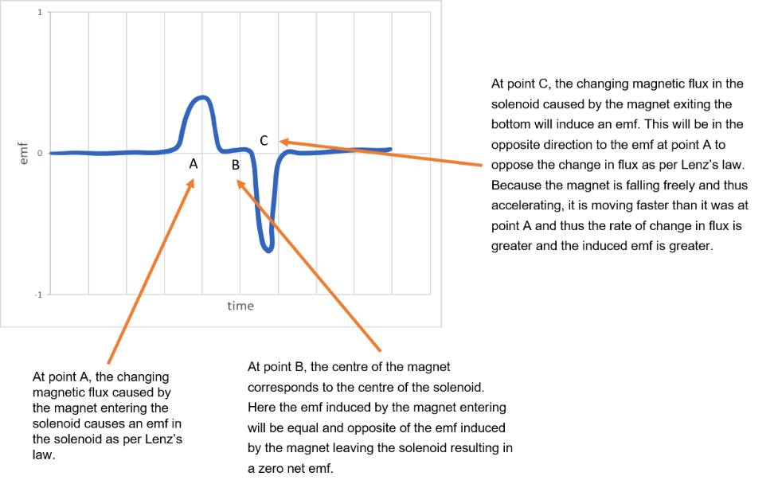
(c)
Criteria | Marks
- predicts an increase in the induced emf at points A and C  - predicts the induced emf at B to remain at zero | 2
- makes a prediction about induced emf | 1
Sample answer
If a stronger magnet were used, we would get a larger emf produced. Therefore, the peaks will be higher within the graph for points A, and C while the emf at B would remain unchanged.

Question 16 (5 marks)
Analyse the use of transformers in the distribution of energy using high voltage transmission lines.

Marking guidelines
Criteria | Marks
- demonstrates a quantitative understanding of how concepts of power and energy are applied to distribution networks  - shows a comprehensive understanding of the roles of transformers and the efficient and safe distribution of energy  - clearly relates the distribution of energy to step-up and step-down transformers | 5
- demonstrates a quantitative understanding of how concepts of power and energy are applied to distribution networks  - shows a sound understanding of the roles of transformers in the efficient distribution of energy | 4
- demonstrates a basic understanding of how power OR energy applies to distribution networks  - outlines the use of transformers in the distribution of energy | 2-3
- provides some relevant information | 1
Sample answer
Alternating current travels through high voltage power lines to move from the source (power station) all the way through to towns and houses. AC is used as it can be stepped-up and down to reduce line loss, and thus, travel more efficiently. Typical Australian domestic circuits use 240 V, but electrical energy must be transmitted for hundreds of kilometres due to power stations being situated far from households. For the power requirements of the network to be supplied at 240 V, the current would have to be extremely large. The long lengths of wire have significant resistance which would result in a large amount of energy being lost as heat due to resistance heating or ‘line loss’ due to the high currents (P_{loss}=I²R). Power stations generate electrical energy at voltages of around 20 kV. This is stepped-up via a transformer to 333 kV. In an ideal transformer, the power in = power out, or $V_{p}I_{p}=V_{s}I_{s}$. By stepping up the voltage, the current is reduced, and therefore, as per the earlier equation, the power lost to heat is reduced. Electrical energy is then transmitted to the consumer where sub-stations are used which contain step-down transformers that reduce the voltage from the lines to 240 V for domestic use. The distance between the substation and the home is less, as is the power requirement for each line, so the power loss is less significant. As shown in the diagram, this may happen progressively, with substations reducing voltage to 132 kV, and then smaller step-down transformers on power poles further reducing voltage.

Question 17 (8 marks)
A student carried out an investigation to measure the strength of a magnetic field. A single square coil of sides 3cm was placed in a magnetic field of unknown strength. A constant current of 3 A was passed through the coil. The torque produced was measured at various angles of θ. The results were recorded in the table as follows:
θ (°) | τ (Nm) x 10⁻³ | Sin θ
75 | 4.35 | 0.97
60 | 3.91 | 0.86
45 | 3.17 | 0.71
30 | 2.25 | 0.50
15 | 1.16 | 0.26
Select and plot data from the student’s investigation to produce a linear relationship and draw a line of best fit on the axes provided. 4
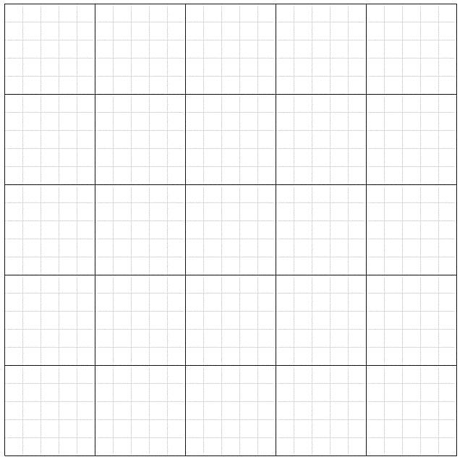
- Use your graph to determine the strength of the magnetic field. 4

Marking guidelines
(a)
Criteria | Mark
- selects appropriate data from the table  - uses appropriate scale  - labels axes correctly with units  - plots points accurately  - draws a line of best fit | 4
- selects appropriate data from the table  - Provides a substantially correct graph | 3
- Provides a substantially correct graph | 2
- Provides some basic features of the graph | 1
Sample answer
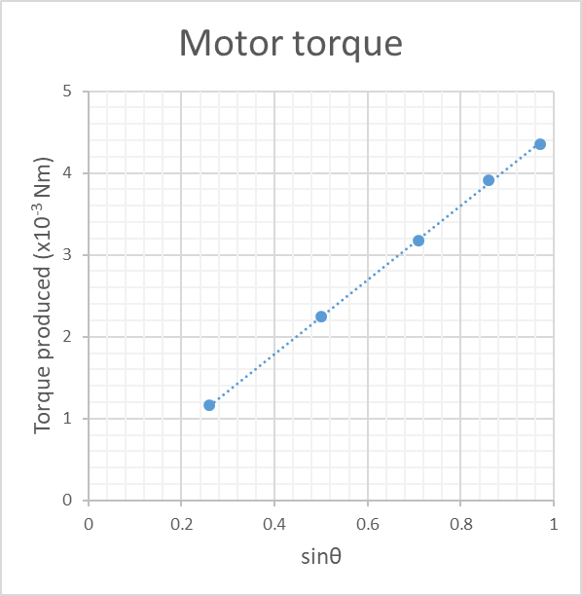
(b)
Criteria | Mark
- determines the gradient, relates it to the equation for torque and calculates the magnitude of the magnetic field | 3
- determines the gradient of the line of best fit  OR  - calculates the strength of the magnetic field from tabulated data point only | 2
- attempts to determine the magnetic field strength using the graph or data provided | 1
Sample answer
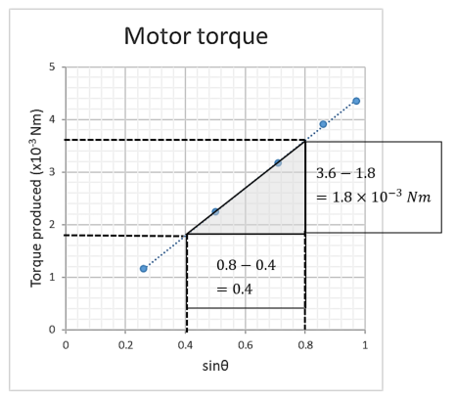
$$gradient=\frac{rise}{run}=\frac{τ}{sinθ}=\frac{1.8×{10}^{-3}}{0.4}$$  $$\frac{τ}{sinθ}=4.5×{10}^{-3} Nm$$ | (from the graph)
$$τ=NIABsinθ$$ | rearranging
$$\frac{τ}{sinθ}=NIAB=4.5×{10}^{-3}$$ | substitute expression for the gradient
$$B=\frac{4.5×{10}^{-3}}{NIA}$$ | where $A=0.03×0.03=9×{10}^{-4}m^{2}$  $$I=3A, N=1$$
$$B=\frac{4.5×{10}^{-3}}{1×3×9×{10}^{-4}}=1.7 T$$

Module 7 – the nature of light

Question 18 (9 marks)
An investigation was performed to verify Malus’ Law. As part of this investigation, the following graph was produced.
Graph of results from the investigation into Malus’ Law
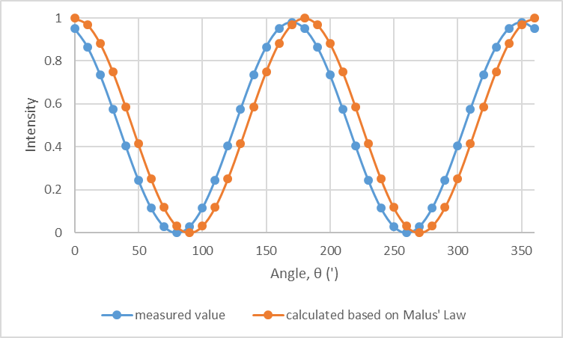
- Describe an investigation that you could perform to obtain data similar to that shown in the graph. 4
- Annotate the graph to show how the method above produces this light curve. 3
- Account for ONE difference between the two curves on the graph. 2

Marking guidelines
a)
Criteria | Marks
- describes a suitable procedure that includes measures to ensure reliability, validity and accuracy | 4
- outlines a mostly complete method that includes measures to ensure TWO of the following (reliability/validity/accuracy) | 3
- outlines some relevant steps | 2
- provides some relevant information | 1
Sample answer
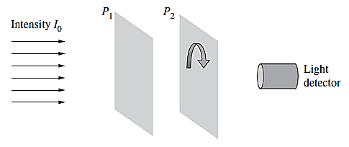
Image credit: NESA
setup an unpolarised light source, two linear polarising sheets, P₁ and P₂ and a light detector as shown in the diagram above
rotate P₂ until the position at which the maximum light intensity is observed, record this value and label the orientation as 0º
use a protractor to mark out angles every 10º from 0-360
Rotate P₂ in 10º intervals, recording the intensity at the sensor each time. Divide each value by the maximum light intensity to normalise the results (to give values between 0-1)
plot intensity vs angle and compare to the results predicted by Malus’ law
Note: complete the experiment in a darkened room, keep light source a fixed distance away and use a retort stand, boss head and clamp to hold P₁ in place.
b)
Criteria | Marks
- at least one maximum intensity AND one minimum intensity are labelled AND related to the relative orientation of filters | 3
- EITHER one maximum intensity OR one minimum intensity is labelled AND related to the angle of the filters  OR  - one maximum intensity AND one minimum intensity are labelled | 2
- either one maximum intensity OR one minimum intensity is labelled | 1
Sample answer
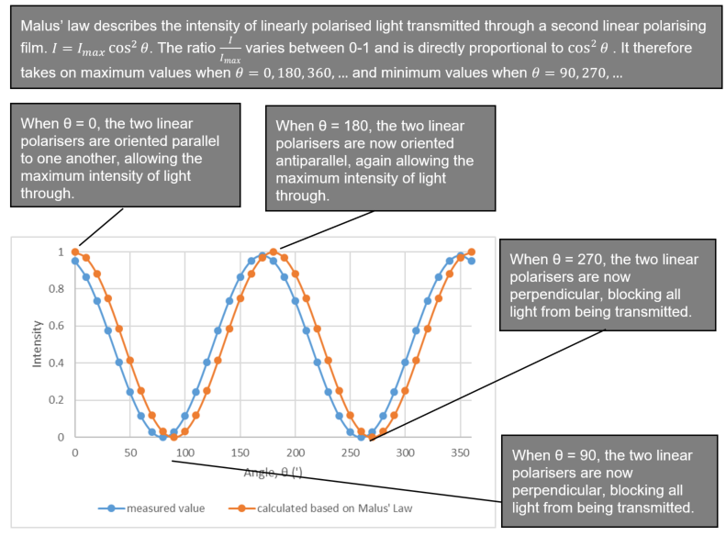
c)
Criteria | Marks
- outlines ONE difference between the curves AND gives a reason for the difference | 2
- identifies a difference between the two curves | 1
Sample answer
The two curves are very similar, except the measured values are offset by about 10 degrees from the predicted values, showing minimum intensities at 80 and 260 degrees rather than at 90 and 270. This could be the result of a systematic error in recording the angle of P₂, incorrectly setting the 0 degrees mark before recording data.

Question 19 (6 marks)
Below is a graph showing part of the blackbody radiation curve for an object with a surface temperature of 6000 K.
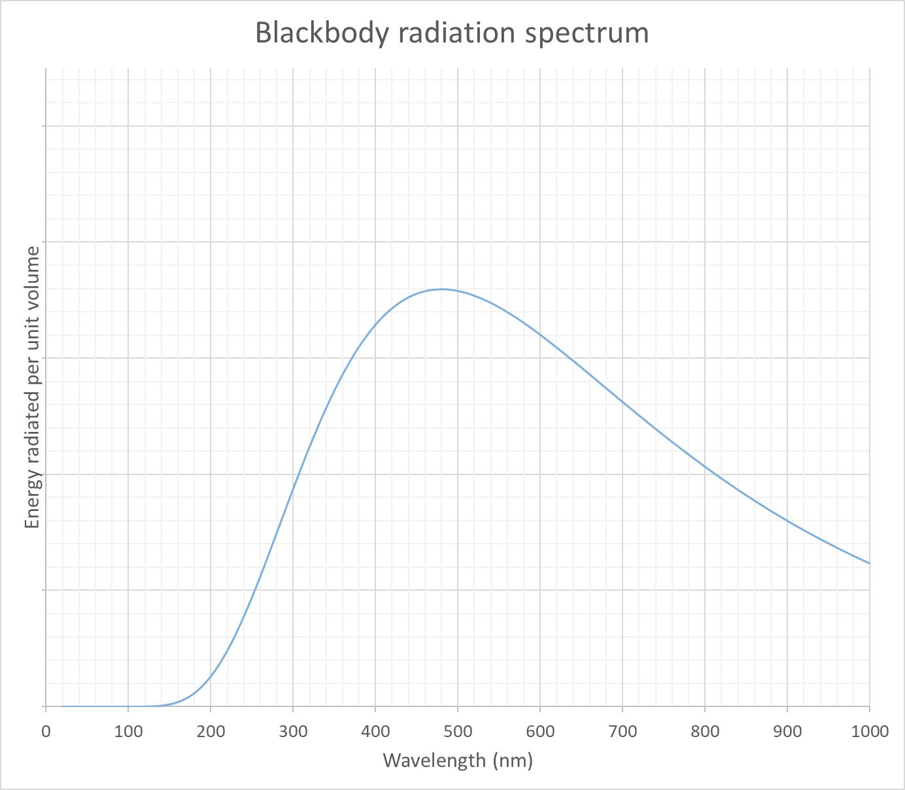
- Predict and sketch on the same set of axes the blackbody radiation curve for an object with a surface temperature of 5000 K. 1
- Qualitatively compare the blackbody spectrum produced by an object with a surface temperature of 6000 K to that produced by an object with a surface temperature of 5000 K. 2
- Account for any similarities and differences that would be observed in the spectrum of a star with the same effective temperature as that of the object shown in the graph. 3

Marking guidelines
(a)
Criteria | Mark
- sketches a spectrum with lower energy radiated at all points and with a longer peak wavelength | 1
Sample answer
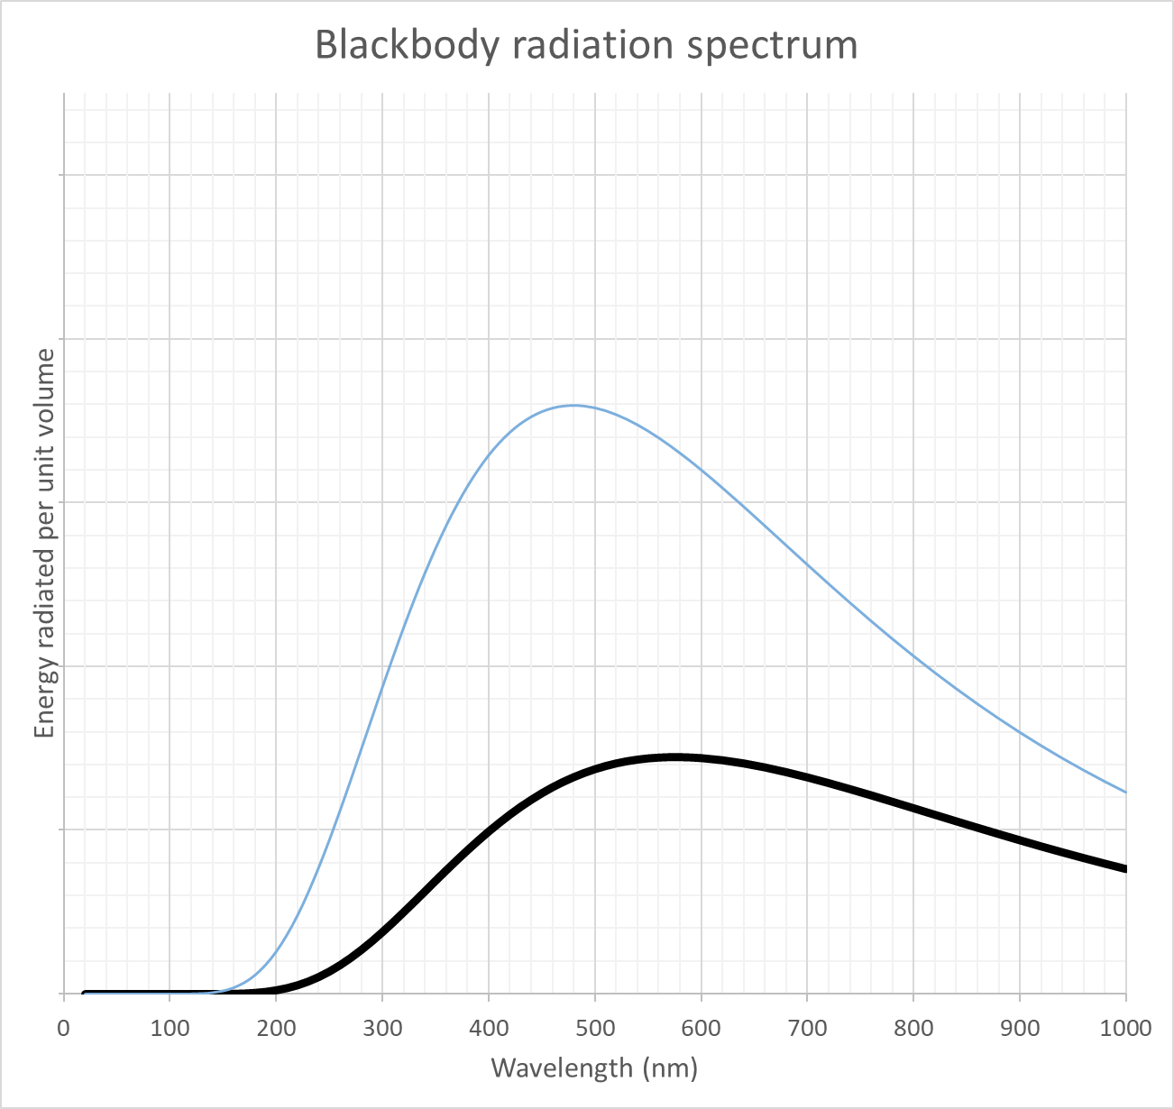
(b)
Criteria | Mark
- compares TWO features of the blackbody spectra | 2
- identifies ONE difference OR similarity between the blackbody spectra | 1
Sample answer
The spectrum produced by an object of 5000 K has essentially the same shape as that of an object at 6000 K. Differences include:
The wavelength at which the maximum intensity is emitted (peak wavelength) for a 5000 K object occurs at a longer wavelength.
Less energy is emitted per unit volume at all wavelengths for the cooler object.
(c)
Criteria | Mark
- demonstrates a sound understanding of absorption spectra and how they relate to blackbody spectra  - accounts for the production of absorption lines in stellar spectra  - identifies a similarity AND a difference between the two spectra | 3
- describes the features of an absorption spectrum  - identifies a similarity OR a difference between the two spectra | 2
- identifies a feature of an absorption spectrum  OR  - identifies a similarity OR a difference between the two spectra | 1
Sample answer
Stellar spectra consist of two components:
a continuous blackbody spectrum produced by the dense photosphere of the star that corresponds with the effective or surface temperature of the star, and superimposed on this,
a series of absorption lines of lower intensity caused by the absorption of specific wavelengths of radiation by the gases in the star’s atmosphere
The two spectra would have a similar profile and the same peak wavelength as they have the same effective temperature. However, the stellar absorption spectra would not be smooth. Instead, a great number of wavelengths would show a lower intensity than the corresponding blackbody curve.
Other answers may include:
An effective, annotate diagram highlighting similarities and differences between the spectra.

Question 20 (6 marks)
The following graph shows the results of an investigation to verify Wien’s Law relating to blackbody radiation emitted from objects heated to different temperatures.
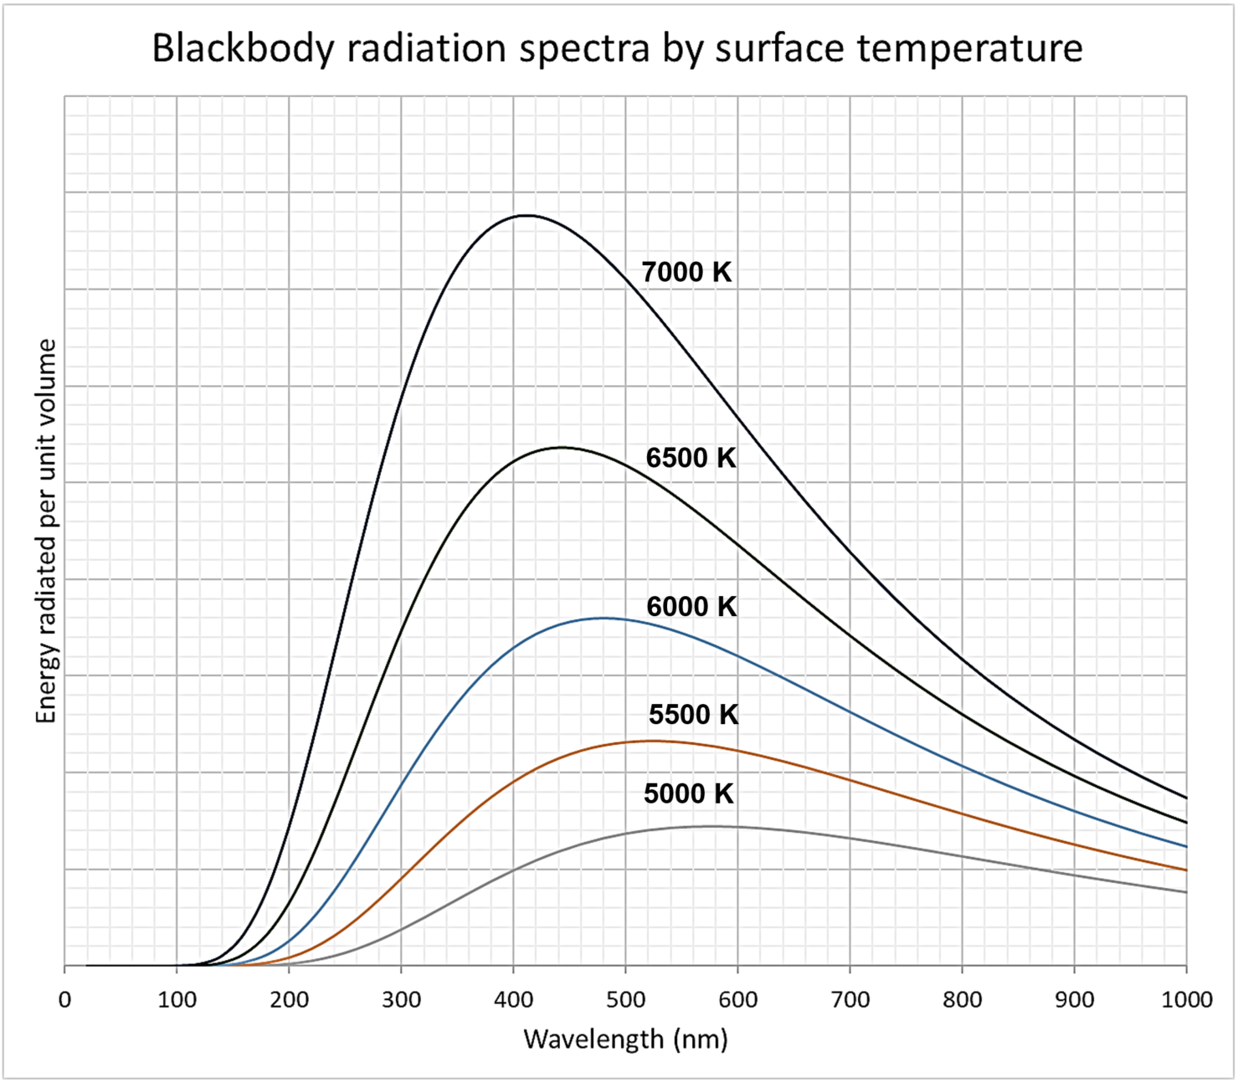
Plot the peak wavelength, λmax, vs $\frac{1}{T}$ on the grid provided below. Include a line-of-best-fit and show all working. 3
Use the gradient of your line-of-best fit to determine a value for Wien’s displacement constant, b. 3

Marking guidelines
(a)
Criteria | Mark
- correctly plots λ_{max}, vs $\frac{1}{T}$ for each effective temperature provided  - includes a line-of-best-fit | 3
- plots λ_{max}, vs $\frac{1}{T}$ for each effective temperature provided with one error  - includes a line-of-best-fit  OR  - correctly plots λ_{max}, vs $T$ for each effective temperature provided | 2
- demonstrates an attempt to extract λ_{max} from the graph provided | 1
Sample answer
Surface temperature, T (K) | 1/T (K⁻¹) | Peak wavelength, λ_{max} (nm)
5500 | 0.00018182 | 550
5000 | 0.0002 | 600
4500 | 0.00022222 | 650
4000 | 0.00025 | 710
3500 | 0.00028571 | 800
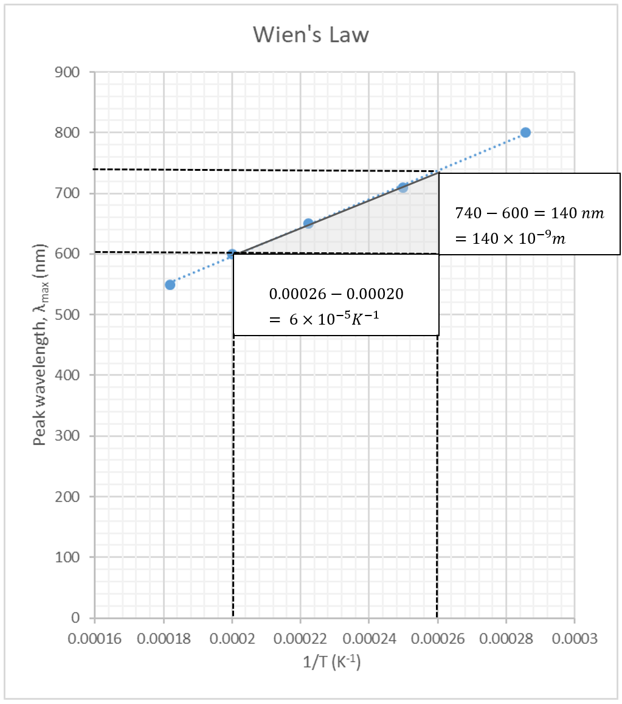
(b)
Criteria | Mark
- correctly calculates a value of b from the gradient of their line-of-best-fit | 3
- calculates a value of b from the gradient of the line-of-best-fit with one error  OR  - correctly calculates the gradient of their line-of-best-fit | 2
- attempts to calculate the gradient of their line-of-best-fit | 1
Sample answer
$$λ_{max}=\frac{b}{T}$$ | Wien’s Law
$$gradient=\frac{λ_{max}}{\frac{1}{T}}=λ_{max}T$$ | from the graph
$$λ_{max}T=b=gradient$$ | rearranging Wien’s law
$$b=gradient=\frac{140×{10}^{-9}}{6×{10}^{-5}}=2.3×{10}^{-3} mK$$

Question 21 (3 marks)
The following diagram shows the interference pattern produced when a monochromatic light source is passed through two narrow slits, S₁ and S₂. The lines P₁ and P₂ describe the path taken by light as it travels from their respective slits to the screen at the point shown.
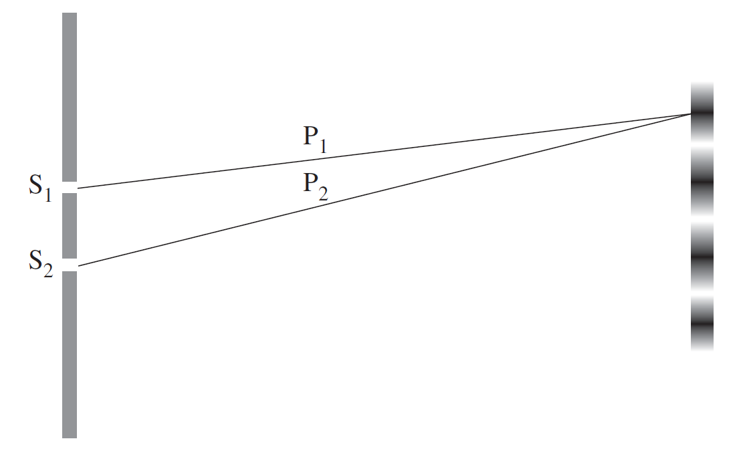NOT TO SCALE
Image credit: NESA
Account for any change in the interference pattern that would be produced if the frequency of the light waves were increased slightly.

Marking guidelines
Criteria | Mark
- describes the criteria for the formation of light and/or dark bands (maxima/minima)  - accounts for the reduced distance between adjacent bands in terms of the decreased wavelength of light used | 3
- demonstrates a sound understanding of the relationship between the wavelength of light used and the spacing of light and dark bands  OR  - correctly describes a change in the interference pattern produced | 2
- demonstrates a basic understanding of the relationship between the wavelength of light used and the spacing of light and dark bands  OR  - correctly identifies a change in the interference pattern produced | 1
Sample answer
The light and dark bands correspond to maxima and minima resulting from the interference of light travelling along paths P₁ and P₂. Bright spots (maxima) are produced at points on the screen in which the path difference between P₁ and P₂ is equal to an integer multiple of the wavelength, making the two beams in phase and resulting in constructive interference. The distance between successive maxima is directly proportional to the wavelength of light used as described by the following equation, $dsinθ=mλ$, where $m=0, 1, 2, …$. Therefore, as the frequency is increased, the wavelength decreases and so too does the spacing between successive light bands or maxima.

Question 22 (6 marks)
In your studies in Physics, you investigated historical and contemporary methods used to determine the speed of light. Outline TWO of the methods that you investigated, and compare how each method minimised error and uncertainty to improve the accuracy of their measurement of the speed of light.

Marking guidelines
Criteria | Mark
- describes TWO methods used to determine the speed of light  - demonstrates a thorough understanding of error, uncertainty and accuracy in first-hand investigations  - relates features of each method to the improved accuracy of the measurement of the speed of light | 6
- describes TWO methods used to determine the speed of light  - demonstrates an understanding of TWO of the following: error, uncertainty and accuracy, in first-hand investigations  - relates features of each method to the improved accuracy of the measurement of the speed of light | 5
- outlines a method used to determine the speed of light  - demonstrates a sound understanding of at least ONE of the following: error, uncertainty and accuracy, in first-hand investigations  - relates a feature of one of the methods to the improved accuracy of the measurement of the speed of light | 3-4
- outlines a method used to determine the speed of light  OR  - demonstrates a sound understanding of error, uncertainty OR accuracy in first-hand investigations | 2
- provides a general description of how the speed of light could be measured  OR  - identifies a basic understanding of error, uncertainty OR accuracy | 1
Sample answer
Errors and uncertainty can limit the accuracy of measurements made in first-hand investigations. The magnitude of the quantities to be measured, coupled with the technologies used to measure them will affect the accuracy of the results obtained in an investigation.
Methods used to measure the speed of light generally involve either:
the simultaneous measurements of distance and time to calculate the speed as $speed=\frac{distance}{time}$, or
using wave properties of light to create standing waves, requiring measurements of distance (wavelength) and frequency to calculate speed using the wave equation ($v=fλ)$
When attempting to measure the speed of light, accuracy can be judged by the extent to which the measured value for the speed of light agrees with its true value ($c=3×{10}^{8} ms^{-1}$).
Method 1 – 1840’s - Fizeau and a rotating cog
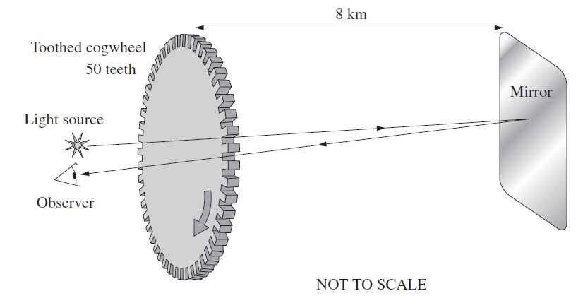
Image credit: NESA
In his experiment, intense light was shone at a mirror 8 km away. The light beam was broken up by a rotating cog, as shown above. The speed of rotation was adjusted until the reflected light been could no longer be seen returning through the gaps between the teeth of the cogs. At this point, the cog will have rotated through exactly the angle required for a tooth to block the part of the returning light in the time it took to travel the 16 km round trip to the mirror and back.
The rotating cog is the technology used to make precise measurements of time with relatively low uncertainty. Placing the mirror 8 km away increases the time the light takes to travel. Together, this reduces the relative error in the time measurement and supports a reasonably accurate measurement of the speed of light. He measured$c≈3.13×{10}^{8} ms^{-1}$, which is within 5% of its true value.
Method 2 – 1894 – Hertz and the speed of radio waves using standing waves
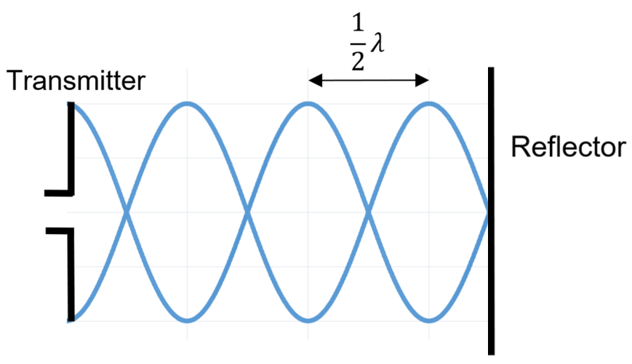
Hertz measured the speed of radio waves (predicted by Maxwell as part of the EM spectrum that includes light and travels at speed, c, in a vacuum). He created a standing wave by reflecting radio waves back towards the transmitter, as shown in the diagram. The distance between adjacent anti-nodes was measured using a ring with a small gap across which a spark would jump. This distance was equal to ½ the wavelength. The frequency of waves could not be directly measured and was instead calculated from the transmitter circuit details. By applying the wave equation, the velocity could then be determined.
The static nature of the node-antinode pattern removed the need to make measurements at short time intervals, which plagued earlier efforts. Random errors in distance measurements for determining the wavelength could be minimised by recording the distance between a larger number of successive anti-nodes and dividing the result accordingly. His measurement for the speed of radio waves (and therefore light) was highly accurate and supported Maxwell’s earlier predictions.
Answers could also include:
Galileo’s shuttered lanterns, Roemer’s eclipse patterns, Focult’s rotating mirror, Michelson’s octagonal mirror, Michelson-Morley interferometer.

Module 8 – from the Universe to the atom

Question 23 (4 marks)
Applying the law of conservation of energy, account for the line emission spectrum of hydrogen.

Marking Guidelines
Criteria | Mark
- demonstrates a sound understanding of how conservation of energy applies to the production of emission spectra  - relates quantisation of energy in the hydrogen atom to the production of a line emission spectrum | 4
- relates quantisation of energy in the hydrogen atom to the production of a line emission spectrum | 3
- describes the quantisation of energy in the hydrogen atom  OR  - demonstrates a basic knowledge of how conservation of energy applies to the production of line emission spectra | 2
- provides some relevant information | 1
Sample answer
The law of conservation of energy states that energy cannot be created or destroyed. Instead, it is transferred or transformed. In Bohr’s model of the hydrogen atom, radiation is emitted or absorbed only when electrons transition between specific energy levels or stationary states. This quantisation of energy states creates a complex but finite number of possible energy transitions.
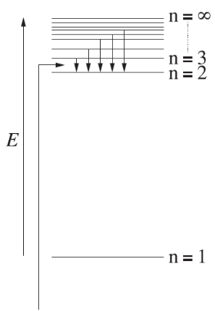
Image credit: NESA
For conservation of energy to be maintained when an electron moves from a higher to a lower energy state, the process must be accompanied by the emission of a photon with corresponding energy. Given that$E=hf$, this results in only a limited set of frequencies being produced, thus creating a line emission spectrum as opposed to a continuous spectrum.
Questions 24–26 refer to the information provided below.
Table 1 – Graph showing the decay of two radioactive samples over time
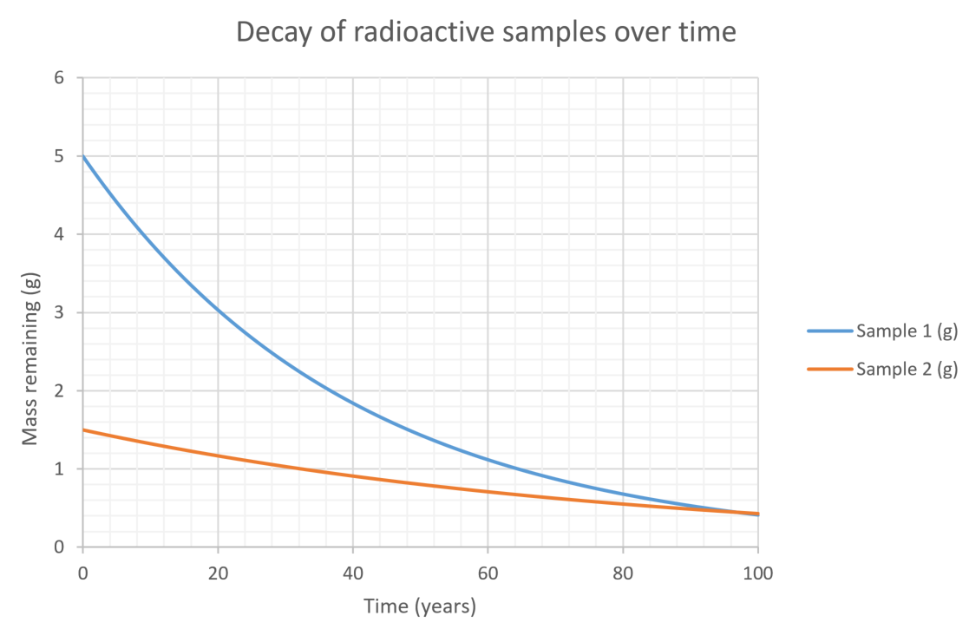

Question 24 Multiple Choice Question (1 mark)
What could be concluded from the information presented in the above graph?
- Sample 1 decays at twice the rate of sample 2.
- The decay constant of Sample 1 is higher than the decay constant of Sample 2.
- The decay constant of Sample 2 is twice that of the decay constant of Sample 1.
- Both Sample 1 and Sample 2 will continue to decay at the same rate after 100 years.

Question 25 Multiple Choice Question (1 mark)
Based on the information presented in the above graph, which of the following statements is correct?
- After 300 years, there will be more of Sample 2 remaining due to its lower decay constant.
- After 300 years, there will be more of Sample 1 remaining due to its lower decay constant.
- After 300 years, there will be more of Sample 2 remaining due to its shorter half-life.
- After 300 years, there will be more of Sample 1 remaining due to its shorter half-life.

Marking guidelines
Multiple-choice answer key
Question | Answer
5 | B
6 | A

Question 26 (3 marks)
Use the information in the above graph to describe the initial relative activity of the two samples.

Marking guidelines
Criteria | Mark
- compares the activity of the samples in terms of their half-lives and/or decay constants based on the information provided in the graph | 3
- provides a general comparison of the activity of the two samples that is consistent with the information provided in the graph | 2
- provides some relevant information | 1
Sample answer
The activity of a sample is proportional to its mass as well as its decay constant, with a more active sample having a higher decay constant, λ, and decaying faster. Mathematically,
$$N_{t}=N_{0}e^{-λt}$$
Where N_{t} is the amount of the sample remaining after a time, t.
Comparing the two samples using the above model
$$N_{t}=N_{0}e^{-λt}$$
$$\frac{N_{t}}{N_{0}}=e^{-λt}$$
$$\ln{\frac{N_{t}}{N_{0}}}=-λt$$
$$λ=-\frac{\left(\ln{\frac{N_{t}}{N_{0}}}\right)}{t}$$
Sample 1 | Sample 2
N₀ = 5 g, t = 100, N_{t} = 0.4 g  $$λ=-\frac{\left(\ln{\frac{0.4}{5}}\right)}{100}$$  $$λ=0.025$$ | N₀ = 2.5 g, t = 100, N_{t} = 0.4 g  $$λ=-\frac{\left(\ln{\frac{0.4}{2.5}}\right)}{100}$$  $$λ=0.018$$ | It can be seen from the graph that sample 1 is more active than sample 2. In addition to sample 1 being initially twice the mass of sample 2, from the data presented, the decay constant for sample 1 (0.025) is also significantly higher than that for sample 2 (0.018).

Question 27 (9 marks)
The image below shows a model of the atom.
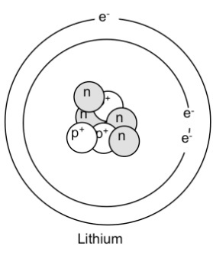
Image credit: ‘Bohr_Model_of_Lithium.jpg’ (CC0 1.0)
With reference to THREE of the following (J.J Thomson, Millikan, Rutherford and Chadwick), explain how their quantitative observations supported the development of this model.

Marking guidelines
Criteria | Marks
- shows a comprehensive understanding of the analysis of THREE quantitative observations about the model presented  - clearly relates the analysis to the development of this model | 9
- shows a sound understanding of the analysis of THREE quantitative observations about the model presented  - relates the analysis to the development of this model | 7-8
- outlines analyses of TWO quantitative observations  - links these to the development of the model | 5-6
- outlines some quantitative observations and/or shows some understanding of the model presented | 3-4
- provides some relevant information | 1-2
Sample answer
The model presented is the culmination of the work of several scientists, including Thomson, Rutherford and Chadwick.
Rutherford: The nuclear model of the atom. He fired alpha particles at gold foil and measured the angle of deflection. About 1 in 8000 of the particles were deflected at an angle greater than 90 degrees (essentially bouncing back). From this result, he determined that most of the mass of the atom was concentrated at the centre into a volume approximately 1/10000th the size of the atom, with the remaining volume of the atom being empty space. The above diagram has exaggerated the relative size of the nucleus to allow its components to be depicted.
Thomson: Discovered the electron. He investigated cathode rays using a modified vacuum tube with perpendicular electric and magnetic fields. He adjusted the E and B fields so that an electron would pass through undeflected. This allowed the velocity of the particles to be determined. By then switching off the E field and recording the radius of curvature of the beam he applied $F_{c}=\frac{mv^{2}}{r}$ and $F=qvBsinθ$ to determine the charge-to-mass ratio of the electron.
Millikan: used electric and gravitational fields to equal and opposite forces to determine the elementary electric charge of an electron. Once the charge was determined, this was applied to Thomson’s work to determine the mass of an electron which was lighter than any known nucleus. ($qE=mg$)
Chadwick: discovered the neutron. He bombarded beryllium with alpha particles. It was observed that this produced a mysterious radiation that was neutral and highly penetrating. When this radiation was directed at paraffin wax, protons were ejected. It was supposed that the mysterious radiation could have been gamma rays. However, analysis of the interaction using the laws of conservation of energy and momentum could not account for the observations unless the mysterious radiation had a mass similar to that of the proton. This led to the proposal of the neutron.

Mapping grid
Question | Marks | Content | Syllabus outcomes | Targeted performance bands
1(a) | 1 | Mod 5 Circular Motion | PH11/12-6, PH12-12 | 3-4
1(b) | 3 | Mod 5 Circular Motion | PH11/12-6, PH12-12 | 4-6
2 | 3 | Mod 5 Circular Motion | PH11/12-7, PH12-12 | 2-5
3 | 3 | Mod 5 Circular Motion | PH11/12-7, PH12-12 | 3-5
4 | 6 | Mod 5 Projection Motion  Mod 6 Charged Particles, Conductors and Electric and Magnetic Fields | PH11/12-7, PH12-12, PH12-13 | 3-6
5 | 6 | Mod 5 Projection Motion | PH11/12-4, PH11/12-5, PH11/12-6, PH12-12 | 2-6
6(a) | 3 | Mod 5 Motion in Gravitational fields | PH11/12-4, PH12-12 | 2-5
6(b) | 3 | Mod 5 Motion in Gravitational fields | PH11/12-4, PH12-12 | 2-4
6(c) | 2 | Mod 5 Motion in Gravitational fields | PH11/12-5, PH12-12 | 3-5
6(d) | 2 | Mod 5 Motion in Gravitational fields | PH11/12-6, PH12-12 | 4-6
6(ei) | 2 | Mod 5 Motion in Gravitational fields | PH11/12-4, PH12-12 | 3-5
6(eii) | 1 | Mod 5 Motion in Gravitational fields | PH11/12-4, PH12-12 | 2-3
6(eiii) | 2 | Mod 5 Motion in Gravitational fields | PH11/12-6, PH12-12 | 3-5
6(f) | 3 | Mod 5 Motion in Gravitational fields | PH11/12-5, PH11/12-7, PH12-12 | 4-6
7 | 6 | Mod 5 Projection Motion | PH11/12-2, PH12-12 | 2-6
8(a) | 1* | Mod 5 Motion in Gravitational Fields | PH11/12-4, PH11/12-6, PH12-12 | 5-6
8(b) | 2 | Mod 5 Motion in Gravitational Fields | PH11/12-4, PH11/12-6, PH12-12 | 4-6
8(c) | 2 | Mod 5 Motion in Gravitational Fields | PH11/12-6, PH11/12-7, PH12-12 | 3-5
9(a) | 4 | Mod 5 Projection Motion | PH12-4, PH12-12 | 3-6
9(b) | 2 | Mod 5 Projection Motion | PH12-5, PH12-6, PH12-12 | 3-5
9(c) | 1 | Mod 5 Projection Motion | PH12-5, PH12-12 | 2-3
9(d) | 2 | Mod 5 Projection Motion | PH12-2, PH12-5 PH12-12 | 3-5
10(a) | 3 | Mod 6 The motor effect | PH11/12-2, PH11/12-4, PH12-13 | 2-4
10(b) | 3 | Mod 6 The motor effect | PH11/12-5, PH11/12-6, PH12-13 | 4-6
11(a) | 3 | Mod 6 Charged Particles, Conductors and Electric and Magnetic Fields | PH11/12-6, PH12-13 | 2-4
11(b) | 3 | Mod 6 Charged Particles, Conductors and Electric and Magnetic Fields | PH11/12-6, PH12-13 | 2-4
12 | 3 | Mod 6 The motor effect | PH11/12-6, PH12-13 | 2-4
13 | 9 | Mod 6 Application of the motor effect | PH12-13 | 2-6
14(a) | 1 | Mod 6 The motor effect | PH11/12-2, PH12-13 | 5-6
14(b) | 3 | Mod 6 The motor effect | PH11/12-2, PH12-13 | 3-5
14(c) | 3 | Mod 6 The motor effect | PH11/12-4, PH12-13 | 3-5
14(d) | 2 | Mod 6 The motor effect | PH11/12-2, PH12-13 | 2-4
15(a) | 3 | Mod 6 Electromagnetic Induction | PH11/12-6, PH11/12-7, PH12-13 | 4-6
15(b) | 3 | Mod 6 Electromagnetic Induction | PH11/12-7, PH12-13 | 3-5
15(c) | 2 | Mod 6 Electromagnetic Induction | PH11/12-6, PH12-13 | 3-5
16 | 5 | Mod 6 Electromagnetic Induction | PH12-13 | 2-6
17(a) | 4 | Mod 6 Applications of the Motor Effect | PH12-4, PH12-5, PH12-13 | 2-5
17(b) | 4 | Mod 6 Applications of the Motor Effect | PH12-5, PH12-6, PH12-13 | 2-5
18(a) | 4 | Mod 7 Light: Wave Model | PH11/12-2, PH12-14 | 2-5
18(b) | 3 | Mod 7 Light: Wave Model | PH11/12-7, PH12-14 | 4-6
18(c) | 2 | Mod 7 Light: Wave Model | PH11/12-5, PH12-14 | 3-5
19(a) | 1 | Mod 7 Electromagnetic spectrum | PH11/12-7, PH12-14 | 2-3
19(b) | 2 | Mod 7 Electromagnetic spectrum | PH11/12-5, PH12-14 | 3-5
19(c) | 3 | Mod 7 Electromagnetic spectrum | PH11/12-6, PH12-14 | 3-6
20(a) | 3 | Mod 7 Light: Quantum Model | PH11/12-4, PH12-14 | 2-5
20(b) | 3 | Mod 7 Light: Quantum Model | PH12-5, PH12-6, PH12-14 | 3-6
21 | 3 | Mod 7 Light: Wave Model | PH11/12-6, PH12-14 | 2-5
22 | 6 | Mod 7 Light: Wave Model | PH12-5, PH12-6, PH12-14 | 2-6
23 | 4 | Mod 8 Quantum mechanical nature of the atom | PH11/12-7, PH12-15 | 3-5
24 | 1 | Mod 8 Properties of the Nucleus | PH11/12-5, PH12-15 | 4-5
25 | 1 | Mod 8 Properties of the Nucleus | PH11/12-5, PH12-15 | 3-4
26 | 3 | Mod 8 Properties of the Nucleus | PH11/12-5, PH12-15 | 4-6
27 | 9 | Mod 8 Structure of the Atom | PH11/12-7, PH12-15 | 2-6

References
This resource contains NSW Curriculum and syllabus content. The NSW Curriculum is developed by the NSW Education Standards Authority. This content is prepared by NESA for and on behalf of the Crown in right of the State of New South Wales. The material is protected by Crown copyright.
Please refer to the NESA Copyright Disclaimer for more information https://educationstandards.nsw.edu.au/wps/portal/nesa/mini-footer/copyright.
NESA holds the only official and up-to-date versions of the NSW Curriculum and syllabus documents. Please visit the NSW Education Standards Authority (NESA) website https://educationstandards.nsw.edu.au and the NSW Curriculum website https://curriculum.nsw.edu.au.
Physics Stage 6 Syllabus © NSW Education Standards Authority (NESA) for and on behalf of the Crown in right of the State of New South Wales, 2017.

© State of New South Wales (Department of Education), 2020
The copyright material published in this resource is subject to the Copyright Act 1968 (Cth) and is owned by the NSW Department of Education or, where indicated, by a party other than the NSW Department of Education (third-party material).
Copyright material available in this resource and owned by the NSW Department of Education is licensed under a Creative Commons Attribution 4.0 International (CC BY 4.0) license.

This license allows you to share and adapt the material for any purpose, even commercially
Attribution should be given to © State of New South Wales (Department of Education), 2020.
Material in this resource not available under a Creative Commons license:
the NSW Department of Education logo, other logos and trademark-protected material
material owned by a third party that has been reproduced with permission. You will need to obtain permission from the third party to reuse its material.
Links to third-party material and websites
Please note that the provided (reading/viewing material/list/links/texts) are a suggestion only and implies no endorsement, by the New South Wales Department of Education, of any author, publisher, or book title. School principals and teachers are best placed to assess the suitability of resources that would complement the curriculum and reflect the needs and interests of their students.
If you use the links provided in this document to access a third-party's website, you acknowledge that the terms of use, including licence terms set out on the third-party's website apply to the use which may be made of the materials on that third-party website or where permitted by the Copyright Act 1968 (Cth). The department accepts no responsibility for content on third-party websites.

