Investigating Science Module 1 – Cause and Effect – Observing

Contents
Teaching the Year 11 Modules 6
Course overview 6
Module summary 7
Big ideas 9
Nature and Practice of Science (also referred to as the process of science) 9
Observations 10
Questioning 10
Relationship to other modules 11
Unpacking the inquiry questions 13
IQ1-1 How does observation instigate scientific investigation? 13
IQ1-2 What are the benefits and drawbacks of qualitative and quantitative observations? 18
IQ1-3 How does primary data provide evidence for further investigation? 19
IQ1-4 How does the collection and presentation of primary data affect the outcome of a scientific investigation? 24
IQ1-5 How do conclusions drawn from the interpretation of primary data promote further scientific investigation? 24
Opportunities for extending concepts 27
IQ1-1 How does observation instigate scientific investigation? 27
IQ1-5 How do conclusions drawn from the interpretation of primary data promote further scientific investigation? 27
Misconceptions 29
Conceptual difficulties 30
Types of data 30
The control of variables 31
Suggested teaching strategies 33
IQ1-1 How does observation instigate scientific investigation? 33
IQ1-2 What are the benefits and drawbacks of qualitative and quantitative observations? 33
IQ1-3 How does primary data provide evidence for further investigation? 33
IQ1-4 How does the collection and presentation of primary data affect the outcome of a scientific investigation? 33
IQ1-5 How do conclusions drawn from the interpretation of primary data promote further scientific investigation? 34
Resources 35
Appendix 1 37
Relationships between modules 1-4 37
Appendix 2 38
Observations instigating inquiry 38
Appendix 3 41
Controlled variables 41
Introduction 41
Question 1 41
Question 2 42
Question 3 43
Question 4 44
Question 5 44
Question 6 45
Misconceptions 46
Appendix 4 48
Teaching resource – the Bernoulli effect 48
IQ1-1 – How does observation instigate scientific investigation? 48
Outcomes 48
Content 48
Context 48
Time estimate 49
Learning intentions 49
Success criteria 49
Task outline 49
Feedback 56
Appendix 5 56
Depth Study – history and observation 56
IQ1-1 How does observation instigate scientific investigation? 56
Outcomes 56
Content 56
Context 57
Time estimate 57
Learning intentions 57
Success criteria 57
Task outline 57
Feedback 59
Task resources 59
Appendix 6 61
Teaching resource – cell observations 61
IQ1-2 What are the benefits and drawbacks of qualitative and quantitative observations? 61
Outcomes 61
Content 61
Context 61
Time estimate 61
Learning intentions 62
Success criteria 62
Task outline 62
Feedback 63
Task resources 63
Appendix 7 64
Teaching resource – rock strata 64
IQ1-4 What are the benefits and drawbacks of qualitative and quantitative observations? 64
Outcomes 64
Content 64
Context 64
Time estimate 65
Learning intentions 65
Success criteria 65
Task outline 65
Feedback 67
Task resources 67
Appendix 8 68
Teaching resource – design an investigation 68
IQ3 How does primary data provide evidence for further investigation? 68
Outcomes 68
Content 68
Context 68
Time estimate 69
Learning intentions 69
Success criteria 69
Task outline 69
Feedback 70
Task resources 70
Appendix 9 71
Teaching resource – comparing the usefulness of observations from investigations 71
IQ1-3 How does the collection and presentation of primary data affect the outcomes of a scientific investigation? 71
Outcomes 71
Content 71
Context 71
Time estimate 71
Learning intentions 72
Success criteria 72
Task outline 72
Feedback 73
Task resources 73
References 74

Teaching the Year 11 Modules
The content and skills covered in the four modules of the Year 11 Investigating Science course lays the foundations for the Year 12 course. This course focuses on the Nature and Practice of Science. The relationship between Investigating Science and the Stage 4/5 science course is not explicit: there is little overlap in the content covered in these syllabuses. However, there are definite continuums in the working scientifically skills between the Stage 4/5 science and the Investigating Science courses. Those continuums can form the basis of instruction in this course.
While it is not focussed on any specific scientific discipline (for example, Biology, Chemistry and Physics), the Investigating Science syllabus enables students to apply the principles of the nature and practice of science to phenomena in those disciplines. In this course, students will explore concepts from various scientific fields. When teaching those concepts, teachers should emphasise their relevance to the inquiry questions.
The course has a high cognitive demand: by the end of the Year 11 and 12 courses, students should be able to demonstrate proficiency in scientific literacy, as well as reasoning and argumentation abilities. Teachers should provide Investigating Science students with opportunities for developing those skills.

Course overview
The Investigating Science syllabus explores the construction of scientific knowledge and the interplay between science, technology and society (Figure 1).
Figure 1 – Science, Technology and Society form the three focal points for the Investigating Science course. Those focal points are centred on Working Scientifically skills.
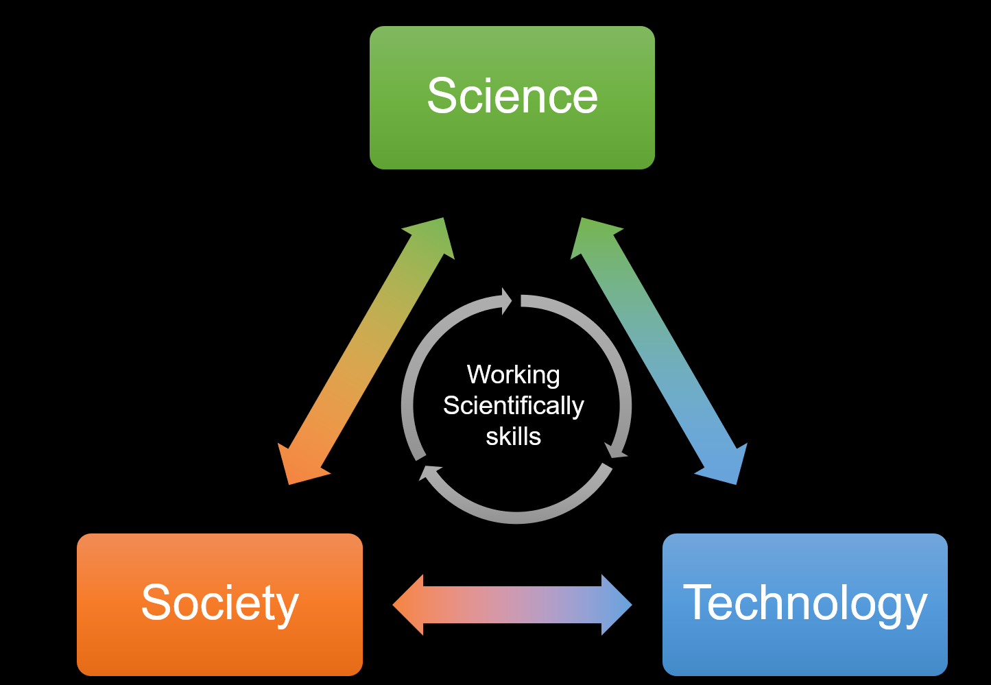
The Year 11 course examines the construction of scientific knowledge. Students will explore the role of observations and experimentation in generating information. Scientific knowledge is produced when meaning is ascribed to scientifically obtained information.
Scientists endeavour to develop explanations for natural phenomena. Such explanations relate cause and effect, thus uncovering the mechanisms that operate in the natural world. Students will explore the different forms of scientific knowledge, such as theories, laws and models). Each knowledge form serves a specific purpose in the scientific understanding of natural phenomena. Understanding the purpose and limits of scientific knowledge form deepens one’s scientific worldview.

Module summary
The inquiry questions in this module are:
- IQ1-1 How does observation instigate scientific investigation?
- IQ1-2 What are the benefits and drawbacks of qualitative and quantitative observations?
- IQ1-3 How does primary data provide evidence for further investigation?
- IQ1-4 How does the collection and presentation of primary data affect the outcome of a scientific investigation?
- IQ1-5 How do conclusions drawn from the interpretation of primary data promote further scientific investigation?
Observations play a central role in scientific inquiry. Observations are used in two ways – to initiate investigations and as evidence that support scientific ideas. Scientific observations are not casual: they must be accurate, reproducible, informative and free of bias.
In this module, students examine historical examples of observations that led to significant scientific discoveries. Those examples include cultural observational knowledge, such as those developed by Aboriginal communities. Then, students compare and contrast quantitative and qualitative observations, understanding the value and limitations of these observation types in the process. Scientific investigations provide opportunities for gathering and analysing quantitative and qualitative observations obtained in controlled settings. Therefore, students will design and conduct a first-hand investigation to collect data. In planning the investigation, students examine the role of variables. The correct manipulation and control of variables ensure the reliability and validity of the investigation.
The data that the students collect must be processed and analysed. Students will consider appropriate methods for representing their data. Proper data representation is a critical step for analysing the data and identifying patterns, trends, and relationships. The data may provide evidence to support existing ideas or highlight exceptions in contemporary scientific understanding. Finally, students learn to make sense and meaning of the data. To do this, students must contextualise their findings with those in the literature. While the data obtained in the investigation may answer the inquiry question, they will invariably spawn further questions. Students will reflect on how other related phenomena may be investigated on the back of the current one.

Big ideas

Nature and Practice of Science (also referred to as the process of science)
- Scientific literacy, or the ability to understand the process of science, is essential for developing scientific knowledge and understanding.
- Scientific inquiry is not a linear process. It is a complex and iterative process involving a sequence of question-answer loops (Figure 2).
Figure 2 – Left: A simplified view of the scientific process, showing the four domains and the complex links between them. Right: A detailed view of the four domains. One important idea shown in these diagrams is that the scientific process is not linear but iterative. © 2008 The University of California Museum of Palaeontology, Berkeley, and the University of California Regents. Larger readable images of these maps may be accessed from Understanding Science.
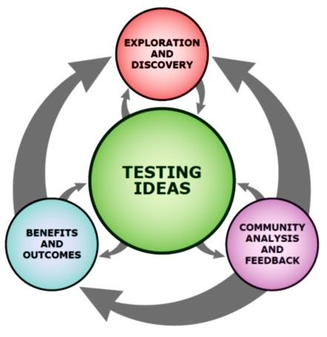 | 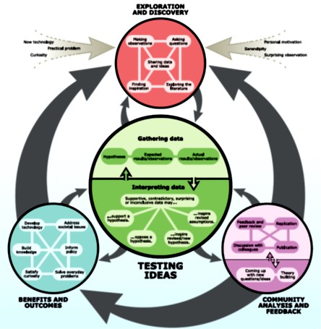
- Scientific inquiry focuses on finding the cause(s) of natural phenomena.
- Scientific knowledge is organised as theories and laws. They differ in the scope of explanations but not in the truth of their propositions.
- Scientific explanations, theories and models are those that best fit the evidence available at a particular time.
- Scientific knowledge is subject to change, as are all forms of knowledge.

Observations
- Investigations are conducted for different reasons, such as
- to explore new phenomena,
- to check on previous results,
- to test how well a theory predicts, and
- to compare theories.
- Observations initiate all scientific investigations.
- Observations also provide evidence to support or reject scientific ideas. When observations are used to test scientific ideas, they are called data. Data can be represented in different ways for visualisation and analysis.
- Observations, when interpreted, become inferences. Inferences can be used to form hypotheses for further inquiry.

Questioning
- The scientific enterprise is focused on finding answers to questions about natural phenomena. Such question stems from a natural curiosity of ourselves and the world in which we inhabit. Scientific explanations help us to construct meaning about our observations.
- The Nobel laureate, Peter Medawar, said that “Science is the art of the soluble”. Scientific questions are those that can be tested through inquiry and experimentation. They define the limits of science.

Relationship to other modules
The conceptual links between module 1 and the other modules of the course are shown in Figure 3. A detailed concept map of the Year 11 course is provided in Appendix 1.
Figure 3 – a map of the conceptual links between module 1 and modules 2–4. The arrows’ colours represent the destination modules, while the connections indicate the conceptual continuity or overlap.
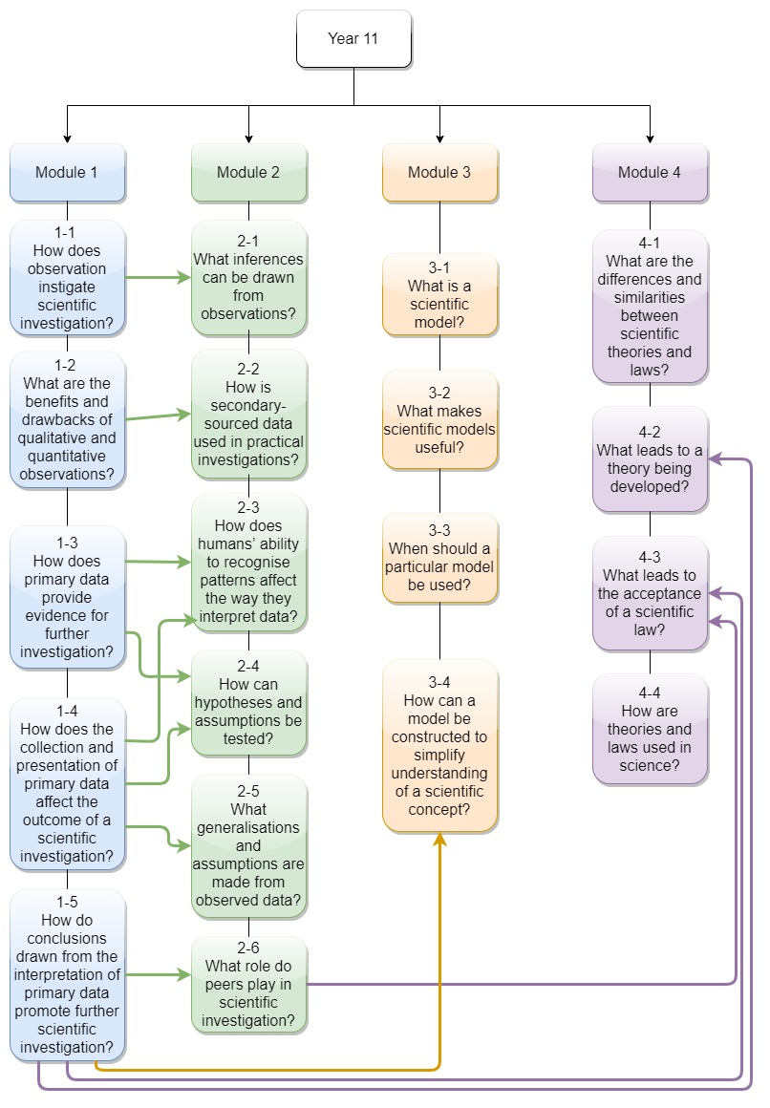
As shown in Figure 3, there are numerous continuums between the concepts described in modules 1 and 2. These may provide opportunities to ‘integrate’ their instruction. The concept map also highlights the holistic elements of the content in the Year 11 course.
Other links between the concepts in the four modules (not shown in Figure 3) are equally plausible. For example, scientific theories and laws, discussed in module 4, are also initiators of investigations. Theories and laws promote further questioning and the development of hypotheses, which are then investigated in controlled experiments. In this way, module 4 can be linked to the relevant inquiry questions in modules 1 and 2.

Unpacking the inquiry questions

IQ1-1 How does observation instigate scientific investigation?
- To observe something is to note, record, or attend to a result, occurrence, or phenomenon (note: read about possible misconceptions students may hold about ‘observations’).
- Observations are usually made with our senses. Such observations are referred to as direct observations. However, tools such as thermometers, microscopes, telescopes, radar, radiation sensors, or mass spectroscopes extend our observational powers’ range, limits, and precision. Observations that rely on the use of instruments are referred to as indirect observations.
- Observations produce quantitative or qualitative data (data: information from observations). These data, in turn, provide evidence that supports or refutes scientific theories and hypotheses.
- Quantitative and qualitative data can be further subdivided into various categories, as shown in Figure 4. Quantitative data (quantity = measure) is numerical, while qualitative data (quality = non-numerical; describes a feature or characteristic). The discussion in conceptual difficulties indicates some complexities when distinguishing quantitative data from qualitative data.
Figure 4 – a classification scheme for the various data types that are commonly used in science. This scheme can be used to obtain quantitative and qualitative data for the investigations suggested in the syllabus (IQ1-1).
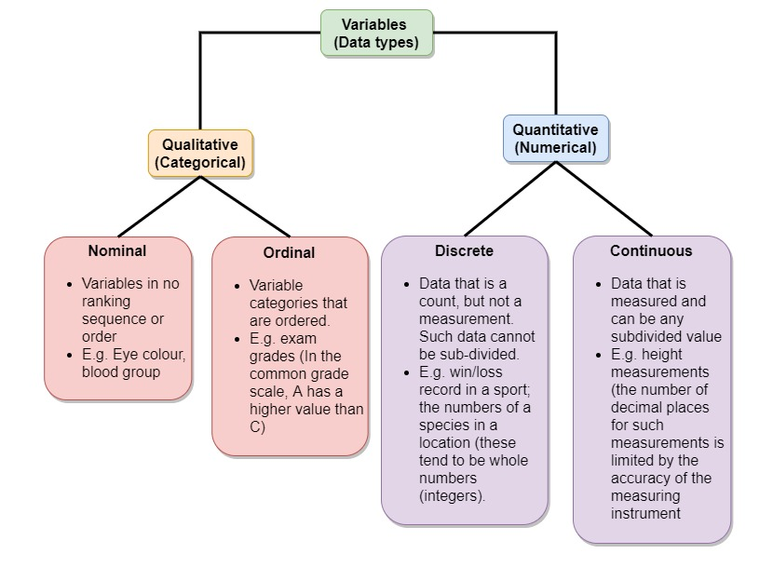
- Qualitative vs quantitative data: Table 1 compares these two data types’ properties in scientific investigations.
- Inferences are interpretations of observations. They refer to the conclusions drawn from observations through reasoning. Inferences, in turn, are tested through further inquiries and investigations (controlled experiments). One example of the relationship between observations and inferences is shown in Figure 5.
Figure 5 – figure showing the relationship between observations and inferences in Darwin’s Theory of Evolution. Darwin made four observation about biological variation, the inheritance of traits and the unequal survival of offspring. From those four observations, Darwin proposed two inferences. The inferences formed the basis of Evolutionary Theory. It took Darwin 20 years to go from inference to theory (that is, to find evidence in support of the theory).
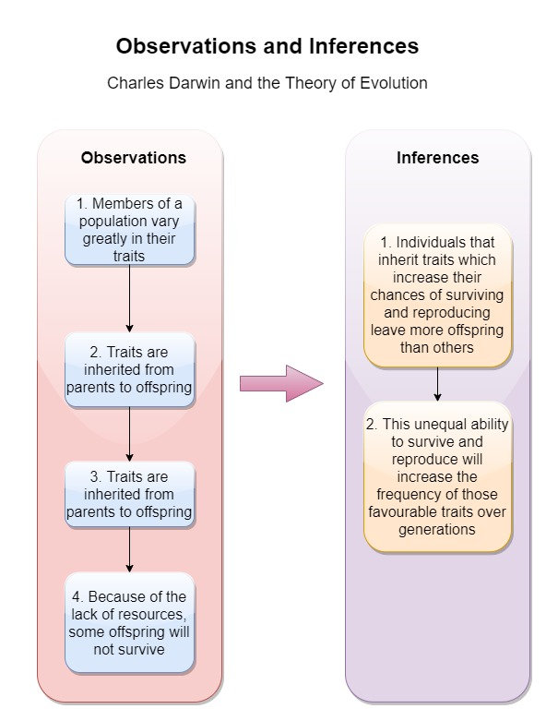
- Prior experience and a deep understanding of the literature are important for developing strong inferences.
- There are numerous historical examples of observations and inferences that instigate experimentation (A detailed discussion is provided in Appendix 2):
- Archimedes: Archimedes observed that when he entered a bathtub filled entirely with water, a specific volume of water was displaced (spilled). He inferred that the amount (volume) of displaced water was related to the object’s volume immersed in it. He investigated this with various objects, which confirmed his inference. Thus, given the mass and volume of any object, its density may be calculated. The density of an object is unique to its composition. This realisation made him conclude that the crown belonging to the King of Sicily was not made of pure gold.
- Alexander Fleming: Fleming observed that in some mouldy bacterial culture plates, no bacteria grew in the region around the mould. He inferred that the fungi produced a substance that killed or prevented the bacteria’s growth in its immediate vicinity. Fleming investigated this further and concluded that the mould, Penicillium, produced an antibiotic that killed Gram-positive bacteria. Further experiments, conducted by other scientists, isolated and purified the antibiotic (called penicillin).
- Galileo: Using his telescope, Galileo observed that Jupiter had four moons that orbited it. Based on these observations, he inferred that planets revolved around (orbited) the sun. This supported the Copernican model of the sun-centred (heliocentric) model of the solar system. Subsequent investigations by other astronomers, such as Tyco Brahe and Kepler, confirmed the model’s accuracy.
- Aboriginal and Torres Strait Islander peoples are an ancient culture whose identity is closely tied with Country and Place. ‘Country and Place’ refers to the land to which Aboriginal peoples and Torres Strait Islander peoples belong, where their ancestors’ spiritual essence remains in the landscape, the sky, and the waters.
- Aboriginal and Torres Strait Islander Peoples have longstanding scientific knowledge traditions and developed knowledge about the world by:
- observation, using all the senses
- prediction and hypothesis
- testing (trial and error)
- making generalisations about food, natural materials, navigation and sustainability of the environment.
- Various Aboriginal societies have used firestick farming practices to modify the ecology of the lands on which they live. They observed that although natural bush fires destroyed the flora and fauna on their lands, the ecosystems always recovered and were restored. This occurred through ecological succession – several species of consumers appeared soon after the burn, followed by primary, secondary and tertiary consumers. Firestick farming practices deliberately used fires in a managed process to remodel ecosystems while providing the following benefits:
- Harvesting of bush foods
- Hunting of animals that graze the new vegetation
- Prevent the growth of weeds
- Firestick farming is not performed randomly but is carried out only after careful observations of local conditions, climate, plants and animals (local knowledge).
- Ethnobotany: Observations of the medicinal and pharmaceutical effects of plant-derived substances (botanicals or phytochemicals) are common to many cultures (for example, turmeric, aspirin and artemisinin), including Australian Aboriginal and Torres Strait Islander peoples. The knowledge of such substances was built on observations and testing (trial and error). Some examples of Aboriginal and Torres Strait Islander communities’ understanding and use of medicinal plants are shown in Table 1.
Table 1 – this table summarises the medicinal use of native plant products by Aboriginal and Torres Strait Islander peoples
Common name | Scientific name | Traditional uses in Aboriginal and Torres Straits Islander communities
Kangaroo apple | Solanum aviculare Solanum laciniatum | The active ingredient is an alkaloid (solanine) – used poultice on swollen joints. The alkaloid functions as a steroid.’
Wattles | Acacia spp | Rheumatism; Indigestion
Old man’s weed | Centipeda cunninghamii | Eye and chest infections; skin complaints; colds and coughs; chest infections; strengthen immunity – ingested as water extract or rubbed onto the skin
Drooping she-oak | Allocasuarina verticillata | Rheumatism – external use
Hop bush | Dodonaea viscosa | Juice of roots used to treat toothaches and cuts

IQ1-2 What are the benefits and drawbacks of qualitative and quantitative observations?
- Qualitative and quantitative data differ in the information that they provide, as well as in their utility (applicability). The advantages and disadvantages of these data types are shown in Table 2.
Table 2 – a comparison of the advantages and disadvantages of quantitative and qualitative data
 | Advantages | Disadvantages
Qualitative data | - Generally, qualitative data is easier to collect (direct observation, surveys, interviews), as measurement tools are not required.  - A broader range of variables can be examined (for example, research in animal behaviour or human psychology), as measurement tools do not limit the inquiry.  - Cost and time effective - equipment purchase is minimal or non-existent, as is the time required to set up and operate them. Qualitative research also uses smaller sample sizes*. | - Qualitative data is more subjective than qualitative data (difficult to standardise), making comparisons more difficult.  - Smaller samples sizes mean that conclusions may be limited and difficult to extrapolate (generalise)*.  - Replication is difficult, as the outcomes depend on the investigator’s skills and may vary from group to group.
Quantitative data | - Quantitative data can be analysed using various mathematical and statistical models, thus enhancing the findings’ robustness.  - When instruments are used to gather quantitative data, the data has improved accuracy and precision.  - Larger sample sizes allow for robust conclusions to be drawn.  - Experiments involving quantitative data are objective, reproducible and reliable. | - Experiments involving collecting quantitative data can be costly (for example, large sample sizes, equipment cost) and time-consuming.  - The studied variables are often limited by the type of data (that is, only those variables that are countable or measurable can be studied).  - A lot of time and effort is devoted to setting up controlled experiments so that the collected data can be meaningfully analysed (using mathematical and statistical models). Therefore, complex interactions between variables may be missed because of the highly structured design of the experiment.

IQ1-3 How does primary data provide evidence for further investigation?
- Most natural phenomena are complex events and have a multitude of causes. Often, when investigating those phenomena, scientists will have to tease apart those causes, which they refer to as variables. Table 3 presents some examples of natural phenomena with multiple variables.
Table 3 – example of phenomena that are influenced by multiple variables
Phenomenon | Variables that affect the phenomena
Gravitation | Mass, distance
Force | Mass, acceleration
Electrostatic | Charge, distance
Ideal gas law | Number of moles, volume, temperature
Human blood groups | Three different alleles (A, B and O)
- In controlled scientific investigations, scientists usually explore relationships between pairs of variables while keeping all others constant. In this way, one variable’s effect on the other can be studied (Table 4).
Table 4 – definitions of variables in scientific experiments
Variable | What is means
Independent | The condition within an experiment that the scientist manipulates
Dependent | The variable that is measured in an experiment (that is, the variable that is affected by the experimental manipulation of the independent variable)
Controlled* | All other variables that are eliminated or maintained at constant levels
*Not to be confused with experimental controls, which are groups that do not receive the treatment being investigated but are otherwise the same.
- A good understanding of experimental variables lays the foundations for:
- successful experimental designs
- the development of strong hypotheses
- optimal data collection, organisation and visualisation;
- outcome validation through statistical tests
- heightened reliability and validity of investigations
- minimising errors and uncertainty of measurements
- Scientists expend much time and effort to minimise risks and hazards when conducting investigations. This process is called a risk assessment and is an integral part of the experimental design. When conducting risk assessments, attention must be given to actions that occur before, during and after a scientific investigation. Some considerations include:
  - Develop a list of all of the chemicals (and the quantities) and equipment needed in an experiment:
- Review the SDS (chemicals) and other safe working guidelines for the use of equipment.
- Identify risky or hazardous processes (for example, working with electricity, heat, corrosive or toxic substances).
- Identify the dangers associated with the locations where the investigation will be carried out.
- Become familiar with specialist methods (for example, microscopes, titration equipment, spectrometers), as breaches of those may cause injury.
- Being aware of the procedures involved in working with animals
- Use relevant PPE during the investigation
- Ensure that proper waste disposal procedures are followed
- For a long time, astronomical observations and measurements were limited to the functional ranges of human senses (vision). For example, features such as hills and clouds obscured views of the night sky. Humans could not explore those astronomical phenomena that were evident in the visual range of the electromagnetic spectrum.
- The invention of various instruments greatly expanded the range of the senses (Table 5).
Table 5 – a list of instrumentation used in more astronomical research. These instruments allow scientists to explore the Universe that lies beyond the range of our senses. Each instrument is limited in the type and scope of information it collects
Technology | Function
Telescopes | - Optical  - Reflecting  - Refracting  - Non-optical  - Cherenkov (Gamma rays)  - X-ray  - Ultraviolet  - Infrared  - Submillimeter (far-infrared and microwave)  - Radio telescopes (radio waves) – the Square Kilometre Array (partly based in Western Australia) will explore the birth of galaxies, dark matter and dark energy.
Recording | Recording of astronomical events for analysis and archiving  - Photographic plates  - Electronic recording
Spectroscopy | Determine the elemental composition and other physical properties (temperature, density, magnetic fields) of planets and stars. Spectroscopes are also helpful for measuring the velocities of astronomical bodies (Doppler shift)
Interferometry | Detection of gravitational waves  - Laser Interferometer Gravitational-Wave Observatory (LIGO)  - Virgo interferometer
- Both digital and analogue instruments can be used to measure variables. Table 6 shows a list of instruments used in the school science laboratory, while Table 7 compares the features of digital and analogue devices.
Table 6 – a comparison of digital and analogue measuring devices commonly used in school laboratories
Quantity | Analogue instruments | Digital instruments
Temperature | Alcohol thermometer | Digital thermometer
Time | Clock, analogue stopwatch | Digital timekeeper
Mass | Spring & beam balances | Electronic scale
Voltage | Analogue voltmeter | Digital voltmeter; multimeter
Current | Analogue ammeter | Digital ammeter; multimeter
Light intensity | Analogue lux meter | Digital light meter
pH | Litmus paper, pH indicators | pH meter
Table 7 – a comparison of some features of digital and analogue measuring devices
Features | Digital measuring devices | Analogue measuring devices
Readouts | Easy | May be complex and subject to error (e.g. parallax)
Construction | Few moving parts – contributes to the accuracy of measurement | Many moving parts – more opportunities for errors of measurements
Cost (comparatively) | Cheap – electronic parts are less costly than non-electronic components. However, digital devices are expensive to repair | Expensive – many working parts to be assembled. Repair costs are relatively cheap
Recording | Data can be recorded/stored for later use | Data recording/storage is not possible
Data analysis | Data may be fed from the device to a computer directly for subsequent analysis with analytical software | The direct transfer of data to a computer is not possible

IQ1-4 How does the collection and presentation of primary data affect the outcome of a scientific investigation?
- The measurements obtained in first-hand investigations (primary data) must be recorded as accurately as possible. Sometimes, data is recorded manually (for example, in lab books), while at other times, electronic recording of data occurs (for example, data loggers and computers).
- Data collection is followed by cleansing, processing, analysis and presentation:
- Cleansing: identify missing or incorrect data
- Processing: organise data for analysis (for example, collating data from replicate measurements, unit conversion)
- Analysis: Apply mathematical or statistical models (for example, calculating the averages of replicate measurements; deriving calculated values using appropriate formulae: calculating data spread – standard deviation: calculating the significance of difference using statistical tools; determining the uncertainties and errors of measurement; identifying patterns and trends in the data)
- Presentation: Display information in the form of graphs, tables, image galleries or other forms
- Raw data should be provided in the appendix or as supplementary information. Only processed data should be included in the results section of the scientific report.
- The processing and analysis of the data must be considered in the experimental design (planning). The analytical methods and software used must be included in the materials and methods.

IQ1-5 How do conclusions drawn from the interpretation of primary data promote further scientific investigation?
- Note: For the following discussion, ‘conclusions’ also incorporate the ‘discussion’ component of scientific reports.
- The conclusion of a scientific investigation represents the sensemaking aspect of scientific inquiry. Sensemaking is the process of developing or refining an explanation (“figuring it out”). It is not a restatement of the result but a construct of its meaning. To do this, students should:
- Explain the findings (the data analysed) in the context of the hypothesis of the inquiry question
- Reflect on the investigation’s findings in the context of relevant scientific theories.
- Evaluate the robustness of the data collected (accuracy, precision and/or reliability)
- Examine the validity of the investigation, including its limitation
Thus, the conclusion provides evidence-based judgements of the findings. It contains both the statements and interpretations of the results. Another term used to depict this is scientific argumentation.
- The three elements of a scientific conclusion are Claims, Evidence and Reasoning (C-E-R).
- The Claim is the conclusion of a scientific investigation and is related to the scientific hypothesis being tested.
- The Evidence is the data collected.
- The Reasoning links the evidence with the claim (the rule or scientific principle that describes why the evidence supports the claim).
- The conclusion(s) of an investigation must be compared to information in the literature. Such comparisons provide a context for the current research findings by indicating whether the conclusions agree or disagree with other findings reported in the literature. Such comparisons may also show the limitations of the current findings.
- A scientific investigation that is well-designed and conducted will spawn questions for further investigation. Some things that scientists consider when designing further investigations include:
- Increasing the sample size (and incorporating statistical testing)
- Expanding the range of variation applied to the independent variable
- Review the validity of the assumptions made in the experiment’s design and change them in further studies.
- Consider what further evidence is required to explain the phenomena being investigated (for example, testing other variables

Opportunities for extending concepts

IQ1-1 How does observation instigate scientific investigation?
While observations initiate inquiries, most observations do not lead to discoveries. However, the findings of Archimedes, Galileo and Fleming represent giants leaps in our understanding of the relevant science concepts. Although the discoveries were chance events, their previous experiences made them understand the significance of their observations. To understand this, students should research the biographies of Archimedes, Galileo or Fleming (see the Depth Study in Appendix 5). They should relate educational and other experiences that enabled those famous science personalities to make sense of their critical observations that led to the discoveries that they are known for.

IQ1-5 How do conclusions drawn from the interpretation of primary data promote further scientific investigation?
In this module, students plan and conduct a first-hand investigation. After that, they analyse the data they collected and develop evidence-based conclusions. They also consider how their conclusion may promote further investigation. To deepen this discussion, teachers may encourage their students to explore published scientific articles. Using these articles, teachers may highlight the following features of scientific inquiry:
- Most scientific investigations are based on contemporary knowledge in the scientific literature
- The results of an investigation must be ‘contextualised’ using the information in the scientific literature (that is, the results must be compared to related findings in the literature)
- The results of an investigation often produce new questions for further inquiry.
It is important to note that these features are true of most, but not all, published scientific studies. The following resources may be useful for such discussions in the classroom. Most of the articles in these resources are aimed at high school students.
- Young Scientist journal
- Science Journal for kids
- *Frontiers for young minds
- The National High School Journal of Science
- Journal of Emerging Investigators
- The Student Journal of Science and Technology
- Science in Schools
- The Young Scientist Awards (a repository of scientific reports that were submitted for the awards)
*Contains articles for primary and high school students

Misconceptions
- In everyday usage, the word ‘observation’ refers to information gathered from visual cues. In science, observation use more broadly to refer to information gathered from our senses (direct observations) or tools (indirect observations).
- Another misconception is that observations are explanatory – they indicate the mechanism behind some phenomena. For example, students may assume that one can explain gravity by observing a falling object’s motion. This is not true. Mechanisms that underlie natural phenomena are only discovered after an exhaustive analysis of observations/data from controlled experiments. Observations that are not derived from experiments can only provide inferences.
- Qualitative data cannot be used for numerical analysis. While qualitative data do not involve measurement, numerical values can be ascribed to them. For example, in survey questionnaires, respondents are often asked to agree with particular statements (disagree, neutral, agree). Those options are usually numbered, allowing analysts to analyse the responses using various mathematical and statistical models.
- Controlled variables – this is a common misconception. Students confuse controlled variables (variables that are kept constant throughout the experiment) with experimental control (the group that does not receive the treatment) being investigated. If the terms are used correctly and consistently, students should overcome this misconception.

Conceptual difficulties
This module is conceptually straightforward. It examines scientific inquiries – from conception to end. Some possible conceptual difficulties include:

Types of data
All data are observations, but not all observations are data. For an observation to be considered data, it must have been collected and recorded systematically. Students may also find the concept of quantitative and qualitative data to be difficult. While quantitative data involves measurements and counts, qualitative data does not include either. Measuring and counting are distinct observational strategies and should not be confused. Some datasets possess multiple properties: the same dataset may be qualitative and quantitative simultaneously (Table 8).
Table 8 – examples of situations where both quantitative and qualitative data may be obtained from a single study
Data | Description | Data types
Blood group distribution | ABS dataset showing the proportion of Australians with the different blood groups (A, B, AB and O) | Blood groups represent qualitative data. Since the groups have no inherent value, the data may be further labelled as nominal qualitative data. The proportions of people represent quantitative data. Since the numbers of people with particular blood groups represent counts, the data may be described as discrete quantitative data.
Examination grades | At the end of the Year 11 Investigating Science course, students were awarded a grade (A – E). | The grading scale, A – E, is qualitative data. Since the grades are ranked (A is better than B, and so on), the grading scale represents ordinal qualitative data. The relative proportions of students achieving specific grades in quantitative data. Since proportions represent counts, that data is discrete quantitative data.
Blood glucose | Researchers measured the blood glucose levels of a group of indigenous Australians. They classified the measurements as low, medium or high. | The blood glucose measurements represent continuous quantitative data (the measurements may be any value in a continuum). The categories (high, medium and low) represent ordinal qualitative data.
The type of data collected in a scientific inquiry influences their analysis, especially when applying mathematical or statistical models. Students should realise that determining the data types for many inquiry questions can be complicated. Consider a research question such as “is diabetes associated with sex?”. While sex is a nominal qualitative data type, the proportions of males and females in the study represent discrete quantitative data. The situation with the diabetes data is a little more complicated. The researchers may rely on the participants’ responses (yes/no/do not know) for this data (in which case, the data is discrete quantitative) or require blood glucose measurements (where the data is continuous quantitative). Therefore, scientists spend a considerable amount of time determining the types of data to be collected to answer the inquiry question in a scientific investigation.

The control of variables
Stage 6 science students are usually able to identify the independent, dependent and controlled variables in investigations. However, both the reasons and the approaches for controlling some variables in investigations may be difficult for some. Before initiating classroom conversations about controlled variables, teachers should review the information in Figure 6.
Figure 6 – this figure outlines four achievement standards to evaluate students’ understanding of the need to control variables in scientific investigations. The standards are not presented in a hierarchical order. However, the arrows depict a possible progression of idea development in students.
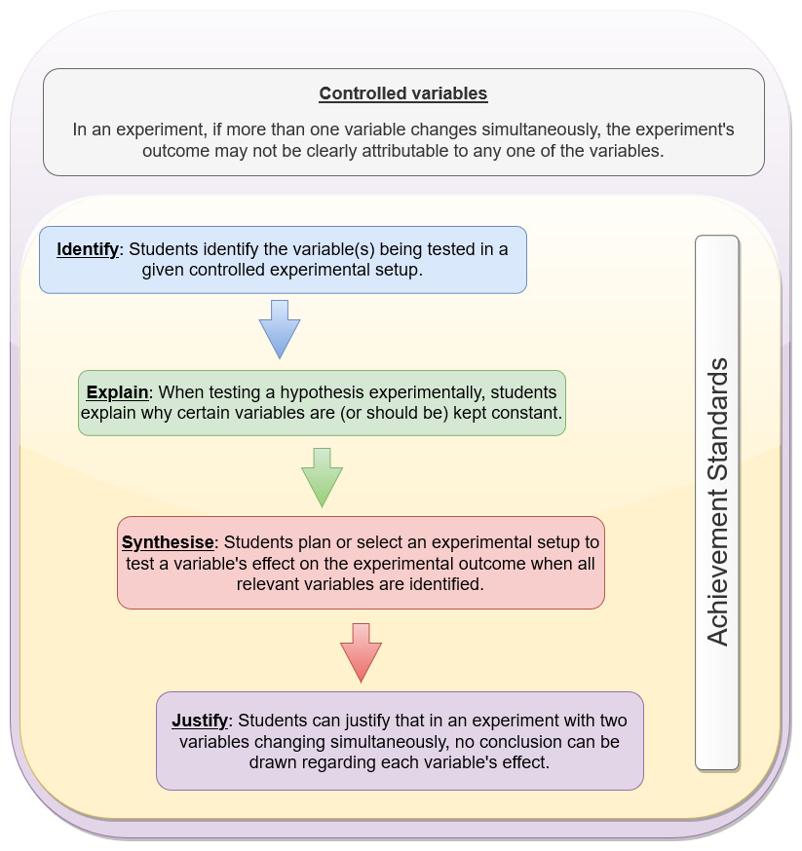
The problem set in Appendix 3 may be used diagnostically or formatively to evaluate students’ understanding of controlled variables.

Suggested teaching strategies
This module’s suggested teaching strategies include approaches that teachers may use to emphasise key concepts behind the inquiry questions. They also include relevant success criteria, which may be used to evaluate student learning. The teaching strategies are integrated into the lesson outlines presented in the appendices.

IQ1-1 How does observation instigate scientific investigation?
- Appendix 4: Boomerangs and the Bernoulli effect
- Appendix 5: Depth study – History and observation

IQ1-2 What are the benefits and drawbacks of qualitative and quantitative observations?
- Appendix 6: Cell observations
- Appendix 7: Rock strata

IQ1-3 How does primary data provide evidence for further investigation?
- Appendix 8: Design an investigation

IQ1-4 How does the collection and presentation of primary data affect the outcome of a scientific investigation?
- Appendix 9: Comparing the usefulness of observations from investigations

IQ1-5 How do conclusions drawn from the interpretation of primary data promote further scientific investigation?
- Appendix 8: Design an investigation

Resources
- Kosso, Peter (2011). A Summary of Scientific Method. Springer. p. 9.
- Bogen, James, “Theory and Observation in Science”, The Stanford Encyclopedia of Philosophy (Winter 2020 Edition), Edward N. Zalta (ed.).
- Observation and science. ScienceLearn, NZ.
- Exploration and discovery. Understanding Science.
- Bernoulli effect
  - Prep room practicals
  - Teach engineering_airplanes
  - Teach engineering_Bernoulli
- Indigenous medicinal knowledge
Packer, J., Brouwer, N., Harrington, D., Gaikwad, J., Heron, R., Yaegl Community Elders, Ranganathan, S., Vemulpad, S. and Jamie, J. (2012). An ethnobotanical study of medicinal plants used by the Yaegl Aboriginal community in northern New South Wales, Australia. Journal of ethnopharmacology, 139 (1), 244- 255.
- Aboriginal and Torres Strait Islander Peoples’ use observation to develop land management practices, e.g. Firestick farming, harvesting of food sources.
Pascoe, Bruce Dark Emu. Black seeds: agriculture or accident, 2014 Magabala Books
- Aboriginal and Torres Strait Islander Peoples use of observation
- Aboriginal people spread native plants by hand, a new study finds. ABC news.
- Protecting Country and culture
- Fighting fire with fire in the Kimberley
- Australian Curriculum: Science Aboriginal and Torres Strait Islander Histories and Cultures cross-curriculum priority
- Indigenous medicinal knowledge -
- Australian edible plants

Appendix 1

Relationships between modules 1-4
The following diagram shows a map of the relationships between the concepts and inquiry questions in the Year 11 course of the Investigating Science syllabus.
Figure 7 – a concept map showing the relationship between the concepts discussed in the Year 11 course
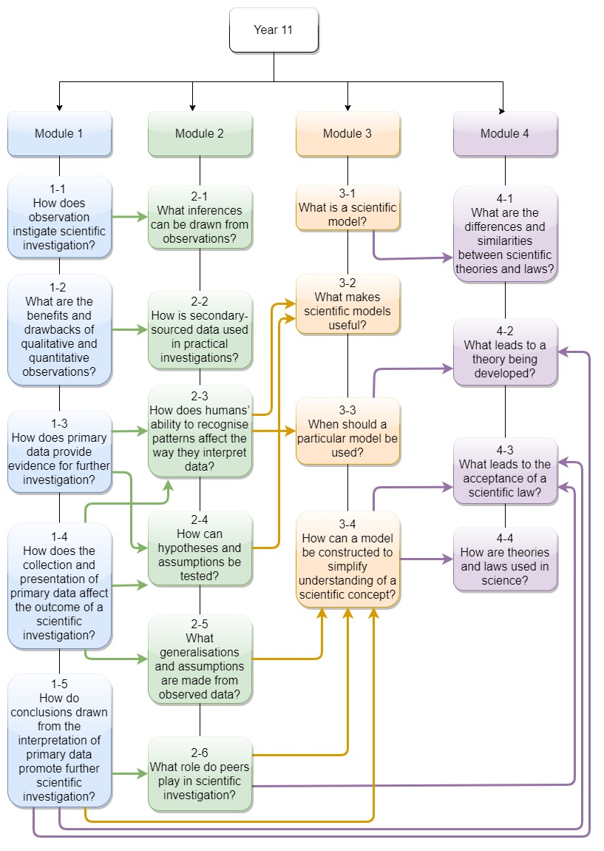

Appendix 2

Observations instigating inquiry
Table 9 – examples of historical discoveries where observations instigated experimentation
Scientist | Known for | Observation | Inference | Investigation
Archimedes | Archimedes’ principle | Archimedes needed to know if the crown belonging to the king of Sicily was made of pure gold or was alloyed with silver. When he entered a bath, he noticed that the water overflowed as he immersed himself into it – the deeper the immersion, the greater the quantity of water that was displaced. | A submerged object displaces a volume of water equal to the object’s volume | Archimedes had two replicas of the crown made – one made of pure silver, and the other pure gold. Both replica crowns weighed the same. Archimedes immersed the silver crown in a vessel that was filled to the brim with water. He collected and measured the volume of the water that overflowed. Then, he repeated the process with the golden crown. This was consistent with his understanding of the metals: gold is heavier than silver. Therefore, for the two crowns to be of the same weight, the silver crown must be larger, thus displacing more water. The original crown displaced more water than the replica golden crown, indicating that it was not made purely of gold but was an alloy.
Alexander Fleming | Discovery of the antibiotic penicillin | Fleming noticed that some of his bacterial culture plates were contaminated with mould (Penicillium notatum). Upon closer inspection, he realised that the region around the mould was free of bacteria. | The mould was producing an antibacterial substance that killed bacteria in its vicinity | Fleming conducted further studies showing that the mould’s secretions killed a range of bacteria (Gram-positive bacteria). However, Fleming only worked with crude extracts of the mould’s secretion. More than ten years after this discovery, scientists at Oxford University purified the antibiotic from the crude extracts. Subsequent studies of the purified antibiotic (called penicillin) confirmed its antibacterial properties.
Galileo Galilei | Discovery of Jupiter’s moons | Using a self-made telescope, Galileo noticed that four moons were orbiting Jupiter.  Over several months, Galileo noticed that the ‘stars*’ around Jupiter moved in predictable patterns (appearing periodically on either side of Jupiter every 7-8 days).  Not all ‘stars’ were visible every night. | The stars are moons (like our moon)  According to Ptolemy’s geocentric model of the solar system (prevalent in Galileo’s time), all heavenly bodies revolved around the Earth. Based on his observations of Jupiter’s moons, Galileo inferred that not all heavenly bodies revolved around the Earth but that they revolved around the sun (as described by Copernicus). | Subsequent work by several astronomers confirmed Galileo’s inference:  Brahe: Detailed astronomical measurements that supported the heliocentric model.  Kepler: Confirmed that planets revolved around the sun in elliptical orbits (thus removing Ptolemy’s requirement for epicycles)  Einstein: Perihelion of Mercury

*When Galileo viewed Jupiter, he was using a low-powered telescope. Through it, Jupiter’s moons were indistinguishable from the stars in the background. Hence, he called them stars. However, he noticed that the stars appeared to ‘follow’ Jupiter’s movement across the sky. Only later did he realise that the ‘stars’ he was studying were Jupiter’s moons.

Appendix 3

Controlled variables

Introduction
The concept of experimental variables may be difficult for some students. Research indicates that many students do not understand the role of variables that are held constant during experiments. In general, to test the validity of a hypothesis, scientific investigations seek to establish the relationship between two variables is tested. To do this meaningfully, other variables (that is, other than those that are being tested) must be held under invariant conditions that minimise fluctuations. As such, the latter is referred to as controlled variables.
The following problem set may be as a diagnostic or formative assessment to uncover students’ thinking about the role of controlled variables. All question in this set are multiple-choice questions and can be easily administered in an online format. However, it is recommended that teachers discuss their students’ answers to determine their reasoning behind their answer choices. A link to common misconceptions about the use and role of controlled variables is provided in Table 10.
Note: some scientific investigations explore the effects of multiple independent variables on their outcomes. Such experiments are complex (they are often referred to as bivariate or multivariate) and usually use various statistical models. They are beyond the scope of high school science.

Question 1
A farmer wants to find out which type of soil is best for growing his corn. He also wants to find out which type of fertiliser is best for growing his corn. He does the following experiment using two different types of soil and two different types of fertiliser:
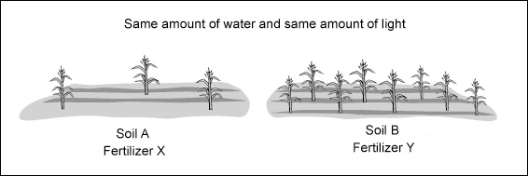
What can the farmer conclude from this experiment?
- He can conclude that Soil B is the best soil for growing his corn.
- He can conclude that Fertilizer Y is the best fertiliser for growing his corn.
- He can conclude that Soil B is the best soil for growing his corn and that Fertilizer Y is the best fertiliser for growing his corn.
- It is NOT possible to conclude from this experiment which soil is best for growing his corn or which fertiliser is best for growing his corn.
Correct answer: D

Question 2
A student is interested in the behaviour of fish. He has four fish bowls and 20 goldfish. He puts eight fish in the first bowl, six fish in the second bowl, four fish in the third bowl and two fish in the fourth bowl. He places each fishbowl under light, he keeps the temperature at 25°C for all four bowls, and he observes the fish’s behaviour.
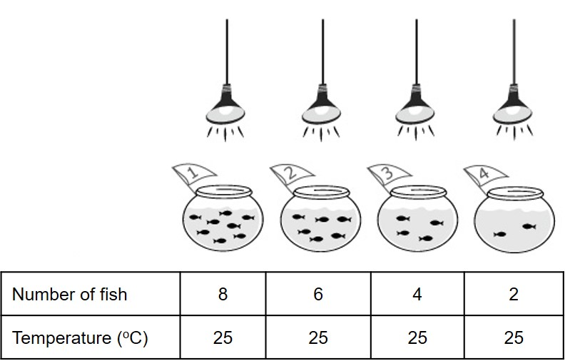
What can the student find out from doing this experiment?
- If the number of fish in the fishbowl affects the fish’s behaviour
- If the fishbowl’s temperature affects the fish’s behaviour
- If the fishbowl’s temperature and the amount of light affect the fish’s behaviour
- If the number of fish, the temperature, and the amount of light affect the fish’s behaviour
Correct Answer: A

Question 3
A student thinks that two variables (X and Y) may affect her experiment’s result. She decides to change only variable X and let variable Y stay the same. What can the student find out about the effects of variables X and Y?
- If variable X affects the result of her experiment
- If variable Y affects the result of her experiment
- If both variables X and Y affect the result of her experiment
- She cannot find out if either variable X or variable Y affects the result of her experiment.
Correct Answer: A

Question 4
A student thinks that three variables (X, Y and Z) may affect her experiment’s result. She decides to change only variable X and let variables Y and Z stay the same. What is the student trying to find out?
- If variable X affects the result of her experiment
- If variables X and Y affect the result of her experiment
- If variables Y and Z affect the result of her experiment
- If variables X, Y, and Z affect the result of her experiment.
Correct Answer: A

Question 5
A student wants to know if a cart’s weight affects its speed at the bottom of a ramp. He can change the cart’s weight by adding different numbers of balls, and he can change the ramp’s height by using different numbers of blocks. Which set of tests should he use (A, B, C, or D)?
- 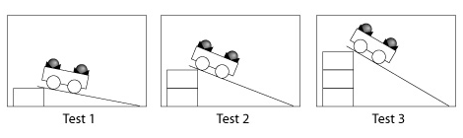
- 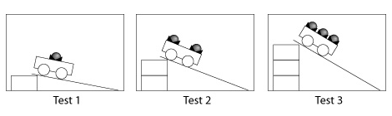
- 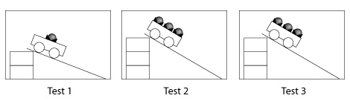
- 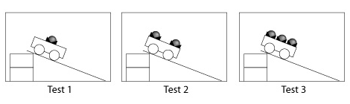
Modified from TIMSS item population 2 (I-12), 1994
Correct Answer: D

Question 6
A consumer group is interested in the effects of a car’s speed and weight on its fuel efficiency. A car’s fuel efficiency is the number of kilometres it can travel for each litre of fuel it uses.
First, the group decides to test if a car’s speed affects its fuel efficiency. They take two identical cars and drive one at 30 kilometres/hour and the other one at 45 kilometres/hour on the same road. They make sure that the two cars have the same weight. Why is it important that the two vehicles have the same weight?
- Using cars of the same weight, the group can learn about both the effect of weight and speed on fuel efficiency.
- Using cars of the same weight, the group can learn about the effect of the weight on fuel efficiency.
- If the cars do not have the same weight, the group cannot learn about the effect of speed on fuel efficiency.
- Both cars do not have to have the same weight because the group is not testing the effect of the weight on the gas mileage.
Correct Answer: C

Misconceptions
Table 10 – misconceptions about controlled variables based on students’ incorrect answers
Misconceptions about controlled variables | Question responses that indicate the misconceptions
A controlled experiment tests for the effects of ALL variables (that is, IV, DV and CV), regardless of whether they vary or are held constant. | 2D, 3C, 4D, 5B, 6A
A controlled experiment tests for the effect of the variable held constant (CV), not the variable that is allowed to change (IV, DV). | 2B, 2C, 3B, 6B
When testing the effect of a variable (IV) on the outcome of the experiment, it does not matter if other relevant variables (DV, CV) change at the same time | 5C, 6D
In an experiment, the variable under investigation (IV) must be kept constant. In contrast, all other variables (DV and others) can change. | 4B,5A
In an experiment, only one variable needs to be controlled. The rest can vary. | 4C
If two variables change at the same time, one can learn about the effect of at least one of the variables on the outcome | 1B, 1C

Appendix 4

Teaching resource – the Bernoulli effect

IQ1-1 – How does observation instigate scientific investigation?

Outcomes
- INS 11-3 conducts investigations to collect valid and reliable primary and secondary data and information
- INS11- 8 identifies that the collection of primary and secondary data initiates scientific investigations

Content
Students:
- carry out a practical investigation to record both quantitative and qualitative data from observations, for example:
- burning a candle floating in a closed container
- the behaviour of slaters in a dry/wet or light/dark environment
- the Bernoulli effect
- strata in rock cuttings
- discuss and evaluate the characteristics of observations made compared to inferences drawn in respect of the practical investigation

Context
In this lesson, students will collect qualitative data on the effects of moving air (a fluid) and construct simple explanations using Bernoulli’s principle. The process of constructing those explanations illustrate how inferences are developed from observations. Finally, they consider how the investigations may be modified to collect quantitative data and the advantages or disadvantages of using such data.

Time estimate
1 lesson

Learning intentions
Students
- Record qualitative and quantitative data from observations
- Discuss and evaluate the observations compared to the inferences drawn

Success criteria
- Distinguish between qualitative and quantitative data
- Use observations to modify investigations
- Compare observations to the inferences made in the investigation

Task outline
Bernoulli’s principle in a nutshell
Bernoulli’s principle relates to the behaviour of moving fluids. A fluid is a substance that can easily change its shape and is capable of flowing. Some examples of fluids are air, water and blood, all of which can move (flow). According to Bernoulli, an increase in the velocity of any fluid always results in a decrease in pressure. This principle is important in many areas of science and engineering. The motion of aircraft, the aerodynamic properties of cars, and the study of blood pressure in humans all illustrate this principle’s use.
Students
- This activity may be implemented in a ‘stations’ format, wherein each activity is performed at a specific station. The activities’ instructions are indicated in Table 12, and laminated copies may be placed in each station.
- Tell the students that they will be conducting a series of experiments to explore the Bernoulli Principle.
- Tell the students that they will learn more about the specifics of the Bernoulli Principle after they have conducted their experiments and recorded their observations.
- Before the students begin their experiments, introduce each experiment by showing them the materials they will be using and providing them with a simple overview of how each of the experiments will be conducted.
- Instruct students to carefully read the directions for each experiment and predict what they think will happen. Once the students’ predictions are discussed and recorded (the Predict-Observe-Infer-Explain template is provided in Table 11), they may begin their experiments.
- During the lesson’s experimentation stage, circulate throughout the classroom, facilitating discussion and guiding students through the experiments as needed. Students may want to know why the items in the experiment behave as they do but resist the temptation to answer any “why” questions just yet. Instead, encourage the students to look for patterns in the outcomes of the experiments.
- After the investigations are complete, discuss the following:
- Explanations of the phenomena using Bernoulli’s Principle
- The type of data that was collected (qualitative)
- How could one or more of the investigations be modified to collect quantitative data
Note: The independent variable (the strength of the blowing through the star or funnel) in these experiments will be qualitative but may be arbitrarily coded as ‘weak’, ‘medium’ or ‘strong’. However, the dependent variable may be measured (quantitative data) by measuring the objects’ displacement.
Table 11 – the Predict-Observe-Inference-Explain template
 | Predict  What do you think will happen? | Observe  What happened? | Inference  Why did it happen? | Explain
Paper Tent: Normal Airflow
Paper Tent: Increased Airflow
Aluminium drink cans
Balancing a ping pong ball
Levitate a Sphere
The broken straw

Table 12 – instructions for Bernoulli’s principle activities
 | Paper Tent | Aluminium cans | Balancing a ping pong ball | Levitate a sphere | The broken straw
Materials | - One 9 cm x 10 cm piece of stiff paper  - One straight straw | - Two empty aluminium drink cans (of the same size)  - Ruler  - One straight drinking straw | - One flexible drinking straw  - One ping pong ball | - Medium-sized funnel  - One ping-pong ball  - Alcohol swab (to clean the funnel when shared between students) | - Scissors  - One clear plastic cup  - Water  - One straight drinking straw
Instructions | - Fold the paper in half to make a paper tent.  - Place the paper tent on a flat surface.  - Position the straw about 5 cm from the paper tent. Blow a steady stream of air across the surface of the table or desk and through the tent.  - Record the observations.  - Next, blow harder and observe what happens.  - Record the observations. | - Place the two cans next to each other, about 2 cm apart.  - Use a straw to blow between the two cans about 3 cm above the table’s surface. Be sure that the straw’s open end is placed in front of the cans and not between them.  - Observe and record what happens. | - Bend your straw into an “L”.  - Place the long end of the straw in your mouth, with the short end pointing upwards.  - Take a deep breath and blow steadily through the straw.  - Try to balance the ping pong ball in the stream of air coming out of the end of the straw.  - Try to tilt your straw.  - Observe and record what happens. | Note: For health reasons, only one student should blow into the funnel.  - Place the ball in the funnel.  - Tilt your head back and point the wider end of the funnel upwards toward the ceiling or sky.  - Blow air forcefully through the narrow end of the funnel to lift the ball out of the funnel.  - Observe and record what happens.  - Now, with the ball in the funnel as before, hold the funnel in front of you and blow.  - Observe and record what happens. | Note: the spray from the straws can get messy. You may wish to place some towel on the table to keep the area as clean as possible  - Fill a clear plastic cup, nearly to the rim, with water.  - Cut the drinking straw in half.  - Place one half of the straw in the water so that the straw’s bottom does not touch the bottom of the cup.  - The top of the straw should be sticking out above the rim of the cup.  - Position the second half of the straw so that it is perpendicular to, but not touching, the straw in the cup of water. You should be able to blow a stream of air over the hole of the straw sticking out of the water.  - Once the straw is in position, blow very hard through the straw.  - Observe and record what happens.
Explanation | The sides of the card will pull towards one another. This occurs because the faster-moving air under the card creates relatively lower pressure than the air over the card. As a result, the card will bend toward the table because higher pressure air pushes toward lower pressure air, according to the Bernoulli Principle. | The two cans will move together. This is because the air blowing through the straw will be faster moving than the air on any other side of the cans. Thus, according to the Bernoulli Principle, the faster-moving air exerts lower pressure, and the two cans are drawn toward each other. | The ping pong ball will balance itself in the steady stream of air coming from the short end of the straw. This happens because the air coming out of the straw is moving fast, so the faster-moving air has less pressure than the slower-moving or still air around the ping pong ball. If the ping pong ball starts to move away from the air stream, it experiences pressure from the still or slower moving air, which pushes the ping pong ball back in place. If the straw is tilted, the force produced by the stream of air will no longer be sufficient to keep the ping pong ball afloat because the force of gravity will then take over. | The air coming directly underneath the ping-pong ball will be moving more quickly than the air over the top of the ball. As Bernoulli’s Principle states, this faster-moving air decreases air pressure under the ball. The higher air pressure at the funnel’s top causes the ball to be pushed into, rather than out of, the funnel. The result is that the ball stays in the funnel. By blowing over the funnel’s top, the air travelling over the funnel’s top moves faster, causing the air pressure in that area to decrease. Therefore, the ball rises because it is being pushed out of the funnel by the higher air pressure below. | The water will rise through the straw in the cup, spraying away from the stream of air being blown across the straw. As the student blows through the straw, the faster-moving air over the top of the straw creates an area of low pressure while the pressure on the surface of the water remains unchanged. Therefore, the water is drawn up the straw because of the area of low pressure.

Feedback
The predict-observe-explain format of this activity allows students to compare their expected outcomes with experimental observations. Teachers should direct their students to develop inferences about the phenomena. Then, they can provide feedback to those inferences using the information provided in Table 11.

Appendix 5

Depth Study – history and observation
Note: the following activity constitutes part of a more extensive activity for a Depth Study in this module.

IQ1-1 How does observation instigate scientific investigation?

Outcomes
- INS 11-3 conducts investigations to collect valid and reliable primary and secondary data and information
- INS11- 8 identifies that the collection of primary and secondary data initiates scientific investigations

Content
Students:
- research how observation has instigated experimentation to investigate cause and effect in historical examples, including but not limited to:
- Archimedes observing the displacement of water
- Alexander Fleming’s observations of the effect of mould on bacteria
- Galileo’s observations of the movement of Jupiter’s moons
- assess ways in which Aboriginal and Torres Strait Islander Peoples use observation to develop an understanding of Country and Place in order to create innovative ways of managing the natural environment, including but not limited to:
- firestick farming
- knowledge about plants for medicinal purposes

Context
This depth study enables students to explore historical Australian Aboriginal & Torres Strait Islander people’s ‘scientific’ way of knowing. Students can explore and link Australian Aboriginal & Torres Strait Islander people’s observations to those by Archimedes, Fleming and Galileo.

Time estimate
1-3 lessons, depending on any adaptations made to the task.

Learning intentions
Students
- Compare Australian Aboriginal & Torres Strait Islander peoples ‘ways of knowing’ with approaches used in Western science

Success criteria
- Articulate how prior experiences and education influence observations and the process of making inferences
- Compare and contrast Australian Aboriginal & Torres Strait Islander peoples’ observations and cultural knowledge to the scientific approaches of known scientists

Task outline
Students
- Research how observations and the corresponding inferences led Archimedes, Fleming and Galileo to the scientific discoveries they made. Students should explore the data that the scientists collected (including repeated observations). Since prior experiences are important for the development of inferences from observations, students should also examine the biographies of these scientists to discover:
- Their educational experiences
- Their professional experiences (including other discoveries or inventions made by the scientists)
- Explore Australian Aboriginal & Torres Strait Islander peoples’ examples of observations that led to inferences. Students may explore firestick farming or the knowledge of medicinal plants (or other topics of interest). The following Australian Curriculum elaborations may be helpful starting points:
- Mazzocchi F. (2006). Western science and traditional knowledge. Despite their variations, different forms of knowledge can learn from each other. EMBO reports, 7(5), 463–466.
- Investigating how the knowledge and experience of Aboriginal and Torres Strait Islander Peoples are being used to inform scientific decisions, such as the care of Country/Place
- Investigating how Aboriginal and Torres Strait Islander Peoples use fire-mediated chemical reactions to facilitate energy and nutrient transfer in ecosystems through the practice of firestick farming
- Investigating how Aboriginal and Torres Strait Islander Peoples used scientific understandings of complex ecological relationships to develop specific fire-based agricultural practices
- Investigating the contributions of Aboriginal and Torres Strait Islander Peoples’ knowledge in the identification of medicinal and endemic plants
- Investigating how disease outbreaks and the emergence of drug-resistant infections have focused scientific research into Aboriginal and Torres Strait Islander Peoples’ traditional medicines to identify effective therapeutic compounds for use in pharmaceuticals
- Investigating how before germ theory, Aboriginal and Torres Strait Islander Peoples used their scientific observations to develop traditional medicines to treat wounds and infections of the skin
- Researching how Torres Strait Islander Peoples are at the forefront of the development of scientific measures to prevent the transfer of certain infectious diseases and pests to the Australian continent
- Compare the observations and inferences of Australian Aboriginal & Torres Strait Islander peoples’ examples to those used by Archimedes, Fleming and Galileo. What are the similarities and differences? How have those approaches led to the development of different types of knowledge about natural phenomena?
Information for teachers
Archimedes was a mathematician and engineer; Fleming was a bacteriologist (and discovered the antibacterial enzyme, lysozyme, before discovering penicillin; Galileo was a physicist-mathematician who knew of Copernicus’ heliocentric model of the solar system before he observed Jupiter’s moons.

Feedback
Throughout the research, teachers provide feedback on the strength of the links between observations made and how those observations may have led to investigations into cause and effect. The feedback should be centred around the learning intention that various individuals and cultures have used observations and inferences in different ways to construct knowledge of phenomena.

Task resources
- Fleming
- Tan, S. Y., & Tatsumura, Y. (2015). Alexander Fleming (1881-1955): Discoverer of penicillin. Singapore medical journal, 56(7), 366–367.
- Alexander Fleming. Science History Institute.
- Sir Alexander Fleming – Biographical. NobelPrize.org. Nobel Media AB 2021. Sun. 28 Feb 2021.
- Galileo
- There are many resources on Galileo’s biography. The Galileo project (Rice University) is an extensive collection of works on the life and discoveries of Galileo
- Archimedes
- The Archimedes Palimpsest
- Archimedes of Syracuse

Appendix 6

Teaching resource – cell observations

IQ1-2 What are the benefits and drawbacks of qualitative and quantitative observations?

Outcomes
INS 11-4 selects and processes appropriate qualitative and quantitative data and information using a range of appropriate media
INS11- 8 identifies that the collection of primary and secondary data initiates scientific investigations

Content
Students:
- carry out a practical activity to qualitatively and quantitatively describe, for example:
- microscopic images of a variety of cells
- analyse the quantitative data from the following information sources, including but not limited to:
- digital images and hand-drawn diagrams of cells

Context
In this lesson, students learn that both quantitative and qualitative data from cell microscopy have helped construct a deep and broad knowledge base about cell structure and function.

Time estimate
1-2 lessons

Learning intentions
Students
- Qualitatively and quantitatively describe microscopic images of a variety of cells
- Analyse quantitative data surrounding cell images

Success criteria
- Describe a variety of cells both quantitatively and qualitatively
- Analyse quantitative data from digital and hand-drawn images of cells

Task outline
Students
- Recall the general characteristics of qualitative and quantitative observations
- In groups, students brainstorm how they might qualitatively and quantitatively describe micrographs of cells. Groups share their ideas with the class to come up with a framework for collecting the information.
- Investigate using microscopes, digital images and hand-drawn diagrams to collect qualitative and quantitative descriptions of various cells.
- Compare the quantitative descriptions from the different sources (microscope, digital and hand-drawn) and analyse the quality of the quantitative description regarding accuracy and reliability.
Note to teachers
Qualitative data from micrographs: shape, arrangements of cells (unicellular, multicellular), colour (stained and unstained), structure (parts of cells, including organelles), cellular processes (for living specimens)
Quantitative data from micrographs: cell size, magnification, scale, sizes of organelles and intracellular structures (from electron micrographs). Newer microscopy techniques that use fluorescence imaging and video microscopy provide quantitative data on cellular reactions.

Feedback
Teachers should try to uncover students’ thinking about the data that can be collected from micrographs. Cells exist beyond the range of our senses, and complex instruments are required to study them. Depending on the type of microscope used and the manipulations applied (for example, staining, DNA and protein tagging), the range and depth of data collected are enormous. Teachers should elicit students’ ideas about the need to collect different types of data so that scientists can develop a deeper understanding of cells.

Task resources
- Dartmouth Electron Microscopy Facility
- Cell Image Library
- Cells Alive
- YouTube resources showing video micrographs – for example, neutrophils, cell division, photosynthesis
- The inner life of the cell – this animation is based on a large volume of qualitative and quantitative data. It is the culmination of many years of work.

Appendix 7

Teaching resource – rock strata

IQ1-4 What are the benefits and drawbacks of qualitative and quantitative observations?

Outcomes
INS 11-3 conducts investigations to collect valid and reliable primary and secondary data and information
INS11- 8 identifies that the collection of primary and secondary data initiates scientific investigations

Content
Students:
- carry out a practical activity to qualitatively and quantitatively describe, for example:
- geological strata in rock faces and road cuttings
- analyse the quantitative data from the following information sources, including but not limited to:
- geological succession obtained from rock strata
- evaluate the differences between qualitative and quantitative observations and data and where these are used.

Context
This lesson or series of lessons enables students to investigate the qualitative and quantitative observations and data generated from geological strata. Students have the opportunity to evaluate both types of data using a PMI chart and determine where these may be utilised in the real world.

Time estimate
1-3 lessons

Learning intentions
Students
- Conduct a first-hand investigation to qualitatively and quantitatively describe geological strata in rock faces and rock cuttings.
- Analyse the quantitative data from geological succession
- Evaluate the differences between qualitative and quantitative observations and data and where these are used.

Success criteria
- Collected qualitative and quantitative data from geological strata
- Analyse quantitative data
- Evaluate the differences between qualitative and quantitative data.

Task outline
- The teacher discusses how geological data can give us an insight into Australia’s geological history. This scientific knowledge usually comes from the data that someone collected and analysed. Part of it might have been numbers and measurements, and another part was perhaps photographs and descriptions. Geographic data can be very diverse. Example of qualitative data in geology: The rock formation is high and looks like a pyramid. Example of quantitative data in geology: Mt Kosciuszko has an elevation of 2228m above sea level and an average annual temperature of 13 degrees Celsius. Outline to students that they are going to explore qualitative and quantitative data around rock strata. The term rock strata refer to stacked-up layers of sedimentary rock. Other kinds of rocks can have layers in them, but the word strata are reserved for sedimentary rocks - rocks composed of individual fragments of minerals or other rocks. Geologists use the term ‘rock strata’ in a generic sense when referring to many rock layers that appear over large areas.
- Images are displayed to the class of different road cuttings. The three laws that have aided scientists to interpret the layers are outlined with images provided.
- Students observe a diagram of rock strata (Figure 8).
Figure 8 – Stratigraphy
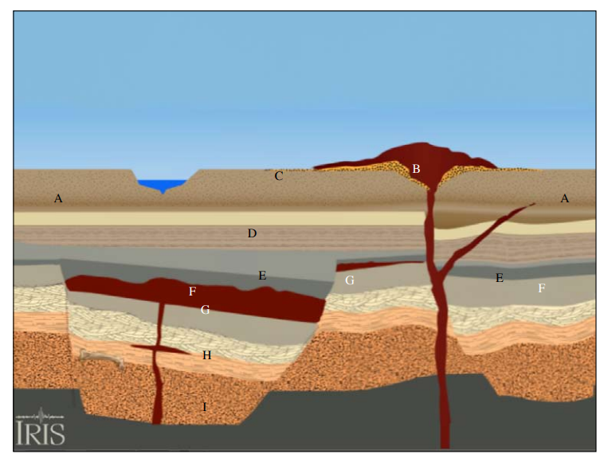
- Students answer the following questions about the section
- What is the oldest layer?
- Which is the youngest rock?
- Which is the youngest fault? The oldest?
- What does the dinosaur bone tell you?
- What is the evidence for erosion?
- Once students have responded to the questions, visit the Stratigraphy site click on the link below to access the video demonstrating the process to create the above cutting. Students can check how close their observations and inferences were to the video.
- Students are divided into groups and undertake the relative and radiometric dating activity found at the University of California Museum of Palaeontology website.
- After completing the above activities, students evaluate each method using a PMI chart to compare the qualitative and quantitative data generated and where these methods could be used.

Feedback
Feedback is provided throughout the lessons to deepen student understanding and to strengthen students’ skills in evaluating. Questioning is used to broaden student responses, and gauge student understanding and the individual support required.

Task resources
- PMI chart
- Relative Dating of Rock Layers

Appendix 8

Teaching resource – design an investigation

IQ3 How does primary data provide evidence for further investigation?

Outcomes
- INS 11-4 selects and processes appropriate qualitative and quantitative data and information using a range of appropriate media
- INS11- 8 identifies that the collection of primary and secondary data initiates scientific investigations

Content
Students:
- develop a method to collect primary data for a practical investigation by:
- describing how to change the independent variable
- determining the characteristics of the measurements that will form the dependent variable
- describing how the data will be collected
- describing how the controlled variables will be made consistent
- describing how risks can be minimised

Context
This generic outline can be used to enable students to design and modify an investigative method. The task enables the students to work individually and collaboratively, so the limits of cognition are not those of the individual mind but the collective group. Students plan an investigation and obtain peer feedback about its suitability, relevance, and suggestions for improving this activity. After incorporating the relevant feedback into their experimental design, they proceed to conduct their investigation.

Time estimate
2-3 lessons

Learning intentions
Students
- develop a method to collect primary data from a first-hand investigation

Success criteria
- developed a suitable method to collect primary data from a first-hand investigation
- modified the method according to peer feedback received on the method design

Task outline
- Initially, students work individually to devise a suitable method for their investigation. They use the following framework to design their method:
- describe how to change the independent variable
- determine the characteristics of the measurements that will form the dependent variable
- describe how the data will be collected
- describe how the controlled variables will be made consistent
- describe how risks can be minimised
- Students are then placed into groups of 3, and each member is required to present their investigation to the team. As a team and using a POOCH (problem, options, outcome, choice) scaffold, they explore each possibility and decide which investigation they will conduct.
- Groups present their investigative method and reasoning to the rest of the class via a gallery walk around the room. Groups must give each team feedback via sticky notes regarding the investigative method’s clarity, reasoning, accuracy, precision, validity, and relevance. Groups respond to this feedback by answering the following questions:
- What will we alter in our method design after receiving feedback?
- How will we alter our method design to improve its outcome?
- After this, the feedback groups conduct the investigation using their refined methodology.
- Groups then analyse the results. At the end of the process, teams are again asked, ‘How could you change your method design if you were asked to rerun the investigation?’

Feedback
Peer feedback is the primary technique used for modification of group method design. Their group modifies their initial design before investigating by utilising specific feedback given to their group during the gallery walk. Teacher feedback through targeted questioning can also be used to generate student thinking during method generation.

Task resources
- POOCH scaffold (free templates are available at various websites)
- Post-it-notes

Appendix 9

Teaching resource – comparing the usefulness of observations from investigations

IQ1-3 How does the collection and presentation of primary data affect the outcomes of a scientific investigation?

Outcomes
- INS 11-4 selects and processes appropriate qualitative and quantitative data and information using a range of appropriate media
- INS11- 8 identifies that the collection of primary and secondary data initiates scientific investigations

Content
Students:
- compare the usefulness of observations recorded in the initial practical activity with the primary data gathered in this planned practical investigation

Context
After collecting primary data, students use a thinking scaffold to compare the data collected in this investigation with the investigations carried out for IQ1-2 (for example, microscopic images of various cells or characteristics of acids and bases).

Time estimate
1 lesson

Learning intentions
Students
- draw comparisons between the usefulness of qualitative and quantitative observations from the initial investigation to the primary data collected in the planned investigation

Success criteria
- Compare observational data and information using the language conventions of compare

Task outline
Students
- Use the information gathered in the two investigations to compare the usefulness of the observations recorded.
- In groups, construct a table to compare the criteria of reliability, validity, accuracy, precision and bias of the observations recorded.
- Direct instruction by the teacher as to the nature of comparing the information in the table. The teacher describes how to compare several ideas and then determine how they are similar and different. The teacher explains the use of the language conventions of compare and outlines an example.
- Individually construct at least one to two sentences for each criterion for each investigation using the keywords from the compare document provided.
- Each student swaps their responses with a partner. Students provide feedback on the response, linking several ideas together, comparing and comparing language conventions and the overall response.
- In groups, determine the overall usefulness of each set of observations and report back to the class.

Feedback
Students provide immediate peer feedback about the depth of the response and any improvements that could be made to the response. The teacher also uses prompting questions to strengthen student responses.

Task resources
- Data and information from the two investigations to be compared
- Keyword document for Compare and Contrast

References
This resource contains NSW Curriculum and syllabus content. The NSW Curriculum is developed by the NSW Education Standards Authority. This content is prepared by NESA for and on behalf of the Crown in right of the State of New South Wales. The material is protected by Crown copyright.
Please refer to the NESA Copyright Disclaimer for more information https://educationstandards.nsw.edu.au/wps/portal/nesa/mini-footer/copyright.
NESA holds the only official and up-to-date versions of the NSW Curriculum and syllabus documents. Please visit the NSW Education Standards Authority (NESA) website https://educationstandards.nsw.edu.au and the NSW Curriculum website https://curriculum.nsw.edu.au.
Investigating Science Stage 6 Syllabus © NSW Education Standards Authority (NESA) for and on behalf of the Crown in right of the State of New South Wales, 2017.

© State of New South Wales (Department of Education), 2021
The copyright material published in this resource is subject to the Copyright Act 1968 (Cth) and is owned by the NSW Department of Education or, where indicated, by a party other than the NSW Department of Education (third-party material).
Copyright material available in this resource and owned by the NSW Department of Education is licensed under a Creative Commons Attribution 4.0 International (CC BY 4.0) license.

This license allows you to share and adapt the material for any purpose, even commercially.
Attribution should be given to © State of New South Wales (Department of Education), 2021.
Material in this resource not available under a Creative Commons license:
- the NSW Department of Education logo, other logos and trademark-protected material
- material owned by a third party that has been reproduced with permission. You will need to obtain permission from the third party to reuse its material.
Links to third-party material and websites
Please note that the provided (reading/viewing material/list/links/texts) are a suggestion only and implies no endorsement, by the New South Wales Department of Education, of any author, publisher, or book title. School principals and teachers are best placed to assess the suitability of resources that would complement the curriculum and reflect the needs and interests of their students.
If you use the links provided in this document to access a third-party's website, you acknowledge that the terms of use, including licence terms set out on the third-party's website apply to the use which may be made of the materials on that third-party website or where permitted by the Copyright Act 1968 (Cth). The department accepts no responsibility for content on third-party websites.

Understanding Science.
Relationships and place.
The Australian Curriculum: Cross curriculum priorities
Note that a claim may be supported by more than one piece of evidence. However, each piece of evidence must be accompanied with the reasoning that connects it to the claim.
Uri, John (2020). 410 Years Ago: Galileo Discovers Jupiter’s Moons.
Adapted from NASA_Museum in a Box_Bernoulli’s principle_Principles of flight

