Investigating Science Module 6 – Technologies

Contents
Teaching the Year 12 Modules 3
Module summary 4
Relationship to other modules 5
Big ideas 6
Core concepts 7
Impact of technology on scientific investigations 7
Conducting scientific investigations – the impact of technology 8
Collecting evidence for scientific concepts 10
Impact of scientific knowledge on technological developments 11
Aboriginal and Torres Strait Islander peoples developed an extensive knowledge base of medicinal uses of plants. 14
Opportunities for extended concepts 16
Alternative conceptions and misconceptions 16
Conceptual difficulties 17
Suggested teaching strategies 17
Depth studies 19
Practical activities 20
Resources 22
Appendices 23
Appendix 1 – understanding graphs 23
Mathematical principles 23
Working with gas laws 24
Analysing the motion of objects 28
Appendix 2 – Newton’s Laws and Earthquakes 30
Appendix 3 – the history of optics and telescopes 34
References 36
Further reading 36

Teaching the Year 12 Modules
The new Stage 6 Investigating Science course was implemented in NSW schools in 2018-2019. This syllabus incorporates new content and learning activities such as Depth Studies. The syllabus is designed around inquiry questions and formal assessment tasks emphasise the skills for working scientifically.
The Year 12 course builds on the skills and concepts learnt in Year 11 with students conducting their own scientific investigations and communicating their findings in scientific reports. Students are provided with the opportunity to examine the interdependent relationship between science and technology and apply their knowledge, understanding and skills to scientifically examine a claim. The course concludes with students exploring the ethical, social, economic and political influences on science and scientific research in the modern world.
Therefore, pedagogies that promote inquiry and deep learning should be employed in the Investigating Science classroom. The challenge presented by the additional content and the change in pedagogical approach were the catalysts for the preparation of these module guides for Stage 6. These guides are intended to assist teachers deliver Investigating Science effectively by outlining overarching concepts (big ideas), core and extended ideas, strategies for teaching the modules, uncovering of alternative conceptions, and strategies to address them. The guides support the teacher in facilitating the development of deep knowledge structures, such as the relationships between concepts. The module guides do not cover all aspects of the syllabus, as that was not within the scope of the project.
It is essential that teachers note that the module guides do not substitute the syllabus, but only support teachers to teach it. The information contained in these documents is correct at the time of publication. While every effort has been made to eliminate errors, any errors or omission that are identified after the release of these documents will be corrected and released as resource updates. It is recommended that teachers access Science Stage 6 for the latest version of these documents.

Module summary
Technology, in its myriad forms, has played a pivotal role in the progress of human civilisation since its inception. Technologies are human inventions that have impacted on all aspects of our existence. Technological developments in medicine, agriculture and communications have changed human societies irrevocably.
Since the development of science as a discipline of inquiry, there has been a close relationship between it and technology. Technology has provided humans with the ability to transcend the limitations of their senses. In that respect, technology has been instrumental in developing a deep scientific understanding of natural phenomena. In turn, scientific knowledge has catalysed the development of new technologies. Thus, science has enabled technological innovations that may not have been possible in its absence.
When learning this Module, students explore how technology can improve the outcomes of scientific investigations conducted using non-technological approaches. For example, the use of digital measuring devices can provide quantitative outcomes with greater accuracy/precision and reliability than analogue devices. Electronic measuring devices may also reduce the errors of measurement associated with analogue devices. When assessing technology’s impact on scientific investigations (both enhancements and limitations), students learn to evaluate the risks associated with the use of technologies.
Students explore how scientific developments are enabled by technological advancement (for example, understanding the structure of DNA using X-ray crystallography), as well as how scientific discoveries drive the development of technologies (for example, knowledge of the structure of DNA has led to the development genetic and biotechnologies).
The development of some technologies has relied on knowledge that is not based on Western scientific ideas, but on the traditional knowledge base of indigenous societies. For example, knowledge of the medicinal uses of native plants in Aboriginal and Torres Strait Islander societies is currently being investigated for the development of new pharmaceuticals (bioharvesting).
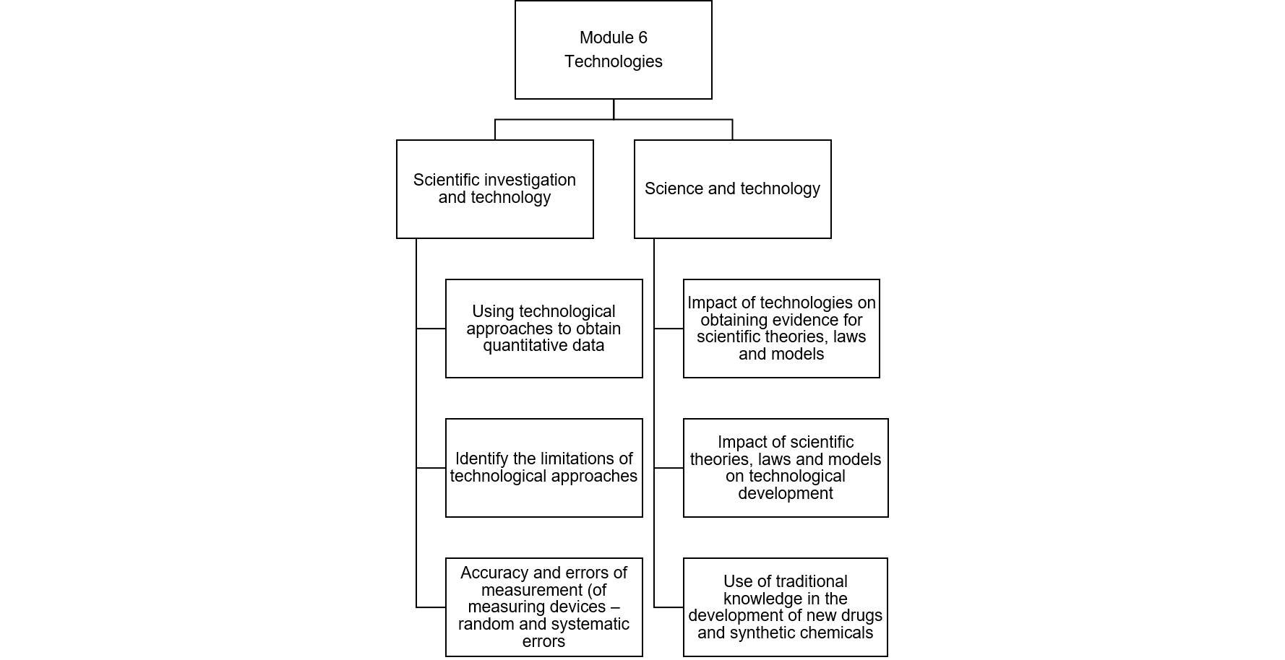

Relationship to other modules
The content in Module 6 is related the ideas discussed in Modules 5 and 8. Technology is often the product of scientific knowledge, and technology often enhances scientific investigations. Therefore, by teaching Module 6 after Module 5, students can develop a continuum of ideas, which deepen their understanding of the concepts discussed in both modules. The impact of science and technology on society, as well as society’s influence on scientific research and technological development, connect Modules 6 and 8.

Big ideas
- Technology encompasses both physical products (for example, instruments) as well as the procedures used to achieve purpose-driven outcomes (for example, biotechnology). Technological developments are non-natural (that is, they are the result of human intervention).
- Technology pre-dates science.
- Technology and modern science co-exist in a continuous cycle.
- Technology may have both positive and negative consequences for people and the environment. Both have benefitted human societies (for example improvements in health and lifespan, as well as communications). The use of technology may be detrimental for the environment (for example, through the depletion of natural resources, or causing environmental pollution). Decisions on the use of any technology must rely on cost-benefit analyses.
- The advancement of science and technology is often determined by societal factors, such as economic and political demands.

Core concepts

Impact of technology on scientific investigations
- Technology can be difficult to define. Some simple definitions of technology include:
- technology is anything made by humans, as opposed to things made by nature.
- tools humans can make to help them adapt to and succeed in their natural environment.
- anything not made by nature.
- This definition of technology, indicated in point 1 above, is not sufficient. It must be extended to include processes that we use to develop products to live in our environments. For example, genetic engineering refers to a set of procedures used to transfer genes from one organism into another. Genetic engineering is a technology. This can create interesting conundrums in science – for example, is a genetically-modified fruit natural or artificial?
- Taken together (points 1 and 2 above), it is evident that technology is more than applied science. Technology is a collection of techniques, skills, methods, and processes used in the production of goods or services or in the accomplishment of objectives, such as scientific investigation (Wikipedia).
- Science and technology differ in their forms of inquiry, in their objects of knowledge, in their values and goals. Table 1 provides an overview of the main differences between science and technology.
Table 1 – table describing the differences between science and technology
Characteristics | Science | Technology
Questions | Questions are about natural phenomena and the natural world | Questions relate to the problems of human adaptations to environments
Approach | Inquiry-driven | Problem-solving
Knowledge developed | Scientific knowledge seeks to develop explanations of natural phenomena | Solutions to the problems of human adaptations

Conducting scientific investigations – the impact of technology
- The syllabus stipulates that students design and conduct several investigations. At a minimum, students should explore:
- the effect of temperature on reaction rate
- the effect of temperature on the volume of gas
- the effect of speed on distance travelled
- the effect of pressure on the volume of gas
For each of those experiments, students should be able to describe:
- the design
- aims
- hypotheses
- materials and methods
- strategies for presenting and analysing data
- variables
- independent, including how it will be varied and measured
- dependent, including how it will be measured (taking into account the accuracy and reliability of measurement)
- Controlled, including how they will be kept consistent in the investigations
- types of quantitative data (including graphs): the data collected should be relevant to the hypothesis, as well as the data collection approach used in the investigation (for example, the equipment used)
- variables that are represented on the axes
- the shapes of the curve, including an explanation for those shapes (see Appendix 1)
- Explain how technological approaches can improve outcomes (for example, use of temperature probes, accelerometers, colourimeters and digital pressure sensors), including the accuracy of the devices (extension: discuss the limitations as well). See Practical Activities.
- Explain how random and systematic errors affect the outcomes.
- Random errors – unpredictable errors of measurements (devices, people, environment): deviation from the true value by random amounts in random directions.
- Systematic errors – a ‘constant’ error in measurement (usually in measuring devices – for example, devices not ‘zero-end’); deviation from the true value by a fixed amount in the same direction.
- Identify risks and hazards associated with using the technologies used in the experiments, and suggest strategies to mitigate or eliminate the risks. The Department has produced resources and templates that may support instruction on performing risk assessments in the classroom.
Table 2 – comparison of the features of digital and analogue measuring devices
Features | Digital devices | Analogue devices
Readouts | Easy | Can be complex and subject to error (for example, parallax)
Construction | Few moving parts – contributes to the accuracy of measurement | Many moving parts – more opportunities for errors of measurements
Cost (comparatively) | Cheap – electronic parts are less costly. However, digital devices are expensive to repair | Expensive – many working parts to be assembled. Repair costs are relatively cheap
Recording | Data can be recorded/stored for later use | Data recording/storage is not possible
Data analysis | Data may be fed from the device to a computer directly for subsequent analysis with analytical software | The direct transfer of data to a computer is not possible

Collecting evidence for scientific concepts
- Technology enhances scientists’ efforts to gather evidence for scientific ideas (theories, laws and models):
- Earth’s geological history. Many of the geological processes that shape the planet are not visible or easily understood. Computer modelling is a technological approach that allows scientists to ‘visualise’ geological events that would normally occur over long periods. Computerised geological models are constructed using data from geology, sedimentology, stratigraphy, climatology, radiometric measurements and palaeomagnetism. It allows scientists to determine past geological activities that have given rise to the features of modern-day Earth. These models also predict future geological events, such as earthquakes, volcanic eruptions, and changing climatic conditions. Computer models have also identified deposits of oil, gas, groundwater and other resources that of economic value.
- Structure of DNA. X-ray diffraction: a method for determining the three-dimensional shape and structure of chemical substances. Crystals of a substance are bombarded with X-rays, which hit the crystals, bounce off, and produce a diffraction pattern on a detector. The pattern of the spots produced on the detector provides information about the molecular structure.). While the chemical analyses of DNA provided clues to the chemical makeup of the molecules, the structure of DNA could not be determined until X-ray crystallographic data were obtained. This discovery enhanced our understanding of molecular genetics. This video shows how diffraction patterns provide information on molecular structure.
- Structure of the atom (Rutherford’s experiment). Development of equipment to detect radioactivity (precursor to the modern Geiger counter). The device was invented to investigate radioactivity, but in Rutherford’s lab, experiments using this equipment led to a better understanding of the structure of the atom, that is, the nucleus. The Geiger counters were used to determine the deflection of radioactive alpha particles after the latter collided with atoms. This discovery fundamentally changed our understanding of the structure of the atom (and proved that the plum-pudding model of the atom, proposed by J.J. Thompson, was incorrect). X-Ray Diffraction of DNA.f4v (duration 3:52) shows a recreation of Rutherford’s experiment, while, in The Discovery of the Atomic Nucleus (3 of 15) (duration 3:27) Brian Cox retells the same story.
- Discovery of the Higgs boson. The large Hadron Collider (LHC) is a technologically-advanced facility that is used to study hadron collisions. The LHC uses high powered electromagnets to accelerate protons to the speed of light (approximately) in a circular tunnel. The tunnel is cooled with liquid helium to temperatures just above absolute zero. Multiple layers of detectors are used to detect the products of the collision, and the large volumes of data are processed by the Grid (a collection of computers in 36 countries). These technologies enabled scientists to discover the Higgs boson. The Higgs boson is difficult to detect because it is a heavy particle. High energy proton collisions (1.18 TeV) are required to observe the Higgs boson, a feat only possible because of the technological developments at CERN. In Higgs Boson Discovery Wins Nobel Prize for Physics (duration 5:45), Brian Greene explains the Higgs Boson and describes the LHC experiment.

Impact of scientific knowledge on technological developments
- Scientific understanding has been the cornerstone of many technological advances, including:
- The laws of refraction and reflection on the development of microscopes and telescopes. Initial telescopes were refracting telescopes, based on the refraction of light through glass lenses. Understanding concepts such as real/virtual images, focal lengths improved the construction of telescopes. Refractive telescopes were plagued with chromatic aberration. Understanding the reflection of light allowed the development of telescopes that used mirrors (Figure 1). Mirrors improved the quality of images and allowed larger telescopes to be built. The Hubble telescope is a double mirrored reflecting telescope and allows scientists to peer further into the universe. See Appendix 3 for a historical account of the relationship between the science of optics and the development of telescopes. The use of finely-ground lenses in optical microscopes (Figure 2) have allowed biologists to discover the secret lives of cells.
Figure 1 – comparison of refracting (left) and reflecting (right) telescopes
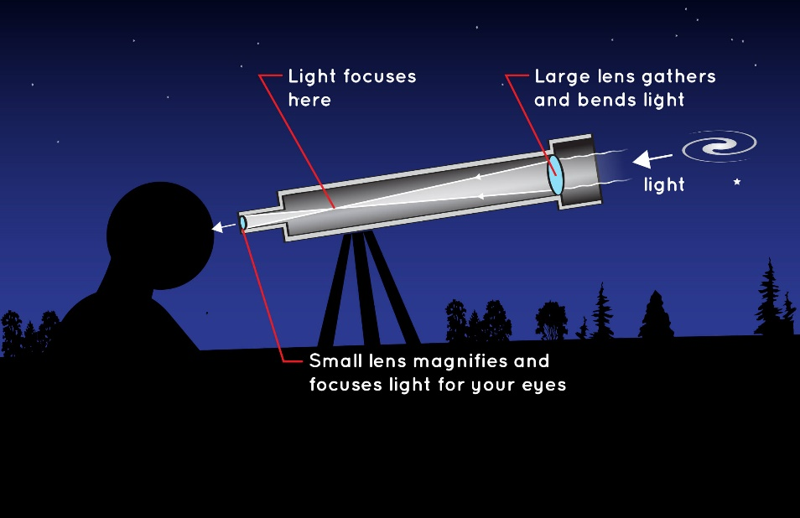 | 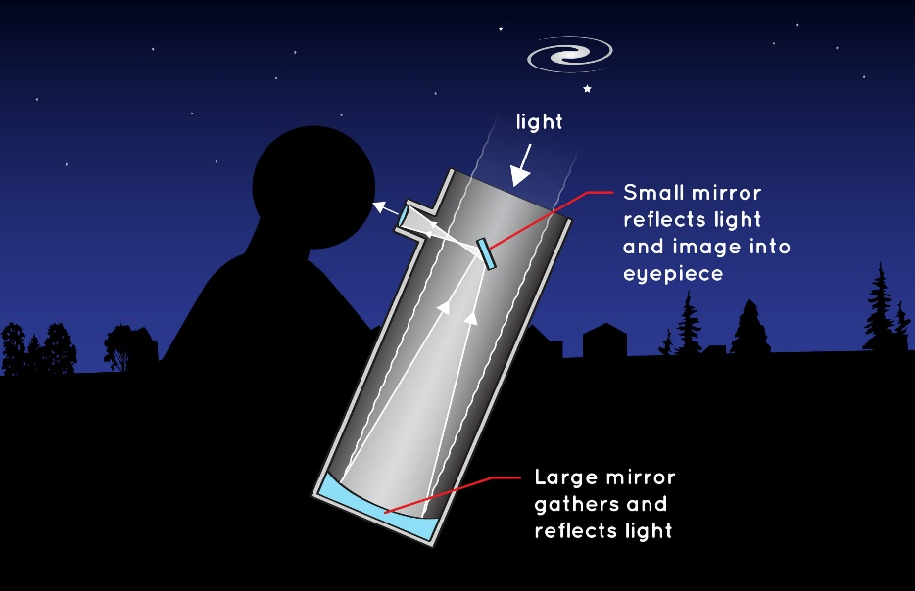
Image credit: NASA.
Figure 2 – image showing how lenses in optical compound microscopes enlarge images. Light rays from the object is refracted by the objective lens to create an inverted image. The eyepiece lens then creates a virtual image from the inverted image. The virtual image is magnified many times, compared to the inverted image. Modern compound microscopes can achieve magnifications of x1000 (with oil immersion lenses).
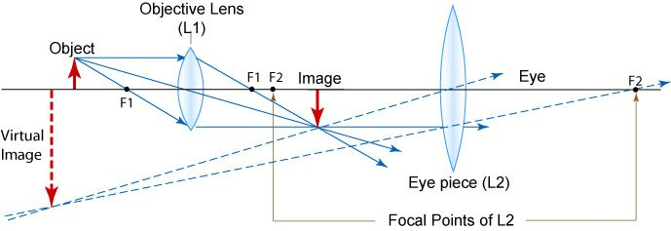
Image credit: Cellinlife.
- Radioactivity and radioactive decay on the development of radiotherapy and nuclear bombs. Studies on radioactivity indicated that some atoms could release large amounts of energy from their nuclei, either in the form of high energy particles or high energy electromagnetic radiation. The effect of radioactivity on living tissues indicated that some types of radioactive emission can be damaging, while others were relatively harmless. Hence, low energy radiation is used for medical imaging, while high energy radioactivity is used to destroy the genetic material of tumours. Other discoveries indicated that unstable nuclei in some elements may be ‘broken down’ in uncontrolled cascading reactions, such as nuclear fission. Large amounts of energy (heat, light and electromagnetic) are released in such reactions. These observations have led to the development of nuclear bombs for military use.
- The discovery of the structure of DNA and the development of biotechnologies to genetically modify organisms. The structure of DNA is remarkably conserved. All living things use DNA as their genetic material, and the structure (the arrangement of the nucleotides in the DNA molecule) is the same in all species of organisms. The process by which genetic information is used is also conserved in all living things. Therefore, it is possible to ‘transfer’ desired genetic traits from one species of organisms to another artificially using recombinant DNA techniques. Collectively, these technologies are called biotechnology and have been used to address issues in medicine, agriculture and biodiversity conservation.
- Newton’s laws and the technology required to build buildings capable of withstanding earthquakes. Newton’s laws of motion describe the interaction between forces and objects. Newton’s developed three scientific laws that described the relationship between forces acting on objects and the motion of objects. He also developed the idea of gravity, which is an attractive force between objects. He provided a mathematical description of gravity. These scientific laws form the basis of many technological developments, such as the construction of earthquake-resilient buildings. Engineers use force calculations to determine the loads experienced by buildings during earthquakes. Using that knowledge, they develop engineering solutions to resist the forces acting on buildings. Understanding the action of forces on buildings has led to advancements such as materials capable of withstanding those forces, as well as dissipating the energy arising from the land movements. Appendix 2 provides an in-depth discussion of Newton’s Laws and their impact on the development of earthquake-resilient buildings.

Aboriginal and Torres Strait Islander peoples developed an extensive knowledge base of medicinal uses of plants.
There are ethical issues associated with the commercialisation of Indigenous knowledge, particularly with patenting medicinal products derived from these plants. Table 3 below summarises how Aboriginal and Torres Strait Islander peoples have used some native plants for medicinal uses.
Table 3 – this table summarises the medicinal use of native plant products by Aboriginal and Torres Strait Islander peoples
Common name | Scientific name | Traditional uses in Aboriginal and Torres Strait Islander communities
Kangaroo apple | Solanum aviculare Solanum laciniatum | The active ingredient is an alkaloid (solanine) – used poultice on swollen joints. The alkaloid functions as a steroid
Wattles | Acacia spp | Rheumatism; Indigestion
Old man’s weed | Centipeda cunninghamii | Eye and chest infections; skin complaints; colds and coughs; chest infections; strengthen immunity – ingested as water extract or rubbed onto the skin
Drooping she-oak | Allocasuarina verticillata | Rheumatism – external use
Hop bush | Dodonaea viscosa | Juice of roots used to treat toothaches and cuts
- Bioprospecting refers to the search for medicinal or other biologically-active products from native plants. Aboriginal and Torres Strait Islander peoples have accumulated a deep knowledge base of the medicinal uses of native plants, and this knowledge will be very useful for bioprospecting. However, is it ethical to benefit economically from such knowledge if those plant products are commercialised? Some companies have developed partnerships with indigenous communities for the commercialisation of medicinal and bioactives from native plants. These partnerships ensure that the commercial agreements allow for the ethical use of indigenous knowledge, the sustainable use of the plants and for the economic benefits of the operation to benefit local societies. One such example is the commercialisation of the Kakadu plum, which is a good source of vitamin C.
- The parts of many plants (roots, stems and barks) were used to make fibres, which were, in turn, used to make ropes, bags, baskets and mats. They were also used to make tools, such as spears, shields, clubs and boomerangs. Softer parts of plants, such as the sap, were used for the manufacture of gums and resins. The Australian Institute of Aboriginal and Torres Strait Islander Studies and the Australian National Botanic Gardens websites host publications on this topic.

Opportunities for extended concepts
One possible area for an extension is to explore the scientific basis of technological developments. The notion that technology is applied science is strong among students. This relationship can be explored by examining the scientific principles behind a modern technology (for example, Wi-Fi technology). An influential paper published in 1967, suggested that the scientific basis of technology may not be as large as previously thought. In that research, investigators at the US Defense Department examined the impact of scientific discoveries on the development of weapons technology after World War II. According to their research, only 0.3% of the technological developments could be attributed to undirected science (science that was not specifically directed at developing weapons-related technology). However, the investigators also noted that without the developments in classical mechanics, thermodynamics, electricity, magnetism, relativity and quantum mechanics, the modern defence industry would not exist.
- Another area for extension would be time taken for scientific discovery to precipitate technological development, as well as the causes for the length of time taken. For example, students could investigate the development of mobile phones (wireless technology) from the discoveries of electromagnetism and communication technologies. Students could also explore the commercial use of genetic technologies from the early discoveries in molecular genetics.

Alternative conceptions and misconceptions
Some misconceptions and alternative conceptions on the content covered in this module concern the relationship between science and technology. These include:
- Science and technology are one and the same. Although there is significant overlap between these, there are instances where the technology may not be based on scientific principles and vice versa)
- Technologies are developed simply by applying science ideas (technology does not always evolve from scientific discoveries – in some instances, the reverse has been true)
- The goal of science is to create new technologies – the false notion that if a scientific discovery does not lead to a technological outcome, then it is worthless. This devalues basic science research.
Other alternative conceptions that teachers may encounter include:
- Technologies are physical devices (and not processes)
- Technological solutions, such as electronic measuring devices, are always better than traditional approaches (for example, analogue measuring devices). These misconceptions may relate to the accuracy and reliability of technological devices or solutions

Conceptual difficulties
Students’ conceptions of technology may be limited objects such as machines and electronic devices. As described in the core concepts, students should be taught that processes and procedures may also be technological developments. The latter definition helps to explain why some traditional knowledge, such as fire making, the use of fish traps and navigational methods are considered to be technological in nature. Modern science is exploring the use of Aboriginal and Torres Strait Islander peoples’ knowledge for further development to benefit all.

Suggested teaching strategies
This module follows naturally from Module 5. In module 5, students explore the principles of scientific research. In module 6, they examine how technologies may develop from scientific discoveries, and, in turn, scientific discoveries are enhanced by technology.
Instruction in this module may begin with uncovering students’ misconceptions and alternative conceptions about science and technology. This may then proceed to discussions about technological developments that were not based on scientific discoveries (students may find this difficult, as modern science and technology are closely intertwined) and students may be reminded that before the Age of Enlightenment (Renaissance), scientific discoveries lagged technological developments. In the ancient world, developments in construction, warfare, textiles, agriculture and metallurgy were not based on scientific discoveries.
After conducting experiments to investigate the benefits of technology in research (for example, improved accuracy, reduced error, data collection), discuss how scientific knowledge was used to develop the technology (for example, how the concept of pH to measure acidity lead to the development of the pH probe). After that, discuss what additional knowledge was required to develop the pH probe (for example, the electrical conductivity of solutions, the development of electronics and the development of conductive glass). In some cases, information that is not derived from scientific investigations is required for technological development. For example, assistive technologies require an understanding of human behaviour.
Explain to students that the goals and approaches of science and technology (engineering) are different. Science is based on inquiry and seeks to develop explanations of natural phenomena, while technological developments rely on problem-solving approaches that develop solutions to human adaptations to the environment. Despite this, science and technology inform each other.
The development and use of indigenous knowledge can be discussed using case studies (some examples are provided in the ‘resources’ section below. A key idea is that indigenous knowledge, which is often experiential and not based on Western scientific principles, provides a deep knowledge base to develop solutions for some of the problems in our society. However, the use of this knowledge must be done ethically, in partnership with Aboriginal and Torres Strait Islander communities, so that the benefits of such endeavours are realised by all.
To further develop students’ understanding of experimental design, it may be worthwhile to analyse the design of different types of investigations. The templates provided in Appendix 4, Module 5, may assist students with the design of the experiment. In their analysis, students should evaluate the impact of technological approaches that may enhance the outcomes of the investigations. An example of this is provided below:
A student carried out a practical investigation to determine the effect of changes in temperature on the reaction rate. Four strips of magnesium were placed into four equal-sized test tubes containing equal volumes of acid at different temperatures as shown.
Figure 3 – diagram of an experiment to determine the effect of temperature on reaction rate
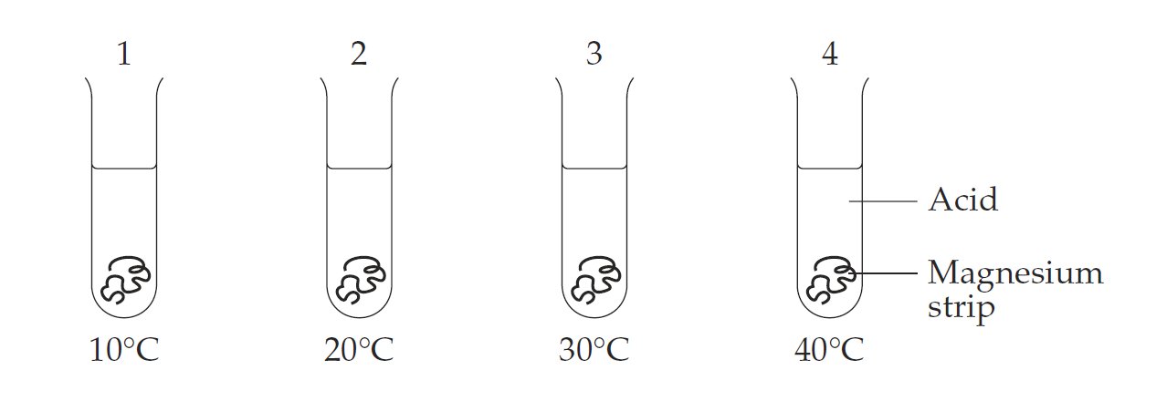
Image credit: NESA
Possible areas for discussion with students:
- Justify the use of a named piece of technology that could be used to measure changes in the independent and dependent variables.
- Describe how the student could use both primary and secondary data to determine the reliability of the results obtained.
- Discuss the validity of the design of the investigation.

Depth studies
Depth studies based on this module can focus on technological developments, as well as the relationship between science and technology. Specifically, students can explore the scientific principles behind modern technologies (for example, space research, biomedical engineering, computer modelling). Also, they can examine the non-scientific information used in the development of the technology, the time lag between the scientific discovery and the technology development, as well as the enhancement of scientific research facilitated by the technology. Students can also explore the negative aspects of technology, such environmental damage (for example consumer electronics), or the inequality of access to technology (such as biomedical devices).
Students can also perform depth studies on how indigenous knowledge can be used to address issues in our society, particularly with technological development. They can look at successful partnerships between governmental, non-governmental and industry partnerships with Aboriginal and Torres Strait Islander communities in areas such as bioprospecting and the development of new pharmaceuticals. The Environmental and Zoo Education Centres in NSW may offer educational programs on indigenous knowledge, which may form part of Depth Studies based on this Module.
- How earthquakes affect buildings . A learning activity/investigation that may be used in the classroom. This resource includes teacher notes.

Practical activities
For module 6, the syllabus specifies several investigations that may be carried out, particularly with the design and conducting of experiments. Students also need to examine the impact of technology on scientific investigations, especially analysing and evaluating data, identifying random and systemic errors, accuracy, and the difference between analogue and digital technologies. Students should assess the risks associated with conducting scientific experiments, including the risks and hazards of technologies used. The Department has produced resources and templates that may support instruction on performing risk assessments in the classroom.
The resources listed below indicate internet resources for the investigations described in the syllabus (these may be used to supplement first-hand investigations or may be used in place of them if resources are not available).
- The effect of temperature on reaction rate
- Effect of temperature on the rate of reaction
- Reaction rate and temperature
- The effect of temperature on the volume of gas
- Introduction to gas laws
- Gas Law simulator
- Collecting gases produced in chemical reactions (duration 1:31)
- The effect of pressure on the volume of gas
- Overview of the relationship between gas volume and pressure(duration 1:04)
- The relationship between speed and distance
- Overview of motion
- Random and systemic errors
- Random and systematic error (duration 5:51) – overview of errors of measurements
- Precision, Accuracy, Measurement, and Significant Figures (duration 20:09)
- Overview of analogue and digital technologies

Resources
The following resources may be used to demonstrate how computer simulations are used to study Earth’s geological history.
- Computer modelling of Earth's mantle flow, plate motions, and fault zones.
- Geologic modelling.
- Top 10 Aboriginal bush medicines article by Australian Geographic.
- Aboriginal plant use and technology by Australian National Botanic Garden Education Services.
- Combating earthquakes: designing and testing anti-seismic buildings – article on building design for earthquake resistance and Newton’s laws by the European Journal for Science Teachers.

Appendices

Appendix 1 – understanding graphs
In Investigating Science, students should be able to draw and interpret simple graphs. Two simple relationships that students should understand are proportional (linear) and reciprocal (inverse) relationships between variables. This is summarised in Table 4:
Table 4 – comparison of the features of linear and inverse relationships between variables
Type of relationship | Example | Type of curve (graph)
Linear | The pressure of a gas is proportional to its temperature (P α T) | Straight-line – the slope of the line may be positive or negative, depending on the type of linear relationship
Inverse | The pressure of a gas is inversely related to its volume (P α 1/V) | Hyperbolic curve

Mathematical principles
Linear relationships between variables can be positive (y α x) or negative (y α –x). The graphs depicting these relationships are shown in the Figure 4.
Figure 4 – graphs of negative (left) and positive linear (right) relationships between variables
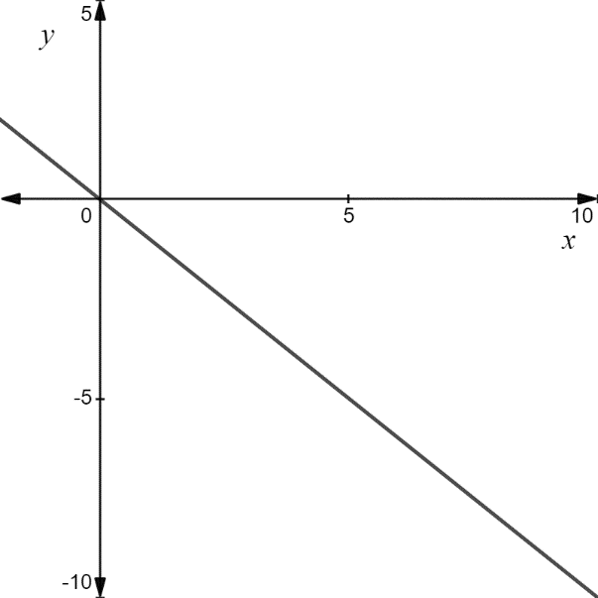 | 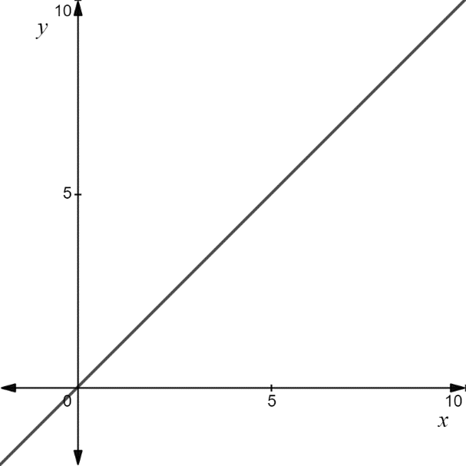
Therefore, all proportional relationships (no matter whether they are positive or negative) are represented as linear graphs. Conversely, a linear graph indicates that a proportional relationship exists between the dependent and independent variables.
Linear graphs can be extrapolated to predict outcomes that have not yet been measured in investigations.
Inverse relationships may be difficult to visualise. For example, for the relationship y α 1/x, the graph is a hyperbolic curve. This is shown in Figure 5.
Figure 5 – graph of an inverse function (1/x)
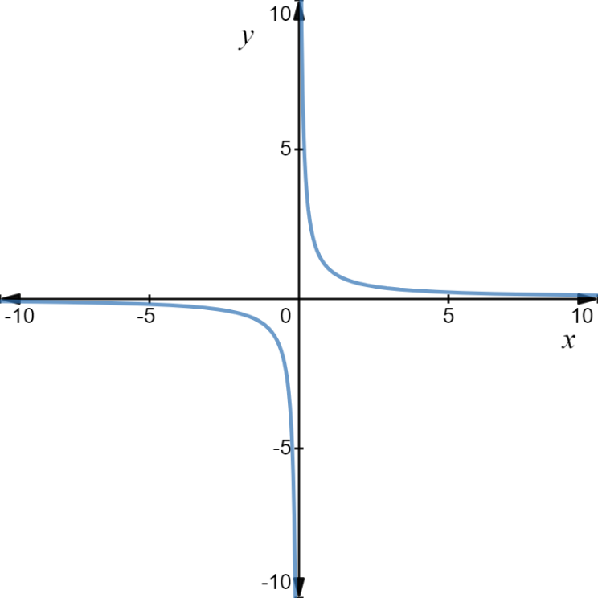
Hyperbolic graphs are complex and non-intuitive. It is easier to visualise linear relationships. Hyperbolic graphs can be converted into linear graphs. To do this, one variable is plotted against the inverse of the other variable. For example, if y α 1/x, then y is plotted on the vertical axis, while 1/x is plotted on the horizontal axis. To summarise,
For $y ∝ \frac{1}{x}$
- Plotting y versus x produces a hyperbolic graph.
- Plotting y versus 1/x produces a linear graph.

Working with gas laws
According to the behaviour of gases, the pressure exerted by a gas is directly proportional to its temperature.
Consider an investigation into the relationship between the pressure and temperature of a gas. The result of such an investigation is shown in the following Table 5:
Table 5 – table showing temperature and pressure data for a gas
Temperature (°C) | Pressure (kPa)
-150 | 36.0
-100 | 46.4
-50 | 56.7
0 | 67.1
50 | 77.5
100 | 88.0
A plot of pressure (dependent variable) against temperature (independent variable) is shown in Figure 6.
Figure 6 – graph of the data shown in Table 5
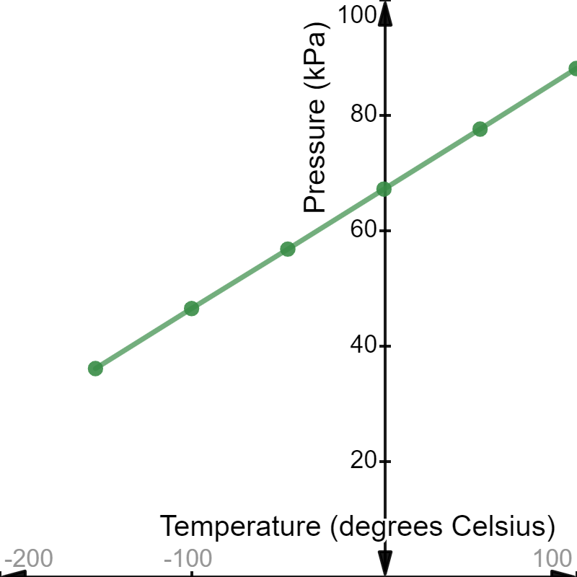
The plot shows a linear graph, indicating that the pressure of the gas is proportional to its temperature. This is mathematically represented as
$$P ∝ T$$
The investigation was extended to determine the relationship between the pressure of the gas and its volume. The following data were obtained:
Table 6 – table showing volume and pressure data for a gas
Volume (L) | Pressure (kPa)
5.0 | 39.0
10.0 | 193.5
15.0 | 13.0
20.0 | 9.8
25.0 | 7.8
30.0 | 6.5
Plotting pressure (dependent variable) against volume (independent variable) produces the graph shown in Figure 7:
Figure 7 – graph of the data shown in Table 6
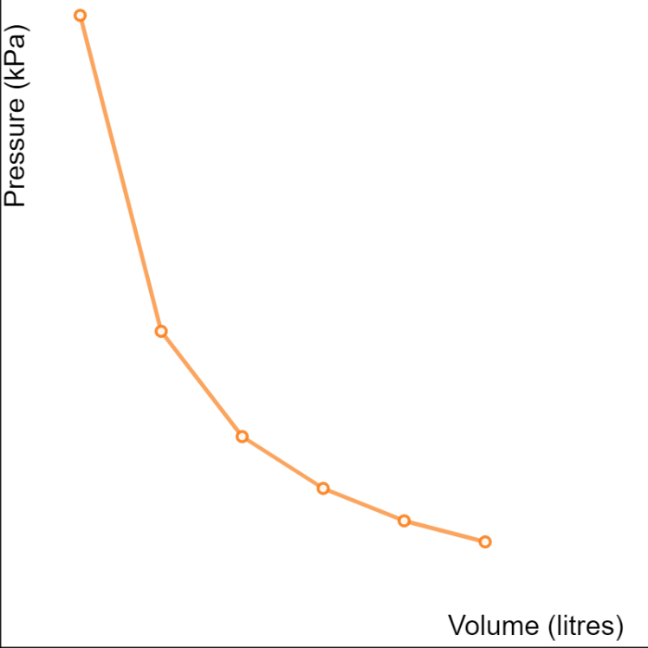
The plot shows a hyperbolic curve. To convert it into a linear graph, a second plot is made: pressure versus 1/volume. The data is shown in the Table 7:
Table 7 – this table is a modified form of Table 6 and includes the 1/volume calculation
Volume (L) | 1/volume (L⁻¹) | Pressure (kPa)
5.0 | 0.20 | 39.0
10.0 | 0.10 | 193.5
15.0 | 0.07 | 13.0
20.0 | 0.05 | 9.8
25.0 | 0.04 | 7.8
30.0 | 0.03 | 6.5
The plot of pressure (dependent variable) against 1/volume (independent variable) is shown in Figure 8:
Figure 8 – graph of the data shown in Table 7
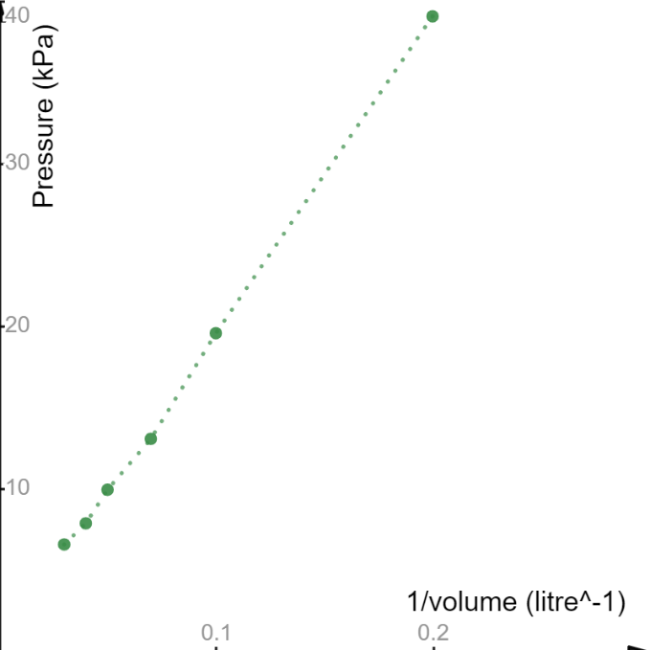
The linear graph between the variables indicates that there is a proportional relationship between the dependent and independent variables. Mathematically, this is represented as
$$P ∝ \frac{1}{V}$$
Where,
P = pressure
V = volume

Analysing the motion of objects
When describing motion, scientists often define variables such as distance, speed and acceleration. After completing Stage 5 science, students are expected to be able to use these terms, as well as the mathematical relationships between them:
$$speed= \frac{distance}{time}$$
$$acceleration= \frac{speed}{time}$$
Students should also be competent in the graphical analysis of motion. For example, students should be able to plot and interpret distance-time and speed-time graphs. In their analysis, they should be able to describe both uniform and non-uniform motion.

Extended concepts of motion analysis
Although the following concepts are not essential, they may be useful for developing students’ mathematical thinking skills. Motion graphs can furnish additional information about the motion of an object, as indicated below:
- On a distance-time graph,
- Slope (or gradient) equals speed.
- The "y" intercept equals the initial distance.
- Straight lines imply constant speed.
- Curved lines imply acceleration.
- An object undergoing constant acceleration traces a portion of a parabola.
- Instantaneous velocity is the slope of the line tangent to a curve at any point.
- Positive slope implies motion in the positive direction.
- Negative slope implies motion in the negative direction.
- Zero slopes imply a state of rest.
- The area under the curve is meaningless.
- On a speed-time graph,
- Slope equals acceleration.
- The "y" intercept equals the initial speed.
- Straight lines imply uniform acceleration.
- Curved lines imply non-uniform acceleration.
- An object undergoing constant acceleration traces a straight line.
- Instantaneous acceleration is the slope of the line tangent to a curve at any point.
- Positive slope implies an increase in speed in the positive direction.
- Negative slope implies an increase in speed in the negative direction.
- Zero slopes imply motion with constant speed.
- The area under the curve equals the change in distance.
- On an acceleration-time graph,
- The slope is meaningless.
- The "y" intercept equals the initial acceleration.
- An object undergoing constant acceleration traces a horizontal line.
- Zero slopes imply motion with constant acceleration.
- The area under the curve equals the change in speed.

Appendix 2 – Newton’s Laws and Earthquakes
The English scientist, Sir Isaac Newton, investigated many phenomena, such as light, the motion of objects and gravity. Newton concluded that motion may be described in terms of the forces acting on objects. These ideas were initially developed Galileo Galilee but were expanded and formalised by Newton. Newton developed three rules to describe the interaction between forces, objects and motion, which are now referred to as Newton’s Laws of Motion. These are:
- The First Law: all objects remain at rest or move with uniform speed unless acted upon by a force (the forces acting on the objects are imbalanced). This law is also called the Law of Inertia.
- The Second Law: The magnitude of the force acting on an object is equal to its mass multiplied by its acceleration. This law is often represented mathematically as $F=ma$.
- The Third Law: When an object exerts a force on another object, the first object will experience a force of equal magnitude (in the opposite direction to the initial force). This law is also described as ‘for every action, there is an equal and opposite reaction’.
Newton also described the force of gravity, which is an attractive force between objects. All objects on Earth experience Earth’s gravitational pull equally. Newton’s Universal Law of Gravitation is expressed mathematically as
$$F=G\frac{m_{1}m_{2}}{r^{2}}$$
Where,
G = the Gravitational Constant
m = the mass of the object (1, 2 indicates the two interacting objects)
r = the distance between the objects
All of these laws apply to buildings. Although buildings are stationary (fixed to the Earth’s surface), forces are acting on them (see Figure 9).
Figure 9 – diagram of the opposing forces acting on a building
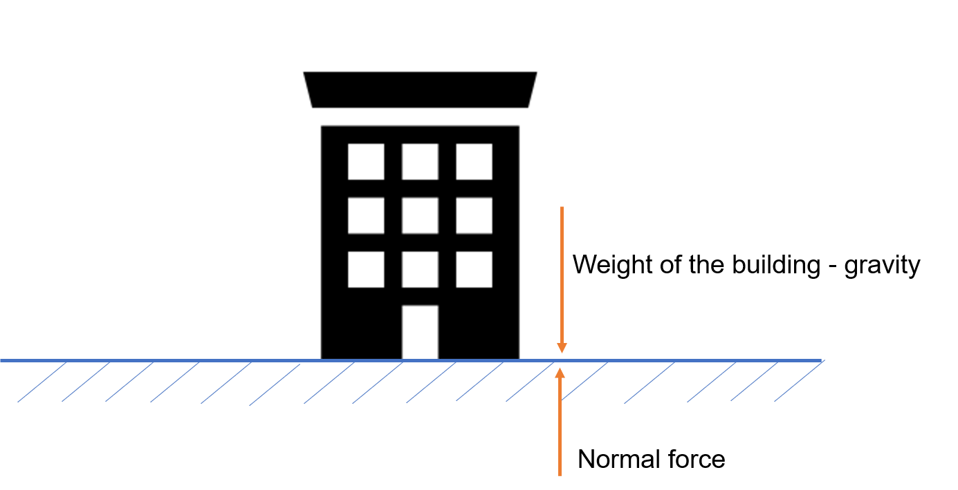
Since these forces are balanced, the building rests on the Earth’s surface (1st and 3rd Laws). The gravitational force acting on the building (that is, the weight of the building) is determined using Newton’s Law of Gravitation.
During seismic events such as earthquakes, the forces exerted by the Earth exceed the other forces acting on the building. Furthermore, the direction of the forces may also differ from the direction of the gravitational force (gravitational forces are directed toward the centre of the Earth). In the following example, the force generated by an earthquake runs parallel to the Earth’s surface (that is, perpendicular to the weight of the building).
Figure 10 – diagram depicting the effect of surface waves generated by earthquakes on buildings
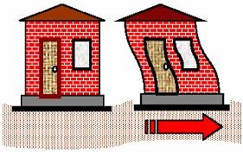
As a result of this force, the base of the building (foundation) moves along the direction of the force (since the foundation is attached to the Earth’s surface). However, the other parts of the building do not move with the foundation. This is due to inertia (Newton’s 1st Law). Consequently, the building topples (Figure 10).
Scientists and engineers have developed technological solutions to alleviate this type of damage to buildings. Base isolators (see Figure 11) absorb much of the force and movement generated by earthquakes.
Figure 11 – Left: Base isolators on earthquake-resistant buildings. Right: a model showing how base isolators protect buildings during earthquake-generated movement.
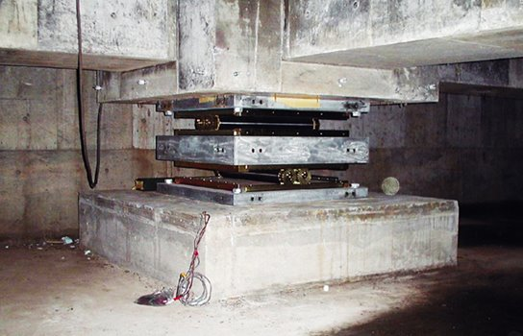 | 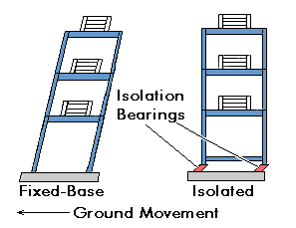
Image credit: Buildcivil (left) and Construction.org (right)
Building in earthquake zones may also experience forces that act in the direction of their weight (the main axis of the building). Several technological solutions, such as sheer walls, cross-beam and seismic dampers, have been developed to improve the resilience of buildings in earthquake-prone areas (Figure 12).
Figure 12 – diagram showing technological developments that improve the earthquake resilience of buildings
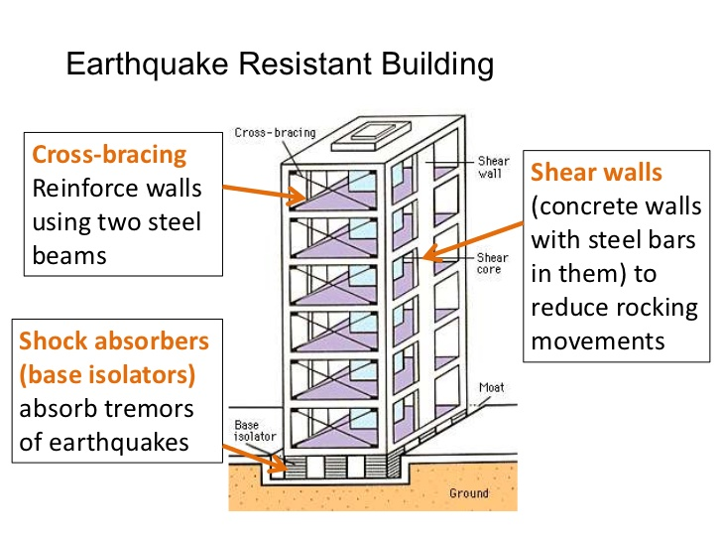

Appendix 3 – the history of optics and telescopes
The development of optical devices, such as spectacles, microscopes and telescopes, generally preceded the development of the science of optics. It is thought that the glassmakers of Italy (Venice) developed the technology for making different types of glass objects. By the 12th century, spectacles were in common use. Telescopes were invented three centuries later. When Galileo peered into the heavens with his telescope and gathered evidence for a heliocentric solar system, science underwent a transformation that set it on the path to modernisation.
The development of optical technologies was not based on advances in optical science. Indeed, much of the early works on the nature and behaviour of light were generally philosophical in nature. The Roman polymath Ptolemy wrote about the nature of light, where he described phenomena such as colour, reflection and refraction. However, the Persian scholar, Ibn AL Haytham, expanded on these ideas by conducting experiments on reflection and refraction (these were published as a seven-volume treatise, The Book of Optics). In his works, Ibn AL Haytham also describes the mathematical basis of the refraction of light, which later came to be known as Snell’s Law.
Before the invention of lenses, pieces of glass or quartz crystals were used to amplify light (as a crude magnifying glass). As glassmaking technology improved, spectacles were invented to improve failing eyesight, although the improvement was only marginal. 13th century Venice was the epicentre of glassmaking and spectacle manufacture in Europe. Further improvements in glass manufacturing (grinding) technology led to the development of convex and concave lenses for treating short- and long-sightedness. The next major advance came with the discovery that by using two lenses set at fixed distances apart, higher levels of magnification could be achieved. This discovery may have occurred in the Netherlands. Galileo used these devices for scientific investigations, including the studies of the solar system. Many of the early telescopes did not produce clear images of their targets because of defects in their lenses. One significant defect was the phenomenon known as chromatic aberration. Galileo worked with the glass manufacturers of Italy to develop finely ground lenses, which he used to construct his telescopes. It was the availability of such lenses that allowed other scientists to investigate phenomena such as refraction (Snell’s Law) and reflection.
European glass manufacturers also developed highly polished surfaces for mirrors. Isaac Newton used these highly polished mirrors to develop reflecting telescopes. Since these telescopes did not use objective lenses, more light was captured by those instruments. Furthermore, they were not affected by chromatic aberrations. Currently, the largest reflecting telescope is the Gran Telescopio Canarias in the Canary Islands (Spain), which has a diameter of 10.4 metres. However, the largest refracting telescope still in use is the Yerkes Observatory, which has a lens diameter of 102 centimetres.

References
This resource contains NSW Curriculum and syllabus content. The NSW Curriculum is developed by the NSW Education Standards Authority. This content is prepared by NESA for and on behalf of the Crown in right of the State of New South Wales. The material is protected by Crown copyright.
Please refer to the NESA Copyright Disclaimer for more information https://educationstandards.nsw.edu.au/wps/portal/nesa/mini-footer/copyright.
NESA holds the only official and up-to-date versions of the NSW Curriculum and syllabus documents. Please visit the NSW Education Standards Authority (NESA) website https://educationstandards.nsw.edu.au and the NSW Curriculum website https://curriculum.nsw.edu.au.
Investigating Science Stage 6 Syllabus © NSW Education Standards Authority (NESA) for and on behalf of the Crown in right of the State of New South Wales, 2017.

Further reading
History of Optics and Lenses. History of Optics-From Ancient to Modern Optics.
“Ilardi V. Renaissance vision from spectacles to telescopes. American Philosophical Society; 2007.

© State of New South Wales (Department of Education), 2020
The copyright material published in this resource is subject to the Copyright Act 1968 (Cth) and is owned by the NSW Department of Education or, where indicated, by a party other than the NSW Department of Education (third-party material).
Copyright material available in this resource and owned by the NSW Department of Education is licensed under a Creative Commons Attribution 4.0 International (CC BY 4.0) license.

This license allows you to share and adapt the material for any purpose, even commercially.
Attribution should be given to © State of New South Wales (Department of Education), 2020.
Material in this resource not available under a Creative Commons license:
- the NSW Department of Education logo, other logos and trademark-protected material
- material owned by a third party that has been reproduced with permission. You will need to obtain permission from the third party to reuse its material.
Links to third-party material and websites
Please note that the provided (reading/viewing material/list/links/texts) are a suggestion only and implies no endorsement, by the New South Wales Department of Education, of any author, publisher, or book title. School principals and teachers are best placed to assess the suitability of resources that would complement the curriculum and reflect the needs and interests of their students.
If you use the links provided in this document to access a third-party's website, you acknowledge that the terms of use, including licence terms set out on the third-party's website apply to the use which may be made of the materials on that third-party website or where permitted by the Copyright Act 1968 (Cth). The department accepts no responsibility for content on third-party websites.

The term ‘human adaptation’ refers to the strategies used by human to live in their local environments, such as land management strategies for habitation and agriculture, resource use for everyday living and industry, as well as strategies to mitigate the effects of weather and climate systems.
Adapted from Gott, Beth. “The Art of Healing: Five Medicinal Plants Used by Aboriginal Australians.” The Conversation, 18 May 2019.
Sherwin, CW and Isenson, RS. Project hindsight. Science. 1967 Jun 23;156(3782):1571-7.
Note that some students may use the vector equivalents of these variables: displacement (distance) and velocity (speed).
Adapted from Elert, G. (2019).Graphs of Motion – The Physics Hypertextbook.
In geoscience, the surface waves are referred to as Love and Rayleigh waves. These are slow moving forces (they appear after the P and S waves have moved through an area) and are responsible for much of the physical damage caused by earthquakes.
Adapted from BuildCivil. (2019). Earthquake resistant building design – Seismic isolation.
Adapted from Mishra, Gopal. Earthquake Resistant Design Techniques for Buildings and Structures. The Constructor, 24 Sept. 2018
Huang, Peishi. “Earthquake Resistant Building Cross-Bracing Shear.” LinkedIn SlideShare, 21 Apr. 2009, slideshare.net/patdesy/managing-earthquakes/11-Earthquake_Resistant_Building_Crossbracing_Shear.

