Chemistry Module 2 –Introduction to Quantitative Chemistry

Contents
Teaching the Year 11 Modules 3
Course overview 4
Module summary 5
Big ideas 5
Relationship to other modules 6
Core concepts 7
Opportunities for extending concepts 7
EAL/D strategies 8
Misconceptions 8
Limiting reagents 8
Concentration 9
Gas properties 9
Writing and balancing chemical equations 9
Molar mass 9
Moles calculations 10
Concentration calculations 10
Gas laws 11
Suggested teaching strategies 12
IQ2-1 – What happens in chemical reactions? 12
IQ2-2 – How are measurements made in chemistry? 14
IQ2-3 – How are chemicals in solutions measured? 18
IQ2-4 – How does the Ideal Gas Law relate to all other gas laws? 23
Gay-Lussac’s Law 24
Boyle’s Law 24
Charles’ Law 25
Combined gas law 25
Avogadro’s Law 26
Ideal Gas Law 27
Further exploration of the gas laws 29
Appendix 1 – practical activities for the mole concept 30
Understanding the mole 30
A molar display 31
Appendix 2 – product comparison 32
Appendix 3 – gas constant units 34
References 36

Teaching the Year 11 Modules
The new Stage 6 Chemistry course was implemented in NSW schools beginning in 2018. This syllabus incorporates new content and learning activities such as depth studies. The syllabus is designed around inquiry questions and formal assessment tasks that emphasise the Working Scientifically skills. The Year 11 course focusses on developing student knowledge and understanding of the relationships between the structure and the properties of atoms and molecules using macroscopic, microscopic and symbolic representations. The Working Scientifically skills and processes are applied to predict outcomes by using physical, conceptual and mathematical models and assessing the limitations of models. Through scientific investigations, students identify and measure quantities of chemicals, leading to a deep understanding of different classes of chemicals including their structure, properties and trends. The role of energy as a driver of chemical change and the relationship between energy and matter are explored in Year 11 as the basis for understanding of chemical change in the Year 12 course.
As the syllabus is written as a series of inquiry questions and depth studies are a mandatory component of the course, pedagogies that promote student inquiry and deep learning should be employed in the chemistry classroom. New and challenging course content, along with the change in pedagogical approach were the catalysts for the preparation of these module guides for Stage 6. These guides are intended to assist teachers deliver the chemistry syllabus effectively by outlining the big ideas, core concepts, strategies for teaching the modules, uncovering alternative conceptions and providing strategies to address them and suggesting opportunities for extension. The guides support the teacher in facilitating the development of deep knowledge structures, such as the relationships between concepts. It is essential that teachers note that the module guides are not a substitute for the syllabus, but only support teachers to teach it. The module guides do not cover all aspects of the syllabus, as that was not within the scope of the project.
The information contained in these documents is correct at the time of publication. While every effort has been made to eliminate errors, any errors or omission that are identified after the release of these documents will be corrected and released as resource updates. It is recommended that teachers access Science Stage 6 for the latest version of these documents.

Course overview
The Chemistry Stage 6 Syllabus explores the structure, composition and reactions of and between all elements, compounds and mixtures that exist in the Universe. The course develops an understanding of chemistry through the application of Working Scientifically skills. It focuses on the exploration of models, the understanding of theories and laws, and the examination of the relationships between energy, matter and change.
The chemistry course enables students to interpret the interconnection between the nature and practice of science, and the knowledge of chemistry. The course addresses the discovery and synthesis of new compounds, the monitoring of elements and compounds in the environment, an understanding of industrial processes and their applications to life processes, our energy needs and uses, the development of new materials, and sustainability issues.
The fundamentals developed in Year 11, include:
- Knowledge and understanding of the :
- properties and structures of matter.
- relationship between observable properties and structures to trends in data and reactions.
- types and drivers of chemical reactions.
- role of energy in bonding within and between particles.
- the use of differing scales, measurements and specialised representations to explain scientific phenomena and chemical interactions.
- skills in making hypotheses and designing valid and reliable investigations.
- skills in conducting investigations, solving problems and explaining using cause and effect.
- constructing models, explaining phenomena using particle theory and discussing atomic models.
- conducting investigations by measuring and/or collecting relevant data and information from first-hand practicals and secondary sources and determining the accuracy, reliability and validity of data and information.

Module summary
In this module, students focus on designing and evaluating investigations that enable them to obtain quantitative data to help them solve problems related to quantitative chemistry. Students should be provided with opportunities to engage with all the Working Scientifically skills throughout the course.
Students are introduced to the quantitative nature of chemistry. Chemists must be able to quantify reactions in order to make predictions about yields and communicate with specific audiences for specific purposes using nomenclature, genres and modes unique to the discipline. Using the mole concept, students will have the opportunity to select and use appropriate mathematical representations to solve problems, make predictions and calculate the mass of reactants and products, whether solid, liquid or gas.
Students further develop their understanding of the universal language of chemistry. They are introduced to the idea that science is a global enterprise that relies on clear communication, international conventions, peer review and reproducibility.

Big ideas
- The underlying chemical structure of substances is a key factor in determining their properties.
- Chemical systems are described using models based on particle theory. Models are revised as new evidence becomes available.
- Chemical bonding and reactions occur in predictable patterns according to their atomic and molecular structures.
- Energy changes can instigate chemical reactions. The underlying structure of the chemicals determines how they react to energy changes.
- Patterns can be determined by making observations, conducting fair tests, analysing data, and explaining trends in observable properties of substances and the periodic table.

Relationship to other modules
Module 2 contains the foundational skills of quantitative chemistry. This underpins all subsequent modules with a range of calculations in each given content area.
Module 2 builds on the following content from module 1:
- IQ1-1 writing chemical formulae for inorganic compounds.
- IQ1-2 and IQ1-4 modelling and representations of chemical systems.
Module 2 focuses on:
- measuring quantities and scale.
- application of science to society, industry, the environment.
- relationships and links between: energy, systems and models, matter, scale and measurement in the context of chemical reactions.
The skills, knowledge and understanding developed in module 2 are required to understand the concepts investigated in modules 3 and 4. These include :
- Patterns in the periodic table and reactivity and making predictions.
- Energy and rates of reaction.
- Modelling and representations of chemical reactions at the symbolic, micro and macro level.
- Matter and collision theory.
- Application of the periodic table trends and patterns to predict reactivity.
- Application to rates of reaction and relating observations to interactions at the atomic level and collision theory.
- Energy and bonding and driving reactions.

Core concepts
Module 2 focuses on the shift from qualitative chemistry, the primary focus of chemistry in stage 4 and stage 5, to quantitative chemistry which is developed throughout stage 6.
- Students use a range of balanced chemical equations to explore and describe chemical changes in terms of the:
- mass of solids.
- mass and volume of liquids and gases.
- The mole is the interconnection between the number of particles and the mass of a substance. The mole is introduced as a new measurement strategy specific to chemistry and the stoichiometric calculations.
- Quantitatively explore liquid concentrations and gas calculations using appropriate mathematical relationships.

Opportunities for extending concepts
- Introducing more complicated stoichiometric relationships can provide additional experience in more difficult reaction types, for example long hydrocarbon chain combustion or redox reactions.
- Scenario-based problems for stoichiometric calculations which involve a range of problem-solving strategies will assist students engage with deeper levels of analysis for stoichiometric problems.
- Investigate the Van der Waals equation for non-ideal gases and compare to calculations of the Ideal Gas Law. Students can examine these differences in terms of particle theory and intermolecular forces of different gases.

EAL/D strategies
One of the most significant challenges in Module 2 is the large amount of new terminology that students are exposed to. It is important that students are explicitly taught the skills necessary to develop a glossary that can be consistently added to during Module 2 and in subsequent modules.
- Explore with students different methods of storing glossary terms, for example using physical flash cards or utilising one of the many digital flash card apps available (Brainscape, Cram, Quizlet, CheggPrep).
- Model for students how to define terms using their own words.
- Encourage students to use analogies and metaphors when appropriate and include diagrams/images.
Videos such as Stoichiometry - Chemistry for Massive Creatures: Crash Course Chemistry #6 can define this terminology. Regularly discussing terminology will reinforce learning. Sentence frames can assist in students constructing sentences independently. Formative assessments and short responses, designed to allow students to practice the use of technical language, linking ideas and constructing explanations and cause and effect relationships, should be frequent with feedback regarding student use of technical language and complex sentences.

Misconceptions

Limiting reagents
Students may believe that the limiting reagent is the one of lowest mass using the mass ratio not the mole ratio in the balanced chemical equation. This comes from the common knowledge of cooking recipes. For example, they may have learned a mass or volume ratio of flour to sugar in a pancake recipe. This is best demonstrated by using chemical reactions that show large differences when comparing the mass and mole ratios. For example, making sherbet using sodium hydrogencarbonate and citric acid:
$$3NaHCO_{3(aq)}+C_{6}H_{8}O_{7(aq)}→{Na}_{3}C_{6}H_{5}O_{7(aq)}+3CO_{2(g)}+3H_{2}O_{(l)}$$
Display the equation and ask the students how much of each ingredient is required to use all of the reagents. Students will probably assume a mass ratio of 3g of sodium hydrogencarbonate to 1g of citric acid. Allow the students to undertake the reaction and make observations of the quality of the product. This will have an excess of sodium hydrogencarbonate and result in a soapy taste. Pose the question of how to improve the quality of the sherbet. Guide students towards using the correct mole ratio of 3:1 and the subsequent calculation to obtain the mass ratio of approximately 1.3g:1g. Testing the product of this reaction will demonstrate the limiting reagent concept.

Concentration
Students may have an overreliance on the colour of a solution to indicate its concentration. Colourless solutions then present difficult situations for analysis. This can be addressed by using colourless solutions that can be tested. For example, sodium chloride or sucrose solutions can be tasted to give an indicator of their relative strength.

Gas properties
Students may have a misconception of gas properties when relating factors within the Ideal Gas Law. This will then cause problems when analysing a range of gas scenarios. This can be addressed through careful selection of gas law demonstrations that clearly articulate each gas law and how it relates to the Ideal Gas Law.
Conceptual difficulties

Writing and balancing chemical equations
For many students, this is experienced for the first time in module 2. Students can find this skill difficult to master. It is therefore critical to carefully scaffold the types of reactions used in class to develop student proficiency in balancing equations. In addition to the online simulations described in this module guide, several more concrete tasks can be undertaken. For example, the use of counters or symbols to represent atoms within molecules in a reaction.

Molar mass
Calculating accurate values for molar mass can be challenging, especially where polyatomic ions are involved. Students may miscalculate molar mass from incorrect interpretation of the molecular formula. For example, aluminium sulfate:
$${Al}_{2}{\left(SO_{4}\right)}_{3}$$
Students may misinterpret the formula using their mathematics knowledge where the integers in front of the symbols and/or parentheses is used to multiply the contents of the parentheses. Students could then interpret this as any combination of the following:
- One aluminium
- Two sulfur
- Four sulfur
- Two sulfate
- Four sulfate
- 12 sulfate
- Eight oxygen
- 12 oxygen
In the use of integers in Chemistry it is the value behind the symbol and/or parentheses which is used as the multiplier. To address this, it is important to carefully scaffold the types of compounds used to calculate molar mass, developing proficiency in simpler molecules, such as sodium chloride, before moving on to more complex arrangements.

Moles calculations
Moles are a novel unit to quantify chemical reactions to most students. This concept is central to all subsequent calculations and it is critical to establish proficiency in module 2. The calculation of moles is also dependant on the accurate balancing of chemical equations and calculation of molar mass. This concept can be illustrated using activities to produce mathematical and visual representations of a mole. These are described in IQ2-2 and appendix 1.

Concentration calculations
Students may have difficulty in interpreting different values of concentration measurements, for example weight per unit weight or volume. Products use different concentration measurements which are best suited to the product type, making direct comparisons is not always easy. This is addressed in IQ2-3. By fully expanding the mathematical representation of the concentration unit and allowing students to explore different concentration units in this way.

Gas laws
The gas laws can be difficult for students to apply. Individually they describe the relationship between two gasses. Each gas law then contributes to an understanding of the Ideal Gas Law. Students need to recognise the constants for each gas law and how this allows the derivation of the Ideal Gas Law, as described in this module guide.

Suggested teaching strategies

IQ2-1 – What happens in chemical reactions?
Students model chemical reactions and make comparisons with practical experiences and observations. By making quantitative measurements to support the theoretical calculations, students can discuss any variations.
This inquiry question could be integrated into the subsequent inquiry questions by taking the first content descriptor into
- IQ2 for solid reactions.
- IQ3 for liquid reactions.
- IQ4 for gaseous reactions.
The second content descriptor of balancing equations, stoichiometry calculations and solving problems is an ongoing skill practised at the time of each reaction being undertaken in this and all future modules.
There is also significant overlap between the following inquiry questions in module 2 and module 3. It may be helpful to consider combining these inquiry questions where appropriate. Some suggestions include:
- Balancing equations appears in both IQ2-1 and IQ3-1.
- Consider doing the practical activities for chemical reaction types described in IQ3-1 here. They are useful examples for balancing equations and moles calculations in IQ2-2.
- Consider doing the practical activities for rates of reaction in IQ3-3 here. The rates of reaction apply to each chemical reaction type covered in IQ3-1 which are also useful examples for balanced chemical equations and moles calculations.
Students can apply the Law of Conservation of Mass to reactions where they can readily measure the mass of the products and reactants. A problem arises when the mass of reactants and/or products are difficult to measure, for example reactions involving gasses. To address this, solid and liquid reactions need to be carefully introduced before moving on to gas reactions which are more difficult to accurately measure mass changes.
Laboratory activities and demonstrations of chemical reactions, such as between metallic carbonate and dilute acid or magnesium and hydrochloric acid, can create interest and provide an experiential basis for the study of later topics. They allow the students to successfully observe and measure change. To assist students with the concept of stoichiometry, it must be clearly related to the law of conservation of mass in chemical reactions. The PhET simulation balancing chemical equations can assist in making the concept clear and online tools can help students to self-check their work throughout this module. Use online assessment tools, for example Kahoot or Quizlet, to provide some formative feedback for students and encourage conversation on strategies for rapid visual analysis of reaction equations. This strategy is more thoroughly described in the module 3 guide.
The meaning of formulae in terms of molecules (rather than atoms) needs to be stressed so students begin to think "molecules" rather than "atoms," or "formula units" when they see a formula or interpret its meaning. This will greatly facilitate calculations encountered later in this module (percent composition and empirical formula) and stoichiometry problems, that continue throughout all modules. For example, the following reaction:
$${CaCO}_{3(s)}+{2HCl}_{(aq)}\overset{→}{}{CaCl}_{2(aq)}+{CO}_{2(g)}+H_{2}O_{(l)}$$
This is described as a reaction between one molecule of calcium carbonate and two molecules of hydrochloric acid to produce, not create, one molecule of calcium chloride, one molecule of water and one molecule of carbon dioxide.
This inquiry question requires students to apply quantitative calculations to solid, liquid and gaseous reactions. As each of the reactions are experienced through the remaining inquiry questions, students can develop a visual aid, to assist in the variety of mathematical calculations experienced. An example is illustrated following IQ2-2.

IQ2-2 – How are measurements made in chemistry?
Students model chemical reactions and make comparisons to practical experiences and observations. By taking quantitative measurements to support the theoretical calculations, students can discuss any variations where present.
Determining a correct molecular formula and accurately calculating molecular mass are the underpinning skills to all stoichiometric calculations. Students can use the periodic table to locate elements and use the atomic mass provided, multiplied by any multiplicative prefix in the molecular formula, to calculate the molecular mass. This can be validated using online molecular mass calculators. There are a multitude of online calculators which can support student learning in a wide range of concepts throughout this module and beyond. Some of these online tools can be found under the heading of Physics, as they regard gas laws as a Physics concept. Caution must be used to ensure these tools are used appropriately as a validation tool and not to avoid learning in how to undertake these calculations manually.
A critical feature of molecular mass calculations is to NOT multiply the molar mass of the compound by the mole ratio used to balance the reaction equation. For example:
$${CaCO}_{3(s)}+{2HCl}_{(aq)}\overset{→}{}{CaCl}_{2(aq)}+{CO}_{2(g)}+H_{2}O_{(l)}$$
In this chemical equation, the molar mass of hydrochloric acid is the sum total of hydrogen and chlorine, ignoring the “2” used in balancing this chemical equation.
The introduction of the mole concept can be very difficult for some students to conceptualise. Some suggested activities which provide an opportunity to visually explore the mole concept are included in appendix 1. A guide to evaluating scientific data is also available to assist with the discussion on this critical point.
There are several online simulation tools which can be used to support students with skill development in this module. Selected examples are linked throughout the remainder of this module guide.

The calculation for moles is represented by the equation:
$$n=\frac{m}{MM}$$
Where:
- n represents the chemical amount in moles.
- m represents the mass in grams.
- MM represents the molar mass grams per mol (gmol⁻¹).
Although it is best to ensure students are capable and confident with the algebraic rearrangement of this equation to calculate other values, this three member equation can be described using a triangle to aid student rearrangement of the equation:
Figure 1 – triangle representation of the mole calculation equation
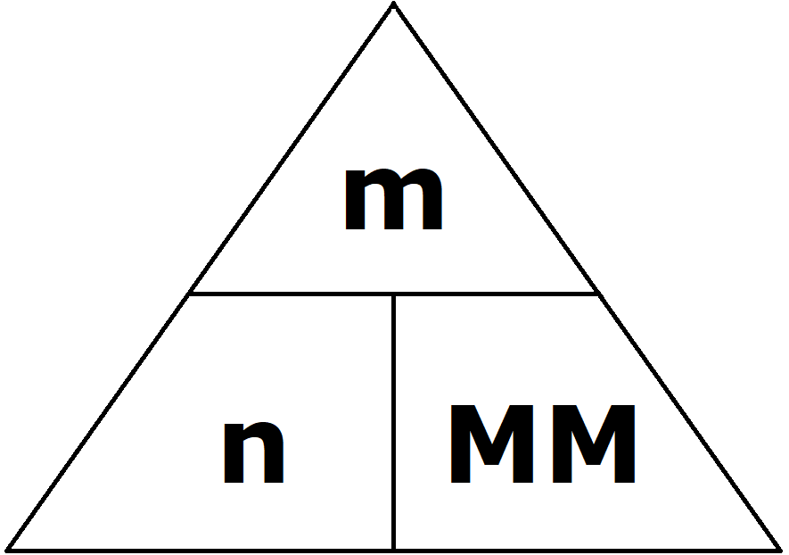
Using a finger to cover the subject of the desired equation gives the equation for the calculation needed. For example, to determine molar mass, covering MM leaves vertical alignment of variables:
$$MM=\frac{m}{n}$$
If calculating mass, covering m leaves adjacent alignment of variables.
$$m=n×MM$$

This is the time to ensure the concept of mole is developed and students understand particles as atoms and molecules and extend the idea to ions, electrons, and/or other entities ensures that students will not associate "mole" exclusively with the term "molecule". To explain the idea of an abstract concept like mole using a concrete practical activity (see appendix 1), with basic math and measurement skills, assists the students in developing their quantitative understanding of mole. The significant magnitude of Avogadro’s number is difficult for students to comprehend. It often helps to create a link with a range of non-chemical analogies to assist students in learning mole calculations and reinforcing the idea of just how small an atom really is:
6.022x10²³ molecules per mole, equivalent to
602,200,000,000,000,000,000,000 or 602 sextillion, 200 quintillion
A visualisation can be created to show this magnitude by using familiar objects and calculating the size of a mole of these object, for example marbles:
- Each marble has a volume of 1cm³
- 6.022x10²³ marbles would have a total volume of 6.022x10²³cm³
- This would be able to cover Australia (area of 7.692x10⁶km² which is equal to 7.692x10¹⁶cm²) to a depth of approximately 78 kilometres (6.022x10²³cm³ / 7.692x10¹⁶cm²).
Alternatively, or additionally, this can be posed as a statement or question to investigate. For example:
There are more atoms in a teaspoon of water, than there are teaspoons of water in all of the oceans on Earth combined.
This can be calculated to determine if this statement true or false:
- A teaspoon of water has a volume of 5mL. This has a mass of 5g.
- 5g of water contains 0.28moles (5g / 18.016gmol⁻¹).
- Each molecule of water is comprised of three atoms .There are therefore 5.06x10²³ atoms (3 x 0.28 x 6.022x10²³) in one teaspoon of water.
- The total volume of all the oceans on Earth has an estimated volume of 1.335x10⁹km³ which is equal to 1.335x10²⁴cm³.
- Each teaspoon of water is 5mL or 5cm³.
- There are approximately 2.67x10²³ teaspoons (1.335x10²⁴cm³ / 5cm³) of water in all of the oceans on Earth combined.
- There are nearly double (5.06x10²³ / 2.67x10²³ = 1.90) the number of atoms in a teaspoon of water than there are teaspoons of water in all of the oceans on Earth combined.
To address the misconception of limiting reagents, a similar approach of using non- chemical macroscopic analogies followed by using a practical activity would demonstrate that the limiting reagent is not the reactant with a smaller quantity. Online resources for limiting reagents give ideas on developing a modelling activity including PhET simulations can also be used to visualise the concept of reactants, products and leftovers.
IQ 2-1 asked for students to apply moles calculations to solid, liquid, and gaseous reactions. As each of these reactions are experienced through the remaining inquiry questions, students can develop a visual aid to assist in the variety of calculations. This diagram would start with the calculations involving solids:
Figure 2 – conversion between number of molecules, mass in grams, and moles
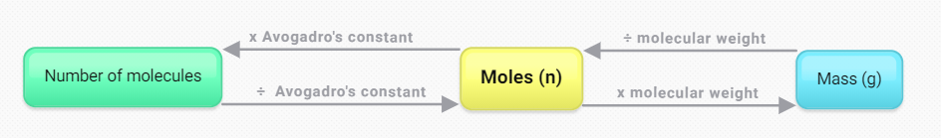

IQ2-3 – How are chemicals in solutions measured?
Students model chemical reactions and make comparisons to practical experiences and observations. By taking quantitative measurements to support the theoretical calculations, students can discuss any variations present.
Students typically have an idea of concentration qualitatively, but not quantitatively, from real world experiences. These experiences, such as making cordial or other drinks from a purchased concentrate liquid or solid and can be used to help build the idea of quantitative concentration by relating to the intensity of colour or flavour of the end product. These concepts can also be explored through a PhET interactive tool.
Concentration can be measured in a range of units and each is typically used for specific mixture types. The interconversion of these concentration units can be helpful to explore and some of these can be applied in subsequent modules. Molar concentration is further explored in this inquiry question, as this is the standard concentration unit used in chemistry. Other measures of concentration include:
- %w/w is the percentage weight/weight of a component in a mixture, grams of solid or liquid substance per 100g of the solid mixture such as a fertiliser. For example, 8.8%w/w phosphorus in single superphosphate.
- %w/v is the percentage weight/volume of a component in a mixture, grams of solid or liquid substance per 100mL of the liquid mixture such as cleaning products. For example, household ammonia is 5%w/v ammonia (and 95% water).
- gL⁻¹ is grams per litre, grams of solid or liquid substance per litre of the liquid mixture, this unit is used in similar mixtures to %w/v. For example, the amount of sulfur in Seasol is 1gL⁻¹.
- %v/v is the percentage volume/volume of a component in a mixture, millilitres of liquid or gas substance per 100mL of the liquid or gas mixture such as air. A standard 375mL bottle of beer contains 4.8%v/v of ethanol.
- ppm is parts per million, one part of the solid/liquid/gas component per one million parts of the solid/liquid/gas solution. This is also written as mgL⁻¹ or milligrams per litre for aqueous mixtures, 1L of water is equivalent to 1kg of water which is one million milligrams. Seawater has a salt concentration of 35,000ppm.

The calculation for molar concentration is represented by the equation:
$$c=\frac{n}{V}$$
where:
- c represents the concentration in moles per litre (M, or molL-1)
- n represents the chemical amount in moles.
- V represents the volume of the solution in litres.
Students can explore the calculation of molarity and its connection to the concentration of solutions through a PhET interactive tool.
Although it is best to ensure students are capable and confident with the algebraic rearrangement of this equation to calculate other values, this three member equation can be described using a triangle to aid student rearrangement of the equation:
Figure 3 – triangle representation of the concentration calculation equation
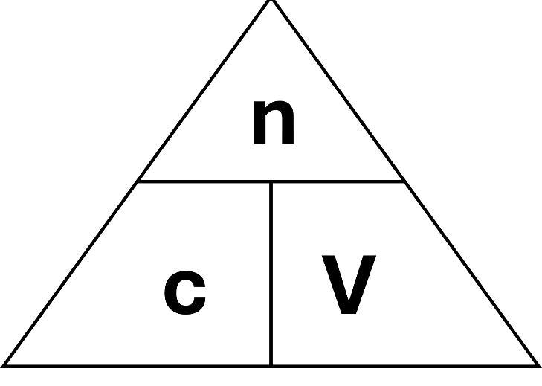
Using a finger to cover the subject of your desired equation gives the equation for the calculation needed. Vertical alignment of variables is dividing them:
$$V=\frac{n}{c}$$
Adjacent alignment of variables is multiplying them:
$$n=c×V$$

IQ2-1 required students to apply moles calculations to solid, liquid and gaseous reactions. As each are experienced through the remaining inquiry questions, students can develop a visual aid to assist in the variety of calculations. This diagram would continue to be developed to now include the calculations involving liquids:
Figure 4 – conversion between number of molecules, mass, moles, and concentration and volume of liquids
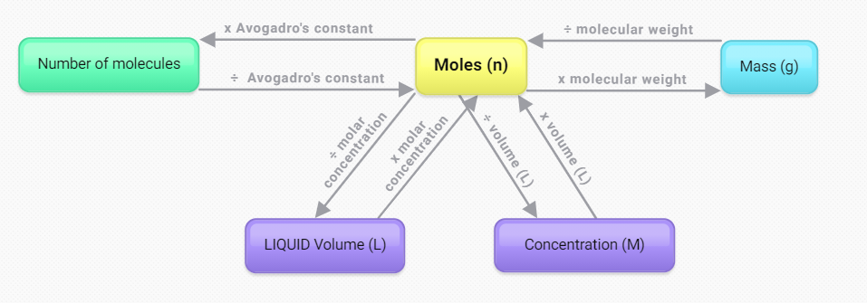
Real-world comparison activities can be undertaken to compare a range of products based on the concentration of their active ingredients in the mixture. Comparing products based on only their unit pricing provided by the retailer may not give a fair comparison. The variability of the concentration of the active ingredient(s) in the product must also be accounted for. A sample of this style of activity is provided in appendix 2. In addition, the concept of concentration can be extended to introduce Beer’s law by connecting the concept of quantitative concentration back to the colour of the solution. The PhET Beer’s Law simulation also introduces the concepts covered later in module 8.
Dilution can be practiced using a wide range of commercial products by taking a concentrated stock and diluting to the final solution using the instructions provided. The final concentration can be calculated from the ratio used. A valuable discussion here is the ramifications of incorrect dilutions to the end product – too concentrated due to not enough solvent, or too dilute due to too much solvent. By illustrating using this important chemical concept using commercial products, students can gain a deep understanding of the critical importance for these dilution procedures and calculations. There are also several excellent online simulations, including:
- Creating a Stock Solution
- Glucose Dilution Problem
- Acid Dilution Problem
Laboratory activities for dilution involve diluting food colouring or a coloured soluble species, such as potassium permanganate, allows students to practice in making and diluting solutions from both solids and liquids. This skill is critical for the later learning in module six where students undertake titrations which require very accurate solutions and dilutions to be made, particularly with colourless solutions. A scaffolded activity may assist student understanding by first diluting using cups or spoons (as would be undertaken in a kitchen), moving beyond this to beakers and measuring cylinders, and finally to dilutions using volumetric pipettes and flasks. This progression also allows for the discussion of precision with each measurement taken and the implications for the use of the final solution, challenging students with the counter question, why do we not use volumetric glassware in our kitchens?
Quantitative dilution calculations are represented by the rearrangement of the concentration equation. The number of moles before and after dilution remains constant:
$$n_{1}=n_{2}$$
where n₁ is the moles before dilution, n₂ is the moles after dilution.
Substituting for n, the rearranged concentration calculation, gives the following dilution equation:
$$c=\frac{n}{V}$$
$$∴n=cV$$
$$c_{1}V_{1}=c_{2}V_{2}$$
Where c₁ and V₁ are the concentration and volume before dilution, c₂ and V₂ are the concentration and volume after dilution. This equation can then be rearranged into multiple forms to calculate any of the individual values:
Calculating | Equation
c₁ | $$c_{1}=\frac{c_{2}V_{2}}{V_{1}}$$
V₁ | $$V_{1}=\frac{c_{2}V_{2}}{c_{1}}$$
c₂ | $$c_{2}=\frac{c_{1}V_{1}}{V_{2}}$$
V₂ | $$V_{2}=\frac{c_{1}V_{1}}{c_{2}}$$
Having a qualitative and quantitative understanding of concentration and dilution are critical to ensure student success throughout the remaining modules of the course.
- Module 3: standard conditions for electrolytes in galvanic cells and rates of reaction.
- Module 4: calorimetry calculations.
- Module 5: equilibrium reaction conditions, equilibrium constant calculations for K_{eq} and K_{sp}, detoxification of foods by Aboriginal and Torres Strait Islander Peoples.
- Module 6: calculation and measurement of pH and pOH, acid/base titrations, equilibrium constant calculations for K_{a}, preparation and function of pH buffers.
- Module 7: safe handling and disposal of hydrocarbons, fermentation reaction conditions, organic synthesis reaction conditions.
- Module 8: gravimetric analysis, precipitation titrations, colourimetry, UV-VIS and atomic absorption spectroscopy, chemical synthesis reaction conditions, yield and purity calculations.

IQ2-4 – How does the Ideal Gas Law relate to all other gas laws?
Students model chemical reactions and make comparisons to practical experiences and observations. By taking quantitative measurements to support the theoretical calculations, students can discuss any variations.
In each exploration of the gas laws, it is vital to clearly define each of the variables, particularly pressure. VALID10 has shown that students may believe that a change in pressure results in a change in the size of the gas molecules. Pressure must be clearly defined as:
Pressure is a measure of the rate of gas molecule collisions with the interior surface of the gas container.
Pressure is affected when volume, temperature and gas moles are changed:
- Volume and pressure are inversely related. Reducing the volume of the container reduces the interior surface area of the container over which the collisions of gas will occur. There will be a greater frequency of collisions and the pressure will consequently increase (Boyle’s Law).
- Temperature and pressure are directly related. Increasing the temperature will increase the kinetic energy of the gas molecules resulting in more frequent collisions with the container walls. The pressure will consequently increase (Gay-Lussac’s Law).
- Gas moles and pressure are directly related. If there are a higher number of gas molecules in the container, there will be more frequent collisions with the container walls. This increases the pressure (combination of Avogadro’s Law and Boyle’s Law).
Each gas law below contains a suggestion for discussion, demonstration or first-hand investigation. There are also many excellent online simulation tools, for example Gases Intro and Gas Properties from PhET. Further reading and ideas to demonstrate the connections between gas laws also provide a range of opportunities to explore with students in this inquiry question.

Gay-Lussac’s Law
Gay-Lussac’s Law states that the pressure of a gas varies directly in proportion to the absolute temperature of the gas, where the mass and volume of the gas remains constant:
$$\frac{P}{T}=k$$
Or alternatively:
$$P∝T$$
When comparing the same gas under two different conditions this can be written as:
$$\frac{P_{1}}{T_{1}}=\frac{P_{2}}{T_{2}}$$
Gay-Lussac’s Law is the cause of aerosol cans detonating when placed in a hot environment, for example, inappropriately disposing of the empty aerosol can by incineration. The increase in temperature produces a corresponding increase in pressure inside the can:
$$P_{2}=\frac{T_{2}P_{1}}{T_{1}}$$
An empty (P₁ = 100kPa, atmospheric pressure) aerosol can at room temperature (T₁ = 298K) is placed into a 925$℃$ wood fire (T₂ = 1198K), the internal pressure will rise to:
$$P_{2}=\frac{1198K×100kPa}{298K}$$
$$P_{2}=402kPa$$
With four times the internal pressure resulting from this temperature rise, the metal structure of the can is unable to hold and results in rupture.

Boyle’s Law
Boyle’s Law sates the pressure of a gas is inversely proportional to its volume where the mass and temperature of the gas remains constant:
$$PV=k$$
Or alternatively:
$$P∝\frac{1}{V}$$
When comparing the same gas under two different conditions this can be written as:
$$P_{1}V_{1}=P_{2}V_{2}$$
To demonstrate Boyle’s Law practically, students can create a Cartesian diver. Squeezing the bottle increases the air pressure inside the diver, reducing its volume. This makes the diver denser ($density=\frac{mass}{volume}$), causing it to sink. When the external pressure is released the opposite effect occurs and the diver rises. Alternatively, or in addition, students can create a PVT syringe to investigate and practically verify the relationship as shown in Boyle’s Law.

Charles’ Law
Charles’ Law sates the volume of a gas is proportional to its temperature where the mass and pressure of the gas remains constant:
$$\frac{V}{T}=k$$
Or alternatively:
$$V∝T$$
When comparing the same gas under two different conditions this can be written as:
$$\frac{V_{1}}{T_{1}}=\frac{V_{2}}{T_{2}}$$
Using liquid nitrogen or dry ice (solid carbon dioxide) enables a series of demonstrations for Charles’ Law. A range of practical examples are available that allow teachers and students to collaboratively investigate the relationship between volume and temperature.

Combined gas law
By combining Gay-Lussac’s Law, Boyle’s Law and Charles’ Law, the combined gas law is derived to show that the product of pressure and volume of a gas divided by the absolute temperature of the gas remains constant:
$$\frac{PV}{T}=k$$
Or alternatively:
$$PV∝T$$
When comparing the same gas under two different conditions this can be written as:
$$\frac{P_{1}V_{1}}{T_{1}}=\frac{P_{2}V_{2}}{T_{2}}$$

Avogadro’s Law
Avogadro’s Law sates the number of molecules of a gas is proportional to its volume where the temperature and pressure of the gas remains constant. With an Avogadro’s number of gas molecules being equal to a mole of gas this can be stated as:
$$\frac{V}{n}=k$$
Or alternatively:
$$n∝V$$
When comparing the same gas under two different conditions this can be written as:
$$\frac{V_{1}}{n_{1}}=\frac{V_{2}}{n_{2}}$$
In summary, the variables and constants of each gas law can be shown as:
Gas Law | Relationship | Constants
Gay-Lussac’s Law | $$\frac{P_{1}}{T_{1}}=\frac{P_{2}}{T_{2}}$$ | Volume and amount of gas
Boyles Law | $$P_{1}V_{1}=P_{2}V_{2}$$ | Temperature and amount of gas
Charles’ Law | $$\frac{V_{1}}{T_{1}}=\frac{V_{2}}{T_{2}}$$ | Pressure and amount of gas
Combined Law | $$\frac{P_{1}V_{1}}{T_{1}}=\frac{P_{2}V_{2}}{T_{2}}$$ | Amount of gas
Avogadro’s Law | $$\frac{V_{1}}{n_{1}}=\frac{V_{2}}{n_{2}}$$ | Pressure and temperature of gas

Ideal Gas Law
In order to obtain the Ideal Gas Law, derived from these components, we can use Avogadro’s Law ($V∝n$), Boyle’s Law ($V∝\frac{1}{P}$), and Charles’ Law ($V∝T$) to obtain:
$$V∝\frac{nT}{P}$$

By inserting the proportionality constant $k,$ this relationship is converted into an equation:
$$V=k\left(\frac{nT}{P}\right)$$
From further experiments it was determined the proportionality constant can be replaced by the Gas Constant $R$:
$$V=R\left(\frac{nT}{P}\right)$$
$$V=\frac{RnT}{P}$$
This equation can then be rearranged to form the normally presented style of the Ideal Gas Law:
$$PV=nRT$$
In the ideal gas law equation:
- P represents the pressure in kilopascals (kPa).
- V represents the volume of the solution in litres (L).
- n represents the chemical amount in moles (mol).
- R represents the universal gas constant, from the data sheet, 8.314 Jmol-1K-1.
- T represents the temperature in Kelvin (K).
Kelvin is the SI unit for temperature. This is a scale from absolute zero (-273.15$℃$), which is where all molecular vibration ceases, to an infinite value. There are no negative temperatures in the Kelvin scale.
There are many different gas constants, each with their own units, which are used for specific purposes. In the Chemistry Data Sheet the particular gas constant given has the units of Joules per mole Kelvin (Jmol⁻¹K⁻¹) and for some students the cancellation of these units through the Ideal Gas Law could present some confusion. The working to show the conversion of units is provided in appendix three.
By combining each gas law, the interaction between pressure, volume, gas moles and temperature can be established for ideal gases. The collapsing can or hot air balloon activities are simple and effective methods to show this combination of effects.
IQ2-1 asked for students to apply moles calculations to solid, liquid, and gaseous reactions. As each are experienced through the remaining inquiry questions, students can develop a visual aid to assist in the variety of calculations. This diagram would continue to be developed to now include the calculations involving ideal gases:
Figure 5 – conversion between number of molecules, mass, moles, concentration and volume of liquids, and volume and pressure of ideal gasses
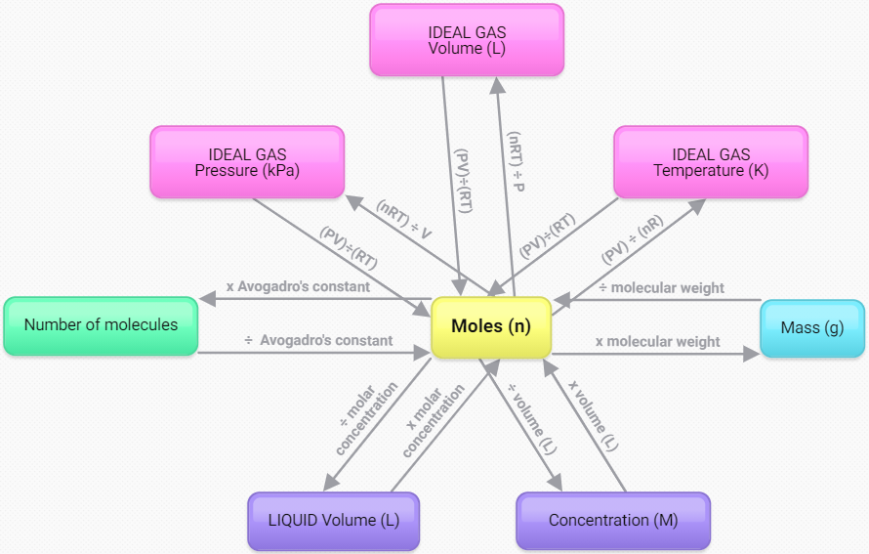

Further exploration of the gas laws
There is an opportunity here for students to engage with further development of this area of the module through a depth study. Students can investigate the nature of the Ideal Gas Law and the factors which cause some gases to behave more ideally than others. The use of the Van Der Waals equation is a more complex mathematical process and can result in very similar results to the Ideal Gas Law for gases like helium but far greater differences with gases like water vapour. There is a suitable online calculator for the Van Der Waals equation which students can use to undertake a comparative study to the same parameters used in the Ideal Gas Law online calculator. This depth study would also assist students refine their understanding of the particle model, intramolecular and intermolecular forces.
Students could also explore the historical applications of the gas laws in the medical treatment of Poliomyelitis using an ‘iron lung’. Using first-hand historical reports from Polio patients, students can explore the connection between chemistry and biology through the use of negative and positive external pressures to influence respiration movements. Students could also explore the reimagination of the iron lung for the treatment of COVID-19 patients in the global shortages of mechanical ventilators during the peak of the epidemic.

Appendix 1 – practical activities for the mole concept
The idea of the mole is central in chemistry. It enables chemists to quickly count out large number of particles. The mole was first developed by Amedeo Avogadro.
He determined that 6.022x10²³ particles would equal one formula weight of the substance. Scientists now had an easy way to count out many particles, for example, what would be occurring in a chemical reaction. From this relationship we have developed the formula:
$$n=\frac{m}{MM}$$
Where:
- n represents the chemical amount in moles.
- m represents the mass in grams.
- MM represents the molar mass grams per mol (gmol⁻¹).

Understanding the mole
A range of online sources have many opportunities to explore and investigate the mole concept through first-hand activities. By exploring the mole concept using simple materials, for example, teaching moles through beans and the activities listed under what is a mole can provide some useful insight for students. Additional activities can be found in the research paper teaching the mole concept.
A possible depth study in this inquiry question could be for students to continue this investigation into the current process to redefine the mole. With the involvement of CSIRO, the process to redefine the mole is explored in the video World's Roundest Object by Veritasium. Additional resources for this concept can be found on FutureLearn and inChemistry.

A molar display
A simple display can be created to illustrate the difference in the mass and volume of one mole of a range of substances. Any range of available pure substances can be used where the molecular mass is able to be calculated by students. Some examples:
Substance | Molecular formula | Molecular mass (gmol-1)
Water | H₂O | 18.016
Ethanol | C₂H₅OH | 46.068
Copper | Cu | 63.55
Sodium chloride (as table salt) | NaCl | 58.44
Carbon (as activated charcoal) | C | 12.01
Sulfur | S | 32.07
Iron (as iron filings) | Fe | 55.85
Sucrose (as table sugar) | C₁₂H₂₂O₁₁ | 342.296
Displaying one mole of different substances in identical containers allows students to observe the relative volume of each substance. Students can relate the differences in molecular mass to the relative size of the display contents.

Appendix 2 – product comparison
All manufacturers are required to publish a Safety Data Sheet (SDS) for their products. These were formerly known as a Material Safety Data Sheet (MSDS). Some retailers, for example ALDI, produce products under their own brand names and publish their own SDS database. Other retailers sell products produced by others. For these it is important to search for SDS documents from the manufacturing brand not the retailer (for example, Bunnings, Woolworths or Coles). Some retailers also change product names. This results in an SDS document which may have several names for the same product depending on the retailer. Some examples are:
- Procter & Gamble brands – SDS search
- GlaxoSmithKline (GSK) brands – SDS search
- Colgate-Palmolive brands – SDS search
- Reckitt Benckiser brands – SDS search
- SC Johnson brands – SDS search
By examining these SDS documents, students are able to examine a range of products and compare similar products from different manufacturers. The different concentrations of each component allow students to perform a range of calculations including concentration unit conversion and dilution.
Students could validate statements, for example, you should not swallow your toothpaste as you could potentially cause fluoride toxicity. By reviewing the:
- SDS for a whitening toothpaste which states it contains 0.243%w/w sodium fluoride:
$$0.243\% NaF=0.243g NaF per 100g toothpaste$$
$$Molar mass NaF=41.99\frac{g}{mol}$$
$$Mass F^{-}=\frac{19.00}{41.99}×0.243g=0.110g per 100g toothpaste$$
- The fluoride level reported can be converted to a dose of fluoride for each time you brush your teeth, assuming you do swallow the toothpaste. For this calculation it is necessary to estimate the mass of toothpaste used when brushing as approximately 0.25g:
$$\frac{0.25g}{100g}×0.110g =0.000275g of F^{-}$$
- Fluoride: Its Metabolism, Toxicity, and Role in Dental Health states fluoride levels increase from 10 minutes post-ingestion, reaching peak levels at 60 minutes with a return to pre-ingestion levels within 15 hours.
- Potential fluoride toxicity from oral medicaments which states the dose of fluoride for children and adults linked to any toxic effects is reported as 5 mg fluoride per kilogram of body weight:
$$5\frac{mg}{kg}×\frac{1g}{1000mg}=0.005\frac{g}{kg}F^{-}$$
Individual | Toxic dose of fluoride calculation
15kg child | $$0.005\frac{g}{kg}F^{-}×15kg=0.075g F^{-}$$  $$\frac{0.075g}{0.000275g}=273$$  To reach the dose reported as toxic, this child must brush their teeth 273 times within 15 hours (approximately every 3m 18s), or directly consume 68.25g ($0.25g×273$) of this toothpaste.
80kg adult | $$0.005\frac{g}{kg}F^{-}×80kg=0.4g F^{-}$$  $$\frac{0.4g}{0.000275g}=1455$$  To reach the dose reported as toxic, this adult must brush their teeth 1455 times within 15 hours (approximately every 37s), or directly consume 363.75g ($0.25g×1455$) of this toothpaste.
This investigation can then be further explored through the use of additional reading, for example, contents of toothpaste - safety implications and using this to describe why the use of lower levels of fluoride is encouraged in toothpaste specifically designed for children.

Appendix 3 – gas constant units
The ideal gas law equation uses a gas constant to equate the pressure (kPa) and volume (L) of a gas to the amount of gas (mol) and its temperature (K). The gas constant provided in the Chemistry Data Sheet is:
$$8.314 J{mol}^{-1}K^{-1}$$
This can also be written as:
$$8.314\frac{J}{mol×K}$$
When this is used in the ideal gas law equation to show the standard units for each variable:
$$PV=nRT$$
$$kPa×L=mol×\frac{J}{mol×K}×K$$
The moles (mol) and temperature (K) will directly cancel with the gas constant to give:
$$kPa×L=J$$
This does not appear to work mathematically, the units on each side of this equation are not equal in this form. Some additional steps to convert Joules can help to explain the underlying operation of this gas constant in this equation. Firstly, converting the unit of Joules to an equivalent unit containing other units we are seeking:
$$1J=1Pa{×m}^{3}$$
$$∴kPa×L=Pa{×m}^{3}$$
Then, exchanging the factor of 1000 from the pressure unit to the volume unit:
$1000kPa=1Pa$ and $1000L=1kL$
$$∴Pa×kL=Pa{×m}^{3}$$
Finally, converting the volume unit to an equivalent unit we are seeking:
$$1kL=1m^{3}$$
$$∴Pa{×m}^{3}=Pa{×m}^{3}$$
Following these steps to convert the units (without changing their values) we now have both sides of the equation being equal and the units are able to cancel when used in the ideal gas law equation.

References
This resource contains NSW Curriculum and syllabus content. The NSW Curriculum is developed by the NSW Education Standards Authority. This content is prepared by NESA for and on behalf of the Crown in right of the State of New South Wales. The material is protected by Crown copyright.
Please refer to the NESA Copyright Disclaimer for more information https://educationstandards.nsw.edu.au/wps/portal/nesa/mini-footer/copyright.
NESA holds the only official and up-to-date versions of the NSW Curriculum and syllabus documents. Please visit the NSW Education Standards Authority (NESA) website https://educationstandards.nsw.edu.au and the NSW Curriculum website https://curriculum.nsw.edu.au.
Chemistry Stage 6 Syllabus © NSW Education Standards Authority (NESA) for and on behalf of the Crown in right of the State of New South Wales, 2017.
© State of New South Wales (Department of Education), 2021
The copyright material published in this resource is subject to the Copyright Act 1968 (Cth) and is owned by the NSW Department of Education or, where indicated, by a party other than the NSW Department of Education (third-party material).
Copyright material available in this resource and owned by the NSW Department of Education is licensed under a Creative Commons Attribution 4.0 International (CC BY 4.0) license.

This license allows you to share and adapt the material for any purpose, even commercially.
Attribution should be given to © State of New South Wales (Department of Education), 2021.
Material in this resource not available under a Creative Commons license:
- the NSW Department of Education logo, other logos and trademark-protected material
- material owned by a third party that has been reproduced with permission. You will need to obtain permission from the third party to reuse its material.
Links to third-party material and websites
Please note that the provided (reading/viewing material/list/links/texts) are a suggestion only and implies no endorsement, by the New South Wales Department of Education, of any author, publisher, or book title. School principals and teachers are best placed to assess the suitability of resources that would complement the curriculum and reflect the needs and interests of their students.
If you use the links provided in this document to access a third-party's website, you acknowledge that the terms of use, including licence terms set out on the third-party's website apply to the use which may be made of the materials on that third-party website or where permitted by the Copyright Act 1968 (Cth). The department accepts no responsibility for content on third-party websites.

