Chemistry Module 1 – Properties and Structure of Matter

Contents
Teaching the Year 11 Modules 3
Course overview 4
Module summary 5
Big ideas 6
Relationship to other modules 6
Core concepts 7
Opportunities for extending concepts 7
EAL/D strategies 9
Misconceptions 9
Conceptual difficulties 10
Suggested teaching strategies 12
IQ1-1 – How do the properties of substances help us to classify and separate them? 12
Separation of mixtures 12
Calculating percentage composition by weight 13
Inorganic IUPAC naming conventions 14
Physical and chemical properties 14
IQ1-2 – Why are atoms of elements different from one another? 15
Structure of the nucleus 15
Unstable nuclei 16
Arrangements of the electrons 17
Flame tests 21
IQ1-3 – Are there patterns in the properties of elements? 23
IQ1-4 – What binds atoms together in elements and compounds? 24
Lewis dot diagrams 24
Ionic and covalent bonding 26
Molecular shapes 27
Intermolecular forces 28
Molecular structures 31
Allotropy 35
Appendix 1 – IUPAC naming 37
Appendix 2 – decay pathways of unstable nuclei 41
Appendix 3 – spdf orbitals template 42
References 43

Teaching the Year 11 Modules
The new Stage 6 Chemistry course was implemented in NSW schools beginning in 2018. This syllabus incorporates new content and learning activities such as depth studies. The syllabus is designed around inquiry questions and formal assessment tasks that emphasise the Working Scientifically skills. The Year 11 course focusses on developing student knowledge and understanding of the relationships between the structure and the properties of atoms and molecules using macroscopic, microscopic and symbolic representations. The Working Scientifically skills and processes are applied to predict outcomes by using physical, conceptual and mathematical models and assessing the limitations of models. Through scientific investigations, students identify and measure quantities of chemicals, leading to a deep understanding of different classes of chemicals including their structure, properties and trends. The role of energy as a driver of chemical change and the relationship between energy and matter are explored in Year 11 as the basis for understanding of chemical change in the Year 12 course.
As the syllabus is written as a series of inquiry questions and depth studies are a mandatory component of the course, pedagogies that promote student inquiry and deep learning should be employed in the chemistry classroom. New and challenging course content, along with the change in pedagogical approach were the catalysts for the preparation of these module guides for Stage 6. These guides are intended to assist teachers deliver the chemistry syllabus effectively by outlining the big ideas, core concepts, strategies for teaching the modules, uncovering alternative conceptions and providing strategies to address them and suggesting opportunities for extension. The guides support the teacher in facilitating the development of deep knowledge structures, such as the relationships between concepts. It is essential that teachers note that the module guides are not a substitute for the syllabus, but only support teachers to teach it. The module guides do not cover all aspects of the syllabus, as that was not within the scope of the project.
The information contained in these documents is correct at the time of publication. While every effort has been made to eliminate errors, any errors or omission that are identified after the release of these documents will be corrected and released as resource updates. It is recommended that teachers access Science Stage 6 for the latest version of these documents.

Course overview
The Chemistry Stage 6 Syllabus explores the structure, composition and reactions of and between all elements, compounds and mixtures that exist in the Universe. The course develops an understanding of chemistry through the application of Working Scientifically skills. It focuses on the exploration of models, the understanding of theories and laws, and the examination of the relationships between energy, matter and change.
The chemistry course enables students to interpret the interconnection between the nature and practice of science, and the knowledge of chemistry. The course addresses the discovery and synthesis of new compounds, the monitoring of elements and compounds in the environment, an understanding of industrial processes and their applications to life processes, our energy needs and uses, the development of new materials, and sustainability issues.
The fundamentals developed in Year 11, include:
- Knowledge and understanding of:
- Properties and structures of matter.
- The relationship between observable properties and structures to trends in data and reactions.
- Types and drivers of chemical reactions.
- Role of energy in bonding within and between particles.
- the use of differing scales, measurements and specialised representations to explain scientific phenomena and chemical interactions.
- skills in making hypotheses and designing valid and reliable investigations.
- skills in conducting investigations, solving problems and explaining using cause and effect.
- constructing models, explaining phenomena using particle theory and discussing atomic models.
- conducting investigations by measuring and/or collecting relevant data and information from first-hand practicals and secondary sources and determining the accuracy, reliability and validity of data and information.

Module summary
In this module, students focus on:
- designing, evaluating and conducting investigations
- obtaining and processing data in the most appropriate manner
- communicating ideas about the structural, physical and chemical aspects of matter.
Students should be provided with opportunities to engage with all Working Scientifically skills throughout the course.
Students analyse trends and patterns in relation to the properties of pure substances and use these to predict the properties of other pure substances. This knowledge is used to determine the ways in which substances can be separated from each other and those that allow them to remain together.
Matter can be either pure substances with distinct, measurable properties (e.g. melting and boiling points, reactivity, strength, density) or mixtures, with properties that are dependent on the identity and relative amounts of the substances that make up the mixture. The analysis of these properties has led to the expansion of the periodic table of elements and the advancement of atomic theory. This understanding has allowed for the development of complex models that have been subject to extensive peer review and has contributed to advances in many disciplines over time.
Students use knowledge obtained from the study of the periodic table to examine trends and patterns that exist between chemical elements and atoms to discover that fundamental particles, and their role in the structure of an atom, give all chemicals their properties.

Big ideas
- The underlying chemical structure of substances is a key factor in determining their properties.
- Chemical systems are described using models based on particle theory. Models are revised as new evidence becomes available.
- Chemical bonding and reactions occur in predictable patterns according to their atomic and molecular structures.
- Energy changes can instigate chemical reactions. The underlying structure of the chemicals determines how they react to energy changes.
- Patterns can be determined by making observations, conducting fair tests, analysing data, and explaining trends in observable properties of substances and the periodic table.

Relationship to other modules
Module 1 is the foundation on which all following modules are based.
Learning experiences should ensure that students develop the essential skills to plan and conduct valid and reliable, primary, and secondary-sourced investigations. The making of predictions and explaining the observations, particularly regarding patterns and trends in the periodic table and bonding, will equip students with skills that enable them to complete depth studies in science.
A deep knowledge and understanding of the interactions between atomic structure, bonding, properties, and the periodic table is required to understand the qualitative and quantitative study of chemical reactions that occur in modules 2, 3 and 4. The analysis of atomic level structures, which provide the basis for stoichiometric calculations and chemical reactions in modules 2 and 3 and the analysis of molecular level structures, provides the basis for chemical reactions and interactions in modules 3 and 4.

Core concepts
- Substances rarely exist in a pure state. The differences in the chemical and physical properties of chemicals are used to separate naturally occurring mixtures into pure substances for use.
- Chemicals are named according to internationally agreed conventions.
- The current model of the atom can be used to account for the properties of different isotopes that can occur naturally or be human-made.
- Unstable nuclei cause different forms of nuclear radiation.
- The configuration of electrons around a nucleus determines its chemical properties. Different models can be used to represent electron configuration.
- The periodic table is a model used to arrange different elements using their chemical and physical properties. Comparisons and predictions about properties of elements can be made using this model.
- The electron configuration is important in determining the:
- nature of bonding between elements.
- shape of molecules.
- chemical and physical properties of atoms and molecules.

Opportunities for extending concepts
- Investigate how complex mixtures are handled and prepared for effective purification using industrial applications of separation techniques, such as mining, wastewater or solid wastes. This creates connections between Chemistry and Earth and Environmental Science (Module 8).
- Introduce quantum features of the atom. This creates connections between spectroscopy in Chemistry and Physics (Module 8).
- Investigate the historical development of the atomic model and periodic table, highlighting the role of new technologies to improve our understanding through improved evidence. Review the limitations of each model that generated a line of inquiry for new models to be developed.
- Analyse the interrelationship of observable trends in the periodic table. Compare successive ionisations energies between elements and relate this to reactivity.
- Students may be interested to explore cutting edge periodic table research through the use of nuclear reactions to produce the transuranic (atomic number > 92) elements - those which are not naturally found in the environment. All these elements currently known have no stable isotopes so this limits their potential use. However, some there are some limited uses. For example, americium-241 is used in ionising smoke alarms. There is a large focus on the research to produce even larger elements in the pursuit of the theorised island of stability, where these superheavy elements become stable again, allowing their more widespread, novel uses. Some of this research is described in the video, This Superheavy Atom Factory Is Pushing the Limits of the Periodic Table by Seeker.

EAL/D strategies
One of the most significant challenges in Module 1 is the large amount of new terminology that students are exposed to. It is important that students are explicitly taught the skills necessary to develop a glossary that can be consistently added to during module 1 and in subsequent modules.
- Explore with students different methods of storing glossary terms, for example using physical flash cards or utilising one of the many digital flash card apps available (Brainscape, Cram, Quizlet, CheggPrep).
- Model for students how to define terms using their own words.
- Encourage students to use analogies and metaphors when appropriate and include diagrams/images.
Videos such as The Nucleus: Crash Course Chemistry #1 can define this terminology and regularly discussing terminology will reinforce learning. Sentence frames can assist in students constructing sentences independently. Formative assessments and short responses, designed to allow students to practice the use of technical language, link ideas and construct explanations and cause and effect relationships should be frequent with feedback regarding student use of technical language and complex sentences. Teaching the root of words can help students decode unfamiliar words. For example:
- electron: electronic
- ionise: ionising, ionisation
- react: reaction, reactive, reactivity
- iso: isotope, isotopic, isomer
- molecule: molecular, intermolecular, intramolecular.

Misconceptions
- Students may retain the flat concentric circle representation of electron orbitals and molecules, creating confusion when 3D models are introduced. Without resolving this misconception, students may find difficulty in explaining the intermolecular forces which determine the properties of substances. This can be addressed by the use of hands-on molecular modelling and digital visualisations of molecular structures.
- Radioactive substances are perceived as only human-made and having no beneficial purpose. Students may not be able to relate nuclear structure to the beneficial uses of radiation. This can be addressed by investigating specific examples of naturally occurring and human-made medical and industrial radioisotopes.
- Students may only relate molecular substances to their empirical formulae instead of the larger lattice in which many inorganic substances exist. This could be due to the nature of IUPAC naming and formulae used in previous years, without recognition of the larger atomic structures that exist in these substances. Students will have difficulty in explaining observable crystal properties of ionic substances if relying on the empirical formula alone. Modelling the larger lattice structures in class provides evidence to support the observable properties of the inorganic substances.

Conceptual difficulties
Particle theory is the basis of a range of topics in chemistry. Many of the concepts can be represented at multiple levels:
- The macroscopic (macro) level: qualitative and quantitative observations of phenomena, for example melting and boiling points of a substance.
- The sub-microscopic (or micro) level: modelling and supporting the observations, for example particle-level drawings.
- The symbolic level: quantitative representations such as symbols, formulae and equations.
Teachers often spend more time teaching at the symbolic level, which is more abstract. Students may have difficulty moving from one level to another, in understanding and explaining chemical phenomena.
The focus on the abstract and symbolic can easily overwhelm novices and overload their working memory. It is therefore important that chemical phenomena are represented by both the particle level and the symbolic level, not at the same time, but in a strategic manner that allows meaning to be attached to chemical symbols. Begin the course by modelling particles in solids, liquids and gases and reviewing Stage 4 concepts such as the influence of energy on particle behaviour, phase changes, expansion and contraction. This will allow time for student preconceptions to become apparent and address misconceptions by developing student thinking through challenge and discussion.
Models can be concrete, such as those made with commercial chemistry model kits or online animations such as PhET. The model can then be applied to learning new material, such as distillation and the reason why larger molecules have higher boiling points than smaller molecules. Models of atoms, molecules of elements and compounds as well as mixtures can then be described with symbols. Physical changes can be represented by subscripts denoting phase.

Suggested teaching strategies

IQ1-1 – How do the properties of substances help us to classify and separate them?

Separation of mixtures
Highlight the practical applications of this learning by providing a real-world use of separation methods and the method of selecting the most appropriate technique.
Teachers may choose to begin the course with this content about mixtures and separating mixtures. This allows the explicit teaching of skills in planning and conducting safe, first-hand investigations and the modification of investigations to ensure students have the basic skills to apply to depth studies. Students could also employ the design process to solve problems in separating mixtures in a depth study. Students can gain experience in planning and conducting investigations commonly found in many science resources.
Technique | Example | Discriminator
Filtration | Sand and water | Particle size
Sedimentation | Mud and water | Particle density
Evaporation and crystallisation | Sodium chloride in sea water | Boiling point and solubility
Distillation | Ethanol and water | Boiling point
Density | Oil and water (using a separatory funnel or centrifuge) | Density and solubility
Chromatography | Dyes or inks | Solubility
Magnetism | Iron filings and sand | Ferromagnetism
A depth study of a real-world example, such as modelling water purification systems, or a secondary source investigation of the purification of salt that contains contaminants such as microplastics or minerals of heavy metals can be used to assess student skills. More advanced concepts can also be carefully introduced here and further explored later, such as precipitation reactions to produce a precipitate which can be filtered and suitably quantified. Students would have some experience from Stage 5 Science and this links through to Module 8.

Calculating percentage composition by weight
When undertaking the separation of mixtures, learning can be integrated to quantify the mixtures used. Emphasise the need for these calculations in quality assurance or certification processes for products.
The percentage composition of substances is an important skill for students to calculate and infer from a given value the comparative composition, and vice versa. Various opportunities to practice this calculation are possible when undertaking separation practicals. Use the results obtained to explore the decisions made based on this data.
For example, the decision to open or close a gold mining operation could be based on the price of the gold being extracted and the operating costs of the mine. In these examples, the gold spot price , correct at time of publication, is $73.52 per gram:
- A gold mine is proposed in an area which will cost $200 per tonne (1000kg) of earth to extract the gold, the gold is determined to be present in this site at 0.000004% w/w or 4g per tonne of earth. What is the minimum gold spot price for this mine to make a profit from their work?
$$\frac{\$200}{tonne}÷\frac{4g}{tonne}=\frac{\$200}{4g}=\frac{\$50}{g}$$
This mine would continue to operate until the gold spot price drops below $50 per gram.
- A gold mine is proposed in an area where the gold is determined to be present at 0.000001% w/w or 1g per tonne (1000kg) of earth. What are the maximum costs per tonne of earth for this mine to make a profit from their work?
$$\frac{\$73.52}{g}×\frac{1g}{tonne}=\frac{\$73.52}{tonne}$$
This mine would continue to operate until the cost of extraction rises above $73.52 per tonne.

Inorganic IUPAC naming conventions
Students need to use algebraic thinking to determine combinations and their multiplicative prefixes suited to the equivalence of charges between cations and anions.
The naming of any chemical substances is vital to ensure the consistent communication of pure substance identities. The IUPAC naming conventions are an international system that allows all users to clarify the exact chemical substance in question. A short guide on nomenclature, tailored for the HSC Chemistry syllabus, is included in Appendix 1. By using this guide, with a suitable reference list of ions and polyatomic ions (see Appendix 1), students can combine a variety of cations and anions to form a range of compounds with the associated formula, molecular weights (linking to IQ1-2) and IUPAC names.
The objective is for students to learn the patterns and strategies for naming a range of compounds, not rote-learning every combination of a given set of cations/anions. This learning is most effective when combined into the activities undertaken during the course, allowing students to interchangeably discuss IUPAC names and formulae, methodically building their capacity throughout Stage 6.
Several online resources provide clear guidance and examples for this process, with varying methods to achieve the same goal:
- ChemLibreTexts - 2.8: Naming Inorganic Compounds
- The University of Sydney - Nomenclature for Inorganic Compounds

Physical and chemical properties
Students search for patterns in the periodic table data and create generalisations for metals, non-metals and semi-metals while also acknowledging exceptions to general patterns.
Students need to be able to use data about a range of properties to classify elements. This is a great opportunity to discuss the comparison of data from secondary sources. By using a variety of hardcopy (Aylward and Findlay's SI Chemical Data, 7th Edition) or online sources such as Ptable, NIH, RSC, Fisher Scientific, or WebElements, elemental data can be extracted and compared. A simple source for most of this elemental data could be the spreadsheet data of the periodic table from Mr Bigler. This file can be used to give students valuable practice in data handling, using Excel or Google Sheets by graphing, sorting and/or filtering the data to show the patterns and trends in a wide range of chemical and physical properties. This activity could form a larger investigation or depth study about what classifies elements as a metal or non-metal, and the inconsistencies that exist in rigid definitions, by using the elemental data.
An important understanding is the difference between physical and chemical properties:
Type of property | Characteristic | Example
Physical | can be measured without changing a substance’s chemical identity | melting point and boiling point
Chemical | can be measured only by changing a substance’s chemical identity | oxidation state and enthalpy of combustion
The important learning here is to look for the patterns rather than memorising every trend.

IQ1-2 – Why are atoms of elements different from one another?
Students may have alternative models and language for atoms, electrons and electron clouds, orbitals and paths. Depending on the origin of the atomic diagrams used in previous years, students will have different ideas in how each nucleon is related and described. By using consistent terminology and clearly defining the model as it is introduced, will avoid confusion for students.

Structure of the nucleus
Students model a stable nucleus and investigate the changes in properties as additional nucleons are added.
The structure of the nucleus is vital not only to the identity of the atom (atomic/proton number) but also to the stability of nucleus (neutron/proton ratio). In addition to the elemental symbols that students will be familiar with, now introduce the concept of isotopes that can be described using simple analogies such as a bunch of bananas, each with the same chemical and physical properties, but slightly different masses. For nuclear equations students use follow the format:
$${}_{Z}^{A}X$$
The hypothetical element symbol X has an:
- atomic mass of A (upper left superscript to the symbol), which is the combined mass of protons and neutrons in the nucleus. Electrons are considered effectively massless, as they contribute only 1/1800th of an atomic mass unit each.
- atomic number of Z (bottom left subscript to the symbol), which is the number of protons in the nucleus.
Using the values A and Z the number of neutrons, N, in the nucleus can be determined by simple subtraction as the masses of protons and neutrons are equal at one atomic mass unit each:
$$N=A-Z$$
Students can use a range of online tools to model different atoms for both nuclear structures and electron arrangements such as PhET Build an Atom and Isotopes and Atomic Mass. The vital understanding here is the general trend of stability for smaller atoms is the equal numbers of protons and neutrons. As the nucleus becomes larger, this stable ratio generally requires more neutrons than protons. Ptable and LiveChart are very useful online tools which provide data on a wide range of stable and unstable isotopes. Additional information is provided by clicking on a specific element. The analysis of isotopic data to deduce the patterns of stability and using this trend to predict stability of an isotope, allows students to explore concepts such as Nuclear Magic Numbers and possibly initiate a depth study into the transuranic elements and the predicted island of stability where new stable elements are predicted to exist.

Unstable nuclei
Students investigate nuclear reactions using alpha and beta decay with examples and equations. They model an unstable nucleus and demonstrate improvements in stability attained through each decay step. Unstable nuclei transform into more stable forms through a number of nuclear reactions. With a limited range of options at each step, unstable nuclei commonly will undergo several decay steps, called a decay chain, to achieve stability. Students can use online modelling tools such as PhET Alpha Decay and Beta Decay to show some of these processes and review the neutron/proton ratios of stable and unstable nuclei. Mechanisms of radioactive decay for unstable nuclei are more completely described in Appendix 2.
ANSTO have several freely available resources to support this inquiry question including radioisotope workbooks, periodic table and nuclear stability posters and several apps that provide useful engagement tools for students.

Arrangements of the electrons
Students model the placement of electrons around a nucleus and the capacity of each orbital. They investigate changes in the properties of the element as electrons are added or removed.
The basis of chemical reactions between different atoms is the exchange of electrons from their respective electron orbitals. To assist students to develop a suitable understanding of electron configurations use tools such as the Bohr atom and the Aufbau principle. These will also assist students to develop their understanding of chemical properties and chemical reactions between atoms.
Electron orbitals are denoted as s, p, d or f orbitals based on their shape.
- s orbitals are a simple spherical shape with no sub-orbitals
- p, d and f orbitals contain several sub-orbitals which accommodate additional electrons.
Each orbital is preceded by an integer which denotes the quantum number of the orbital, its energy level. When comparing the same orbital type (1s, 2s, 3s), this is equivalent to their sequence from the nucleus.

Figure 1 – the various arrangements of electrons in S, P, D and F orbitals
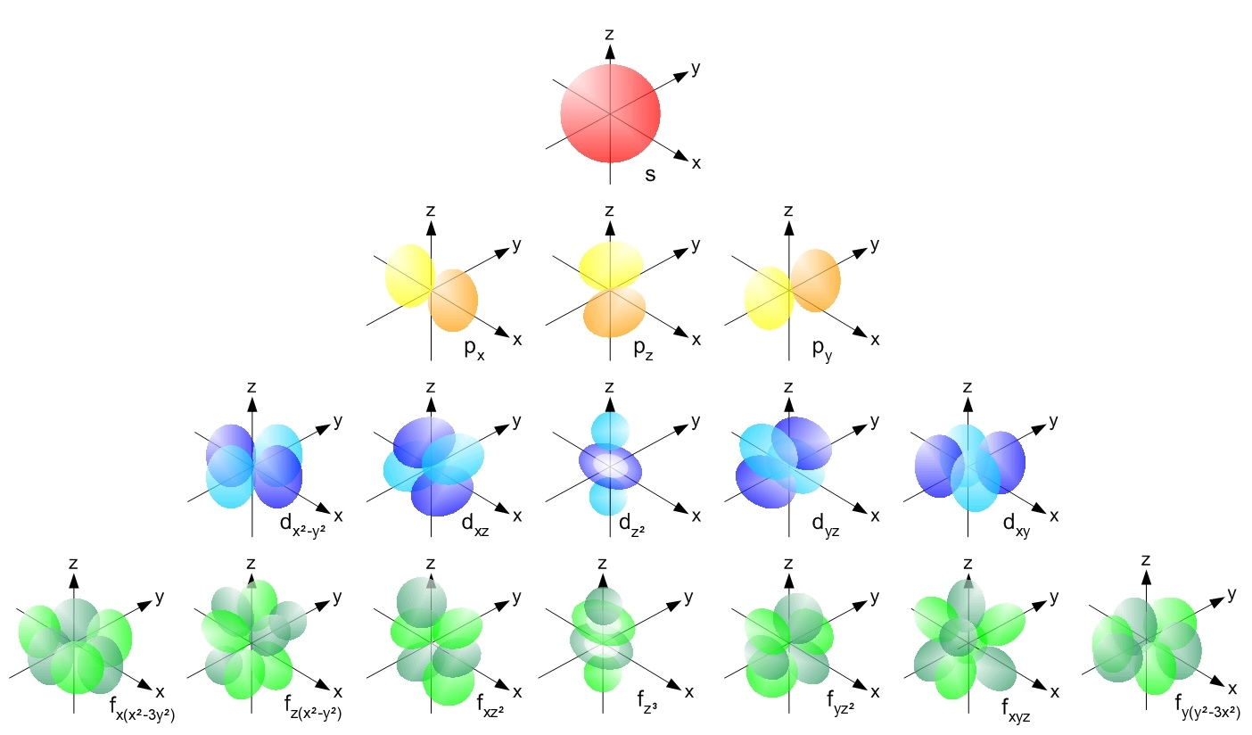
Source: licensed under CC BY-SA 3.0.
In the diagram above:
- Red s orbitals can accommodate only two electrons in one pair.
- Yellow p orbitals can accommodate six electrons in three pairs (in the X, Y and Z axis directions).
- Blue d orbitals can accommodate 10 electrons in five pairs.
- Green f orbitals can accommodate 14 electrons in seven pairs.

Each sub-orbital can accommodate a pair of electrons arranged in opposite spins, denoted by an arrow up and arrow down. Use a template showing the various orbitals and a fill order or energy comparison (see a blank template in Appendix 3). This template structure allows students to actively construct the electron orbitals using Hund’s rule and the Pauli Exclusion Principle to describe their electron configuration, for example, calcium.
Figure 2 – electron orbital diagram showing the electron configuration for calcium
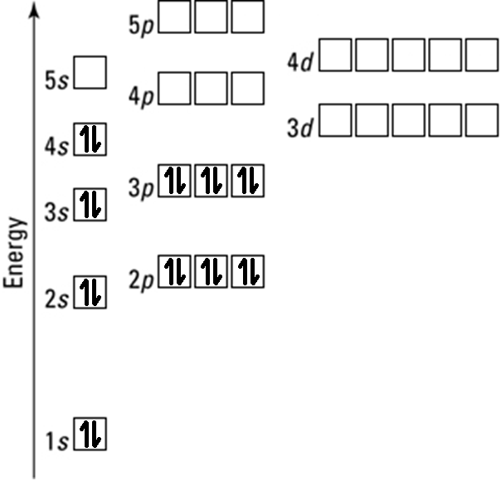
This diagram shows the 20 electrons surrounding a ground-state calcium atom organised in their respective orbitals and filled from the lowest energy until all electrons are accounted for. The electron configuration represented above can be written as:
1s² 2s² 2p⁶ 3s² 3p⁶ 4s²
A simpler depiction of these electron configurations is to substitute the electron configuration of the noble gas which immediately precedes the element depicted, in order of atomic number. In the case of calcium (Z = 20) this is argon (Z = 18) with the configuration:
1s² 2s² 2p⁶ 3s² 3p⁶
By performing the substitution, using the noble gas symbol in brackets, the short-hand version of calcium’s electron configuration becomes argon, with an additional two electrons in the 4s orbital:
[Ar] 4s²

Another step to shorten the identification of electron configurations is to annotate on the periodic table as shown in the below diagram. Allocating each section in this manner, the identity of the valence electrons can be more easily deduced by taking the:
- period number, noting the step backwards in the d-block elements and double step backwards for f-block elements);
- followed by the block identity (s, p, d or f) to the power of the group number within the block (start counting again for each block):
Figure 3 – periodic table showing the common valence electron orbitals for elements
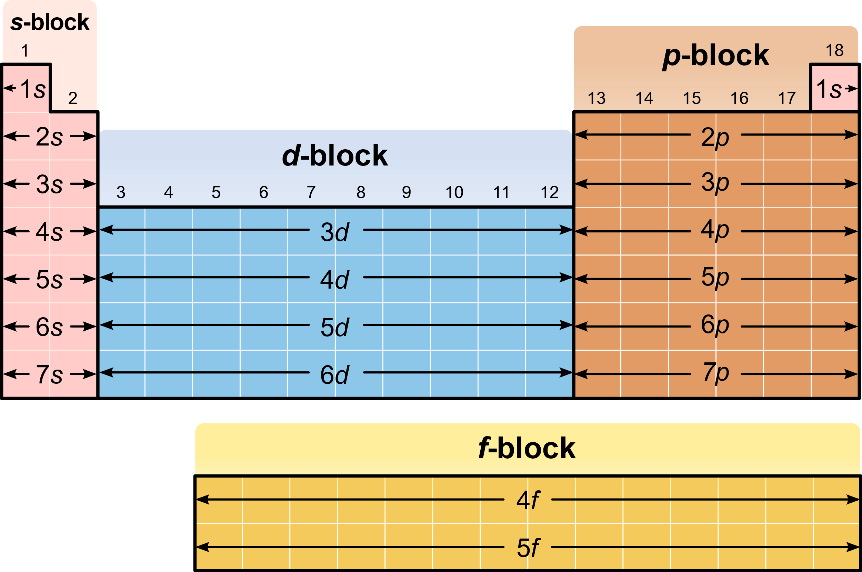
Source: licensed under CC BY-SA 3.0.
Using this diagram, the position of calcium gives the valence electron configuration of period four of the s-block in group two, meaning the 4s² orbital which agrees with the complete electron configuration discussed previously.
Scandium (Z = 21) is placed in period 3 (noting this one step backwards compared to s-block and p-block elements) of the d-block in group one (within the d-block, ignoring the s-block groups). This means the 3d¹ orbital is the valence electron for scandium.
There are many online tools such as Ptable which have a useful depiction of electron configurations for each element as a ready reference. The AUFBAU principle is reliable for the smaller atom. As a general rule up to calcium is reliable, however the 3d and 4s orbitals can become problematic. The electron configurations of chromium and copper are examples of how one fixed model can cause misconceptions with the structure of the atom. As the atomic number rises and additional electrons are added, so too are protons in the nucleus. This causes a difference in the forces between electrons and protons, which in turn changes the energy levels shown in the electron configuration template. This can create different orbital filling orders based on the lowest energy orbital available at any given point. Not every atom will have the same filling order, as is implied by this template.

Flame tests
Students undertake first-hand investigations of a range of cation solutions to observe similarities and differences. These can be used to illustrate the arrangement of electrons in each element.
Flame tests are a useful qualitative technique to obtain the emission spectrum of particular metal ions in solution.
For flame tests, avoid the use of respiratory irritants such as nitrate and sulfate salts that can result in the production of hazardous oxides upon heating.
When the metal ion is excited by the heat energy obtained from the Bunsen burner flame, an electron jumps from its ground state to an excited state. Here it is less stable and within a very short time will fall back to its original ground state with an accompanying emission of light energy. These emissions can be either observed using the naked eye (as the aggregate of all emission lines) or viewed using a spectroscope (to see the individual emission lines). Some common colours are shown in this infographic from CompoundChem:
Figure 4 – infographic showing flame colour with the excitation of various cations
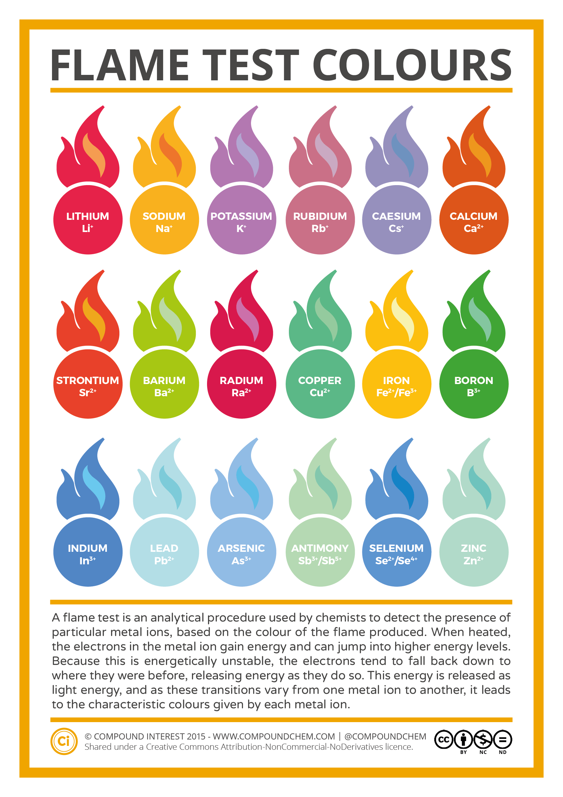
Source: licensed under CC BY-NC-ND 4.0.

This emission is one-to-one. One electron will emit one photon when the excited electron falls back to its ground state. This may happen in a single jump or in a series of smaller jumps to produce a narrow range of colours/frequencies. Each line on the spectrum therefore represents one particular transition possible with the electrons already in the orbitals of that atom. Some of the emission lines may be common between elements due to similar electron transitions, but the overall pattern of these emission lines is characteristic of each element. No two elements share the exact same electron arrangement. When viewed through a spectroscope, the pattern of emission lines can be used as a fingerprint to identify a metal. Caution must be used if this is being done visually as colour is a personal attribute and some elements share very similar visible colours – such as calcium and strontium, both appear red to the naked eye. This feature of elemental spectra is exploited in Atomic Absorption Spectrophotometry (AAS) which will be explored further in Module 8.
When investigating the spectral evidence for the Bohr model the emission lines in the hydrogen spectrum are seen to correspond to the predictions made by the Bohr model. This is an opportunity to demonstrate the limitations of models. While the Bohr model is limited, it is much simpler to understand than the Schrödinger model. The Schrödinger model gives a much more current version of how these electrons are arranged in the hydrogen atom and larger atoms but comes at the cost of the ability to apply a particle model for student understanding. Science Teachers’ Conceptions of Atomic Models is an article that discusses the comparison between models which are used to describe the atom. Depending on your students, you may find one model more suitable than another. It is important that students recognise a model is not reality but a tool to aid understanding. Each has their own advantages, limitations, and exceptions.

IQ1-3 – Are there patterns in the properties of elements?
Students search for patterns in data, creating generalisations for metals, non-metals and semi-metals while also acknowledging exceptions to general patterns.
This inquiry question can easily be integrated with IQ1-1 where students are reviewing elemental data to classify elements. By using a raw dataset such as the Excel periodic table available from Mr Bigler, students develop skills in:
- processing and analysing data.
- creating a range of filtered and sorted tables of data along with charts to visualise this data.
- demonstrating the relationships between physical and chemical properties and the position of elements on the periodic table.
An important skill for every module in Chemistry is for students to be able to locate elemental data quickly and easily. The Periodic Table of Mistakes is an activity that can be undertaken to help students become familiar with the periodic table.
Explaining the trends in the Periodic table is undertaken by a review of the structure of each element in relation to the observable trends. By reviewing the nuclear structure (atomic mass) and electron configuration, students will be able to observe the patterns and then use these to make predictions about elements in adjacent groups and periods. Any suitable opportunities to practically measure and demonstrate these properties are highly valuable for student learning as they provide first-hand data to support the patterns and trends observed in the secondary-sourced data.
Looking for the exceptions to the general patterns in the periodic table is highly valuable. Specific case studies can be used to stimulate further research, for example:
- Why are there no stable isotopes of technetium?
- Why is mercury a liquid at room temperature?
- How can we form compounds with xenon despite it being a noble gas?

IQ1-4 – What binds atoms together in elements and compounds?

Lewis dot diagrams
Students model the placement of electrons around a nucleus and the interactions between valence electrons of adjacent nuclei in the formation of chemical bonds.
Lewis dot diagrams are efficient diagrams that show the position of bonding and non-bonding electron pairs in compounds. These diagrams connect the concept of electrons in the valence orbital and the formation of bonds. Following the organisation of electrons, the number of valence electrons needing to be included in the Lewis dot diagram is determined by the total number of electrons in the outermost orbital. For example, calcium was previously depicted using the short-hand form of an argon nucleus plus two additional electrons in the 4s orbital:
[Ar] 4s²
This informs us that the valence electrons involved in the formation of chemical bonds come from the two electrons in the 4s orbital. Electrons are negatively charged and will seek to be separated by the greatest distance possible around the nucleus. Each valence electron is drawn as a small dot:
Figure 5 – Lewis dot diagram of calcium
Similarly, chlorine has the electron configuration:
[Ne] 3s² 3p⁵
Chlorine has seven valence electrons from the combined 3s and 3p orbitals that need to be included in the Lewis dot diagram. Electrons in spin pairs are included with three pairs and one lone electron:
Figure 6 – Lewis dot diagram of chlorine

When these species are combined, they produce compounds that provide the completion of the valence electron orbitals. Each non-metallic symbol is surrounded by eight electron dots, organised in four pairs:
Figure 7 – Lewis dot diagram of chlorine gas, Cl₂
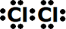
Ionic compounds are depicted as cations having lost their valence electrons and the respective positive charge, they are associated with anions showing completed valence electron orbitals and the respective negative charge. This produces the following valid molecule drawn as Lewis dot diagrams:
Figure 8 – Lewis dot diagram of calcium chloride, CaCl₂

Multiple bonds are represented by adjacent electron pairs drawn between atomic symbols. Oxygen gas (O₂) involves a double bond and nitrogen gas (N₂) contains a triple bond.
Figure 9 – Lewis dot diagram of oxygen gas (O₂) and nitrogen gas (N₂)
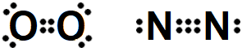

Ionic and covalent bonding
Students compare samples of substances and correlate their observations with secondary–source data to justify their properties based on the nature of bonding across the spectrum of bond types.
Chemical bonding is typically classified as either ionic or covalent. In reality, this binary classification system is less accurate when describing certain compounds. Bonds are known to have a percent ionic character. In either case, a pair of electrons, one from each element (or in the case of coordinate bonds, both from the same element) are shared. The type of bond formed between two elements is determined by any difference in their electronegativity. Electronegativity is a relative value on the Pauling scale, this is not the same as electron affinity. Larger differences in electronegativity between the two elements results in a bond in which the electrons are unequally shared, with the electron being more likely to be found nearer the more electronegative element. Smaller differences in electronegativity, or bonds, between two identical elements (zero electronegativity difference), result in bonds which have more equal electron location probabilities between the two elements.
Students can show the relative nature of bonds by plotting bonds on a continuum scale between the two extremes of electronegativity. By developing this type of chart, students can move from the binary definition of ionic or covalent bonding towards the understanding of a continuum of bonds between both terms:
- Chlorine (Cl₂) has the same electronegativity on each side of the bond. The difference in electronegativity is therefore zero. This bond is considered purely covalent There is no distortion of the electron cloud in either direction.
- Caesium fluoride (CsF) has the least electronegative element (caesium, 0.79 Pauling units) bonded to the most electronegative element (fluorine, 3.98 Pauling units). Although the electrons in this bond are highly distorted towards fluorine, there is still a small component associated with caesium. The electronegativity difference is at its highest between these two elements, as shown below:
$$3.98-0.79=3.19 Pauling units$$
Figure 10 – linear electronegativity difference scale between 0 and 3.19 showing the relative ionic and covalent characteristics of bonds
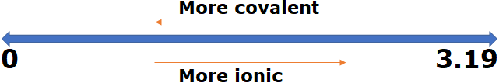

Molecular shapes
Students model a range of examples that connect the concepts of electron arrangement, bonding and non-bonding electron pairs, and the natural arrangement of electrons around the central atom view of a molecule.
The Valence Shell Electron Pair Repulsion (VSEPR) theory is a simple and useful way to predict and rationalise the shapes of molecules. The theory is based on the minimisation of electrostatic repulsion between bonding and non-bonding electron pairs in molecules. Some molecular modelling kits have the capacity to model the shapes of a range of molecules, using small balloon shaped parts to indicate the presence of non-bonding electron pairs. PhET have two simulation tools to help with this concept, available as the basic concepts or more advanced concepts. A simple table can be generated which gives the molecular shape based on the number of bonding and non-bonding electron pairs around the central atom:
Figure 11 – molecular shapes showing the relationship between bonding and non-bonding electrons
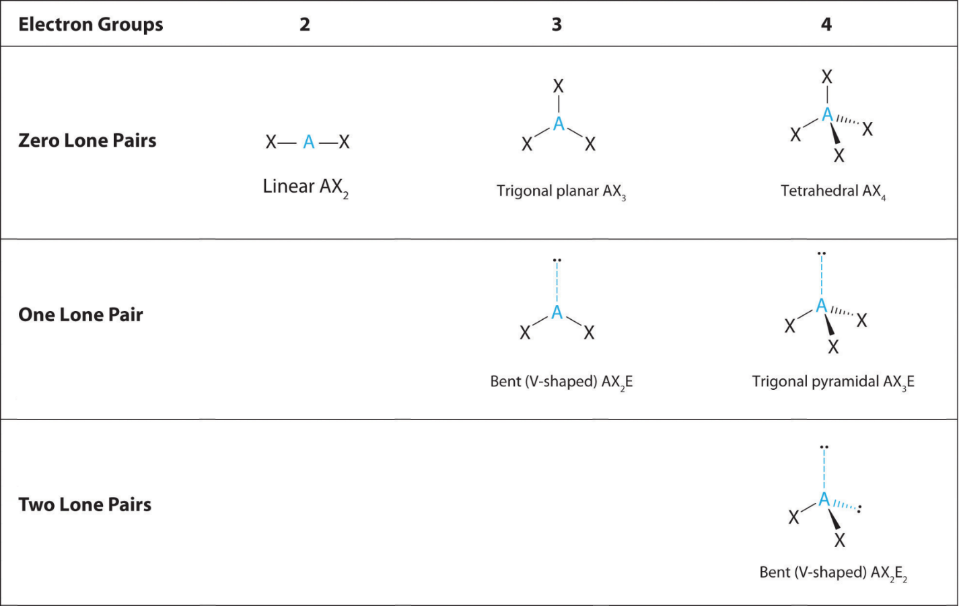
Source: image adapted by NSW Department of Education, 2021 from an image licensed under CC BY-NC-SA 4.0.

Intermolecular forces
Students model a range of examples that connect the concepts of bond dipoles and molecular shapes to the formation of molecular dipoles. Intermolecular forces are a result of the interaction between adjacent molecular dipoles.
The nature of intramolecular bonding is responsible for each substance’s observable and measurable properties. Intermolecular forces are produced from the interplay of bonding electrons, non-bonding electron pairs and bond dipoles and give rise to molecular dipoles and molecular shapes. There are three main types of intermolecular forces, each of which have specific origins and impacts - dispersion forces (also known as London dispersion forces), dipole-dipole forces and hydrogen bonding.
Intermolecular force | Origin | Impact | Example
Dispersion forces | Temporary charges due to distortion of the electron cloud. | All molecules exhibit dispersion forces and are very weak. | Pentane  C5H12
Dipole-dipole forces | Permanent charges on polar molecules attracting their opposite charges. | All substances with a molecular dipole. Strength determined by the molecular dipole strength. | Hydrochloric acid  HCl
Hydrogen bonding | Very strong dipole-dipole force created when hydrogen directly bonds to nitrogen, oxygen, and fluorine. | Any substance with a molecular dipole where hydrogen is directly bonded to N, O or F. | Ammonia  NH₃
Each of the intermolecular forces create attractive forces between adjacent molecules. This influences the physical properties of elements and molecules. A good example is boiling point which typically increases with molecular weight, and also increases as the intermolecular forces within the liquid become stronger. Melting point or Boiling point can be plotted against molecular weight to show the difference between those compounds with different types of intermolecular forces. By looking for trends and exceptions in these charts, students are better placed to relate the overall influence of these intermolecular forces.
Figure 12 – chart of molecular weight vs. boiling point for a range of compounds with hydrogen

Bond polarity and molecular shapes determine molecular polarity. This plays a central role in the intermolecular forces of the molecule, which then determine the substances physical properties. The molecular shape gives an angular difference between the charged bonds which can be represented as a vector diagram, with the resultant vector representing the molecular dipole. The PhET molecular polarity simulation models this with a range of molecules and has options to show each bond and the overall molecular dipole.
For example, water (H₂O) has two polarised hydrogen-oxygen bonds, due to the electronegativity difference between hydrogen and oxygen. It has a bent molecular shape due to the two non-bonding electron pairs on oxygen, resulting in a molecular dipole. This molecular dipole gives water a slight charge, where hydrogen bonding is the primary intermolecular force. This explains why water has a high melting and boiling point, surface tension and the ability to dissolve many ionic compounds and other polar molecules.
Figure 13 – bond and molecular dipole diagram for water showing the direction and magnitude of the dipole
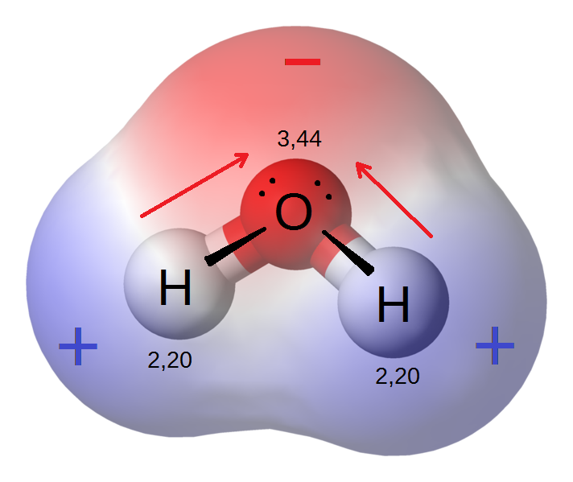
Source: licensed under CC BY-SA 3.0.

Molecular structures
Students model a range of examples across the spectrum of molecule types. They use first-hand samples and secondary–source data to justify properties of molecules based on the nature of bonding.
The physical arrangement of particles within a substance is an important consideration when modelling. Each structural arrangement is a result of the combined influence of the intramolecular and intermolecular forces operating in each substance. Ionic compounds exist in a large network of interconnected cations and anions where each ion is surrounded in all three dimensions by its opposite charged ion. Ionic networks are strong crystal structures due to the overall attraction between the cations and anions throughout the entire structure, however, physical impact along one plane of the lattice can shift the ions by an odd number of spaces. This places ions of the same charge adjacent to each other and creates a repulsive force, fracturing the crystal lattice. Sodium chloride comprises of sodium cations and chloride anions and forms an ionic network.
Figure 14 – ionic network structure of sodium chloride showing the 3D structure
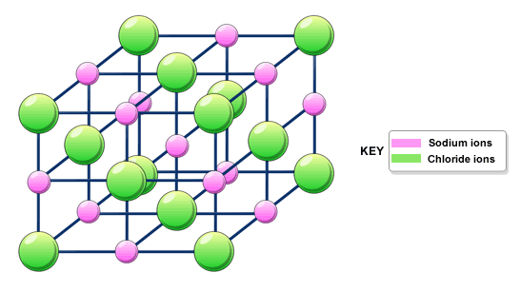
Source: licensed under CC BY 4.0.
Covalent compounds will typically exist as discrete molecules with no intramolecular bonds joining adjacent molecules. Intermolecular forces create interactions between adjacent molecules, and this heavily influences their physical properties. Water has a covalent molecular structure with hydrogen bonding between adjacent molecules:
Figure 15 – water molecules, red oxygen and white hydrogens, shown as separate to each other yet connected via intermolecular hydrogen bonding
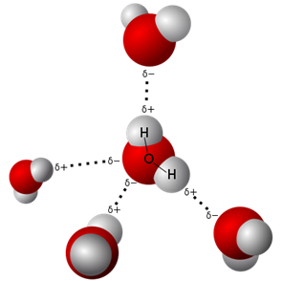
Source: available in the public domain.
Covalent networks are very strong three-dimensional structures using covalent bonds to bind adjacent atoms. These structures are also very brittle due to the inflexibility of these bonds when subjected to physical stress, causing the structure to shatter along specific lines known as cleavage lines. When covalent bonds are formed between carbon atoms, each atom forms a tetrahedral arrangement with the adjacent carbons. This structure is incredibly strong yet very brittle. As a natural formation this structure is known as diamond. Similarly, silicon and oxygen form the compound silica (SiO₂) which also exists as a large covalent network. This structure is also very strong and brittle. It is the compound commonly found in glass:
Figure 16 – covalent network structure of diamond and silica showing the 3D structure
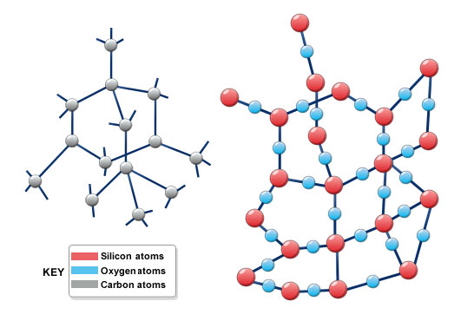
. Source: licensed under CC BY 4.0.
Lastly, metals form a structure whereby the valence electrons dissociate from their parent nucleus and begin traversing the lattice structure as a delocalised electron cloud. These electrons typically move randomly however, under the influence of external electrical fields, the flow of these electrons can be manipulated. It is important to note that disruption of a metallic lattice by physical force does not produce the same fracture observed in ionic lattices. The absence of opposing charged nuclei and the accommodation of the electron cloud produces a structure which is highly malleable and ductile.
Figure 17 – metallic structure showing the 3D structure
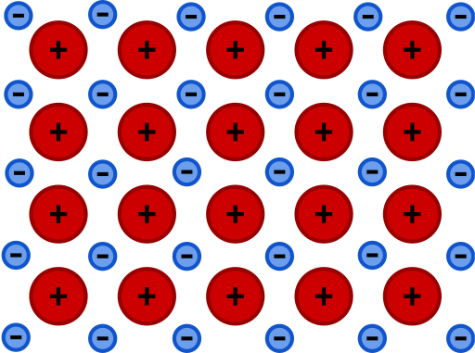
Source: available in the public domain.
Using these models to explain the physical and chemical properties of substances is critical to embedding this learning in the later modules. Students are better placed to engage with more advanced concepts, such as solubility, when they have a clear model for the substance they are investigating. Students could compile a clear and succinct table to compare the molecular structure of each substance according to a range of physical properties:
 | Sodium chloride | Water | Silicon dioxide | Iron
Data source | PubChem | PubChem | PubChem | PubChem
Type of bonding | Ionic | Covalent molecular | Covalent network | Metallic
Melting point | 800.7$℃$ | 0$℃$ | 1710$℃$ | 1538$℃$
Boiling point (at 101.3kPa) | 1465$℃$ | 100$℃$ | 2230$℃$ | 2861$℃$
Density (at $25℃$) | 2.17$\frac{g}{mL}$ | 0.997$\frac{g}{mL}$ | 2.2$\frac{g}{mL}$ | 7.87$\frac{g}{mL}$
Ductile | No | No | No | Yes
Malleable | No | No | No | Yes
Solubility in water | 360$\frac{g}{L}$ | $$∞$$ | Insoluble | Insoluble

Allotropy
Students model a range of examples across the spectrum of molecule types. They use their experiences of first-hand samples (where possible) and correlate with secondary–source data to assist in the justification of properties based on the nature of bonding.
Different elemental forms can exhibit different properties depending on the arrangement of the atoms. This is known as allotropy. Carbon has two main allotropes due to the wide range of bonding capacity possible with the electron configuration of carbon:
Figure 18 – diagram and image of graphite and diamond
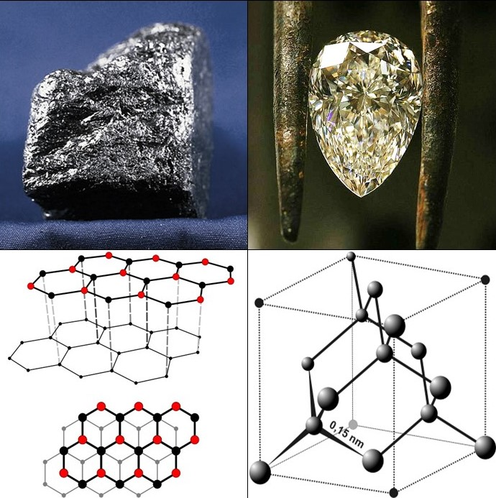
Source: licensed under CC BY-SA 4.0.
Graphite is a two-dimensional covalent network of interconnected hexagons with carbon atoms as the vertices. This forms as large, single atomic layer thick sheets with weak dispersion forces holding adjacent sheets together. When disrupted, these sheets easily slide over each other. Diamond is a large three dimensional covalent network. The carbon atoms are connected to four others as a tetrahedron which provides incredible hardness to the material.
There are many more allotropes of carbon including Buckminsterfullerene or ‘buckyballs’ and nanotubes, most of which are either synthetic or found only sparingly in nature. Many other elements such as sulfur, phosphorus, oxygen, nitrogen, silicon, and iron. also have allotropes. A further investigation into these allotropes and their potential uses could be used to initiate a depth study with students.

Appendix 1 – IUPAC naming
A good strategy to allow students to become accomplished writers of chemical formulae is:
If you use it or produce it, name it and use the formula. Any compounds experienced in the laboratory or in diagrams throughout the course need to be introduced to students.
Element atomic symbols consist of one, two or three roman letters which are often, but not always, related to their name in English. An atomic symbol can carry up to four modifiers to convey further information. For the hypothetical atom with the symbol X:
Figure 19 – symbol X showing the four possible modifier positions A, B, C and D
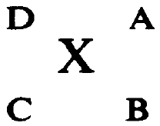
This shows the four positions – A, B, C and D. In each position the following information can be conveyed.
- A - charge number with positive or negative integers for example 2+ or 2- indicating X is an ion. It is incorrect to write charges as +2, -2, ++ or --). A single + or – is acceptable for single charges where the 1 may be omitted. In the absence of a value, it is assumed zero.
- B - number of atoms of this symbol bound together in a single chemical entity or species. For an empirical formula, this number represents the relative proportions of this atom. Where this value is 1, it may be omitted.
- C - atomic number. This position is commonly left blank as the atomic symbol implies the atomic number.
- D - mass number. The precise number of nucleons (protons and neutrons in the nucleus) for the isotope to which this symbol refers.
The name is derived by combining the names of the electropositive constituent(s) with the electronegative constituent(s), suitably modified by any necessary multiplicative prefixes (mono, di, tri, tetra) and separated by a space. The multiplicative prefixes may not be necessary if the oxidation states are explicit or are clearly understood. The name of the electropositive constituent is the unmodified name followed by roman numerals in parentheses where needed to indicate the oxidation state. Monoatomic electronegative constituents are named by using the suffix ‘ide’ added to the first syllable. Polyatomic anion names are retained in full.
If there is more than one electropositive and/or electronegative constituent, the names are separated by a space and cited in alphabetical order (ignoring any multiplicative prefixes). Hydrogen is always cited last among the electropositive constituents and where associated with an anion, ‘hydrogen’ is not separated by a space from the following anion name:
Formula | Correct | Incorrect
NaCl | sodium chloride | sodium chlorine
AlK(SO₄)₂ | aluminium potassium sulfate | potassium aluminium sulfate
NaHCO₃ | sodium hydrogencarbonate | sodium hydrogen carbonate
FeCl₂ | iron(II) chloride | iron chloride
The atoms belonging to polyatomic groups are retained as a group (Leigh, 2011, p.16). For all other constituents, electropositive constituents are cited first followed by the electronegative constituents. Within each group, the symbols are cited in alphabetical order (ignoring any multiplicative prefixes) by the symbol letter(s). Like the compounds name, hydrogen in the formula is always cited last among the electropositive constituents (Leigh, 2011, pp. 40-43). This may create a sequence in the formula which differs to the name in some compounds due to the difference in alphabetical order of the names compared to the symbols of elements or polyatomic ions:
Name | Correct | Incorrect
ammonium sodium hydrogenphosphate | NaNH₄HPO₄ | NH₄NaHPO₄
potassium sodium tartrate | KNaC₄H₄O₆ | NaKC₄H₄O₆
The list below is not comprehensive for the requirements of the syllabus as the naming of substances should be completed on a need’s basis - if you use it, name it.
Ion IUPAC name | Ion formula | Ion charge
Sodium | Na⁺ | +1
Magnesium | Mg²⁺ | +2
Chloride | Cl⁻ | -1
Sulfide | S²⁻ | -2
Hydroxide | OH⁻ | -1
Sulfate | SO₄²⁻ | -2
Phosphate | PO₄³⁻ | -3
Valid binary compounds contain one cation, the positively charged ion, A, followed by one anion, the negatively charged ion, B. By crossing over the respective ion charges (x- and y+) to create multiplicative factors (x and y) a ratio is produced that gives a resulting charge of zero for the final compound. In general terms:
$$xA^{y+}+yB^{x-}\overset{→}{}A_{x}B_{y}$$
- Sodium chloride is the combination of Na⁺ (charge +1) and Cl⁻ (charge -1) ions, resulting in a combination of +1 + -1 = 0 which requires no multiplicative factors for either ion. This results in the final compound formula of NaCl.
- Magnesium chloride is the combination of Mg²⁺ (charge +2) and Cl⁻ (charge -1) ions, resulting in a combination of +2 + -1 = +1. This requires multiplicative factors for the anion to reduce the overall charge by using two chloride ions. This results in a combination of +2 + 2(-1) = 0. The final compound formula is MgCl₂.
- Sodium sulfide is the combination of Na⁺ (charge +1) and S²⁻ (charge -2) ions, resulting in a combination of +1 + -2 = -1 This requires multiplicative factors for the cation to increase the overall charge. By using two sodium ions this results in a combination of 2(+1) + -2 = 0. Thus, the final compound formula is Na₂S.
- Sodium phosphate is the combination of Na+ (charge +1) and PO₄³⁻ (charge -3) ions, resulting in a combination of +1 + -3 = -2. This requires multiplicative factors for the cation to increase the overall charge. By using three sodium ions this results in a combination of 3(+1) + -3 = 0. The final compound formula is Na₃PO₄.
- Magnesium phosphate is the combination of Mg²⁺ (charge +2) and PO₄³⁻ (charge -3) ions, resulting in a combination of +2 + -3 = -1 which requires multiplicative factors for the cation to increase the overall charge. In this instance we are looking for the lowest common multiple for the factors 2 and 3. By using three magnesium ions and two phosphate ions this results in a combination of 3(+2) + 2(-3) = 0. The final compound formula is Mg₃(PO₄)₂.
References cited:
Leigh, G. J., 2011. Principles of Chemical Nomenclature. Cambridge, UK: Royal Society of Chemistry.

Appendix 2 – decay pathways of unstable nuclei
Many different pathways are possible and this could form the basis of a depth study. The commonly used patterns and trends are generally summarised as:
- The nucleus is too large to allow stability. These nuclei typically undergo alpha decay which results in the emission of a particle comprised of two protons and two neutrons. The daughter isotope has a mass four atomic mass units lower than its parent. The atomic number decreases by two, resulting in the transmutation into the element two spaces back on the periodic table, for example, Uranium-238:
$${}_{92}^{238}U\overset{→}{}{}_{90}^{324}{Th}+{}_{1}^{4}{He}$$
- Neutron/proton ratio is too high with too many neutrons in the nucleus. These nuclei typically undergo beta decay, resulting in a daughter isotope that has one more proton and one less neutron than its parent. The mass remains unchanged but the atomic number increases by one, resulting in the transmutation into the next element on the periodic table, for example, Carbon-14:
$${}_{6}^{14}C\overset{→}{}{}_{7}^{14}N+{}_{-1}^{0}e$$
- Neutron/proton ratio is too low with not enough neutrons in the nucleus. These nuclei typically undergo electron capture, resulting in a daughter isotope that has one less proton and one more neutron than its parent. The mass remains unchanged but the atomic number decreases by one, resulting in the transmutation into the previous element on the periodic table, for example, Rubidium-83:
$${}_{37}^{83}{Rb}+{}_{-1}^{0}e\overset{→}{}{}_{36}^{83}{Kr}$$
- There is too much energy contained in the nucleus to allow stability. These nuclei typically release gamma radiation, resulting in the emission of very high energy electromagnetic radiation. The daughter isotope is unchanged from its parent and now has less internal energy which improves its stability. Many other types of nuclear decay are also commonly associated with concurrent gamma emissions.

Appendix 3 – spdf orbitals template
Figure 20 – blank template for electron orbital diagrams as used in this guide

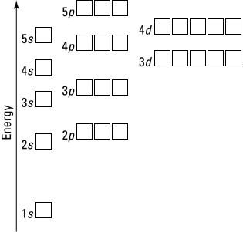

References
This resource contains NSW Curriculum and syllabus content. The NSW Curriculum is developed by the NSW Education Standards Authority. This content is prepared by NESA for and on behalf of the Crown in right of the State of New South Wales. The material is protected by Crown copyright.
Please refer to the NESA Copyright Disclaimer for more information https://educationstandards.nsw.edu.au/wps/portal/nesa/mini-footer/copyright.
NESA holds the only official and up-to-date versions of the NSW Curriculum and syllabus documents. Please visit the NSW Education Standards Authority (NESA) website https://educationstandards.nsw.edu.au and the NSW Curriculum website https://curriculum.nsw.edu.au.
Chemistry Stage 6 Syllabus © NSW Education Standards Authority (NESA) for and on behalf of the Crown in right of the State of New South Wales, 2017.
© State of New South Wales (Department of Education), 2021
The copyright material published in this resource is subject to the Copyright Act 1968 (Cth) and is owned by the NSW Department of Education or, where indicated, by a party other than the NSW Department of Education (third-party material).
Copyright material available in this resource and owned by the NSW Department of Education is licensed under a Creative Commons Attribution 4.0 International (CC BY 4.0) license.

This license allows you to share and adapt the material for any purpose, even commercially.
Attribution should be given to © State of New South Wales (Department of Education), 2021.
Material in this resource not available under a Creative Commons license:
- the NSW Department of Education logo, other logos and trademark-protected material
- material owned by a third party that has been reproduced with permission. You will need to obtain permission from the third party to reuse its material.
Links to third-party material and websites
Please note that the provided (reading/viewing material/list/links/texts) are a suggestion only and implies no endorsement, by the New South Wales Department of Education, of any author, publisher, or book title. School principals and teachers are best placed to assess the suitability of resources that would complement the curriculum and reflect the needs and interests of their students.
If you use the links provided in this document to access a third-party's website, you acknowledge that the terms of use, including licence terms set out on the third-party's website apply to the use which may be made of the materials on that third-party website or where permitted by the Copyright Act 1968 (Cth). The department accepts no responsibility for content on third-party websites.

