Chemistry Module 7 –Organic Chemistry

Contents
Teaching the Year 12 Modules 2
Course overview 3
Module summary 4
Big ideas 4
Relationship to other modules 4
Core concepts 5
Opportunities for extending concepts 6
Alternative conceptions and misconceptions 6
Conceptual difficulties 8
Suggested teaching strategies 8
IQ7-1 – How do we systematically name organic chemical compounds? 8
IQ7-2 – How can hydrocarbons be classified based on their structure and reactivity? 11
IQ7-3 – What are the products of reactions of hydrocarbons and how do they react? 12
IQ7-4 – How can alcohols be produced and what are their properties? 14
IQ7-5 – What are the properties of organic acids and bases? 15
IQ7-6 – What are the properties and uses of polymers? 16
Appendix 1 – practical opportunities 18
Data analysis 18
Alcohols 18
Carboxylic acids and amines/amides 22
Polymers 23
Appendix 2 – IUPAC naming 24
References 25

Teaching the Year 12 Modules
The new Stage 6 Chemistry course was implemented in NSW schools in 2018-2019. This syllabus incorporates new content and learning activities such as Depth Studies. The syllabus is designed around inquiry questions and formal assessment tasks emphasise the skills for working scientifically.
The Year 12 course builds on the concepts introduced in Year 11 by the examining of particular classes of chemicals, processes and a variety of chemical reactions which incorporate organic compounds and acid/base and equilibrium reactions. The application of this knowledge to the investigation of a range of methods used in identifying and measuring quantities of chemicals leads to a deep understanding of the structure, properties and trends of, and between, classes of chemicals. The Working Scientifically skills and processes are applied to predict outcomes by using physical, conceptual and mathematical models and assessing the limitations of models.
Therefore, pedagogies that promote inquiry and deep learning should be employed in the Chemistry classroom. The challenge presented by the additional content and the change in pedagogical approach were the catalysts for the preparation of these module guides for Stage 6. These guides are intended to assist teachers deliver Chemistry effectively by outlining overarching concepts (big ideas), core and extended ideas, strategies for teaching the modules, uncovering of alternative conceptions, and strategies to address them. The guides support the teacher in facilitating the development of deep knowledge structures, such as the relationships between concepts. It is essential that teachers note that the module guides do not substitute the syllabus, but only support teachers to teach it. The module guides do not cover all aspects of the syllabus, as that was not within the scope of the project.
The information contained in these documents is correct at the time of publication. While every effort has been made to eliminate errors, any errors or omission that are identified after the release of these documents will be corrected and released as resource updates. It is recommended that teachers access Science Stage 6 for the latest version of these documents.

Course overview
The chemistry course develops student ability to apply processes that underpin the understanding of the nature and practice of science and enables students to interpret the interconnection between the nature and practice of science, and a knowledge of chemistry. Through applying the Working Scientifically skills processes, the course aims to examine how theories, models and practices are used and developed.
The fundamentals developed in Year 11 include:
- Knowledge and understanding of the properties and structures of matter, and relating properties and structures to trends in data and reactions
- knowledge and understanding of the types of and drivers of chemical reactions
- skills in making hypotheses and designing valid and reliable practical investigations
- skills in conducting investigations and solving problems
- constructing models
- conducting investigations by measuring and/or collecting relevant data and information from first-hand practicals and secondary sources and determining the accuracy, reliability and validity of data and information
The Year 12 course builds on the concepts introduced in Year 11 by:
- the examining of classes of chemicals, processes and a variety of chemical reactions which incorporate organic compounds and acid/base equilibrium reactions
- the application of this knowledge to the investigation of a range of methods used in identifying and measuring quantities of chemicals, which leads to a deep understanding of the structure, properties and trends of, and between, classes of chemicals
- using physical, conceptual and mathematical models to predict outcomes and assessing the limitations of models.

Module summary
This module addresses the significance of organic compounds in our lives, the major impacts of these chemicals on society and the environment, the benefits of further research and the development of materials that would benefit society and the environment. Students become familiar with the internationally agreed naming conventions for a range of organic structures including chain length, functional groups and isomers. A variety of modelling and practical activities are available throughout this module to expand on the students developing working scientifically skills. In most of the inquiry questions there are opportunities to explore the applications of these organic substances and students can develop an appreciation for the positive and negative implications of these compounds.

Big ideas
The nomenclature, properties and reactivity of organic compounds are based on their underlying structure and intermolecular interactions. These structures allow us explain patterns and predict reactivity to synthesise many new compounds and materials that are useful in society. Many of these compounds may pose problems in terms of their environmental impacts and disposal.

Relationship to other modules
This module links to:
- IQ1-4: Connecting the nature of intermolecular and intramolecular bonds and relating this to the properties of compounds
- IQ3-1: Products of chemical reactions in organic chemistry, writing and describing chemical reactions
- IQ4-1: Enthalpy changes, activation energy and catalysis as they relate to organic compounds and their reactions
- IQ5-1 Equilibrium and the reversibility of chemical reactions
- IQ5-3: Processes used by Aboriginal people to remove toxicity from foods as related to the intermolecular forces explained by organic functional groups and structures
- IQ6-3: Chemical analysis of common household substances for their organic components and matching properties of substances to their intended uses.
- IQ8-2: Analysis of organic compounds and the chemical and instrumental tests used to identify the compounds
- IQ8-3: Implications for society of chemical synthesis and design with organic compounds, implications for societies use of organic compounds

Core concepts
The structure of homologous groups, IUPAC rules for nomenclature and a range of first-hand and secondary sourced investigations allow for inquiry based learning to uncover the relationship between the structure and the properties and reactions of organic compounds, such as halogenated hydrocarbons, alcohols, aldehydes, ketones, carboxylic acids, amines, amides, and esters. The effect of isomerism on the properties of organic compounds is also investigated.
Organic compounds and their reactions are described using representations such as models, diagrams, structural formulae and equations. The observations from investigations are used to write equations for, and predict the products of, reactions such as combustion, oxidation, hydration, dehydration, addition, substitution, condensation, fermentation, saponification, esterification, and polymerisation. A knowledge and understanding of the structure of organic compounds is used to predict reactivity and design synthesis reactions.
The hazards of working with organic compounds are identified and risks are controlled, with students performing reactions safely in the laboratory. Organic chemistry is the basis of investigations into the synthesis of new compounds and materials, and the examination of the environmental, economic and sociocultural implications of obtaining and using hydrocarbons from the Earth, such as the comparing and contrasting of fuels from inorganic sources to biofuels, such as ethanol. Further exploration of current issues, future research and development allows students to engage with the content in an authentic context.

Opportunities for extending concepts
This module contains a wide variety of opportunities to extend concepts covered as a depth study or differentiation for students to explore, this includes:
- Nomenclature of functional group priority for organic compounds with more than one functional group attached
- Investigation of optical isomerism and nomenclature around cis/trans isomers
- Nomenclature, structure and/or properties of cyclic and aromatic compounds
- Reduction of carboxylic acids to aldehydes, further reduction of aldehydes to primary alcohols and ketones to secondary alcohols
- Design a procedure to manufacture and safely test a range of soaps
- Investigate the improvements to chemical synthesis processes such as green chemistry
- Investigate the properties of natural and synthetic polymers from biomass such as starch, cellulose and biopolymers
- Investigate the structure and properties of proteins and materials formed from proteins

Alternative conceptions and misconceptions
- The more common use of the term “organic” as natural compounds contrasted with its meaning in chemistry as any type of carbon-based compound. This terminology is very important in this module. Students need to be very clear that organic compounds are both natural and synthetic with the underlying chemical bonding structures being the defining feature. Using examples of products branded as organic and reviewing the structures of their constituents will be valuable to deter this misconception of terminology.
- Older naming conventions have been superseded by new developments in rules from IUPAC, such as base chain naming of unsaturated hydrocarbons with sidechains (see appendix 2). Using an updated source for naming conventions and online modelling tools which utilise the most recent convention is valuable to reduce the problems which could result from outdated sources of nomenclature or relying on teacher experience alone.
- Alternative naming conventions carried over from older naming systems are still generally accepted in chemistry such as formic/methyl and acetic/ethyl. IUPAC has a series of recommended naming conventions and in many instances still accepts alternative names for the same compound. Allowing students to see examples of compounds with a mixture of these naming styles is beneficial to break down the right/wrong dichotomy with this naming system. In many storerooms there will be chemical bottles labelled with both naming systems, sometimes even on the same label for example, ethyl acetate.
- Handling and disposal rules and regulations for organic compounds are necessary considerations for student safety and the safety of the environment. By introducing students to the safety data sheets for the compounds used in the laboratory they can begin to gain a deeper appreciation for this important aspect of using organic compounds.
- The process and products of oxidation reactions in organic compounds may be confused with inorganic chemistry. Ensuring the definition of oxidation given in IQ3-2 is clearly linked with electron transfer whereas the oxidation process in organic reactions has multiple meanings. A clear description is available at masterorganicchemistry.com
- Organic synthesis reactions do not always yield only the desired product due to side reactions. Using examples of current organic synthesis pathways which have been improved over their lifespan such as ibuprofen (see Ibuprofen – a case study in green chemistry and The BHC Company - Synthesis of Ibuprofen) will allow students to see how small some yields are and how ongoing research and development is needed. This is important to not only develop new compounds but also to improve current synthesis pathways to reduce wastes and costs of the products. Resources on green chemistry are available to describe the changing yields without delving too heavily into the precise organic reaction mechanisms used
- The comparison between the terms “plastic” and “polymer” for the compounds in this module needs careful definition when introduced. It needs to be made clear that ‘polymer’ is the umbrella term for long repeating chain organic compounds. Plastics is just one type of polymer (the others being elastomers, fibres and adhesives/paints). Polymers can be natural (for example, cotton) and synthetic. Synthetic polymers are commonly referred to as plastics (for example, PVC). Polymers and plastics - An introduction to their structures and properties of all subtypes could be useful for extension.

Conceptual difficulties
This module contains a wide variety of different organic structures, reactions and products to remember and apply to a variety of circumstances. Teachers need to regularly use various modelling strategies incorporating practical opportunities, molecular modelling kits and digital resources to effectively demonstrate the concepts covered. Regular checkpoint quizzes and formative assessment opportunities are vital to reinforce student understanding and develop proficiency. Appropriate, relevant and engaging examples of organic compounds and reactions need to be used in order to prevent this topic from appearing as rote learning to students.

Suggested teaching strategies
This module can be reorganised to incorporate IQ7-1 into the other inquiry questions and address the nomenclature of each class of organic compound as the initial component of each of the remaining inquiry questions in this module. It is also possible to integrate IQ8-2 into each inquiry question looking at the chemical and instrumental techniques used to analyse organic compounds. Many of the older text books and laboratory manuals will have useful summaries, data analysis and practical activities relevant to this module. If using these resources it would be advisable for teachers to:
- review the current CSIS policy to ensure these activities are still suitable for classroom use including the chemical substances used, the processes undertaken and the safe disposal of chemicals.
- review the nomenclature to ensure current IUPAC conventions are used.

IQ7-1 – How do we systematically name organic chemical compounds?
This inquiry question could be divided up, as appropriate, between the other inquiry questions in this module to address nomenclature, structure and properties of each specific functional group as they are addressed.
The nomenclature of organic compounds can become quite complex and many alternative conceptions from students are possible. By using simplified steps to focus on the core naming principles used for organic compounds it can be easier to avoid these pitfalls for students. Online compendiums of organic nomenclature strategies such as ChemGuide and Michigan State University Chemistry Nomenclature are very helpful but can go into advanced concepts which will need curation by teachers before using with students.
The key strategies for this inquiry question will be the use of a variety of modelling techniques to both digitally and physically manipulate the organic compounds while attempting naming using the nomenclature guides. By allowing students to more freely explore the modelling of a variety of organic compounds with molecular modelling kits and online modelling tools like MolView, it can be easier for students to see how the rules are applied to a wider range of compounds. In these processes it is valuable to include opportunities for students to formatively assess each other and obtain teacher feedback on names given to modelled compounds. Students can use also MolView to find the systematic name of models using the information card option in the tools menu. It will be vital for teachers to ensure these opportunities are frequently utilised so that students are able to obtain regular practice of their nomenclature and modelling skills throughout all inquiry questions in this module.
Many schools will have access to some version of molecular modelling kits with the familiar colour coded atoms and selection of bonds. Online modelling tools like molview.org can assist for a free online alterative. Using a combination of these resources to assist students to learn to draw a range of organic compounds showing the correct structural arrangements. Using a hexagonal graph paper template for students to draw organic compounds could be a helpful introductory scaffold. Modelling compounds in this way will be a vital strategy which is a common theme through all the inquiry questions in this module.
The concept of isomerism allows the complex nature of organic chemistry to be more fully realised through the study of chain (structural), functional group and positional isomers. It is important for students to link isomerism to the change in properties under each type of isomerism:
- Chain isomers are those which have the same molecular formula as each other but due to the different connections have a different structure. Pentane and 2-methylbutane (isopentane) are both C₅H₁₂ but have distinctly different structures:
Figure 1 – pentane and 2-methylbutane, both are C₅H₁₂
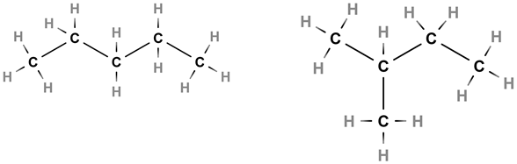
- Functional group isomers have the same molecular formula as each other with different functional groups included in the structure. Acetone (propanone) and propanal are both C₃H₆O but have distinctly different structures:
Figure 2 – acetone and propanal, both are C₃H₆O
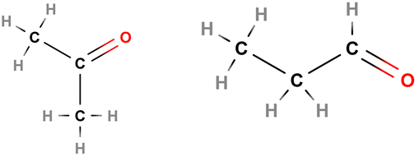
- Positional isomers have the same molecular formula as each other with the same functional groups included in the structure at different locants. 1-butanol and 2-butanol are both C₄H₉OH but have distinctly different structures:
Figure 3 – 1-butanol and 2-butanol, both are C₄H₉OH
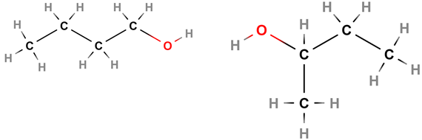

IQ7-2 – How can hydrocarbons be classified based on their structure and reactivity?
This inquiry question encompasses a very wide variety of possible organic compounds that can be used for student learning experiences. Where available, samples of these substance can be used to demonstrate some of the properties of hydrocarbons in practical situations. Integration of the tests for unsaturation from IQ8-1 and instrumental analytical techniques from IQ8-2 (see the module 8 guide for more information) are useful here to distinguish the alkene/alkyne functional groups from the alkane. Taking appropriate practical opportunities to investigate hydrocarbons is vital to ensure students can clearly connect nomenclature and structure to intermolecular forces which drive the physical properties of these compounds.
Modelling is particularly important when looking at molecular shapes. This concept can be difficult to instil in students and is foundational to the understanding of intermolecular forces which drive the properties for these compounds. Using molecular models and tools like PhET and MolView can be useful to illustrate this content elaboration with students. Through the effective data analysis of the hydrocarbons' physical properties, the observed trends can be described and linked back to the modelling of the organic compounds. A helpful description of this trend can be found for alkanes and alkenes. Comparison between increasing chain length within a homologous series (for example, methane, ethane, propane) and between different homologous series of the same chain length (for example, ethene, propene, 1-butene) can be useful activities for students to explore the concept and gain a better understanding of the relationship between the physical properties (macroscopic) and relative strengths of intermolecular bonding (sub-microscopic).
Handling and disposal of hydrocarbons is a key part of this inquiry question and can form another inquiry-based learning activity with reviewing the safety data sheet (SDS) for the hydrocarbons stored in the school (also including other areas in the school for example, TAS and CAPA). Each SDS contains the key information for the handling and disposal of the organic compound. Students could explore the procedures used in school to comply with these requirements. It is important to emphasise the connection between these procedures and the physical properties of the organic compound so that students can link all concepts covered in this inquiry question. These physical properties can be observed practically using micro-scale techniques for solubility in water and calculating density. Using a water-soluble dye to assist in observing the phase layers is valuable as many of these compounds are colourless. In all activities it is critical teachers and students are aware of the CSIS policy for the organic compounds they are using, including appropriate waste disposal procedures. Geoscience Australia have a set of resources on petroleum resources in Australia which can provide a useful discussion on the extraction and use of hydrocarbons.

IQ7-3 – What are the products of reactions of hydrocarbons and how do they react?
In this inquiry question students are asked to consider the wide range of applications for the reactivity of the unsaturated hydrocarbons (inclusive of alkenes and alkynes) with a range of reagents. The specific reagents which are applied in this content elaboration are specified and can be extended upon in order to formatively assess students understanding of electrophilic addition in unsaturated hydrocarbons. The wide range of products possible from this functional group is a result of the increased susceptibility of the double bond to attack by many other reagents:
Figure 4 – molecular electrostatic potential (MEP) surface of ethene
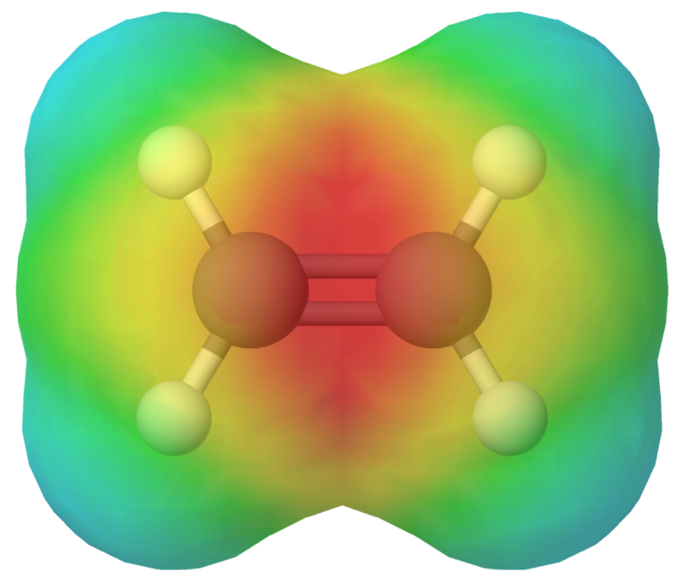
Considering how this is applied beyond this inquiry question, such as the hydrogenation of vegetable oils to produce margarine, is a valuable strategy so that students do not distance themselves from what could be seen as a purely industrial process. Many of the practical opportunities suitable for students in this inquiry question link strongly with the chemical tests for functional groups in IQ8-2. The bromine test for unsaturation is documented in the module 8 guide which can be applied in this inquiry question. In all of reactions included it is important to clarify any catalysts used in the reactions. The following information is provided for teachers to provide a depth of knowledge, and all reactions as written may not be required by students, unless as extension or part of a depth study.
- Hydrogenation of a double bond involves the use of various metal catalysts such as nickel, platinum or palladium to cleave the double bond and add hydrogen across the opened double bond forming the corresponding alkane, for example ethene to ethane:
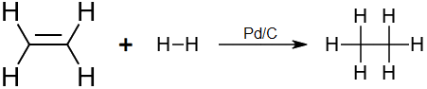
- Halogenation of a double bond involves the use of the halogens in their elemental forms (Fluorine, Chlorine, Bromine and Iodine) adding across the double bond forming the corresponding dihaloalkane, for example ethene to 1,2-dibromoethane:
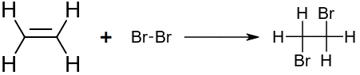
- Hydrohalogenation of a double bond involves the use of hydrogen halides (Hydrofluoric acid, Hydrochloric acid, Hydrobromic acid, Hydroiodic acid) adding across the double bond forming the corresponding haloalkane, for example ethene to bromoethane:
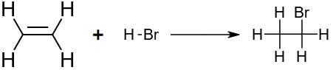
- Hydration is an important reaction to make clear that water does not directly add to a double bond. It first must be treated with sulfuric acid to produce the alkyl hydrogen sulfate as the intermediate product:
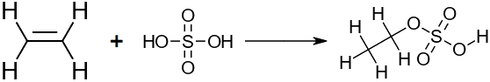
Water then substitutes the alkyl hydrogen sulfate to produce the corresponding alcohol and sulfuric acid. In many cases this reaction is written as the reaction between dilute sulfuric acid and the alkene, the sulfuric acid can be written above the arrow as a catalyst:
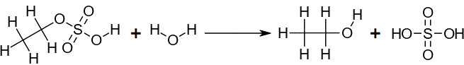
- For unsymmetrical alkenes both the hydrohalogenation and hydration reactions will follow Markovnikov’s Rule. When H-X is added across the alkene, the hydrogen will bond to the carbon in the alkene with the greater number of existing hydrogen atoms, for example 1-propene forming 2-bromopropane in greater amounts to 1-bromopropane:
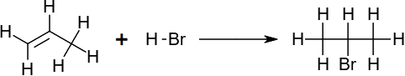
In the case of a hydration reaction with 1-propene, this forms 2-propanol in greater amounts than 1-propanol:
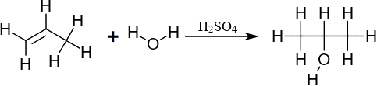
Halogenation of alkanes can also occur to produce several isomeric forms of the haloalkane. This process becomes more complex as the length of the alkane and the number of halogen substitutions is increased. The ratio of individual haloalkane isomers differs depending on conditions and which halogen was used. For this reason, it is advisable to use methane or ethane where the pattern of substitution is easier to model for teachers and students.

IQ7-4 – How can alcohols be produced and what are their properties?
Students explore a range of reactions which are used to produce alcohols and use alcohols as a reactant for producing other useful compounds. Integration of the tests for alcohols from IQ8-1 and instrumental analytical techniques from IQ8-2 (see the module 8 guide for more information) are useful here to identify the alcohol functional groups. The production of ethanol through fermentation is a well-documented practical opportunity (see appendix 1) and can easily be replicated in the laboratory with the products being tested to verify the presence of ethanol in the mixture. Examining the combustion reaction of alcohols, while undertaking an investigation of the enthalpy of combustion, is a useful combination of content descriptors which also assists students to connect with the bond energy concept from IQ4-3 of the Year 11 course. Dehydration can be easily linked to IQ7-3 as the opposite process to the reaction of alkenes with water. Consideration of the careful separation of these two processes based on the nature of the catalyst used is a very important distinction between these two reactions.
The comparison of fuels provides an interesting opportunity to open a discussion of the carbon economy and allows the linking of nomenclature, bonding, combustion and the real impacts of these decisions. Students can easily explore a wide number of interconnecting ideas between chemistry, agriculture, engineering and economics with reference to ethanol as a fuel from biomass. There are many online resources for this content and this can open an interesting discussion on the validity of secondary sources. The USA Department of Energy has their own information on ethanol but consideration of the source is necessary. Collecting data on heat of combustion and calculating energy density can be useful for comparing current fuel technologies (petrol and diesel) to ethanol and ethanol blended fuels (E10 and E85), and to other biomass fuels such as biodiesel. This is an ideal opportunity to scaffold and offer feedback to students on the construction of long responses which link reactions, structure and properties to social, economic and ecological issues.
Each practical opportunity needs to be supported by ongoing modelling so that students have a clear link between the model and practical observations to consolidate their understanding of the process rather than just inputs and outputs of the reactions undertaken. Appendix 1 contains a selection of practical opportunities to give students experience in both the investigating of this inquiry question and the appropriate handling of organic compounds in the laboratory.

IQ7-5 – What are the properties of organic acids and bases?
The content elaboration for alcohols, aldehydes, ketones and carboxylic acids could be integrated with the previous inquiry question when discussing oxidation reactions of alcohols. Through this learning pathway it can be easier to draw out the interconnections between inquiry questions to ease the cognitive load in this module. Amines and amides can be examined by modelling with particular reference to the intermolecular forces which create the organic base from these functional groups. Contrasting to the acidic nature of organic acids resulting from the carboxylic acid functional group is important for students to see the link to the concept of K_{a} and the acid/base models covered in module 6. Integration of the tests for carboxylic acids from IQ8-1 and instrumental analytical techniques from IQ8-2 (see the module 8 guide for more information) are useful here to identify the range functional groups presented in this inquiry question.
The data analysis of physical properties is another opportunity to have students locate appropriate data and perform the analysis to compare and explain the patterns within and between homologous series. Some data on alcohols and carboxylic acids along with amines are readily available and other functional group data can be located on a range of other sites. Through this comparison of physical properties, the models of each compound can be analysed to determine the influence of intramolecular and intermolecular bonding on structure and properties. These activities make explicit links between the various representations: the macroscopic (observable properties) to the symbolic (structure) and sub-microscopic (molecular bonding).
The use of these functional groups in the production of esters and soaps is a well-documented practical opportunity from the previous chemistry course (see appendix 1) which can be utilised to draw connections between these functional groups and their applications. Integrating IQ7-6 with the production of nylons and polyesters (condensation polymerisation) can also be helpful in linking the other content in this inquiry question (esterification is also a condensation reaction). All these opportunities can be used as a case study for the final component of this inquiry question where students are to examine the reaction pathways for multiple steps in a chemical synthesis process.

IQ7-6 – What are the properties and uses of polymers?
This inquiry question could be amalgamated into IQ7-3 and IQ7-5 while engaging in the reactivity of double bonds to produce addition polymers and carboxylic acids/amines to produce polyamides (nylons) and carboxylic acids/alcohols to produce polyesters. Polymerisation can occur as addition or condensation as homopolymers (where the monomers are all the same) or copolymers (where the monomers are different).
Addition polymers are a good introduction to polymerisation reactions and can be easily modelled (see appendix 1) in the classroom to show the stages of polymerisation. By clearly modelling this process in polyethylene, the same understanding can be easily be linked to the other addition polymers covered in this inquiry question for example, polyvinylchloride (PVC). A homopolymer addition polymerisation between monomers of “A” can be generically and specifically represented as:
$$A+A→{\left[AA\right]}_{n}$$
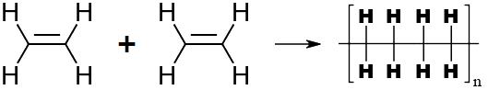
This understanding will then also aid student understanding of the slight variation to account for condensation polymerisation. The primary difference is the production of water as a by-product for each polymerisation reaction which takes place as a result of the combining functional groups on each monomer. Similarly, condensation polymers can be a homopolymer of the one monomer “A”, for example the formation of a peptide bond in polyamides like glycine:
$$A+A→{\left[AA\right]}_{n}+H_{2}O$$
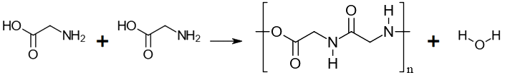
For a condensation copolymer between the monomer's “A” and “B” for example the formation of Nylon-66 from the two monomers, 1,6-Hexanediamine and hexanedioic acid:
$$A+B→{\left[AB\right]}_{n}+H_{2}O$$
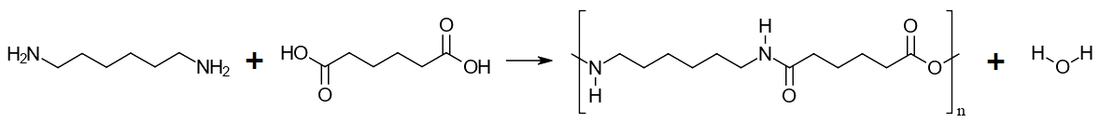
Like many of the previous inquiry questions for this module this inquiry question is best covered with the effective use of extensive modelling. Introducing a suitable narrative to this inquiry question through the history of plastics can also help students grasp the importance of polymers to the industrial revolution despite their contemporary impacts on the environment. There is an important focus for both types of polymers for students to recognise the connection between structure, properties and uses which is a key driving factor for the massive variety of polymers available and the ongoing research to develop new more environmentally suitable polymers. By linking the past, present and future of polymer technologies, students will be able to develop a connection between this inquiry question and the broader context of this module. Appendix 1 contains a selection of practical opportunities to give students experience in this inquiry question and the appropriate handling of organic compounds in the laboratory.

Appendix 1 – practical opportunities
Due to safety requirements, this module is an ideal place to incorporate a range of secondary data sources to process and represent data to develop an improved chemical understanding of the organic compounds covered in the module. Some key first-hand practical opportunities are still possible, and a selection are outlined in this appendix. Teachers must follow all health and safety requirements

Data analysis
Effectively using data analysis tools such as Microsoft Excel and Google Sheets to extract data from suitable data sources, and process and graphically represent the data to gain insights into the trends which exist within and between these homologous series, is an important skill in several inquiry questions covered in this module. Through a graphical representation of selected physical properties students can then link the intramolecular and intermolecular features which are responsible for this observed trend. This can form a range of inquiry-based learning activities using investigation questions in order to drive student exploration of the content, for example:
- How do models help predict the observed trends in the physical properties of a homologous series?
- Why do some physical properties provide a clearer representation of the trends of a homologous series compared to others?

Alcohols
The alcohol homologous series comprises of primary, secondary and tertiary alcohols. This refers to the type of carbon on which the alcohol is connected:
- Primary alcohols are connected to terminal carbons, those on the end of the chain and connected to one other carbon only.
- Secondary alcohols are connected to carbons in non-terminal positions, these carbons are connected to two other carbons only.
- Tertiary alcohols are connected to carbons with connections to three other carbons.
Reviewing the physical properties of the alcohols and comparing the different isomers of each alcohol can show patterns which are linked to the intermolecular forces generated by the functional group interactions. Many of the practical opportunities suitable for students in this inquiry question link with the chemical tests for functional groups in IQ8-2. The Jones test for primary and secondary alcohols is documented in the module 8 guide can be applied in this inquiry question. If desired, the Lucas test can be used to extend this chemical testing as a determination for tertiary alcohols. Please review CSIS for zinc chloride and concentrated hydrochloric acid before completing this activity with students.
Comparing the heat of combustion (ΔH_{c}) between different alcohols is a practical opportunity that is well documented in textbooks from the previous chemistry course. Many different iterations are possible for this practical and all will likely result in values for ΔH_{c} which vary significantly from literal values, however the data does give a trend line showing an increase in enthalpy of combustion as molecular mass increases. It is important when selecting the alcohols for use that students are aware of the safety regulations with each alcohol, for example the toxicity of methanol. Separate spirit burners containing methanol, ethanol, 1-propanol and 1-butanol are a typical combination for this activity. This type of open atmosphere calorimetry results in much of the heat energy being lost to the surroundings instead of entering the water to be recorded on the thermometer as a temperature change. It is important to follow through with this method and calculate the final ΔH_{c} despite this deficiency. As a result of this inaccuracy it enables a deep discussion of practical methodology and the improvements made by using advanced apparatus such as the bomb calorimeter.
Several different reactions of alcohols are covered in this inquiry question:
- Combustion reactions can be linked with the above activity on the heat of combustion measurements for a range of alcohols. This can occur as complete or incomplete and is best modelled with a longer chain alcohol, such as butanol, due to the ease of obtaining an incomplete reaction. Complete combustion occurs when the supply of oxygen is sufficient, or in excess of, the stoichiometric ratio. This allows all the carbon to be converted to carbon dioxide only and all the hydrogen to be converted to water only. For example, 1-butanol has a stoichiometric ratio of 1:6 fuel-to-oxygen to burn completely:
$$C_{4}H_{9}OH+{6O}_{2}→4CO_{2}+{5H}_{2}O$$
Incomplete combustion is where the supply of oxygen is insufficient for the stoichiometric ratio, this causes a combination of carbon-based combustion products which can include carbon dioxide, carbon monoxide and/or carbon (observed as black soot) along with the water normally produced. For example, 1-butanol in a 1:3 fuel-to-oxygen ratio is less than the 1:6 needed for complete combustion. This produces carbon and carbon monoxide (other combinations are possible):
$$C_{4}H_{9}OH+{3O}_{2}→3C+CO+{5H}_{2}O$$
- Dehydration can be combined with the hydration reaction of alkenes in IQ7-3, addressed as the reversal of the hydration reaction. When an alcohol is dehydrated it will release water and form its corresponding alkene. This process requires heated aluminium oxide powder or concentrated sulfuric acid as a catalyst. For example, 1-propanol dehydrates to propene and water:
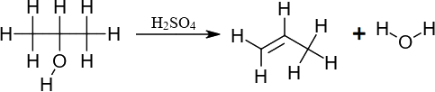
For unsymmetrical alcohols this elimination reaction follows Zaitsev's rule. This states the hydrogen removed (to form water with the alcohol functional group also removed) will come from the adjacent carbon with the least number of existing hydrogen atoms. For example, 2-butanol forming 2-butene as the major product and 1-butene is a minor product as shown below. It is unlikely that students will be required to demonstrate knowledge of major and minor organic products. This information is provided for teacher understanding should the question arise.
- Halogenation of alcohols creates their corresponding haloalkane by reacting with a hydrogen halide. In this process, the functional group is substituted in the same position on the parent chain. For example, 2-propanol reacts with hydrobromic acid to produce 2-bromopropane and water:
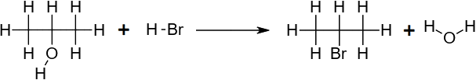
- Oxidation of alcohols creates different products depending on the extent of the oxidation and the type of alcohol used. Many oxidising reagents are possible, as a generic form for reaction equations, “[O]” is used to represent the oxidising agent. Primary alcohols are oxidised first to their corresponding aldehyde and if there is an excess of the oxidising agent this will continue. The aldehyde will oxidise to form the corresponding carboxylic acid. For example, propanol will oxidise to propanal producing water as a by-product:
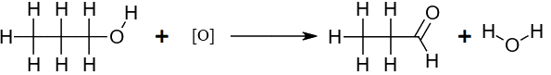
Propanal can then continue to oxidise, if conditions permit, to form propionic acid:
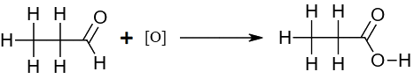
Secondary alcohols will oxidise only once to form their corresponding ketone, for example, 2-propanol will oxidise to form 2-propanone (acetone) and water:
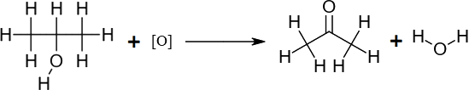
Tertiary alcohols are unable to be oxidised as there is no capacity for the tertiary alcohol carbon to establish additional bonds to the oxygen. This series of oxidation reactions can be completed practically to demonstrate each of the above processes and the relative rates for primary, secondary and tertiary alcohols. This practical is an example of the Jones test for alcohols and links with the content of IQ8-2.
This inquiry question also looks at the production of alcohols from two different sources. Students can model the production of alcohols from haloalkanes as the reverse process of the halogenation of alcohols covered previously in this inquiry question. This nucleophilic substitution reaction involves reagents to encourage the exchange of the halogen for an alcohol functional group, for example, the production of 2-propanol from 2-bromopropane using sodium hydroxide:
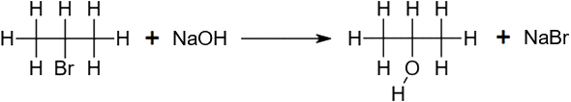
Fermentation is the production of alcohols from more complex carbohydrate sources such as glucose. This can be easily completed by students in the laboratory using glucose. The ethanol product can be distilled and confirmed using the previously mentioned oxidation reactions linked to IQ8-2 with the Jones test. Many of the textbooks for the previous chemistry course have a fairly straight forward method to complete this fermentation. Through the mass lost in the fermenter (due to carbon dioxide release) the calculation of alcohol mass can be completed adding a quantitative analysis step and giving students a means to compare different strains of yeast (baking vs brewing yeast) for their ethanol production capacity under common conditions. An example of this calculation could be:
$$initial mass of the fermenter=10.62g$$
$$final mass of the fermenter=8.91g$$
$$mass lost \left(equivalent to carbon dioxide produced\right)=10.62g-8.91g=1.71g$$
$$moles carbon dioxide produced=\frac{1.71g}{44.01g{mol}^{-1}}=0.0389mol$$
$$C_{6}H_{12}O_{6 (aq)}\underset{→}{yeast}{2C}_{2}H_{5}{OH}_{(aq)}+{2CO}_{2 (g)}$$
$$moles ethanol=moles carbon dioxide=0.0389mol$$
$$Mass ethanol=0.0389mol×46.07g{mol}^{-1}=1.79g$$

Carboxylic acids and amines/amides
Esterification can be completed in microscale to reduce the consumption of organic materials and production of wastes. This practical opportunity is qualitative so yield is inconsequential but could be calculated to add a level of data analysis to this task by relating the length of the ester to its percentage yield under set reaction conditions. A simple method can be found on edu.rsc.org or any of the textbooks from the previous course will have the method utilising a reflux apparatus to allow the esterification of longer chain alcohols and carboxylic acids. Both methods will require some extraction of the ester and washing to ensure students are able to appropriately assess their product and compare the odour with a simplified reference chart available online.
Saponification reactions are an optional and well documented practical opportunity from the previous Chemistry course, Industrial Chemistry option. The syllabus does not require students to produce soap, only to investigate the action of soaps and detergents. Should teachers wish to investigate the making of soap, the materials and methods used can vary and a simple method can be found on edu.rsc.org. Comparisons of the properties and use of soaps produced by a range of different fats/oils (including blends of different fats/oils) can be made and by linking to the chain length and degree of unsaturation gives students a deeper appreciation for the complexity of industrially producing a product frequently taken for granted.

Polymers
A range of activities can be optionally completed to compare the properties of polymers specified in this inquiry question to those produced in the laboratory:
- Making Nylon-66 is an easily teacher demonstrated example of a condensation polymer. In many methods adipoyl chloride is used which results in the production of hydrochloric acid instead of water during polymerisation.
- Making Rayon is easily produced in the laboratory

Appendix 2 – IUPAC naming
In the most recent 2013 update to the IUPAC rules for the naming of organic compounds there was one change which could impact students who investigate hydrocarbon nomenclature to a deeper level. The first step to naming any hydrocarbon has always been to name the longest parent chain of carbon atoms and for many cases this is still the case. Consider this example:
In this example the functional group (in this case the alkene) is not part of the longest parent chain. Under the original rule this fact would be discounted, and the compound would be named 2-ethylhexene which accounts for the double bond in the parent name. Following the 2013 update, this rule was updated with alkene and alkyne bonds no longer having a naming preference over chain length. This results in the longest carbon chain being counted irrespective if it includes the double bond or not and the new name of 3-methyleneheptane being preferred. This name is formed from the longest carbon chain of seven carbons giving the “heptane” base being prefixed with the methylene (-CH2) group at the third carbon giving it the lowest locant possible.

References
This resource contains NSW Curriculum and syllabus content. The NSW Curriculum is developed by the NSW Education Standards Authority. This content is prepared by NESA for and on behalf of the Crown in right of the State of New South Wales. The material is protected by Crown copyright.
Please refer to the NESA Copyright Disclaimer for more information https://educationstandards.nsw.edu.au/wps/portal/nesa/mini-footer/copyright.
NESA holds the only official and up-to-date versions of the NSW Curriculum and syllabus documents. Please visit the NSW Education Standards Authority (NESA) website https://educationstandards.nsw.edu.au and the NSW Curriculum website https://curriculum.nsw.edu.au.
Chemistry Stage 6 Syllabus © NSW Education Standards Authority (NESA) for and on behalf of the Crown in right of the State of New South Wales, 2017.

© State of New South Wales (Department of Education), 2020
The copyright material published in this resource is subject to the Copyright Act 1968 (Cth) and is owned by the NSW Department of Education or, where indicated, by a party other than the NSW Department of Education (third-party material).
Copyright material available in this resource and owned by the NSW Department of Education is licensed under a Creative Commons Attribution 4.0 International (CC BY 4.0) license.

This license allows you to share and adapt the material for any purpose, even commercially.
Attribution should be given to © State of New South Wales (Department of Education), 2020.
Material in this resource not available under a Creative Commons license:
- the NSW Department of Education logo, other logos and trademark-protected material
- material owned by a third party that has been reproduced with permission. You will need to obtain permission from the third party to reuse its material.
Links to third-party material and websites
Please note that the provided (reading/viewing material/list/links/texts) are a suggestion only and implies no endorsement, by the New South Wales Department of Education, of any author, publisher, or book title. School principals and teachers are best placed to assess the suitability of resources that would complement the curriculum and reflect the needs and interests of their students.
If you use the links provided in this document to access a third-party's website, you acknowledge that the terms of use, including licence terms set out on the third-party's website apply to the use which may be made of the materials on that third-party website or where permitted by the Copyright Act 1968 (Cth). The department accepts no responsibility for content on third-party websites.

