 Student reflection – Science investigations
Put an X in the box that fits best.
I have: |  |  |  | 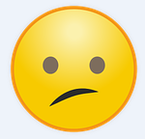 | 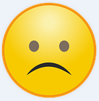
- identified a question to investigate
- described why I chose this question
- stated the independent variable
- stated the dependent variable
- written a hypothesis that links the independent and dependent variables
- described the controlled variables

I can:
- describe how I did the experiment
- accurately record my results
- describe what I found out
- explain how this investigation has built on what we already knew (provided new information)
- suggest an idea for a further investigation

