 Locating the Earth’s shadow zone

Overview
The lesson involves modelling observations that scientists made when analysing earthquake waves and their movement through the interior of the Earth; and then interpreting the information to propose the internal structure of the Earth. This activity is suitable for students in Stage 4 to model the enquiring nature of scientists using a set of observations.

Aims of the lesson
- To understand that the Earth’s core is made of a different type of material to the mantle.
- To model the refraction of earthquake waves through the core.
- To appreciate the benefits and limitations of using models in science to explain phenomena.

Equipment needed
- Ray boxes and power source
- 2 x Semi-circular prisms – ray box kits
- “Circle sheets” - handout
- pencil, ruler
- Question sheets

Lesson Introduction
Teacher instruction and explanation:
Question:
- What is inside the Earth?
- How do scientists get information about what the inside of the Earth is like?
- Where do Earthquakes originate?
Scientists believe that there are layers within the Earth. The layers represent different materials with different densities. Earthquakes originate below the Earth’s crust and the earthquake waves radiate in all directions through the Earth. Scientists noticed that when an earthquake occurred and they plotted the areas around the world where the earthquake waves were detected, using seismographs, there were two areas where the earthquake waves did not reach. They called these the Shadow Zones.
This activity aims to model what the scientists observed in order to understand how they came to the conclusion that the Earth had a core made of material with a greater density than the mantle.

Instructions for the activity
- Remember that scientists did not know at this stage that the inside of the Earth was denser than the outer part.
- Set up a ray box with one slit so that the start of the light ray lines up with the cross, on the outer circle; this represents the epicentre of an earthquake.
- Shine the ray of light at different angles around the outer circle. Mark a dot on the outside of the circle where the light ray reaches and then draw a straight line from the ‘x’ to that point.
- Where the light hits the prism, mark the point at which it hits the prism, then mark the point at which it leaves the prisms and then the point at which it touches the outer edge of the larger circle again. Join the marks together.

Student worksheet
Position two semi-circular prisms so that they fill the smaller circle within the larger one.


Example of a completed Student worksheet showing the expected paths of light and the resulting Shadow Zone.
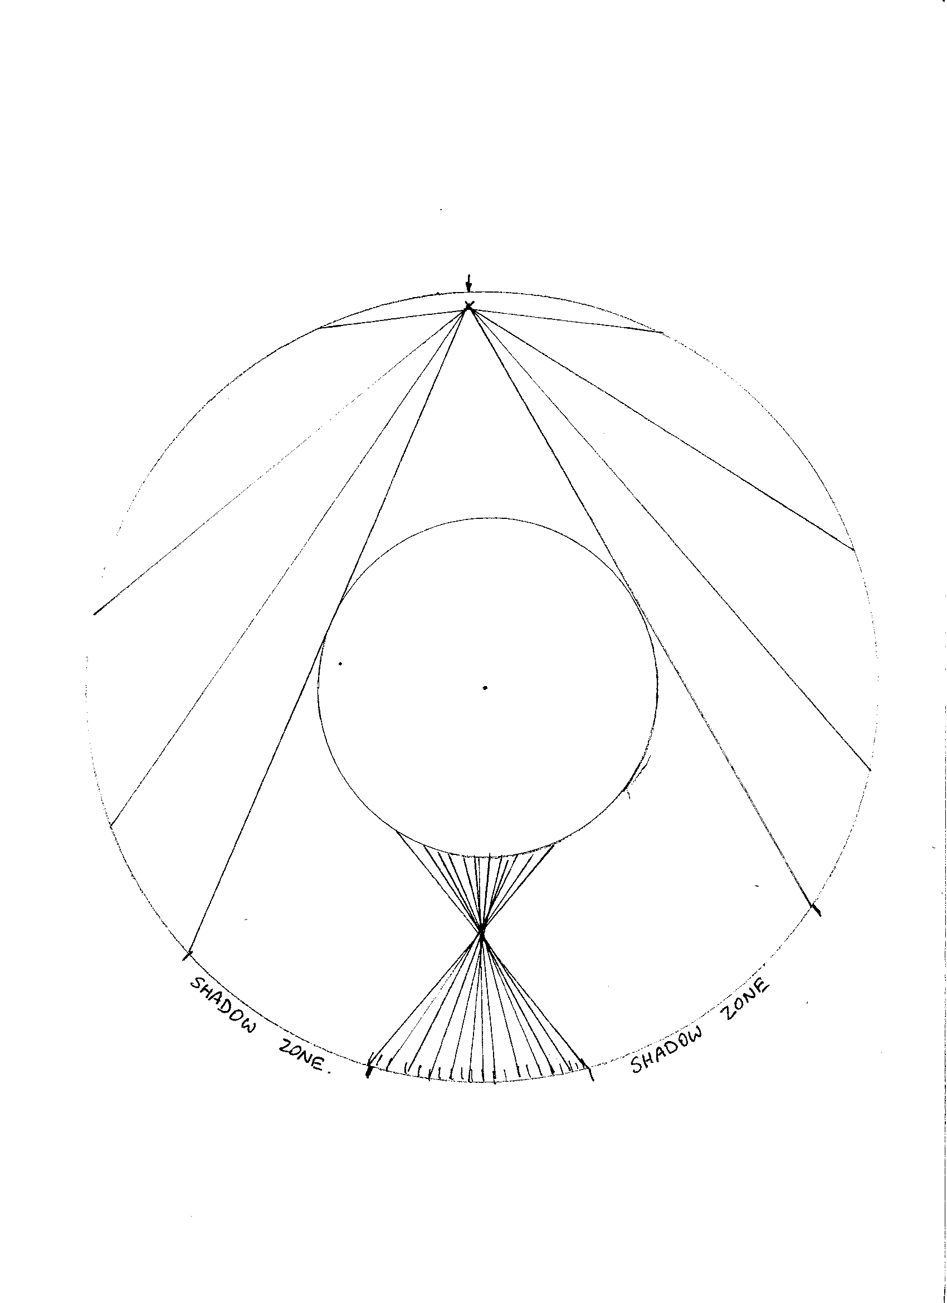

Ideas about the structure of the Earth
Write a report about this activity. This report should ultimately explain how your activity with the ray boxes simulates how scientists have used earthquake waves to make predictions about the size and nature of the Earth’s core. Your report should refer to the diagram you created.
You can either answer the following questions in your workbook
Or
You can use the questions as a guide to structuring the writing of a report as if you were a scientist having made this discovery and wish to communicate what you did and what you found out to others.
- What does the cross ‘X’ on your diagram represent?
- What do the light rays represent?
- What do the semi-circular prisms represent?
- Mark a red line around the edge of the circle on your diagram to indicate where the light rays are reaching. What does this represent in terms of earthquake waves?
- Describe the path of light that does not pass through the prisms in the centre.
- Describe the path of light that passes through the prisms.
- Explain why the light rays bend or change direction as they pass through the prism.
- Relate this bending (refraction) of light rays to earthquake waves within the Earth.
- Label the “Shadow Zones”. These are the areas on the Earth’s surface where earthquake waves do not reach. Why do the Shadow Zones exist?
- In summary, explain how the passage of earthquake waves through the Earth has enabled scientists to gain an idea about the nature and size of the Earth’s core.

Syllabus links

Science K-10 syllabus

Outcome
Describes the dynamic nature of models, theories and laws in developing scientific understanding of the Earth and solar system SC4-12ES.

Content
ES1 Sedimentary, igneous and metamorphic rocks contain minerals and are formed by processes that occur within Earth over a variety of timescales. (ACSSU153)
Students:
- Describe the structure of the Earth in terms of core, mantle, crust and lithosphere.
Science (incorporating Science and Technology K-6) K-10 Syllabus © NSW Education Standards Authority (NESA) for and on behalf of the Crown in right of the State of New South Wales, 2012.

