PDHPE Stage 1 – Child Protection Education

Resources – Strengths and strategies for safety

Contents
Teacher notes: Strengths cards 2
Cards: Strengths 3
Cards: How does it rate? (Labels) 7
Same but different images 8
Worksheet: See, Think, Wonder 10
Cards: Number cards (1 – 10) 11
Images of different types of families 14
Support network templates 17
Cards: Yes, sometimes, no and uncertain 20
Babies images 21
Cards: Body signals 23
Soft animal toy images 25
Cards: Safe and unsafe touch situations 26
Cards: Touch flashcards 29
Cards: Secrets 31
Cards: Yes and no feelings 33
No feelings 33
Yes feelings 34
Teacher notes: Definition match 36
Cards: Definition match 37
Cards: What would you do? 40
Copyright register 42

Teacher notes: Strengths cards
Strengths | Definition
Honest | You tell the truth even when it is not easy.
Funny | You try to cheer people up by making them laugh.
Forgiving | You accept your friends’ apologies.
Kind | You help others and use kind words.
A leader | You help your group work well together.
Brave | You are able to do what is important even when you feel scared.
Self-control | You can do what is important even if you don’t want to.
Notice others | You think of how others might be feeling.
Assertive | You are able to say things in a strong, clear and fair way.
Fair | You include everyone and you follow the rules.
Determined | You keep trying even when it gets hard.
Curious | You like to learn new things and ask questions.
Patient | You can wait for your turn even if it takes a while.
Generous | You are good at sharing and giving.
Creative | You like to come up with new ideas and new ways of doing things.
Persistent | You keep trying even if you fail.
Notice myself | You notice how you are feeling and how that makes you behave.
Good listener | You listen to others ideas and how they feel.

Cards: Strengths
Honest | Fair
Funny | Determined
Forgiving | Curious
Kind | Patient
A leader | Generous
Brave | Creative
Self-control | Persistent
Notice others | Notice myself
Assertive | Good listener

Honest  You tell the truth even when it is not easy. | Fair  You include everyone and you follow the rules.
Funny  You try to cheer people up by making them laugh. | Determined  You keep trying even when it gets hard.
Forgiving  You accept others’ apologies. | Curious  You like to learn new things and ask questions.
Kind  You help others and use kind words. | Patient  You can wait for your turn even if it takes a while.
A leader  You help your group work well together. | Generous  You are good at sharing and giving.
Brave  You are able to do what is important even when you feel scared. | Creative  You like to come up with new ideas and new ways of doing things.
Self-control  You can do what is important even if you  don’t want to. | Persistent  You keep trying even if you fail.
Notice others  You think of how others might be feeling. | Notice myself  You notice how you are feeling and how that makes you behave.
Assertive  You are able to say things in a strong, clear and  fair way. | Good listener  You listen to others ideas and how they feel.

Cards: How does it rate? (Labels)
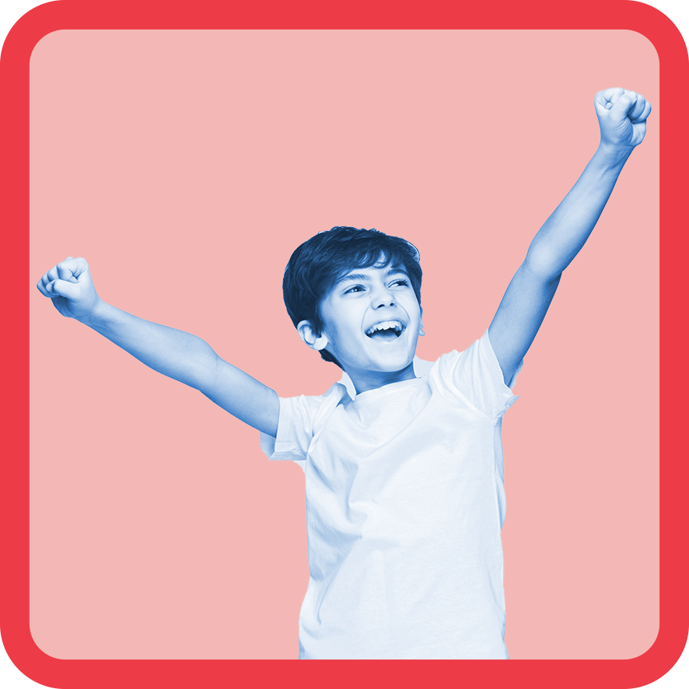1 | 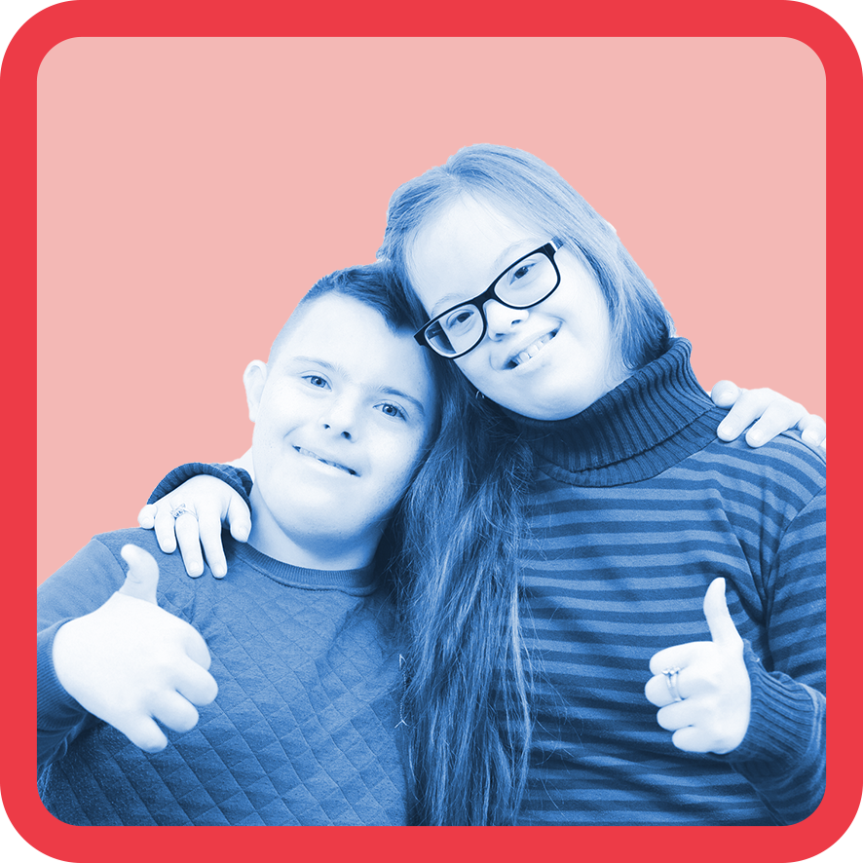2
Love it | Like it
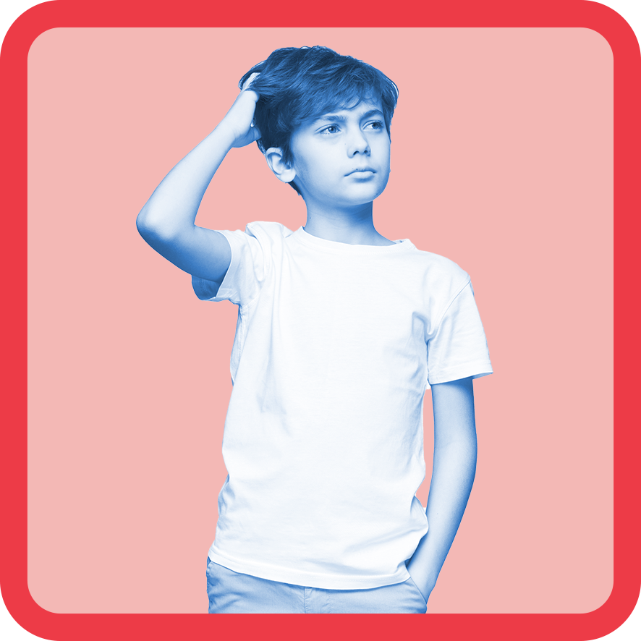3 | 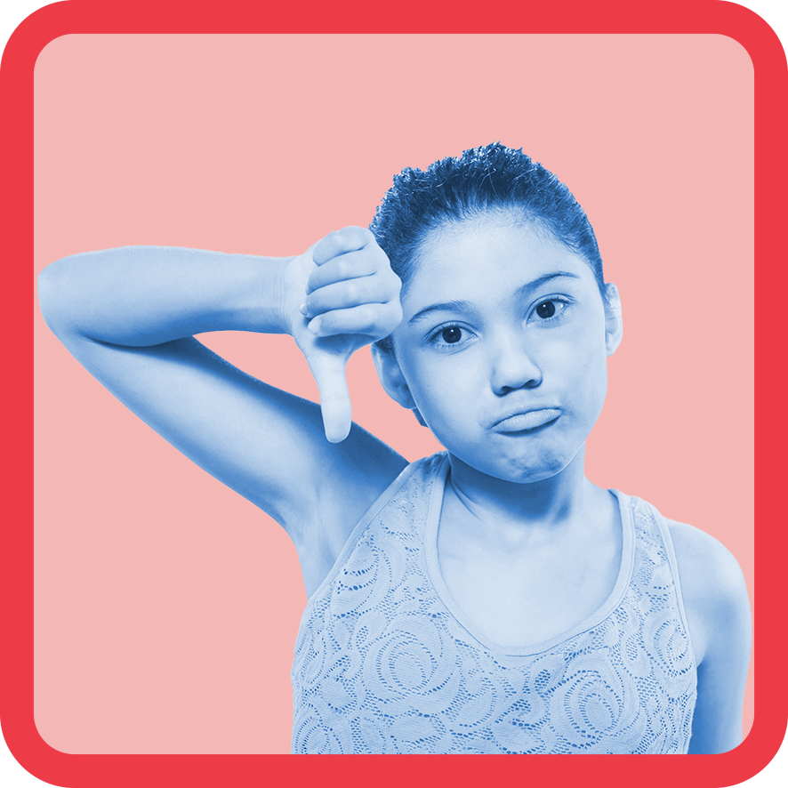4
Unsure | Don’t like it

Same but different images
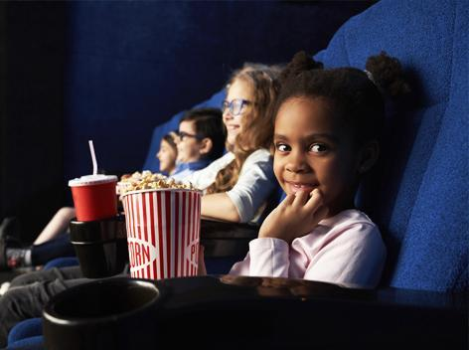  27 | 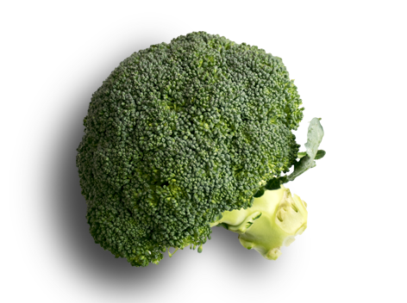  28
Going to the movies | Broccoli
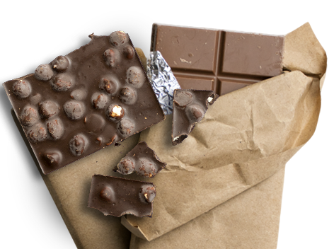 | 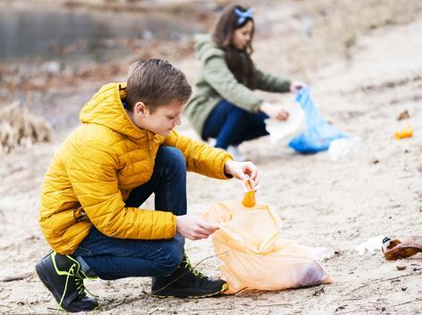  29
Chocolate | Cleaning
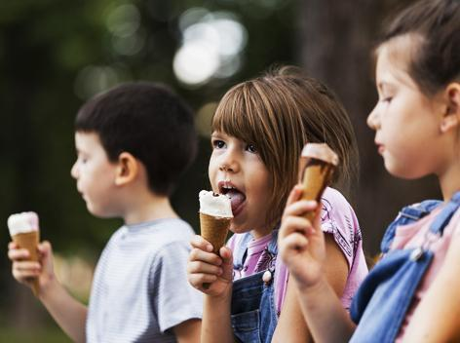  30 | 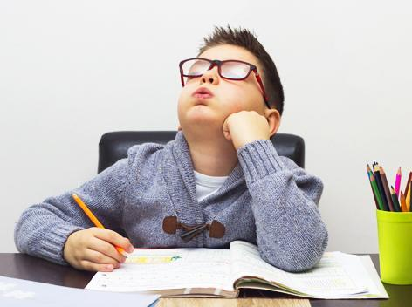  31
Eating ice cream | Homework
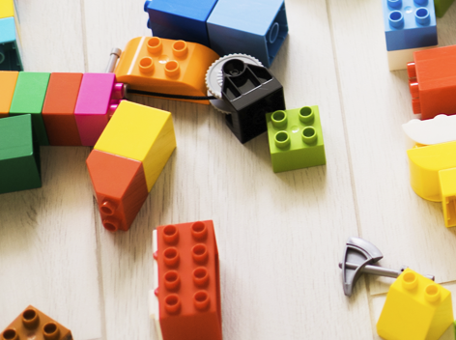  32 | 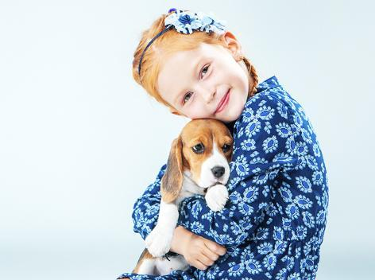  33
Lego | Patting a dog
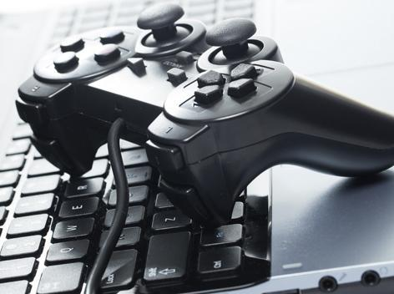  34 | 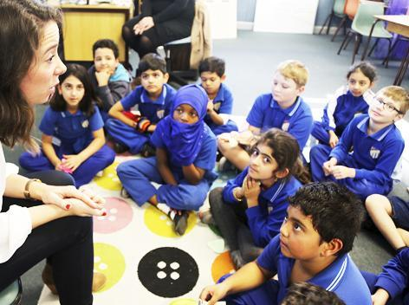
Playing online | School
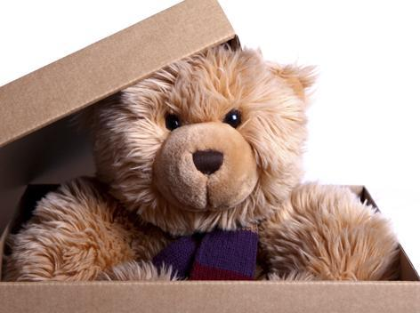  26 | 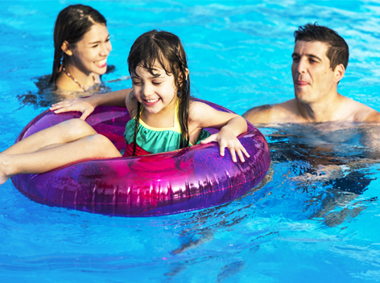  35
Stuffed toys | Swimming at the pool

Worksheet: See, Think, Wonder

Cards: Number cards (1 – 10)
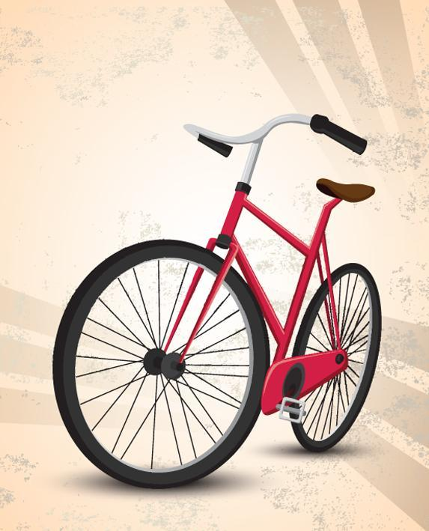5 | 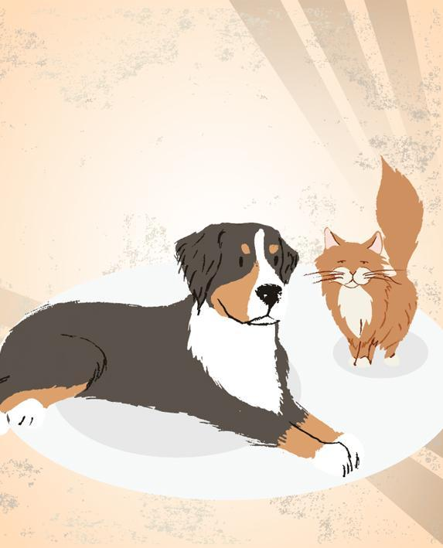6
1 bike | 2 pets
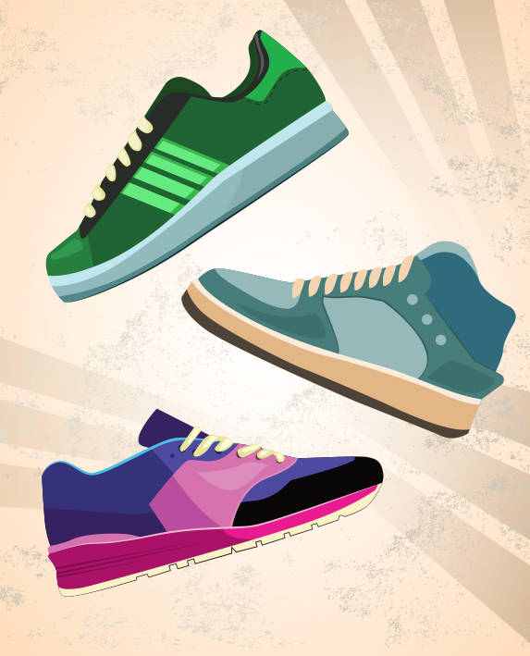7 | 8
3 shoes | 4 balls

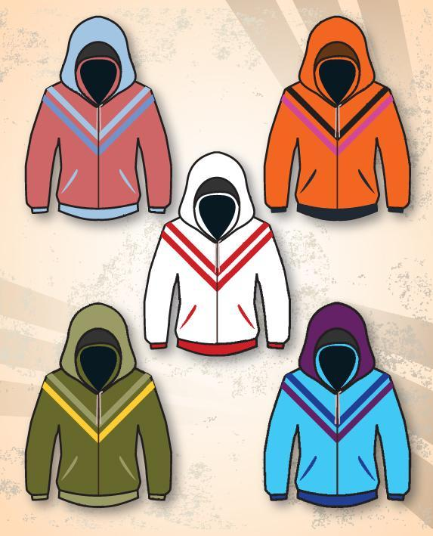9 | 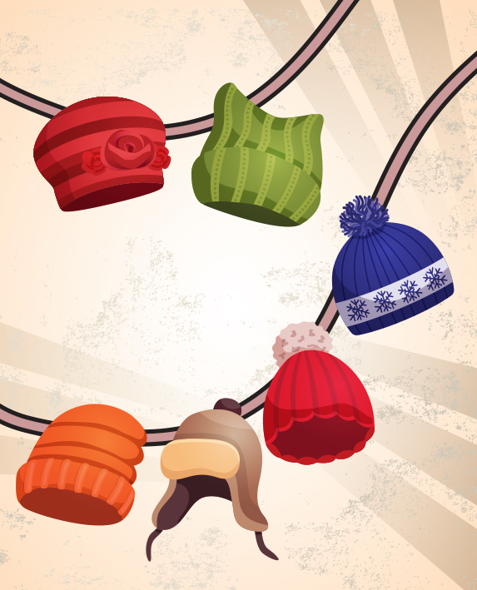10
5 hoodies | 6 beanies
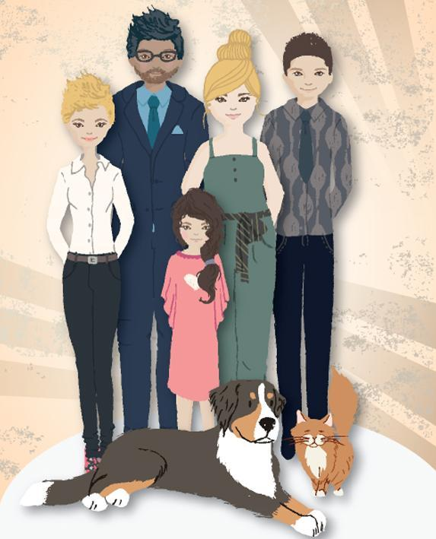 | 11
7 family members | 8 awards

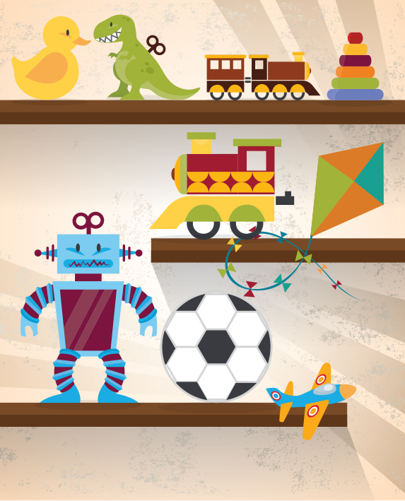12 | 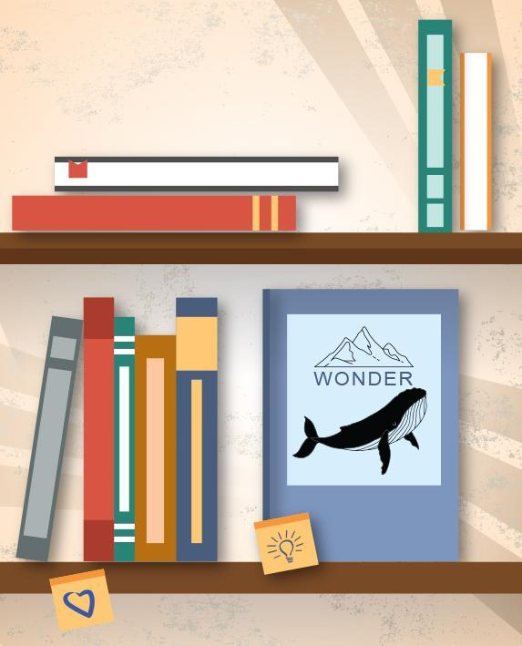13
9 toys | 10 books

Images of different types of families
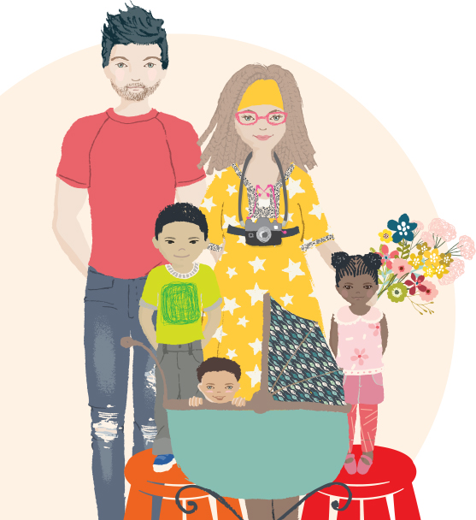 | 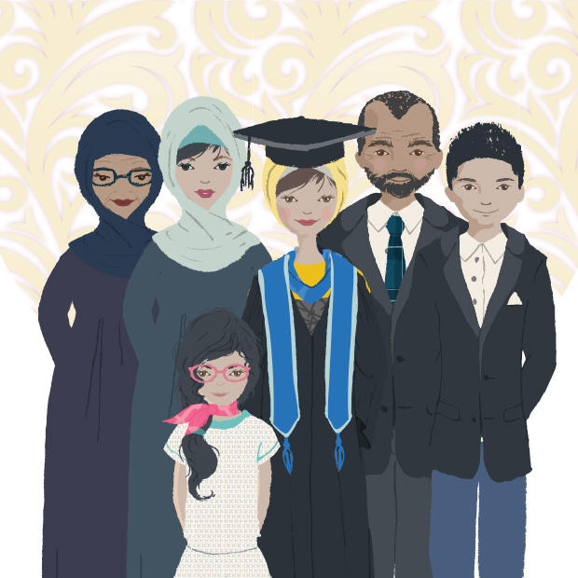
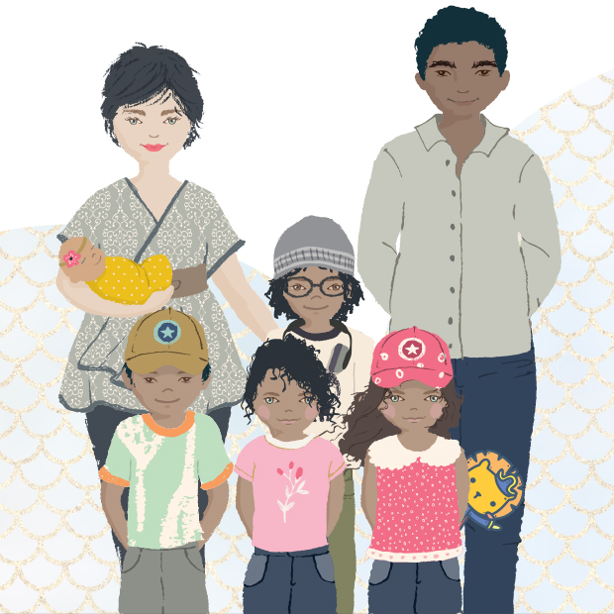 | 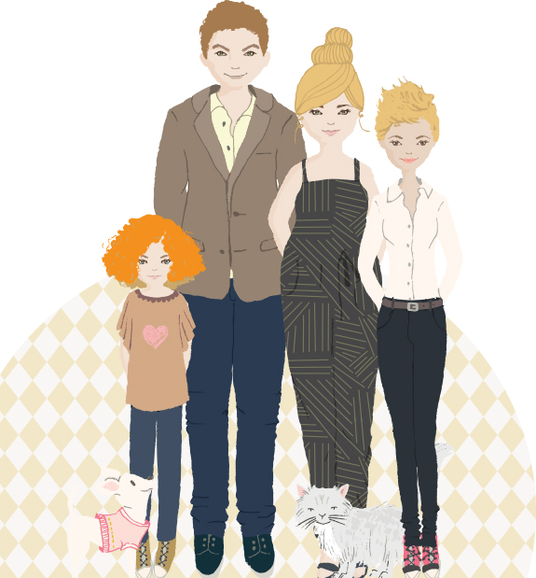
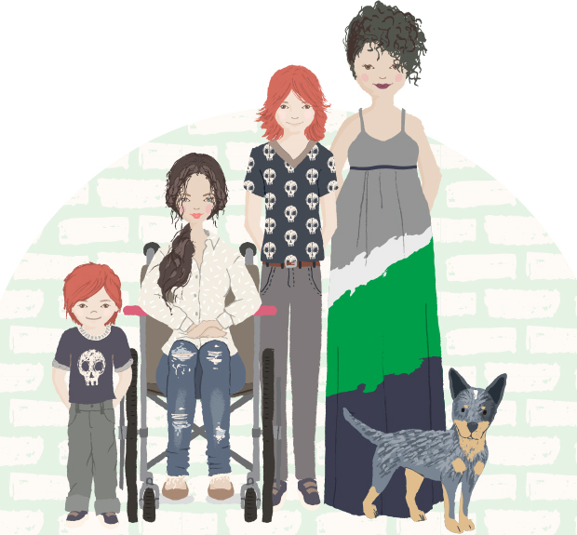 | 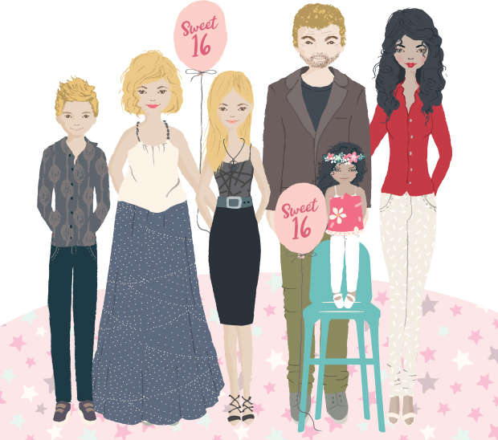
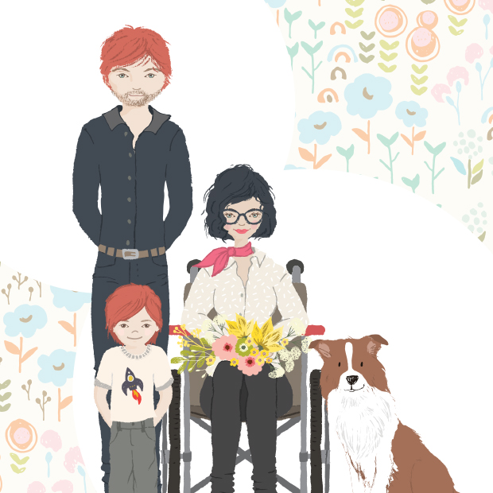 | 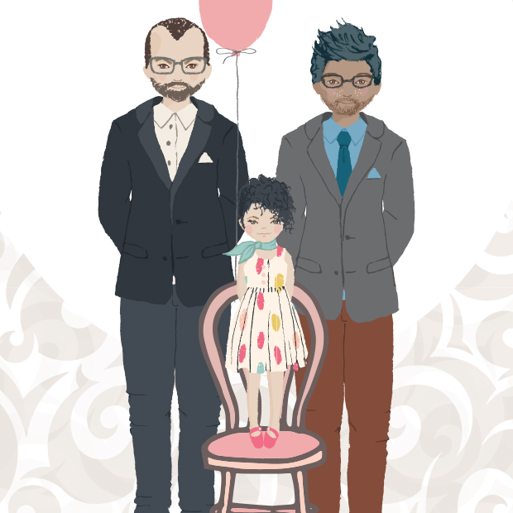
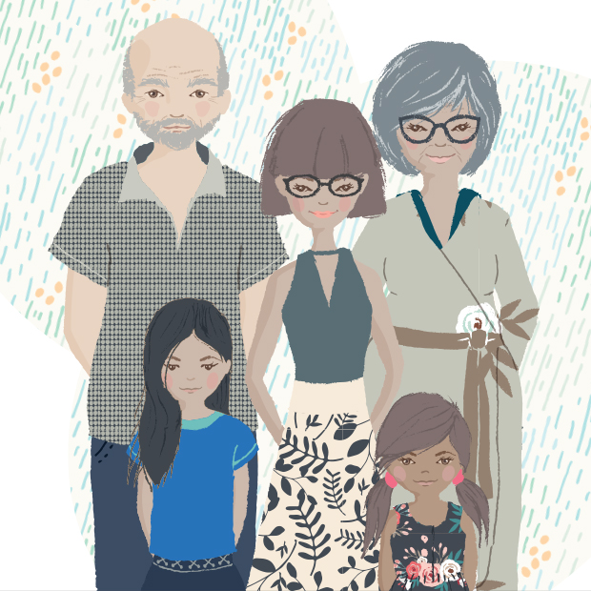 | 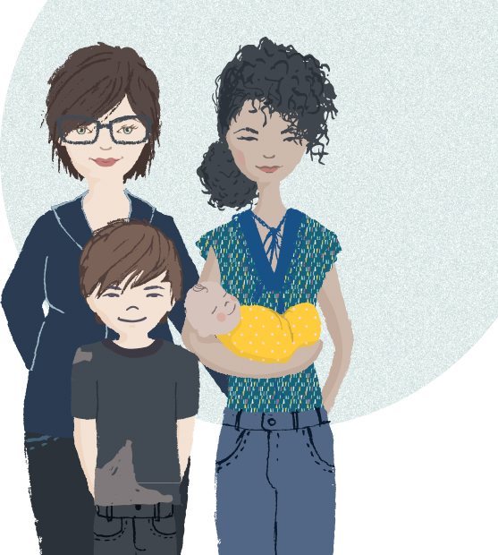
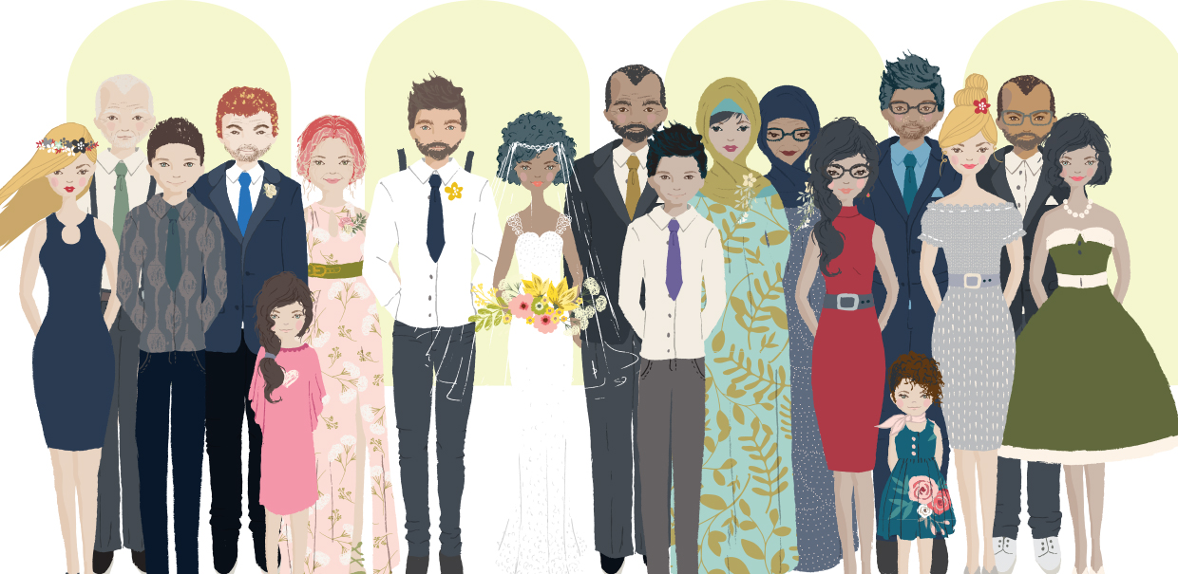

Support network templates


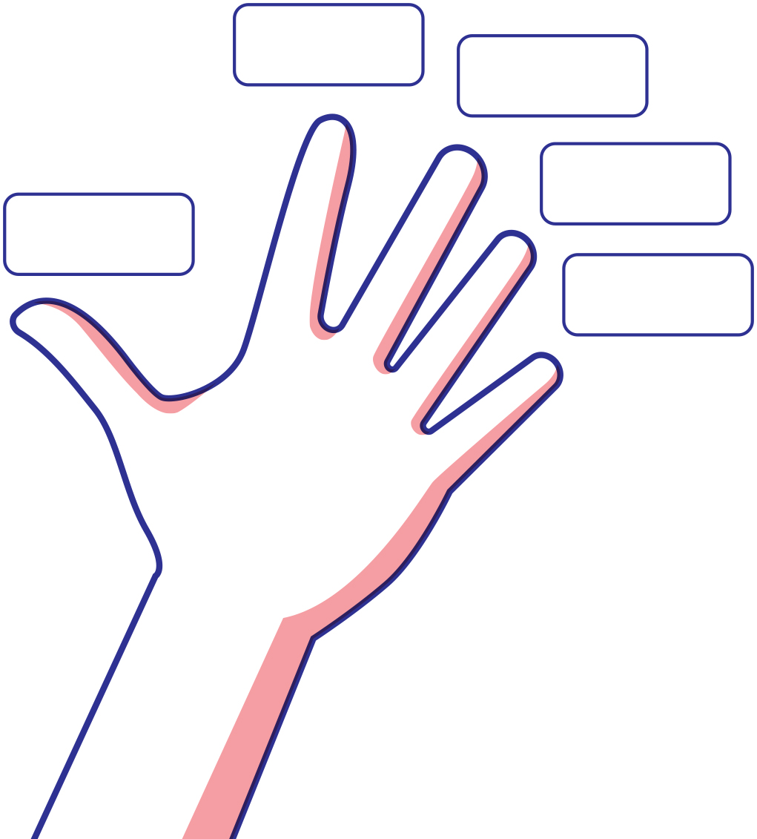

Cards: Yes, sometimes, no and uncertain
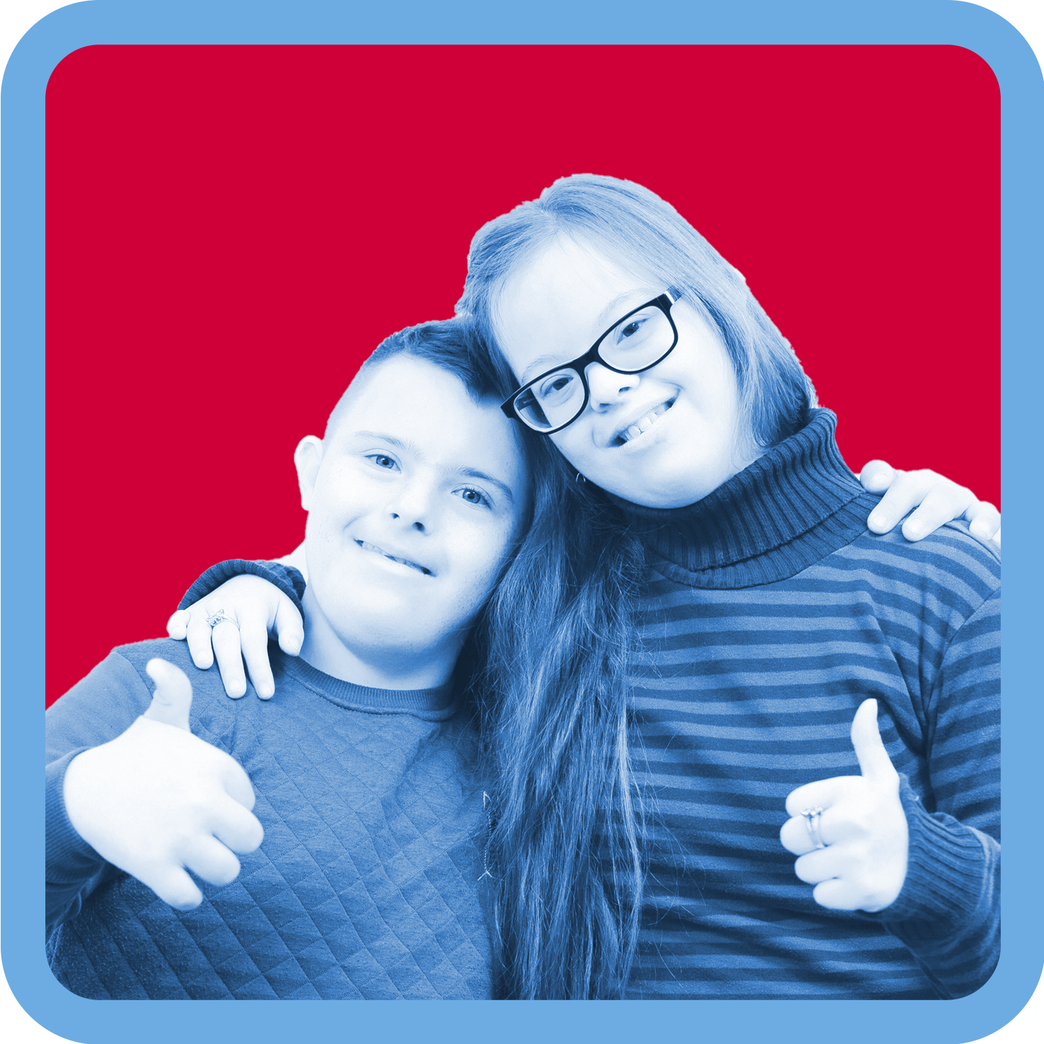2 | 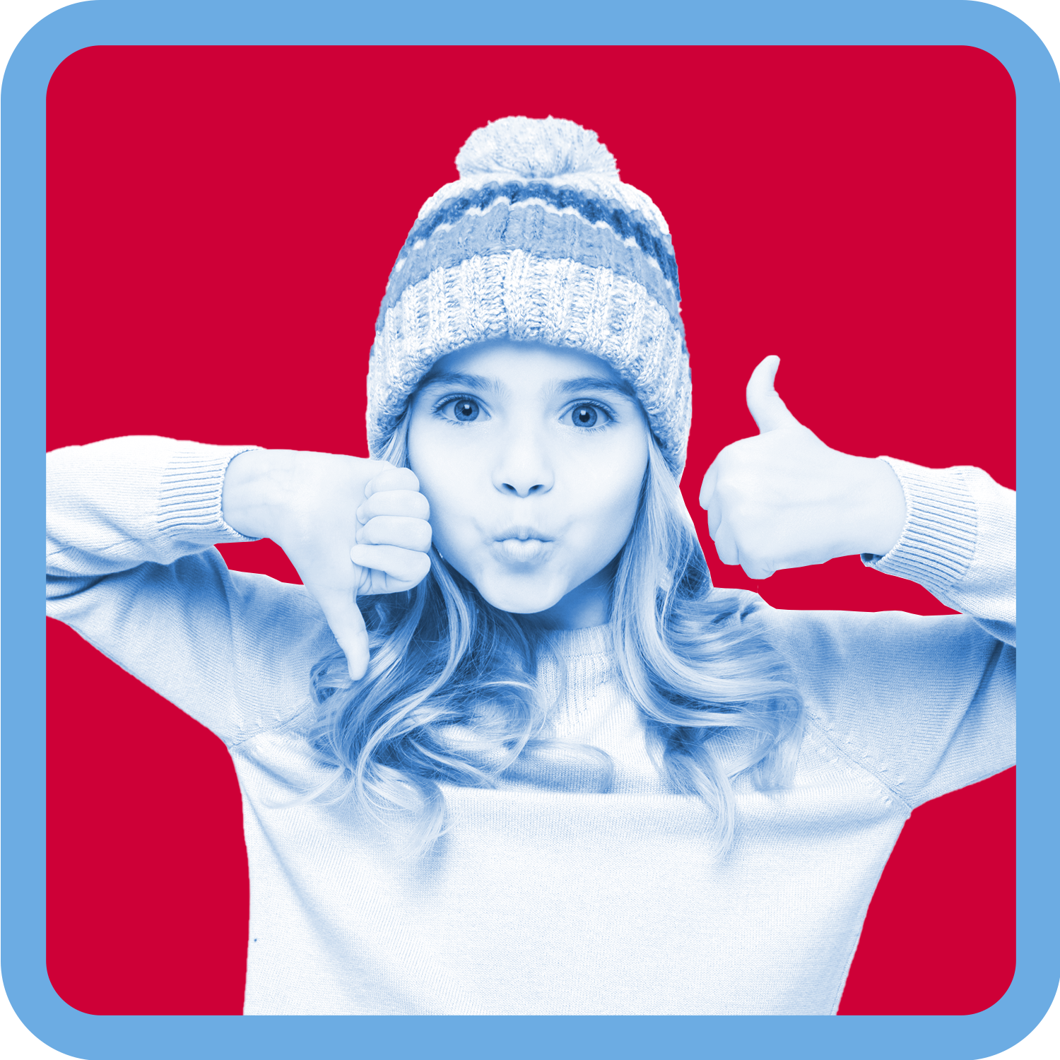14
Yes | Sometimes
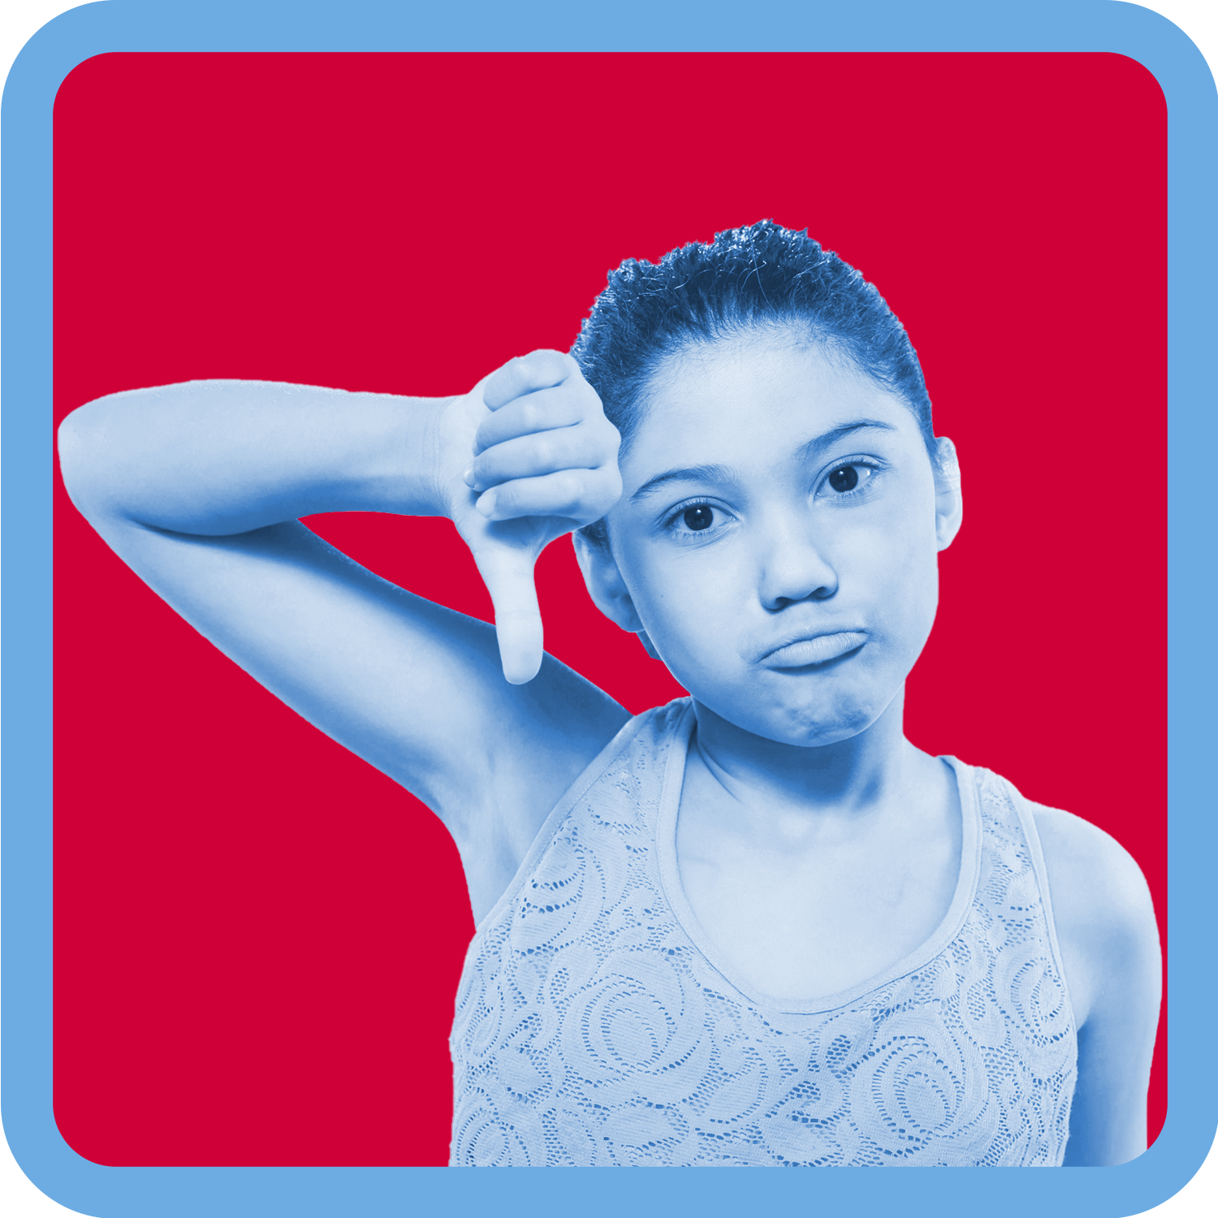4 | 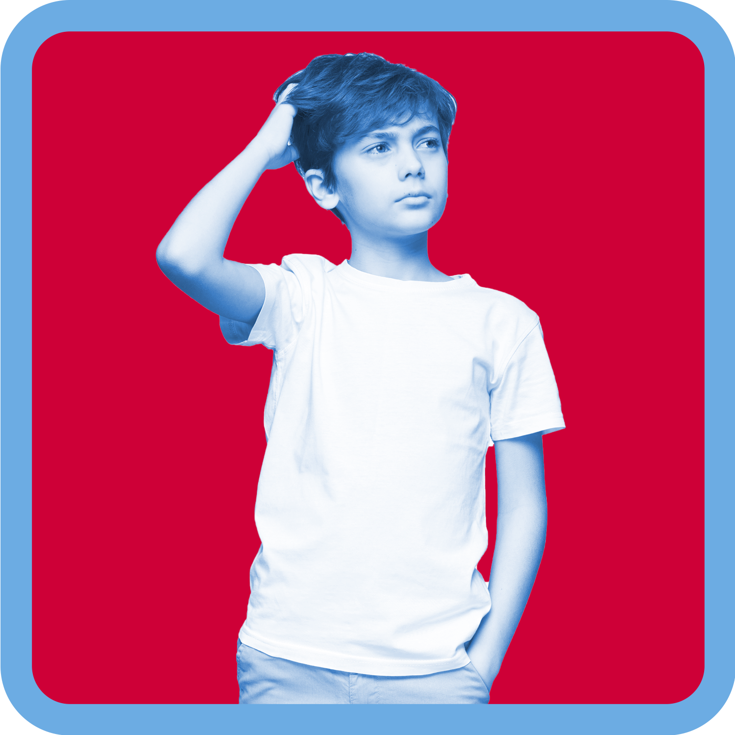3
No | Uncertain

Babies images
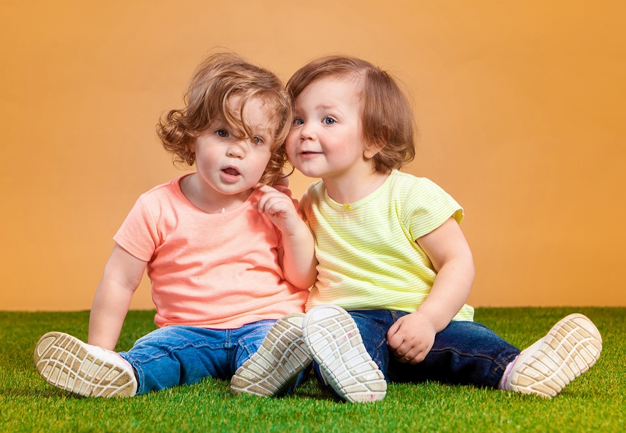15
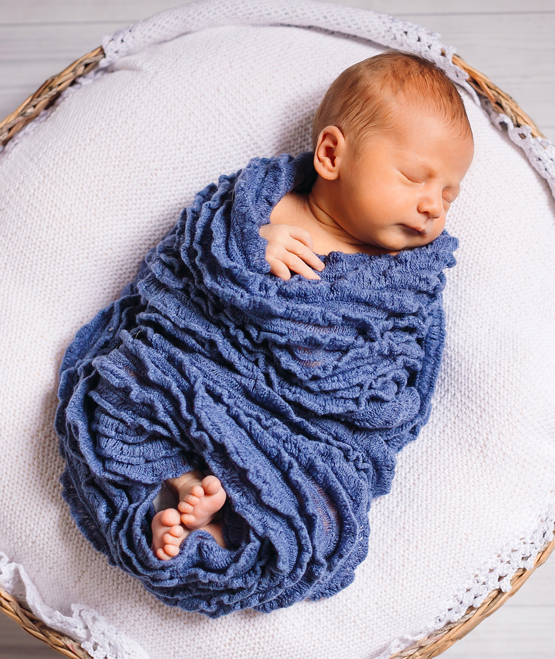16

Cards: Body signals
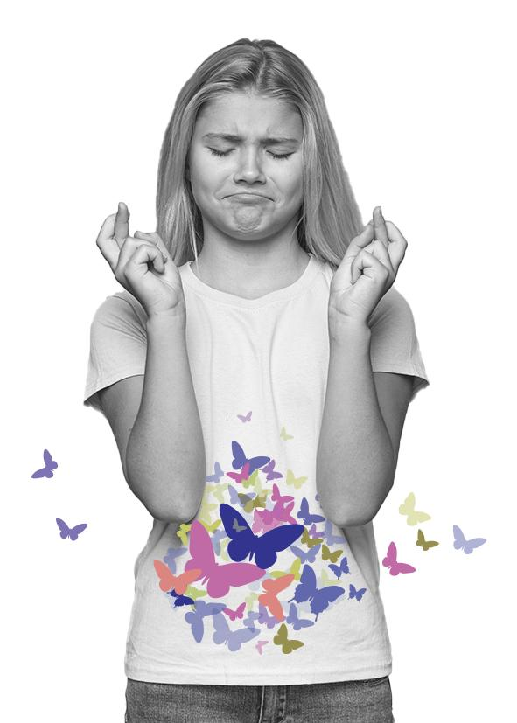5 | 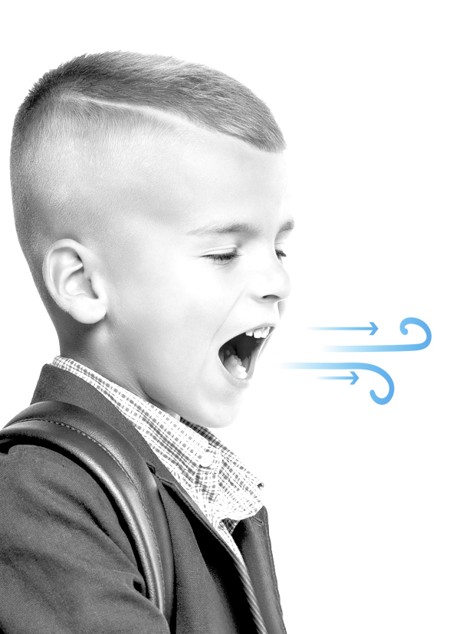6
Butterflies in your tummy | Quick breathing
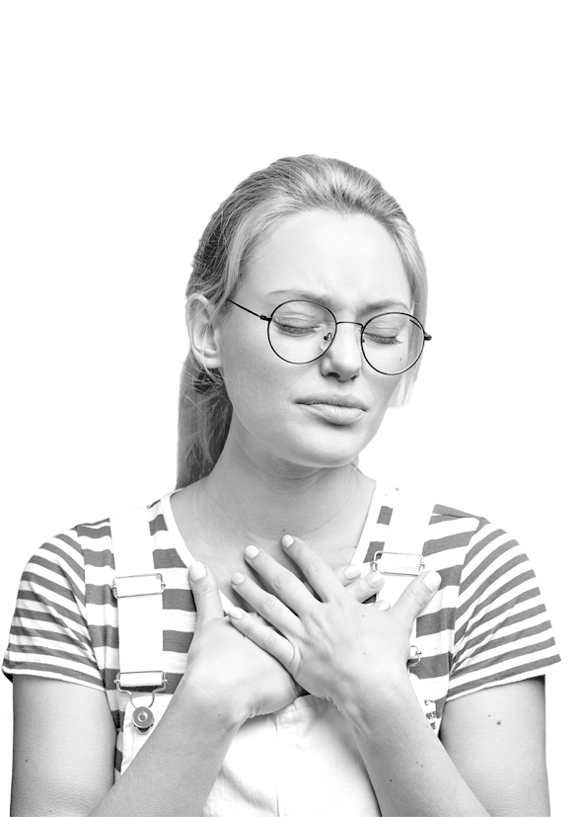7 | 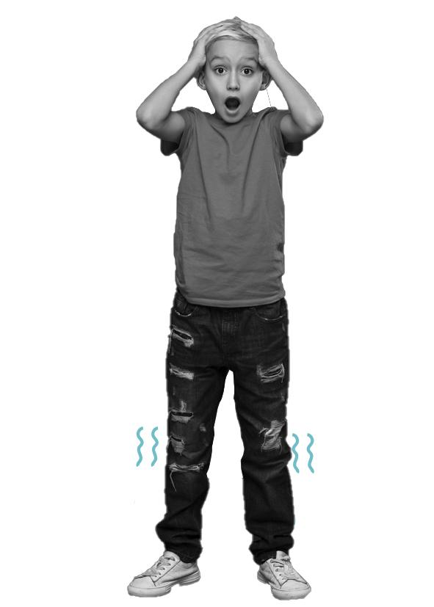8
Racing heart | Shaky knees
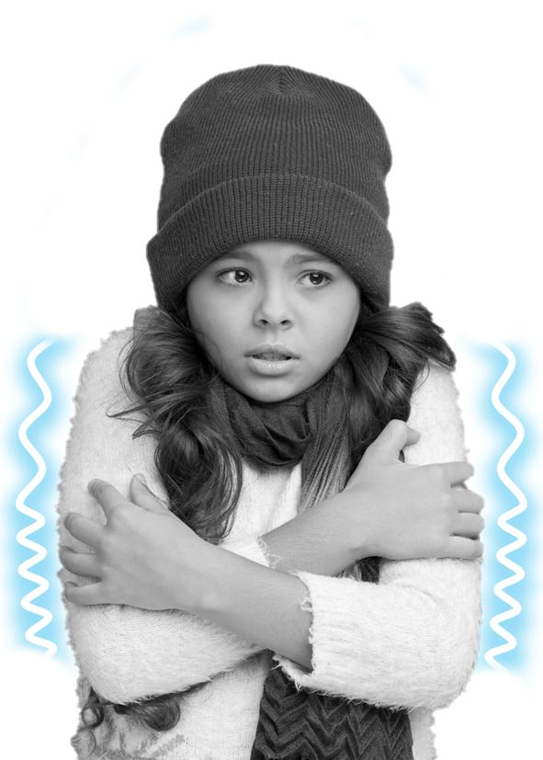 9 | 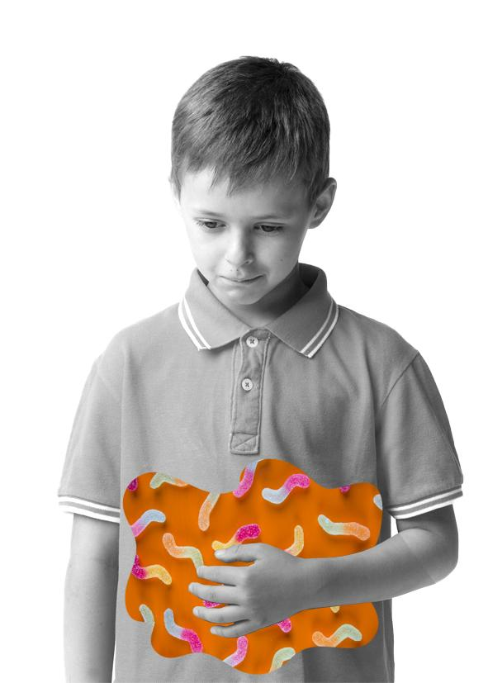10
Cold-shivery body | Squirmy tummy
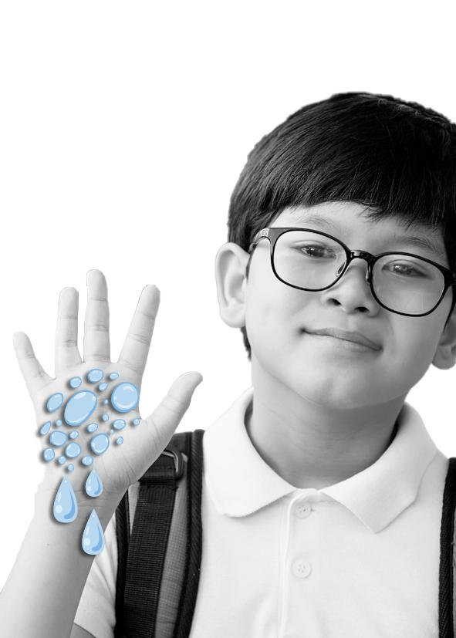11 | 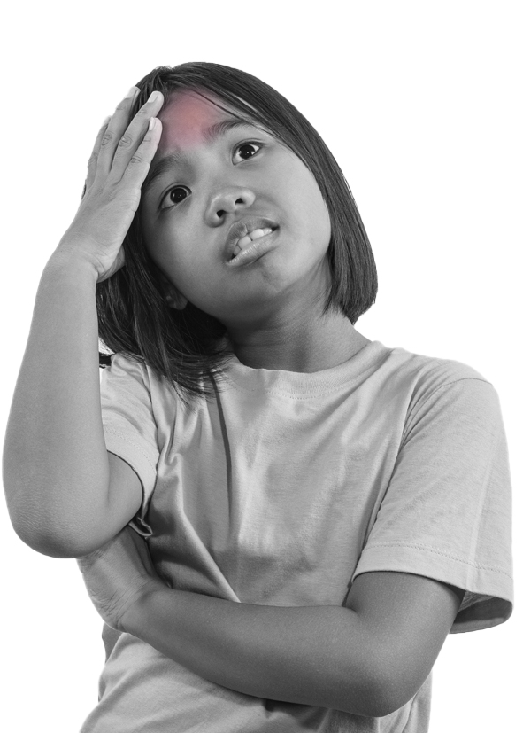12
Sweaty hands | Warm body

Soft animal toy images
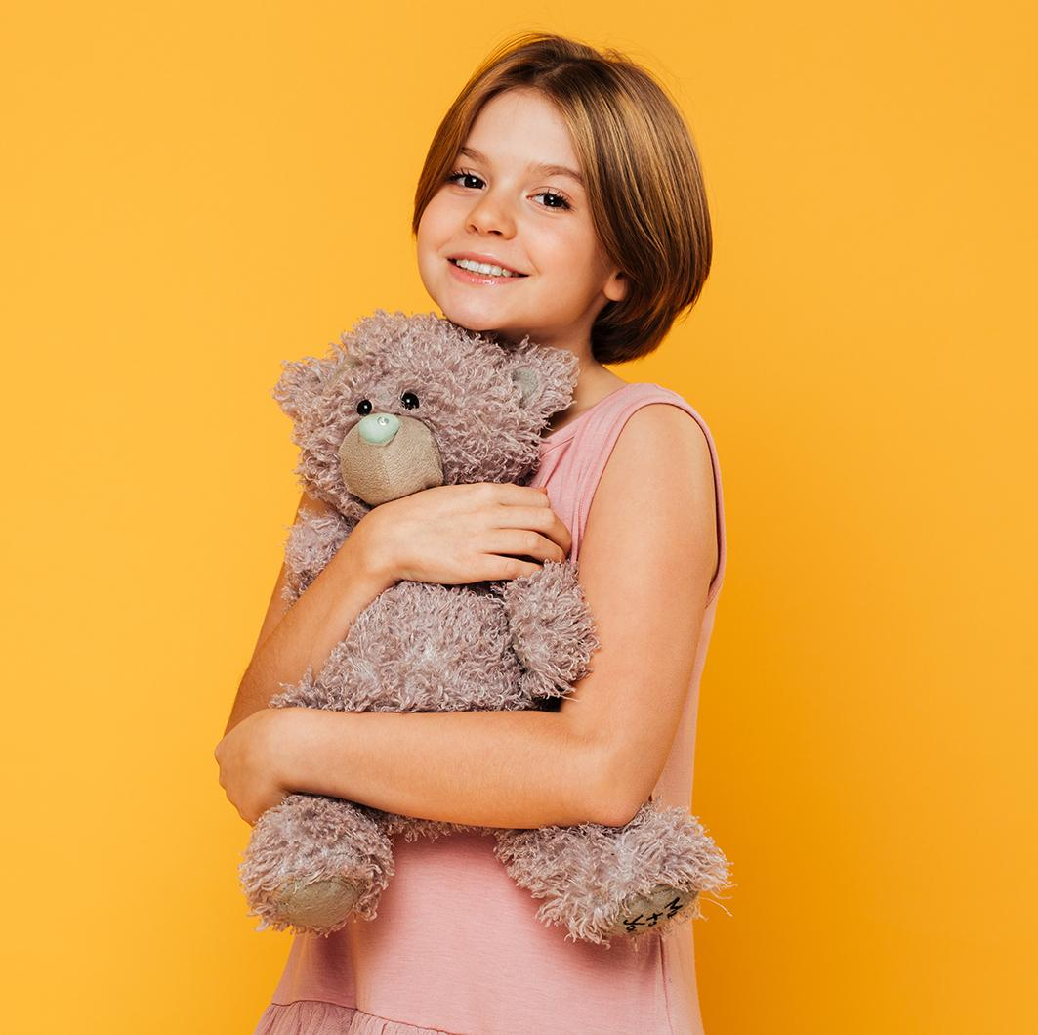25

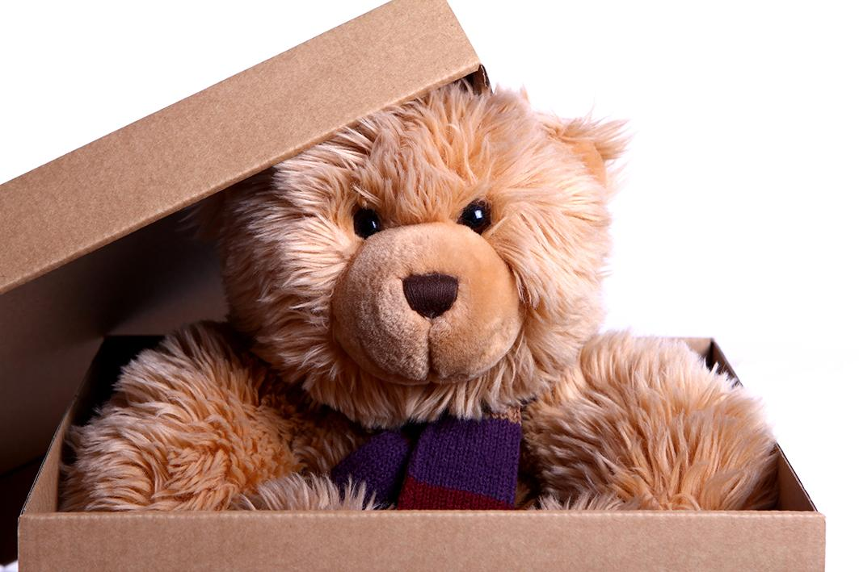 26

Cards: Safe and unsafe touch situations
As a class read through the safe and unsafe situation touch cards. Work together to sort the situations into safe and unsafe.

Georgie likes to stay at her cousin’s house with her little cousins. Georgie’s older cousin loves playing soccer. When Georgie plays too, her cousin kicks the ball really hard at her. Georgie asks her cousin to kick it softer but her cousin keeps doing it and says it’s part of the game and she has to get used to it. | Jenson loves reading books. Every night he reads to his Dad. He sits on his Dad’s lap as he reads, and his Dad puts his arm around him. Jenson loves reading time.
Jesse catches the bus home from school every day. When Jesse is waiting in line to catch the bus another student stands in the line in front of him. When Jesse asks this student not to push in, they push Jesse. | Zane’s uncle visits often. He makes Zane sit on his lap and read his home reader. Zane doesn’t like sitting on his uncle’s lap to read but his uncle won’t let him go.
Shontelle fell over in the playground and hit her head. Her friends help her to the sick bay. The teacher there checks Shontelle’s head and applies an icepack. | Maya goes to tennis coaching.  Her coach shows her how to hold her tennis racquet. Sometimes her hands are in the wrong place on the racquet and her coach needs to move them.
Shaun’s sister is younger than him. They were playing a game together but when Shaun won the game his sister got angry at him. She started kicking and punching him. | Xavier’s friends have a special greeting they use when they see each other. It includes a high five, fist pump and a pat on the back.
Sebastion and his Mum are playing together. His Mum grabs him and starts tickling him. He laughs and tries to tickle her back. | Carly’s parents have their friends over for parties and barbeques all the time. She doesn’t like one of her parent’s friends that comes over. He comes into her room  and makes her give him a kiss goodnight. Carly only likes kissing her Mum and Dad goodnight.
Sienna was playing with her friends at school. Her friend Josie wanted Sienna to only play with her and no one else. Josie grabbed Sienna’s arm, squeezed it really tight and tried to pull Sienna away from the group. | Meeka goes to her Dad’s three nights a week. She misses her Dad when she doesn’t see him. When she’s there she gets as many hugs from her Dad as she can.

Cards: Touch flashcards

who
touch
what
how
when

Cards: Secrets
As a class read the secrets cards and sort them into either a secret you should keep or a secret you shouldn’t keep.

Card 1  Mum and Dad find out that Mum is going to have a baby. Everyone is very happy. They don’t want you to tell anyone yet. They have told you not to tell anyone until just before the baby is born. | Card 2  The music teacher at school is leaving. Everyone will miss him. Your class is planning a farewell party for him. They don’t want him to find out yet.
Card 3  You stay at your friend’s house. The older brother asks you to take your clothes off and have a bath with him. He tells you that you must never tell anyone or you’ll be in trouble. | Card 4  Everyone in your family likes the lady next door. She is kind and gives your family lemons from her tree. Mum and Dad say that she is a bit strange because she talks to her tree. They have told you not to tell your friends about this.
Card 5  Your friend from school is sick. You all make a card and the teacher sends it in the mail. If you see your friend before he gets it, you can’t tell him about the card. | Card 6  Your Grandad’s favourite drink is pink lemonade. Everyone in your family thinks this is funny. Your Grandad laughs about it too. When it is ‘pink’ day at school your family asks you not to talk about it at news time.
Card 7  When your Dad gets angry, he often hits you. Mum and Dad have told you never to tell. | Card 8  Your coach often touches the private parts of your body when you are training. The coach does this to your friends too. The coach has threatened to stop coaching your team if anyone ever tells about this.

Cards: Yes and no feelings

No feelings
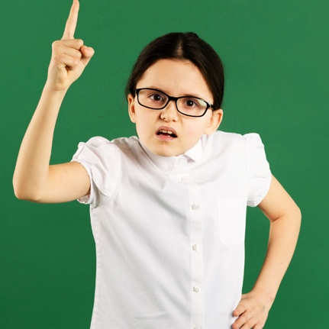36 | 37 | 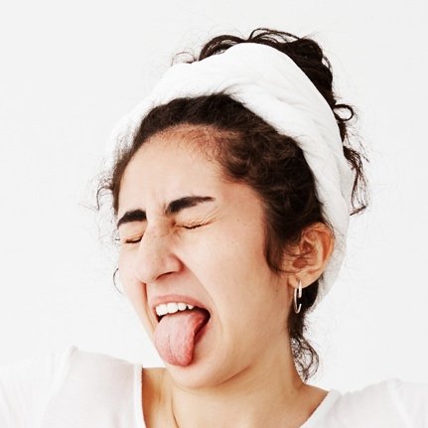38
Angry | Confused | Disgusted
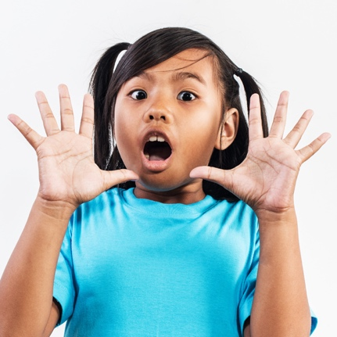39 | 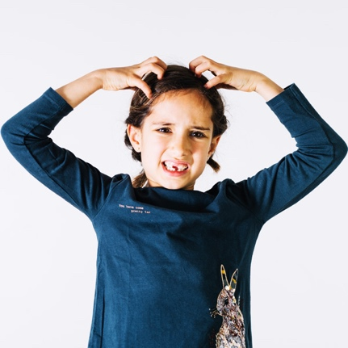40 | 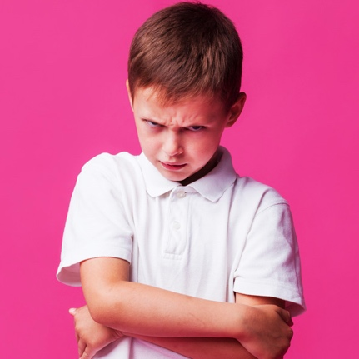41
Frightened, afraid, scared | Frustrated | Grumpy
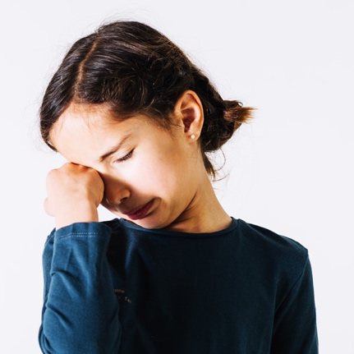42 | 43 | 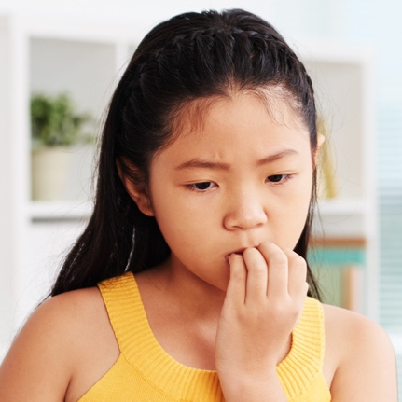44
Hurt | Lonely | Nervous
45 | 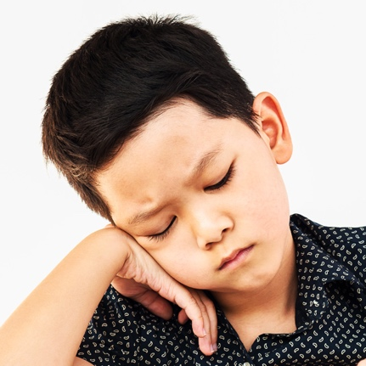46 | 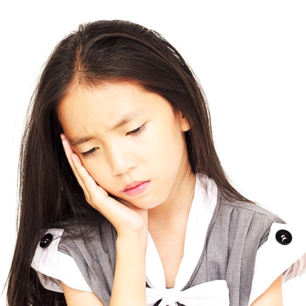47
Shocked | Unhappy, sad | Worried

Yes feelings
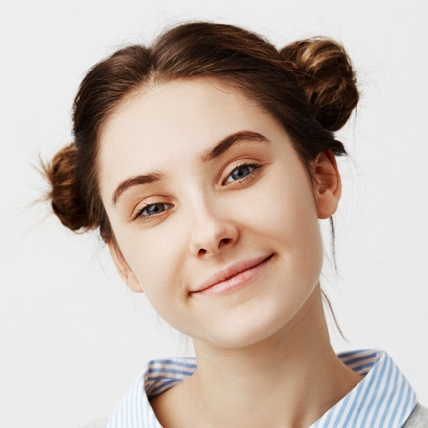48 | 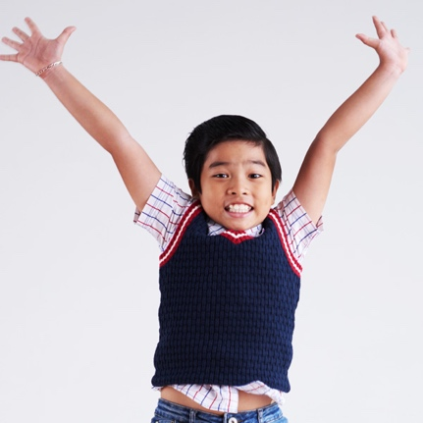49 | 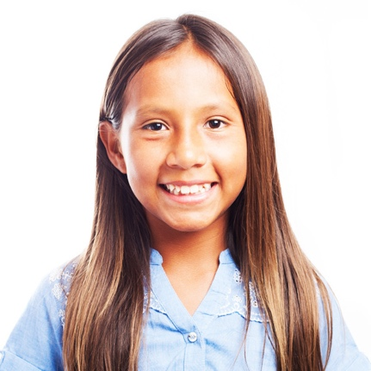50
Peaceful, calm | Excited | Happy
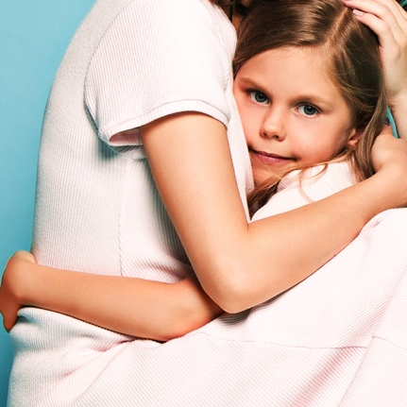51 | 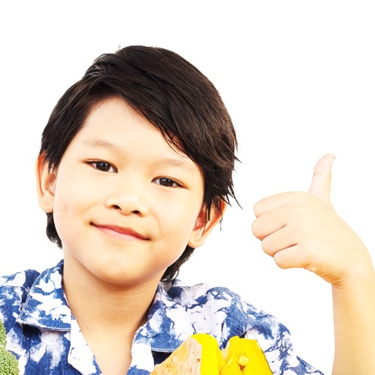52 | 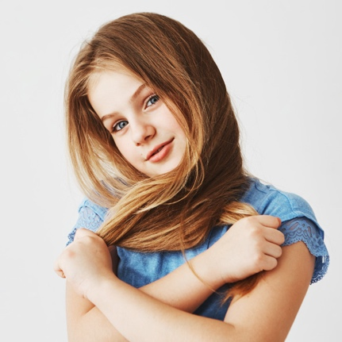53
Loved, safe | Proud | Shy
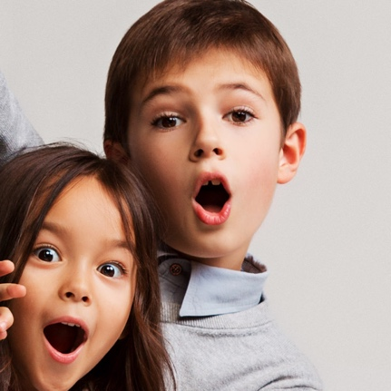54
Surprised

Teacher notes: Definition match
As a class match the words to their definition.
abuse | When someone does something on purpose to make someone else feel hurt or harm or to put them in danger.
body signals | A message our body gives us when we feel safe or unsafe.
bullying | When someone’s behaviour hurts or harms someone on purpose and it keeps happening.
harm | Injury or damage to someone or something.
No-Go-Tell | Steps children can use when they feel No feelings or are feeling unsafe.
No feelings | Feelings we get when we feel unsafe or uncomfortable.
respect | Being caring and kind and thinking and acting in a way that shows others you care about them and their feelings
secrets | Something that not everyone knows.
strengths | Tasks or actions that you do really well and find easy to do.
support network | People that we trust will help us when we need it.
Yes feelings | Feelings we get when we feel safe and comfortable.

Cards: Definition match
abuse | no feelings
body signals | respect
bullying | secrets
harm | strengths
no-go-tell | support network
yes feelings

When someone does something on purpose to make someone else feel hurt or harm or to put them in danger. | Steps children can use when they feel No feelings or are feeling unsafe.
A message our body gives us when we feel safe or unsafe. | Feelings we get when we feel unsafe or uncomfortable.
When someone’s behaviour hurts or harms someone on purpose and it keeps happening. | Being caring and kind and thinking and acting in a way that shows others you care about them and their feelings
Injury or damage to someone or something. | Something that not everyone knows.
Tasks or actions that you do really well and find easy to do. | Feelings we get when we feel safe and comfortable.
People that we trust will help us when we need it.

Cards: What would you do?
Read the scenario on each card. After each card ask students to think about the strategies they have learnt that could help them to respond in each situation.

Oliver’s parents are going out for dinner and Oliver’s babysitter is coming over to look after him. Last time his parents went out the babysitter touched Oliver’s private parts. What would you do if you were Oliver? | You are staying at your friend’s house. After dinner you and your friend go to have a bath. Your friend’s older brother comes in and watches you. He tells you that you must never tell anyone or you will be in trouble. What would you do?
Stella was hiding in her room. Her mum was very angry and was screaming bad words. Stella’s mum had hit her hard across the face and told her she wished she wasn’t there. What would you do if you were Stella? | Bindi and Charli are online gaming friends. They have been chatting for a while. Charli notices that Bindi has been saying really mean things to another online friend. This starts to happen every time they are online. One day Bindi tells their other friend that they can’t play the game with them today because they can’t play properly. What would you do if you were Charli?

Copyright register
- Love it boy: Children photo created by freepik – www.freepik.com
- Like it boy and girl: Children photo created by freepik – www.freepik.com
- Don’t like it girl: Background photo created by freepik – www.freepik.com
- Unsure boy: Children photo created by freepik – www.freepik.com
- Red bike: Background vector created by freepik – www.freepik.com
- Pet food bowl: Food vector created by stories – www.freepik.com
- 3 shoes – Banner vector created by pch.vector – www.freepik.com
- Various sports balls: Sport vector created by macrovector – www.freepik.com
- Various kids clothes: Winter vector created by freepik – www.freepik.com
- Beanies: Fashion vector created by macrovector – www.freepik.com
- Ribbons: Certificate vector created by freepik – www.freepik.com
- Toys: Kids vector created by freepik – www.freepik.com
Shelves: Book vector created by freepik – www.freepik.com
- Books and shelves: Book vector created by freepik – www.freepik.com
- Sometimes: Camera photo created by drobotdean – www.freepik.com
- Babies: People photo created by master1305 – www.freepik.com
- Single baby: Background photo created by freepic.diller – www.freepik.com
- Butterflies in your tummy butterflies: Background photo created by freepik – www.freepik.com
butterflies in your tummy girl: Woman vector created by freepik – www.freepik.com
- Quick breathing boy: Food photo created by diana.grytsku – www.freepik.com
- Racing heart girl: People photo created by wayhomestudio – www.freepik.com
- Shaky knees: Shaky knees boy: Cute photo created by drobotdean – www.freepik.com
- Cold shivery body girl: Winter photo created by freepik – www.freepik.com
- Squirmy tummy boy: Background photo created by freepik – www.freepik.com
Worms: Food photo created by freepik – www.freepik.com
- Sweaty hands boy: School photo created by jcomp – www.freepik.com
Droplets: Water vector created by pch.vector – www. www.freepik.com
- Warm body girl: Designed by jcomp – www.freepik.com
- Girl hugging bear: Love photo created by drobotdean – www.freepik.com
- Teddy bear in box: Christmas photo created by Racool_studio – www.freepik.com
- Kids at movies: Designed by serhii – www.freepik.com
- Broccoli: Food photo created by jcomp – www.freepik.com
- Kids cleaning (picking up rubbish): Kids photo created by freepik – www.freepik.com
- Kids eating ice cream: Kids photo created by freepik – www.freepik.com
- Boy doing homework: Background photo created by photoroyalty – www.freepik.com
- Lego blocks: Baby photo created by Kireyonok_Yuliya – www.freepik.com
- Girl hugging dog: Dog photo created by master1305 – www.freepik.com
- Gaming console: Business photo created by Racool_studio – www.freepik.com
- Family in a pool: People photo created by rawpixel.com – www.freepik.com
- Angry: Education photo created by freepik – www.freepik.com
- Confused: People photo created by cookie_studio – www.freepik.com
- Disgusted: Woman photo created by cookie_studio – www.freepik.com
- Frightened: Kids photo created by freepik – www.freepik.com
- Frustrated: Girl photo created by freepik – www.freepik.com
- Grumpy: Designed by Freepik – www.freepik.com
- Sad/hurt: Girl photo created by freepik – www.freepik.com
- Lonely: People photo created by jcomp – www.freepik.com
- Nervous: Designed by pressfoto – www.freepik.com
- Shocked Designed by Freepik – www.freepik.com
- Unhappy: Designed by jcomp – www.freepik.com
- Worried: Designed by jcomp – www.freepik.com
- Peaceful/calm: Woman photo created by cookie_studio – www.freepik.com
- Excited: People photo created by jcomp – www.freepik.com
- Happy: Designed by Asier_Relampagoestudio – www.freepik.com
- Loved/safe: Family photo created by master1305 – www.freepik.com
- Proud: Designed by jcomp – www.freepik.com
- Shy: For websites: Designed by cookie_studio – www.freepik.com
- Surprised: People photo created by drobotdean – www.freepik.com

© State of New South Wales (Department of Education), 2023
The copyright material published in this resource is subject to the Copyright Act 1968 (Cth) and is owned by the NSW Department of Education or, where indicated, by a party other than the NSW Department of Education (third-party material).
Copyright material available in this resource and owned by the NSW Department of Education is licensed under a Creative Commons Attribution 4.0 International (CC BY 4.0) license.

This license allows you to share and adapt the material for any purpose, even commercially.
Attribution should be given to © State of New South Wales (Department of Education), 2023.
Material in this resource not available under a Creative Commons license:
- the NSW Department of Education logo, other logos and trademark-protected material
- material owned by a third party that has been reproduced with permission. You will need to obtain permission from the third party to reuse its material.
Links to third-party material and websites
Please note that the provided (reading/viewing material/list/links/texts) are a suggestion only and implies no endorsement, by the New South Wales Department of Education, of any author, publisher, or book title. School principals and teachers are best placed to assess the suitability of resources that would complement the curriculum and reflect the needs and interests of their students.
If you use the links provided in this document to access a third-party's website, you acknowledge that the terms of use, including licence terms set out on the third-party's website apply to the use which may be made of the materials on that third-party website or where permitted by the Copyright Act 1968 (Cth). The department accepts no responsibility for content on third-party websites.

