PDHPE

Early Stage 1: Child Protection Education

Resources

Keeping myself safe

Contents
Images of different types of families 2
See, think, wonder template 5
Visual representation of a support network 6
Body parts images 10
Cards: Body parts 12
Worksheet: Body outlines 13
Cards: Yes, sometimes, no and uncertain 15
Cards: Feelings and emotions 16
Body signals images 19
Wanted and unwanted touch images 21
Images of toys 23
Cards: No-go-tell scenarios 24
No-go-tell images 29
Copyright register 30

Images of different types of families
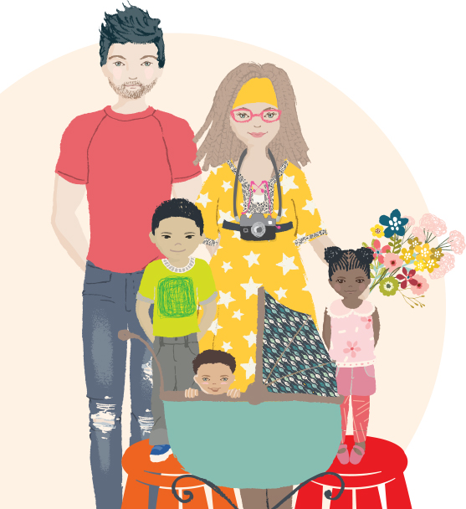 | 
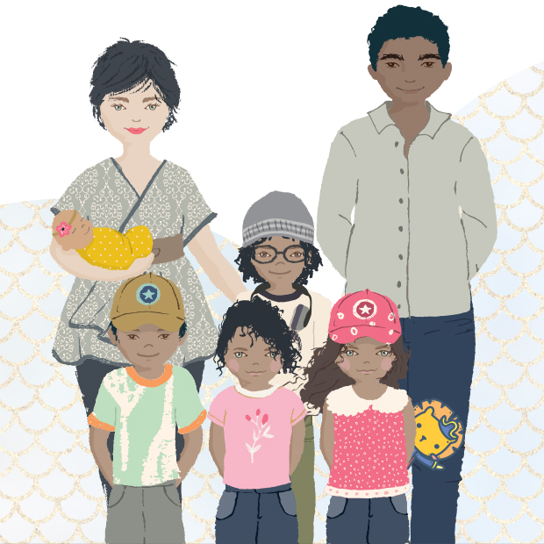 | 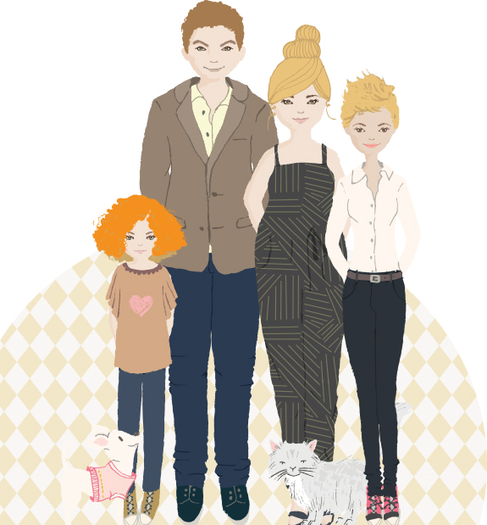
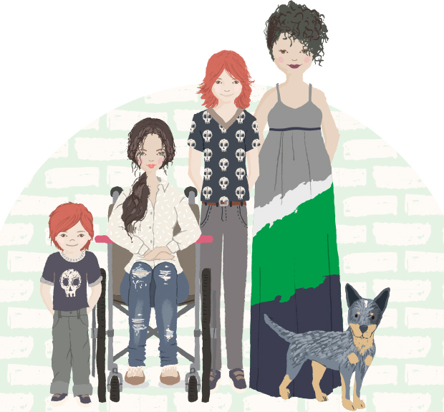 | 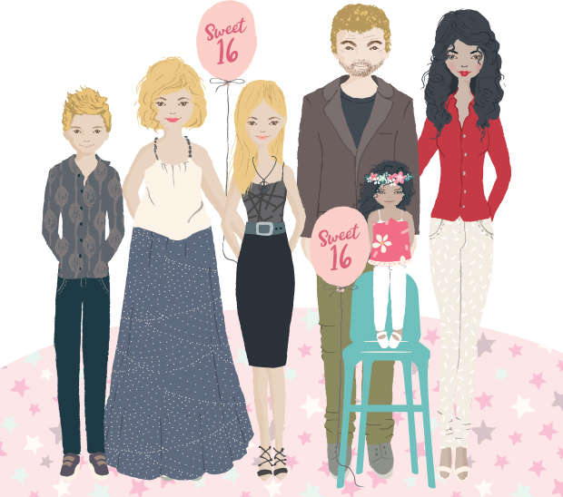
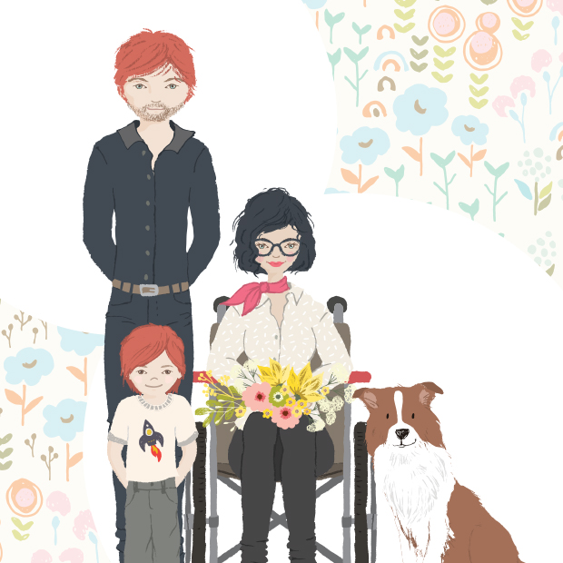 | 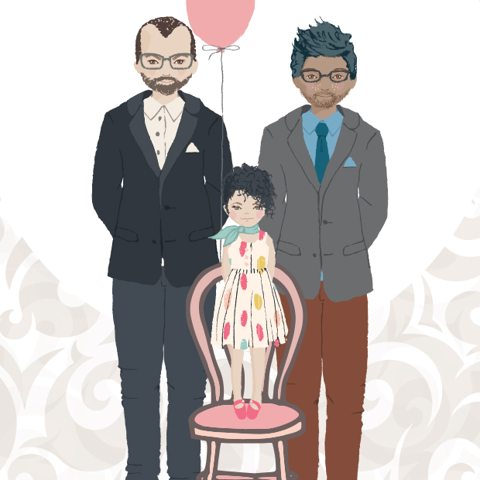
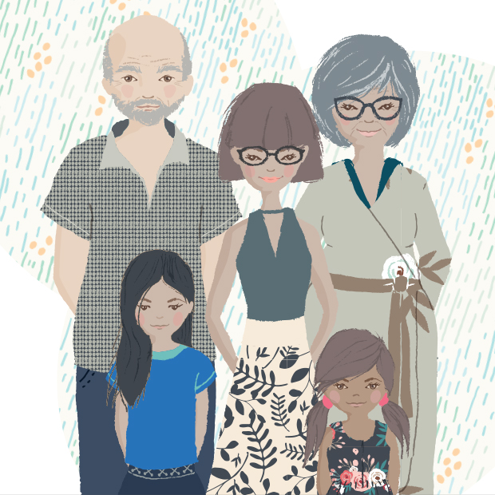 | 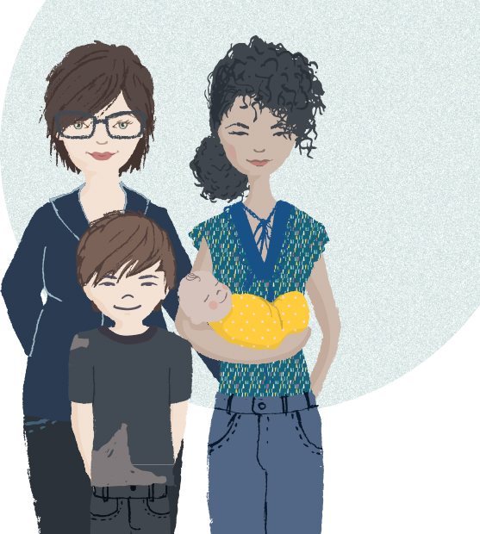
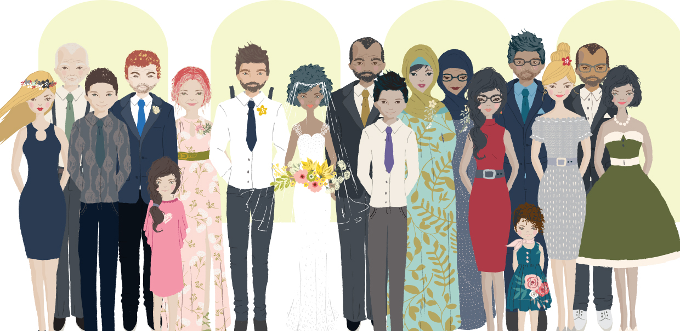

See, think, wonder template

Visual representation of a support network






Body parts images
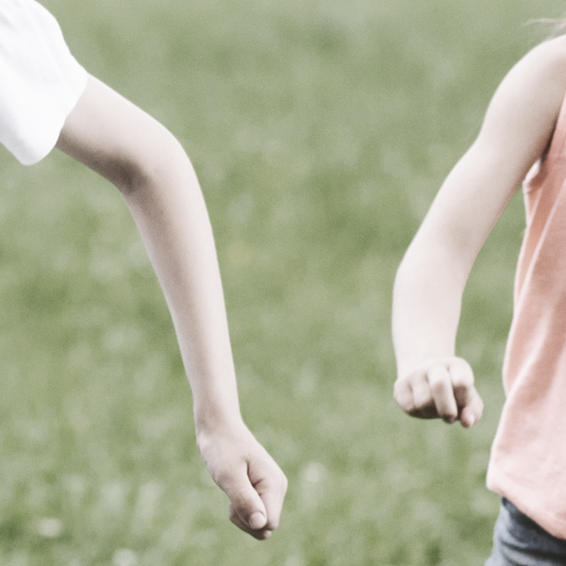 | 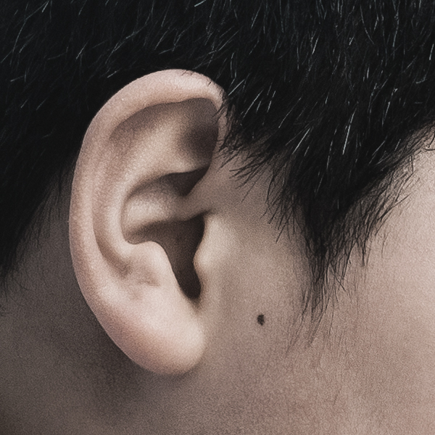 | 
Arms | Ear | Elbows
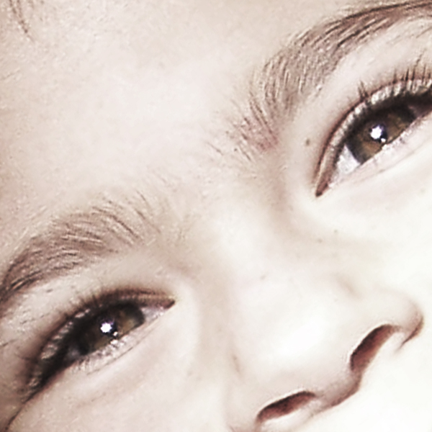 | 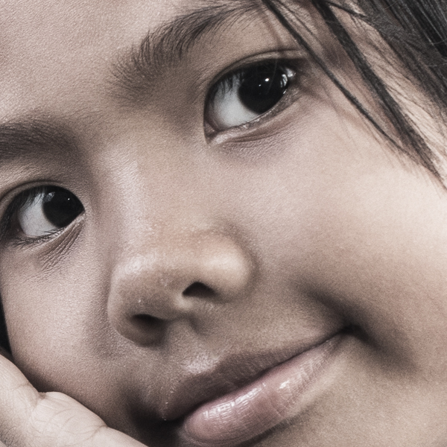 | 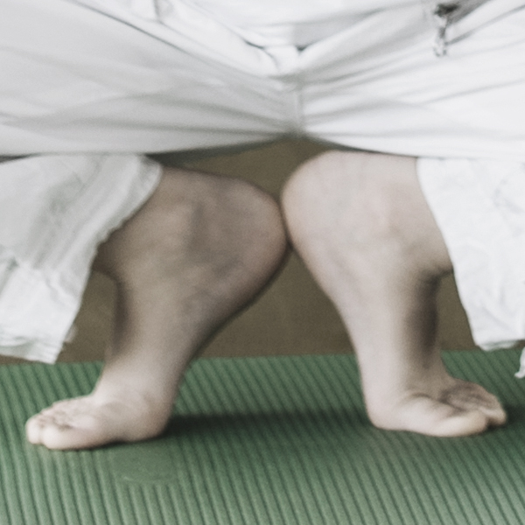
Eyes | Face | Feet
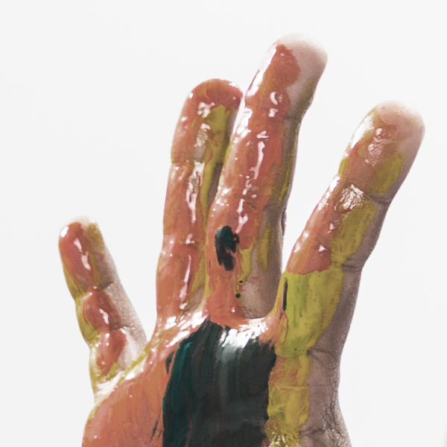 |  | 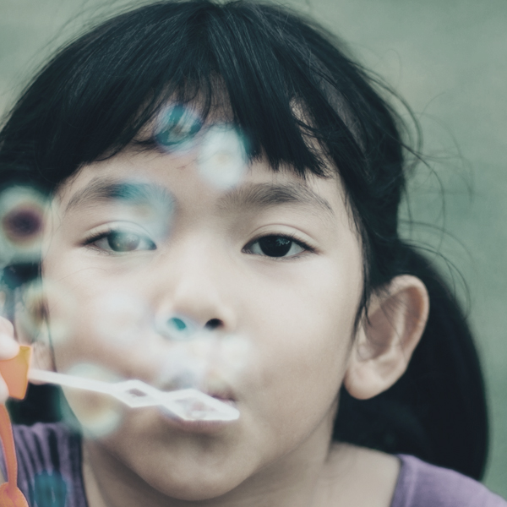
Fingers | Hands | Head
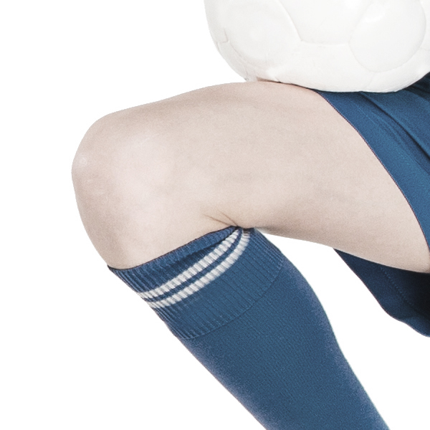 | 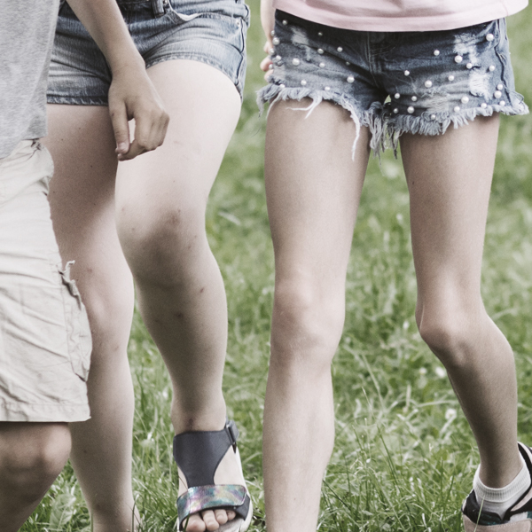 | 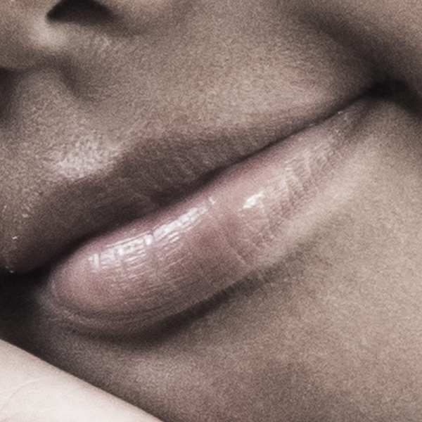
Knee | Legs | Lips
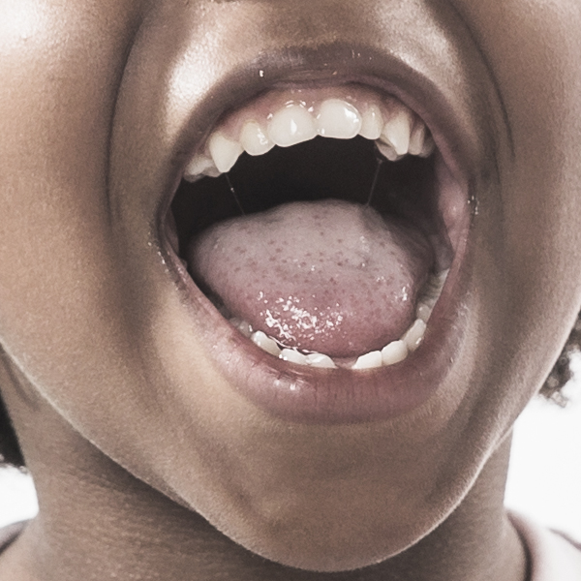 | 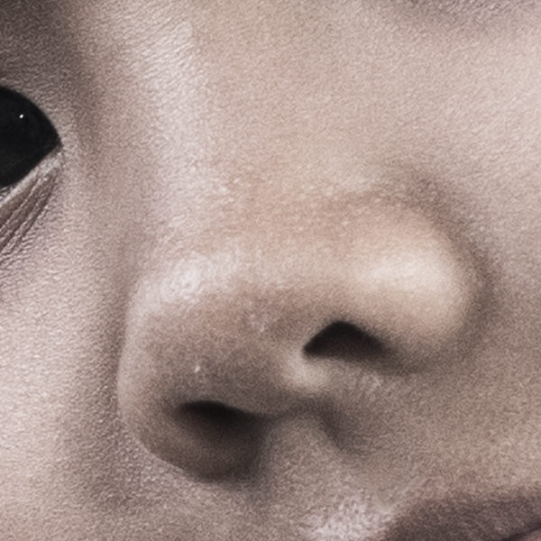 | 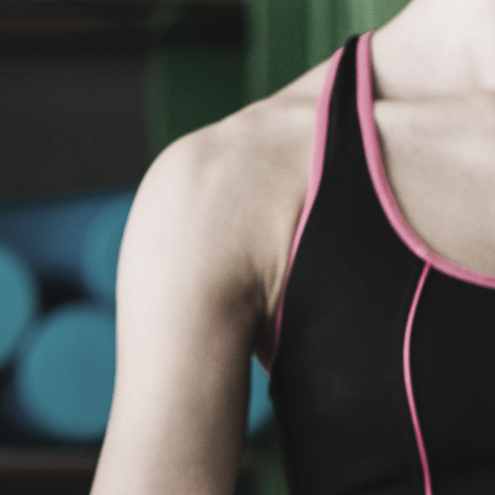
Mouth | Nose | Shoulder
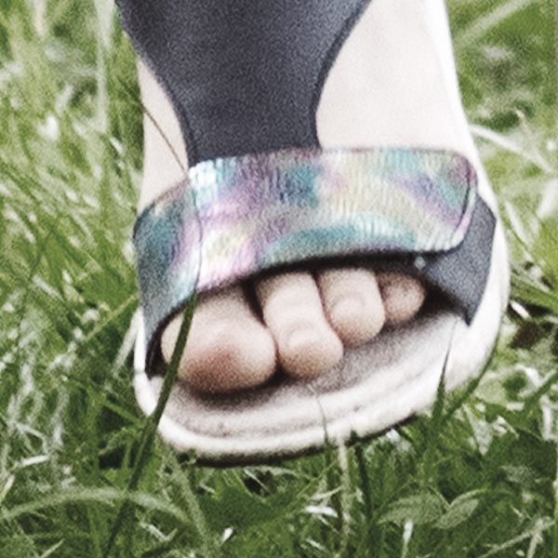
Toes
41

Cards: Body parts
arms | ear | neck
elbows | eyes | thighs
face | feet | nipples
fingers | hands | breasts
head | knee | bottom
legs | lips | testicles
mouth | nose | penis
shoulder | toes | vagina

Worksheet: Body outlines
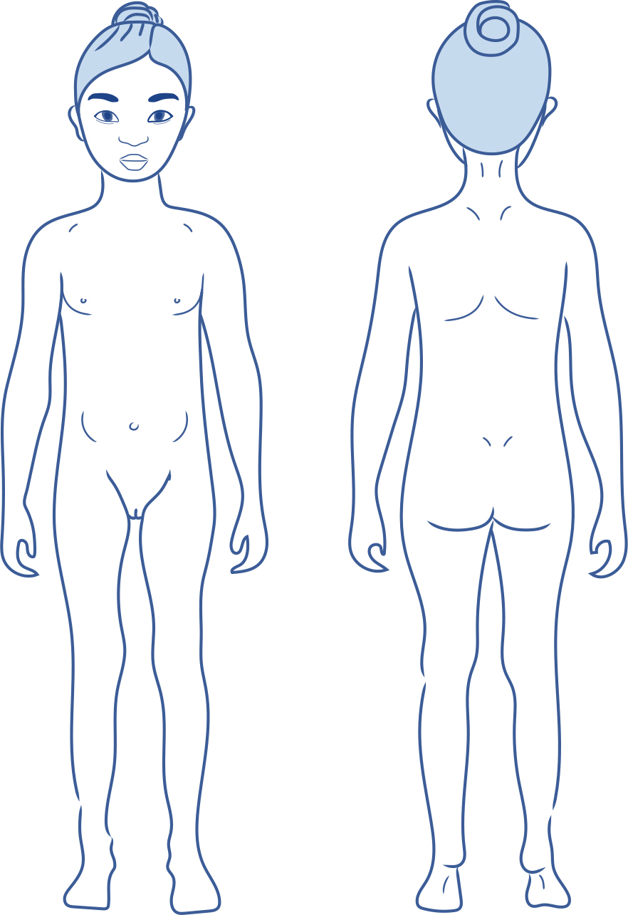
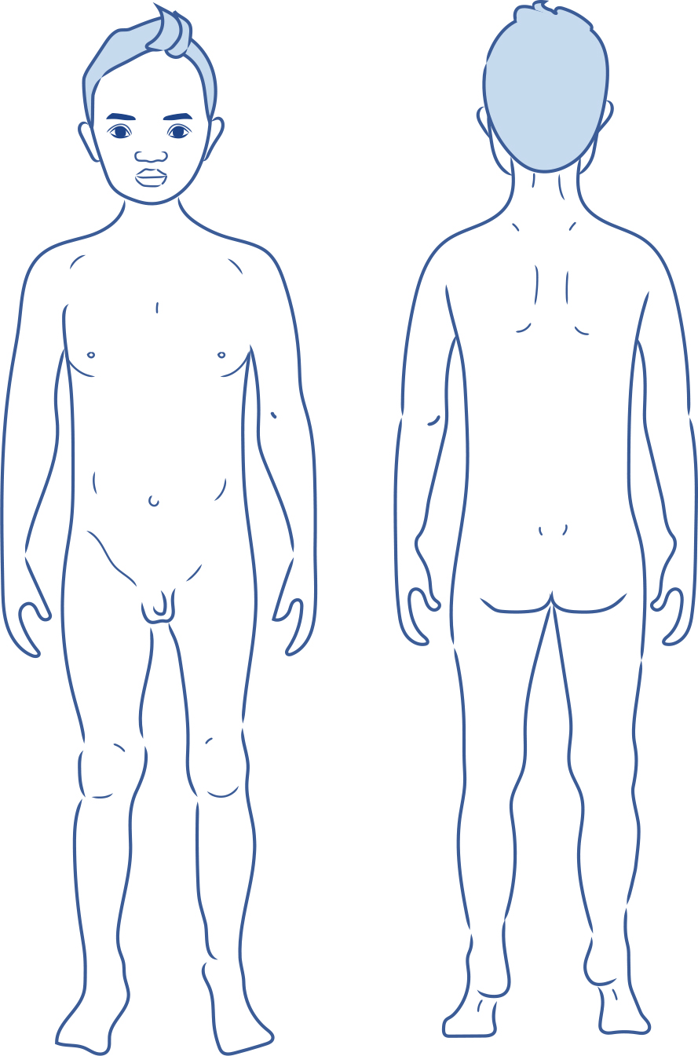

Cards: Yes, sometimes, no and uncertain
1 | 2
Yes | Sometimes
3 | 4
No | Uncertain

Cards: Feelings and emotions

No feelings
5 | 6 | 7
Angry | Confused | Disgusted
8 | 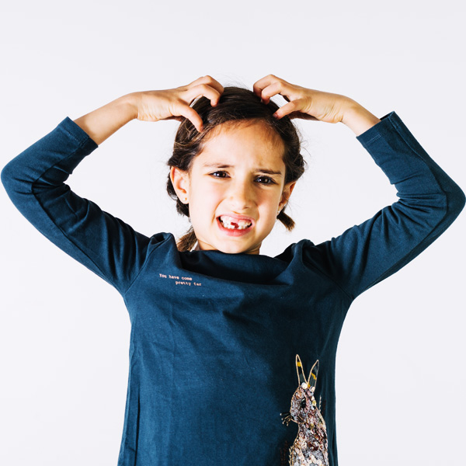9 | 10
Frightened, afraid, scared | Frustrated | Grumpy
11 | 12 | 13
Hurt | Lonely | Nervous
14 | 15 | 16
Shocked | Unhappy, sad | Worried

Yes feelings
17 | 18 | 19
Peaceful, calm | Excited | Happy
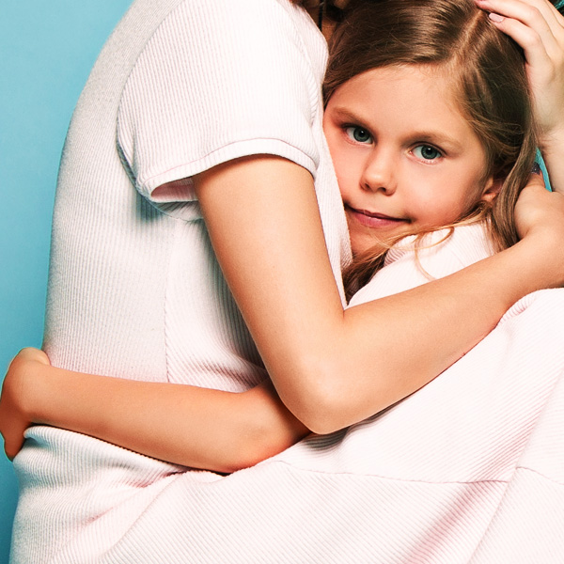20 | 21 | 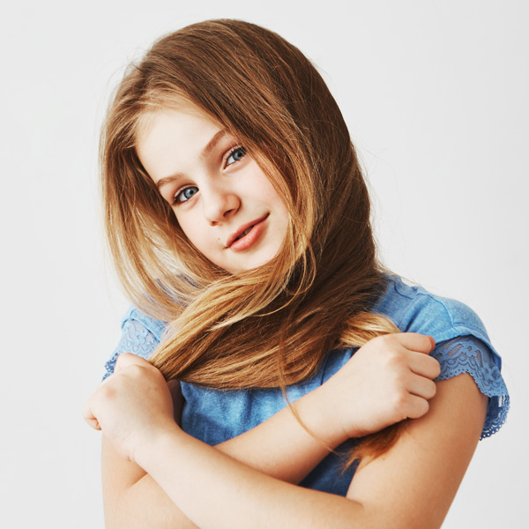22
Loved, safe | Proud | Shy
23
Surprised

Body signals images
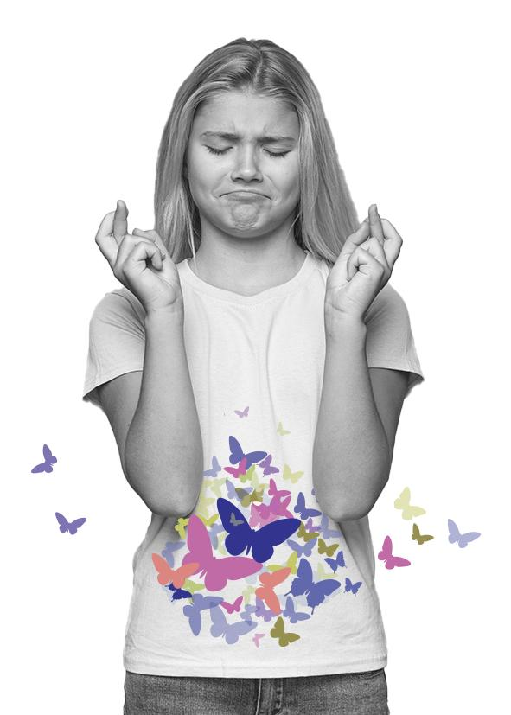49 | 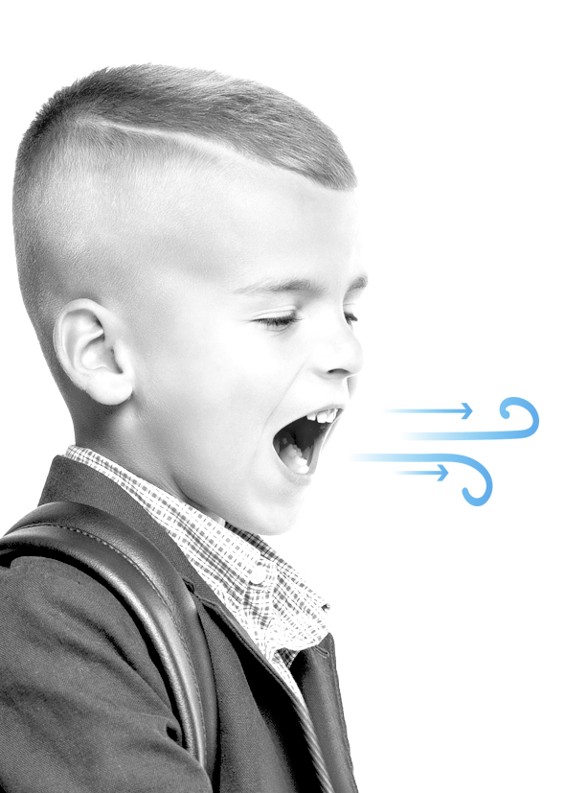50
Butterflies in your tummy | Quick breathing
51 | 52
Racing heart | Shaky knees
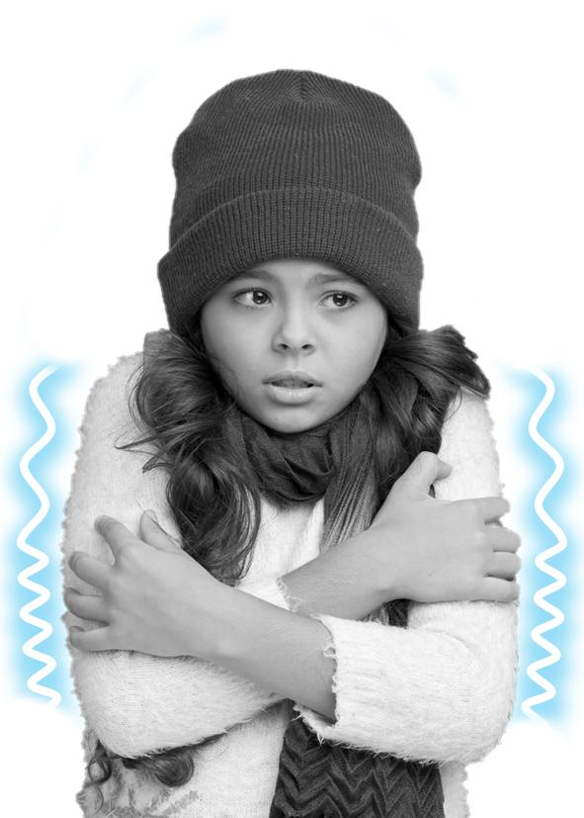 53 | 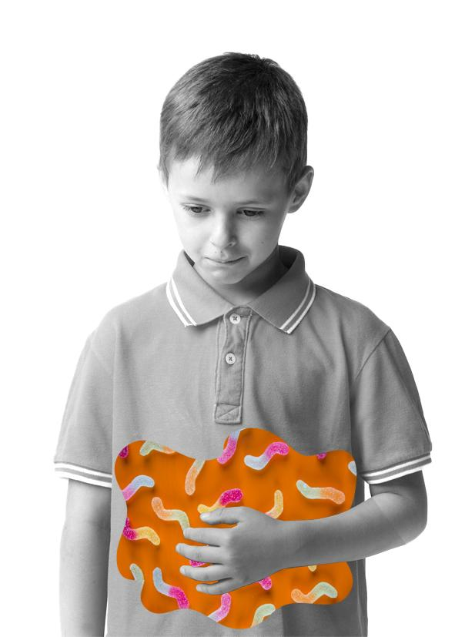54
Cold-shivery body | Squirmy tummy
55 | 56
Sweaty hands | Warm body

Wanted and unwanted touch images
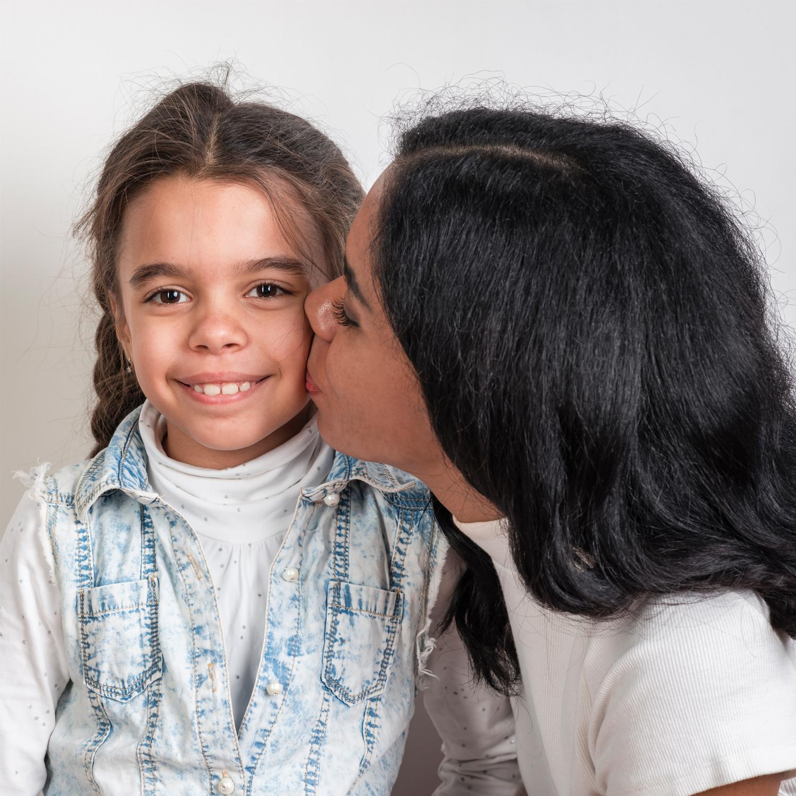  45 | 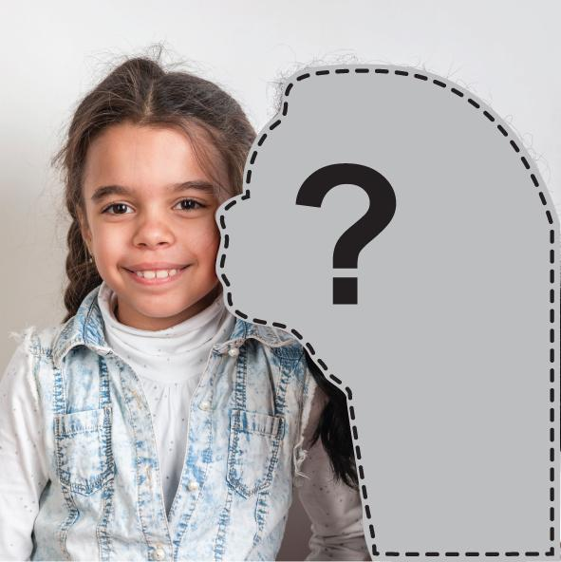  45
Wanted kissing | Unwanted kissing
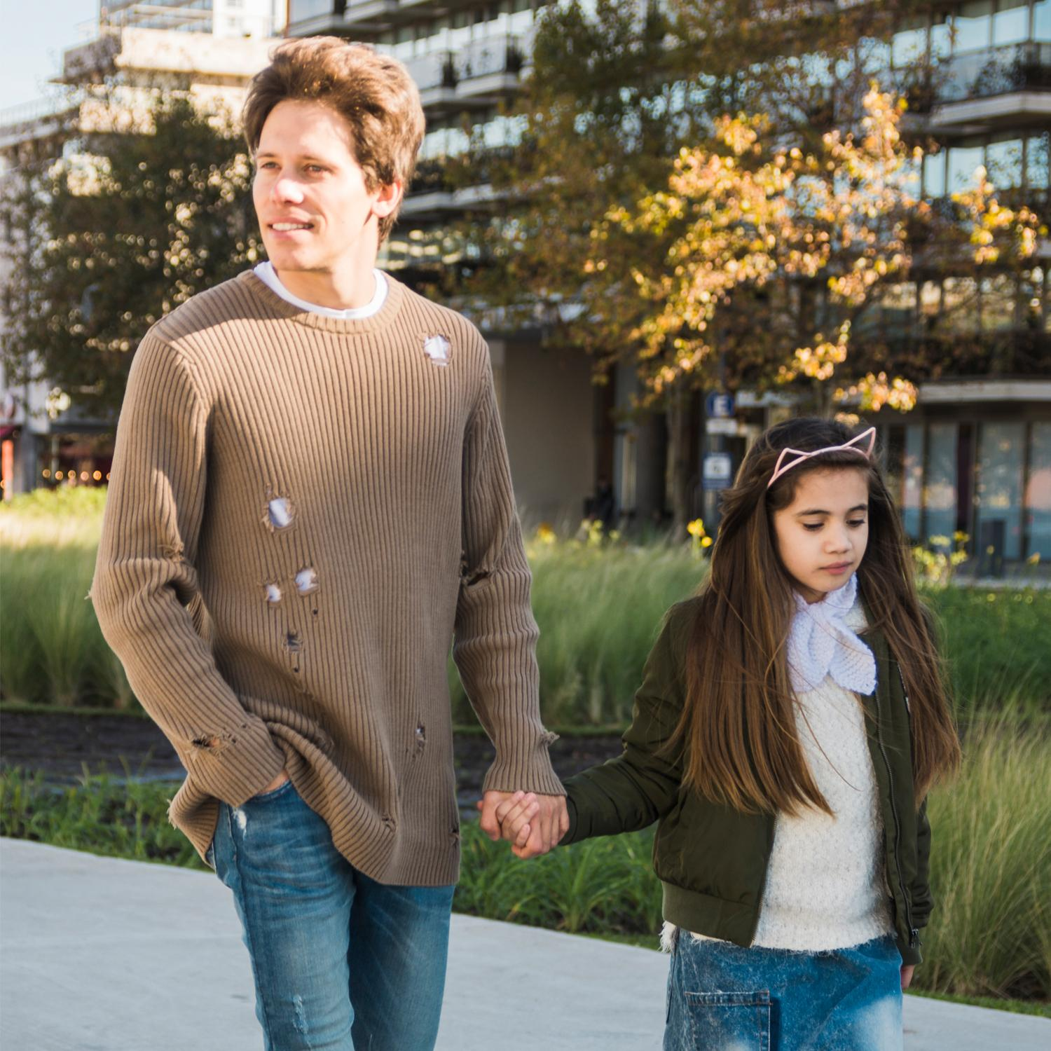  46 | 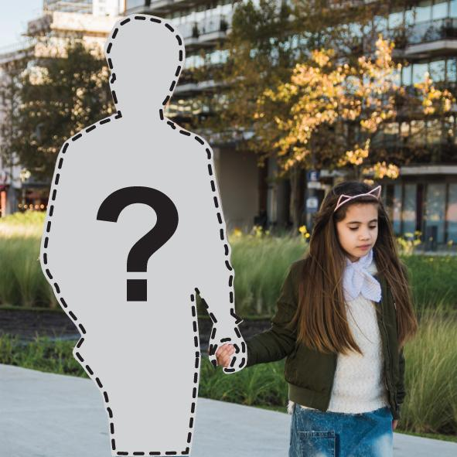  46
Wanted holding hands | Unwanted holding hands
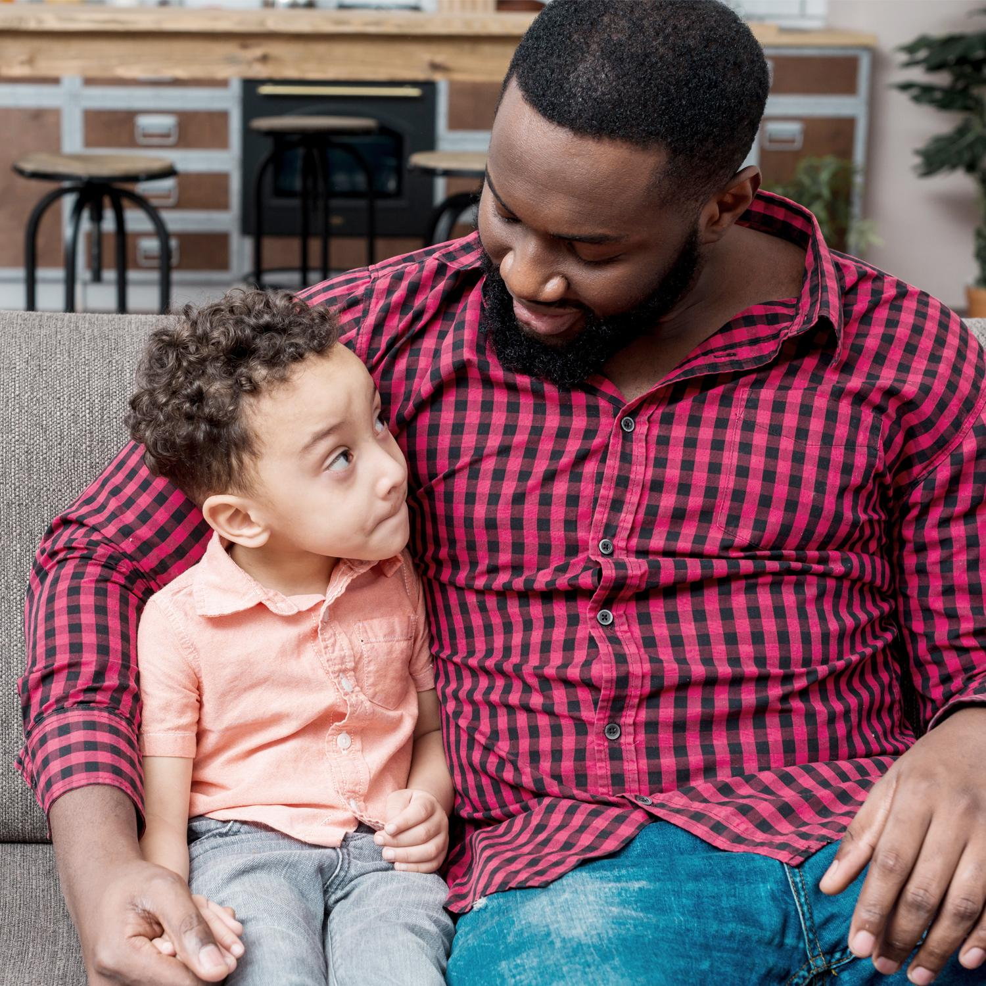  47 | 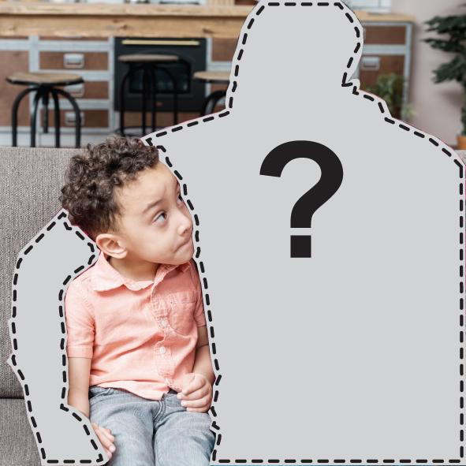  47
Wanted hug | Unwanted hug
  48 | 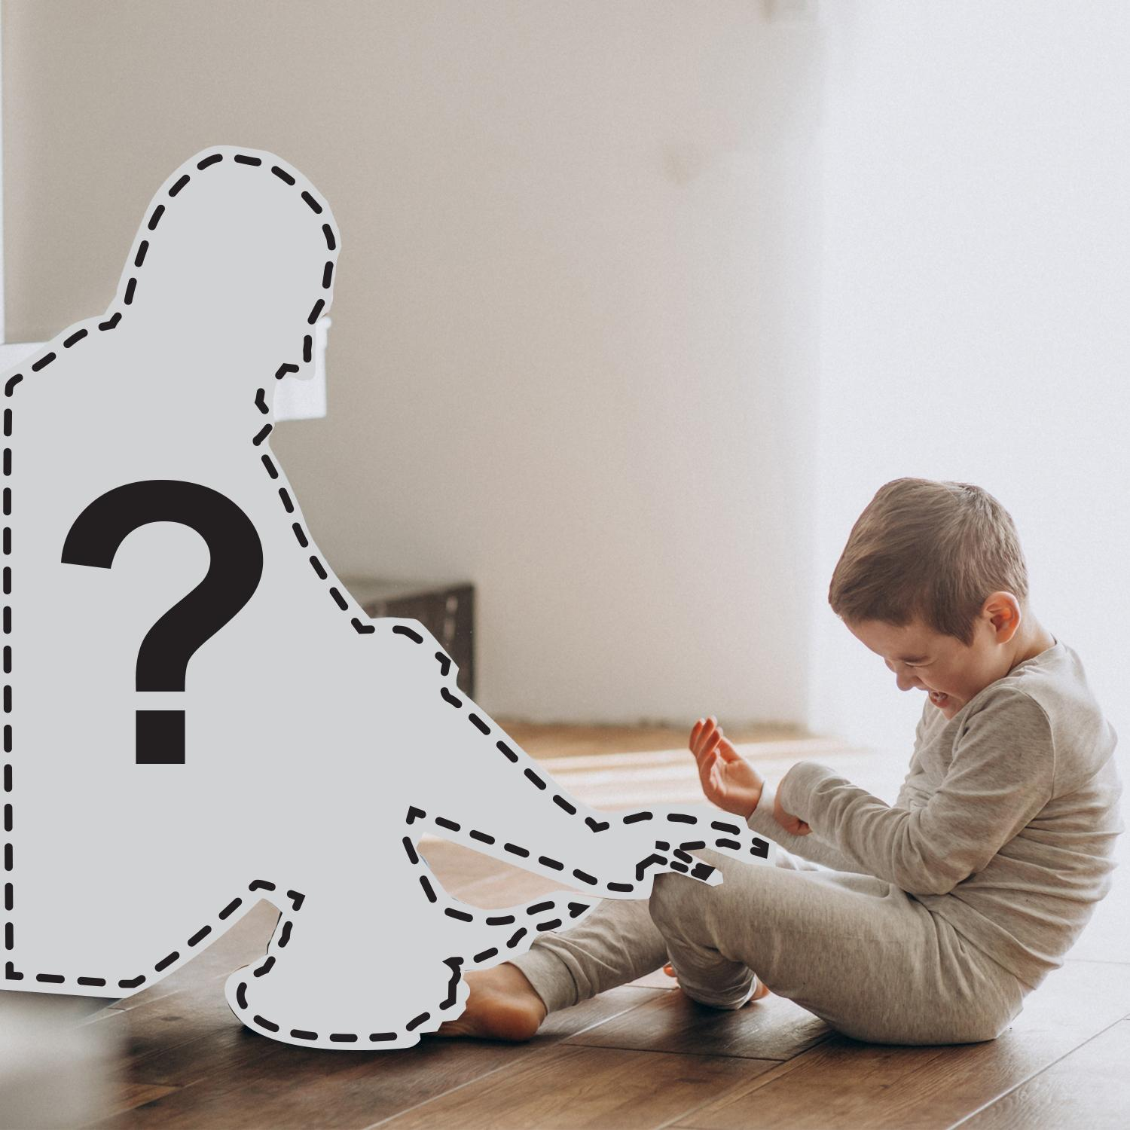  48
Wanted tickling | Unwanted tickling

Images of toys
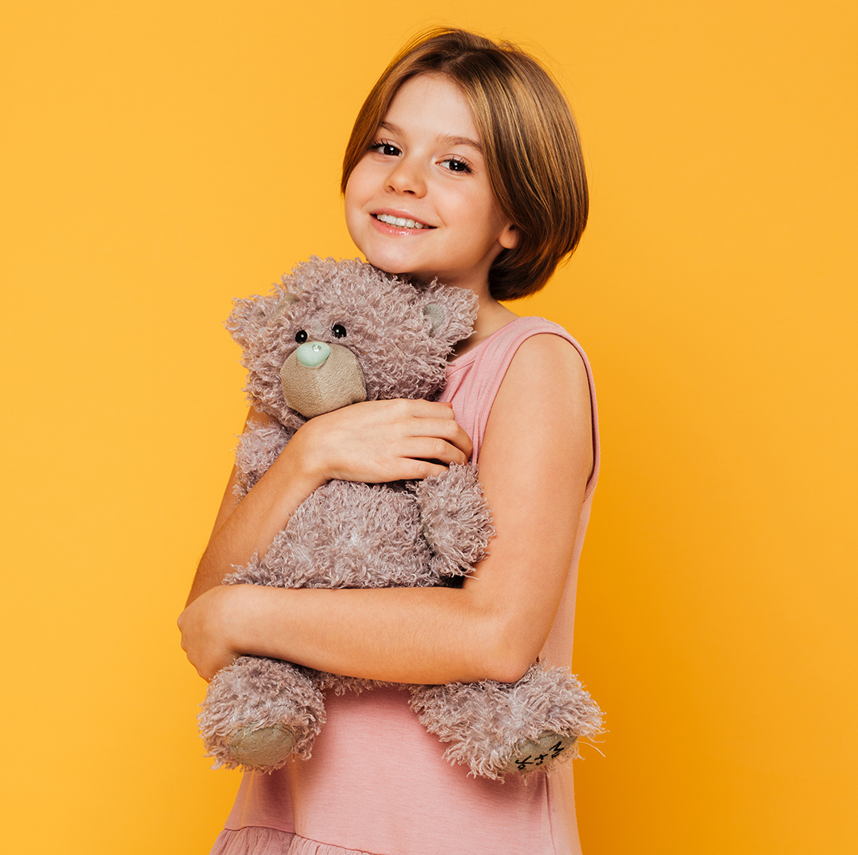57

 58

Cards: No-go-tell scenarios
  24 | 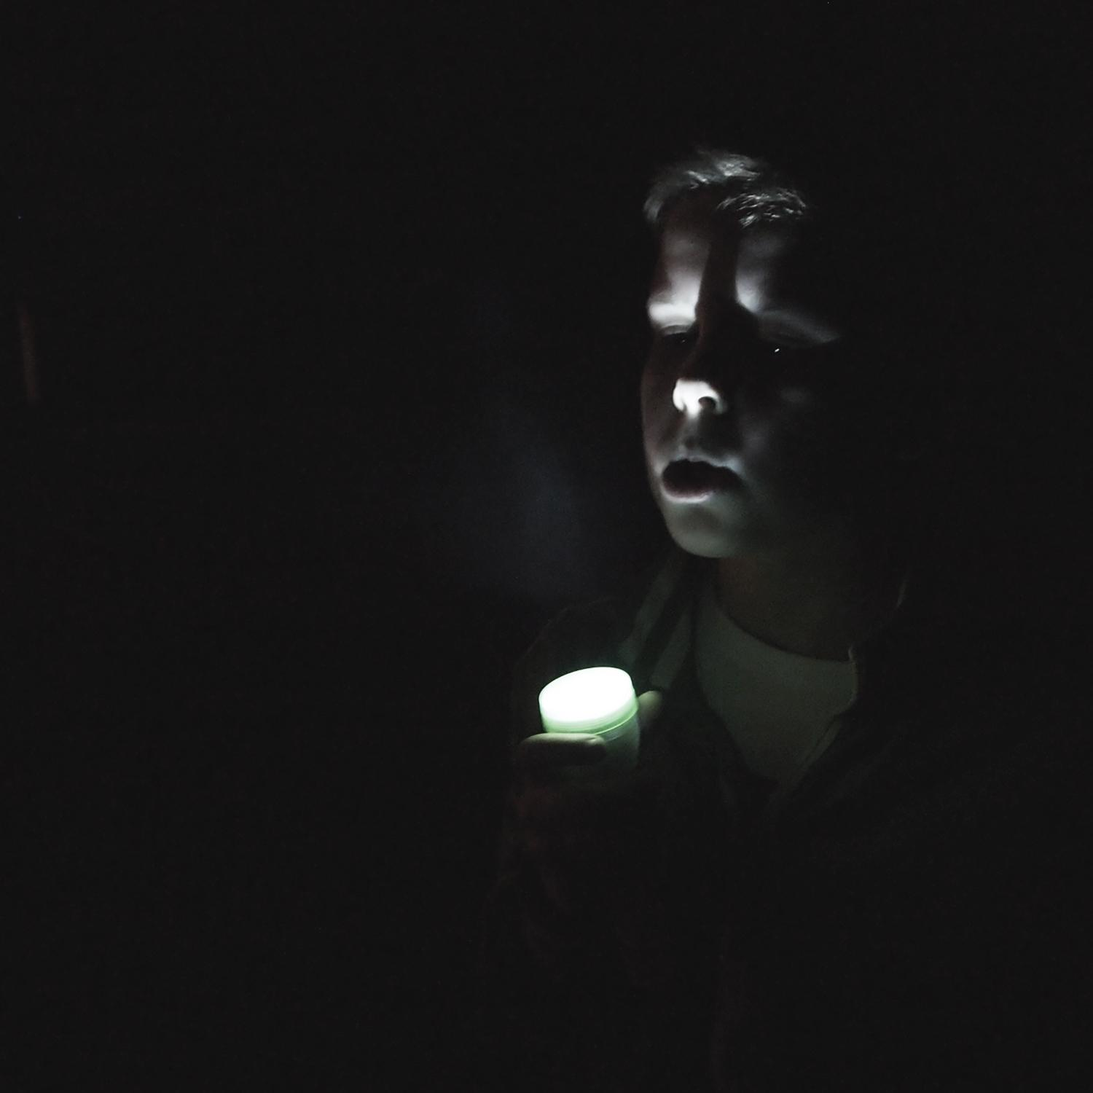  25
Going to the movies | Being in the dark
  26 | 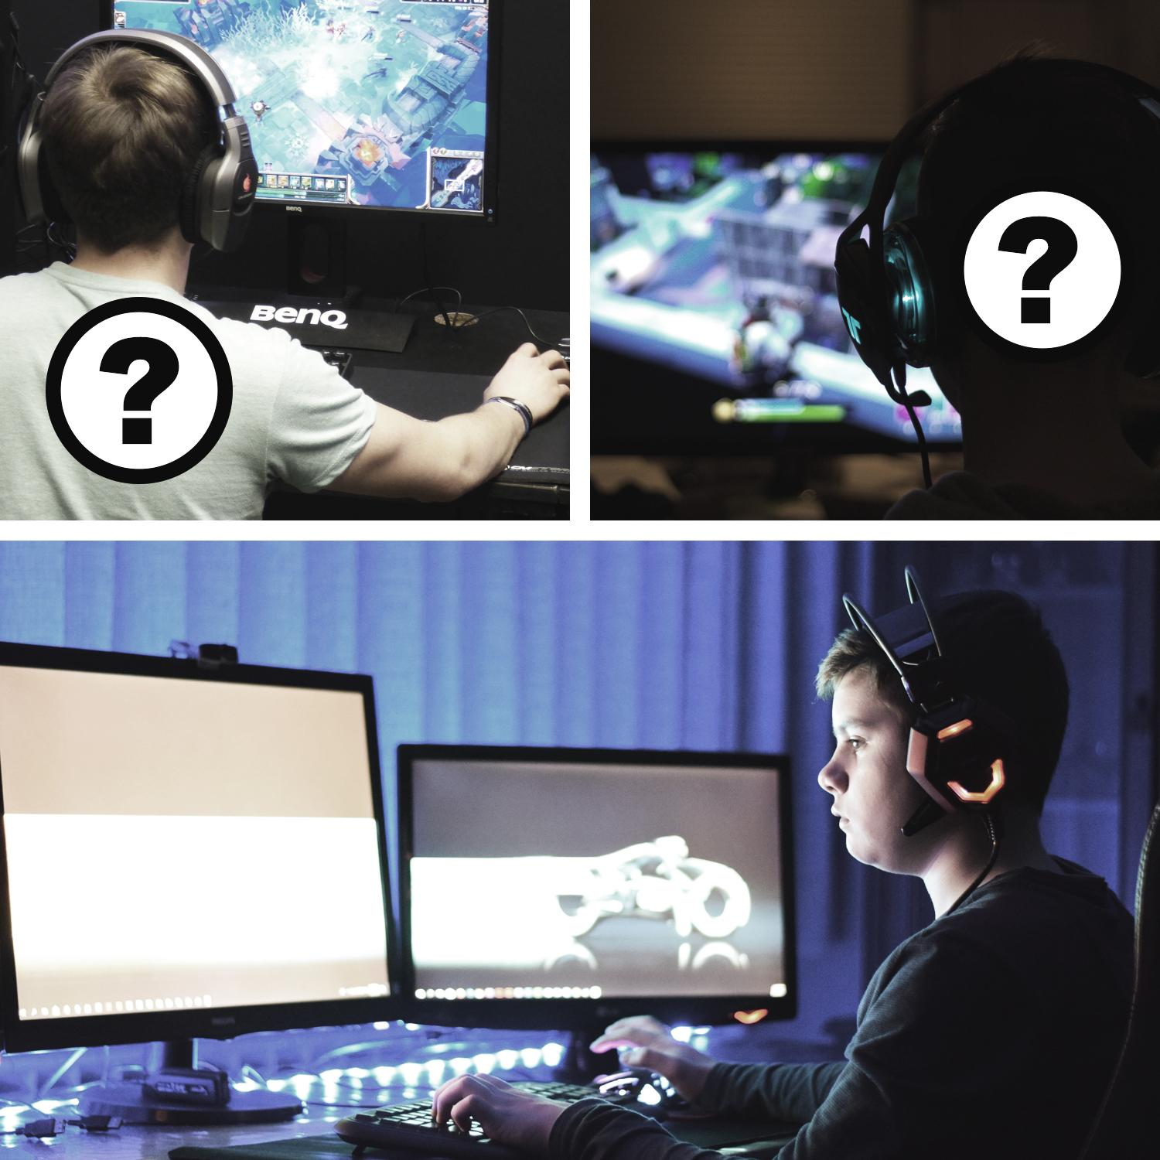  27
Having a picnic with family | Playing a game online with people  you don’t know
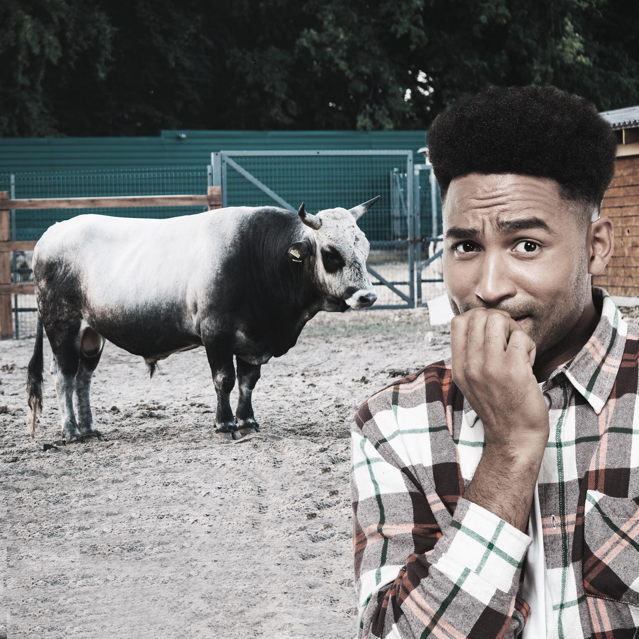  28 |   29
Being in a paddock with a bull | Lost in a shopping centre
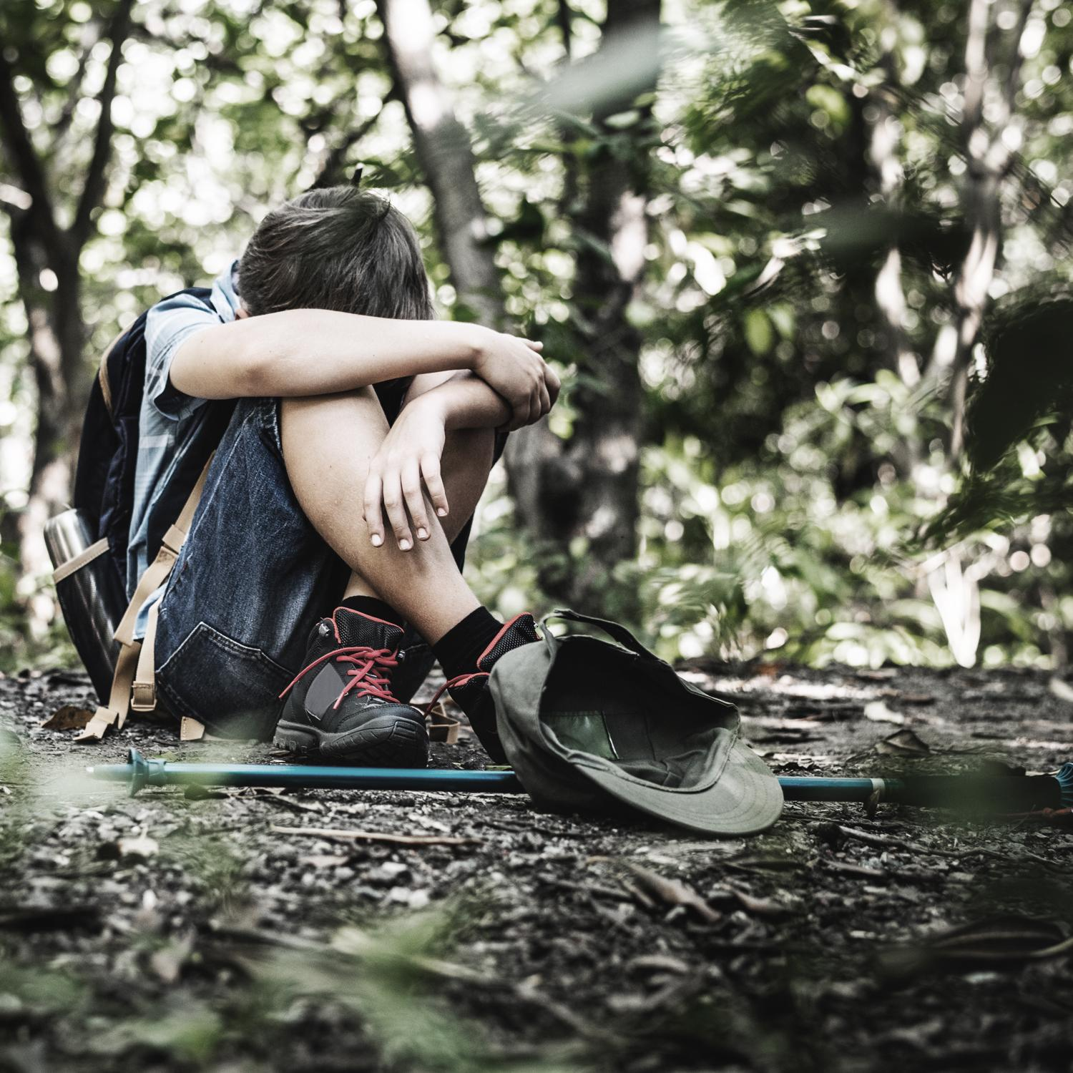  30 | 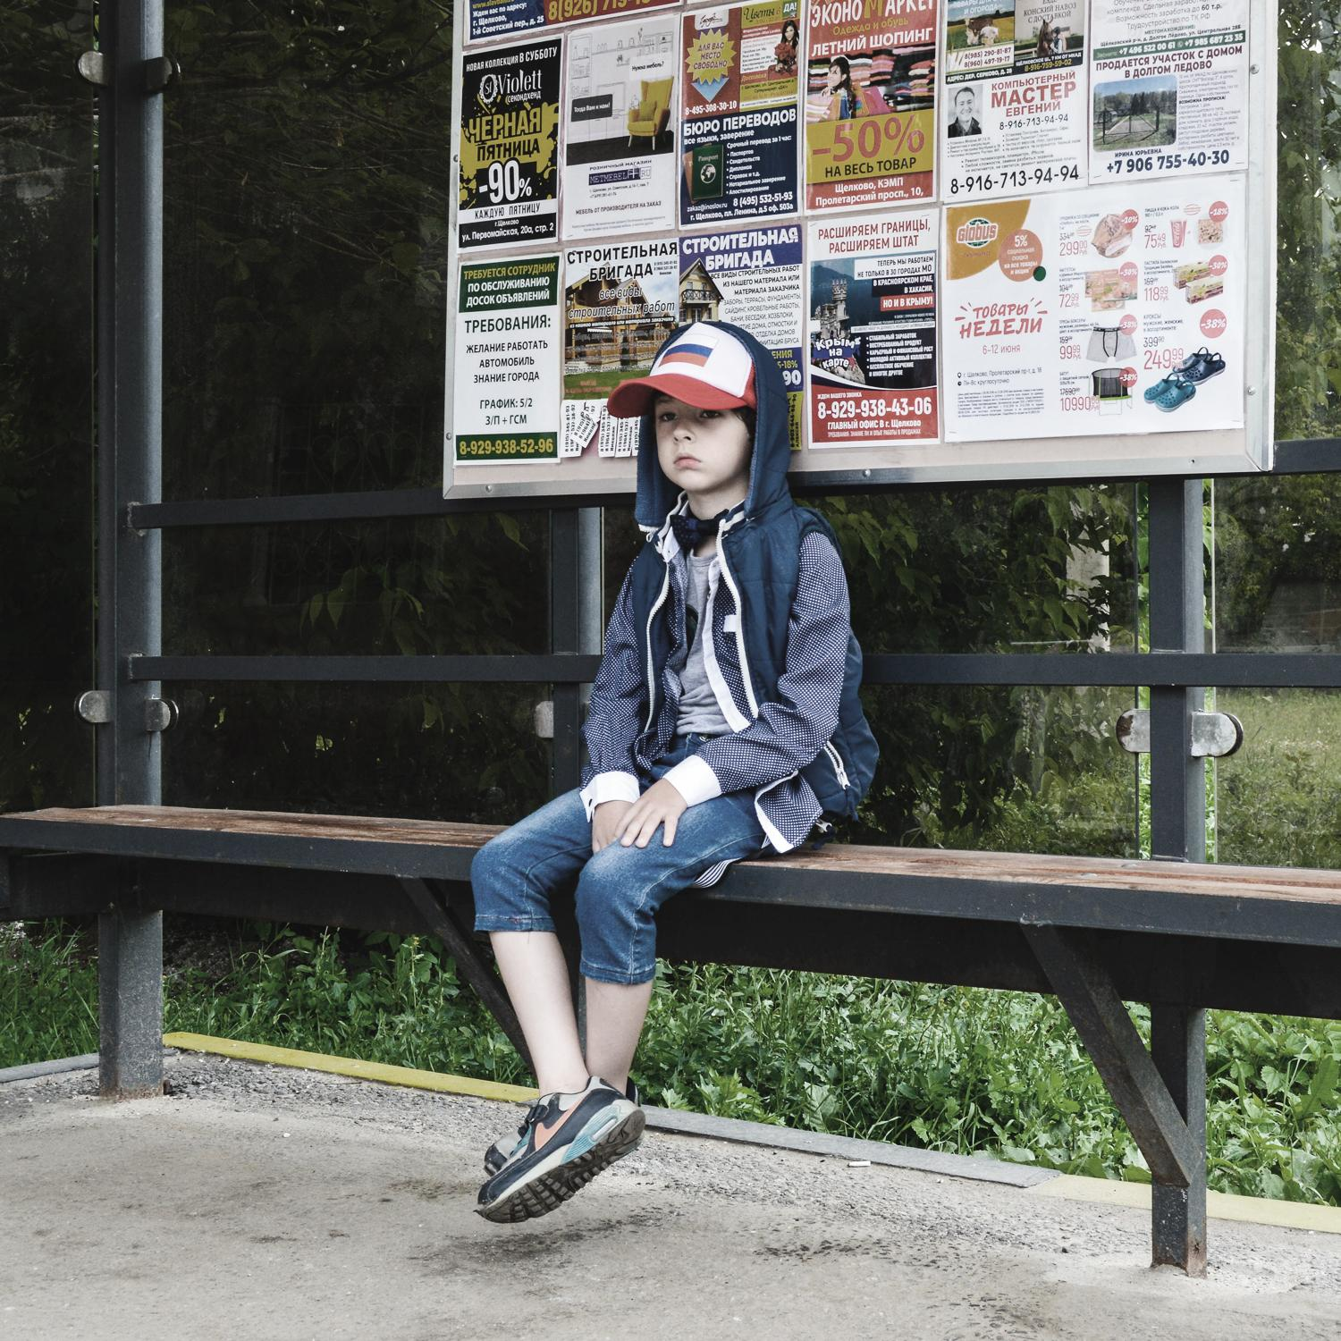  31
Lost in the bush | Missing the bus home
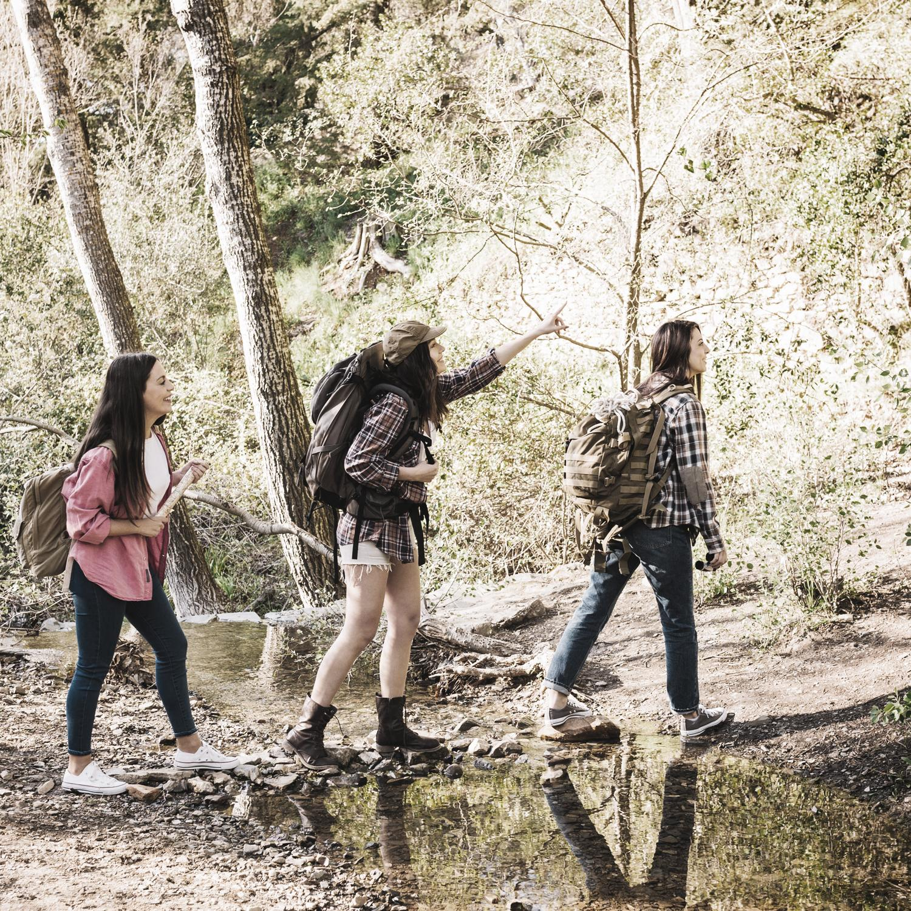  32 | 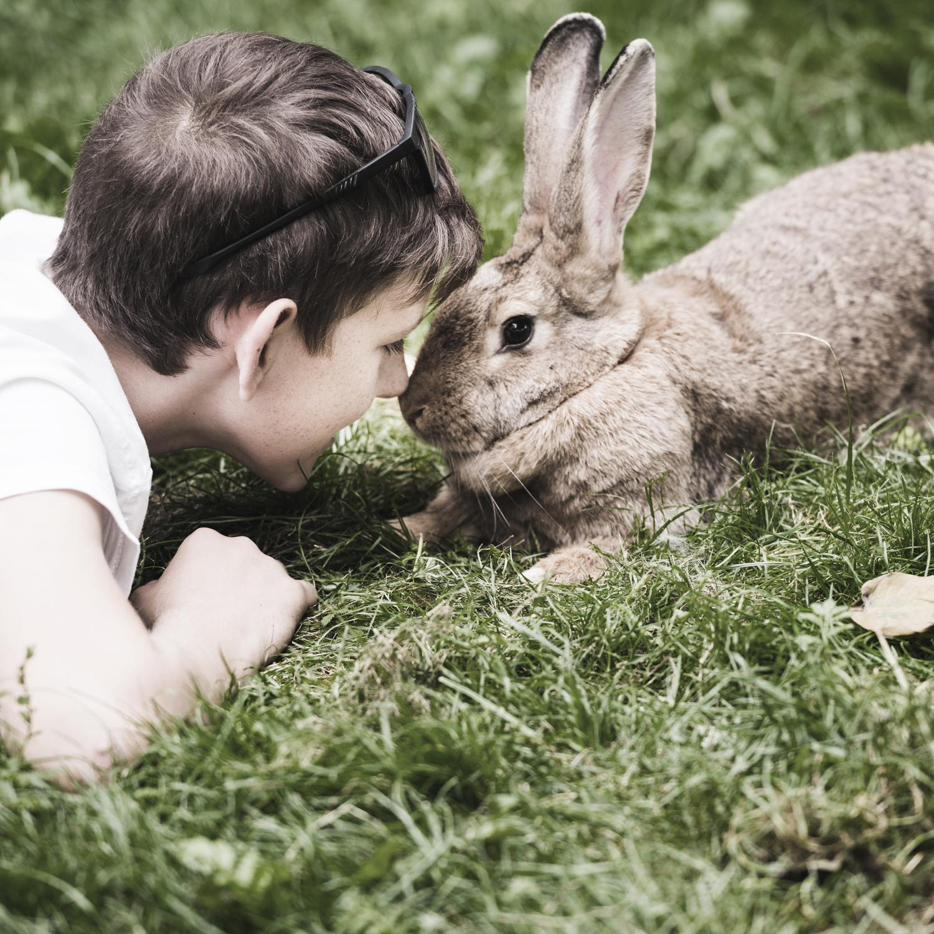  33
Going on a bush walk | Playing with a pet
  34 | 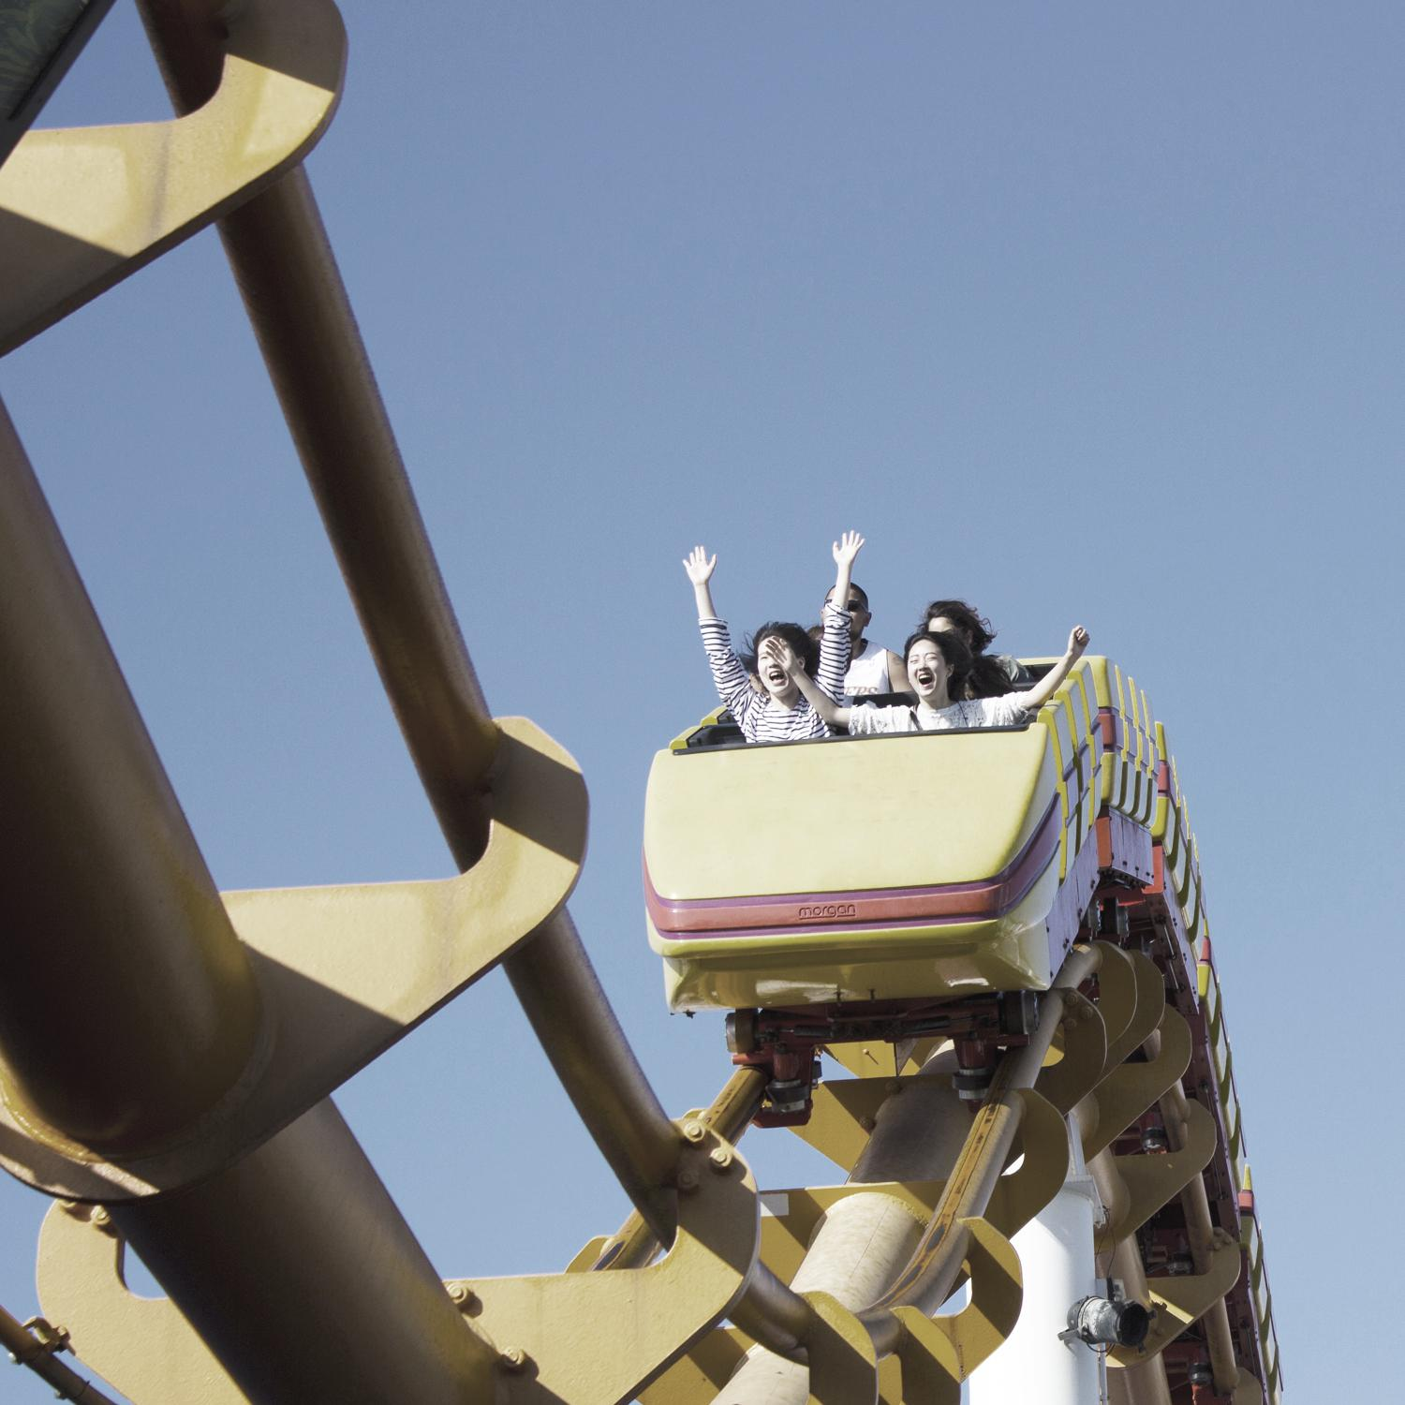  35
Reading a book at night with a torch | Riding on a roller coaster
  36 | 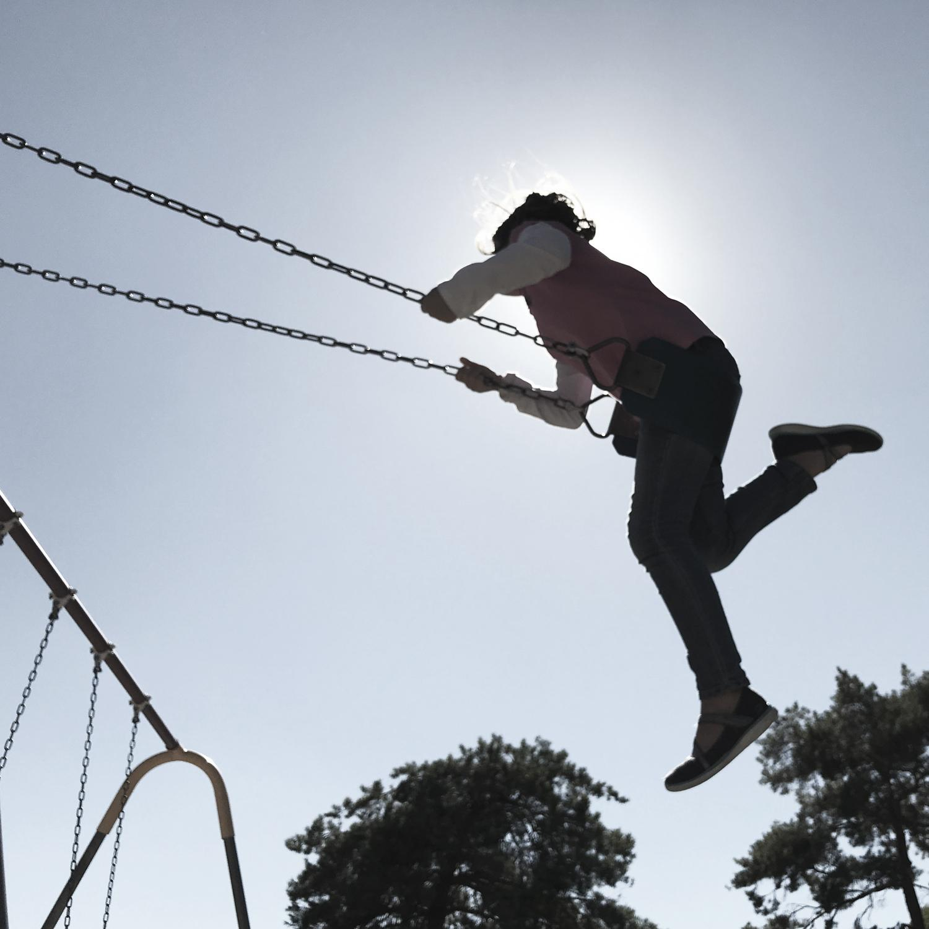  37
Seeing a snake | Swinging on the swings at the park
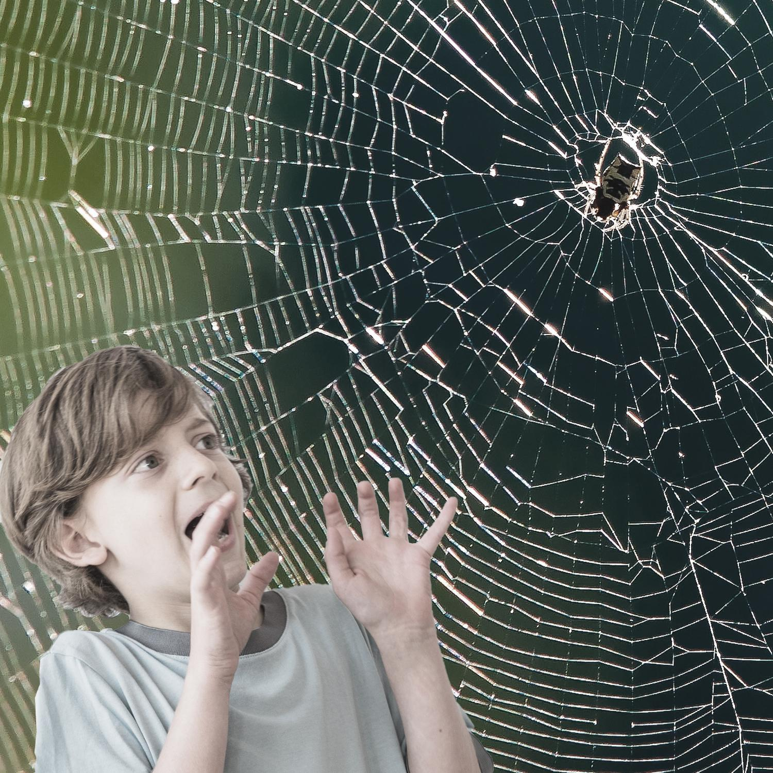  38 | 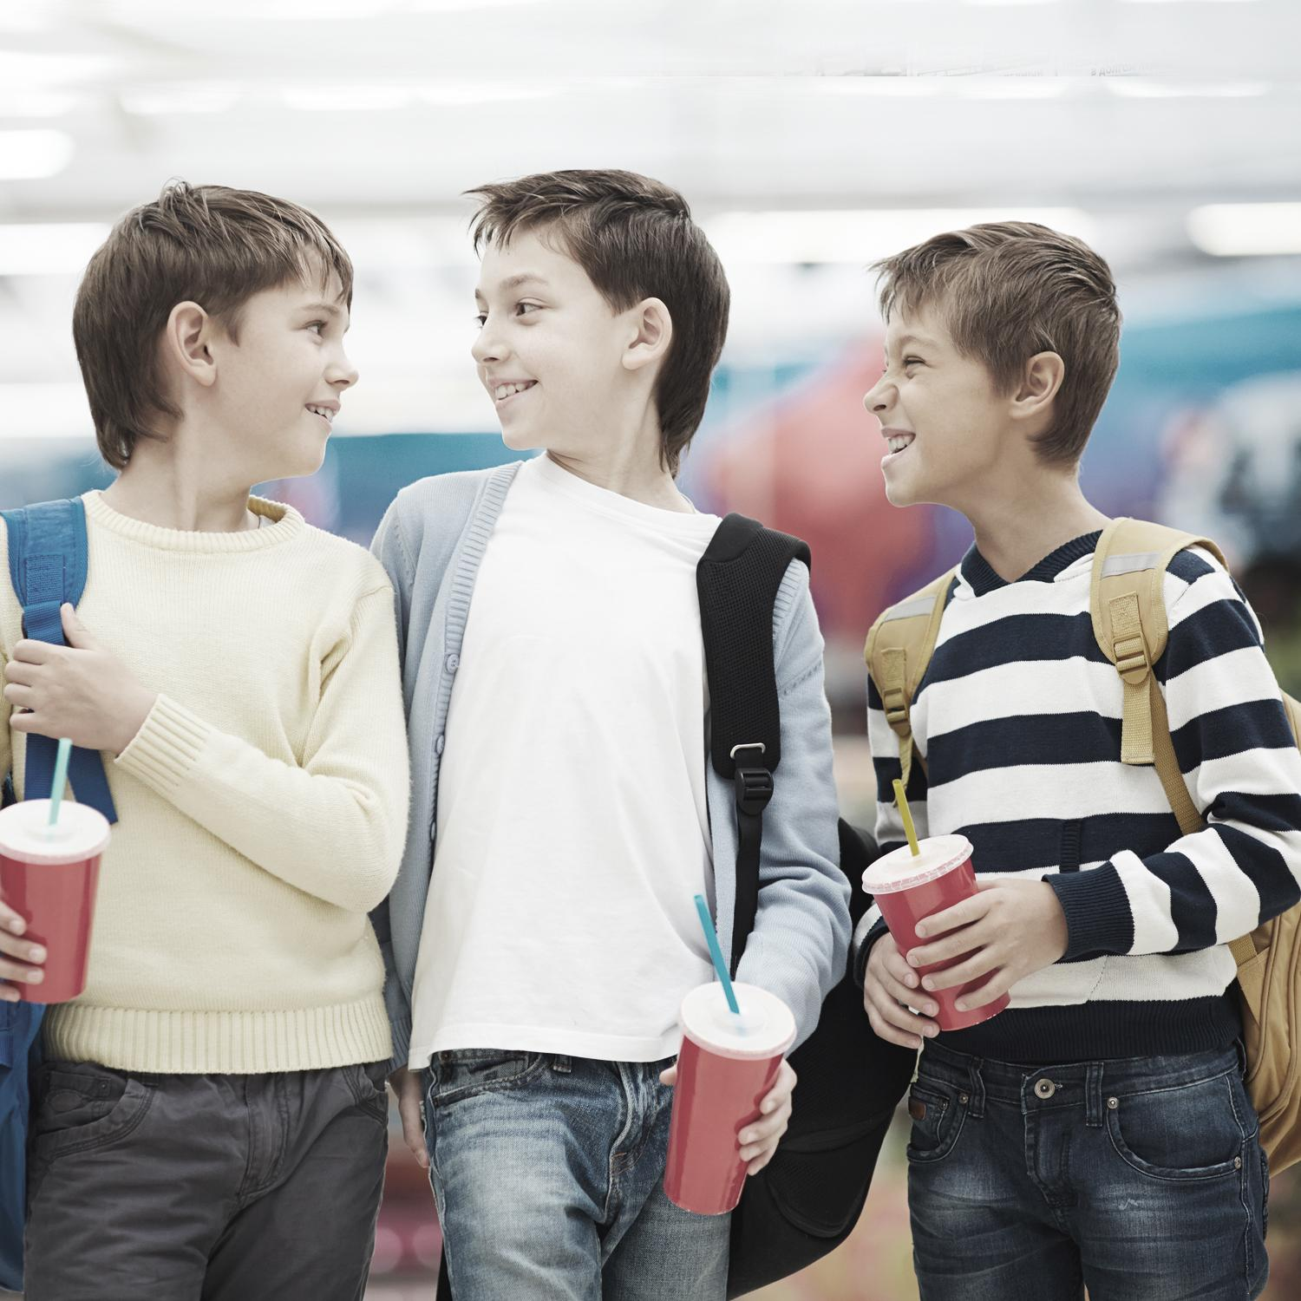  39
Walking into a spider web | Walking to school with friends
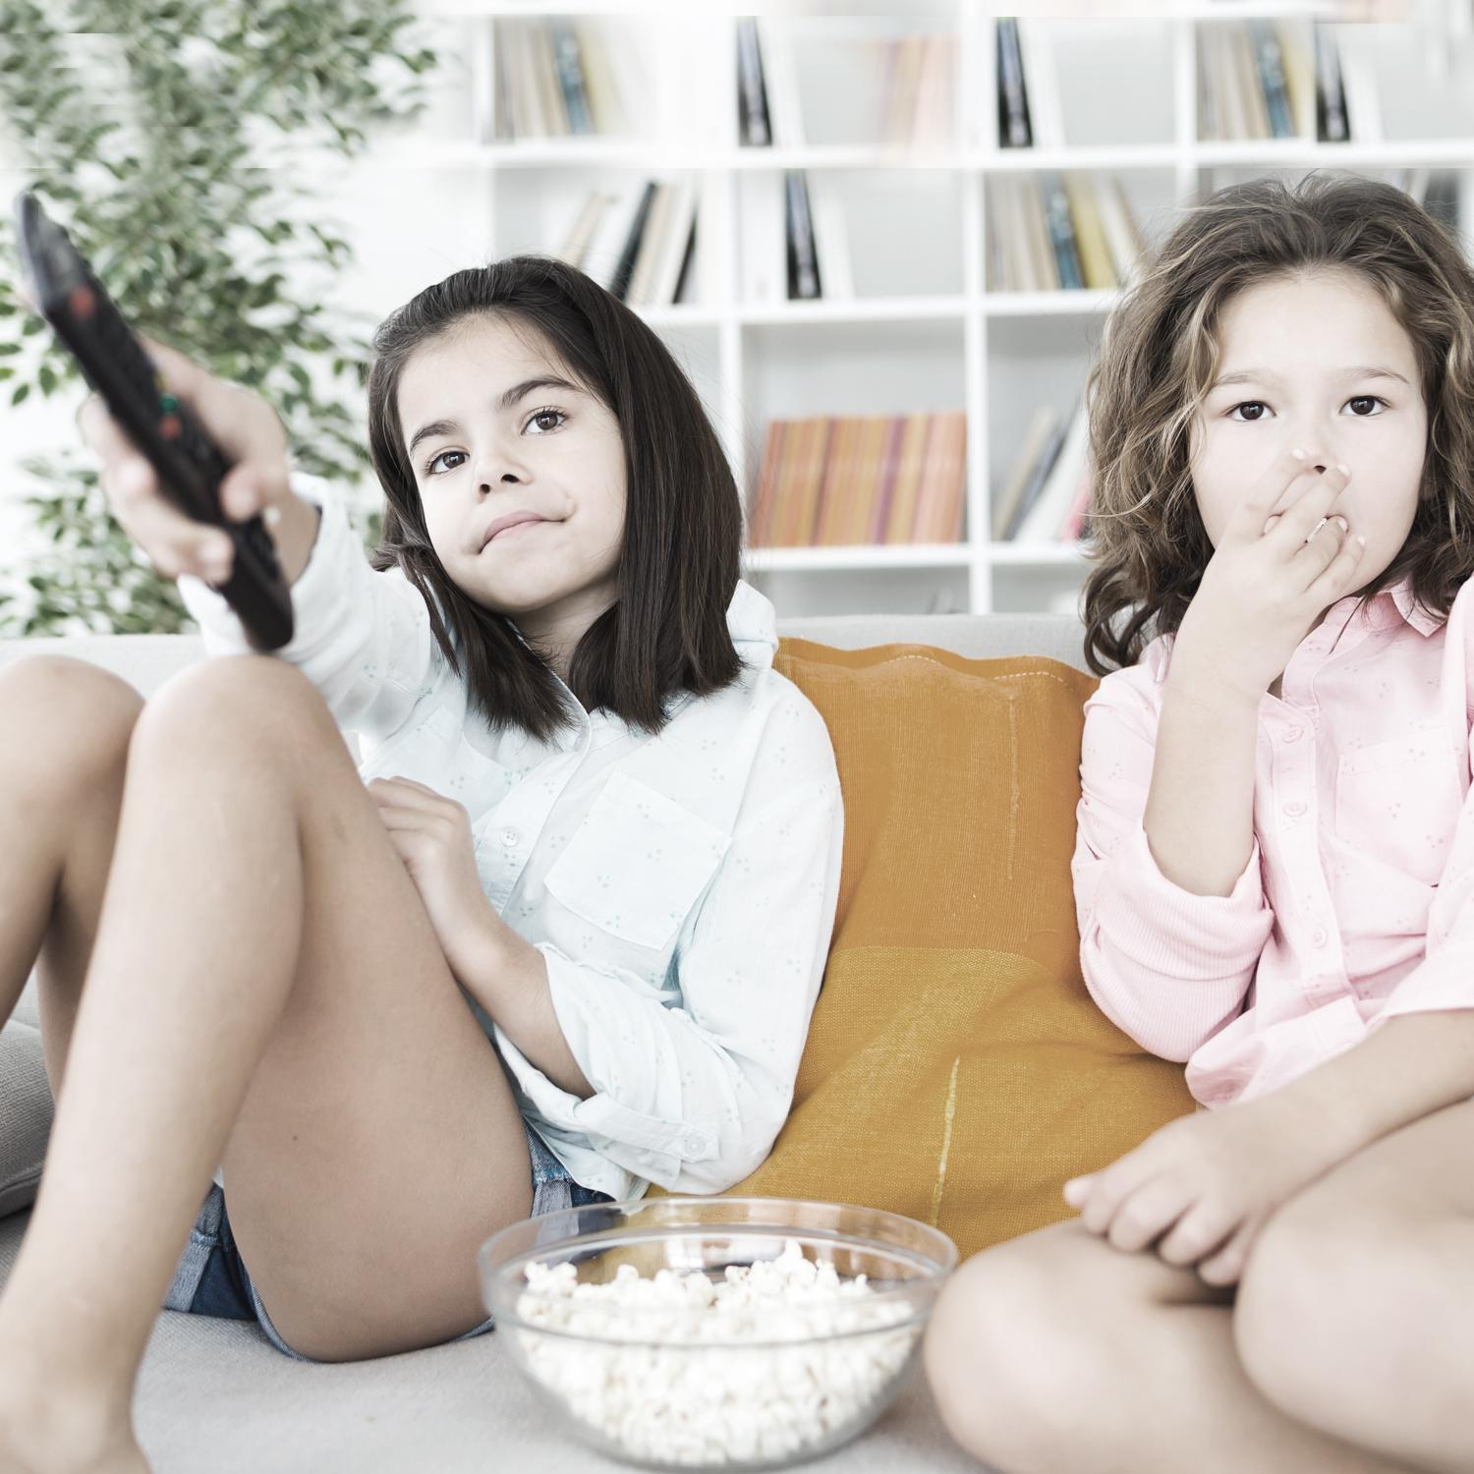
40
Watching television at home

No-go-tell images
42
4344

Copyright register
- Yes boy and girl: Children photo created by freepik – www.freepik.com
- Sometimes girl: Camera photo created by drobotdean – www.freepik.com
- Don’t like it girl: Background photo created by freepik – www.freepik.com
- Uncertain boy: Children photo created by freepik – www.freepik.com
- Angry: Education photo created by freepik – www.freepik.com
- Confused: People photo created by cookie_studio – www.freepik.com
- Disgusted: Woman photo created by cookie_studio – www.freepik.com
- Frightened: Kids photo created by freepik – www.freepik.com
- Frustrated: Girl photo created by freepik – www.freepik.com
- Grumpy: Designed by Freepik – www.freepik.com
- Sad/hurt: Girl photo created by freepik – www.freepik.com
- Lonely: People photo created by jcomp – www.freepik.com
- Nervous: Designed by pressfoto – www.freepik.com
- Shocked Designed by Freepik – www.freepik.com
- Unhappy: Designed by jcomp – www.freepik.com
- Worried: Designed by jcomp – www.freepik.com
- Peaceful/calm: Woman photo created by cookie_studio – www.freepik.com
- Excited: People photo created by jcomp – www.freepik.com
- Happy: For websites: Designed by Asier_Relampagoestudio – www.freepik.com
- Loved/safe: Family photo created by master1305 – www.freepik.com
- Proud: Designed by jcomp – www.freepik.com
- Shy: For websites: Designed by cookie_studio – www.freepik.com
- Surprised: People photo created by drobotdean – www.freepik.com
- Kids at movies: Designed by serhii – www.freepik.com
- Being in dark: Image by FotoRieth from Pixabay
- Family picnic: People photo created by freepik – www.freepik.com
- Playing online with strangers: Profile of boy with monitors: Image by ExplorerBob from Pixabay
Back view of guy: Image by 11333328 from Pixabay
Shadowed guy: Image by Tomasz Mikołajczyk from Pixabay
- Bull in paddock: Tree photo created by freepik – www.freepik.com
Guy scared: Business photo created by drobotdean – www.freepik.com
- Lost in shopping centre: Boy: Background photo created by freepik – www.freepik.com
Shopping centre background: Background photo created by mrsiraphol – www.freepik.com
- Lost in bush: Green photo created by rawpixel.com – www.freepik.com
- Missing the bus: Image by Виктория Бородинова (Victoria_Borodinova) from Pixabay
- Bushwalking: People photo created by freepik – www.freepik.com
- Playing with a pet: People photo created by freepik – www.freepik.com
- Reading a book with torch: People photo created by photoroyalty – www.freepik.com
- Roller coaster: Image by Jose Aitor Pons Buigues from Pixabay
- Seeing a snake: Snake: Nature photo created by brgfx – www.freepik.com
Shocked man: Background photo created by freepik – www.freepik.com
- Park swings: Image by jrwhip from Pixabay
- Spiders web: boy: Kids photo created by freepik – www.freepik.com
Spider’s web: Image by Stockvault Non-Commercial License: https://www.stockvault.net/terms-of-use
- Walking with friends: School photo created by pressfoto – www.freepik.com
- Watching TV: Food photo created by nensuria – www.freepik.com
- Body parts: Kids photo created by freepik – www.freepik.com
- No girl: People photo created by master1305 – www.freepik.com
- Go footprints: Background vector created by macrovector_official – www.freepik.com
- Tell girl: People photo created by master1305 – www.freepik.com
Trusted people headshots: People vector created by freepik – www.freepik.com
- Kiss: Family photo created by freepik – www.freepik.com
- Holding hands: People photo created by freepik – www.freepik.com
- Hug: Designed by Freepik – www.freepik.com
- Tickle: Love photo created by freepik – www.freepik.com
- Butterflies in your tummy butterflies: Background photo created by freepik – www.freepik.com
Butterflies in your tummy girl: Woman vector created by freepik – www.freepik.com
- Quick breathing boy: Food photo created by diana.grytsku – www.freepik.com
- Racing heart girl: People photo created by wayhomestudio – www.freepik.com
- Shaky knees: Shaky knees boy: Cute photo created by drobotdean – www.freepik.com
- Cold shivery body girl: Winter photo created by freepik – www.freepik.com
- Squirmy tummy boy: Background photo created by freepik – www.freepik.com
Worms: Food photo created by freepik – www.freepik.com
- Sweaty hands boy: School photo created by jcomp – www.freepik.com
Droplets: Water vector created by pch.vector – www.freepik.com
- Warm body girl: Designed by jcomp – www.freepik.com
- Girl hugging bear: Love photo created by drobotdean – www.freepik.com
- Teddy bear in box: Christmas photo created by Racool_studio – www.freepik.com

