Using digital tools to enhance language learning
Table 1 – To develop speaking and listening skills
Name | URL | Purpose
EDpuzzle | www.edpuzzle.com | Make any video your lesson  Choose a video, give it your magic touch and track your students' comprehension  Requires parental consent for children under 13 years old
Voki | www.voki.com | Voki is a fun tool that students can use for homework, classwork or projects
Audible | https://stories.audible.com/start-listen | Free for 2020  Stories to use as listening texts
Flip | https://info.flip.com/ | Present and collaborate through speaking about topics
Blabberize | https://blabberize.com | Create animations with own voice
Table 2 – To build vocabulary and script
Name | URL | Purpose
Quizlet | https://quizlet.com/en-gb | Quizlet makes simple learning tools that let you study anything. Start learning today with flashcards, games and learning tools
Kahoot! | https://kahoot.com/ | Kahoot! is a free game-based learning platform that makes it fun to learn – any subject, in any language, on any device, for all ages!
Quizzizz | www.quizzizz.com | Gamified quizzes to play in class and at home  Can be used for practice or formative assessment
Gimkit | https://www.gimkit.com/ | Gimkit is a game show for the classroom that requires knowledge, collaboration, and strategy to win  Similar to Quizlet live
Lino | http://en.linoit.com/ | Lino is a free sticky and canvas service for sharing ideas and collaboration
Formative | https://goformative.com/ | Create engaging work for students
Quia | www.quia.com | Templates for creating online activities  Automatic grading and immediate feedback
Socrative | https://socrative.com/ | Teachers create a ‘room’ and students can login to that room to complete quizzes
Learn a language | https://www.learnalanguage.com/ | Vocabulary lists in a number of languages and topics
Wordwall | https://wordwall.net/ | Create interactive and printable activities
Flippity | https://flippity.net/ | Create activities from templates for students which can include audio
Blooket | https://www.blooket.com/ | Blooket allows students to play a variety of games one on one or in teams. Like Gimkit, it requires knowledge and strategy to win
Table 3 – To develop writing skills
Name | URL | Purpose
Animoto | www.animoto.com | Create and share videos for free with Animoto's video maker  Combine your photos and video clips with music to make professional videos
Powtoon | https://www.powtoon.com/ | Create animations
Table 4 – To develop reading skills
Name | URL | Purpose
Chalk academy | https://chalkacademy.com/ | Multilingual books for children
Table 5 – Interactive worksheets
Name | URL | Purpose
Wizer me | https://wizer.me/ | Build interactive, engaging worksheets
Live worksheets | https://www.liveworksheets.com/ | Transform your traditional worksheets into live, interacting exercises with self-correction
Table 6 – Other
Name | URL | Purpose
Wakelet | https://wakelet.com/ | Capture, organise and share multi-media resources from across the web with students, teachers, and learning communities
ImmerseME | https://immerseme.co/ | Interactive website
Table 7 – Collaborative tools
Name | URL | Purpose
Google Apps for Education | Access through the Portal | Collaborative educational resources
Microsoft 365 | Access through the Portal | Work collaboratively across the Microsoft Office suite
Slidesmania | https://slidesmania.com/ | Free themes, templates, resources for Google Slides
Miro | https://miro.com/ | Online collaborative whiteboard platform to bring teams together, anytime, anywhere
Mindmeister | https://www.mindmeister.com/ | Brainstorm collaboratively
Whiteboards | https://whiteboard.fi/ | Online whiteboards for collaboration or games like Pictionary
Kapwing | https://www.kapwing.com | Students can create and edit videos collaboratively from different locations
Bubbl.us | https://bubbl.us/ | Brainstorm and create mind maps
Conceptboard | https://conceptboard.com/ | A visual collaboration space
Padlet | https://padlet.com/ | A platform where you can create a single or multiple walls for sharing content. Students and teachers can post text, flies, images, audio and video. An excellent tool for sharing and collaboration

Table 8 – Apps for language teachers
App name | App description
Voice memos  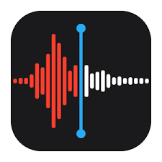 | Voice memos turns your iPhone, iPad, or Apple Watch into a portable audio recorder
Voice recorder Pro   | Best app for recording voice  Free for iPhone and iPad
Tellagami  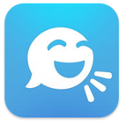 | Talking full body avatar, choices for hair, skin, library of backgrounds or use own background image  Free for iPhone and iPad
Spelling Free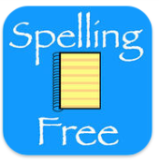 | Create word lists, record the clue (in language) and test themselves on vocab meanings  Free for iPhone and iPad
Quizlet   | Create or access study lists  Free for iPhone and iPad
Puppet Pals HD   | Create movies with animation and sound  Free for iPad
Duolingo  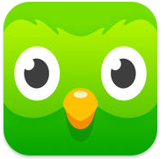 | Learn languages for free  Free for iPhone and iPad
Photocard by Bill Atkinson  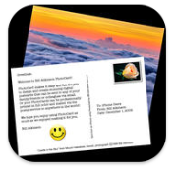 | Personalised postcards  Free for iPhone and iPad
LineLearner lite  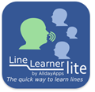 | Learn lines of a dialogue (5 lines each), good for independent practice of dialogue  Free for iPhone and iPad
Book creator for iPad  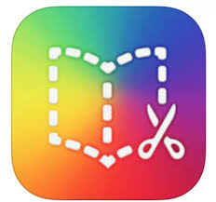 | Make books with photos, video and sound  $7.99 for iPad
word clouds by ABCYa.com   | Allows you to create word clouds
Greenscreen by Do Ink  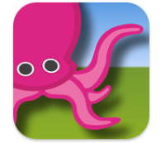 | Green screen, can put video in background  $7.99 for iPhone and iPad
Edmodo   | Collaborating tool for teachers and students  Free for iPhone and iPad
Pages  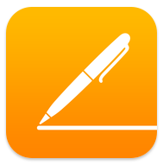 | Word processor  Free for iPhone and iPad
Bingo Number Generator   | A portable bingo cage  Free for iPhone and iPad
ClassDojo  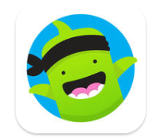 | Classroom management  Free for iPhone and iPad
Google Translate   | Translates blocks of text and text in images  Free for iPhone and iPad
Plickers   | Poll your class for free
MemRise   | Language learning app  Free for iPhone and iPad
Busuu   | Language learning app  Free for iPhone and iPad
Babbel  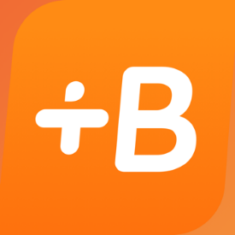 | Language learning app  Free for iPhone and iPad
Microsoft Office Lens  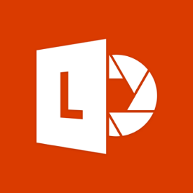 | Trims, enhances and makes pictures of whiteboards and documents readable
SoundCloud  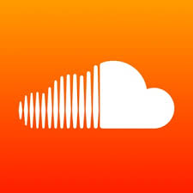 | Music and audio streaming platform

