Embedding Aboriginal pedagogies in language teaching

Rationale
This document supports language teachers to make connections between the Aboriginal processes described in the 8 Ways pedagogical framework and language teaching pedagogy. It includes suggestions for how to communicate the use of Aboriginal pedagogies to your students.
Embedding Aboriginal pedagogies enables teachers to include Aboriginal perspectives, while maintaining the focus on core curriculum content. Aboriginal perspectives are not found in Aboriginal content, but in Aboriginal processes.
By embedding Aboriginal processes, language teachers can contribute to ensuring every Aboriginal child and young person achieves their potential through education as agreed in the Partnership Agreement with the NSW AECG 2020-2030, Walking Together, Working Together. It also supports the 10 Year Plan – Footprints to the Future where all learners and teachers develop an understanding of Aboriginal heritage and culture.
The Stage 3 ‘Eating at a restaurant’ unit [DOCX 456KB] and Stage 5 ‘Food trucks’ unit [DOCX 562KB] illustrate how language teachers can easily and meaningfully embed Aboriginal pedagogy in their lessons.
Register your interest in the 8 Ways training program.

Aboriginal processes
Aboriginal process | About this Aboriginal process | How you can align Aboriginal pedagogy with language teaching | How to communicate this to your students
Story sharing    TELL A STORY | The Aboriginal process of story sharing aligns with the quality teaching element ‘Narrative’.  Note that ‘narrative’ in a quality teaching context differs from ‘narrative’ as a text type.  In a quality teaching context, narrative refers to the use of stories to help bring to life and contextualise lesson content. | Share your language learning journey with students – the challenges and successes of learning how to communicate.  Share experiences of language and/or cultural observations and stories from your time in [Country].  For example, you may want to share a story about your reaction to new food, a miscommunication you had, or something you found different or surprising.  Some students may also wish to share relevant stories. | An Aboriginal way of learning is to use stories. Stories help bring learning to life, and can contextualise why that learning is important.
Community links    SHARE IT WITH OTHERS | In traditional Aboriginal pedagogy, the motivation for learning is inclusion in the community, and good teaching methods always draw upon community life and values (Stairs, 1994).  Research describes Aboriginal pedagogy as group-oriented, localised and connected to real-life purposes and contexts.  It is best to celebrate individual success within a framework of community achievement. Aboriginal students can feel uncomfortable when promoted as a ‘role model’ or ‘success story’. | Aboriginal pedagogy is often localised and connected to real-life purposes and contexts. There can be a similar motivation of inclusion in the community in community languages education.  Language learners, especially in the community languages setting, can bring the knowledge gained back to their own community.  Where relevant, explore the concept of individual success in other cultures, for example in Japanese culture.  Set students tasks which have a real-life purpose, context and audience, even if simulated. Provide opportunities for students to make connections and share their learning beyond the classroom. This could be with a younger year group, or through an online connection with another class learning the language. | An Aboriginal way of learning is to travel out for knowledge and then bring that knowledge home. When learning a language, you will also learn about the culture of the country. Think about how you share that knowledge, and how it may help others.
Deconstruct/  reconstruct    WATCH FIRST, THEN DO | Aboriginal learners may ‘concentrate(s) on understanding the overall concept or task before getting down to the details’ (Hughes and More, 1997).  It can be helpful to start by seeing the whole thing, before looking at the smaller parts or stages. For some learners, exploring the smaller parts with a teacher equips them to put it all together for themselves.  Expressed in its most basic form, this way of learning is ‘watch first, then do’. | Deconstruct/reconstruct involves seeing the big picture before concentrating on details. By explaining in detail exactly what students need to do and, ideally, also showing completed work samples, students will have a clear picture of what the end product looks like.  Seeing the whole thing at the start complements learning maps, while ‘Watch first, then do’ reinforces the importance of work samples.  Providing students with a scope and sequence at the start of each year supports them to see the ‘big picture’ of their learning, broken down into smaller parts, through terms.  In task-based language learning, we identify the learning goal/task, then backward map the students’ journey to achieve that goal, teaching step by step the vocabulary and grammatical structures required to communicate effectively and complete the task. Students then practise putting all the language together before independently completing the task. Providing the assessment task and marking guidelines at the start of each unit supports students to see how it will all fit together.  Ensuring work samples and learning maps are included in task-based learning units not only embeds Aboriginal perspectives, it also improves language teaching pedagogy. | An Aboriginal way of learning is to look at what the whole thing or end result looks like, then work on each step needed to get to the end result. After exploring each step in detail, you then put it all together by yourself to complete the task and communicate in [language].
Non-linear    TRY A NEW WAY | Aboriginal students may have an indirect rather than direct orientation to learning, as can be seen in the avoidance of direct questioning (Hughes 1987) and in the avoidance of direct instruction and behaviour management (West in Harris and Malin, 1994).  Traditionally, there are non-sequential, complex cycles of Aboriginal learning composed of multiple processes that occur continuously (Wheaton, 2000). Aboriginal people may think and perceive in a way that is not constrained by the serial and sequential nature of verbal thinking (Gibson, 1993). That linear perspective in Western pedagogy has been identified as a key factor in marginalising Aboriginal people and preventing the construction of identity.  It is helpful to look at things from multiple perspectives, and then find new ideas and inventions by putting the perspectives together. | An indirect orientation to learning is promoted by the student-centred approach of task-based language learning. Choice boards/task boards for languages allow students to choose the pathway of language learning activities in any order they wish, in a non-linear way.  Explore words and concepts in [language] that have no English translation and English words that have no translation in [language]. Idioms also provide a unique view into different ways of viewing. When students come across these types of language quirks, their linear thinking is broken and they have to adopt a non-linear way of thinking.  Ask students to consider English words which are used in the target language and explore why English may have been adopted, and if there is any difference in meaning  Students could also brainstorm cultural considerations from their own and other cultures, and how these may impact communication. For example when meeting someone for the first time, or entering a home or making plans. What impacts can hidden cultural norms have on communication? | When we learn in a non-linear way, learning focuses as much on the journey as on the destination.  An Aboriginal way of learning is to look at things from 2 sides. Put yourself in the shoes of a person from another culture and find things that are in common from both cultures.
Land links    TAKE IT OUTSIDE | Aboriginal pedagogies are intensely ecological and place-based, being drawn from the living landscape within a framework of profound ancestral and personal relationships with place (Marker, 2006).  No knowledge exists without land and place.  All of the animals, plants and places in land and water carry knowledge and can help us learn. Also, the things we are learning can affect them. Everything we learn and do is linked to the land.  Situate learning for students, at least by acknowledging the place where the information came from and the impacts and potential impacts this information has on the environment.  Acknowledge that this is an Aboriginal protocol for knowledge, and you will be bringing an Aboriginal perspective to anything you might teach. | Include relevant cultural connections in your lessons, where appropriate. For example, Japanese people believe that spirits are in everything including mountains, rocks and water. These natural features are sacred, have stories behind these and the places need to be protected.  Include content on sustainability, such as the Stage 5 generic unit, A sustainable future, making changes together, available on the language-specific pages of the department’s website or the Stage 3 learning sequence Caring for the environment. | An Aboriginal way of learning is that everything we learn and do is linked to land.  It is important we acknowledge the Aboriginal land where the learning is taking place. Also, we should acknowledge the place or places in [Country] where knowledge comes from and the relationship to land people from the [Country] have.
Symbols and images    DRAW IT | All cultures have symbols to support learning and understanding.  In traditional Aboriginal ways of learning, a teacher engages all the senses to build symbolic meaning in learning new concepts, as a specifically Indigenous pedagogy involving the use of both concrete and abstract imagery.  This way of learning enfolds the recurring concept in Aboriginal pedagogy research of our students being primarily visual-spatial learners (Hughes, 1992). However, it goes beyond the problematic notion of ‘learning styles’, reframing visual learning as symbolic learning – a strategy rather than an orientation. | Use shapes and images, symbols and diagrams to help students see, remember and learn.  Use graphic organisers and images to help learn vocabulary and word webs to explore topics.  The use of images in chatterboxes and infographics can support learning and practising new structures.  Explore images which are synonymous with the culture(s) of the target language.  Connect Aboriginal pedagogy to the images and pictographs behind the characters of some scripted languages and how they developed into script. | An Aboriginal way of learning is for knowledge to be carried in symbols and diagrams, to help us see and remember.
Non-verbal    THINK AND DO | Aboriginal learners may test knowledge non-verbally through experience, introspection and practice, thereby becoming critical thinkers who can judge the validity of new knowledge independently.  They may look for the things people say without words, when watching people.  The role of body language in Indigenous pedagogy (Craven, 1999) is a feature of Aboriginal learning and language use. | Explain to students that when learning a new language, we can achieve a communicative goal by using non-linguistic resources. For example, we may point to an object to purchase or use fingers to show number.  When students complete a communicative language learning task, they use a combination of language and non-linguistic resources, such as gestures and facial expressions, to successfully communicate.  Many cultures have unique gestures. Explore the gestures in the language you teach, and their meanings.  Non-verbal learning also involves student self-reflection on learning and subsequent goal setting. They evaluate the learning how they can apply it, make connections between learning journey pathway points in a unit of work. | Using body language and hands-on learning are Aboriginal ways of learning.  In any language, we can use gesture and facial expression to support communication.
Learning maps    MAKE A PLAN | In traditional Aboriginal pedagogy, the teacher and learner create ‘a concrete, holistic image of the tasks to be performed. That image serves as an anchor or reference point for the learner’ (Hughes and More, 1997).  This relates to visualising processes before doing them. Planning ahead is an important part of Aboriginal culture, but these plans are not only verbalised – they are visualised as well. | Share a visual learning map when you introduce a new unit or task to show students how they will get there. Learning maps are a visual representation of the backward mapping process language teachers use to develop units based on communicative language tasks. | Learning maps are a visual pathway of what you will learn. They show what will happen, broken down into steps along the way.  You can also design learning maps to plan your own work.

Sample learning maps
Image 1 – eating at a restaurant (Stage 3)
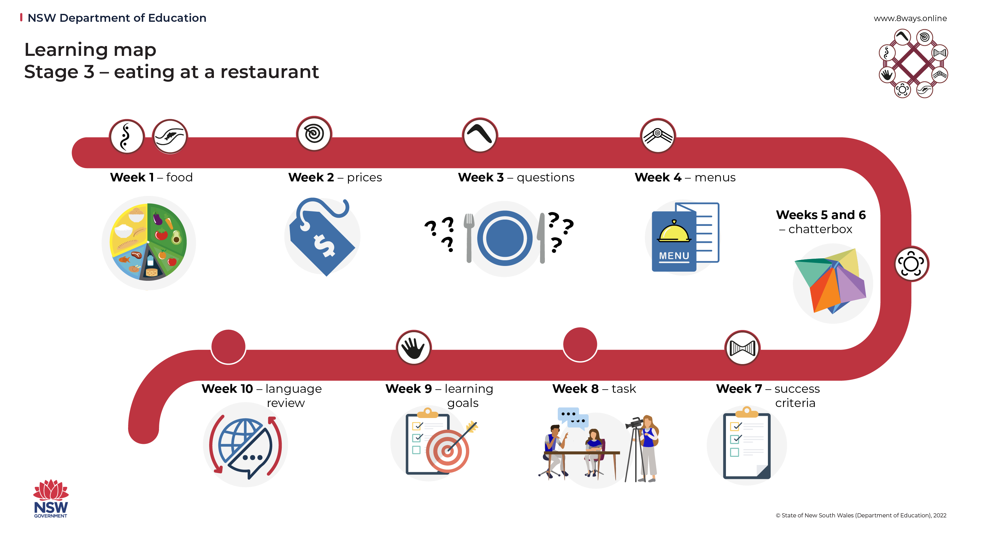
Image 2 – food trucks (Stage 5)
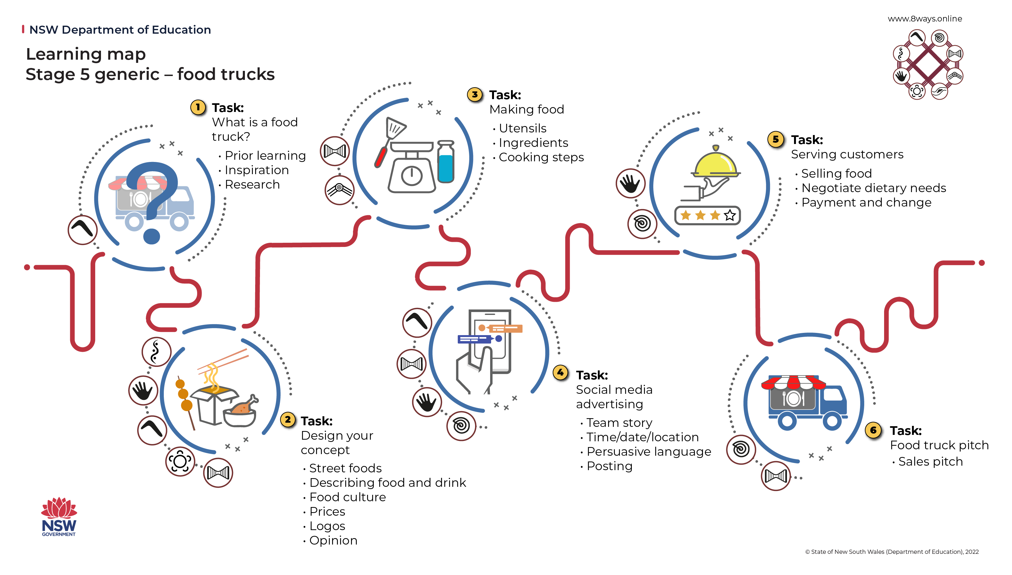
Image 3 – visual scope and sequence
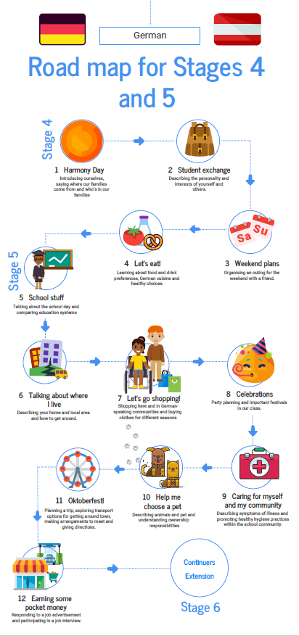

About this resource
- The target audience for this resource is language teachers K-12.
- Email questions and feedback about this resource to languagesnsw@det.nsw.edu.au using the subject line ‘Aboriginal pedagogies’.
- This resource will be reviewed in 12 months’ time as part of ongoing internal evaluation.
- Created/last updated: 10 August 2022

How to use this resource
This resource supports language teachers to embed Aboriginal pedagogies into language learning pedagogies. The content of this document is not mandated – it is suggested only, to better support the needs of all students, including Aboriginal and Torres Strait Islander students. Teachers consider the suggestions in the document, amending their planned teaching and learning activities and assessment opportunities accordingly.

Evidence base
This unit of work supports the following themes from ‘What works best’ 2020 update:
- explicit teaching
- wellbeing.

Further information
- Aligned to system priorities and/or needs: NSW Department of Education 2018-2022 Strategic Plan – academic achievement
- Aligned to School Excellence Framework: Learning domain – curriculum; Teaching domain – effective classroom practice
- Consultation: Aboriginal Education and Wellbeing Officers (Glenfield and Wagga)

