Supporting students with disability in the languages classroom
A practical guide for language teachers

Contents
Contents 1
Introduction 2
Why is the study of a language important? 2
Inclusive education 2
Personalised learning and support planning 3
Functional impact 3
Curriculum planning using a multi-tiered approach 4
Evidence-based practices and examples for the languages classroom 7
Prompting and visual supports 8
Graphic organisers 10
Response cards 10
Video supports 11
Peer-mediated instruction and intervention 12
Task analytic instruction 12
Inclusive and assistive technologies 13
Immersive Reader 14
Microsoft Lens 14
Read&Write for Google Chrome 14
Diffit 15
Magic ToDo 15
Case studies 15
Mariam 15
Darius 16
Han 17
Sienna 18
Links to support and further resources 19
References 21

Introduction
This guide has been developed to support the teaching of languages to students with disability.
Within the context of languages, this guide aims to:
- outline the importance of an inclusive approach when planning for students with disability
- provide examples of evidence-based practices and adjustments to support students with disability
- provide an overview of inclusive and assistive technologies available to support language learning
- outline further support available to language teachers.

Why is the study of a language important?
Studying a language benefits all students, including students with disability. Through learning languages, students engage in purposeful communication and reflect on the heritage, culture and identity of themselves and others. Students may also benefit from learning additional languages by:
- being able to positively transfer literacy skills between languages, as they learn about grammatical structures and broaden their vocabulary
- improving their communication skills
- developing more open and curious attitudes to other cultures
- experiencing opportunities to socialise with others.

Inclusive education
Inclusive education means all students can access and fully participate in learning, through a multi-tiered approach to teaching and learning that may include reasonable adjustments and teaching strategies tailored to meet their individual needs.
The NSW Department of Education’s Inclusive education for students with disability policy and Personalised learning and support procedures guide inclusive practice.
Inclusive practice benefits all students. Curriculum inclusion is one of the 6 key principles of inclusive education outlined in the Department’s Inclusive Education Statement for students with disability. Teachers play an important role in supporting students with disability to access the curriculum on the same basis as their peers.
This guide aims to support language teachers to implement reasonable adjustments and differentiated teaching, learning and assessment activities, and to use evidence-based practices that address the diverse needs of students in their classes.

Personalised learning and support planning
Personalised learning and support planning helps address the diverse strengths, needs and interests of students with disability. Personalised learning and support planning is a collaborative process which includes the student, parents and carers, and the school.
Under the Disability Standards for Education 2005 all school staff have legal obligations to ensure that every student is able to participate in the curriculum on the same basis as their peers.
Adjustments are the ways that teachers and schools make changes to teaching and learning programs, lessons, assessments or the school environment for students with disability, so that they can participate in learning on the same basis. Teachers can make a range of reasonable adjustments in the classroom according to a student’s personalised learning and support needs.
Getting to know students and their unique goals, strengths, interests and abilities is at the forefront of curriculum inclusion. For example, in the languages classroom, a student may find writing by hand challenging but may be skilled at creating animations with captions on the computer to express ideas in the target language.

Functional impact
When planning support for students with disability, it is crucial to consider the functional impact of the disability. This means focusing on what a student can do and what support they need to participate, access and achieve in the classroom.
Functional impact – key questions
- What can the student do?
- What are their strengths and interests?
- What support do they need to participate, access and achieve in the classroom?
Aspects of learning a language can be challenging for all students. For some students with disability, there may be additional considerations during the planning phase to maximise learning and success. Careful planning and reasonable adjustments may be required for students with disability who, for example:
- use alternative communication
- have poor working memory and may require support to retain new vocabulary
- experience challenges interacting and socialising with others, including their peers
- have difficulty decoding words in their first language, making reading and writing in another language even more challenging (particularly in scripted languages)
- need additional processing time.
Understanding how disability may impact a student’s learning helps teachers when planning adjustments and the differentiation of teaching, learning and assessment. Using evidence-based practices and designing experiences to cater to students’ learning needs can help them to be engaged, motivated and successful in their learning.

Curriculum planning using a multi-tiered approach
A multi-tiered approach to curriculum planning enables teachers to provide optimal learning opportunities and support for all students to achieve their full potential. It involves 3 tiers or levels of support. Each of these 3 tiers involves increasingly intensified support for learners. It is important to remember that the tiers refer to the level of support provided rather than to the student. Students could be benefitting from support from each tier. The 3 tiers are Universal, Targeted differentiation and Personalised learning and support.
Figure 1 – multi-tiered curriculum planning
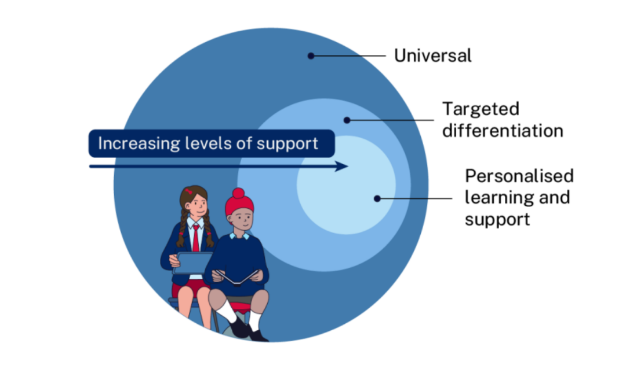

Tier 1 – Universal
Universal planning is a proactive and overarching approach which focuses on inclusive design of the whole learning environment from the outset. Options are provided to facilitate full participation of all students in all stages of learning. High expectations are set for all students, and students receive support to self-direct their learning and monitor progress in ways that work for them. The key message of universal planning is that there is no ‘one size fits all’ approach.
Universal planning will look different in every class. There are no ‘average’ students, and designing to the edges of learner variability will support all students to thrive. Universal planning aims to cater for the learning needs of as many students as possible from the beginning and minimises what is required at the Targeted differentiation and Personalised learning and support tiers.
Some examples of universal strategies that could be implemented in the languages classroom to benefit all students are:
- providing learning materials and instructions in multiple formats (for example, digital, print and verbal)
- using consistent language learning routines to reduce cognitive overload and allow students to demonstrate their learning confidently
- engaging students through multiple means, such as both audio and visual use of the target language
- offering a range of language-specific supports, such as mnemonics, visual vocabulary lists or flashcards
- explicitly teaching language-based skills when they are new (for example, listening for key words and details)
- giving positive reinforcement or reminders to stay on task in the target language
- personalising learning, such as using individual anchor charts with personalised vocabulary
- adding student interests into the learning process, such as interests in cultural aspects (for example, anime or manga in Japanese).

Tier 2 – Targeted differentiation
Targeted differentiation refers to the direct and intentional response of teachers to meet identified needs of individual students or groups of students. Teachers can plan to differentiate by using flexible teaching, learning and assessment strategies that provide sufficient challenge and engage students in their learning. Effective universal planning followed by effective targeted differentiation minimises what is required for personalised learning and support.
Some examples of differentiation that could be implemented in the languages classroom to meet the identified needs of some students are:
- providing concrete examples, simplified vocabulary or text, and short and clear instructions
- adjusting time limits or expectations when completing tasks
- providing sentence starters or scaffolds to assist students when creating texts in the target language
- using accessibility features within resources, such as providing translated subtitles with a video or adjusting the speed of an audio file.

Tier 3 – Personalised learning and support
Some students with disability may require personalised adjustments to access curriculum content and participate in learning on the same basis as their peers. This tier of support is a process that responds to the individual needs of students with disability and occurs in addition to universal planning and differentiation. It provides an opportunity to further personalise these options and strategies to specifically meet the needs of individual students. Personalised adjustments enable students with disability to access syllabus outcomes and content on the same basis as their peers. They are based on assessment of individual student needs and are planned in collaboration between teachers, parents and carers, support staff, and students.
Depending on student and class contexts, some examples of personalised adjustments to meet the needs of individual students with disability in the languages classroom are:
- supporting a student’s communication strategies and systems so that they can initiate and respond in the target language (for example, using text-to-speech software which is compatible with the target language)
- explicitly teaching interaction skills to students to include a peer who has a different communication or social interaction style
- developing a procedure for students to ask for help which suits their learning needs (for example, a cue card or phrase in the target language)
- adapting resources for accessibility reasons (for example, adapting a worksheet to Braille).

Evidence-based practices and examples for the languages classroom
An evidence-based practice is an educational intervention that has been evaluated in research and found to be effective for supporting students to learn and succeed at school. An intervention may refer to an instructional practice, program or curriculum that addresses any academic or behavioural outcome.
The NSW Department of Education’s Evidence-based practices for students with disability resource assists teachers in selecting, using and evaluating evidence-based practices that develop targeted skills in students with disability.
Below are some examples of evidence-based practices and how they can be implemented in the languages classroom. The sample resources provided are available to use and adapt, via an editable version on Canva.

Prompting and visual supports
Prompting is the use of a cue to help a student learn a skill or engage in a target behaviour or response. Prompts are delivered by teachers and support staff with visuals, words, gestures or physical supports as a one-off event or as part of a planned approach.
Applying this practice in the languages classroom could include creating prompt cards in both the target language and/or English. An example of prompt cards in Indonesian is provided below.
Figure 2 – example of prompt cards in Indonesian and English
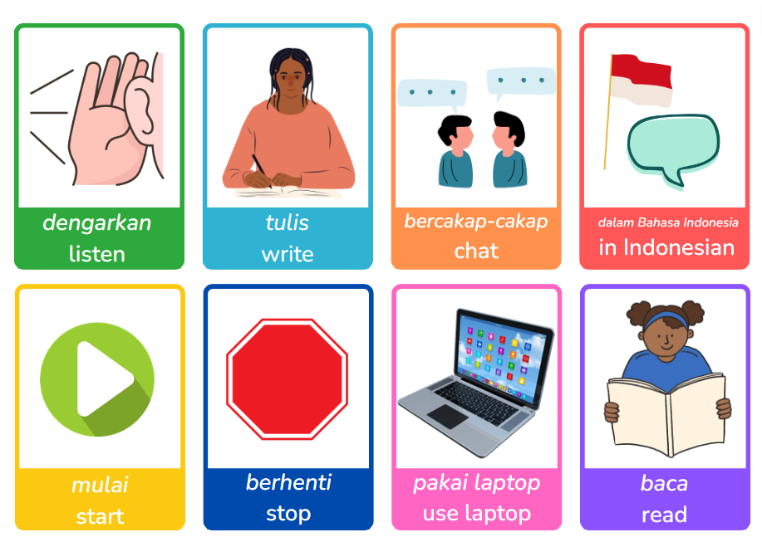
In this example, the prompt cards relate to common learning activities or routines that take place within the languages classroom. For example, prompting a student to understand that they are going to interact with other students in the next activity, by using the ‘bercakap-cakap – chat’ prompt card.
Prompt cards such as these are not only an effective practice for students with disability. All students can benefit from clear prompting in learning activities. Prompting helps to reduce cognitive load, by enabling students to categorise a learning activity immediately so that they know ‘what to do’ and understand the expectation of the activity. This way, students can focus more clearly on the specific instructions of the upcoming activity.
When designing prompts or prompt cards, it is important to ensure the resources are explicitly taught, personalised, age-appropriate and reflect inclusivity.
Visual supports are materials that provide students with visual information about activities, rules, routines and skills. Visual supports can reduce how much information students need to hold in their head within a specific moment (working memory). This gives them clear information about what is expected or what is coming up and may help them to feel less worried or frustrated.
In the languages classroom, a visual support could be used to provide students with an overview of what activities they will be doing in their languages lesson. An example for a Japanese lesson is provided below.
Figure 3 – example of visual support for a Japanese lesson
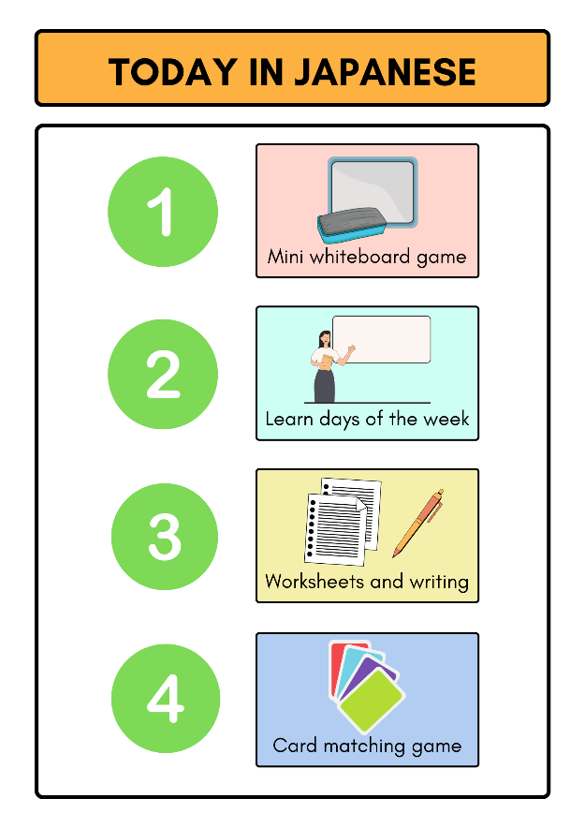
Depending on student context, this visual schedule could be created in English and/or the target language. For some students, as they become more familiar with the prompts and visual supports, consider removing the English translation from the cards to build confidence in the target language.

Graphic organisers
Graphic organisers are a type of visual support that shows relationships between ideas or concepts that can be used by students to solve problems or complete tasks. The Digital Learning Selector can be used to access templates.
The template below demonstrates the use of a Y chart graphic organiser to organise categories of French vocabulary into transport, places and activities for use in an activity. The graphic could be adjusted to cater for a range of needs, for example, by including the English translations as well as the target language vocabulary.
Graphic organisers such as this one can help to make vocabulary more accessible to students, by ‘chunking’ it into categories so that students can readily draw upon it.
Figure 4 – example of Y chart graphic organiser with categories of French vocabulary
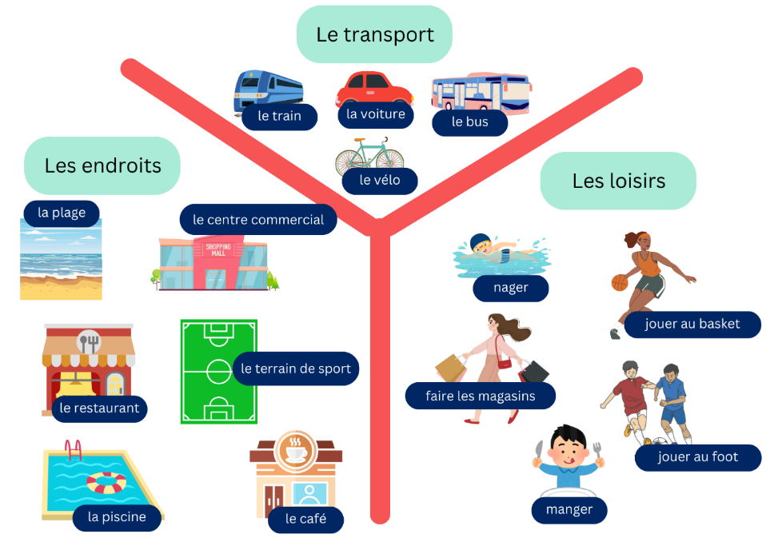

Response cards
Response cards are readily accessible materials such as signs, cards or items that are held up simultaneously by all students in the class to display their responses to questions or problems presented by the teacher. They can be pre-printed or written on (such as mini whiteboards). Response cards are a type of formative assessment. After students have provided their response, the teacher reviews each response and provides individual and group feedback.
In the languages classroom, response cards could be prepared in the target language. An example is provided below for Spanish. These cards use the target language to indicate ‘yes’, ‘no’, ‘I’m not sure’ and ‘I’m ready’.
Figure 5 – example of a set of response cards in Spanish
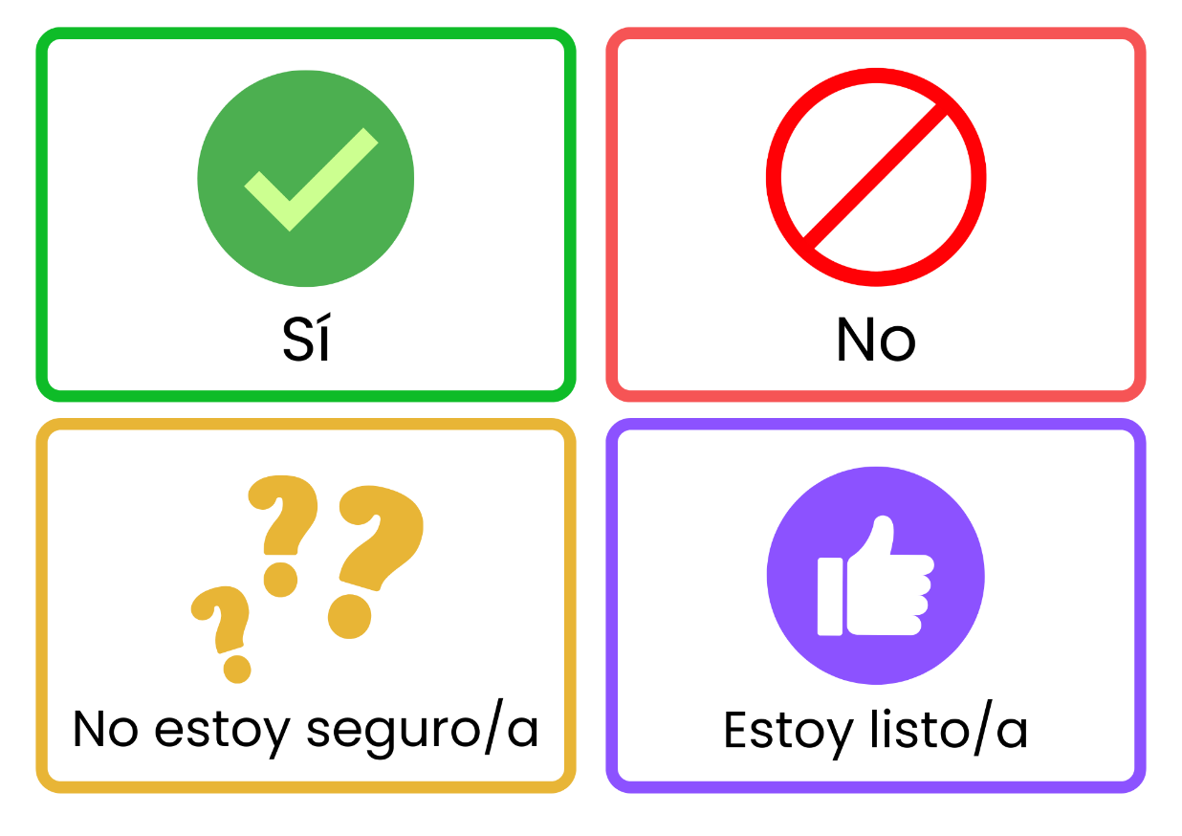
Once a student consistently uses the response cards without prompting, consider encouraging the student to respond verbally in the target language, to further promote authentic interaction in classroom activities. Response cards in the target language could also be developed using technology so that a student can respond in their preferred communication style, such as through digital devices.

Video supports
Video supports are a collection of strategies that use video as an instructional aide to build targeted skills through opportunities to imitate. A short video is created in which the skill is demonstrated successfully. The student watches the video and is asked to reproduce the skill. The use of the video is faded as the skill is developed.
Creating videos may initially be labour and time intensive, but their ability to be shared, reused, watched, paused and replayed as needed make them make them a time-effective way to provide the repetition of instruction that some students need.
Using a video creation platform that generates closed captioning can assist further in making videos accessible and support written language development. Adjusting the volume control of teacher videos can also meet student sensory needs.
In the languages classroom, an example of this in practice may look like the teacher demonstrating or modelling new vocabulary, phrases or a skill on video, then providing this video to the student directly so that they can access it whenever needed, for example, via a learning platform such as Google Classroom. Languages classrooms are busy places, where teachers are in demand from all students, often at the same time, because the teacher may be the only ‘language expert’ in the room. Providing a modelled video to a student who may need repeated reassurance or guidance means providing an on-demand version of the teacher that can be replicated across the classroom.

Peer-mediated instruction and intervention
Peer-mediated instruction and intervention (PMII) is a system of teaching selected peers how to engage students with disability in positive and meaningful ways. PMII can be used for any skill being taught to the student, such as initiating conversations, academic skills, accepting ‘no’ and engaging in positive classroom behaviour.
In the languages classroom, PMII such as peer modelling could be implemented to support a student’s participation in activities which rely heavily on social interactions and/or spontaneity in the target language. In this scenario, selected peers model how to use the target language in a social way, supporting the student with disability to observe in action and practise.

Task analytic instruction
Task analysis involves breaking complex tasks or skills down into smaller teachable components and understanding the underpinning skills for each component. These smaller components are then sequentially ordered.
To develop task analytic instruction, teachers should identify the skill they want to teach, identify and sequence all measurable steps, write the task analysis using the chaining method, customise the task analysis to meet the needs of the individual student and explicitly teach the student how to use the task analysis.
In the languages classroom, task analytic instruction could be used to break down tasks such as creating and performing a dialogue, or accessing and responding to a text in the target language. An example of a task analysis is provided below for a task in Indonesian.
Figure 6 – example of task analysis for a shopping list task in Indonesian
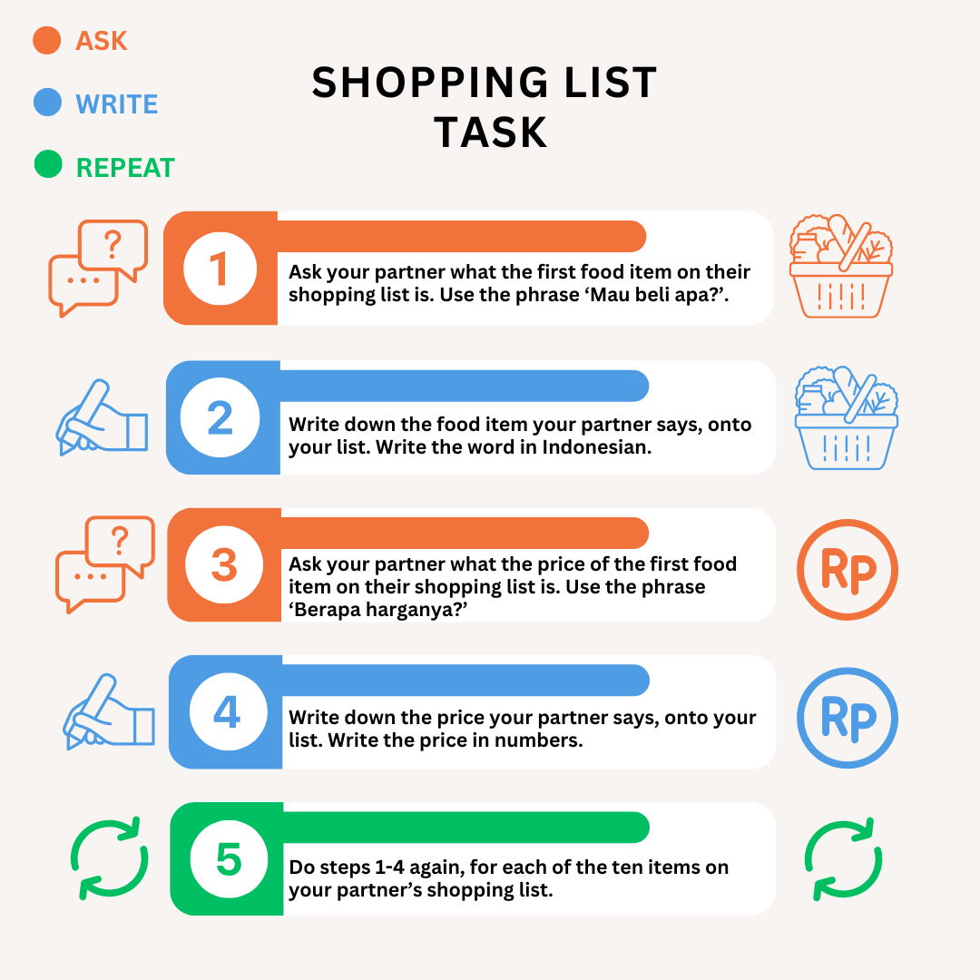

Inclusive and assistive technologies
Technology can support language learning for all students. There are various tools available for classroom use that:
- allow text to be presented in different ways, such as adjusting font size and spacing
- include speech-to-text functions, allowing students to dictate responses in English or the target language
- include text-to-speech functions, so that students can listen to activities and texts being read aloud in English and the target language
- support translation of texts or resources into different languages.
The information below explores some tools and their application in the languages classroom. You can read more about inclusive and assistive technology at the Technology 4 Learning webpage.

Immersive Reader
Immersive Reader works across Microsoft applications such as Word, PowerPoint, OneNote and the Microsoft Edge internet browser. It includes a range of functions to assist students to read and access text. For example, Immersive Reader can quickly and easily change the font size and style, line spacing and background colour of a text. It can read text aloud to students and includes a built-in dictionary. It also includes tools for identifying nouns, verbs and adjectives, which can assist with grammar skills. Immersive Reader supports texts in a wide range of languages, making it useful for language teachers when differentiating texts or activities in both the target language and in English.

Microsoft Lens
The Microsoft Lens application can be used to scan hard-copy texts, such as pages from a languages textbook or notes on a classroom whiteboard, turning them into digital form. This text can then be exported into Immersive Reader (see above) so that the text becomes more accessible.

Read&Write for Google Chrome
Read&Write is an extension for the Google Chrome web browser which helps to make documents, webpages and common file types such as Google Docs and PDFs more accessible. It includes a text-to-speech function to hear words and passages read aloud, as well as a speech-to-text function to enable dictation. It is compatible with various languages.

Diffit
Diffit is an online tool which enables teachers to generate resources in many formats, which can be customised to varying student levels. Depending on the prompt input by the teacher, Diffit can create printable or digital resources on a range of topics, or quickly adjust content for different levels in the classroom.

Magic ToDo
Magic ToDo is an online tool that helps to break down complex tasks into manageable steps. It can be used to break down a task into smaller, manageable steps for students. Magic ToDo will provide a step-by-step approach to reaching the final product, for example, writing a postcard in the target language or preparing for a vocabulary quiz.

Case studies
The following case studies provide examples of how a multi-tiered approach to curriculum planning can be applied in different classroom contexts. They are not intended to prescribe a single approach, but to illustrate how strategies can be adapted to meet the needs of individual students in specific contexts. Teachers are encouraged to consider these examples while remembering that the tiers of support are flexible. A single strategy might be applied at different tiers depending on the student, the class and the school context.

Mariam
Mariam is learning French in Year 7 at a comprehensive high school. Mariam requires additional support with thinking skills, such as memory, planning and problem solving. She requires additional processing time to learn new skills and additional support when following multi-step instructions. She receives one-on-one support from an SLSO, but not every lesson. Mariam loves socialising with others and enjoys dancing and singing.
Mariam’s French teacher uses the multi-tiered approach to curriculum planning and plans the following opportunities at each tier of support for Mariam.

Universal tier
- Use digital or paper graphic organisers to help students categorise vocabulary into key themes, such as greetings, family or hobbies.
- Strategically group students in group activities to allow opportunities for peer modelling, for example, placing Mariam with supportive peers.
- Incorporate student voice and interest when possible, such as connecting Mariam’s enjoyment of dance to ballet vocabulary and other aspects of French-speaking culture.

Targeted differentiation tier
- Provide instructions in a simplified, visual format and break down complex tasks, such as creating a short dialogue in French, into smaller components using task analytic instruction.
- Allow extra time for Mariam to complete activities and tasks.
- Explicitly teach and provide Mariam with visual prompt cards in French and English, where key instructions and activities are paired with images.

Personalised learning and support tier
- Provide simplified visual vocabulary lists along with modelled examples of the language in use, prioritising functional communication.
- Support Mariam to use assistive technology on her device, such as text-to-speech to assist her in accessing class online flashcards and PowerPoint presentations, or speech-to-text to help her create sentences in French.

Darius
Darius is in Year 8 and is learning Japanese. A learning difficulty affects his ability to read and decode words and texts, blend sounds together and connect speech sounds with written letters. As a result, Darius has low confidence in tasks that rely on reading text and/or creating written responses, and he has expressed that he finds it difficult to understand Japanese characters. Darius enjoys using his computer and is skilled at creating animations.
Darius’ Japanese teacher uses the multi-tiered approach to curriculum planning and plans the following opportunities at each tier of support for Darius.

Universal tier
- Give instructions in multiple formats whenever possible, such as verbal and visual instructions, to reduce pressure on all students, including Darius, to read and decode task instructions.
- Use visual aids and mnemonics to help students learn and remember characters in hiragana, katakana and kanji, and providing visual vocabulary lists to reinforce learning.
- Make class materials, such as notes and PowerPoint presentations available to students on their devices, such as through OneNote or Google Classroom, to reduce the need to copy information from the board.

Targeted differentiation tier
- Provide Darius with response cards with Japanese phrases and images, allowing him to show his understanding in formative assessment activities or discussions without the pressure of writing Japanese characters on the spot.

Personalised learning and support tier
- Support Darius to use assistive technology on his device, such as text-to-speech to assist him in accessing class notes and worksheets, or speech-to-text to help him create text in Japanese.
- Incorporate student voice and interest when possible, such as connecting Darius’ skills in animation to manga and anime, and adjust some tasks to allow Darius to express his understanding of Japanese language in an animation format.

Han
Han is in Year 10 and is learning Spanish through distance education. Han has been identified as a High Potential and Gifted (HPG) student. Han performs well in most of his subjects and enjoys exploring topics deeply, especially history. He tends to focus on the small, intricate details of his school tasks, though sometimes needs support to identify the main ideas. Han needs support with executive functioning, such as planning, managing tasks with multiple components and meeting deadlines.
Han’s Spanish teacher uses the multi-tiered approach to curriculum planning and plans the following opportunities at each tier of support for Han.

Universal tier
- Provide instructions and task expectations in a clear, concise format and break down complex tasks, such as creating an infographic in Spanish, into smaller components using task analytic instruction.
- Incorporate self-paced video supports, such as teacher explanation videos or modelling of language structures.
- Provide additional activities, such as grammar or vocabulary exercises, when time allows, to keep Han challenged and engaged.

Targeted differentiation tier
- Provide visual schedules and checklists to structure Han’s learning sessions and assist him to manage transitions between tasks.
- Organise designated checkpoint times with Han to check in on task completion and provide individualised guidance and support.
- Encourage Han’s strengths and interests, for example, by fostering a passion project linking his Spanish language skills with history.

Personalised learning and support tier
- Negotiate with Han to allow flexibility in tasks when possible, such as changing the expected format of the response, or allowing student choice of the topic.

Sienna
Sienna is a Year 9 student studying Indonesian. Sienna has had bilateral hearing loss since she was born and has a cochlear implant which allows her to understand speech and communicate verbally. Sienna is a high-performing student and she enjoys playing sport. Sienna often relies on lip-reading and can miss out on spoken information at times, particularly if there is excessive background noise in the environment around her.
Sienna’s Indonesian teacher uses the multi-tiered approach to curriculum planning and plans the following opportunities at each tier of support for Sienna.

Universal tier
- Make class materials such as notes and PowerPoint presentations available to students on their devices, such as through OneNote or Google Classroom, to reduce the need for students to listen and copy down information simultaneously.
- Provide accessible resources, such as enabling captions on videos viewed in class.
- Pre-record teacher videos when possible which can be accessed at any time, such as videos demonstrating the pronunciation of key vocabulary.

Targeted differentiation tier
- Check in with identified students, including Sienna, regularly to ensure they understand instructions and task expectations.

Personalised learning and support tier
- Seat Sienna in a spot in the classroom which allows her to see the teacher and board clearly, away from noises like a fan or doorway.
- Make adjustments to listening activities, such as providing extra time and/or a transcript of recordings, and allowing Sienna to use headphones.

Links to support and further resources
- The NSW Department of Education’s Inclusive Practice hub is a platform that provides resources for schools to support students with disability and additional needs.
- The Evidence-based practices for students with disability resource supports school staff to choose which evidence-based practice best meets the needs of their students. Access a list of evidence-based practices and learning modules to explore each practice.
- The Curriculum planning for every student in every classroom professional learning is available via MyPL and is designed to equip teachers to effectively identify and meet the diverse learning needs of all their students.
- The Languages statewide staffroom provides a space for language teachers to share ideas and ask questions about supporting students with disability in the languages classroom.

References
Australian Government Department of Education (2005), Disability Standards for Education 2005, Australian Government website, accessed 30 August 2025.
NSW Department of Education (n.d.) Digital Learning Selector, NSW Department of Education website, accessed 30 August 2025.
NSW Department of Education (2021) Differentiation reflection tool for teachers, NSW Department of Education website, accessed 30 August 2025.
NSW Department of Education (2023) Evidence-based practices for students with disability, NSW Department of Education website, accessed 30 August 2025.
NSW Department of Education (2025) Inclusive education for students with disability policy, NSW Department of Education website, accessed 30 August 2025.
NSW Department of Education (n.d.) Inclusive Education Statement for students with disability, NSW Department of Education website, accessed 30 August 2025.
NSW Department of Education (2025) Personalised learning and support procedures, NSW Department of Education website, accessed 30 August 2025.
© State of New South Wales (Department of Education), 2025
The copyright material published in this resource is subject to the Copyright Act 1968 (Cth) and is owned by the NSW Department of Education or, where indicated, by a party other than the NSW Department of Education (third-party material).
Copyright material available in this resource and owned by the NSW Department of Education is licensed under a Creative Commons Attribution 4.0 International (CC BY 4.0) license.

This license allows you to share and adapt the material for any purpose, even commercially.
Attribution should be given to © State of New South Wales (Department of Education), 2025.
Material in this resource not available under a Creative Commons license:
- the NSW Department of Education logo, other logos and trademark-protected material
- material owned by a third party that has been reproduced with permission. You will need to obtain permission from the third party to reuse its material.
Links to third-party material and websites
Please note that the provided (reading/viewing material/list/links/texts) are a suggestion only and implies no endorsement, by the New South Wales Department of Education, of any author, publisher, or book title. School principals and teachers are best placed to assess the suitability of resources that would complement the curriculum and reflect the needs and interests of their students.
If you use the links provided in this document to access a third-party's website, you acknowledge that the terms of use, including licence terms set out on the third-party's website apply to the use which may be made of the materials on that third-party website or where permitted by the Copyright Act 1968 (Cth). The department accepts no responsibility for content on third-party websites.

