HSIE: History S3 workbook
Name:
Class:

Overview
Stage 3 – The Australian Colonies
Students look at colonial Australia in the 1800s, the founding of British colonies and the development of a colony. They learn about what life was like for different groups in the colonial period. They examine significant events and people, political and economic developments, social structures and settlement patterns.
Key inquiry questions:
• What do we know about the lives of people in Australia's colonial past and how do we know?
• How did an Australian colony develop over time and why?
• How did colonial settlement change the environment?
• What were the significant events and who were the significant people that shaped Australian colonies?

Activity 1
During this activity students are learning to:
• identify events that have shaped Australia's identity
• discuss why these events were significant.
 Resources – pens, pencils, paper, student workbook
Instruction
During this activity you will investigate significant events that shaped Australia’s identity for one decade or era within the 1800s. You will share your information in chronological order to create a timeline of significant events and their effects for the time period 1800 to 1900.
Brainstorm/think
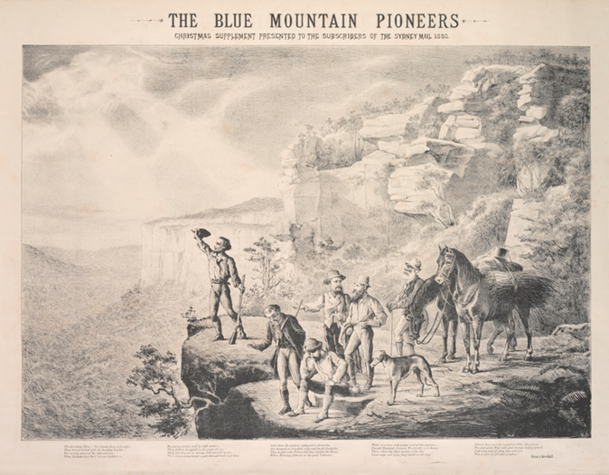
Source 1:
The Blue Mountain pioneers, lithograph by M Emile Ulm, The Sydney Mail, 25 December 1880. State Library of NSW. Public domain
 Read
Examine source 1
In 1813 Gregory Blaxland, William Lawson, William Charles Wentworth, a local guide, three convict servants, four pack horses and five dogs set off on an expedition to cross the Blue Mountains. Whilst they didn’t complete the crossing, their report of the suitability of land west of the mountains for grazing led to rapid inland colonial expansion in New South Wales. The lithograph in source 1 shows an 1880 artist’s impression of the exploration party at the summit of their 1813 expedition. It was published in The Sydney Mail as a double page Christmas supplement on Christmas Day 1880.
Brainstorm/discuss
- significance of the crossing of the Blue Mountains in 1813
- impacts on the colony
- brainstorm other events or developments that were significant to colonial expansion and helped shape the identity of Australia
- list these in a personal K-W-L chart
- write your questions in the Want to know and Wonder columns.
Write
Fill in the K-W-L chart
What were the significant events and who were the significant people that shaped Australian colonies?
K  What I know | W  What I wonder | L  What I learnt
With reference to your K-W-L charts, formulate some inquiry questions.
Sample questions could include:
- What significant events and developments occurred in Australia between 1800 and 1900?
- Where did the significant events occur?
- Who were the key people related to these events?
- Why did the event or development occur?
- How did these events help shape Australia?

Activity 2
During this activity students are learning to:
- Use a range of sources to investigate significant developments and events in Australian colonies 1800 -1900
- Investigate the impact (economic, political, social) on the Australian colonies
Resources – pens, pencils, paper, student workbook
Read
Read the sequence of events in Source 2. Select one decade of events and outline the social, political and economic effects of these events. Complete Table 1.
Source 2 – Defining moments in Australian history, National Museum Australia
Read and write
9 June 1803 – Matthew Flinders circumnavigates continent, which he names Australia
1808 – Rum Rebellion in NSW, Governor Bligh is deposed by the NSW Corps
25 April 1809 – Convict Isaac Nichols appointed as Australia’s first Postmaster
18 May 1813 – Blaxland, Lawson and Wentworth cross the Blue Mountains
7 May 1815 – Governor Macquarie establishes Bathurst – first inland European settlement
1 January 1816 – The Rum Hospital, the first public hospital in Australia, opens
1823 – John Oxley founds the settlement that later becomes Brisbane
1823 – New South Wales Act (UK) establishes the Legislative Council for NSW
1832 – Introduction of assisted migration
1833 – Convict transportation to Australia peaks when nearly 7,000 people arrive in one year
1835 – Australia’s first political party, Australian Patriotic Association, is formed
1836 – Founding of South Australia, the first colony established with only free settlers
10 June 1838 – Myall Creek massacre, New South Wales
1840 – British Government decides to end convict transportation to NSW
1840 – six- year depression halts economic growth
1 July 1841 – New Zealand separates from NSW to become an independent colony
3 April 1848 – Ludwig Leichhardt’s third expedition vanishes
12 February 1851 – Gold rushes in New South Wales and Victoria begin
1 July 1851 – the separation of the colony of Victoria from New South Wales
12 September 1854 – Australia’s first steam railway line opens in Melbourne
3 December 1854 – Rebellion of goldminers at Eureka Stockade, Ballarat, Victoria
4 February 1856 – secret ballot, introduced and all adult men given the vote
20 August 1860 – Robert O’Hara Burke and William John Wills leave Melbourne, aiming to cross the continent from south to north
1860 – the arrival of the first cameleers in Australia: known as the ‘Afghans’ only a few were from that country
9 January 1868 – Convict transportation to Australia ends
22 August 1872 – Completion of the Overland Telegraph from Darwin to Port Augusta, South Australia
31 January 1880 – The Bulletin magazine is established
1 January 1885 – BHP begins mining silver, lead and zinc at Broken Hill in NSW
24 October 1889 – Sir Henry Parkes gives his Tenterfield Oration
1890 – Banjo Patterson writes ‘The Man from Snowy River’
1892 – discovery of gold at Coolgardie leads to gold rush in Western Australia
1894 – Womens Suffrage, South Australia
12 November 1894 – Lawrence Hargraves lifts off in his box-kite at Stanwell Park
1899 – Colonial Australian troops depart for Boer War
19 January 1900 – Bubonic Plague arrives in Australia
1 January 1901 – Inauguration of the Commonwealth of Australia

Table 1 – Timeline of significant events
Date | Event | Location | Reason | Key people | Effects | Image
Write

Reflection
Think about what you have learnt in this activity. Use the two stars and a wish structure to guide your reflection.
Star  Something that went well! | Star  Something that went well! | Wish  A goal for next time…

