People live in places
HSIE – Geography student workbook ES1
Name:
Class:

Overview
ES1 – People live in places
Students explore the places they live and that are important to them. They investigate how the location of places can be represented on maps. They develop an understanding of what makes a place special and how this may differ for different people.

Resources

Activity 1
- Pencil, coloured pencils, markers

Activity 2
- Pencil, coloured pencils, markers

Activity 3
- Pencil, safety scissors, glue

Activity 1
 Observe  Draw Write

Drawing of the front of my home
- Special features of your home need to be labelled e.g. letterbox, roof, garage etc.

My address is: ____________________________________________________________

Drawing of my room
- Label the drawing with important or special objects.
- How do I take care of my room?

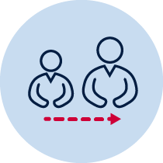Parent support Observe/find
How can Peter get to school?
- Show the way that Peter could walk safely to school, using paths, with a red marker
- Show the way Peter could go to school in the car, using roads, with a blue marker
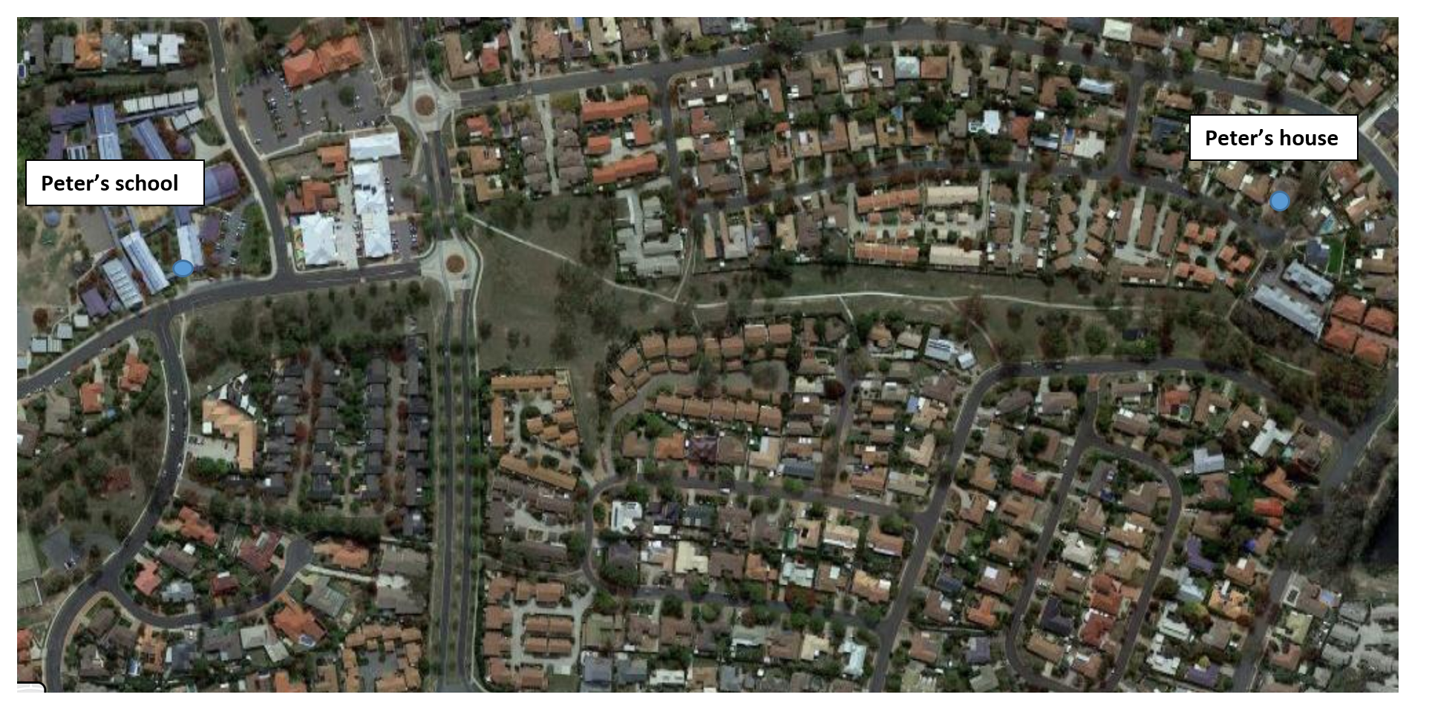

Activity 2
Adult support Discuss
Habitat match – Draw a line to match the animal with where it lives
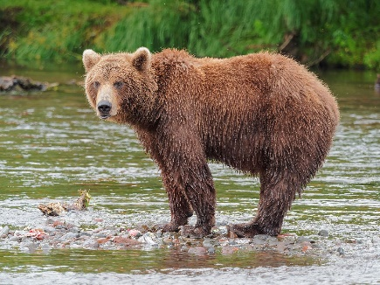  https://upload.wikimedia.org/wikipedia/commons/thumb/5/5d/Kamchatka_Brown_Bear_near_Dvuhyurtochnoe_on_2015-07-23.jpg/1200px-Kamchatka_Brown_Bear_near_Dvuhyurtochnoe_on_2015-07-23.jpg |  | 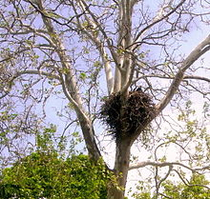  https://upload.wikimedia.org/wikipedia/commons/thumb/e/ec/Bald_Eagle_on_Nest.jpg/220px-Bald_Eagle_on_Nest.jpg
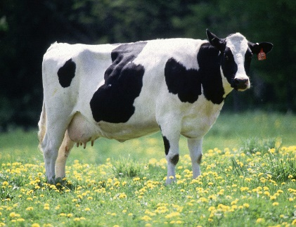  https://upload.wikimedia.org/wikipedia/commons/0/0c/Cow_female_black_white.jpg |  | 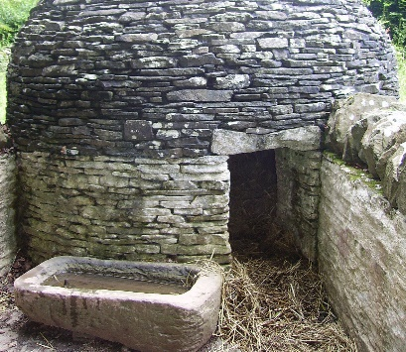  https://upload.wikimedia.org/wikipedia/commons/thumb/f/f1/Pigsty_St_Fagans_2.JPG/1180px-Pigsty_St_Fagans_2.JPG
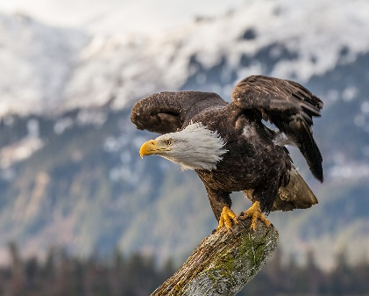  https://upload.wikimedia.org/wikipedia/commons/thumb/1/1a/About_to_Launch_%2826075320352%29.jpg/1200px-About_to_Launch_%2826075320352%29.jpg |  | 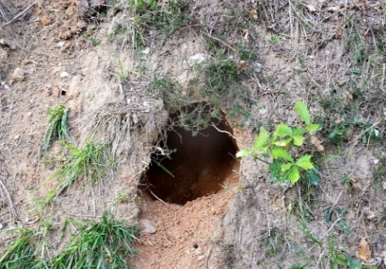  https://cdn.pixabay.com/photo/2015/09/07/11/10/den-928407_960_720.jpg
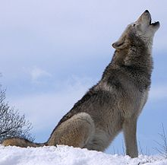  https://upload.wikimedia.org/wikipedia/commons/thumb/f/f5/Howlsnow.jpg/220px-Howlsnow.jpg |  | 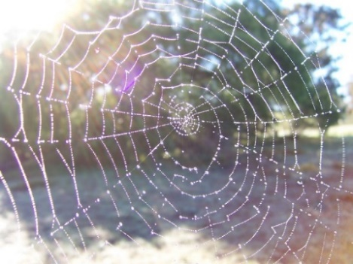  https://upload.wikimedia.org/wikipedia/commons/2/21/Dewy_spider_web.jpg
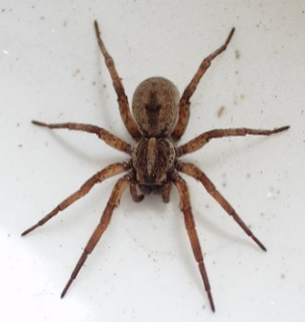  https://upload.wikimedia.org/wikipedia/commons/2/25/Hogna_lenta_18.jpg |  | 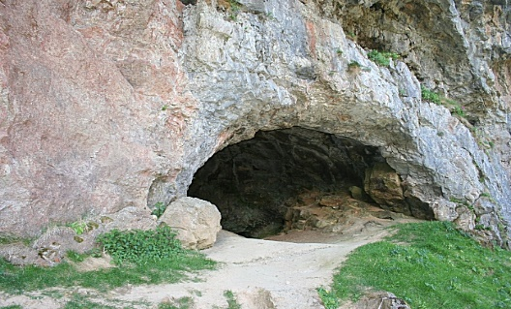  https://upload.wikimedia.org/wikipedia/commons/2/28/Bone_Cave_Entrance_-_geograph.org.uk_-_822892.jpg
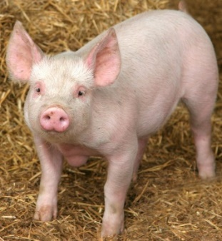  http://4.bp.blogspot.com/_PqWkHhzHACo/S-JhUpu50FI/AAAAAAAAALI/pMbsPjqpf9E/s1600/cute-pig.jpg |  | 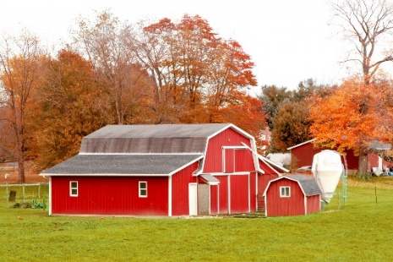  https://www.publicdomainpictures.net/pictures/60000/velka/red-barn-in-autumn-field.jpg

Draw Observe

This is my pet’s special place

Discuss Adult supportDraw

These are two of my family member’s favourite places.

Activity 3
Adult support Write Think
Name these famous special places and the countries they are found.
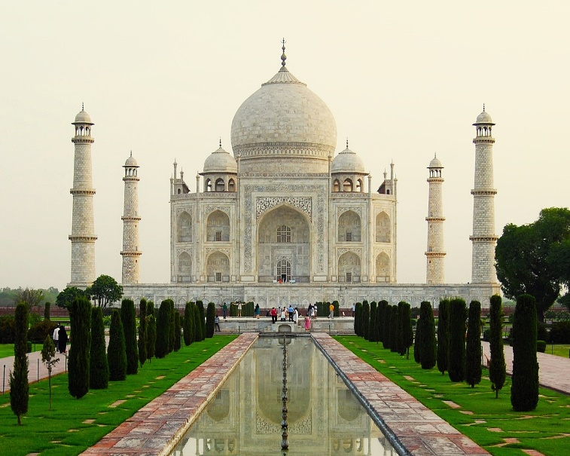
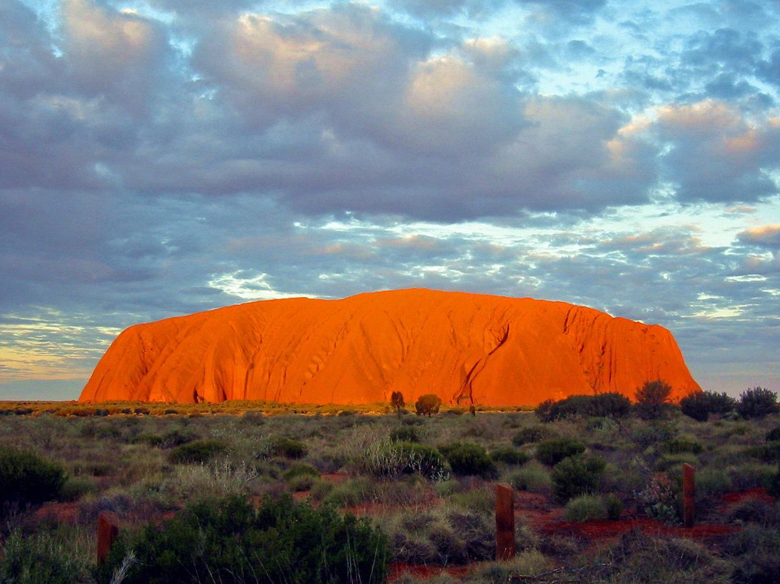
https://upload.wikimedia.org/wikipedia/commons/thumb/1/1a/Uluru_Australia%281%29.jpg/1200px-Uluru_Australia%281%29.jpg https://upload.wikimedia.org/wikipedia/commons/thumb/a/a2/Taj_Mahal_Exterior.jpg/1200px-Taj_Mahal_Exterior.jpg

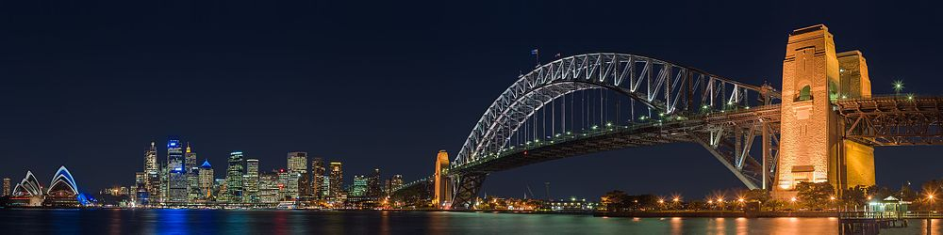

https://upload.wikimedia.org/wikipedia/commons/thumb/e/ea/Sydney_Harbour_Bridge_night.jpg/1000px-Sydney_Harbour_Bridge_night.jpg
https://upload.wikimedia.org/wikipedia/commons/thumb/d/dd/Lady_Liberty_under_a_blue_sky_%28cropped%29.jpg/250px-Lady_Liberty_under_a_blue_sky_%28cropped%29.jpg
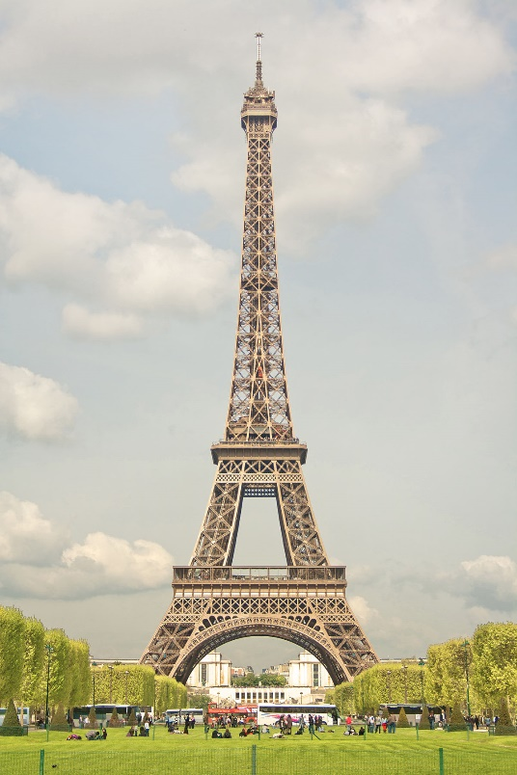
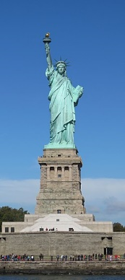
https://upload.wikimedia.org/wikipedia/commons/2/26/Mysterious_Giza..._-_panoramio.jpg
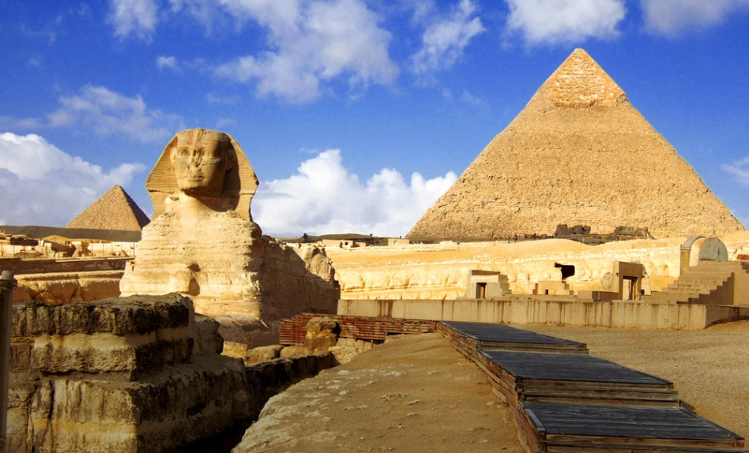

https://upload.wikimedia.org/wikipedia/commons/thumb/5/50/Tour_Eiffel_(8972106418).jpg/1200px-Tour_Eiffel_(8972106418).jpg

Observe  Reflect Adult support
Cut and Paste
Complete the T-chart that shows houses that are like, or similar, to those in your school neighbourhood and houses that are very different to what you see around your school area.
Use the homes on the next page to cut and paste.

Like | Different

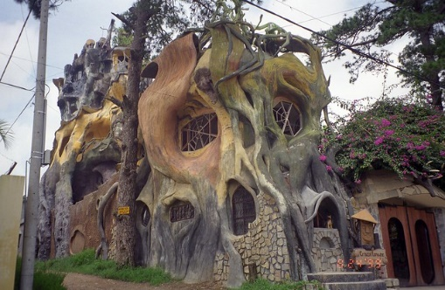  https://farm1.staticflickr.com/31/40289332_51b9bedad8_z.jpg | 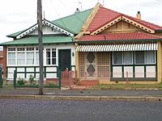  https://upload.wikimedia.org/wikipedia/commons/thumb/1/15/Edwardian_Semi_Detached_Homes.jpg/200px-Edwardian_Semi_Detached_Homes.jpg | 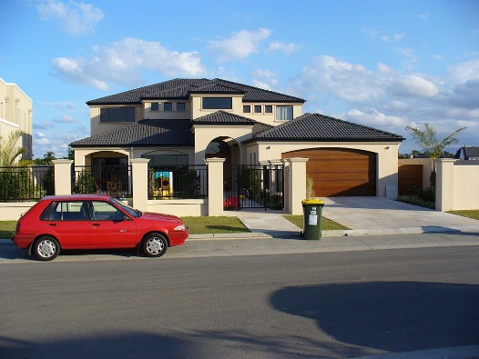  https://upload.wikimedia.org/wikipedia/en/thumb/1/10/Gold_Coast_suburban_home.jpg/1024px- Gold_Coast_suburban_home.jpg
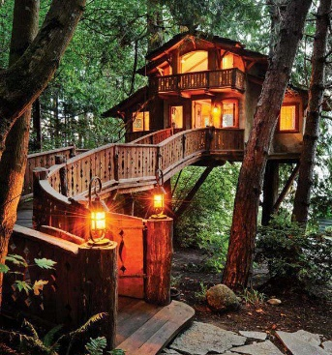  https://tahliasmasks.files.wordpress.com/2012/06/tree-house.jpg | 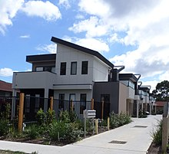  https://upload.wikimedia.org/wikipedia/commons/thumb/e/e0/Townhouses_in_Victoria_Australia.jpg/220px-Townhouses_in_Victoria_Australia.jpg | 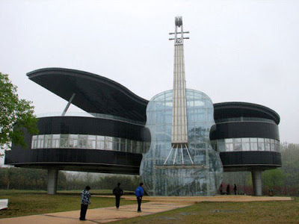  http://3.bp.blogspot.com/_NpINLHeo8rM/SEjJZR8_XNI/AAAAAAAAW5I/AQ_IusUUUxE/s400/15.jpg
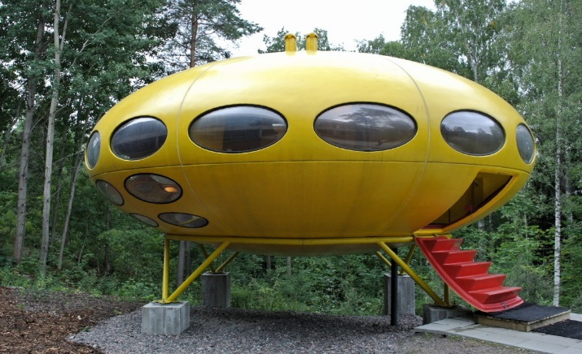  https://upload.wikimedia.org/wikipedia/commons/e/e5/Futuro_WeeGee_Espoo.jpg | 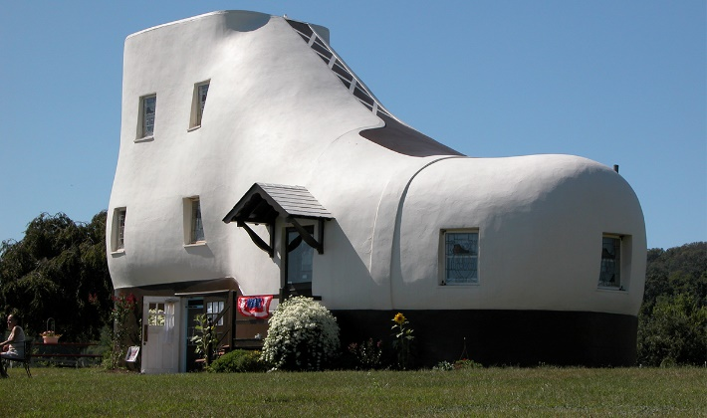  https://images.wired.it/wp-content/uploads/2014/09/1411570866__0005_Haines-Shoe-House-Hellam-USA.jpg | 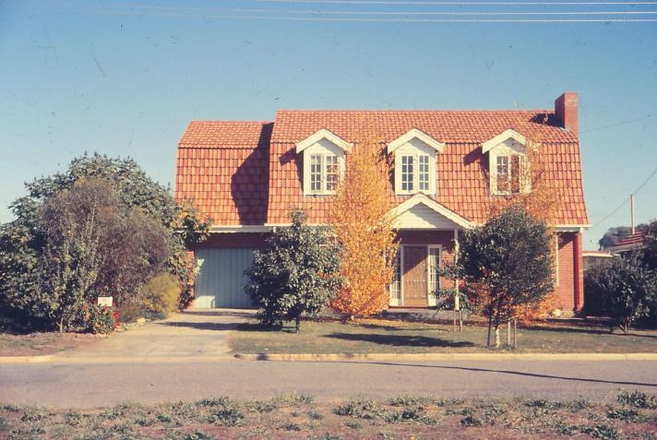  https://live.staticflickr.com/5290/5273427730_20f8ae1d87_b.jpg

