Pygmalion: The composer’s language

British accents
Shaw's play explores aspects of language in a variety of ways. Higgins and Pickering study linguistics and phonetics, taking note of how people from different backgrounds speak differently.
They conclude that the way different people speak the same language reveals a surprising amount about their identity. View the Guess These Accents video and try to guess the accents.

Characters: culture and language
Eliza
Character | Position in society | - Evidence in play
Eliza | Working class | - Behaviour – respectful to people of higher class  - Language – calls gentleman “sir” and “cap’in” (or captain), which is a compliment

Characters: culture and language
Henry
character | Position in society | - Evidence in play
Henry Higgins | Middle class | - Behaviour – rude (and patronising) to lower class; polite to same or upper class  - Language – calls Eliza “you silly girl” and Pickering “my dear man” (an equal and friend)

Characters: culture and language
Pickering
character | Position in society | - Evidence in play
Colonel Pickering | Upper class | - Behaviour – generally confident and polite; but ignores Eliza  - Language – prepared to begin a conversation with Henry, whom he does not know; generous with praise to him

The Phonetic Alphabet
What is it?
The International Phonetic Alphabet (IPA) is a system used to transcribe words phonetically, or by how they sound. This is done by utilising universal symbols to represent the spoken sounds in language.
Because pronunciation varies from region to region, the IPA provides a systematic and uniform way to perform these transcriptions. Most English dictionaries use the IPA as a standardised system to show pronunciation for all words.
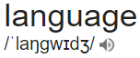
Any guess how you might pronounce these words?
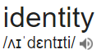
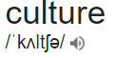
Introducing the International Phonetics Alphabet
TASK: Use the International Phonetics Alphabet and determine the correct pronunciation of these words.
Language identity culture

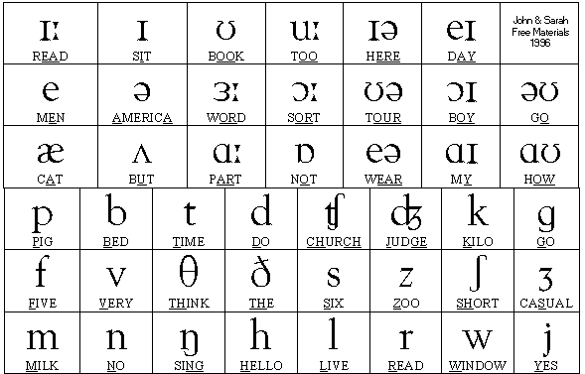
Phonetics Alphabet Task
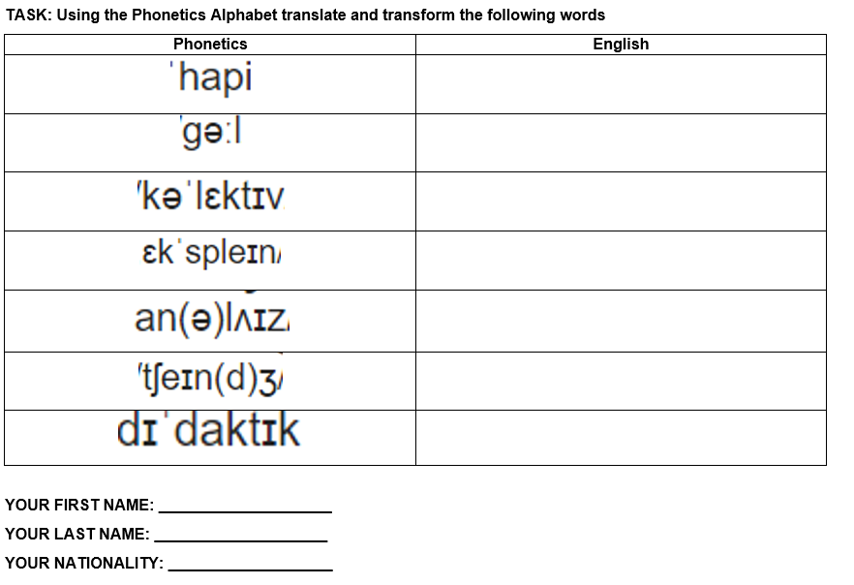

Understanding the British Cockney Accent
TASK: View the video and explore the way a Cockney accent alters the way an individual pronounces words.
- British Accents: Cockney video
Write down FOUR features of a British Cockney accent you have learnt from the video.

Understanding British Slang
TASK: View the video and discover what the following British slang words mean.
- British Slang vs Australian Slang video

British Slang | What it means
Codswallop | Nonsense
Dishy | Good looking
To blow off | To pass wind
Nosh | Food
(Add your own) | ?
(Add your own) | ?
(Add your own) | ?

Although a Pygmalion is a dramatic play, Shaw placed a significant amount of emphasis on critiquing the way people spoke.
He believe it reflected class, position and education.
The play Pygmalion focuses on Higgins teaching Eliza the proper way to speak.
Why is Language and SPEECH so important do you think?
Do you think Language and SPEECH still play a significant role in today’s society?

MY FAIR LADY FILM- Activity 1
How does the clip from My Fair Lady convey the idea that language has power to reflect individual and collective identities?
My Fair Lady - Why Can't The English?
https://www.youtube.com/watch?v=EAYUuspQ6BY

