 Year 12 English Standard

Identifying British Class Culture
The social structure of the United Kingdom has historically been highly influenced by the concept of social class, with the concept still affecting British society in the early-21st century. Although definitions of social class in the United Kingdom vary and are highly controversial, most are influenced by factors of wealth, occupation and education.
Given that Pygmalion is set in London, class and a desire to transform out of one’s class plays significant role in the play.
Remember! The English Standard Syllabus Glossary 2017 defines ‘culture’ as the social practices and ways of thinking of a particular group or people, including shared beliefs, values, knowledge, customs, lifestyle and artefacts.
Task – Using the images below, simply write next to them which class you think they belong to: upper class, middle class or working class.

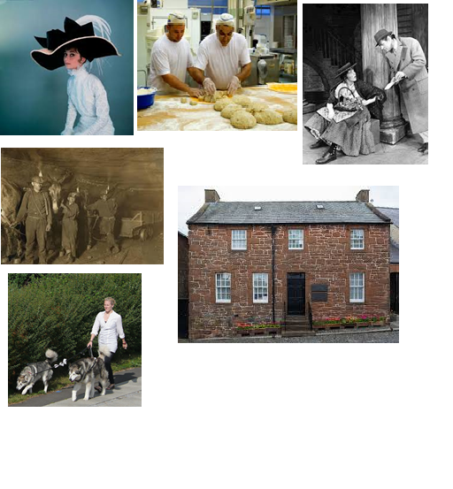
All images sourced from creative commons images

