Student resource booklet

Engagement phase – English Advanced Module B
Module case study – Year 12 Module B – Critical study of literature
Case study text – King Henry IV, Part 1, William Shakespeare (Shakespearean Drama), Cambridge University Press, 1988, ISBN: 9781782953463
Technology focus – Microsoft Sway (support outlined in resource 2) for student-centred presentation

Resource one – syllabus statement Advanced Module B
In this module, students develop detailed analytical and critical knowledge, understanding and appreciation of a substantial literary text. Through increasingly informed and personal responses to the text in its entirety, students understand the distinctive qualities of the text, notions of textual integrity and significance.
Students study one prescribed text. Central to this study is the close analysis of the text’s construction, content and language to develop students’ own rich interpretation of the text, basing their judgements on detailed evidence drawn from their research and reading. In doing so, they evaluate notions of context with regard to the text’s composition and reception; investigate and evaluate the perspectives of others; and explore the ideas in the text, further strengthening their informed personal perspective.
Students have opportunities to appreciate and express views about the aesthetic and imaginative aspects of the text by composing creative and critical texts of their own. Through reading, viewing or listening they critically analyse, evaluate and comment on the text’s specific language features and form. They express complex ideas precisely and cohesively using appropriate register, structure and modality. They draft, appraise and refine their own texts, applying the conventions of syntax, spelling and grammar appropriately.
Opportunities for students to engage deeply with the text as a responder and composer further develops personal and intellectual connections with the text, enabling them to express their considered perspective of its value and meaning.
English Advanced Stage 6 Syllabus © NSW Education Standards Authority (NESA) for and on behalf of the Crown in right of the State of New South Wales, 2017.

Resource two – technology
Sway is a presentation app that is available within the Microsoft 365 suite. If you are going to create your own Sway from scratch select the Microsoft 365 icon in your student portal and then choose Sway from within the apps.
If your teacher has shared a Sway template with you, you will receive a link to that template through your email or notice board. Make sure your teacher has set it to ‘can edit’ so you can work on it! Follow his or her instructions carefully: she will let you know what you are allowed to change and what you must keep the same. Generally the order of ‘cards’ will be set and you will be asked to fill in your own content.
Here are screenshots of the two opening cards of a Sway template on the topic of ‘Crime Genre’, taken from the ‘dashboard’ view.
Note: when you have finished working on your ‘cards’ select play to see the Sway as a proper presentation.
Screenshot 1 – the ‘title’ card
Depending on your teacher’s instructions you may need to keep the title the same, but you will be able to edit and put in your own image.
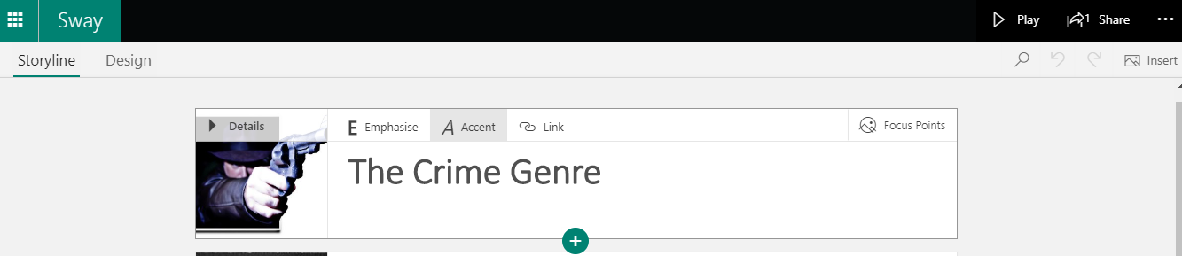
Image: Stick Em Up by Bart, licenced under CC BY-NC 2.0
Screenshot 2 – the ‘image’ card
An example of an ‘image’ card. In edit mode you will be able to replace the picture with a choice of your own, create your own caption, then add to or change the text.
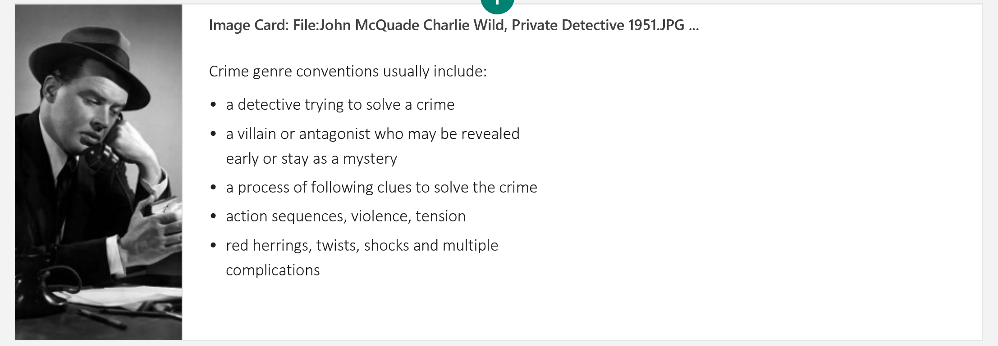
Image: John McQuade Charlie Wild, Private Detective 1951 by CBS, licensing released under public domain

Resource three – Socratic questioning
Explore this online. Here are some questions for ‘conceptual clarification’:
- Why are you saying that?
- What exactly does this mean?
- How does this relate to what we have been talking about?
- What is the nature of …?
- What do we already know about this?
- Can you give me an example?
- Are you saying … or …?
- Can you rephrase that?

