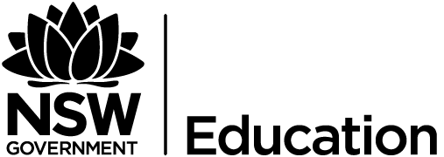 Vernon Ah Kee
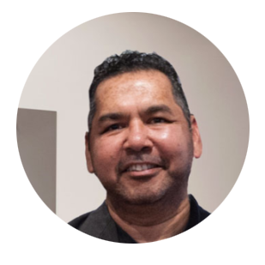
(Vernon Ah Kee lecture, 2017).

Key artist: Vernon Ah Kee.
Theme: events, political art, contemporary issues.
Time: 2018 (current).
Place: Australia.
Syllabus connections: frames, conceptual framework, practice.
Key art works addressed:
- “Austracism”- Printed text on board, 2003
- "Can’t chant"- Installation, 2007.
General key words:
- symbolism, identity, community, personal experience, culture, racism, difference, post modernism, popular culture, visual cues, drawing, installation, multimedia.
Sophisticated key terms/words:
- political voice, oppression, cultural pluralism, marginalised, dichotomy, sardonic and satirical light, wry sense of humour, Australian multiculturalism, social norms, double entendre, ambiguity, confronting tension, mistreatment of humanity, evocative, discourse, intimate , distressing, stigmatic presence, art as provocation, ostracism, alienation, disenfranchised and disillusioned.

Literary progression:
- speaking, listening, interacting, comprehension, process, vocabulary, writing (informative and persuasive), grammar (whole text, sentences), and spelling.
Explore more of Vernon Ah Kee's work.
What was your personal view about some of his artworks you looked?
Critically look at the t-shirt design
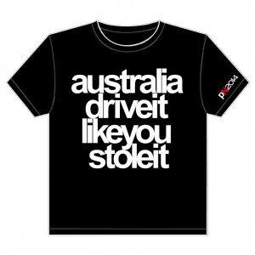
(Ah Kee, 2013).

"Australia drive it like you stole it"
Ah Kee uses a double entendre (phrase that can have more than one meaning) to convey his message.
- In class discuss the different meanings this could have.
- Why has Ah Kee used a t-shirt to deliver his message?
- Is text art?

Vernon Ah Kee
"Australia, as a country, as an idea, as an ideal, as a social-political system, thinks of and believes itself, despite its history of racism and exclusion, to be essentially good. I of course disagree. These drawings and what they represent are my evidence".
Vernon Ah Kee, 2004.
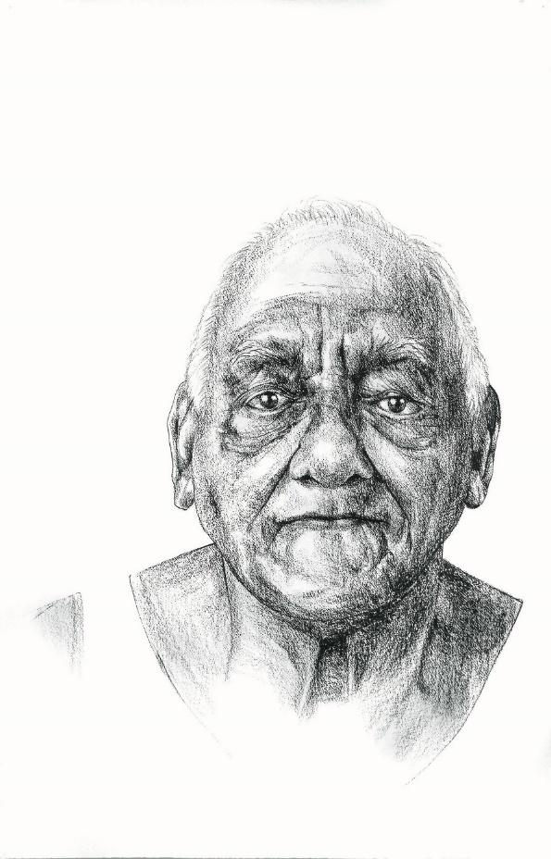
(Ah Kee, 2004).
Read the paragraph below
Vernon Ah Kee is a member of the Kuku Yalandji, Waanji, Yidinji and Gugu Yimithirr peoples. His multi-faceted practice includes works that range from large-scale drawings of his ancestors to hard-hitting text-based works and installations. Through clever puns and plays on words and objects, Ah Kee fuses the history and language of colonisation with contemporary black/white political issues to expose degrees of underlying racism in Australian society…Ah Kee’s work has consistently addressed the subject of Aboriginal experience and identity within a culture of colonial racism. His work is a direct engagement between artist and viewer, concerned with Indigenous politics and culture…Ah Kee’s word play points to prejudices and agendas embedded in Australian society and politics. These puns and words-within-words fuse the history and language of colonisation with contemporary experiences and issues, such as the governmental control of Aboriginal lives…Creating a confronting tension between word and image, these works encourage the viewer to re-examine their own perspectives on race-related issues.
(McDowell, 2016).
In class discussion
Vernon Ah kee's practice explores the history and language of colonisation with contemporary black/white political issues.
- How can art help inform people about important issues? Refer to “ABC” image on the next page in your answer.
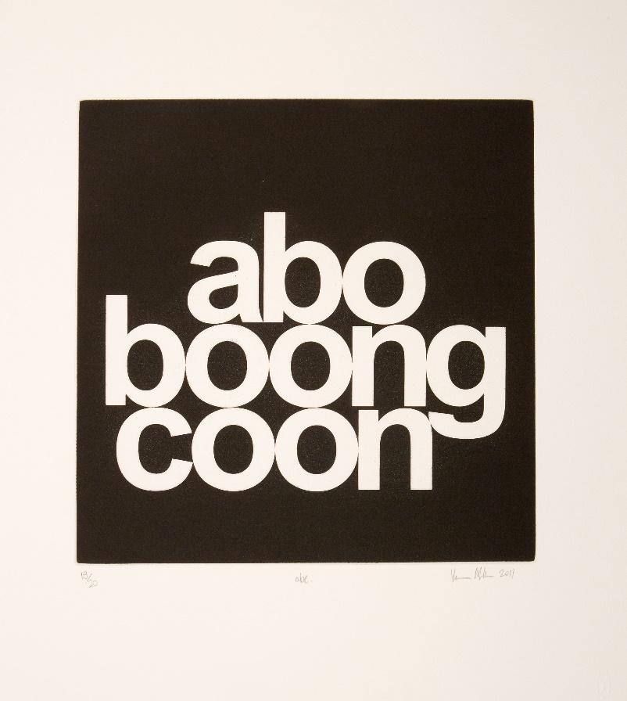
“ABC” (Ah Kee, 2011).

Vernon Ah Kee
Watch, listen, interpret and discuss:
- "Indigenous art".
(National Gallery of Australia, 2013).
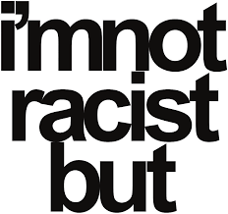
(Ah Kee, 2003).
Spoken Text:
Vernon Ah Kee belongs to a new wave of young politically motivated artists. His text-based work—photography, installations and films—expose the black and white dichotomy from historical times to the present. They are often cast in a sardonic and satirical light, lending his work a wry sense of humour. He was selected as one of four emerging Australian artists to exhibit at the Venice Biennale in 2009.
Ah Kee’s arresting, bold and innovative arrangement of letters and words reveal an underlying racial tension present in the written language. He uses direct quotes, puns, double entendres, split and repositioned and sometimes without spaces between them. Meaning and context are often changed, in effect turning them back on themselves to reveal an Indigenous perspective. Many Indigenous people living with issues of race every day connect with Ah Kee’s works, with many nodding in recognition and understanding as the words resonate with them. Many non-Indigenous people find a different perspective on race-related issues, which they had often never thought of or noticed before.
Austracism 2003 is a direct play on the word ‘ostracism’, looking at the commonly expressed and all too familiar sentiments surrounding racism in Australia. Each opening line starts with I’m not a racist but …, a powerful statement in itself that sets the scene for the following conflicting personal statements of others. This large panel uses black and white Helvetica font, typical of wall panels used in public art institutions. Direct quotes and playing on words provoke thought, encouraging the viewer to question their inner narrative about race, equality and identity.
Tina Baum, National Gallery of Canberra, (Baum, 2010).
Write down some words.

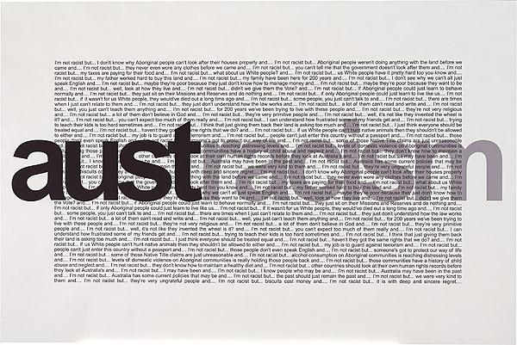
Look at the bold words in the text above. Some have been added to the word bank on page 1 already, however, you could add a few more from this text to your personal word bank, these will help with your writing later.
(Ah Kee, 2003).

Vernon Ah Kee
Abstract
"If I didn't have art as an outlet, I would be angry, really angry, and frustrated. Aboriginal people in this country are angry to varying degrees. Some are very, very angry; some have it on a low simmer; some hardly sense it at all. At different times, I experience all those things."
Vernon Ah Kee, (Jones, 2010).
Watch, listen, interpret and discuss the following:
- "Vernon Ah Kee 16 x9 jdw"(Ah Kee, 2009)
- download the accompanying booklet of the Australian artists and artworks from here.

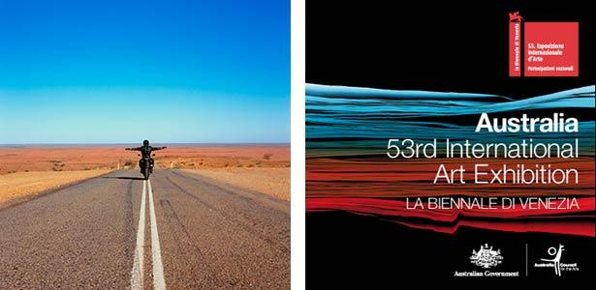
("Vernon Ah Kee", 2009).
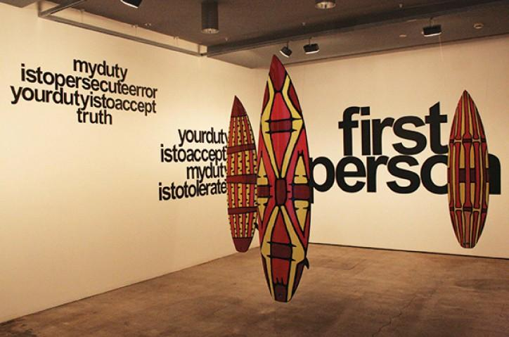
("Vernon Ah Kee", 2009).
Extension reading
- This article from the Guardian is an impressive in-depth study into Ah Kee’s practice.
- Vernon Ah Kee- Sovereign warriors is a paper from the Faculty of Creative arts, University of Wollongong, Australia. It is another extensive study of Vernon Ah Kee's art practice.

"Cant Chant" by Vernon Ah Kee
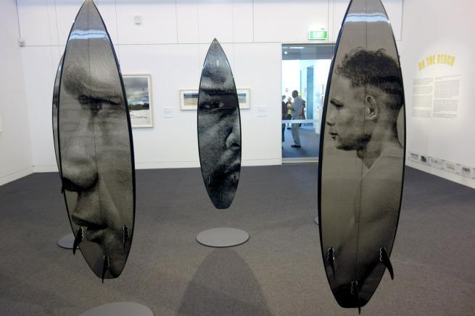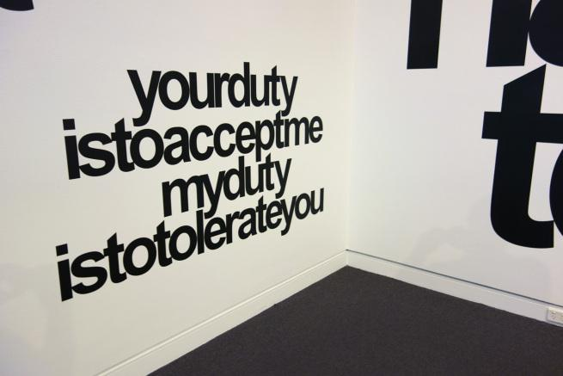
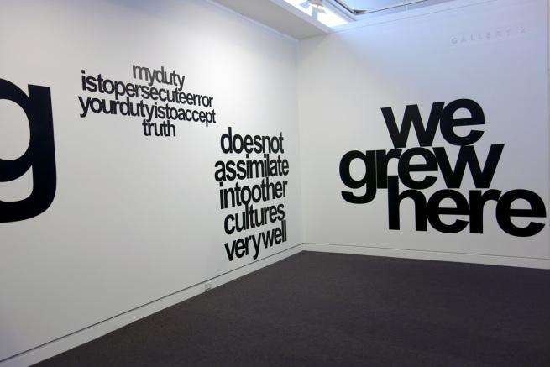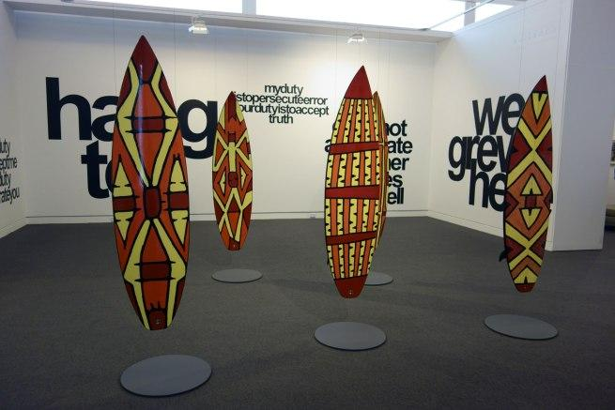
All images, (Ah Kee, 2007).
The practice of a critic, Wendy Shaw
After Nulla: Through the Lens of Aboriginal Art
Abstract
Based on the Cronulla riots
…Vernon Ah Kee’s Cantchant series also provides commentary on the riots. These Aboriginal artists recall that racialised extremism is not a recent or one-off phenomenon in neocolonial Australia…These artworks provide a reminder of the uneasy relationships between the identifications of Aboriginality and the groups that have arrived since invasion. Cronulla ‘ten years on’ was a time to reflect by including some of the understandings and commentaries of those with the longest memories of racialisation and processual whiteness, in Australia.
Written by Wendy Shaw, Journal of Intercultural Studies, Issue 3: After Cronulla, (Shaw, 2017).
Discuss in class
- Art Critic Wendy Shaw commented that "Cant chant" provides commentary on the riots. Elaborate on what she mean by that?
- She also uses the term neocolonial Australia, discuss this term.

"Can’t Chant" by Vernon Ah Kee
Text extract
Vernon Ah Kee’s response to the events at Cronulla (the Cronulla Riot) is a powerful retort to the racists and their mantra ‘we grew here, you flew here’ chanted on the beach during the riots. Ah Kee takes issue pointing out the hypocrisy in their statement.
We grew here, you flew here is an insincere statement and they were chanting it over and over again. It’s a way to exercise racism. I’m like ‘WE’ grew here, say what you want, but we’re the fellas that grew here.
The surfboards are printed with Yidinji shield designs and the portraits are members of the artist’s family. The work was exhibited in the Australian Pavilion at the 2009 Venice Biennale.
Written by Dr Marcus Bunyan, (Bunyan, 2016).
(Ah Kee, 2007).
Answer the following questions through written responses.
15min questions
Frames
- Examine how Vernon Ah Kee's work "can’t chant" is a personal expression of his political views. Refer to the text extract in your answer.
Conceptual framework
- Art work can be a direct reflection on events in the world, looking at Vernon Ah Kee's text on the wall, "we grew here" discuss this.
Practice
- Art can be a political statement. Refer to the practice of Vernon Ah Kee in your answer.
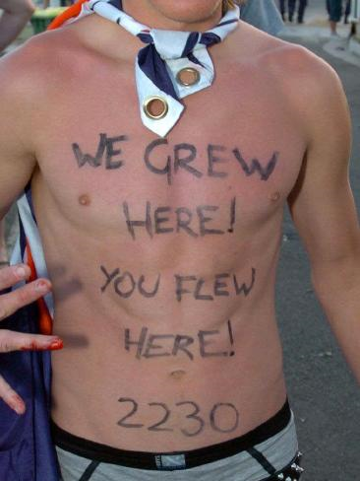
Participant in the Cronulla riots, (We grew here, you flew here, 2007).

References for Booklet 3 Artist Vernon Ah Kee
Ah Kee, V. (2003). Austracism [Prints, digital print, printed in colour inks, from digital file]. Canberra: https://cs.nga.gov.au/detail.cfm?irn=129593
Ah Kee, V. (2004). George Drahm (Uncle George) from fantasies of the good [Charcoal on paper]. Sydney: https://www.mca.com.au/artists-works/works/2006.11.1/
Ah Kee, V. (2007). cantchant [Synthetic polymer paint and resin over digital print on roamer, vinyl]. Mornington Penninsula Regional Art Gallery.
Ah Kee, V. (2009). Chant Chant - Once removed [Mixed Media Installation]. Venice: http://www.australiacouncil.gov.au/international/venice-biennale/
Ah Kee, V. (2011). abc [Etching on paper]. Sydney: https://www.mca.com.au/artists-works/works/2013.31/
Ah Kee, V. (2013). Australia, drive it like you stole it. [Printed text on a t-shirt]. Sydney: https://www.darkanddisturbing.com.au/shop/drive-like-stole-vernon-ah-kee/
Ah Kee, V. (2018). Vernon Ah Kee | Milani Gallery. Retrieved from http://www.milanigallery.com.au/artist/vernon-ah-kee
Baum, T. (2010). Ah Kee,Vernon| Austracism. Retrieved from https://cs.nga.gov.au/detail.cfm?irn=129593
Bunyan, D. (2016). Cronulla beach | Art Blart. Retrieved from https://artblart.com/tag/cronulla-beach/
Doggett- Williams, J. (2009). Vernon Ah Kee 16 x 9 jdw [Video]. Venice: Australia Council for the Arts.
https://whatson.cityofsydney.nsw.gov.au/events/vernon-ah-kee-lecture (2017). Vernon Ah Kee lecture [Photography]. Sydney.
https://www.springfielddailyrecord.com.au/news/immigration-debate-is-just-leftwing-racism/3364048/ (2007). We grew here, you flew here [Photography]. Sydney.
Jones, G. (2010). Vernon Ah Kee - sovereign warrior [Ebook]. Woolongong: University of Wollongong. Retrieved from https://ro.uow.edu.au/cgi/viewcontent.cgi?referer=https://www.google.com.au/&httpsredir=1&article=1224&context=creartspapers
McDowell, T. (2016). Vernon Ah Kee. Retrieved from https://www.mca.com.au/artists-works/artists/vernon-ah-kee/
National Gallery of Australia. (2013). Indigenous art [Video]. Retrieved from https://vimeo.com/channels/indigenousart/63287336
Shaw, W. (2017). After Nulla: Through the Lens of Aboriginal Art. Journal of Intercultural Studies, 38(3), 301-314. doi: 10.1080/07256868.2017.1314253
Vernon Ah Kee. (2009). Retrieved from http://www.australiavenicebiennale.com.au/vernon-ah-kee-artists-booklet/.

