 Free Snags with Tabouli

"Free Snags with tabouli"
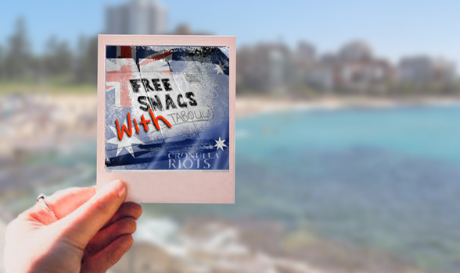

McAuley, A. (2018).
A stage 6 case study for NSW Visual Arts Students.

Teacher guidelines
Be mindful that this case study contains sensitive material. Teachers are encouraged to approach topics only after setting the class guidelines and expectations regarding respect and acceptance of difference in the classroom and community.

Contents and links
There are several links to more in-depth information attached below and throughout the text. It is the teachers choice how long you stay on each artist or if you watch all the videos in their entirety. Thus this case study could range from 7 to 10 weeks.
Topic | Feature | Downloads available throughout text to print or videos linked
Cronulla riots  Introduction booklet page 3 | SBS Documentary | - Cronulla riot documentary http://www.sbs.com.au/cronullariots/documentary
Multicultural Australia  Introduction booklet page 4 | The people of Australia- Australia's multicultural policy, 2011
Craig Greenhill  Introduction booklet pages 5-6 | Documentary photography | - Cronulla riot captured by photographer Craig Greenhill
Artist  Abdul Abdullah  Booklet 2  8 pages | Artist Practice | - "Abdul Abdullah: The Bad Guy''  - "Don't call me aussie- combating prejudice through art"  - Winner of the 2011 Blake Prize for Human Justice  - You see monsters https://www.acmi.net.au/events/you-see-monsters-q/
Artist  Vernon Ah Kee  Booklet 3  8 pages | Artist Practice | - "Indigenous art"  - Download the booklet of the Australian artists and artworks from here  - "Vernon Ah Kee 16 x9 jdw"  - This article from the Guardian is an impressive indepth study into Ah Kees practice.  - Vernon Ah Kee- Sovereign warriors is a paper from the Faculty of Creative arts, University of Wollongong, Australia.
Artist  Fiona Foley  Booklet 4  8 pages | Artist Practice | - Fiona Foley - part 1  - Fiona Foley - part 2  - Explore "forbidden " further here  - Extension learning resource " Forbidden, Fiona Foley"  - Art collectors review of Fiona Foley with timeline of works
Written test on topic  Booklet 5  7 pages | Frames  Conceptual framework  Practice | - Links to theory assessment task

Cronulla riots
“This Sunday, every Aussie in the Shire get down to North Cronulla to support the Leb and Wog bashing day.”(Balendra, 2014)

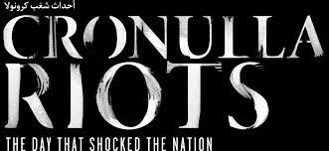
Rated M
Warning this content contains strong language and content which might distress some viewers.

About the project
On December 11, 2005 a riot occurred on Cronulla Beach in Sydney's south targeting men of ‘Middle Eastern appearance’.
Phrases like “100% Aussie Pride” were scrawled in the sand while slogans such as “We grew here you flew here” became a new source of national shame. In the following days, Lebanese-Australian youth rose up, responding swiftly in a series of retaliations.
Leading up to these events, 270,000 text messages were sent and received to mobilise the rioters and those who retaliated.
This interactive documentary explores these events. A 60-minute video is a springboard to explore a wall of content that adds further depth and perspective to the themes that fuelled the infamous Cronulla Riots. Watch the untold stories. Investigate the themes. Explore the riots in an entirely new, immersive way.
(Balendra, 2014).
Watch, listen, interpret and discuss the following video:
- Cronulla riots documentary http://www.sbs.com.au/cronullariots/documentary.
(Balendra, 2014)
Chapters to watch - pause between each and discuss with the class
- Refection's on Cronulla
- Being Lebanese-Australian
- Rising tensions
- Fuelling the fire: Alan Jones
- Riot day
- The retaliation: An eye for an eye
- A dangerous Aftermath
- The Nation reflects.
(Balendra, 2014)

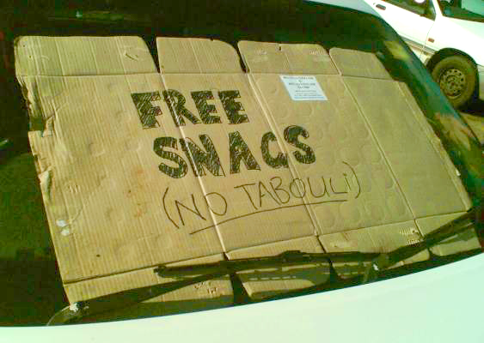
Sign on a car at Cronulla during the riots (Free snags, no tabouli, 2015).

Multicultural Australia
Multiculturalism has been an critical ideological moment in Australia’s conceptualisation of itself as a nation. It attempts to signify a break from a racist exclusionary past and promote the idea of Australia as a tolerant, equitable, inclusive and diverse nation (we are one, but we are many). (Hage, 1998).
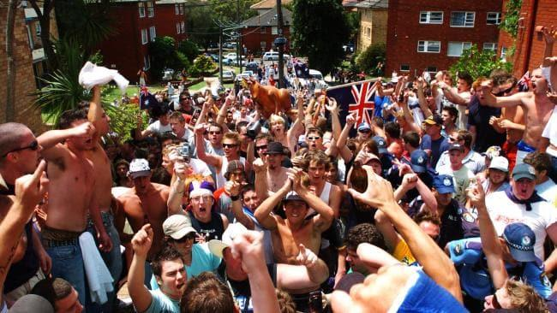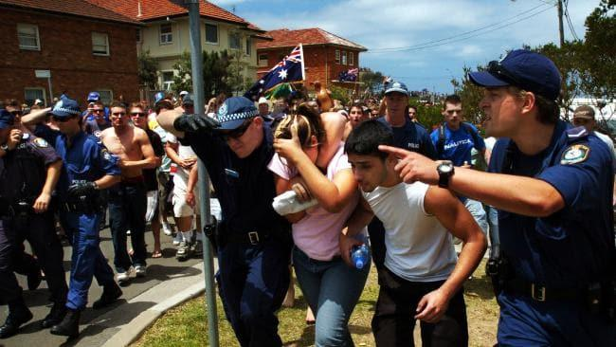
(Greenhill, 2015).

Class discussion
- After watching the SBS documentary of the Cronulla riots, reflect on Australia's multicultural policy, specifically looking at “Principle 4” and “Rights and Responsibilities” below.

The people of Australia - Australia's multicultural policy, 2011.
Principle 4:
The Australian Government will act to promote understanding and acceptance while responding to expressions of intolerance and discrimination with strength, and where necessary, with the force of the law.
Racism and discrimination affects people’s health and wellbeing and denies people fair access to opportunities and services. The Australian Government opposes all forms of racism, discrimination, intolerance and prejudice. The Government has in place anti-discrimination laws and is committed to measures which counter racism and discrimination.
Rights and Responsibilities:
Australia’s successful multicultural society and our democracy are built around shared rights and responsibilities that are fundamental to living in Australia. These key rights and responsibilities are enshrined in our citizenship pledge which requires future citizens to pledge their loyalty to Australia and its people, uphold our laws and democracy and respect our rights and liberties. These rights and liberties include Australians of all backgrounds being entitled to celebrate, practice and maintain their cultural heritage, traditions and language within the law and free from discrimination. P6-7
(The people of Australia- Australia's multicultural policy, 2011).

Craig Greenhill

(Greenhill, n.d.)
Key photojournalist: Craig Greenhill.
Theme: current events.
Time: 2018 (current).
Place: Australia.
Syllabus connections
- frames, conceptual framework, practice.
Key art works addressed
- "Cronulla Riots"-Photography.
General key words
- Symbolism, identity, community, personal experience, culture, racism, photography, difference, post modernism, popular culture, visual cues.
Sophisticated key terms/words
- Political voice, oppression, cultural pluralism, marginalised, Australian multiculturalism, social norms, ambiguity, mistreatment of humanity, evocative, discourse, intimate , distressing, stigmatic presence, art as provocation, alienation, disenfranchised and disillusioned.

‘If I wasn’t on that train we wouldn’t have proof of Australia’s shameful violence’
Craig Greenhill, Senior photographer, The Daily Telegraph, December 10, 2015 1:56pm
Discuss this statement.

Explore Craig Greenhill's website.
After looking at Craig Greenhill's folio online discuss the following:
- what makes his works successful?
- what technical considerations has he focused on? (look at aperture, focus, light, movement, composition)
- how is he capturing a reflection of Australian culture?

Class discussion
- Documentary photography captures the truth society often doesn’t want us to see.
The Daily Telegraph photographer Craig Greenhill won a number of awards for his Cronulla riot pictures.

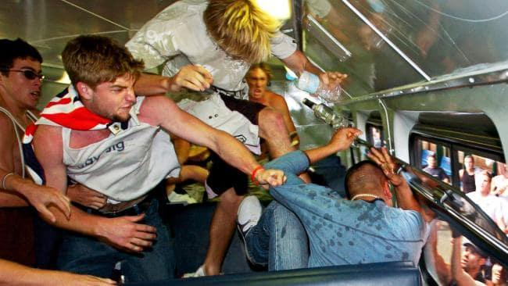
(Greenhill, 2015).
Craig Greenhill captured the ugly truth behind the Cronulla Riots and Australia's racism issues.

References for Booklet 1 Introduction
Australian Government. (2011). The People of Australia: Australia’s Multicultural Policy [Ebook]. Australian Government. Retrieved from http://apo.org.au/system/files/27232/apo-nid27232-75716.pdf
Balendra, J. (2014). Cronulla Riots, the day that shocked the nation [Video]. Sydney, Australia: The Board of the Special Broadcasting Service (SBS).
Commonwealth of Australia 2011. (2011). The people of Australia- Australia's mulicultural policy [Ebook] (pp. 6-7). Canberra.
Greenhill, C. (2015). Train bashing [Photography]. Sydney.
Greenhill, C. Portrait of photographer [Photography]. Sydney.
Hage, G. (1998). White Nation: Fantasies of White Supremacy in a Multicultural Society, (pp. 78-116). Sydney: Pluto Press.
http://photos1.blogger.com/blogger/5106/161/1600/12-110E9VC0N00.jpg. (2015). Free snags, no tabouli [Photography]. Sydney.
McAuley, A. (2018). Free Snags with tabouli [Digital photograph]. Coffs Harbour.
Weeks, J. (2015). Cronulla's day of infamy: the 2005 race riots in pictures. The Guardian. Retrieved from https://www.theguardian.com/australia-news/gallery/2015/dec/11/cronullas-day-of-infamy-the-2005-race-riots-in-pictures.

