 Photoshop worksheet
Please note: changes to photoshop since this version are not taken into consideration, so just use this as a guide on the steps to how to manipulate. Alternate options to manipulating in photoshop can be given online through tutorials on the adobe website.

You are to create your own Kruger appropriation:
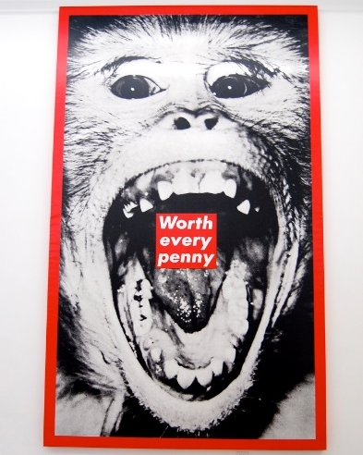
(Image found at: c1.staticflickr.com/3/2740/4177103094_e28f704bb9_b.jpg date accessed 7/3/18).

Photoshop workshop: follow the checklist to assist you using, layers, colours, opacity and filters.
- Open Adobe Photoshop CS5 or 7:
- Save file as A4 in your name:
  - select file
  - select new
  - type your name as title
  - select international paper
  - select A4
  - select save.
- Create background colour:
  - select the window tape from the menu bar
  - make sure layers is checked
  - the following menu should appear at the side of your screen if you have done this correctly
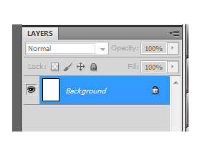
  - make sure the background layer is highlighted
  - select edit
  - select fill
  - select colour
  - choose a background colour and select ok
  - your page should turn that colour if you have selected correctly.

- Copy and paste image:
  - image search for an image of choice
  - save the image to the pc you are on
  - select file
  - select open
  - find your image that you save to the pc and open this image
  - you should have two tabs in Photoshop if you have done this correctly.
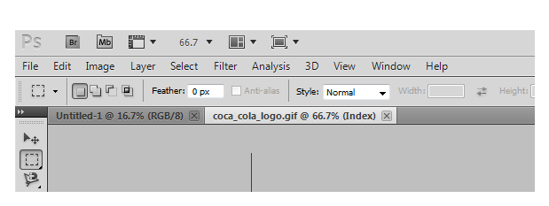
  - ensure that the image file is selected
  - select the rectangular marquee tool m (highlighted above to the left)
  - drag this across the area of the image you wish to copy
  - select edit
  - select copy
  - then select your A4 document, and select edit
  - select paste. The image should appear on the page if you have done this correctly
  - select edit
  - select free transform. Then your mouse should be able to move your image around and resize it if you have done this correctly
  - when you have positioned and resized your image to your desire, click on another tool on the available tool bar and select apply to save.

- Layers to enhance features:
- brightness/ contrast
  - select ‘image’, then ‘Adjustments’ followed by ‘Brightness/ Contrast’ and adjust.
- opacity
  - follow step 4 again to find the layer you wish to see as a texture behind your work
  - ensure this layer is highlighted and hold down the mouse to move it below the layer you previously worked on
  - select the top layer and adjust the ‘opacity’ of this layer below 100%, until you can see the image through it.
- text
  - select the ‘Type Tool’ (T)
  - choose your colour, font and size along the toolbar at the top
  - type your text
  - ‘edit’ and ‘free transform’ if you wish to relocate and change size.
- stamp filter
  - select ‘Filter’ from the main toolbar
  - select ‘Filter Gallery’
  - find the ‘Stamp’ filter and apply this to the image
  - select the ‘Magic Wand’ (W) tool
  - adjust the number of pixels to be adjusted to be larger or smaller depending on the area you wish to recolour
  - select ‘Edit’ and ‘Fill’ and limit your colour palette to 3 colours.

If you make a mistake at any time, select edit and step backward until you reach the desired step that you were up to.
Remember to save your work as you go.
Have fun and enjoy. Submit your work, saved as a .jpg image file to the teacher’s USB for printing.

