 2b or not 2b resources

Quote cards
Quote Cards | Quote Cards
“To be, or not to be: that is the question.”  Hamlet (Act 3, Scene 1) | “Romeo, Romeo! Wherefor art thou Romeo?”  Romeo & Juliet (Act 2, Scene 2)
“Now is the winter of our discontent.”  Richard III (Act 1, Scene 1) | “Is this a dagger which I see before me, the handle toward my hand?”  Macbeth (Act 2, Scene 1)
“Some are born great, some achieve greatness, and some have greatness thrust upon them.”  Twelfth Night (Act 2, Scene 5) | “Cowards die many times before their deaths: the valiant never taste of death but once.”  Julius Caesar (Act 2, Scene 2)
“How sharper than a serpent’s tooth it is to have a thankless child!”  King Lear (Act 1, Scene 4) | “Frailty, thy name is woman!”  Hamlet (Act 1, Scene 2)
“The lady doth protest too much, methinks.”  Hamlet (Act 3, Scene 2) | “I am one who loved not wisely but too well.”  Othello (Act 5, Scene 2)
“We are such stuff as dreams are made on, and our little life is rounded with a sleep.”  The Tempest (Act 4, Scene 1) | “If music be the food of love, play on.”  Twelfth Night (Act 1, Scene 1)
“What’s in a name? A rose by any other name would smell as sweet.”  Romeo & Juliet (Act 2, Scene 2) | “The better part of valor is discretion.  Henry IV Part I (Act 5, Scene 4)
“To thine own self be true.”  Hamlet (Act 1, Scene 3) | “All that glistens is not gold.”  The Merchant of Venice (Act 2, Scene 7)
“Friends, Romans, countrymen, lend me your ears: I come to bury Caesar, not to praise him.”  Julius Caesar (Act 3, Scene 2) | “Nothing will come of nothing.”  King Lear (Act 1, Scene 1)
“The course of true love never did run smooth.”  A Mid-Summer Night’s Dream (Act 1, Scene 1) | “Cry “havoc!” and let slip the dogs of war!”  Julius Caesar (Act 3, Scene 1)
“There is nothing either good or bad, but thinking makes it so.”  Hamlet (Act 2, Scene 2) | “A horse! A horse! My kingdom for a horse!”  Richard III (Act 5, Scene 4)
“Love looks not with the eyes, but with the mind; and therefore is winged Cupid painted blind.”  A Mid-Summer Night’s Dream (Act 1, Scene 1) | “The evil that men do lives after them; the good is oft interred with their bones.”  Julius Caesar (Act 3, Scene 2)
“We know what we are, but know not what we may be.”  Hamlet (Act 4, Scene 5) | “Uneasy lies the head that wears the crown.”  Henry IV Part II (Act 3, Scene 1)
“We have seen better days.”  Timon of Athens (Act 4, Scene 2) | “I am a man more sinned against than sinning.”  King Lear (Act 3, Scene 2)
“Brevity is the soul of wit.”  Hamlet (Act 2, Scene 2) | “What light through yonder window breaks?”  Romeo & Juliet (Act 2, Scene 2)

What was that?
Draw a line matching Shakespeare’s words to their modern equivalent.

- has
- eyne
- behold
- I protest
- adieu
- o’er
- hath
- thy
- thou
- prithee
  - your
  - what did you say?
  - Has
  - I insist
  - Over
  - Look!
  - Goodbye
  - Please, may I ask you
  - Eye
  - You (informal or disrespectful)

Use the Shakespearean words to complete these sentences:
- That’s a lie in throat. I charge you in his majesty’s name. (Henry V, VI. Viii)
- Heaven truly knows that art false as hell. (Othello IV.ii)
- , there stand the caskets, noble Prince. (Merchant of Venice II.ix)
- And their executors, the knavish crows, disposer of remains/ Fly them all, impatient for their hour. (Henry V, IV.ii)
- no more: let him come when he will. (Othello III.iii)
- Portia, I have too grieved a heart. (Merchant of Venice II.vii)
- I in the sincerity of love and honest kindness. (Othello II.iii)
- We doubt not of a fair and lucky war,/ since God so graciously brought to light/ This dangerous treason lurking in our way. (Henry V II.ii)

Portrait of Shakespeare

For and against
Shakespeare Should Still Be Read
Do some research with a partner, and come up with reasons for and against the topic—Shakespeare should still be read, not watched.

For | Against

Shakespeare on film
Below are just some examples of Shakespeare’s plays on film, not adaptations.

Henry V
1989 Rated PG
Director—Kenneth Branagh
The Taming Of The Shrew
1967 Rated U
Director—Franco Zeffirelli
Hamlet
1996 Rated PG
Director—Kenneth Branagh

Romeo & Juliet
1996 Rated M
Director—Baz Luhrman
Original Dialogue/some adaptation
Much Ado About Nothing
1993 Rated PG
Director—Kenneth Branagh
Merchant of Venice
2004 Rated PG
Director—Michael Radford

Shakespeare on film—adaptations
Below are just some examples of Shakespeare’s plays on film that are adaptations of the original works.

10 Things I Hate About You
Taming of The Shrew
1999 Rated PG
Director—Gil Junger
She’s the Man
Twelfth Night
2006
Director—Andy Fickman
Gnomeo & Juliet
1996 Rated PG
Director—Kelly Asbury

Romeo & Juliet
1996 Rated M
Director—Baz Luhrman
Original Dialogue/some adaptation
O
Othello
2001 Rated MA
Director—Tim Blake Nelson
The Lion King
Hamlet
2004 Rated PG
Director—Rodger Allers, Bob Minkoff

No Women Allowed - fact sheet
When Shakespeare was writing his plays, no women were allowed to act on stage. All of the female parts had to be played by males. These were usually teenage boys, who still had a relatively high voice. The boys would be dressed as women and had hair and makeup to create the effect.
Additionally, during this time acting was considered to not be a credible profession. Even the playwrights usually had a ’normal, respectable’ job. Writing was not even considered to be a career, just a waste of time.
Women were not just discouraged from acting on stage, it was against the law for some time.
It was also considered immoral for women to be acting on stage. The theatre was a form of entertainment and quite violent at times. It was not considered to be a place for women. It was socially unacceptable for women to be mixing with males who were not a part of their family, without a chaperone.
This all changed on the 8th of December 1660, when the very first female actress in a Shakespearean play took to the stage. The actress’s name was Anne Marshall and she played the role of Desdemona in a production of Othello.
By this time, Shakespeare had passed away, and he never got to see a female actress take on one of his famous female character roles.
These days, women are not only playing the female roles in Shakespeare, but are increasingly taking on some of the male roles as well, almost turning theatre history on its head.

Situation cards
Situation Cards | Situation Cards
You have just found out that your best friend has been spreading rumours behind your back. | Your father has lost of all of your family’s money and possessions.
You want to go and fight in the war, but you are told that you are too young. | Because you are the oldest sister, you have to get married first, before your other sisters, but you don’t want to!
Your father has promised that you will marry an old man that you don’t really like. | You are starting to fall in love, but with someone from a family that you are not allowed to hang out with.
You have just found out that your best friend has been spreading rumours behind your back. | Your father has lost of all of your family’s money and possessions.
You believe that there is a spy in your army regiment, who is trying to get you killed. | You are visited by the ghost of your father, who has passed away.
You are doing a job that you don’t really want to, because your parents say that you must. | You are madly in love with somebody who doesn’t love you back.
You have just found out that your children are plotting to take away your land, behind your back. | Your ship has been lost at sea, and you have washed up shipwrecked on a deserted island.
You are playing a trick on your best friend, trying to convince him that he has slept right through the night. | Your mother is going to marry your father’s brother, against your wishes.

Soliloquy - fact sheet
A soliloquy is used in a play, to allow a character to give the audience insight into their inner thoughts. The character is talking to themselves, giving voice to their innermost thoughts and feelings.
Usually, no other characters are present on stage whilst a soliloquy is given. If any other characters are on stage, it is made obvious to the audience that they cannot hear what is being said.
The character might speak directly to the audience, or simply speak as though just thinking to themselves.
The word soliloquy comes from the Latin word soliloquium, which means “talking to oneself”.
In Shakespeare’s plays, a soliloquy reflected on the character’s inner state of mind, it also let the audience know about events and actions that might help them to understand what is going to happen next.
The audience sometimes learns things in soliloquys that even the other characters might not know, such as motives and crimes.
Shakespeare’s most famous soliloquys can be found in three of his most popular plays— Romeo and Juliet, Hamlet and Macbeth.
The best known line starting a soliloquy is from Hamlet, which starts: “To be or not to be, that is the question.” Hamlet is thinking about life and death and the advantages of each.
In King Lear, we only really understand how upset the King is by his daughter’s betrayal, because of his soliloquies such as this one in Act 2, Scene 4:

“ … Stain my cheeks! No, you unnatural hags,
I will have such revenges on you both,
That all the world shall—I will do such things—
What they are, yet I know not: but they shall be
The terror of the Earth. You think I’ll weep
No, I’ll not weep …”

Soliloquy plays an important role in Shakespeare’s plays, and have been used in different forms throughout history.

Twitter proforma


OMG Shakespeare series
Please note that this recommended reading list is a suggestion only and implies no endorsement, by the New South Wales Department of Education, of any author, publisher or book title.
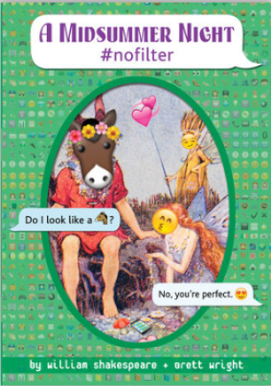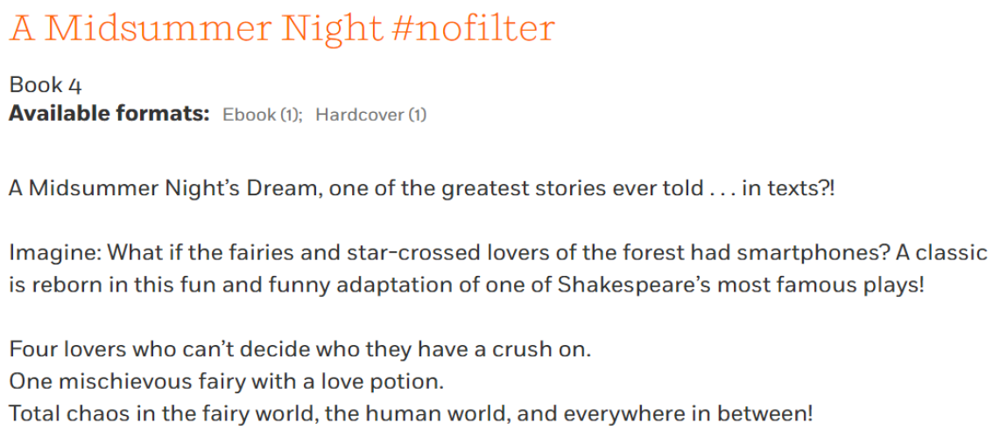
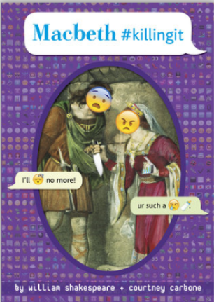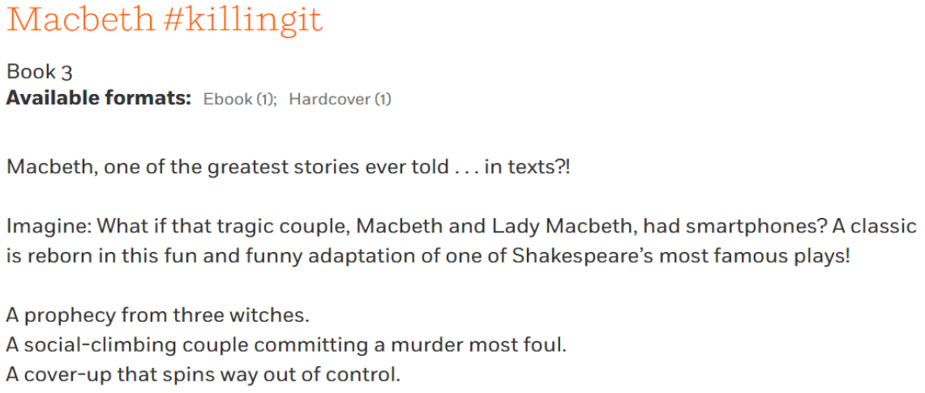
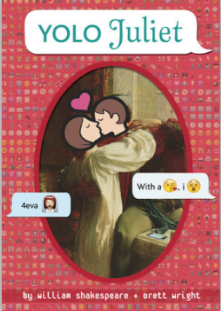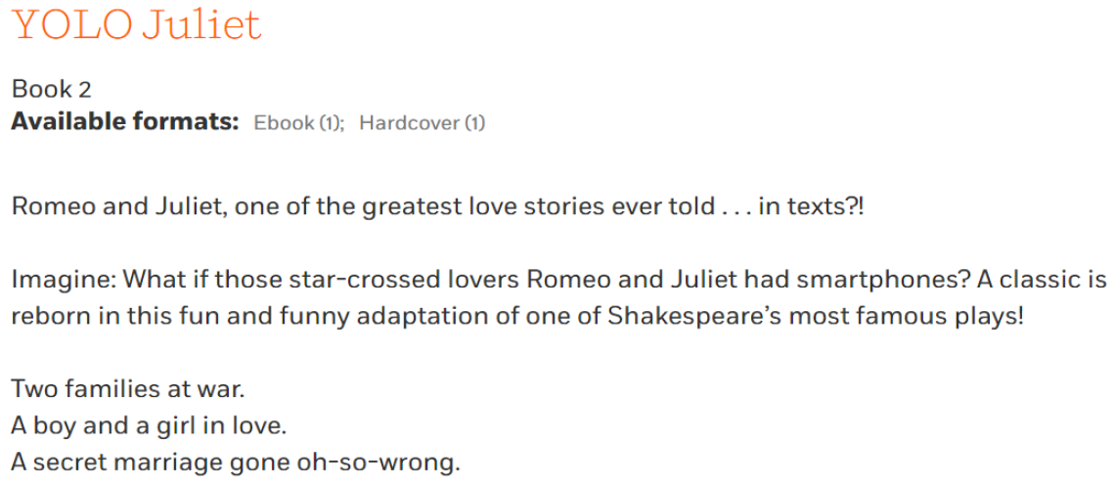
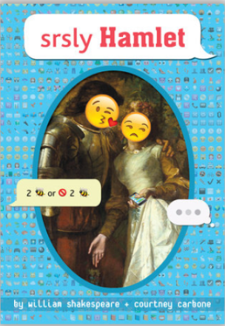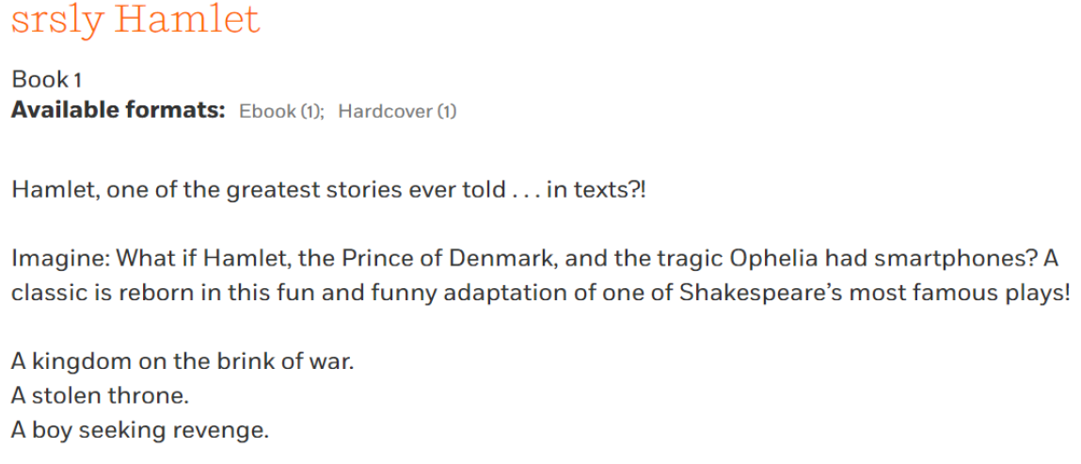

Shakespearean compliments
Screenshot from https://www.folger.edu/ date accessed 27/03/2019/.

