Creative arts student workbook character Stage 2
Name:
Class:

Overview
You will learn about the role of character in the creative arts. Character is the way people are represented in a narrative or story. Characters can help to create meaning in songs and artworks.

Lesson 1
Character in a song

 Resources
- Household items that can be used to make sounds
- Art supplies:
- Paper and pencils
- Artwork previously created of a mythical creature
- Household items that can make a sound for soundscape compositions
- Device to record compositions

Warm up (sing a song)
Listen to and follow Where the Creatures Roam Animated Score by Paul and Tracy Burjan. Get to know the song using the animated score
Keep the beat while you learn the song. Remember that the beat stays the same and is the pulse underneath the music.
Follow the melodic contour of ‘Where the Creatures Roam’ using movement to support the learning. This means moving your body or hands up and down as the pitch changes.
Learn to sing the song using the lyrics below.

‘Where the creatures roam’
By Tracy and Paul Burjan
Chorus 1
Africa, where the great creatures roam,
We know about the lion and the big hippo.
But who has heard of Ninki Nanka?
Ninki Nanka who?
Get the medicine man, he’ll tell you what is true.
Verse 1
Down in the swamps of Gambia,
Lives the great dragon monster called Ninki Nanka.
So don’t go and play, don’t go and stray,
He has mirrored scales, a big long tail and gobbles up his prey.
Chorus 2
Africa, where the great creatures roam,
We know about the zebra and the big baboon,
But who has heard of Tikoleshe?
Tikoleshe who?
Get the medicine man, he’ll tell you what is true.
Verse 2
In the land of the Zulu, he sounds rather sweet.
Just 1 foot tall and hairy, but wait till you meet.
Whatever you do just don’t go to sleep,
Because that’s when he eats the toes right off your feet!
Chorus 3
Africa, where the great creatures roam,
We know the rhino, cheetah and giraffe call it home.
But what about the Yumboe?
Yumboe who?
Get the medicine man, he’ll tell you what is true.
Verse 3
Down beneath the Paps Hills of Senegal,
The silver haired Yumboe won’t eat your toes at all.
They dance by the moonlight and feast on fish.
And if you come across them, they just might grant you a wish.
Chorus 4
Africa, where the great creatures roam,
Now you know about some creatures there that also call it home.
The Ninki Nanka of Gambia,
And the Tikoleshe of South Africa.
The Yumboe fairy of Senegal,
There are far too many more to name them all Africa, where the great creatures roam,
Africa, strange creatures call it home.
What are African instruments?
Identify the sounds of the instruments being played. Reflect on why the composer may have chosen these instruments to represent mythical African creatures. What instruments are used a lot in African music?
Think about mythical creatures
Identify the mythical creatures used in ‘Where the Creatures Roam’.
- In Zulu mythology, a Tikoloshe is a dwarf-like water sprite.
- A Ninki Nanka is a legendary creature in West African folklore that is reptilian and possibly dragon-like.
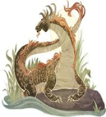
- Yumboes are a kind of fairy in the mythology of the Wolof people in Senegal, West Africa.
Describe a mythical creature
Who and what are these creatures? What do we know about their characters? Are they scary or kind, large or small, happy or sad? Write two adjectives to describe their appearance and their character.

Creature name | Appearance adjective | Character adjective
Tikoleshe
Ninki Nanka
Yumboe
 Make a mythical creature
Think about a mythical creature you could create.
Create a 2D artwork of a mythical creature of your choice. This can be done through drawing, painting or printmaking. Focus should be on the shapes and colours of these creatures. A page has been left blank for your artwork.
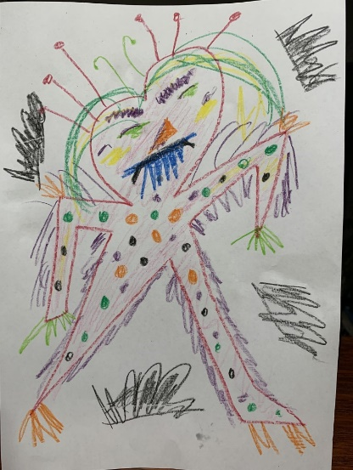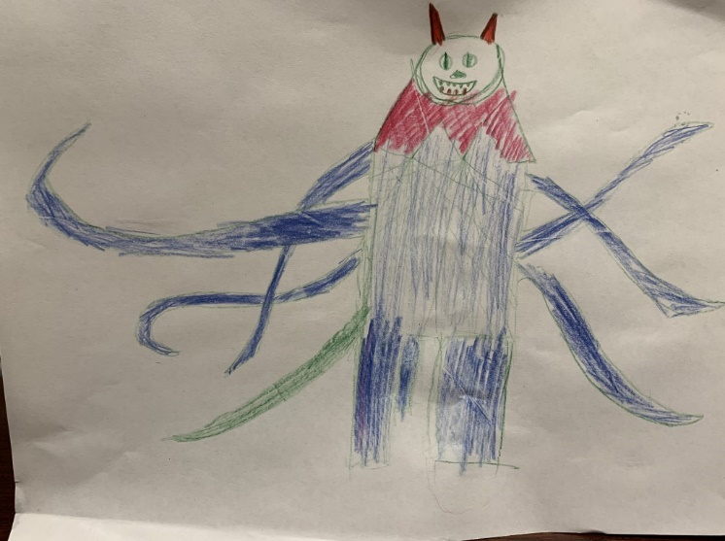
Show the character of the creature by giving them an expression. For example, are they scary or kind, happy or sad?

Page for your mythical creature artwork

Create a creature composition
Create a musical creature composition based on the artwork you created. This piece of music should be a soundscape, using sound to match your picture. There is no strict time limit on this soundscape but you must consider these musical concepts:
- structure – it must have a beginning, middle and an end with a climax somewhere
- tone colour – what ‘instruments’ will be used? For example, consider kitchen items, furniture, homemade instruments, body percussion, vocal sounds, sound effects and so on. For example
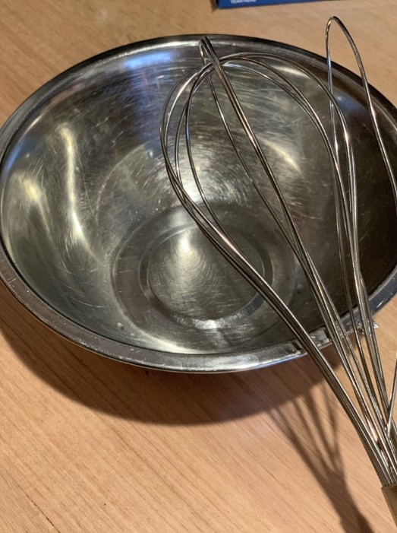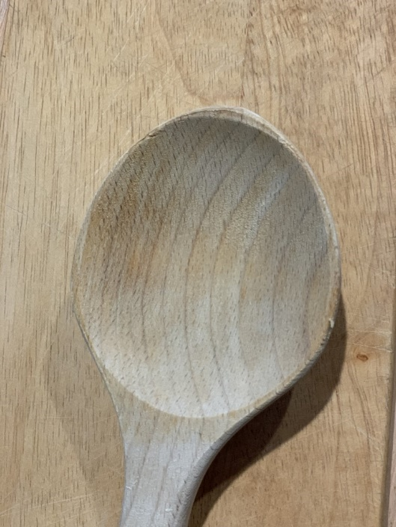
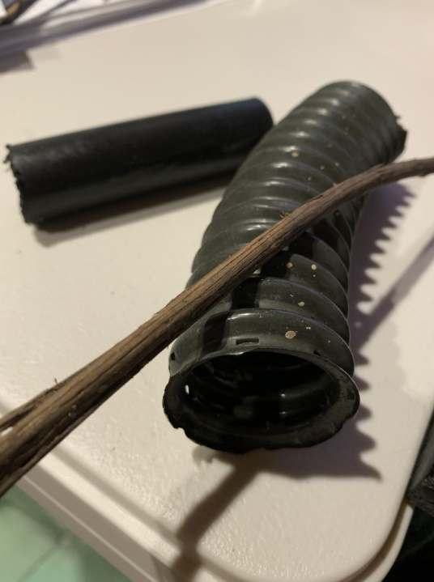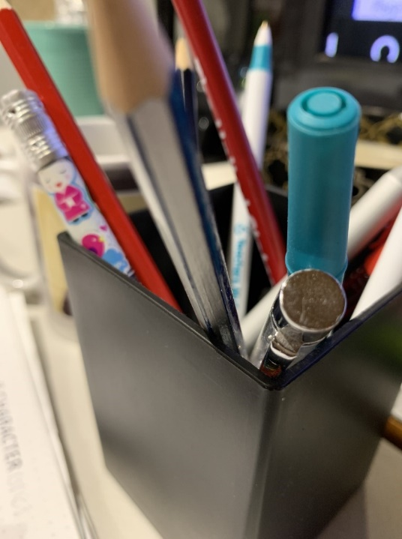
- duration – will it change tempo (speed)? Will it have a steady beat or rhythm or just be a series of sounds?
- pitch – will there be a melody, high or low pitched instruments and so on?
- dynamics – soft and loud sounds can be used to create tension or calm in the pieces.
Consider how the creatures would sound if they were kind, scary or other characteristics for example. Use whatever items you have in your house to create a composition such as furniture or other objects.
Make a recording
Video or audio record your composition using a device or a voice memo recording system in a smartphone. You should be prepared to share this at a later stage.

Lesson 2
During this activity you will explore character in visual artworks.
Resources
- Old, unused, clean and long sock
- Electrical, duct or masking tape
- Elastic bands
- Old paper such as newspaper or magazine pages
- Paints and paintbrushes
- ‘Shadow party’ poem
- Chalk
- Paper and pencil, crayon or texta
- Aluminium foil
- Black texta, pencil or paint

 Revise and discuss a song
Replay the music of ‘Where the Creatures Roam’ and sing through if you are able. Do you notice anything new this time about the notation? For example, how many beats are in each bar or what do you notice about the structure?
Examine the artwork created previously and describe their mythical creature to a household member.
Create a figurative sculpture
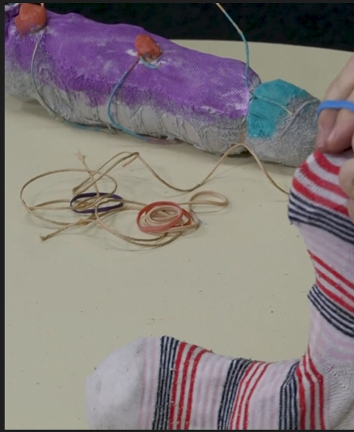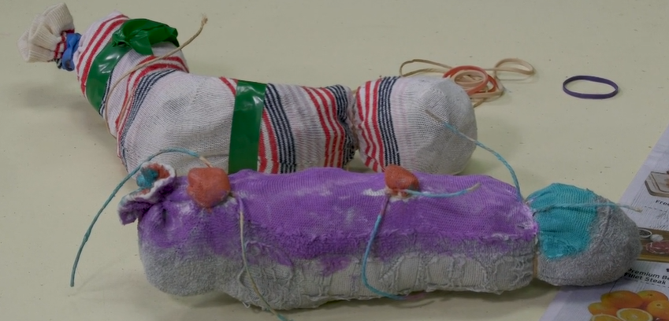
Create a mythical creature sculpture based upon the creature created earlier or you may choose to make a completely different one.
Finish and show it off
Decorate your sculpture and take a photo of it. Be prepared to share this at a later stage.
Read a poem
Read the ‘Shadow party’ poem.
‘Shadow party’
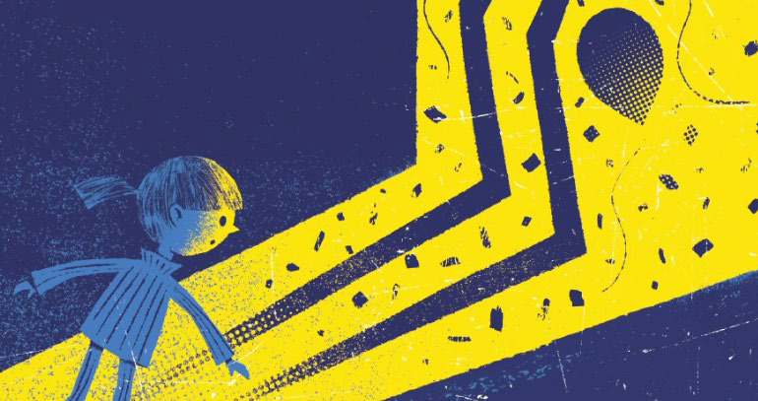
Poem by Sioban Timmer, illustrated by Christopher Nielsen
Copyright: The School Magazine, Blast Off, Issue 2, 2020
‘People think that shadows go
Each time we lose the light
But that’s when shadows party—
When the daytime turns to night
We just assume our silhouette
Is waiting for our call
But when we close our eyes at night
Well, they’re not there at all
In sunshine they just copy (Which can really be a bore) But free to roam within the dark
They dance and fly and soar
The darkness makes it possible
For them to leave your side
And when our shadows get the chance
They wander far and wide
So every night while you’re in bed
And sleep is close to hand
You can dream about your shadow
Dancing free across the land.’

What does the poem mean? What do you know about shadows?
Play with shadows
On a sunny day or in a dark room with a torch, use the creature sculpture you made earlier to explore the shadows you can create. Trace these sculptures with chalk on the ground or using paper and pencils in indoors.
You may need a household member to help hold the creature in place.
Strike a pose
Pose with your body to represent some sort of movement and explore your shadow. With assistance, take a photo or again trace the shadows where possible.
Make a model
Using either Lego characters, a doll or any other figurines you may have available, model the body shape you created earlier. Now try to re-create this pose using aluminium foil as a 3D sculpture.
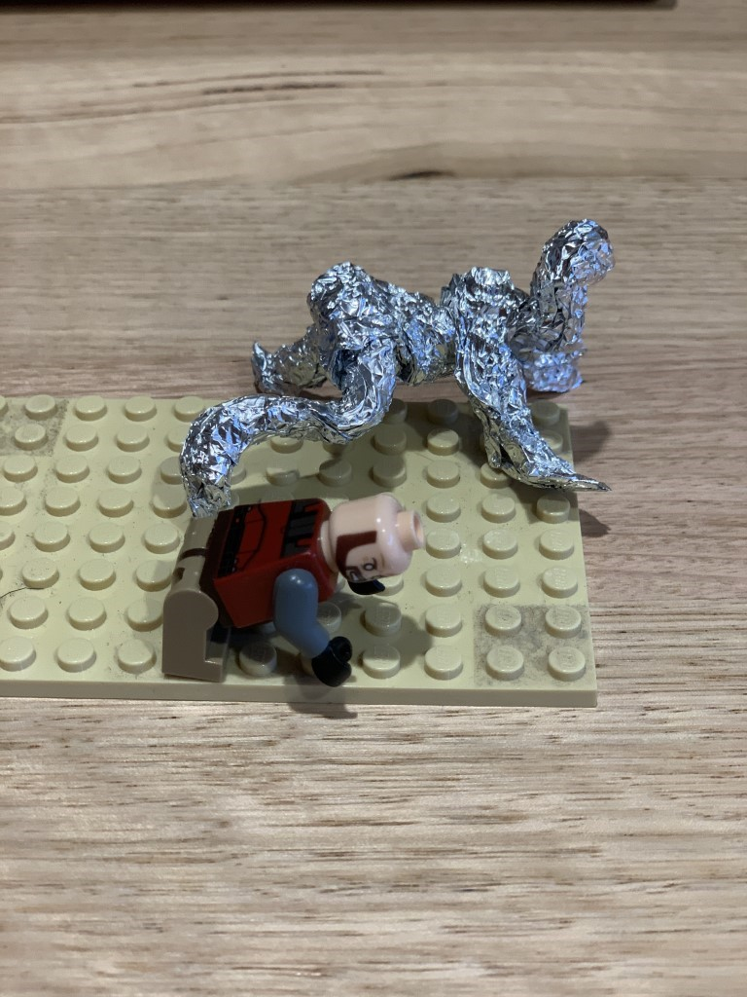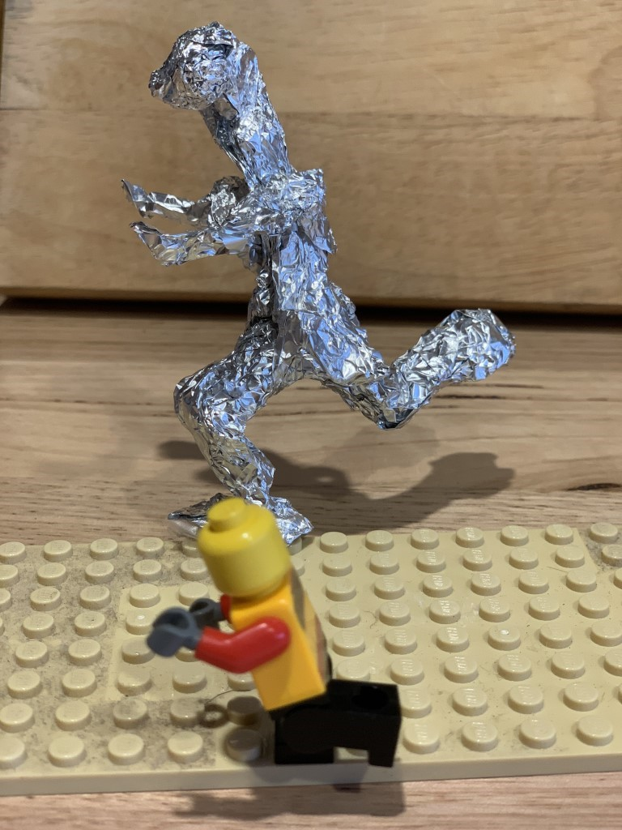
Draw a sculptural shadow
Use this sculpture to create a shadow. Draw or trace the shadow of the sculpture and fill in using black marker, pencil or paint. Sticky tape or Blutak the figure prior to doing your drawing to make sure it is stable. The next page has been left blank for you to do your shadow drawing.
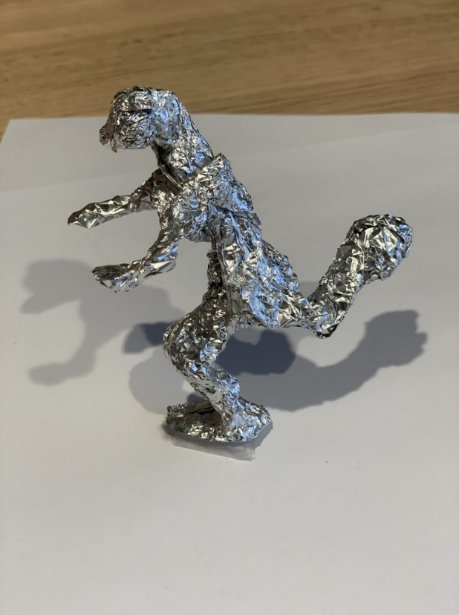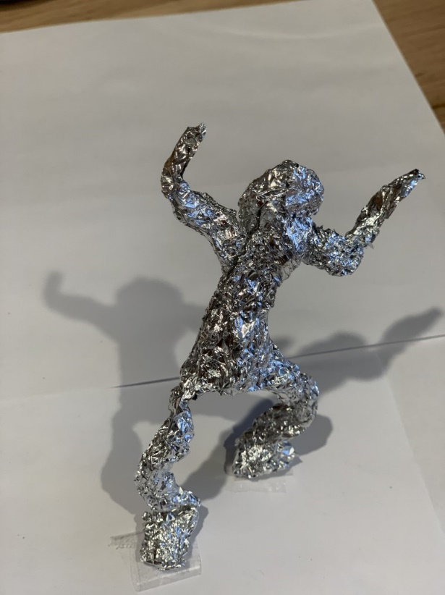

Blank page for your sculptural shadow drawings
Draw an action figure
If you want to take this activity further, draw the figures too. Remember that the focus is on the shapes of the figures, not the fine details. There is no need for a face. The next page has been left blank for you to experiment with figurative drawing.
Use this to create a variety of action figures or characters that may in turn be used to create sculptures.
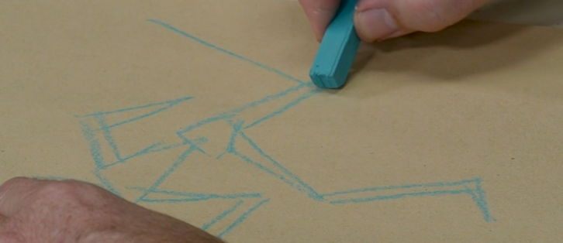
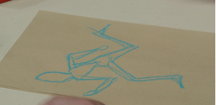

Blank page for your figurative drawings

