Assessment task two
Stage 5
Subject: Year 9 Music

Unit of work: The concepts of music - Task two - listening and musicology
Issue date:
Due date:
Outcomes
A student:
5.7 demonstrates an understanding of musical concepts through the analysis, comparison, and critical discussion of music from different stylistic, social, cultural and historical contexts
5.8 demonstrates an understanding of musical concepts through aural identification, discrimination, memorisation and notation in the music selected for study
5.9 demonstrates an understanding of musical literacy through the appropriate application of notation, terminology, and the interpretation and analysis of scores used in the music selected for study
5.12 demonstrates a developing confidence and willingness to engage in performing, composing and listening experiences.

Task description
For this task you are required to complete an open book, music theory and listening test which will take place during class time. The assessment consists of two parts, part A and part B. You must complete both parts.

Part A - 40 marks
Part A will contain short answer questions in relation to both duration and pitch concepts which we have done in class this semester.
Through listening, you must be able to identify:
- note values through rhythmic dictations (8 marks)
- the time signature in a piece of music (5 marks)
- major and minor chords (5 marks)
- major and minor melodies (5 marks)
- major and minor keys within a piece of music using a score (5 marks)
- elements of duration using a table for two selected pieces of music (6 marks)
- elements of pitch using a table for two selected pieces of music (6 marks)

Part B - 20 marks
Part B will consist of two questions.
- You will be given one musical excerpt and will be asked to produce an extended paragraph response in relation to the duration elements found within the music. (10 marks)
- You will be given one musical excerpt and will be asked to produce an extended paragraph response in relation to the pitch elements found within the music. (10 marks)
Total: /60
The student:
Criteria | Mark
- demonstrates an excellent ability to identify and describe the concepts of pitch and duration in unprepared listening examples.  - demonstrates excellent knowledge and understanding of music in a range of styles, periods, genres and social, cultural and historical contexts.  - demonstrates excellent musical literacy skills through the understanding and application of notation and musicianship terminology.  - demonstrates a strong ability to identify and describe the concepts of pitch and duration in unprepared listening examples.  - demonstrates strong knowledge and understanding of music in a range of styles, periods, genres and social, cultural and historical contexts.  - demonstrates strong musical literacy skills through the understanding and application of notation and musicianship terminology. | A (51-60)
- demonstrates a strong ability to identify and describe the concepts of pitch and duration in unprepared listening examples.  - demonstrates strong knowledge and understanding of music in a range of styles, periods, genres and social, cultural and historical contexts.  - demonstrates strong musical literacy skills through the understanding and application of notation and musicianship terminology. | B (39 - 50)
- demonstrates a sound ability to identify and describe the concepts of pitch and duration in unprepared listening examples.  - demonstrates a sound understanding of music in a range of styles, periods, genres and social, cultural and historical contexts.  - demonstrates sound musical literacy skills through the understanding of notation and musicianship terminology. | C (27-38)
- demonstrates basic musical awareness in the identification or description of the concepts of pitch and duration in unprepared listening examples.  - demonstrates a basic understanding of music in a range of styles, periods, genres and social, cultural and historical contexts.  - demonstrates a basic ability to identify notes of pitch, note values and musicianship terminology. | D (15 - 26)
- makes an attempt to describe some aspects of the concepts of pitch and duration in unprepared listening examples.  - demonstrates a limited understanding of music in a limited range of styles, periods, genres and social, cultural and historical contexts.  - demonstrates a limited ability to identify notes of pitch, note values and musicianship terminology. | E (1-14)

Listening test

Listening and musicology
This is an open book assessment in two parts. Please ensure you have your book and any study notes ready before you start.

Part A: (40 marks)
- Rhythmic dictation (eight marks)
The teacher will clap to you each example three times for you to notate the rhythm on the stave below:
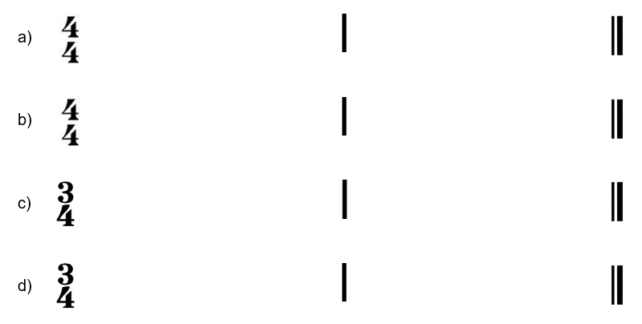
- Major or minor chords? (five marks)
The teacher will play a major or minor chord on the piano and you need to identify whether the chord played is major or minor and write your answer below:
  - …………………………..
  - …………………………..
  - …………………………..
  - …………………………..
  - …………………………..
- Major or minor melodies? (five marks)
The teacher will play a major or minor chord on the piano and you need to identify whether the chord played is major or minor and write your answer below:
  - …………………………..
  - …………………………..
  - …………………………..
  - …………………………..
  - …………………………..
- Key signatures - name the key signature of each melody below. For example, A major. (five marks)
Number | Melody example | Answer
1.
2.
3.
4.
5.
- Name the time signature of each excerpt as either 4/4, 3/4 or 6/8 (five marks)
- Excerpt 1 by Ariana Grande (00:04:17) (date accessed 11/11/20) …………………
- Excerpt 2 by Grieg (00:02:41) (date accessed 11/11/2020) …………………………..
- Excerpt 3 by Shostakovich (00:03:48) (date accessed 11/11/2020) ……………….....
- Excerpt 4 by BlackPink (00:03:36) (date accessed 11/11/2020)………………………
- Excerpt 5 by The Beatles (00:02:45) (date accessed 11/11/2020) ……………………
- Complete the duration table below according to the two excerpts your teacher will play for you. You will receive three playings for each example. (six marks)
Piece one: ‘Don’t Start Now’ by Dua Lipa (00:00:11 – 00:00:36) (date accessed 11/11/2020)
Piece two: ‘The Red’ by Chevelle (00:00:16 – 00:01:00) (date accessed 11/11/2020)

Duration
Piece | Time signature | Beat | Note values | Tempo | Bar length | Syncopation
1.
2.
- Complete the pitch table below according to the two excerpts your teacher will play for you. You will receive three playings for each example. (six marks)
Piece one: The Lion King: ‘Be Prepared’ by Tim Rice and Elton John from the Lion King (0:00 - 0:45) (date accessed 11/11/2020)
Piece two: ‘Canon in D’ by Pachelbel (00:00:00 – 00:00:41) (date accessed 11/11/2020)

Pitch
Piece | Tonality | Main pitch instrument | Steps/Leaps | Contour | Range | Register
1.
2.

Part B: (20 marks)
  - Write an extended response (approximately two - three paragraphs) about the duration elements found within the excerpt of ‘Dance Monkey’ by Tones and I (00:00:00 - 00:01:22) (date accessed 11/11/2020). You will be given six playings in total. (ten marks)
Write an extended response (approximately 2 - 3 paragraphs) about the pitch elements found within the excerpt of ‘Exist for Love’ by Aurora (00:00:00 – 00:01:15) (date accessed 11/11/2020).

