Year 7 English student booklet: Welcome to High School and welcome back to poetry

Duration of Unit
Year 7, Term 1, Weeks 1 – 5

Purpose of this learning
- The main purpose is for you get the chance to learn some strategies to help you as you start high school in a positive way.
- You will have a chance to explore different experiences of school by reading, thinking about and writing a poem and working collaboratively to teach your own poetry lesson.

Key questions of the unit
- How can we make our classroom a positive learning environment for everyone by sharing our voices?
  - What are my rights and responsibilities in the classroom?
  - How can I be a leader in my own learning?
  - How can I contribute to the learning of others?
  - Why is it important to listen to others and value their point of view?
  - How can I express my point of view positively in the classroom?
  - How can self-reflecting enhance my learning?

Syllabus outcomes
A student:
- EN4-1A responds to and composes texts for understanding, interpretation, critical analysis, imaginative expression and pleasure
- EN4-4B makes effective language choices to creatively shape meaning with accuracy, clarity and coherence.
- EN4-9E uses, reflects on and assesses their individual and collaborative skills for learning

How you show what you know and can do
Assessment for your learning – KWL charts, teacher and peer feedback, self-reflection activities.
Assessment as you are learning – a range of individual and group tasks (including written and spoken tasks) that show you are: (a) learning the various skills and (b) developing the ability to think deeply (weeks 1–4) including writing a poem (Week 4).
Assessment of what you have learned – a group presentation on poetic techniques (week 5).

Evaluation
You will complete a KWL chart throughout the learning unit. You will also complete an evaluation of the unit at the end of your learning. You will have the chance to think about what you what learned and the positives and negatives of the learning tasks.

Activity 1: Developing personal learning goals for English
What are your strengths in literacy? Use these sentence starters to write at least 3 strengths: I know… / I like…. / I’m good at….
I learn best when…. (for example, in complete silence, in group work)
I would like to be better at… (for example, organisation, handwriting, developing writing ideas, spelling, typing, speaking up in class, working with others)
Something I find really challenging is…
What I think I could do to help me improve / extend my skills…
What I think my teacher could do to help me improve / extend my skills…

Activity 2: Building respectful relationships – Group work roles
Everyone will have the opportunity to try each role. Every group member also has the responsibility to contribute to the discussion / activity.

Pre-activity student reflection:
The role I usually took in Primary school was __________________________________ because
______________________________________________________________________________
Pre-activity prediction: The role I will be best at is ______________________________ because
______________________________________________________________________________
Pre-activity: Which role don’t I want to try, and why? ____________________________________
______________________________________________________________________________
Pre-activity: Why is it important to learn how to do all the roles? ___________________________
______________________________________________________________________________
Two reasons I like group work are: __________________________________________________
______________________________________________________________________________
Two reasons I don’t like group work are: ______________________________________________
______________________________________________________________________________

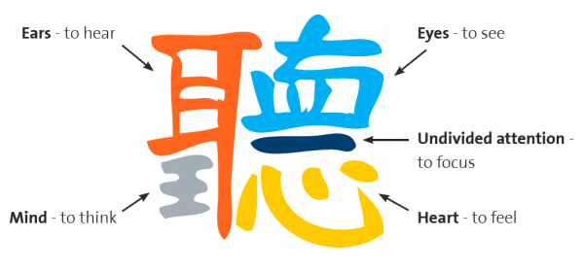
Activity 3: Building respectful relationships – Active listening
This is the Chinese symbol for 'Listen'.
Why do you need more than ears to hear?
Today we are going to be learning about active listening.

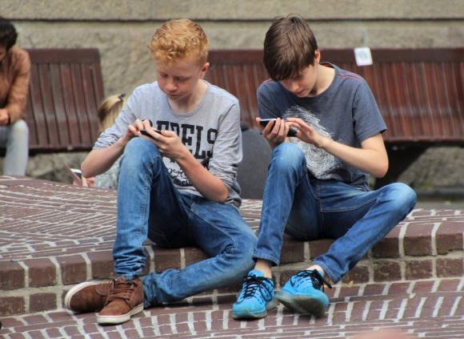
Class discussion: What is active listening?
In your groups of 4, allocate one of the group roles to each person. Only the recorder needs to write anything at this stage (record the group discussion on a separate piece of paper). The presenter will be reading some key points to the class. You have 10 minutes.
Discussion starters:
Think about a time when someone listened to something that you wanted to talk about. What do good listeners say and do? What about bad listeners?
How can you use your body and face to show what ‘good listening’ looks like? Are the boys in the photo modelling active listening? What effects are mobile phones having on active listening?
Why is active listening important?
After the whole class discussion, write down 4 – 5 points on how and why you can actively listen to others in the space below.

Post group work reflection #1:
On a scale of 1 – 10, 10 being best, how well do you feel you demonstrated respect for the opinions of others in the group?
What is one skill you have that you feel really benefitted the group?
If you had done this yourself, would the outcome have been better or worse?

Homework Task: Look back at the Chinese symbol for listening. Design your own logo for active listening. Write a few sentences down the bottom to explain what it means. Hand in your work on an A4 piece of paper. They will be displayed around the room.

Activity 4: Active listening – Information gap
Some students will read out the missing information. You are allowed to ask questions and practice your active listening. For example, ‘We have Science in Science Lab 3 every Tuesday and Thursday after lunch. We also have it period 4 on a Thursday.’

 | MONDAY | TUESDAY | WEDNESDAY | THURSDAY | FRIDAY
Period 1
Period 2
Recess
Period 3
Period 4 |  |  |  | Science  Science Lab 3
Lunch
Period 5 |  | Science  Science Lab 3 |  | Science  Science Lab 3
Period 6

Homework and class activity 5: Student voice - having your say.
- Look at your own Year 7 timetable. What are 1 – 2 things you would change and WHY?
- Write a one minute speech to convince the whole class and the teacher that your ideas should be used.
- Practice saying your reasons with a partner. Get and give some feedback to make your arguments stronger.
- Present revised speech to the class.
Beyond the classroom: If you really wanted to change the timetable, who would you speak to? How would you do it? Do you feel like you would be listened to? Do you feel you have rights? Do you feel confident in using your ‘voice’?

Activity 6: Student rights and responsibilities
- What are student rights within the classroom / school? Brainstorm in your groups and create a list. Remember to swap roles in your group.
- For every right, you must write a matching responsibility.
- Read the UN Rights of the Child online at http://www.unicef.org.au/Upload/UNICEF/Media/Our%20work/childfriendlycrc.pdf
- Discuss: similarities / differences to your own list of rights.
Key idea: We all have rights, but these rights come with responsibilities

Right: The right to an education
Responsibility: The responsibility to come to school and learn

Your group’s list:
Classroom rights | Classroom responsibilities
The class list:
Classroom rights | Classroom responsibilities

Activity 7: Top 10 excuses for missing homework.
(Circle, then correct the spelling mistakes in each sentence. There are 2-3 mistakes per line)
- I bought my brother’s bag to school by ackident!
- I was skared do it because my room is huanted by a goast who steals papers.
- I coudn’t do my homework because I was at a ralley for hire teacher pay.
- I didn’t do it because I didn’t want to add to you’re already heavey workload.
- I had a cold and I snezed on the homework. I thort you’d get sick if I brougt it in.
- I was abdukted by aliens last night and they took it as a sample of human handewriting.
- I was realy sick yesterday and couldn’t do any homework. The only reson I came to school today is I didn’t want to miss any more work. I love school.
- I was so busy voluntering at the hopital and the nursing home, I just forgot to do it!
- My Mum bought a paper shreder and we needed a peace of paper to see if it was working.
- Our heater broke and I had to burn all my school equippment to stop from freezeing to death.
Group discussion: What are teachers’ rights?
Using the above activity as a conversation starter, brainstorm teachers’ rights and responsibilities in the classroom in your groups. How many are the same as the students’ rights and responsibilities? Change roles again and have one person write down your main ideas.
Teachers’ rights | Teachers’ responsibilities

Post group work reflection #2:
- If you were to work with this same group again, what is one change the group could make to work together more effectively?
- How would you rate yourself, on a scale of 1 – 10, on how well you were willing to agree with group decisions? What could you do to move yourself up a number on that scale?
- If you could pick one person in the group to whom to give a specific compliment about their work in the group, who would it be and what would you say?
- Now that you’ve experienced each group role, which are you best at? Look back at your prediction on page 3. Were you right?
We are now going to start a mini poetry unit which focuses on UNLOCKING and USING student voice. Your homework task is to bring in your favourite poem. Next period, you will read your poem to your group and tell them why you like it!

Year 7 Poetry Unit

Activity 1: KWL chart
What do you already know about poetry? Fill the columns below.
Before we start | Before we start | After we learn
What do you KNOW about the topic? | What do you WANT to know? | What did you LEARN?

Activity 2: In your groups, collate your results and have your group presenter share them with the class.
Key idea: Poets use techniques to highlight key messages or ideas
How worried are you about the persona in the following poem?

My heart is completely broken.
I have cried a million tears.
I’m never getting out of bed.
Not for a zillion years.

Activity 3: Poetic techniques
We will be learning about the following techniques: metaphor, simile, personification, alliteration and rhyme. In your groups, fill in JUST the definitions in the following table. If you don’t know any of them, check online, with another group or ask the teacher!

Technique | Definition | Example | Effect
Metaphor
Similes
Personification
Alliteration
Rhyme

Activity 4A: The effect of techniques (imagery)
Many techniques, such as similes, metaphors and personification, create a picture in the reader’s head – also known as imagery. Draw the pictures you see with the following example and write whether they are examples of similes, metaphors or personification.

My sisters’s teeth are sharp, white daggers. I ate like a pig.
This is an example of __________________ This is an example of _________________

Her hair was an angry snake twisted around her head. His face is as round as a balloon.
This is an example of __________________ This is an example of _________________

The sun smiled down on the earth Draw your own and see if the person
This is an example of _____________________ sitting next to you can guess what it is!

Activity 4B: The effect of techniques (rhythm and sound effects)
Other techniques, such as alliteration and rhyme, create RHYTHM and SOUND EFFECTS.
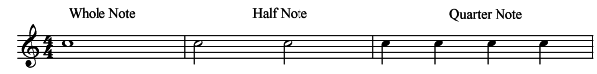
The following are the questions based on the above – get ready to answer one!

What subject do you learn this in?
What do you know about this?
What are the names of each type of note? For eg: quaver…
What is metalanguage? Can you give me some examples of metalanguage from this unit?
Clap the following rhythms (one line per student).
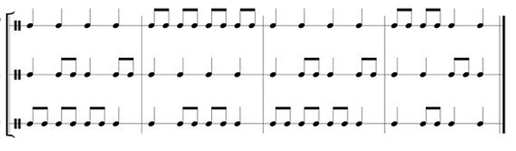
How does this relate to poetry?
Rhythm is the musical quality of language. True or false?

Creating rhythm through syllables and meter
Meter is a generally regular pattern of stressed (/ ) and unstressed ( x ) syllables in poetry. Just as we can measure distance in meters, we can measure the beats in a poem in meter.
In English, one syllable is always stressed (emphasised) more than others.
Rule 1: In most two syllable nouns and adjectives, the stress is on the first syllable. For example:
/ x / x / x / x / x / x / x
TAble CLEver PREtty SAMples PURple CHIna HAppy

Rule 2: In most two syllable verbs and prepositions, the second syllable is stressed. For example:
x / x / x / x / x / x / x /
reLAX reCEIVE diRECT aMONG aSIDE beTWEEN deCIDE

Say each of the following words… what pattern do you notice?
PREsent / preSENT SUSpect / susPECT
OBject / obJECT PROject / proJECT

Creating rhythm through alliteration
Alliteration is the recurrence, in close succession, of the same consonant sounds, usually at the beginning of words. For example, "Peter Piper picked a peck of pickled peppers" The alliteration of the ‘p’ sound creates a fast rhythm that is hard and fast.
Alliteration also helps emphasise certain words. Why do we use highlighters? To make words stand out. Alliteration is way of making some words stand out, which emphasises (or highlights) the meaning contained in those words.
Alliteration also creates different moods or tones. The sound of alliteration can help create the mood or tone of a poem or piece of prose. For example, alliteration with an "s" can create a sound like a snake, which can contribute to a dangerous mood.
For example, “The students celebrated the cessation of school by selling cinnamon soaps to innocent senior citizens”.
The S / Ce / Ci / Cy sounds throughout the sentence create a rhythm and connect the words together.Please note: Not every word in a phrase must be alliterative, this is an exaggerated example.
Activity: Write two sentences – one alliterating a hard sound ‘D’ and one a soft sound ‘L’. You may be asked to read them aloud and compare the sound effects and rhythm they make. What type of mood does each sound create?
‘D’ sound: ____________________________________________________________________
Mood created: __________________________________________________________________
‘L’ sound: _____________________________________________________________________
Mood created: __________________________________________________________________

Creating rhythm through rhyme
Rhyme creates rhythm which can;
- unify poems
- make them easier to memorise
- create relationships between the rhyming words
- highlight certain words by making them not rhyme (when the reader expects one)
For example,
The rhyme scheme is the pattern in which rhyming happens. The rhyme scheme of this poem is a,a,b,b,c,c,d,e.
Until the last line, each line has 6 syllables and the rhyming pattern is predictable. What is the effect on the reader of having the last word not rhyme and the meter (syllable pattern) change?
Also note the change from the soft ‘s’ alteration to a hard ‘d’ sound. WHY?
We waited till he snored a
Then quietly snuck on board a
The boat was finally free b
We all set off to sea, b
The moon was silvery white, c
The sea was swamped with light; c
The fishes swam and splashed, d
Then we died. e

Activity 5: “Year 7 Roll call” poem
Read the poem aloud in your groups. Every student should read one stanza.
Year 7 Roll call by Karen Jackaman
Rhyme pattern Syllables
The bell sings its song, us kids sadly stand ______ _______
Walking to classes with bags in our hands ______ _______
The hallways are seas with dangerous tides ______ _______
As students all jostle to be first inside. ______ _______

Kids run to desks that they claim as their own, ______ _______
teachers are hawk-like, their prey is our phones ______ _______
Tweets float like feathers above teachers’ heads ______ _____
As laptops come out and Instagrams read. ______ _______

A hush fills the room as minds follow suit ______ _______
Thinking of problems obtuse and acute ______ _______
The teacher’s sweet smile to see us at work ______ _______
These moments are gold, her only real perk. ______ _______

The bell sings once more, we stand up to go ______ _______
To find Room 18 or someone who knows ______ _______
what was the homework and when is the test ______ _______
and many years before we can rest? ______ _______

Activity 6: Rhythm, rhyme, syllables
Read the poem again then:
- circle all the rhyming words.
- write down the rhyming pattern
- count the syllables and write them down
- find the examples of the techniques and fill in the second column of the table in Activity 3.
- EXTENSION: Can you find any other techniques used? (There are at least 3)
  - ___________________________________
  - ___________________________________
  - ___________________________________

Activity 7: Group discussion
- What is the purpose of this poem? Is there a deep meaning to this poem or is it really just about Year 7 roll call? Does a poem have to have a deeper meaning?
- Does the use of the techniques enhance the poem? If so, how? Why do you think the poet used them? (Enhance = make it better)
- Whose voice is being given in this poem?
- Can you find any other techniques used? (There are at least 3)
- Does this look like a poem? If it was written in another language, how would you know it was a poem?
- Write a question you want the teacher to answer.

Activity 8: Opinion continuums
Think about your opinion on the next five statements and circle the number that aligns to your opinion. You may be asked why you think this!

1  I strongly disagree | 2  I disagree | 3  I neither agree/disagree | 4  I agree | 5  I strongly agree

- A good poem must rhyme 1 2 3 4 5
- This poem has no deep meaning 1 2 3 4 5
- The use of poetic techniques enhances this poem 1 2 3 4 5
- A poem must have a deep meaning and techniques to be 'good' 1 2 3 4 5
- This poem was written in 2019 1 2 3 4 5

Context and clues
Key idea: Poetry, like all art forms, is a product of its context.
When and where a poem is written will impact on many things including the theme, the language, the form and the setting.

Activity 9: Context and clues in two poems
Read the Australian poem, “Slates and Sums” by Rhyll McMaster online. Rhyll was born in Brisbane in 1947. Compare and contrast this poem with the “Year 7 Roll call poem” written by Karen Jackaman in 2019.
 | Similarities | Differences
‘Slates and Sums’
‘Year 7 roll call’
Indvidual question: What context clues can you find to prove that “Year 7 Rollcall” was written in 2019? ___________________________________________________________________
______________________________________________________________________________
Class question: How has context shaped each poem?
Extension question: Which poem do you relate to more – and why?

Key idea: Poetry can be used to communicate a deep idea/message, or can be read just for fun. It's just communicating an idea - and there are no wrong ideas.

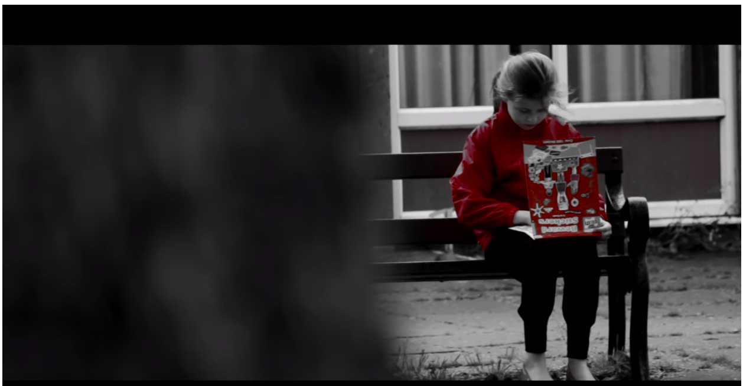
Activity 10: Poems communicating ideas
Watch: https://youtu.be/8JZ-P2vcFQs
“I AM Anti-bullying Film”,
Homework task: Re-watch the YouTube clip. How does the poem make you feel? Have any of your experiences affected your response to this poem? Explain why. You can present your opinion / reaction any way you like; for example, a page of writing, drawings, taping yourself speaking or a video. Your answers won’t be shared with the class unless you want to share them.
Homework task: What is the purpose of this poem? What idea is being communicated?
______________________________________________________________________________
______________________________________________________________________________
Film technique has been used to make the message clearer. List four things the filmmaker does to make you feel empathy for the persona in the poem.
1. ____________________________________________________
2. ____________________________________________________
3. ____________________________________________________
4. ____________________________________________________
Class discussion: Do you think that adding these film techniques made the poem more powerful?

Activity 11: Listening activity
How is the persona feeling?
______________________________________________________________________________
How do you know they are feeling this way?
______________________________________________________________________________
Who is Ben?
______________________________________________________________________________
How do you know this? (think about the word ‘even’)
______________________________________________________________________________
What is the context of this poem?
______________________________________________________________________________
How do you know this?
______________________________________________________________________________
______________________________________________________________________________
What is the purpose of this poem? What idea is being communicated?
______________________________________________________________________________
How do you know this?
______________________________________________________________________________
List all the ‘cold’ words
______________________________________________________________________________
How does this poem make you feel? Explain your answer.
______________________________________________________________________________
______________________________________________________________________________

Activity 12: Individual assessment task
Write a poem about your experience in Year 7. Make sure you include a metaphor, a simile, an example of personification and alliteration. Hand it in on a separate piece of paper. Use the following assessment rubric to guide your planning and writing. Expess your ideas.
Extension task: Write an an explanation of your poem’s meaning, purpose, context and the intended effects of the techniques.
Original Poetry Assessment Rubric
Category | 4 | 3 | 2 | 1
Word Choice | The poem includes vivid words and phrases that paint a picture in the reader’s mind. | The poem includes words and phrases that sometimes paint a picture in the reader’s mind. | The poem includes some descriptive words and phrases. | The poem lacks description and does not allow the reader to visualize the poem.
Grammar and Spelling | No mistakes (except purposeful mistakes to further the meaning) | Writer makes 1-2 mistakes in spelling and grammar. | Writer makes 3-4 mistakes in spelling or grammar. | Writer makes 5 or more mistakes in spelling or grammar and/or the project is presented in pencil.
Adding Personality (voice) | The writer seems to be writing from experience. The poem is unified around a clear focus/theme | The writer may be writing from experience, but there is some lack of ownership. | The writing does not “belong” to the writer. There is no clear point of view or voice. | The ideas and expression seem to belong to someone else. It does not seem like the writer has made a lot of effort.
Techniques | The writer uses 4 or more different techniques effectively | The writer uses 2 or more different techniques effectively | The writer uses less than 2 different techniques. | The writer did not include any techniques within their poetry.
Visual features | The form of the poem on the page is appropriate to the ideas expressed  There is a title, stanza breaks and ‘white space’ | The form of the poem on the page is mostly appropriate to the ideas expressed. More than 1 visual feature is used. | There is only one visual feature (e.g. title, stanzas or white space) | The form is not appropriate for the text or the ideas. There is no title.
Original poetry assessment self-reflection
Something I did well is:
______________________________________________________________________________
Something I need to work on is:
______________________________________________________________________________
Something I wish I had done is:
______________________________________________________________________________

Group work assignment: Teaching the class
Year 7 students need to know the following techniques;
- Form groups of 4 and assign group roles.
emotive language imagery narrative voice
hyperbole rhetorical questions
- Your group will need to select one of these techniques, find 1 – 2 poems which feature the techniques and teach the whole class what they mean and what effect they have on the reader. (Students can choose other techniques to prevent double up – must negotiate with the teacher)
- All group members will be required to speak during the presentation and have to have contributed to the script and the visual supports.
- The presentation must take between 10 -15 minutes.
- You must assess students’ learning of the technique during the presentation (any way you wish).
- When you are teaching the technique, you will need to have visual supports. You can do this any way you want, for example, PowerPoint presentation, using the whiteboard, posters or giving handouts.
- Study the assessment rubric on the next page for more information about the expectations of the group. You can self-assess using the rubric as a checklist before your presentation.
Due date: ______________

Criteria | Excellent | Meets expectations | Approaches expectations | Needs improvement
Teamwork | The group worked very well with each other and the presentation was shared equally among the group members. | The group worked well with each other and communicated well. Some members participated slightly more than others. | Group communicated relatively well with a few lapses in the presentation; some students dominated the presentation and others did not participate much. | Group did not work well together. There were obvious miscommunications and lapses in the presentation.
Focus | The technique is very clearly defined / explained with supporting examples from poems. The effect of the technique is made clear. The presentation is appropriate for Year 7 students. | The technique is explained with some examples from poems and some mention of the effect. The presentation is mostly appropriate for Year 7 students. | The technique explained but the examples do not support the explanation. No mention of effect. The presentation is somewhat appropriate for Year 7 students. | The technique is poorly explained with no examples. The presentation is inappropriate for Year 7 students.
Organisation | Clear introduction, main points and conclusion delivered with a clear purpose and structure. | The introduction and conclusion are clear and somewhat related to the whole; some transitions are used | The introduction and conclusion may be ineffective and not related to the whole; the logical plan must be inferred, as no transitions are used | No attempt has been made to compose an effective introduction or conclusion; there is no logical plan to the presentation
Materials | The medium through which the information is given (e.g.: PowerPoint) is used effectively and is appropriate for purpose and audience. Visuals are clear, engaging, and fully support the presentation. | The medium through which the information is given (e.g.: PowerPoint) is used effectively and is mostly appropriate for purpose and audience. Visuals are mostly clear, engaging, and support the presentation. | Some materials created to support the information but not appropriate for purpose and / or audience. Visuals are somewhat clear, engaging, and support the presentation. | Visuals are not clear, engaging, or supporting of the presentation.  OR no materials supporting the information.
Delivery | Eye contact is used effectively; gestures and verbal cues are used to reinforce particularly important ideas; students are very articulate. Adheres to time limit / requirement of 10 – 15 minutes. | Some eye contact is used; gestures and verbal cues are sometimes used to reinforce particularly important ideas; student is somewhat articulate. Adheres to time limit/requirement of 10 – 15 minutes. | Eye contact with the audience is hardly established; gestures and verbal cues are seldom used to reinforce particularly important ideas; students are not very articulate | No eye contact is made; gestures and verbal cues are not used to reinforce particularly important ideas. Students do not speak clearly. Significantly below the time requirements.
Assessment of class | Assessing the class’ understanding of the technique was effective and there is evidence that most / all students understood the concept. | The group assessed the class’ understanding but it wasn’t clear whether most / all of the students understood the concept. | An effort was made to assess the class’ understanding but results were unclear and /or didn’t assess effectively. | No assessment or assessment wasn’t valid.

Self-reflection task following group presentation
Use the following questions as a guide to reflect on and assess your learning within this collaborative task. You can present your information any way you like; for example, a page of writing, drawings, taping yourself speaking or a video.
- What role did you adopt within your group?
- How did you allocate tasks?
- What challenges and issues did you experience as a group?
- What process did you use to develop your presentation?
- What were your personal strengths and weaknesses as a member of the group?
- How would you personally do things differently if you were to work with the same group?
- How has this experience helped you to understand the role of groups in the workplace?
- What else have you learnt about working in groups?
- What percentage of the work do you think you did?
- How can I contribute to the learning of others?
- How can I be a leader in my own learning?
You will be emailed an evaluation of the unit. Please complete it. It helps the teacher know what works and what doesn’t work! If you have any ideas on how to make the unit better, please include them.

