Enrolment links
When you view courses in the tabs below, the information is linked to your personal MyPL profile and cannot be accessed by other users:
- Browse Learning
- My Learning
- Mandatory Training
- My Learning Transcript
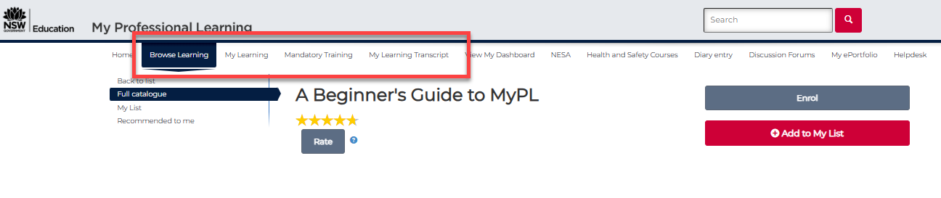

Details link – enrolment link for courses published in the public catalogue
- Select the hamburger menu (top right corner of your MyPL screen).
- Select Manage Learning.
- Search by course title keyword or by course number (type the details in the Search for Courses text box).
- Select the Search button.
- Select the relevant course title.
- Use the Details link – you can use the copy icon at the end of the link.
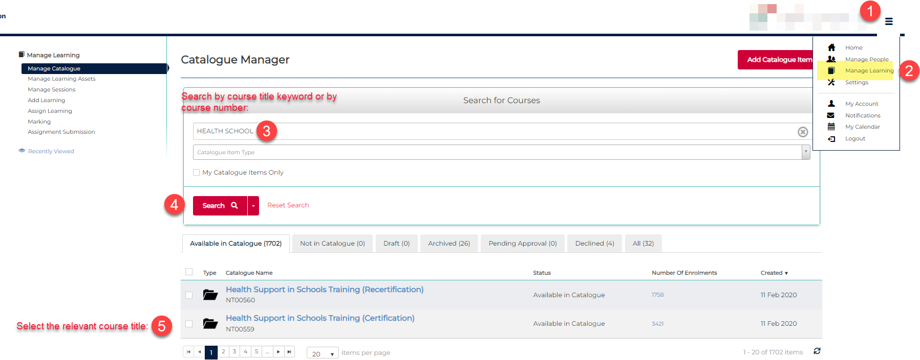

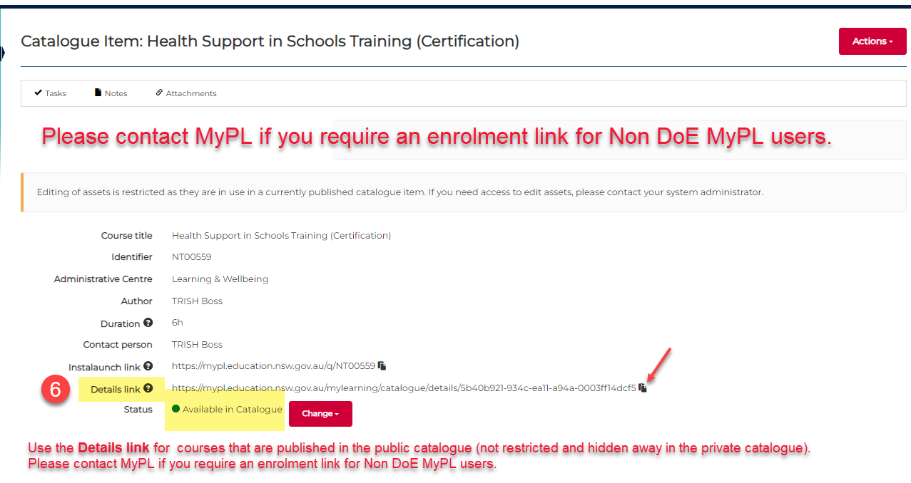
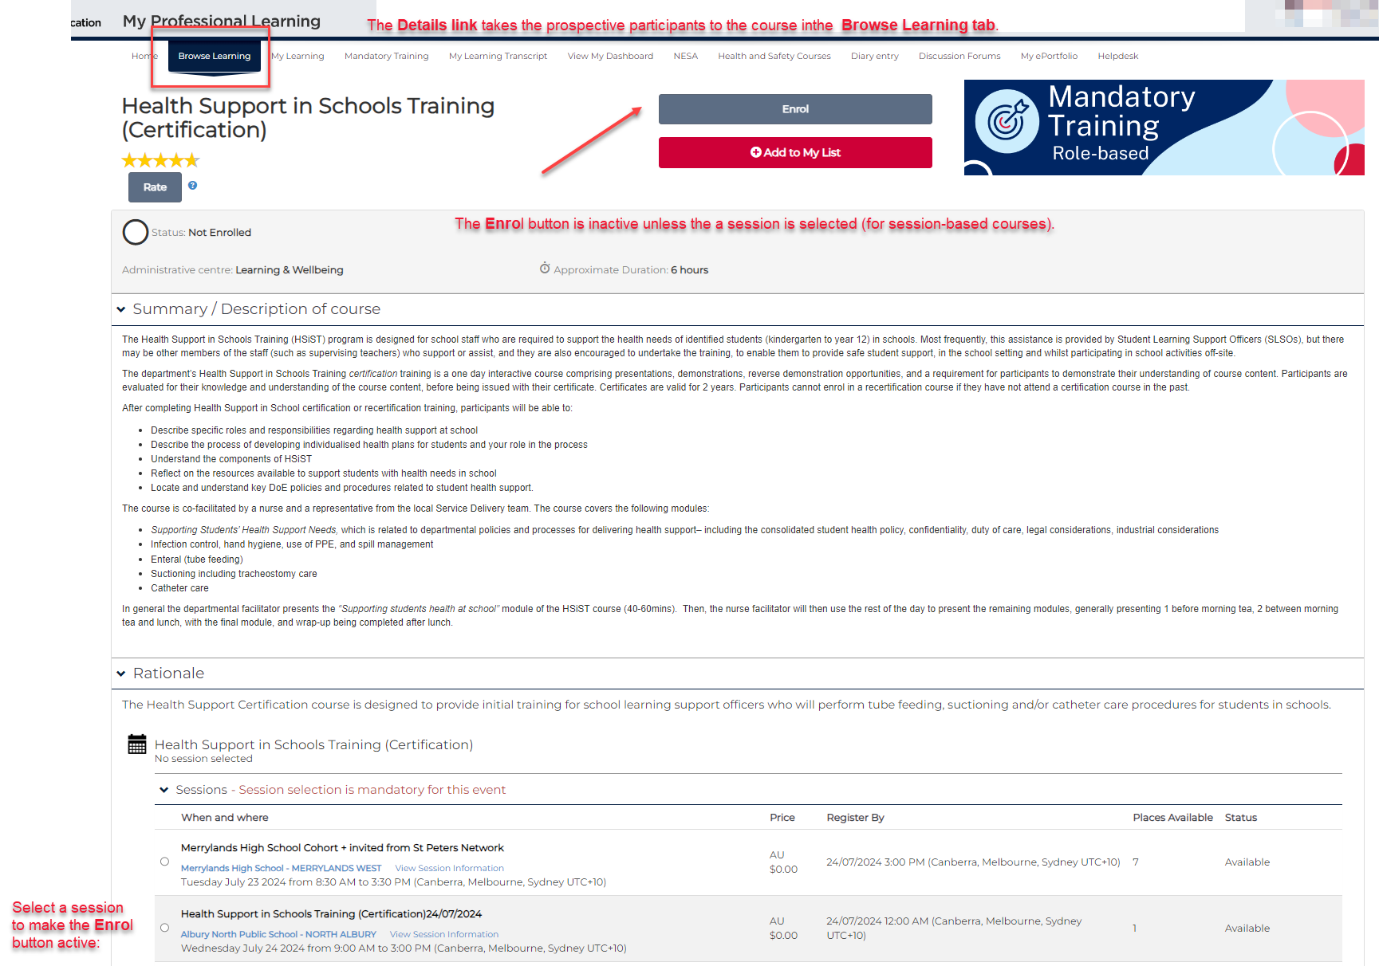

Details link vs Instalaunch link
The Instalaunch link is used for courses in the private catalogue and will automatically enrol a user in the course.
If used incorrectly, it may:
- place participants on a course waitlist without enrolling them in the correct session, or
- enrol users who only intended to view the course information.
For courses in the public catalogue, the Details link is used instead. This allows participants to view the course information, check available sessions, and then choose to enrol.
