How to schedule a session
Step 1: Select Manage Learning from the hamburger menu.
Step 2: Enter the course number or title keyword in the Search for Courses text box.
Step 3: Select the Search button.
Step 4: Click the course title.
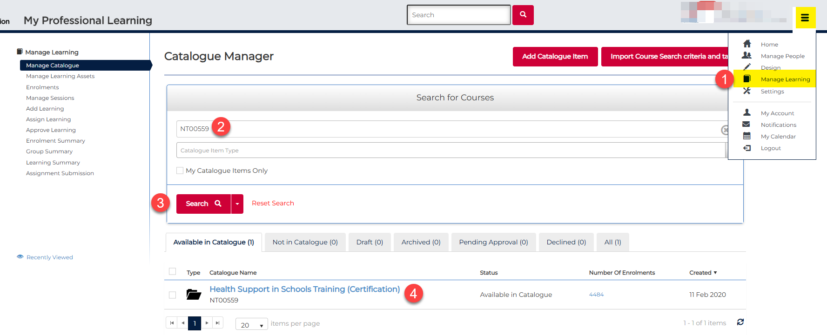

Step 5: Scroll towards the end of the screen until you see the Learning Event (look for the calendar icon).
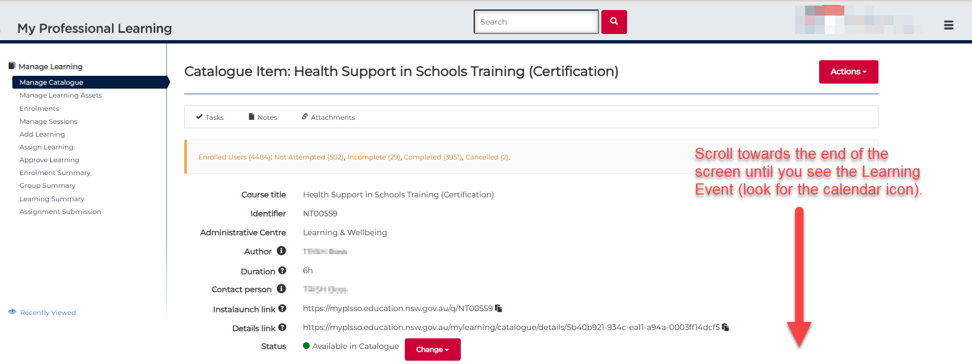

Step 6: Select the Learning Event asset.
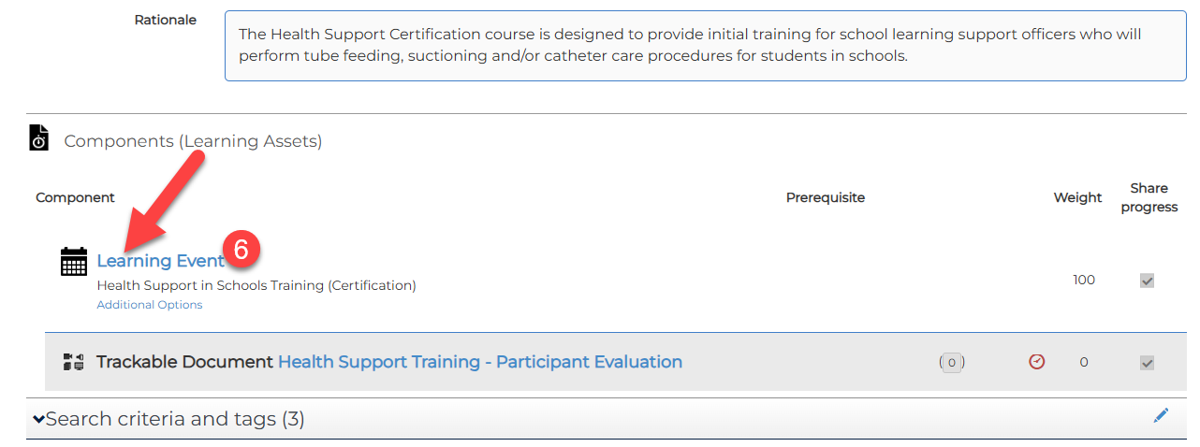

Step 7: Select the Add Session button – this step takes you to the New Learning Event Session screen.
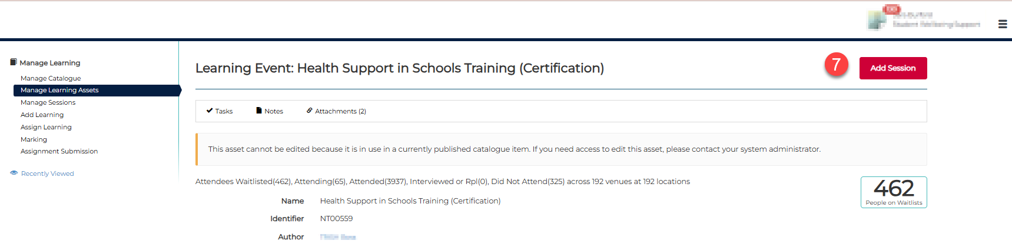

IMPORTANT: If you’re seeing Add Learning Asset you’re in the wrong place! That option is for creating a brand new course, not for scheduling a new session for an existing course.
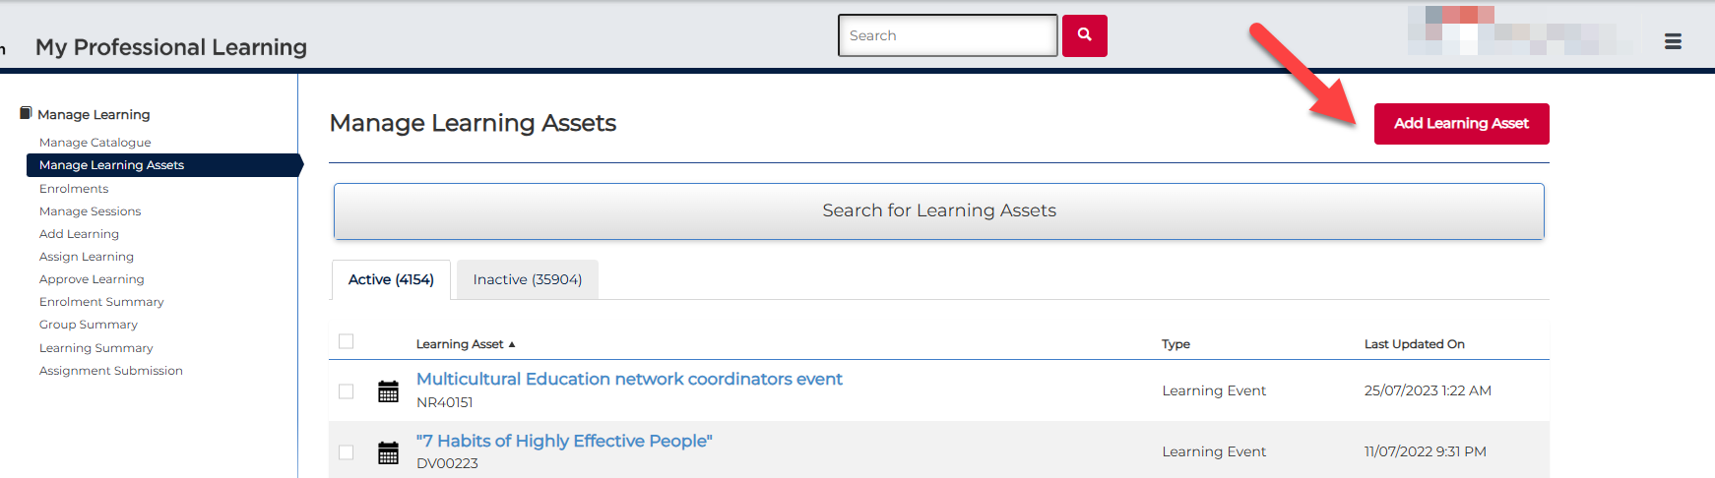

Step 8: Add the session Name (free text).
Step 9: Add the start date and start time (date and time session starts).
Step 10: Add the end date and time (date and time sessions ends).
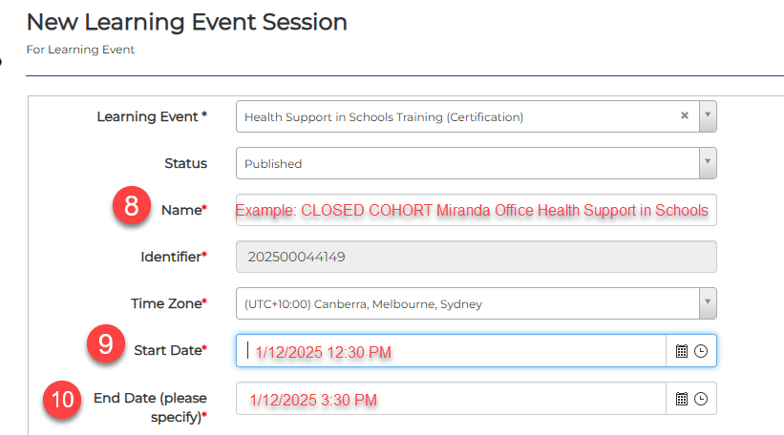

Step 11: Add the Venue details (new venue details can be added if required).
Step 12: Add the Registration Open date (date and time you want to open the session for enrolments.
Step 13: Add the Registration Closed date (date and time you want to stop enrolments).

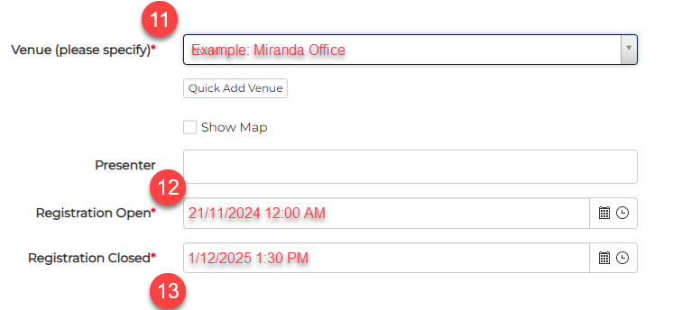

Step 14: Add the session duration e.g. 3h for 3 hours.
Step 15: Add the Min Attendance number.
Step 16: Add the Max Attendance number.
Step 17: Upload any relevant documents you want to share with the participants.
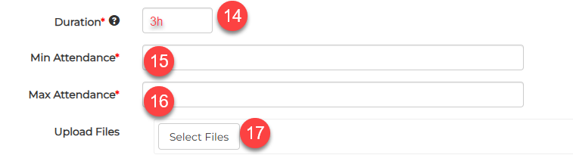

Step 18: Add the session Instructions (participants will receive this after they correctly enrol in the scheduled session.
Step 19: Add the relevant Administrative Centre.
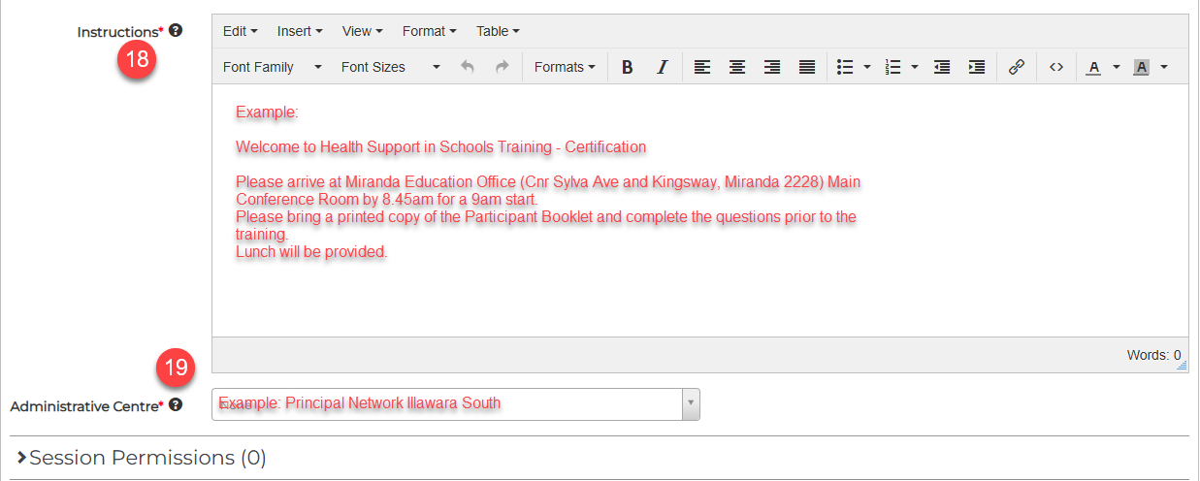

Step 20: Click Session Permissions – this is where you add session support officers, or session managers.
Step 21: Locate and select the relevant session support officer (search by DoE email address).
Note: Request the MyPL team to add any session support officers that will not come up in our search.
Step 22: Select the Session Support Officer role.
Step 23: Select the Add button.
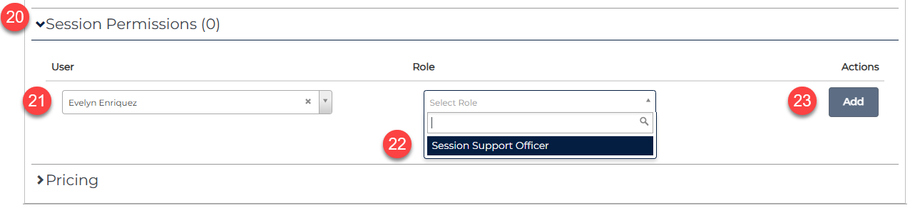
Step 24: Add the price if relevant.
Step 25: Add the relevant details in the Extended Information section.
Step 26: Select the Save Learning Event Session button.
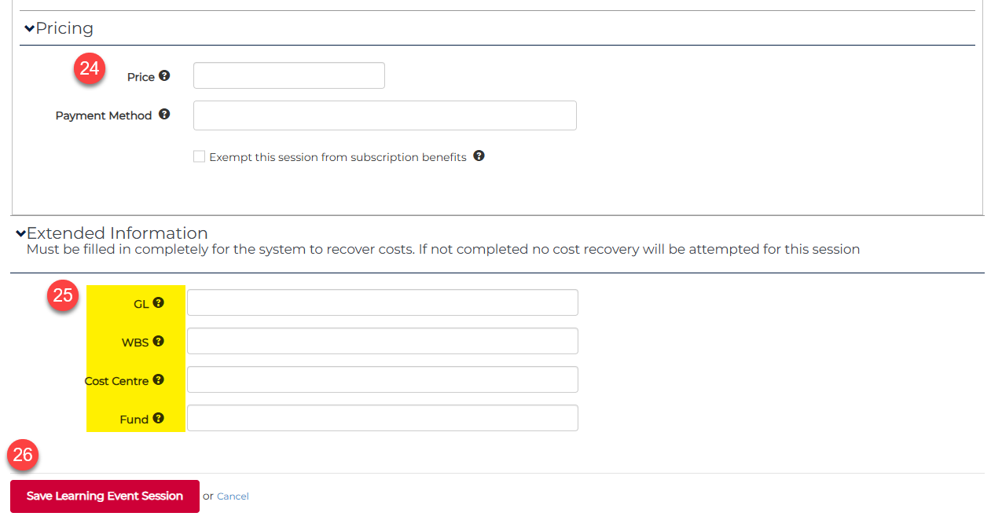

If you see the "Notify users of update?" prompt, please choose Don’t notify users.
The automatic message is quite generic, and people often think they’ve been incorrectly enrolled in the session you created.
