Certificates
You can download your certificate of completion from the My Learning section: click the green or active certificate icon.
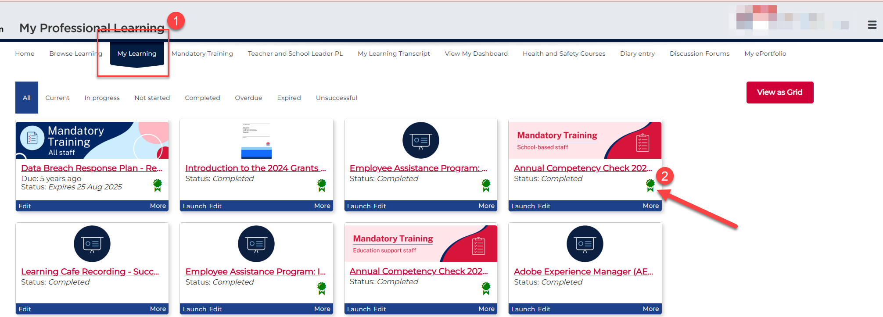

If you have lots of enrolments, click the View as Grid button to make them easier to see.
You can click the Title heading to sort them alphabetically. To find the right certificate, look at the Completed Date column and choose your most recent completion, then download the matching certificate.
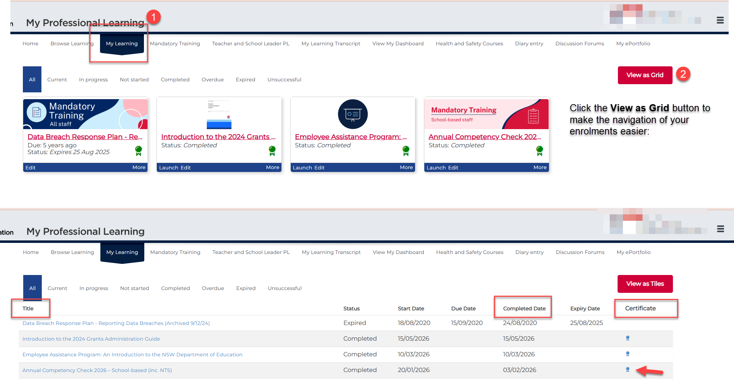

If you only need your mandatory training certificates, go to the Mandatory Training section. Then choose the option that matches your role location. For example, if you work in a school, select School-based staff (inc NTS).
My Learning shows all of your course enrolments, which can be a long list. The Mandatory Training section makes it easier by only showing your mandatory courses, so you can find what you need faster.
Select the Mandatory Training menu.
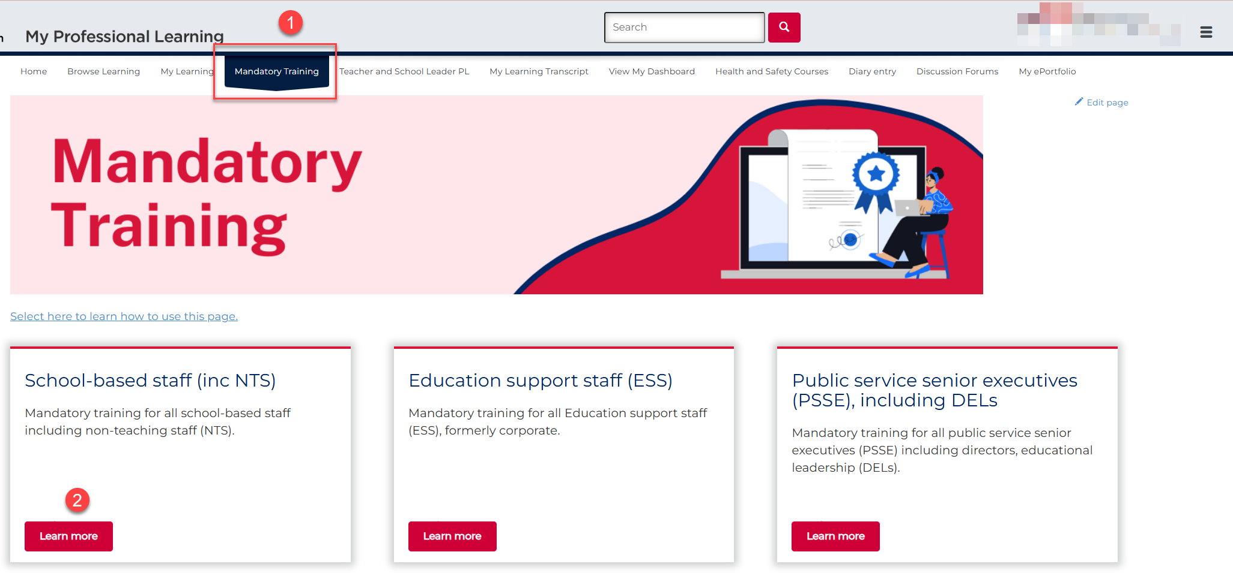

Locate the relevant course, then select the Launch button.
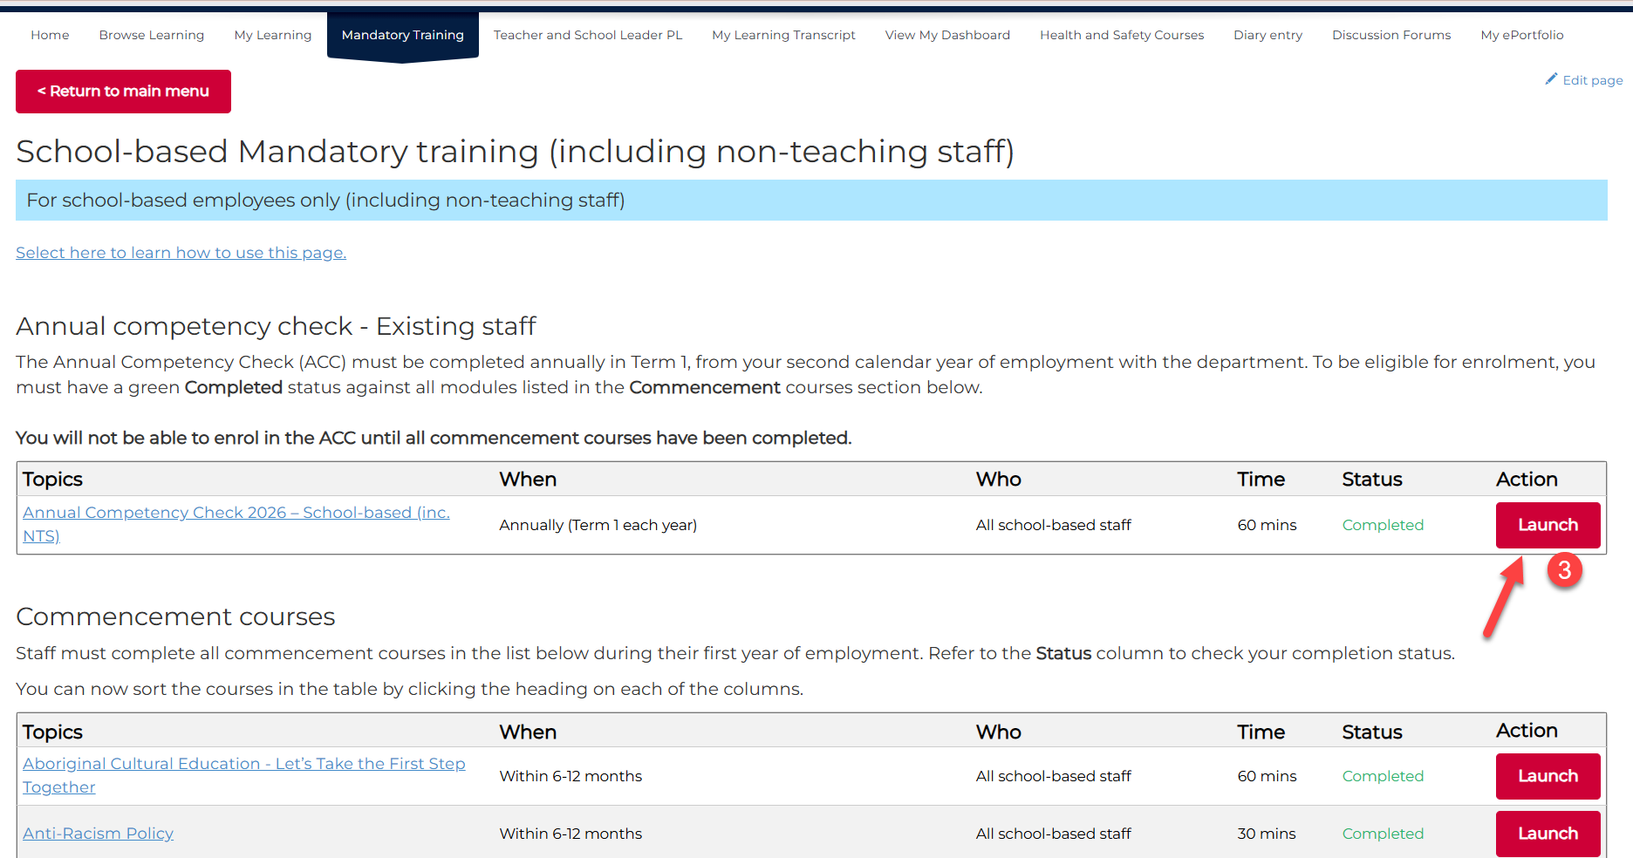

Select View now (next to Certificate is available) to download your certificate.
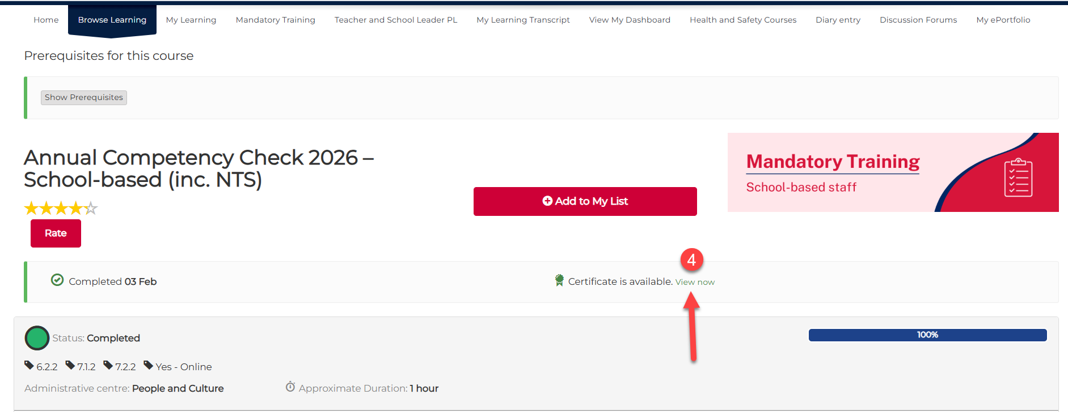

The certificate examples below can’t be downloaded from My Learning or the Mandatory Training section.
At the end of the mandatory course, you will be asked to enter your name and email address.
Once you complete these details, a certificate will appear. It will only be available while you are still inside the eLearning, after you finish the course but before you leave it.
