Task Approver
Please don’t select an approver at random from the list. If you can’t see the correct approver, you can update your Reports To field in your MyPL profile before submitting the task.

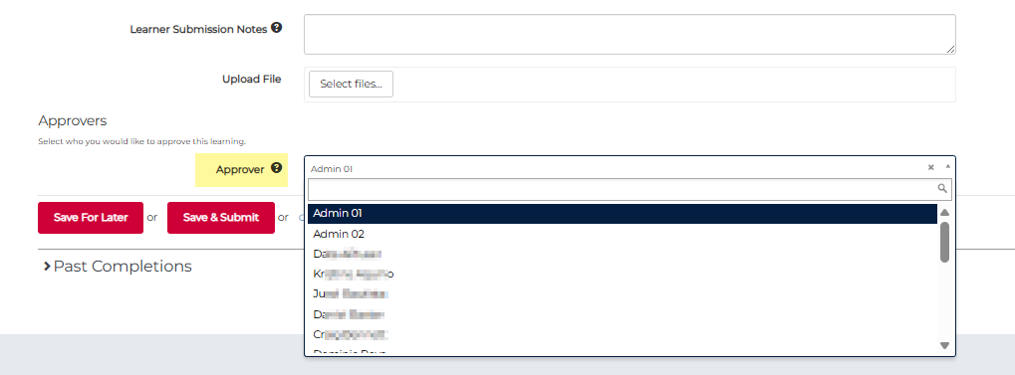

Changing your school or directorate

Step 1: Go to the hamburger menu.
Step 2: Select My Account from the hamburger drop down menu.
Step 3: Select Edit User from the Actions drop down menu.
Step 4: Update the Org Unit to the relevant setting e.g. your current school.
Step 5: Update the Reports To field to the relevant manager or approver.
Step 6: Select the Update button at the end of the screen to save the changes you made.
Important notes:
Note 1: Casual staff details in HR persist in MyPL. Updating your MyPL profile won't update your HR details, so you'll need to update your MyPL profile regularly.
Note 2: If your HR details still show your permanent position (e.g., substantive school), they will overwrite your MyPL profile. Update your HR details to retain changes you make in MyPL.
