Marking task submissions
Step 1: Go to the hamburger menu.
Step 2: Select Manage Learning.
Step 3: Select Approve Learning .
Step 4: Check for submission in these tabs:
My Approval Required
Requested
Step 5: Select View more once you have located the relevant task submission.
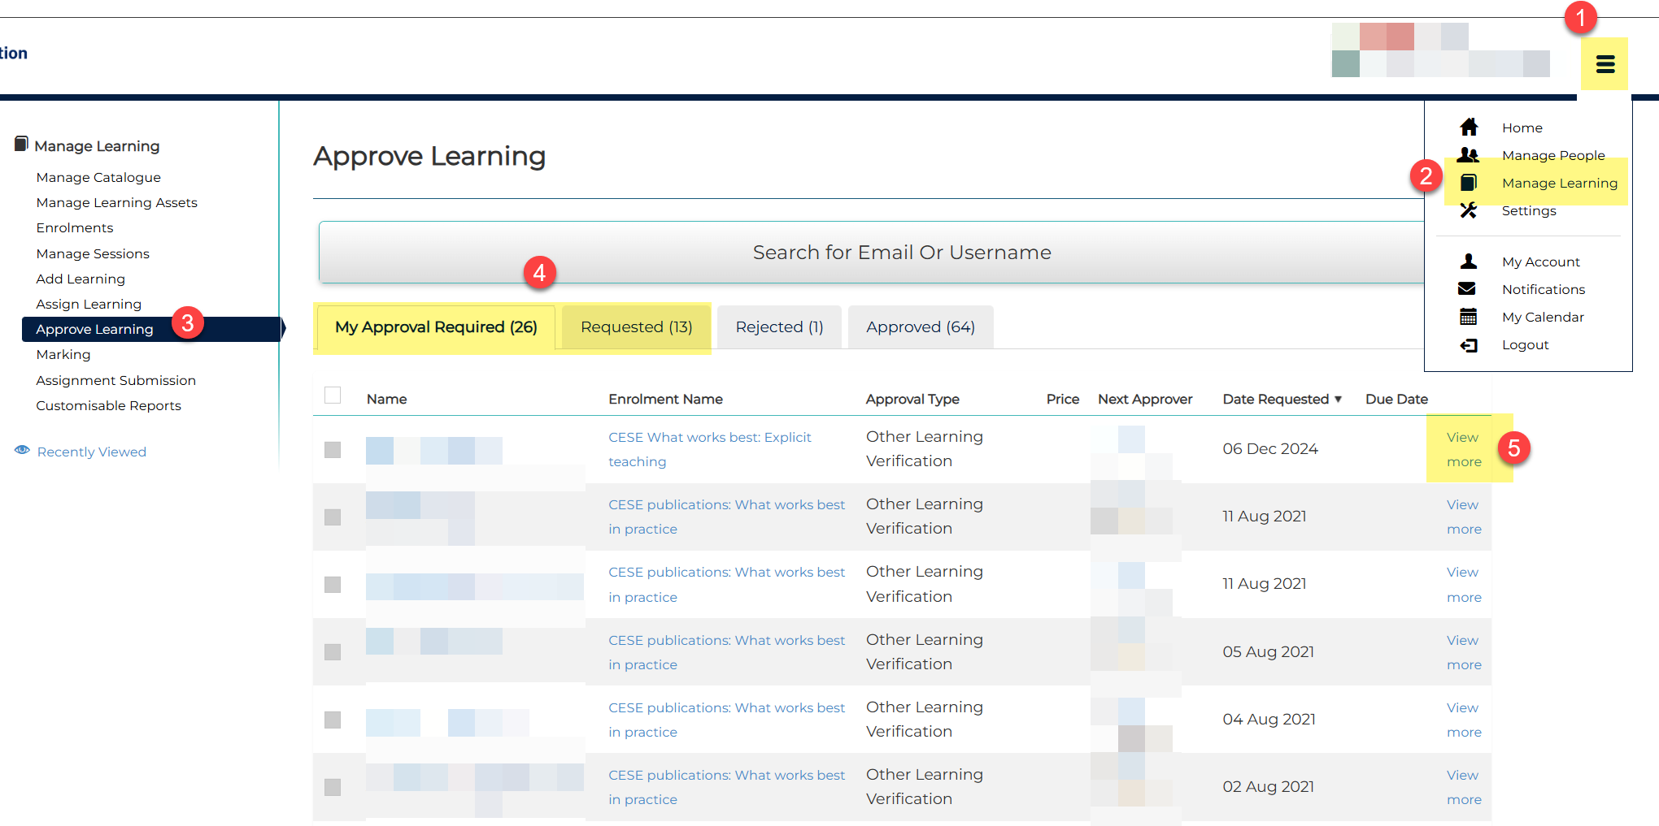
Step 6: Review the task submission.
Note: Participants can submit a task by uploading a file or adding their response in the Learner Submission Notes section.
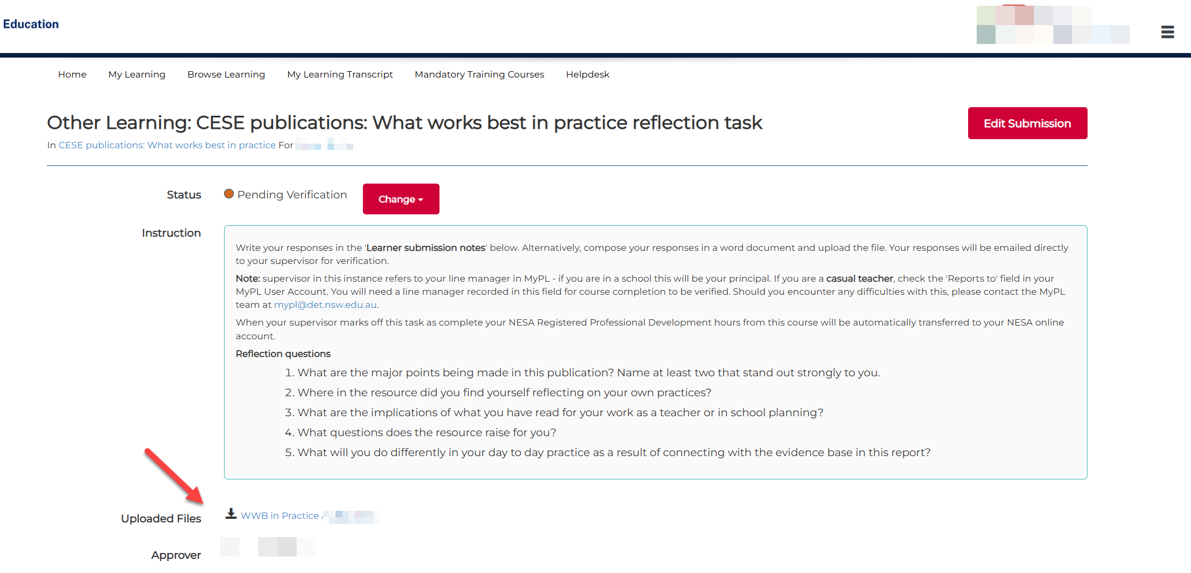
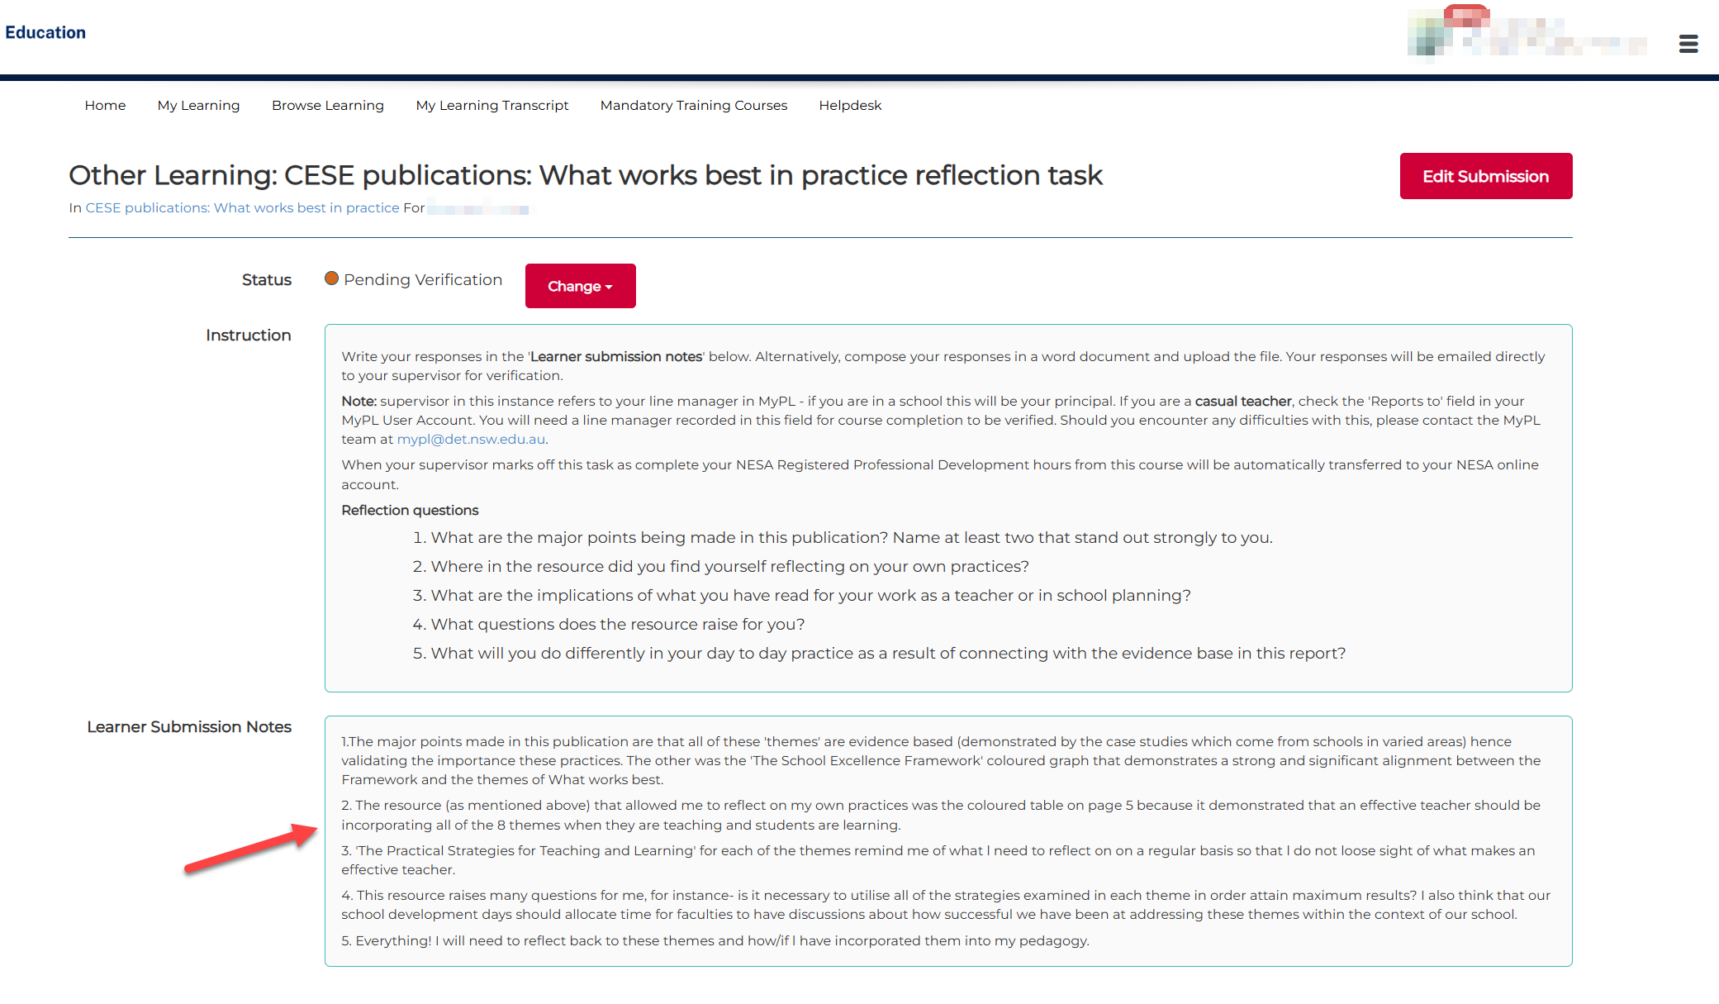

Step 7: From the Change menu, select the submission status you want to apply.

