Marking assignment submissions
Step 1: Go to the hamburger menu .
Step 2: Select Manage Learning.
Step 3: Select Assignment Submission
Step 4: Select the Submitted tab to see all assignment submissions you're marking.
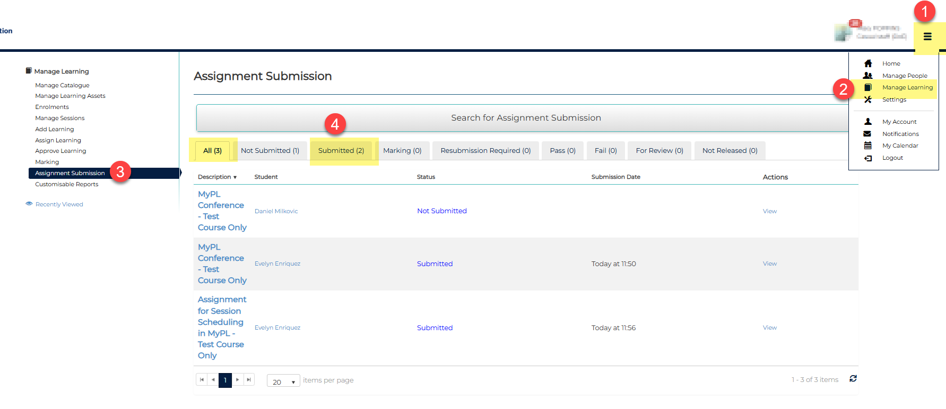

Step 5: Select View to access the assignment submission.
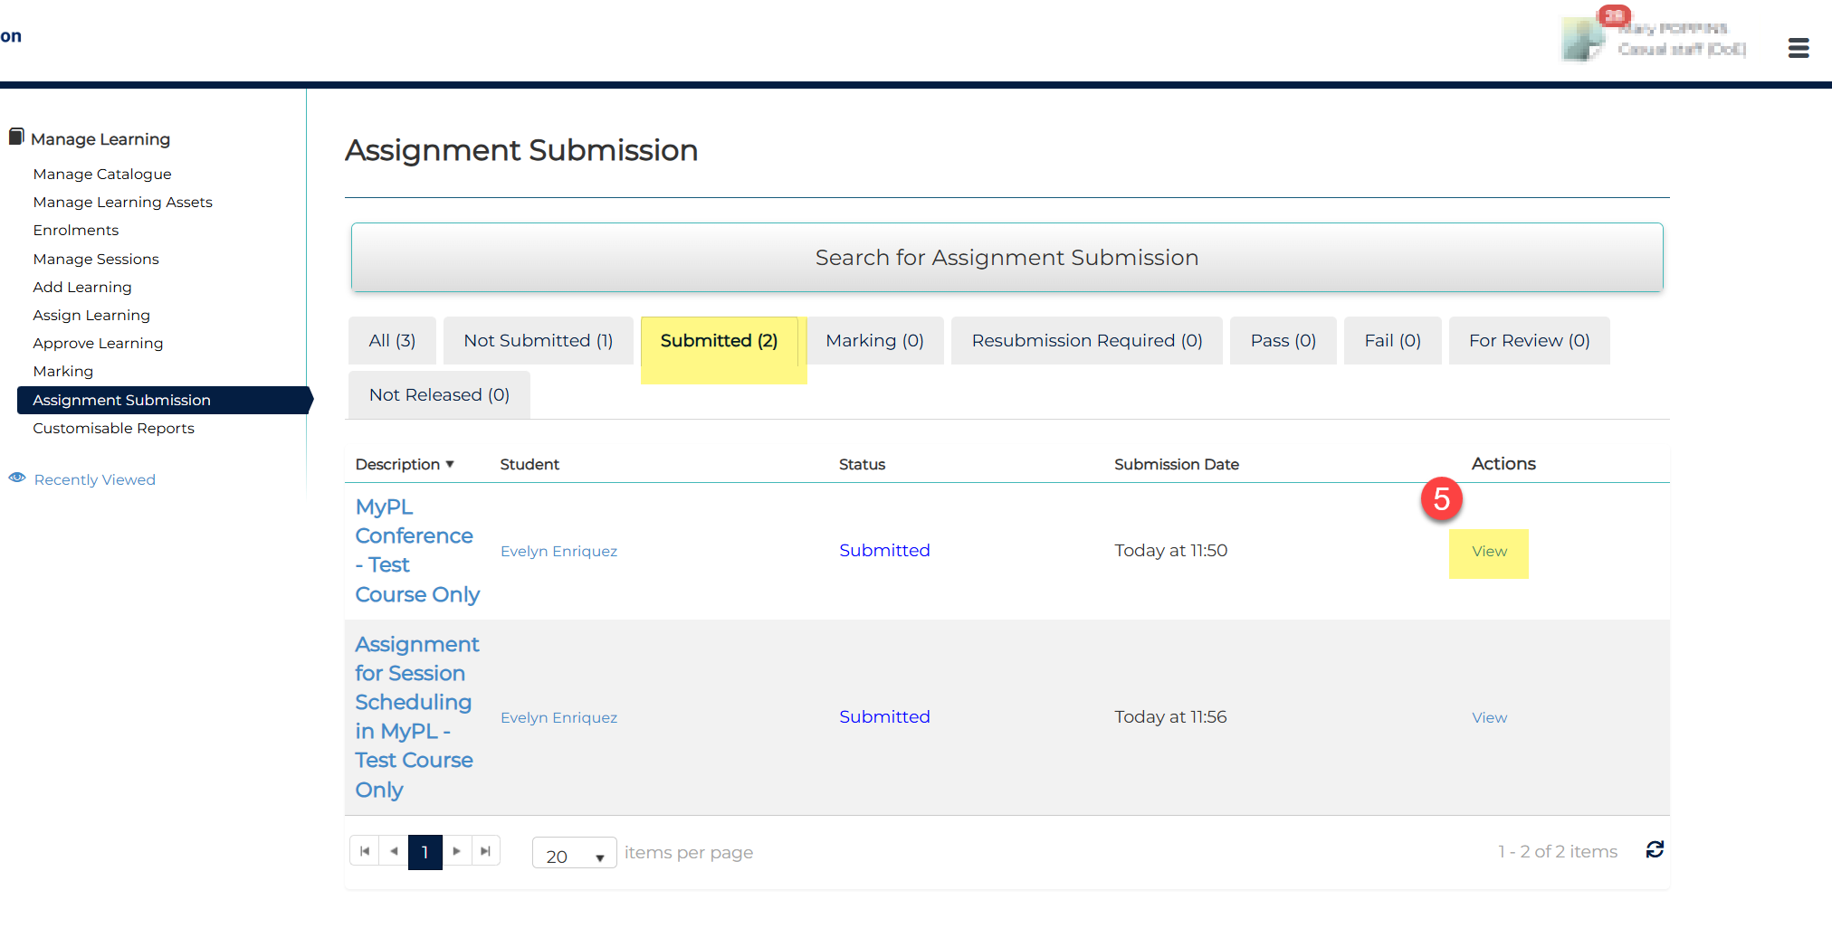

Step 6: Download the attached assignment submission.
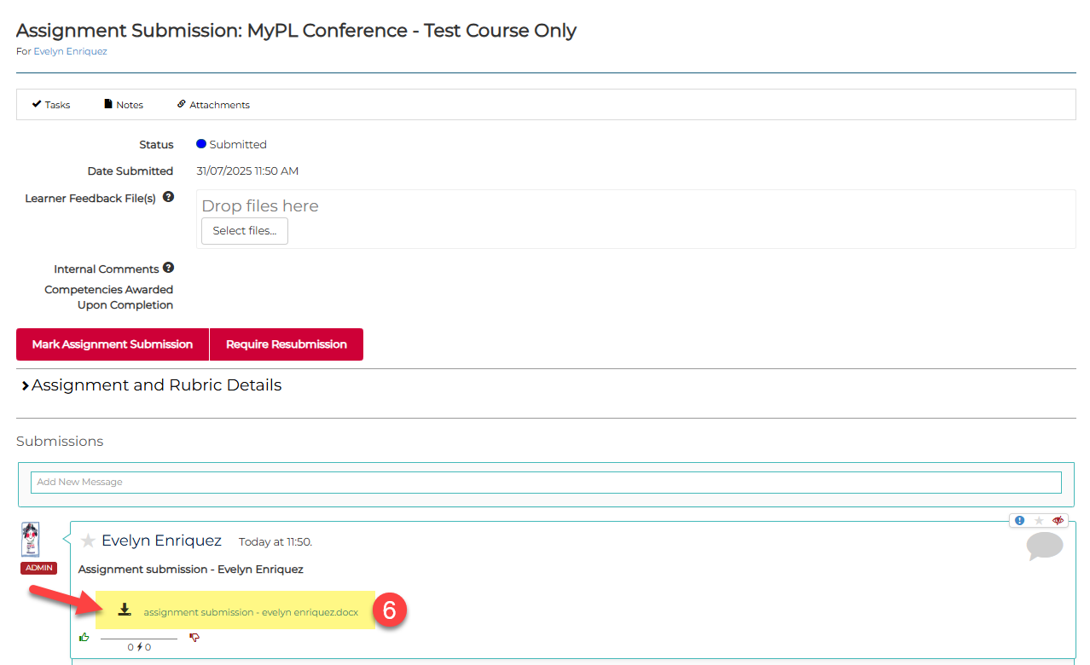

Step 7: Select the Mark Assignment Submission button. 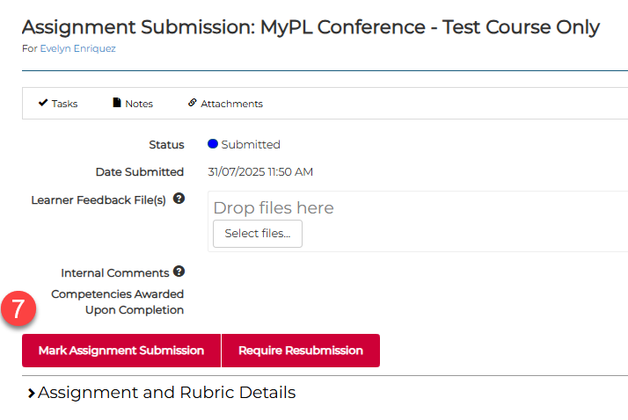

Selecting the Mark Assignment Submission button updates submission status from Submitted to Marking.
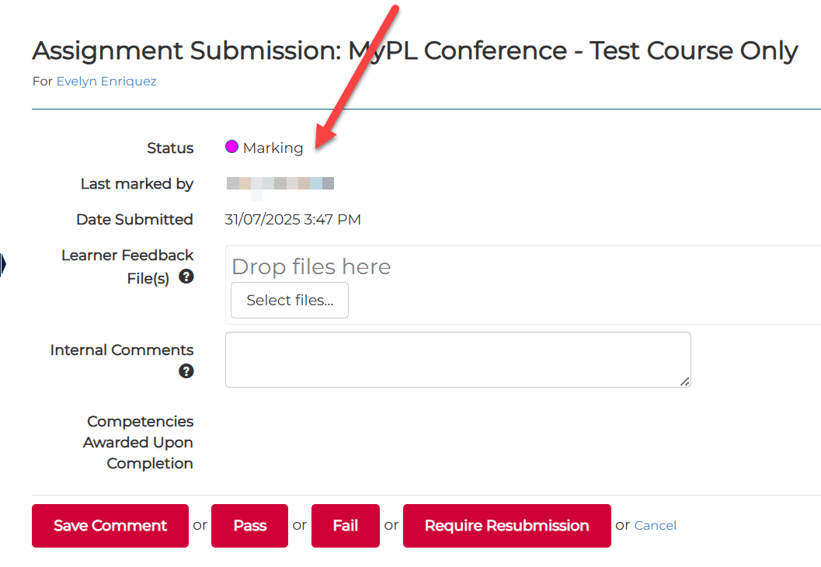

Step 9: Add comments, notes in the Add a comment text box (this will be visible to the participant).
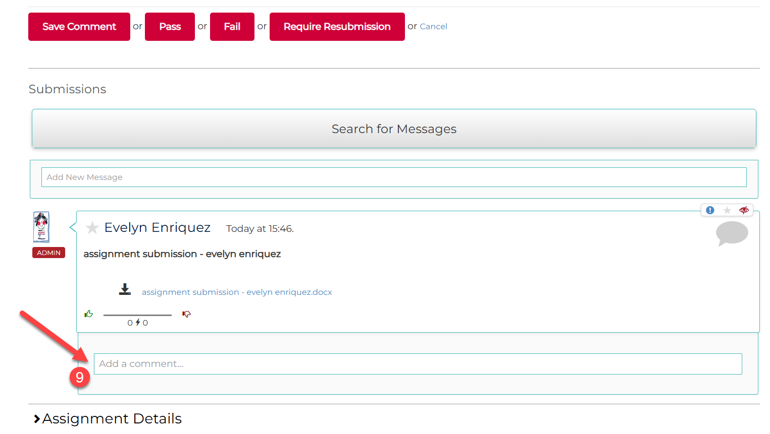

Step 10: Assign the relevant submission status: Pass or Fail or Require Resubmission
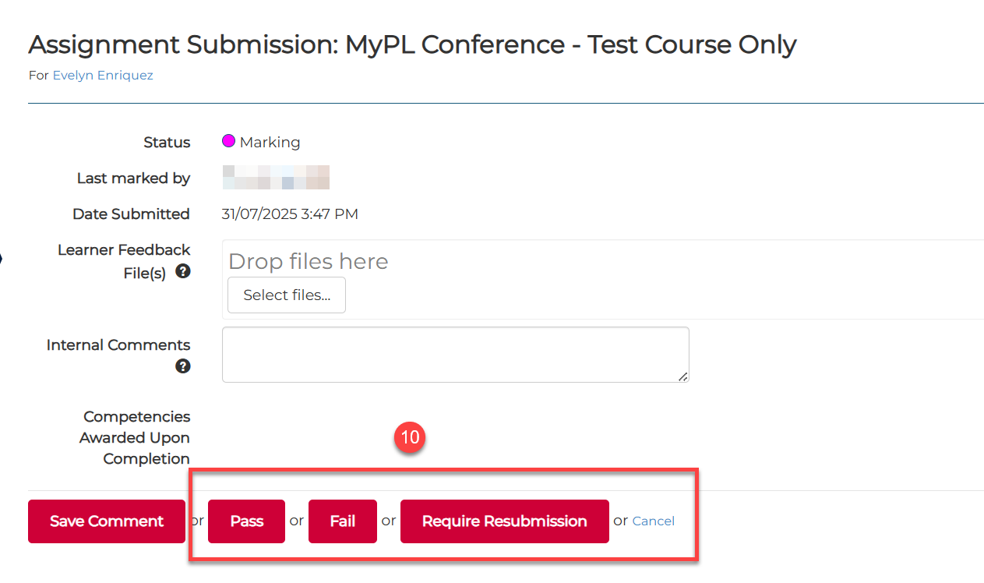

Navigating the Assignment Submission tabs
How to get to the Assignment Submissions section:
Step 1: Go to the hamburger menu.
Step 2: Select Manage Learning.
Step 3: Select Assignment Submission
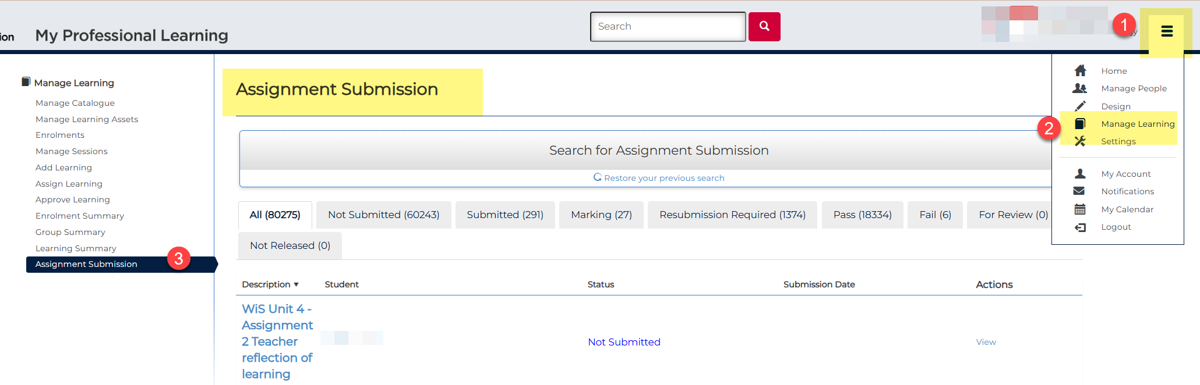

The All tab shows every assignment you have access to.
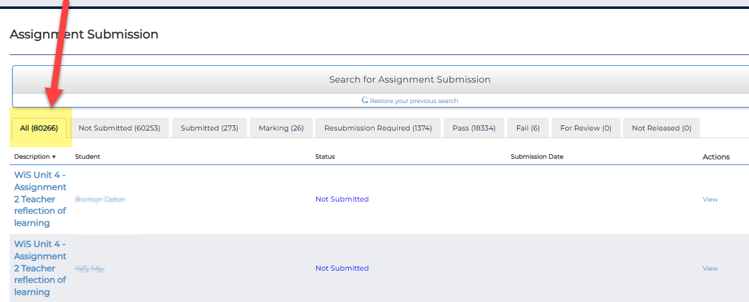

To see all submissions, go to the Submitted tab. You can sort them by date by clicking the Submission Date heading.
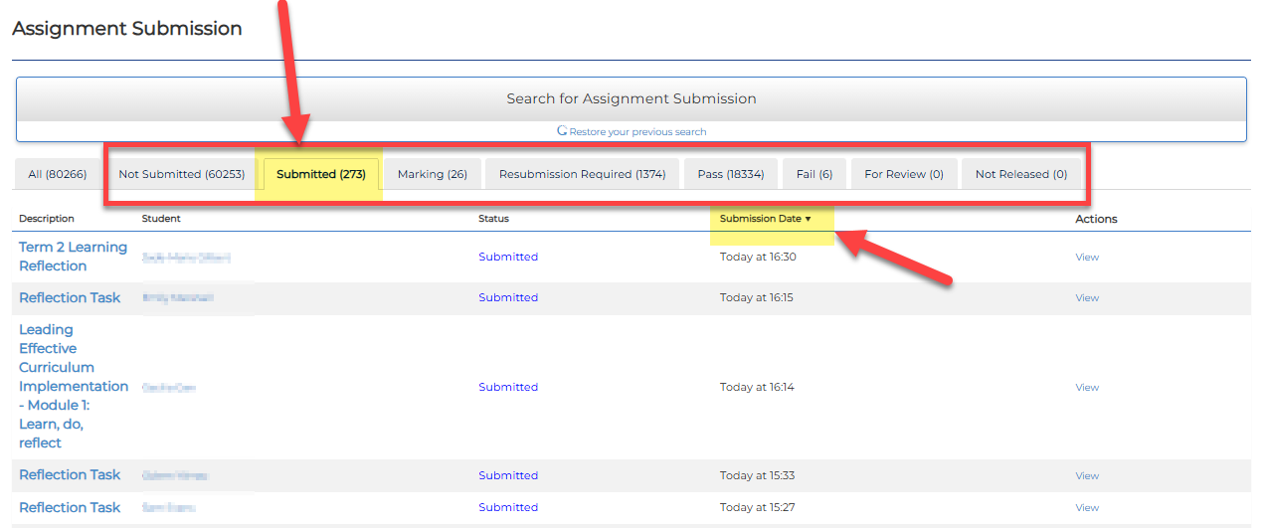

You can view all assignments with the same enrolment status by selecting the relevant tab. For example, select the Marking tab to see all submissions that have been opened but don’t yet have a status.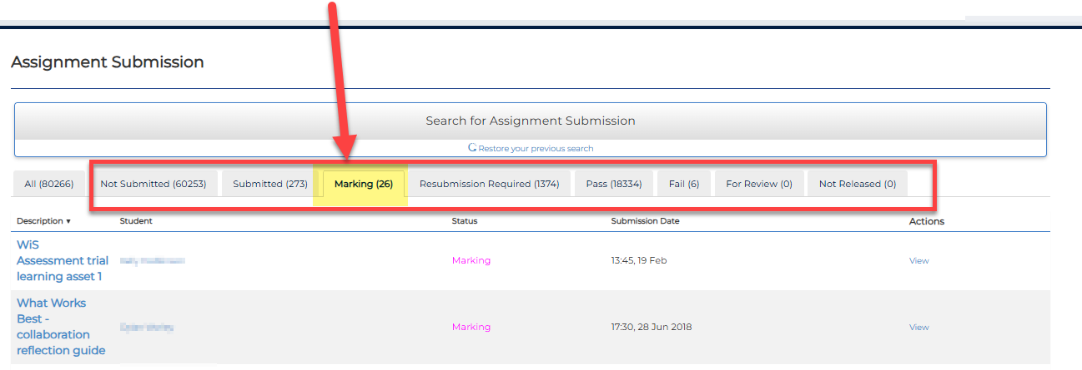

If you are managing multiple assignments, you can choose to view them one at a time to make things easier.
Step 1: Select Search for Assignment Submission.
Step 2: Type the assignment name.
Step 3: Select the Search button.
Once you've selected the relevant assignment, you can organise the information by student name, assignment status, or submission date.
