Chinese writing practice – weather descriptions
Using the information you have learned about Hanzi formation, practise writing the characters for weather description words in the table below.
Use the space within the practice grid to consider the following questions:
- How many strokes does the character have?
- What tips can you give yourself to help remember and recognise these in the future?
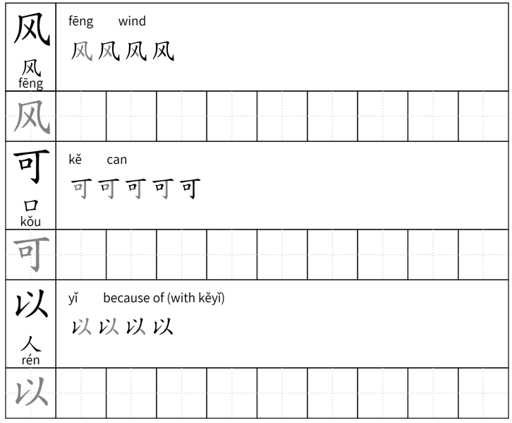
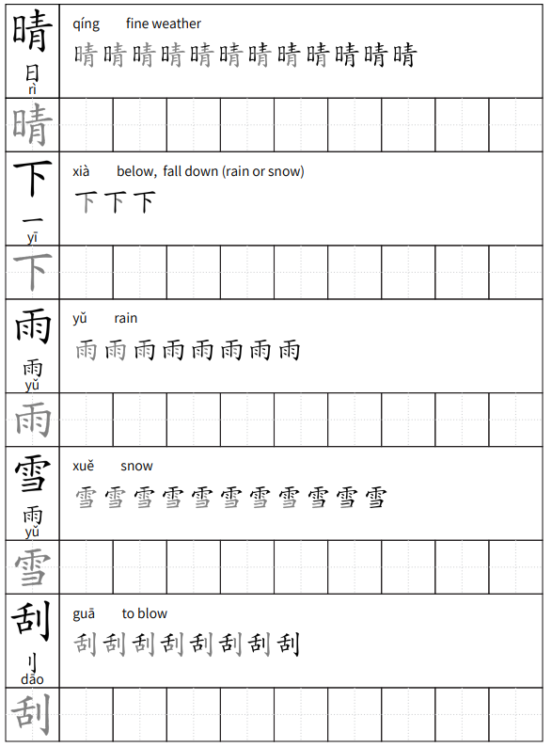

A deeper look
Write these phrases in Hanzi from this unit and from prior learning.
- You can read books on rainy days.
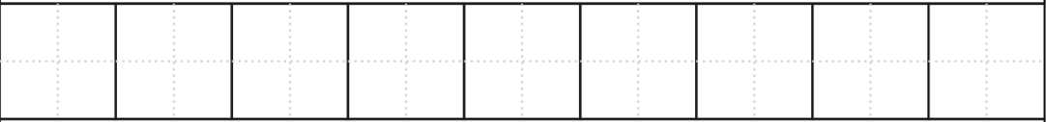
- On windy days I like to play games.
- On snowy days I can not swim.
- On fine days of spring I play basketball.
- When it is sunny I can go for a picnic.
- When it is snowy in China we can do martial arts.
© State of New South Wales (Department of Education), 2023
The copyright material published in this resource is subject to the Copyright Act 1968 (Cth) and is owned by the NSW Department of Education or, where indicated, by a party other than the NSW Department of Education (third-party material).
Copyright material available in this resource and owned by the NSW Department of Education is licensed under a Creative Commons Attribution 4.0 International (CC BY 4.0) license.

This license allows you to share and adapt the material for any purpose, even commercially.
Attribution should be given to © State of New South Wales (Department of Education), 2023.
Material in this resource not available under a Creative Commons license:
- the NSW Department of Education logo, other logos and trademark-protected material
- material owned by a third party that has been reproduced with permission. You will need to obtain permission from the third party to reuse its material.
Links to third-party material and websites
Please note that the provided (reading/viewing material/list/links/texts) are a suggestion only and implies no endorsement, by the New South Wales Department of Education, of any author, publisher, or book title. School principals and teachers are best placed to assess the suitability of resources that would complement the curriculum and reflect the needs and interests of their students.
If you use the links provided in this document to access a third-party's website, you acknowledge that the terms of use, including licence terms set out on the third-party's website apply to the use which may be made of the materials on that third-party website or where permitted by the Copyright Act 1968 (Cth). The department accepts no responsibility for content on third-party websites.

