Introduce yourself

Activity
Imagine you are one of the people in the table below. In your book, write a self-introduction in German.
Category | Person 1 | Person 2 | Person 3 | Person 4 | Person 5
Name | Pierre | Anna | Zeynep | Carl | Karin
Age | 15 | 16 | 12 | 14 | 13
Nationality | French | Australian | Turkish | German | Swiss
Lives | Paris | Newcastle | Berlin | Hamburg | Zürich
Likes to eat | 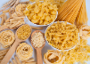 | 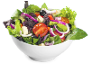 | 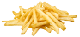 | 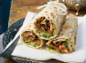 | 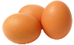
Doesn’t like to eat | 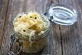 | 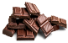 | 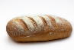 | 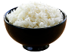 | 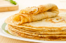
Likes to drink | 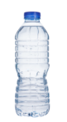 | 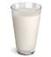 | 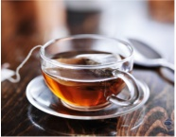 | 
Doesn’t like to drink | 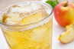 |  |  |  | 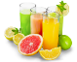

For the teacher
Remove this section before sharing this resource with students.
- Ich heiße Pierre. Ich bin fünfzehn Jahre alt. Ich komme aus Frankreich. Ich wohne in Paris. Ich esse gern Nudeln. Ich esse nicht gern Sauerkraut. Ich trinke gern Wasser. Ich trinke nicht gern Apfelshorle.
- Ich heiße Anna. Ich bin sechzehn Jahre alt. Ich komme aus Australien. Ich wohne in Newcastle. Ich esse gern Salat. Ich esse nicht gern Schokolade. Ich trinke gern Milch. Ich trinke nicht gern Wasser.
- Ich heiße Zeynep. Ich bin zwölf Jahre alt. Ich komme aus der Türkei. Ich wohne in Berlin. Ich esse gern Pommes frites. Ich esse nicht gern Brot. Ich trinke gern Tee. Ich trinke nicht gern Kaffee.
- Ich heiße Carl. Ich bin vierzehn Jahre alt. Ich komme aus Deutschland. Ich wohne in Hamburg. Ich esse gern Döner. Ich esse nicht gern Reis. Ich trinke gern Kaffee. Ich trinke nicht gern Tee.
- Ich heiße Karin. Ich bin dreizehn Jahre alt. Ich komme aus der Schweiz. Ich wohne in Zürich. Ich esse gern Eier. Ich esse nicht gern Pfannkuchen. Ich trinke gern Wasser. Ich trinke nicht gern Saft.

© State of New South Wales (Department of Education), 2024
The copyright material published in this resource is subject to the Copyright Act 1968 (Cth) and is owned by the NSW Department of Education or, where indicated, by a party other than the NSW Department of Education (third-party material).
Copyright material available in this resource and owned by the NSW Department of Education is licensed under a Creative Commons Attribution 4.0 International (CC BY 4.0) license.
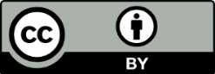
This license allows you to share and adapt the material for any purpose, even commercially. Attribution should be given to © State of New South Wales (Department of Education), 2024.
Material in this resource not available under a Creative Commons licence:
- the NSW Department of Education logo, other logos and trademark-protected material
- material owned by a third party that has been reproduced with permission. You will need to obtain permission from the third party to reuse its material.
Links to third-party material and websites
Please note that the provided (reading/viewing material/list/links/texts) are a suggestion only and implies no endorsement, by the New South Wales Department of Education, of any author, publisher, or book title. School principals and teachers are best placed to assess the suitability of resources that would complement the curriculum and reflect the needs and interests of their students.
If you use the links provided in this document to access a third-party's website, you acknowledge that the terms of use, including licence terms set out on the third-party's website apply to the use which may be made of the materials on that third-party website or where permitted by the Copyright Act 1968 (Cth). The department accepts no responsibility for content on third-party websites.

