Image cards – German foods and drinks
This resource is for the teacher. It provides the content and instructions you need to share with students.
Print enough cards to give each student one card. Students walk around the classroom asking and answering the question Was ist das? or Was sind das?, answering according to what is on their card. Students must pay attention to whether the card requires a singular or plural question or answer.
For example, for Schnitzel, the interaction would be:
- Was ist das?
- Das ist Schnitzel.
For Frikadellen, the interaction would be:
- Was sind das?
- Das sind Frikadellen.

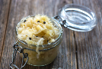 | 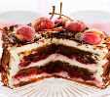 | 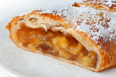 | 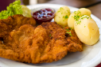
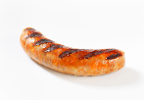 | 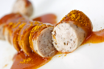 | 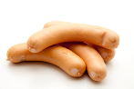 | 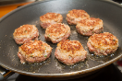
 | 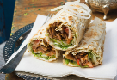 | 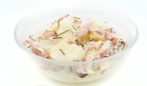 | 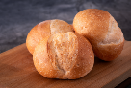
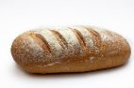 | 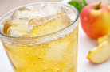 |  | 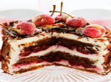

© State of New South Wales (Department of Education), 2024
The copyright material published in this resource is subject to the Copyright Act 1968 (Cth) and is owned by the NSW Department of Education or, where indicated, by a party other than the NSW Department of Education (third-party material).
Copyright material available in this resource and owned by the NSW Department of Education is licensed under a Creative Commons Attribution 4.0 International (CC BY 4.0) license.

This license allows you to share and adapt the material for any purpose, even commercially.
Attribution should be given to © State of New South Wales (Department of Education), 2024.
Material in this resource not available under a Creative Commons license:
- the NSW Department of Education logo, other logos and trademark-protected material
- material owned by a third party that has been reproduced with permission. You will need to obtain permission from the third party to reuse its material.
Links to third-party material and websites
Please note that the provided (reading/viewing material/list/links/texts) are a suggestion only and implies no endorsement, by the New South Wales Department of Education, of any author, publisher, or book title. School principals and teachers are best placed to assess the suitability of resources that would complement the curriculum and reflect the needs and interests of their students.
If you use the links provided in this document to access a third-party's website, you acknowledge that the terms of use, including licence terms set out on the third-party's website apply to the use which may be made of the materials on that third-party website or where permitted by the Copyright Act 1968 (Cth). The department accepts no responsibility for content on third-party websites.

