German foods and drinks – descriptions

Activity 1
To understand what different German food and drinks are, complete the table below by writing the German word next to its description.
German word | English description
 | A popular Austrian and German pastry made with thin layers of dough filled with spiced apples, raisins and cinnamon.
 | A type of German sausage made from pork, beef, or veal. It is usually seasoned with various herbs and spices and is often grilled or fried.
 | A breaded and fried cutlet of meat, typically made from pork or veal, but can also be made from chicken or turkey.
 | German potato salad, typically made with potatoes, onions and a mayonnaise or vinegar-based dressing.
 | A type of German gingerbread cookie or cake, often flavoured with honey and spices and decorated with icing.
 | German bread, which comes in a wide variety of types, including dark rye bread and whole-grain bread.
 | Fermented cabbage, often used as a side dish in German cuisine.
 | A German fast food dish made of Bratwurst sausage served with a curry ketchup sauce and often sprinkled with curry powder.
 | A type of sausage, similar to a hot dog, named after Frankfurt, Germany. It is usually made from pork or a pork and beef blend.
 | Also known as Black Forest cherry cake, it's a traditional German dessert consisting of layers of chocolate sponge cake, whipped cream, cherries and kirsch (cherry schnapps).
 | Small bread rolls, commonly served as a breakfast item or as a side with various dishes in Germany.
 | A popular German beverage made by mixing apple juice or apple spritzer with sparkling water, creating a refreshing and slightly sweet drink.
 | German pretzels, a type of baked bread product with a twisted knot shape, usually sprinkled with coarse salt.
 | German meatballs, often made from ground pork or beef and mixed with onions, herbs and breadcrumbs.
 | A popular Turkish and German street food consisting of seasoned meat (usually lamb, chicken, or beef) shaved from a vertical rotisserie and served in a flatbread with vegetables and sauce.

Activity 2
Write the German word underneath the picture in the table below.
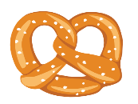 | 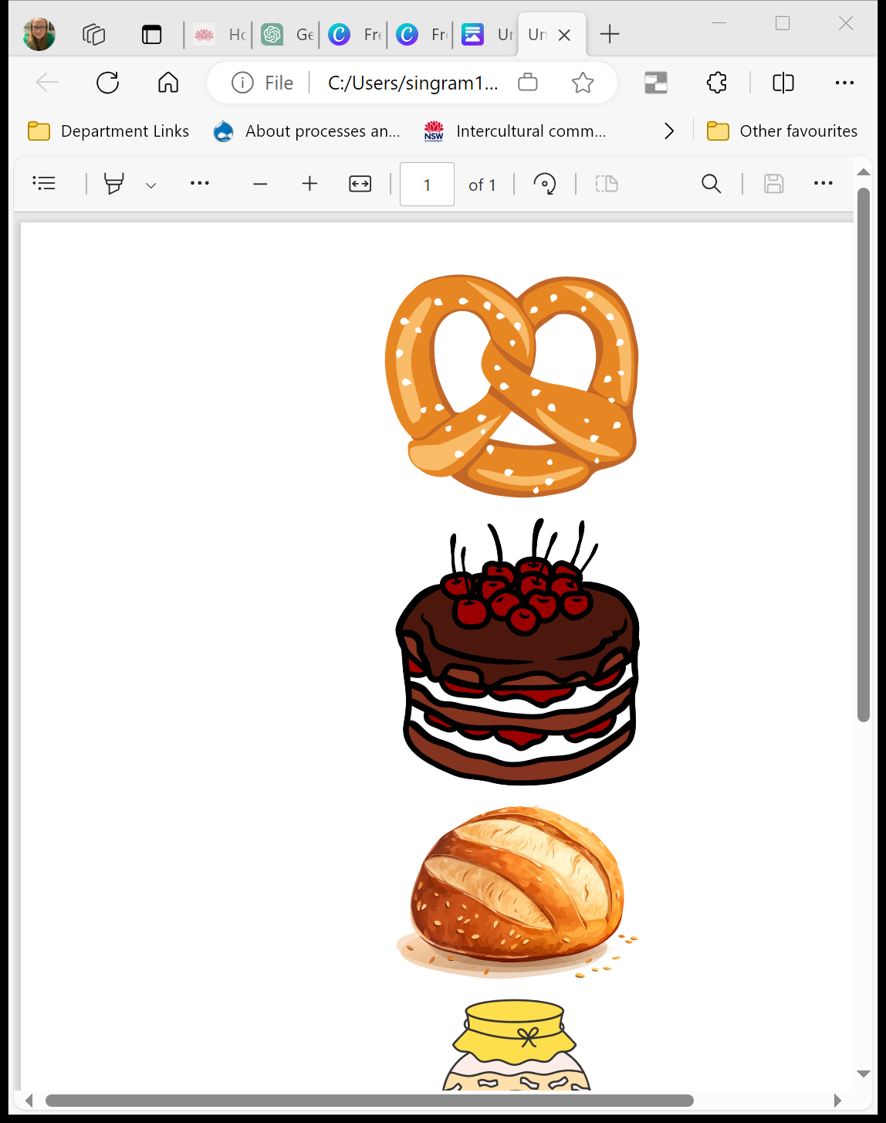 |  | 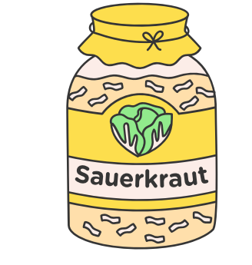

Activity 3
Write the name of 3 German food or drinks you would like to try in the table below.

Activity 4
Write the new words in random spaces below to play 4 in a row. Mark off the words as the teacher calls them out and once you have 4 in a row either vertically or horizontally, call out fertig.

For the teacher
Remove this section before sharing this resource with students.

Activity 1
German word | English description
Apfelstrudel | A popular Austrian and German pastry made with thin layers of dough filled with spiced apples, raisins and cinnamon.
Bratwurst | A type of German sausage made from pork, beef, or veal. It is usually seasoned with various herbs and spices and is often grilled or fried.
Schnitzel | A breaded and fried cutlet of meat, typically made from pork or veal, but can also be made from chicken or turkey.
Kartoffelsalat | German potato salad, typically made with potatoes, onions and a mayonnaise or vinegar-based dressing.
Lebkuchen | A type of German gingerbread cookie or cake, often flavoured with honey and spices and decorated with icing.
Brot | German bread, which comes in a wide variety of types, including dark rye bread and whole-grain bread.
Sauerkraut | Fermented cabbage, often used as a side dish in German cuisine.
Currywurst | A German fast food dish made of Bratwurst sausage served with a curry ketchup sauce and often sprinkled with curry powder.
Frankfurter | A type of sausage, similar to a hot dog, named after Frankfurt, Germany. It is usually made from pork or a pork and beef blend.
Schwarzwälder Kirschtorte | Also known as Black Forest cherry cake, it's a traditional German dessert consisting of layers of chocolate sponge cake, whipped cream, cherries and kirsch (cherry schnapps).
Brötchen | Small bread rolls, commonly served as a breakfast item or as a side with various dishes in Germany.
Apfelschorle | A popular German beverage made by mixing apple juice or apple spritzer with sparkling water, creating a refreshing and slightly sweet drink.
Brezeln | German pretzels, a type of baked bread product with a twisted knot shape, usually sprinkled with coarse salt.
Frikadellen | German meatballs, often made from ground pork or beef and mixed with onions, herbs and breadcrumbs.
Döner | A popular Turkish and German street food consisting of seasoned meat (usually lamb, chicken, or beef) shaved from a vertical rotisserie and served in a flatbread with vegetables and sauce.

Activity 2
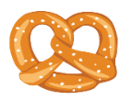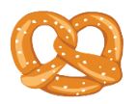 | 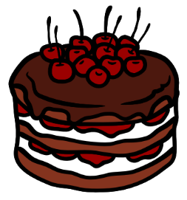
Brezeln | Schwarzwälder Kirschtorte | Brot | Sauerkraut

© State of New South Wales (Department of Education), 2024
The copyright material published in this resource is subject to the Copyright Act 1968 (Cth) and is owned by the NSW Department of Education or, where indicated, by a party other than the NSW Department of Education (third-party material).
Copyright material available in this resource and owned by the NSW Department of Education is licensed under a Creative Commons Attribution 4.0 International (CC BY 4.0) license.

This license allows you to share and adapt the material for any purpose, even commercially.
Attribution should be given to © State of New South Wales (Department of Education), 2024.
Material in this resource not available under a Creative Commons license:
- the NSW Department of Education logo, other logos and trademark-protected material
- material owned by a third party that has been reproduced with permission. You will need to obtain permission from the third party to reuse its material.
Links to third-party material and websites
Please note that the provided (reading/viewing material/list/links/texts) are a suggestion only and implies no endorsement, by the New South Wales Department of Education, of any author, publisher, or book title. School principals and teachers are best placed to assess the suitability of resources that would complement the curriculum and reflect the needs and interests of their students.
If you use the links provided in this document to access a third-party's website, you acknowledge that the terms of use, including licence terms set out on the third-party's website apply to the use which may be made of the materials on that third-party website or where permitted by the Copyright Act 1968 (Cth). The department accepts no responsibility for content on third-party websites.

